West Virginia PYs 2022-2023 (Mod)

Contents
West Virginia PYs 2022-2023 (Mod)
Overview
Options for Submitting a State Plan
How State Plan Requirements Are Organized
I. WIOA State Plan Type and Executive Summary
a. WIOA State Plan Type
Combined Plan Partner Program(s)
b. Plan Introduction or Executive Summary
II. Strategic Elements
a. Economic, Workforce, and Workforce Development Activities Analysis
b. State Strategic Vision and Goals
c. State Strategy
III. Operational Planning Elements
a. State Strategy Implementation
b. State Operating Systems and Policies
IV. Coordination with State Plan Programs
V. Common Assurances (For All Core Programs)
VI. Program-Specific Requirements for Core Programs
Program-specific Requirements for Adult, Dislocated Worker, and Youth Activities under Title I-B
Program-Specific Requirements for Wagner-Peyser Program (Employment Services)
Program-specific Requirements for Adult Education and Family Literacy Act Programs
Program-Specific Requirements for Vocational Rehabilitation (Combined or General)
VII. Program-Specific Requirements for Combined State Plan Partner Programs
Career and technical education programs authorized under the the Carl D. Perkins Career and Technical Education Act of 2006, as amended by the Strengthening Career and Technical Education for the 21st Century Act (Perkins V) (Title 20, United States Code (20 U.S.C. 2301 et seq.))
Temporary Assistance for Needy Families (TANF)
Employment and Training Programs Under the Supplemental Nutrition Assistance Program (Programs Authorized Under Section 6(d)(4) of the Food and Nutrition Act of 2008 (7 U.S.C. 2015(d)(4)))
Trade Adjustment Assistance (TAA)
Jobs for Veterans’ State Grants
Unemployment Insurance (UI)
Senior Community Service Employment Program (SCSEP)
Community Services Block Grant (CSBG)
Performance Indicator Appendix
All WIOA Core Programs
Additional Indicators of Performance
Other Appendices

Overview
Under the Workforce Innovation and Opportunity Act (WIOA), the Governor of each State must submit a Unified or Combined State Plan to the Secretary of the U.S. Department of Labor that outlines a four-year strategy for the State’s workforce development system. The publicly-funded workforce development system is a national network of Federal, State, regional, and local agencies and organizations that provide a range of employment, education, training, and related services and supports to help all job-seekers secure good jobs while providing businesses with the skilled workers they need to compete in the global economy. States must have approved Unified or Combined State Plans in place to receive funding for core programs. WIOA reforms planning requirements, previously governed by the Workforce Investment Act of 1998 (WIA), to foster better alignment of Federal investments in job training, to integrate service delivery across programs and improve efficiency in service delivery, and to ensure that the workforce system is job-driven and matches employers with skilled individuals. One of WIOA’s principal areas of reform is to require States to plan across core programs and include this planning process in the Unified or Combined State Plans. This reform promotes a shared understanding of the workforce needs within each State and fosters development of more comprehensive and integrated approaches, such as career pathways and sector strategies, for addressing the needs of businesses and workers. Successful implementation of many of these approaches called for within WIOA requires robust relationships across programs. WIOA requires States and local areas to enhance coordination and partnerships with local entities and supportive service agencies for strengthened service delivery, including through Unified or Combined State Plans.

Options for Submitting a State Plan
A State has two options for submitting a State Plan— a Unified State Plan or a Combined State Plan. At a minimum, a State must submit a Unified State Plan that meets the requirements described in this document and outlines a four-year strategy for the core programs. The six core programs are—
- the Adult program (Title I of WIOA),
- the Dislocated Worker program (Title I),
- the Youth program (Title I),
- the Adult Education and Family Literacy Act program (Title II), and
- the Wagner-Peyser Act Employment Service program (authorized under the Wagner-Peyser Act, as amended by title III),
- the Vocational Rehabilitation program (authorized under Title I of the Rehabilitation Act of 1973, as amended by Title IV).
Alternatively, a State may submit a Combined State Plan that meets the requirements described in this document and outlines a four-year strategy for WIOA’s core programs plus one or more of the Combined State Plan partner programs. When a State includes a Combined State Plan partner program in its Combined State Plan, it need not submit a separate plan or application for that particular program. If included, Combined State Plan partner programs are subject to the “common planning elements” (Sections II-IV of this document) where specified, as well as the program-specific requirements for that program where such planning requirements exist separately for the program. The Combined State Plan partner programs are—
- Career and technical education programs authorized under the Carl D. Perkins Career and Technical Education Act of 2006, as amended by the Strengthening Career and Technical Education for the 21st Century Act (Perkins V) (20 U.S.C. 2301 et seq.)
- Temporary Assistance for Needy Families program (42 U.S.C. 601 et seq.)
- Employment and Training programs under the Supplemental Nutrition Assistance Program (programs authorized under section 6(d)(4) of the Food and Nutrition Act of 2008 (7 U.S.C. 2015(d)(4)))
- Work programs authorized under section 6(o) of the Food and Nutrition Act of 2008 (7 U.S.C. 2015(o))
- Trade Adjustment Assistance for Workers programs (Activities authorized under chapter 2 of title II of the Trade Act of 1974 (19 U.S.C. 2271 et seq.))
- Jobs for Veterans State Grants Program (programs authorized under 38, U.S.C. 4100 et. seq.)
- Unemployment Insurance programs (programs authorized under State unemployment compensation laws in accordance with applicable Federal law)
- Senior Community Service Employment program (programs authorized under title V of the Older Americans Act of 1965 (42 U.S.C. 3056 et seq.))
- Employment and training activities carried out by the Department of Housing and Urban Development
- Community Services Block Grant (Employment and training activities carried out under the Community Services Block Grant Act (42 U.S.C. 9901 et seq.)) ¹
- Reintegration of Ex-Offenders program (programs authorized under section 212 of the Second Chance Act of 2007 (42 U.S.C. 17532))
[1] States that elect to include employment and training activities carried out under the Community Services Block Grant (CSBG) Act (42 U.S.C. 9901 et seq.) under a Combined State Plan would submit all other required elements of a complete CSBG State Plan directly to the Federal agency that administers the program. Similarly, States that elect to include employment and training activities carried out by the Department of Housing and Urban Development that are included would submit all other required elements of a complete State Plan for those programs directly to the Federal agency that administers the program.

How State Plan Requirements Are Organized
The major content areas of the Unified or Combined State Plan include strategic and operational planning elements. WIOA separates the strategic and operational elements to facilitate cross-program strategic planning.
- The Strategic Planning Elements section includes analyses of the State’s economic conditions, workforce characteristics, and workforce development activities. These analyses drive the required vision and goals for the State’s workforce development system and alignment strategies for workforce development programs to support economic growth.
- The Operational Planning Elements section identifies the State’s efforts to support the State’s strategic vision and goals as identified in the Strategic Planning Elements section. This section ensures that the State has the necessary infrastructure, policies, and activities to meet its strategic goals, implement its alignment strategy, and support ongoing program development and coordination. Operational planning elements include:
  - State Strategy Implementation,
  - State Operating Systems and Policies,
  - Assurances,
  - Program-Specific Requirements for the Core Programs, and
  - Program-Specific Requirements for the Combined State Plan partner programs. (These requirements are available in a separate supplemental document, Supplement to the Workforce Innovation and Opportunity Act (WIOA) Unified and Combined State Plan Requirements. The Departments are not seeking comments on these particular requirements).
When responding to Unified or Combined State Plan requirements, States must identify specific strategies for coordinating programs and services for target populations.² States must develop strategies that look beyond strategies for the general population and develop approaches that also address the needs of target populations.
Paperwork Reduction Act: The Paperwork Reduction Act of 1995 (PRA) provides that an agency may not conduct, and no person is required to respond to, a collection of information unless it displays a valid OMB control number. Public reporting burden for this information collection is estimated to be 86 hours per state; including time for reviewing instructions, searching existing data sources, gathering and maintaining the data needed, and completing and reviewing the collection of information. Responding to this collection is required to obtain or retain the Federal grant benefit. In addition, responses to this information collection are public, and the agencies offer no assurances of confidentiality. Send comments regarding the burden estimate or any other aspect of this collection of information, including suggestions for reducing this burden, to the U.S. Department of Labor, Office of Workforce Investment, and reference OMB control number 1205-0522. Note: Please do not return the completed plan to this address.
[2] Target populations include individuals with barriers to employment, as defined in WIOA Sec. 3, as well as veterans, unemployed workers, and youth.

I. WIOA State Plan Type and Executive Summary

a. WIOA State Plan Type
Unified or Combined State Plan. Select whether the State is submitting a Unified or Combined State Plan. At a minimum, a State must submit a Unified State Plan that covers the six core programs. Unified or Combined State Plan. Select whether the State is submitting a Unified or Combined State Plan. At a minimum, a State must submit a Unified State Plan that covers the six core programs.
Unified State Plan. This plan includes the Adult, Dislocated Worker, Youth, Wagner-Peyser Act, Adult Education and Family Literacy Act, and Vocational Rehabilitation programs.
Combined State Plan. This plan includes the Adult, Dislocated Worker, Youth, Wagner-Peyser Act, Adult Education and Family Literacy Act, and Vocational Rehabilitation programs, as well as one or more of the optional Combined State Plan partner programs identified below.
This is a combined plan

Combined Plan Partner Program(s)
Indicate which Combined Plan partner program(s) the state is electing to include in the plan.
Career and technical education programs authorized under the Carl D. Perkins Career and Technical Education Act of 2006, as amended by the Strengthening Career and Technical Education for the 21st Century Act (Perkins V) (20 U.S.C. 2301 et seq.)
Yes
Temporary Assistance for Needy Families program (42 U.S.C. 601 et seq.)
Yes
Employment and Training programs under the Supplemental Nutrition Assistance Program (programs authorized under section 6(d)(4) of the Food and Nutrition Act of 2008 (7 U.S.C. 2015(d)(4)))
Yes
Work programs authorized under section 6(o) of the Food and Nutrition Act of 2008 (7 U.S.C. 2015(o))
No
Trade Adjustment Assistance for Workers programs (activities authorized under chapter 2 of title II of the Trade Act of 1974 (19 U.S.C. 2271 et seq.))
Yes
Jobs for Veterans State Grants Program (programs authorized under 38, U.S.C. 4100 et. seq.)
Yes
Unemployment Insurance programs (programs authorized under State unemployment compensation laws in accordance with applicable Federal law)
Yes
Senior Community Service Employment program (programs authorized under title V of the Older Americans Act of 1965 (42 U.S.C. 3056 et seq.))
Yes
Employment and training activities carried out by the Department of Housing and Urban Development
No
Community Services Block Grant (Employment and training activities carried out under the Community Services Block Grant Act (42 U.S.C. 9901 et seq.))
Yes

b. Plan Introduction or Executive Summary
The Unified or Combined State Plan may include an introduction or executive summary. This element is optional.

II. Strategic Elements
The Unified or Combined State Plan must include a Strategic Planning Elements section that analyzes the State’s current economic environment and identifies the State’s overall vision for its workforce development system. The required elements in this section allow the State to develop data-driven goals for preparing an educated and skilled workforce and to identify successful strategies for aligning workforce development programs to support economic growth. Unless otherwise noted, all Strategic Planning Elements apply to Combined State Plan partner programs included in the plan as well as to core programs.

a. Economic, Workforce, and Workforce Development Activities Analysis
The Unified or Combined State Plan must include an analysis of the economic conditions, economic development strategies, and labor market in which the State’s workforce system and programs will operate.

1. Economic and Workforce Analysis

A. Economic Analysis
The Unified or Combined State Plan must include an analysis of the economic conditions and trends in the State, including sub-State regions and any specific economic areas identified by the State. This must include—

i. Existing Demand Industry Sectors and Occupations
Provide an analysis of the industries and occupations for which there is existing demand.

ii. Emerging Demand Industry Sectors and Occupations
Provide an analysis of the industries and occupations for which demand is emerging.

iii. Employers’ Employment Needs
With regard to the industry sectors and occupations identified in (A)(i) and (ii), provide an assessment of the employment needs of employers, including a description of the knowledge, skills, and abilities required, including credentials and licenses.
West Virginia’s economy can be divided into 11 major sectors: natural resources and mining; construction; manufacturing; trade, transportation and utilities; information; financial activities; professional and business services; education and health services; leisure and hospitality; other services; and total government. Between 2018 and 2028, many of these sectors will see sharp employment declines while others will experience strong growth.
Figure 1: Projected Employment for the Natural Resources and Mining Sector

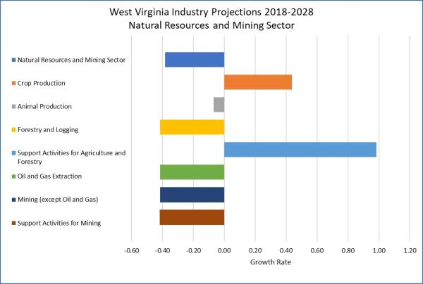
Most industries in the natural resources and mining sector are forecasting declines. Exceptions include crop production and support activities for agriculture and forestry. Coal mining and oil and gas extraction are anticipating employment declines through 2028.
Figure 2: Projected Employment for the Construction Sector

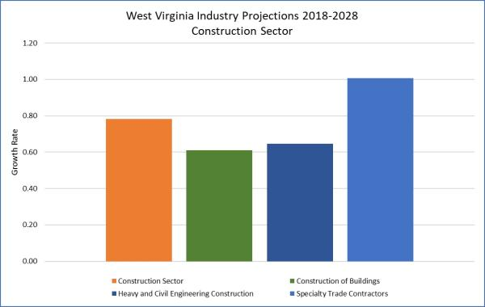

All industries in the construction sector are forecasting growth through 2028, as an increase in infrastructure upgrades is anticipated. However, the greatest growth is expected in specialty trade contractors.
Figure 3: Projected Employment for the Manufacturing Sector

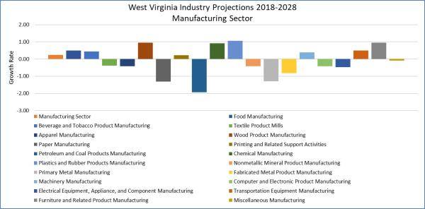

Employment through 2028 in the manufacturing sector is a mixed bag with declines in many industries and growth in others. Manufacturing industries anticipating notable growth through 2028 include wood products, chemicals, plastics and rubber products, and furniture and related products. Manufacturing industries anticipating notable declines include petroleum and coal products, and paper products. While primary metal manufacturing is projected to decline through 2028, a steel manufacturing employer has recently announced plans to locate in West Virginia. If this occurs, a turnaround in declining employment in this industry will take place.
Figure 4: Projected Employment for the Trade, Transportation and Utilities Sector

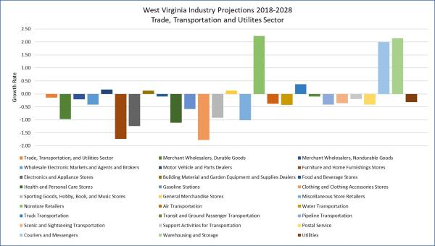
Most industries within the sector of trade, transportation and utilities will experience employment declines through 2028. However, there are some exceptions. The strongest growth is anticipated in non-store retailers, warehousing and storage, and couriers and messengers. Notable projected declines will occur in furniture and home furnishing stores, electronics and appliance stores, clothing and clothing accessories stores, and health and personal care stores.
Figure 5: Projected Employment for the Information Sector

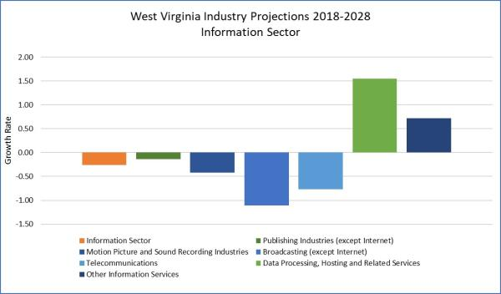
The information sector should see minor employment growth in both data processing, hosting and related services and in other information services through 2028. All remaining industries are anticipating declines.
Figure 6: Projected Employment for the Financial and Insurance Sector

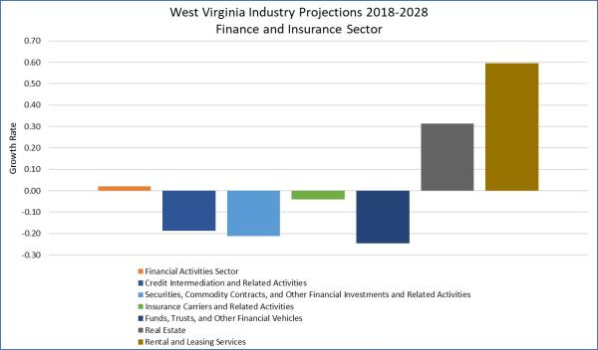
Within the financial services sector, employment growth is projected for real estate and for rental and leasing services. All other industries within this sector are projecting employment declines through 2028.
Figure 7: Projected Employment for the Professional and Business Services Sector

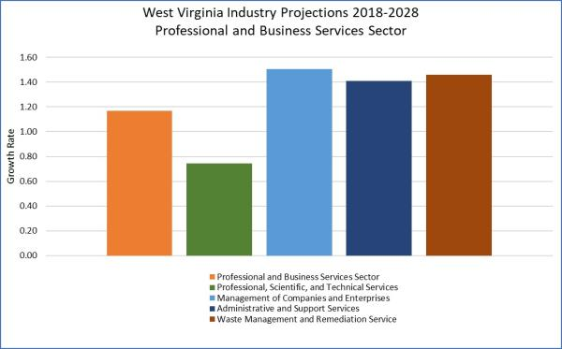
The professional and business services sector should see steady employment growth through 2028 among all its industries. Greatest growth is expected within management of companies and enterprises.
Figure 8: Projected Employment for the Education and Health Services Sector

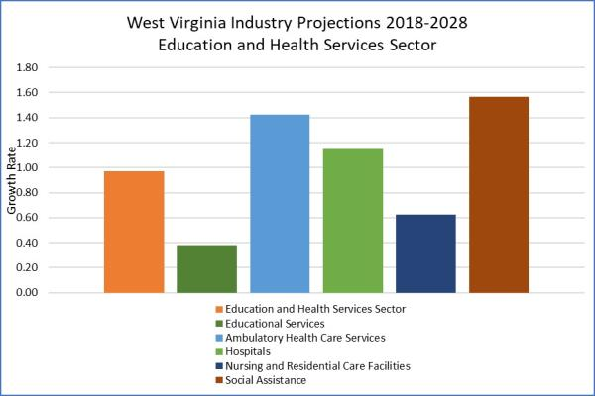
The education and health services sector overall will see growth through 2028, with the most employment growth in social assistance and in ambulatory health care services. West Virginia’s aging population as well as the high rate of diabetes and COPD solidify the need for additional healthcare workers.
Figure 9: Projected Employment for the Leisure and Hospitality Sector

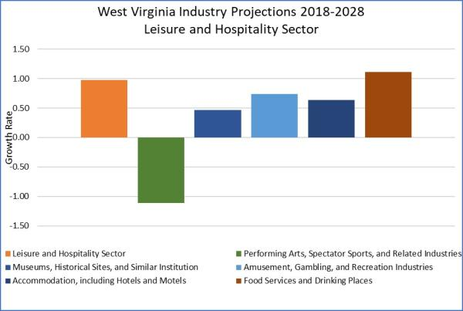
Within the leisure and hospitality sector, the strongest growth through 2028 is anticipated in food services and drinking places, with lesser growth among other industries. An employment decline is expected in performing arts, spectator sports, and related industries.
Figure 10: Projected Employment for the Other Services Sector

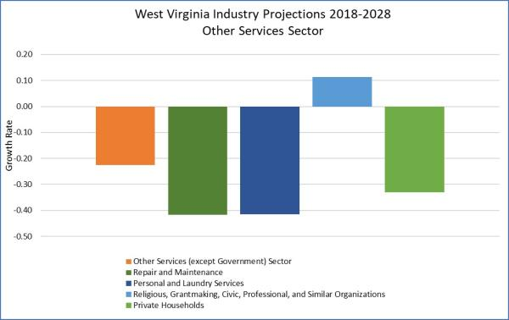
Through 2028, the other services sector is projecting employment growth only in religious, grantmaking, civic, professional, and similar organizations. The remaining industries are anticipating employment declines. West Virginia’s population continues to decline, and many other services industries experience the fallout from this population decline.
Figure 11: Projected Employment for the Government Sector

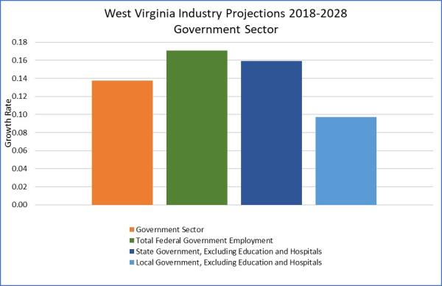
Employment growth is expected in all major sectors of government through 2028, particularly in the federal sector.
The Division of Research, Information and Analysis of WorkForce West Virginia produces both short-term and long-term occupational and industry projections. Short-term projections are produced annually, while long-term projections are produced biennially.
Figure 12: Map of WIOA Regions in West Virginia
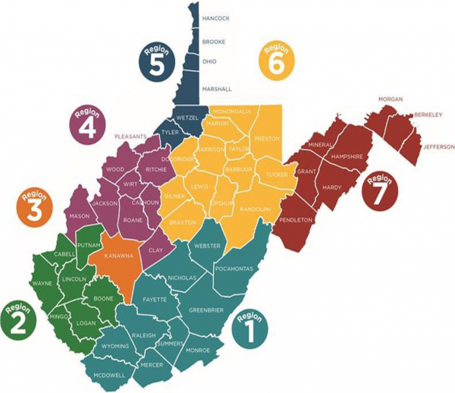
Figure 13: WDR Region 1 Industry Projections 2018-2028
(Contains growing and declining industries by Numeric Change)

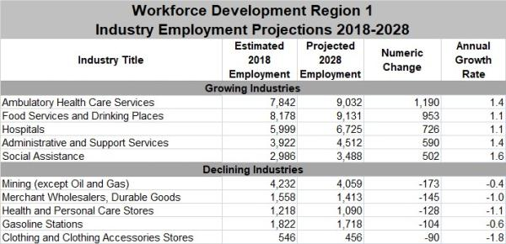
Based on an annual growth rate, three of the top five growing industries in Workforce Development Region (WDR) 1 are found within healthcare and social assistance. The health services sector contains the greatest numeric growth of the industries on the list and includes ambulatory healthcare services, hospitals and social assistance. The food services and drinking places industry is expected to add employment through 2028 as employers struggle to fill positions created by workers who left their jobs during the COVID pandemic. The greatest declines by growth rate in WDR 1 are found in clothing and clothing accessory stores, health and personal care stores, and merchant wholesalers of durable goods.
Figure 14: WDR 2 Industry Projections 2018-2028
(Contains growing and declining industries by Numeric Change)

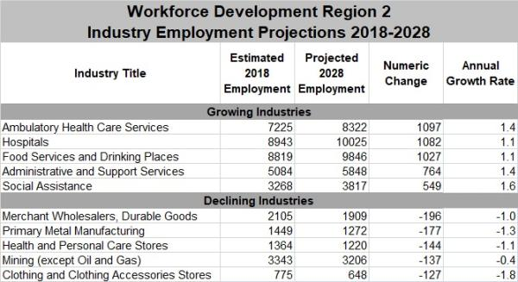
Based on an annual growth rate, growing industries in WDR 2 are contained largely within healthcare and social assistance. The health services sector contains the greatest numeric growth of industries on the list and includes ambulatory health care services, hospitals, and social assistance. Other growing industries include food services and drinking places and administrative and support services. The greatest declines by growth rate in WDR 2 are found in clothing and clothing accessories stores, primary metal manufacturing, and health and personal care stores.
Figure 15: WDR 3 Industry Projections 2018-2028
(Contains growing and declining industries by Numeric Change)

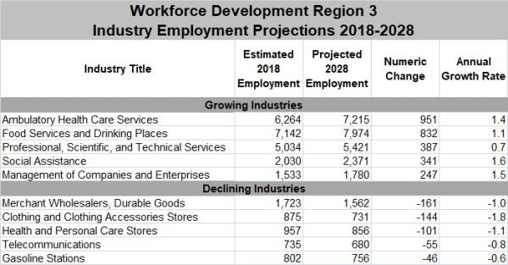
The top five growing industries in WDR 3 based on an annual growth rate are contained largely in health care and professional and business services. The health care sector contains the greatest numeric growth of industries on the list and includes ambulatory health care services and social assistance. Growth in professional and business services includes professional, scientific, and technical services; and management of companies and enterprises. The greatest declines in WDR 3 are found in merchant wholesalers, durable goods; clothing and clothing accessories stores; and health and personal care stores.
Figure 16: WDR 4 Industry Projections 2018-2028
(Contains growing and declining industries by Numeric Change)

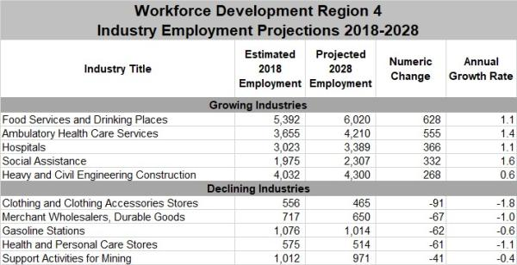
The top five growing industries in WDR 4 are contained largely within the health care and social assistance sector. The health care sector contains the greatest numeric growth of industries on the list and includes ambulatory health care services, hospitals, and social assistance. Other growing industries include food services and drinking places and heavy and civil engineering construction. The greatest declines in the region will be in clothing and clothing accessories stores, health and personal care stores, and merchant wholesalers, durable goods.
Figure 17: WDR 5 Industry Projections 2018-2028
(Contains growing and declining industries by Numeric Change)

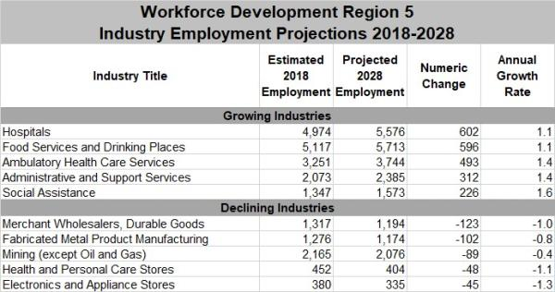
The top five growing industries in WDR 5 are contained largely within health care and social assistance. The health care sector contains the greatest numeric growth of industries on the list and includes ambulatory health care services, hospitals, and social assistance. Other growing industries include food services and drinking places and administrative and support services. The greatest industry declines in WDR 5 based on the growth rate include electronics and appliance stores, health and personal care stores, and merchant wholesalers, durable goods.
Figure 18: WDR 6 Industry Projections 2018-2028
(Contains growing and declining industries by Numeric Change)

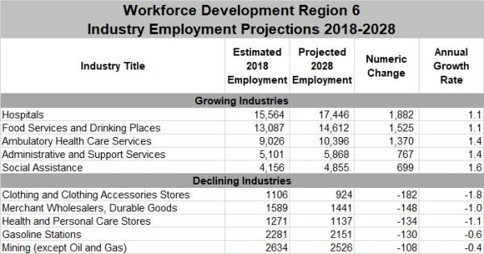
The industries in WDR 6 projecting the greatest growth through 2028 are found largely within the health care and social assistance sector. These include social assistance, ambulatory health care services, and hospitals. Food services and drinking places and administrative and support services are anticipating employment growth as well. Declining industries include clothing and clothing accessory stores, health and personal care stores, and merchant wholesalers, durable goods.
Figure 19: WDR 7 Industry Projections 2018-2028
(Contains growing and declining industries by Numeric Change)

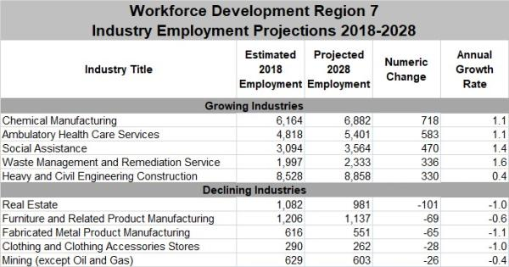
The top five growing industries in WDR 7 through 2028 are scattered throughout various economic sectors. Industries with the highest projected growth rate include waste management and remediation services, social assistance, ambulatory health care services, and chemical manufacturing. The greatest projected declines in WDR 7 are found in fabricated metal product manufacturing, clothing and clothing accessories stores, and real estate.
Occupational Demand 2020-2022
Many outside of our state erroneously believe that most West Virginia workers are employed in the coal mining industry, but this is hardly the case. Coal mining and other extraction occupations make up only a small part of the entire labor force. As a matter of fact, Construction and Extraction Occupations rank eighth among the top ten employment groups during the 2020-2022 period. Figure 20 shows that the largest employment group is Office and Administrative Support Occupations (90,584). This is followed by Food Preparation and Serving Related Occupations (74,221), Sales and Related Occupations (64,168), Healthcare Practitioners and Technical Occupations (61,421), and Transportation and Material Moving Occupations (55,471) rounding out the top five.
Figure 20: Pie Chart of Top 10 Occupational Groups 2020-2022
(Pie chart is divided into ten sections and contains employment numbers for these largest occupational groups)

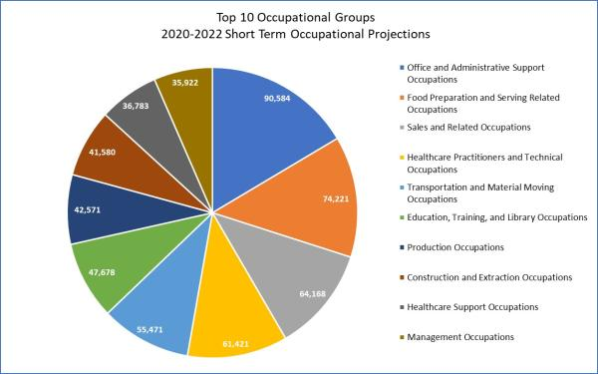
The years 2020 through 2022 have seen high demand for Office and Administrative Support Occupations (Customer Service Representatives, Stock Clerks,), Transportation and Material Moving Occupations (Driver/Sales Worker, Heavy and Tractor-Trailer Truck Drivers), and Construction and Extraction Occupations (Construction Laborers, Extraction Workers). Completing the list of top ten occupations with the highest demand are Production Occupations (Production Workers, Team Assemblers), Building and Grounds Cleaning and Maintenance Occupations (Maids and Housekeeping Cleaners, Landscaping and Groundskeeping Workers), Health care Support Occupations (Medical Assistants, Nursing Assistants, Home Health Aides), Food Preparation and Serving-Related Occupations (Combined Food Preparation and Serving-Related Workers, Counter Attendants), Sales and Related Occupations (Retail Salespersons, Sales Representatives), Protective Service Occupations (Security Guards, First-Line Supervisors of Correctional Officers), and Farming, Fishing, and Forestry Occupations (Log Graders and Scalers, Fallers).
Figure 21: Occupational Groups with Highest Job Demand for Fiscal Years 2019 to 2021
(Bar graph reflecting demand for workers within Occupational Groups for the three-year period of 2019-2020-2021 according to MACC staff-assisted job orders)

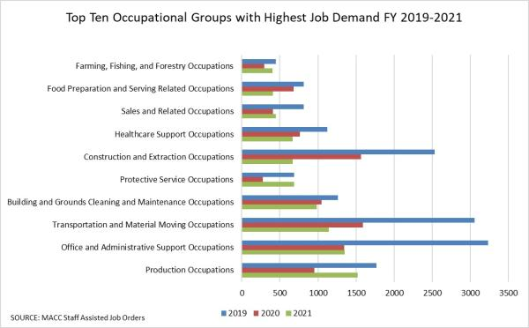
Breaking down the data into greater detail, Customer Service Representatives were in greatest demand in Fiscal Year 2021, with 943 openings, followed by Protective Service Workers, All Others (453), Production Workers, All Others (446), Laborers and Freight, Stock, and Material Movers, Hand (439), Farmworkers and Laborers, Crop, Nursery, and Greenhouse (393), Computer Numerically Controlled Tool Operators (338), Landscaping and Groundskeeping Workers (304), Home Health Aides (288), Maids and Housekeeping Cleaners (276), Community and Social Service Specialists, All Other (271), Janitors and Cleaners, Except Maids and Housekeeping (261), Team Assemblers (250), Personal Care Aides (178), Security Guards (173), and Heavy and Tractor-Trailer Truck Drivers (156).
Figure 22: Top 15 Demand Occupations in Fiscal Year 2021
(Bar graph reflects the top 15 occupations requested by employers through WorkForce West Virginia in 2021)

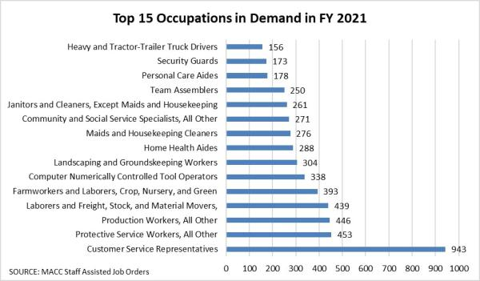
The top five occupational groups with the greatest number of job openings reported in 2021 by WorkForce West Virginia included Production Occupations, Office and Administrative Support Occupations, Transportation and Material Moving Occupations, Building and Grounds Cleaning and Maintenance Occupations, and Protective Service Occupations. West Virginia employers were seeking workers to fill various manufacturing occupations, as well as positions such as Tellers, Drivers/Sales Workers, Heavy and Tractor-Trailer Truck Drivers, Janitors and Cleaners, Landscapers, Security Guards, and Correctional Officers.
Figure 23: Job Openings by Occupation Group 2019-2021
(Table shows 22 Occupational Groups and the number of job openings within these groups for the years 2019, 2020, 2021)

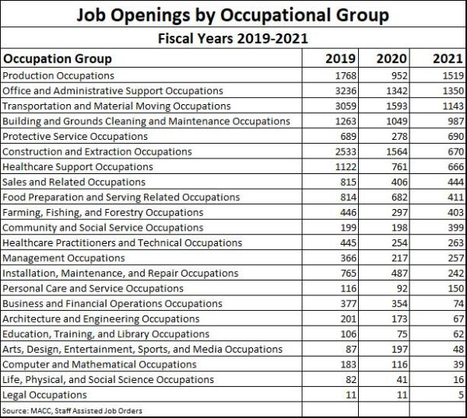
Figure 24: Annual Openings by Occupation 2018-2028
Table displays occupations with a high number of Total Annual Openings between 2018 and 2028. Includes Estimated and Projected Employment)

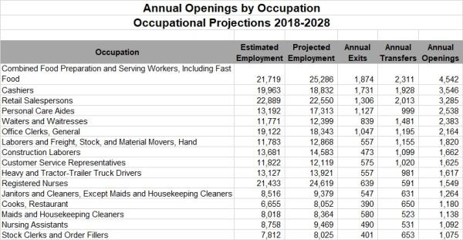
Nearly all of the top 15 occupations (figure 24) ranked by annual growth rate are contained within two occupational clusters: Healthcare Support Occupations and Healthcare Practitioners and Technical Occupations. These two clusters include such occupations as Personal Care Aides, Home Health Aides, Respiratory Therapists, Physician Assistants, Nurse Practitioners, Psychiatric Aides, and Physical Therapists.
Median Hourly Wage in 2020:
Combined Food Preparation and Serving Workers: $12.53
Cashiers: $12.03
Retail Salespersons: $13.02
Personal Care Aides: $13.02
Office Clerks, General: $16.98
Construction Laborers: $18.22
Nursing Assistants: $14.83
Home Health Aides: $13.02
Physical Therapist Assistants: $28.74
Registered Nurses: $36.22
Psychiatric Aides: $15.18
Figure 25: Annual Job Growth Rate for Selected Occupations 2018-2028
(Table contains top ten occupations by Annual Growth rate for the years 2018-2028)

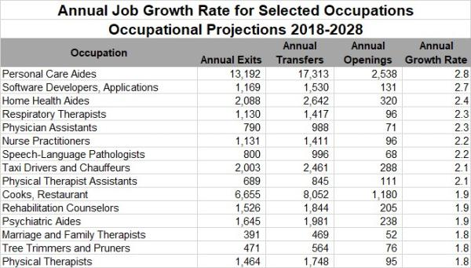
In general, employers assess employees based on three categories: Knowledge, Skills, and Abilities.
With fast growing technology and globalized trends dominating the workplace, knowledge is imperative. According to the late management guru Peter Drucker, “Today, knowledge has power. It controls access to opportunity and advancement.” It is always a basic need for everyone. If someone has a better knowledge base, he or she will acquire confidence and work more effectively. That’s why employers prefer their employees to be knowledgeable in order to perform a job properly.
Employers are also willing to send employees to advanced training classes, because “An investment in knowledge always pays the best interest” (Benjamin Franklin).
Figure 26: Model Knowledge, Skills, & Ability for Registered Nurse
(Figure 26 shows the top Knowledge, Skills, and Abilities needed for Registered Nurses)
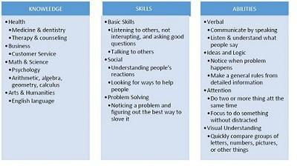
With the intensive growth of Healthcare and Social Assistance industries through 2022, the need for education and higher-skill workers is anticipated. Figure 26 shows that for a nurse, therapist, or physician assistant, knowledge of medicine is a must (ranks 86 to 98 out of 100). Fluent English is necessary to understand medical terminology and communicate with patients and medical staff.
Customer and Personal Services knowledge is also important for Registered Nurses and Licensed practical nurse (86 of 100) and Physical Therapists (87 of 100) because of the close relationships formed between nurse and patient.
Figure 27: Knowledge Assessment for Top 5 Healthcare Occupations
(Figure 27 assesses the knowledge needed for the top five healthcare occupations)
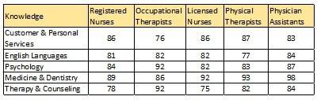
Similarly, figure 28 shows that Critical Thinking, Problem Solving, and Programming Skills are essential for people working in the computer science field (rank from 70-90 of 100). However, several skills in certain jobs are not evaluated depending on the field and skill value. Table 3 shows only the most required skills that rank from 70 to 100. The higher ranking, the more important the skill.
Figure 28: Skill Assessment for Top 5 Computer Occupations
(Figure 28 provides skills assessment for the top five computer-related occupations)
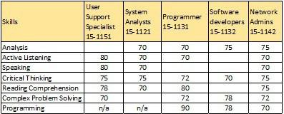
Numerous occupations in West Virginia require licensing. This is to ensure the competency of those practicing these professions, and in many cases the safety of those utilizing their services. There are approximately 110 occupations that require licensure in the State of West Virginia, eleven of which are in-demand occupations. The majority of these In-demand occupations are found in the healthcare field, such as Physician Assistant, Registered Nurse, Licensed Practical Nurse, Pharmacist, Physical Therapy Assistant, Radiologic Technologist, and Dental Hygienist. The remaining in-demand occupations that require licensing include Accountant, Attorney, Elementary School Teacher, and Social Worker.

B. Workforce Analysis
The Unified or Combined State Plan must include an analysis of the current workforce, including individuals with barriers to employment, as defined in section 3 of WIOA⁴. This population must include individuals with disabilities among other groups⁵ in the State and across regions identified by the State. This includes—
[4] Individuals with barriers to employment include displaced homemakers; low-income individuals; Indians, Alaska Natives, and Native Hawaiians; individuals with disabilities, including youth who are individuals with disabilities; older individuals; ex-offenders; homeless individuals, or homeless children and youths; youth who are in or have aged out of the foster care system; individuals who are English language learners, individuals who have low levels of literacy, and individuals facing substantial cultural barriers; farmworkers (as defined at section 167(i) of WIOA and Training and Employment Guidance Letter No. 35-14); individuals within 2 years of exhausting lifetime eligibility under the Temporary Assistance for Needy Families program; single parents (including single pregnant women); and long-term unemployed individuals.
[5] Veterans, unemployed workers, and youth, and others that the State may identify.

i. Employment and Unemployment
Provide an analysis of current employment and unemployment data, including labor force participation rates, and trends in the State.

ii. Labor Market Trends
Provide an analysis of key labor market trends, including across existing industries and occupations.

iii. Education and Skill Levels of the Workforce
Provide an analysis of the educational and skill levels of the workforce.

iv. Skill Gaps
Describe apparent ‘skill gaps’.
Employment and Unemployment
Labor Market Trends. Provide an analysis of key labor market trends, including across existing industries and occupations.
Demographics of the State’s Economy
Age
Figure 29: West Virginia and United States Population by Age Group
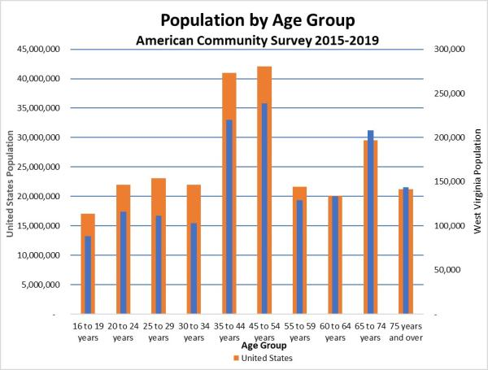
Figure 30: West Virginia and United States Labor Force Participation by Age Group
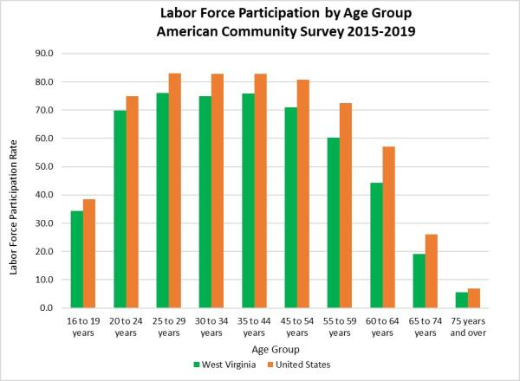
The U.S. Census Bureau’s 2019 5-year estimates American Community Survey records West Virginia’s population 16 years of age and older at 1,491,316. Approximately 53.3 percent of this total is in the labor force. The employment to population ratio is 49.7 percent, while the unemployment rate for this population is 6.5 percent.
West Virginians aged 16 to 19 are estimated to number 88,179, or 34.3 percent in the labor force. The employment to population ratio for this group is 27.0 percent, and the unemployment rate is 21.0 percent, the highest unemployment rate among all age groups. Many teenagers have difficulty finding or keeping employment because of lack of work experience, and because some employers are unwilling to hire teens due to labor laws and the inconvenience of scheduling around school functions and extracurricular activities.
The number of 20 to 24 years of age is estimated at 115,710. Of these, 69.8 percent are in the labor force. The employment to population ratio for this group is 60.8 percent, while the unemployment rate is 12.9 percent.
The number of state residents 25 to 29 years old is estimated at 111,245. The labor force participation rate is 76.0 percent, the highest among the established age groups, and just slightly higher than the age group containing residents aged 35 to 44 years. The employment to population ratio is 69.2 percent, while the unemployment rate for this group is 8.7 percent.
West Virginians aged 30 to 34 years are estimated at 102,871. The labor force participation rate is 74.9 percent, and the employment to population ratio is 69.1 percent. The unemployment rate for this group is 7.3 percent.
The age group of those 35 to 44 years old contained 220,301 residents. The labor force participation rate is 75.9 percent. The employment to population ratio is 71.4 percent, the highest among the established age groups. The unemployment rate is 5.7 percent.
The group containing those aged 45 to 54 years is estimated at 238,533. The labor force participation rate is 71.0 percent, and the employment to population ratio is 67.9 percent. The unemployment rate for this age group is 4.3 percent.
The group containing residents aged 55 to 59 is estimated at 128,759. The labor force participation rate is 60.3 percent and the employment to population ratio is 58.5 percent. The unemployment rate is 2.9 percent.
West Virginians aged 60 to 64 years numbered 133,604, with a labor force participation rate of 44.3 percent. The employment to population ration is 43.0 percent, with an unemployment rate of 3.1 percent.
The group containing those 65 to 74 years of age is estimated at 208,258, with a labor force participation rate of 19.2 percent. The employment to population ratio is 18.7 percent, and the unemployment rate is 2.7 percent, tied with the age group of 75 and older for the lowest unemployment rate among all the age groups.
The number of West Virginia residents aged 75 and over is estimated at 143,856 The labor force participation rate is 5.5 percent, and the employment to population ratio is 5.4 percent. The unemployment rate is 2.7 percent.
West Virginia’s Net Migration
Figure 31: West Virginia's Net Migration 2010-2019
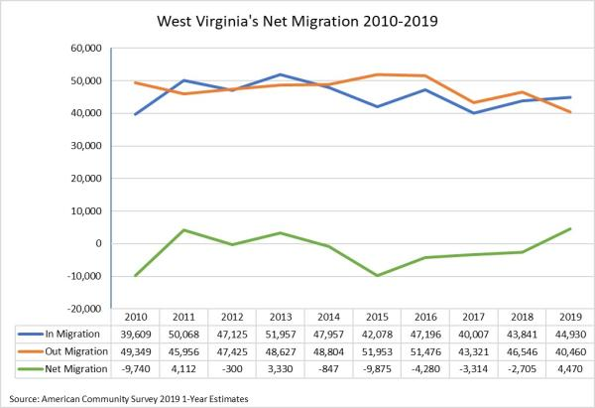
Between 2010 and 2019, West Virginia experienced an increase of 5,321 in in migration and a decline of 8,889 in out migration. In 2019, in migration (44,930) was greater than out migration (40,460), by a difference of 4,470. This has not occurred since 2013.
Figure 32: West Virginia's Population Migration by Age
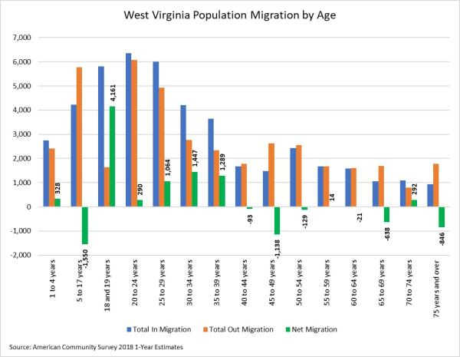
The age group of those aged 25 to 29 experienced the greatest out migration (7,216), followed by the group of those 20 to 24 years of age (6,280). It appears that many West Virginia residents leave the state to seek employment after completing their education.
Disability
According to the U.S. Census Bureau’s 2019 American Community Survey, West Virginia’s total civilian noninstitutionalized population 16 years of age and older is estimated at 1,463,067, with 331,409 having a disability and 1,131,658 having no disability. Of this total noninstitutionalized population, 50.6 percent are employed. The percentage of those with some form of disability who are employed is 18.1 percent. The percentage of those with no disability who are employed is estimated to be 60.2 percent.
The percent of the total civilian noninstitutionalized population not in the labor force is estimated at 45.8 percent. The percentage of those with some form of disability who are not in the labor force is 79.4 percent. The employed population 16 and over is estimated to be 740,908. Of this number, 59,991 are estimated to have a disability, while 680,917 are estimated as having no disability.
The total number of West Virginians 25 years of age and older is 1,261,483, with 315,418 having a disability and 946,065 having no disability. The number of West Virginians 25 and older holding less than a high school diploma or its equivalent is approximately 12.8 percent. The percentage of West Virginians with a disability who did not graduate from high school is estimated at 24.3 percent.
Figure 33: West Virginia Education Attainment by Disability
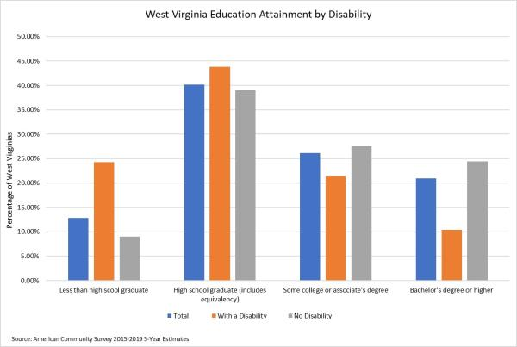
Those state residents 25 years of age and older with a high school diploma, GED, or alternative are estimated at 40.2 percent. An estimated 43.8 percent of residents with a disability are contained in this group. The percent of the population 25 and over with some college or an Associate’s degree is approximately 26.1 percent. An estimated 21.5 percent of residents with some college or an Associate's degree also has a disability. The portion of the population 25 and older who hold a Bachelor’s degree or higher is 20.9 percent. An estimated 10.4 percent of West Virginians with a disability are contained within this group.
Figure 34: Poverty Level of West Virginians with a Disability
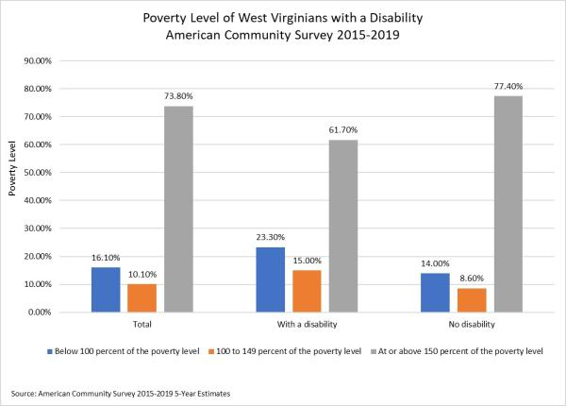
The West Virginia population 16 years of age and older for whom the poverty status is determined during the 2019 survey is estimated to be 1,447,012, with 330,557 estimated to have a disability and 1,116,455 having no disability. Approximately 16.1 percent of this total civilian noninstitutionalized population is below 100 percent of the poverty level. An estimated 23.3 percent in this group report a disability. Those West Virginians at 100 to 149 percent of the poverty level registered at 10.1 percent. An estimated 15.0 percent within this group report a disability. Persons at or above 150 percent of the poverty level are estimated at 73.8 percent. An estimated 61.7 percent of persons reporting a disability are contained within this category.
Sex and Race
Figure 35: West Virginia Population by Sex and Race
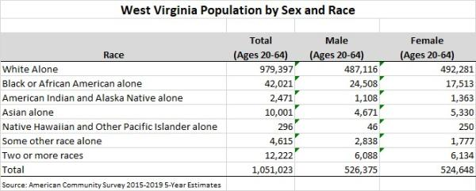
West Virginia’s population 20 to 64 years of age is approximately 1,051,023, with an estimated 67.1 percent in the labor force. The employment to population ratio for this group is 63.8 percent. The estimated unemployment rate for those aged 20 through 64 is 6.2 percent.
The population age 20 to 64 years broken out by sex is 526,375 males and 524,648 females. It is estimated that 72.4 percent of males are in the labor force, while 63.8 percent of females are in the labor force. The employment to population ratio for males aged 20 through 64 is 67.2 percent and 60.4 percent for females. The estimated unemployment rate for males is 6.9 percent and 5.4 percent for females.
West Virginia’s population 16 years and over broken out by race and Hispanic or Latino origin stood at 1,491,316 during the 2015-2019 estimate period. Of this total, 1,396,967 are White alone, 54,975 are Black or African American alone, 3,318 are American Indian and Alaskan native alone, 12,380 are Asian alone, 387 are Native Hawaiian and other Pacific Islander alone, 5,756 are some other race alone, and 17,533 are two or more races. The total of Hispanic or Latino origin of any race stood at 20,294 and White alone, not Hispanic or Latino stood at 1,382,818.
Race and the Labor Force
Data by race for West Virginia's labor force are as follows: 53.2 percent of the White alone population is in the labor force with an unemployment rate of 6.4 percent. 53.5 percent of the Black or African American alone population is in the labor force with an unemployment rate of 10.5 percent. 64.0 percent of the Asian alone population is in the labor force with an unemployment rate of 3.6 percent. 43.6 percent of the American Indian and Alaska Native alone population is in the labor force with an unemployment rate of 9.3 percent. 52.2 percent of the Native Hawaiian and Other Pacific Islander alone population is in the labor force with an unemployment rate of 45.5 percent. 59.2 percent of Hispanic or Latino origin (of any race) is in the labor force with an unemployment rate of 4.6 percent. 56.4 percent of some other race alone population is in the labor force with an unemployment rate of 5.5 percent. 51.1 percent of the two or more races population is in the labor force with an unemployment rate of 10.6 percent.
Education and the Labor Force
Figure 36: Population and Labor Force Participation Rate by Educational Attainment
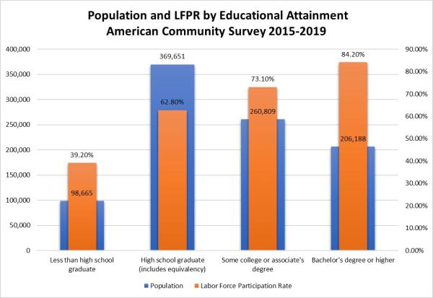
Figure 37: Unemployment Rate by Educational Attainment
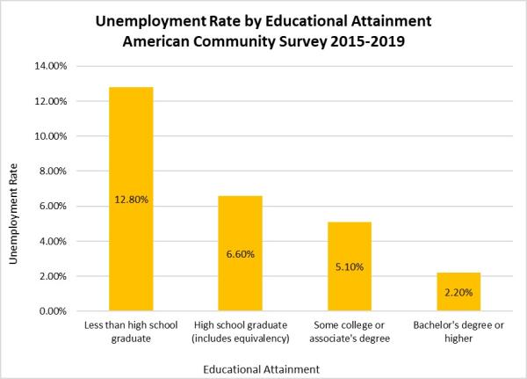
According to the American Community Survey 5-Year Estimates (2015-2019), the total number of West Virginians ages 25-64 is 935,313. The estimated number who did not graduate from high school is 98,665 (10.5%) with 39.2 percent in the labor force and an unemployment rate of 12.8 percent. This group exhibits the lowest amount of employment among the categories of educational attainment.
Those with a high school or equivalent education number 369,651, with 62.8 percent in the labor force and an unemployment rate of 6.6 percent. Those with some college or an Associate's degree number 260,809, with 73.1 percent in the labor force and an unemployment rate of 5.1 percent. Those with a Bachelor’s degree or higher number 206,188 with 84.2 percent in the labor force and an unemployment rate of 2.2 percent.
Population Forecast
West Virginia’s overall population is expected to decline at a rate of 0.2 percent a year through 2026. Regionally, it is anticipated that the most significant population decreases will occur primarily in west central and southwestern West Virginia, while portions of the Eastern Panhandle and northeastern West Virginia are expected to grow. Correspondingly, the greatest employment gains are expected in the regions experiencing population growth.
Labor Force
Figure 38: Labor Force Participation Rate by County
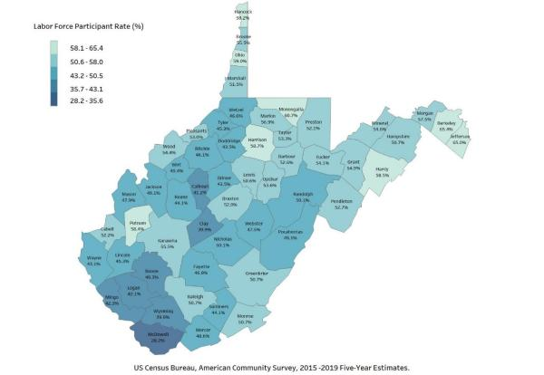
The labor force participation rate (LFPR) in West Virginia registered at 53.3 percent in 2019, the lowest in the nation. The national labor force participation rate stood at 63.4 percent.
Less than one-half (41.8%) of West Virginia counties recorded a labor force participation rate less than 50.0 percent during the 2015-2019 period. Several of these counties are located in the southern coalfields of West Virginia (Workforce Development Regions 1 & 2). McDowell County recorded a labor force participation rate of 28.2 percent, the lowest in the state. Other southern counties with a labor force participation rate less than 50 percent included Wyoming (39.9%), Boone (40.3%), Logan (42.1%), Mingo (42.3%), Wayne (43.1%), Summers (44.1%), Lincoln (45.3%), Fayette (46.8%), and Mercer (48.6%).
Three counties recorded a labor force participation rate greater than 60.0 percent. Monongalia County recorded a labor force participation rate of 60.7 percent, while Berkeley (65.4%) and Jefferson (65.0%) recorded labor force participation rates greater than that of the United States (63.4%).
Figure 39: Labor Force Participation Rate by State
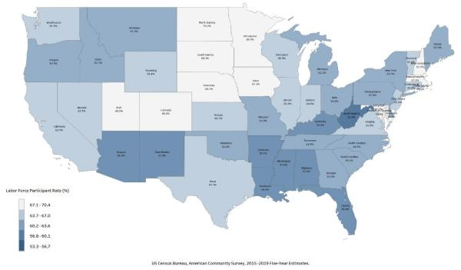
According to the Bureau of Labor Statistics, the U.S. labor force is projected to increase by 8.9 million, from 160.7 million people in 2020 to 169.6 million people in 2030. Several factors, including population decline, uncertainty around population migration patterns in the coming decade, and an aging workforce continue to affect West Virginia's projected labor force as well. Workforce-related factors include the discouraged worker effect, health-related limitations, and retirement.
Turnover rates are another important aspect to consider in reviewing employment trends. Turnover rates can vary by industry and by a variety of demographic characteristics such as education, race, sex, and age. In West Virginia, between 2015 and 2019, industry sectors with the highest average turnover rates included Accommodation and Food Services; Arts, Entertainment, and Recreation; Administrative and Support and Waste Management and Remediation Services; Construction; and Agriculture, Forestry, Fishing, and Hunting. Sectors with the lowest turnover rates included Utilities, Educational Services, Manufacturing, Finance and Insurance, and Public Administration. High turnover rates in industry sectors can be caused by a number of factors, including, but not limited to, seasonality, short business cycles, part-time employment status, employee dissatisfaction, low wages, and health risks.
Figure 40: Average Turnover Rates by Industry 2015-2019
(Bar graph reveals a list of industries ranked from lowest to highest turnover rates for the period 2015-2019)
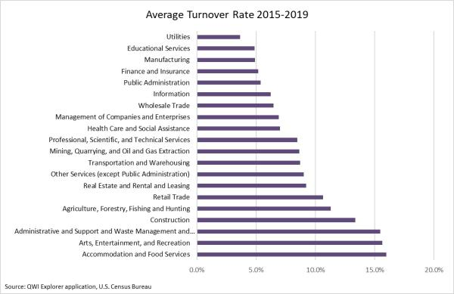
Between 2015 and 2019, Turnover rates were highest in Accommodation and Food Services; Arts, Entertainment, and Recreation; and Administrative and Support and Waste Management and Remediation Services. These industries tend to employ lower wage positions such as food servers, theater workers, etc., often require limited education or experience, and are usually filled by younger workers. These three factors contribute greatly to the high turnover rate. Turnover rates are highest among younger workers aged 14-21 and drop precipitously for workers 35 and older. Industries with the lowest turnover rates include Utilities, Educational Services, Manufacturing, Finance and Insurance, and Public Administration. These industries tend to pay higher wages and require extensive education or training.
Average weekly wage in 2019:
Accommodation and Food Services: $350.68
Arts, Entertainment, and Recreation: $344.55
Administrative and Support and Waste Management and Remediation Services: $727.76
Utilities: $1,868.07
Educational Services: $724.10
Manufacturing: $1,173.35
Finance and Insurance: $1,126.68
Public Administration: $939.09
Figure 41: Average Turnover Rates 2013-2017 by Sex
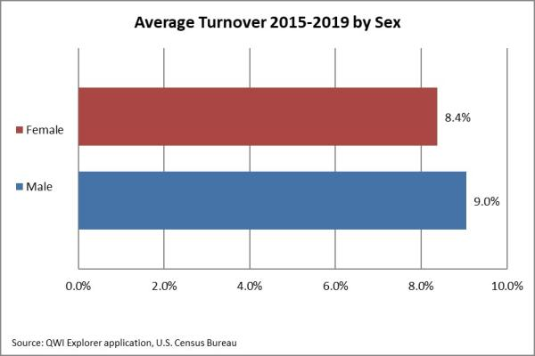
Between 2015 and 2019, turnover rates were higher among males (9.0%) compared with females (8.4%).
Figure 42: Average Turnover Rates 2013-2017 by Race
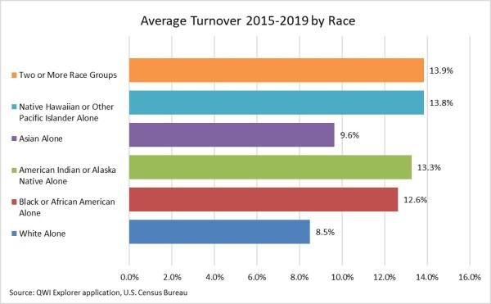
Regarding race, turnover rates were lowest among Whites (8.5%) and Asians (9.6%). The highest turnover rate was among Two or More Races (13.9%), followed by Native Hawaiian or Other Pacific Islander (13.8%), American Indian or Alaskan Native (13.3%), and Black or African American (12.6%).
Figure 43: Average Turnover Rates 2013-2017 by Age
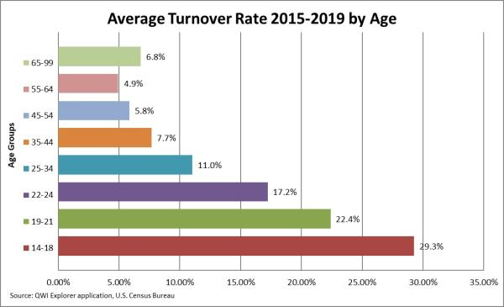
Turnover rates were highest among the age group of 14-18 years of age (29.3%), followed by the age group 19-21 (22.4%), and age group 22-24 (17.2%). Turnover rates were lowest for the age group 55-64 (4.9%).
Also, higher levels of education correspond with lower rates of job turnover, where between 2015 and 2019, the average turnover rate of those with less than a high school diploma was 9.4 percent compared with 6.4 percent for those with a Bachelor’s degree or an advanced degree.
From a regional perspective, overall employment turnover rates from 2015 to 2019 ranged from 9.1 percent in Workforce Development Region 1, to 8.2 percent in Workforce Development Regions 3.
Figure 44: Average Turnover Rates for Workforce Development Regions 2015-2019
(Bar graph reflects turnover rates for the seven regions for the years 2015-2019)
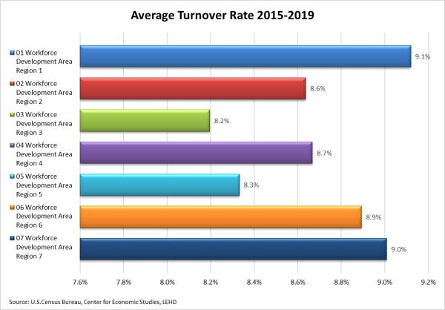
Figure 45: West Virginia Job Openings 2018-2020
(Graph reflects job openings from the Job Openings and Labor Turnover Survey conducted by the U. S. Bureau of Labor Statistics)
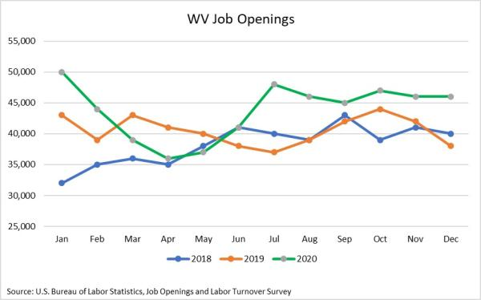
Figure 46: West Virginia Total Separations 2018-2020
(Graph reflects total separations from the Job Openings and Labor Turnover Survey conducted by the U. S. Bureau of Labor Statistics)
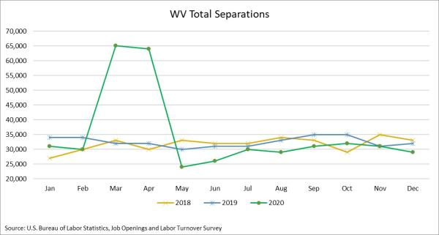
The U.S. Bureau of Labor Statistics publishes monthly data on Total, Separations, Job Openings, and Quits, among other topics. This JOLTS (Job Openings and Labor Turnover Survey) data show job openings in West Virginia climbed in 2020, as employers sought to fill positions which became vacant during the COVID-19 pandemic (Figure 45). Total Separations spiked in March 2020 due to the onset of the pandemic, but recovered in May, falling below the number of separations during the two previous years(Figure 46). Additional data on this topic can be found at https://data.bls.gov.
Occupations
Among the seven Workforce Development regions in West Virginia, occupations anticipating the greatest annual growth rates between 2018 and 2028 are largely healthcare and social services related. This trend can be attributed to the state’s aging population, the opioid epidemic, and the state’s high concentration of health issues including obesity, diabetes, heart disease, and tobacco use. Fortunately, many of these in-demand healthcare occupations require less extensive education or on-the-job training, such as an Associate’s degree for a Registered Nurse.
Workforce Development Region 1 Occupational Employment Projections 2018-2028
Figure 47: WDR 1 Top 15 Occupations by Growth Rate
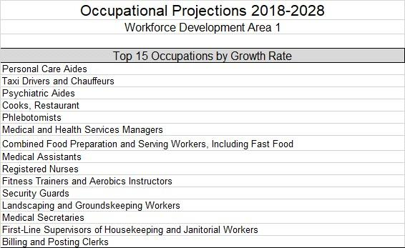
Three of the top five occupations with the greatest projected annual growth rate within WDR 1 are healthcare related and require only a small amount of training. These occupations are Personal Care Aides, Psychiatric Aides, and Phlebotomist. Other medical occupations making the list include Registered Nurses (requiring at least an Associate’s degree), Medical Assistants, and Medical Secretaries. The two latter occupations may require a range of education levels, from a high school diploma or equivalent to an Associate’s degree.
Workforce Development Region 2 Occupational Employment Projections 2018-2028
Figure 48: WDR 2 Top 15 Occupations by Growth Rate
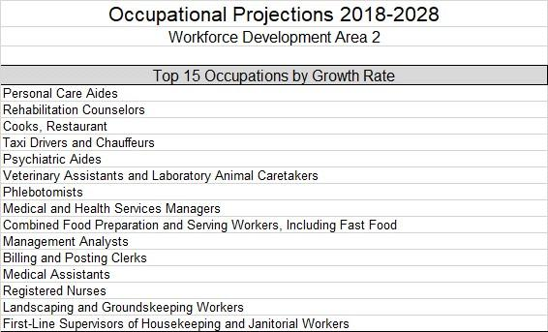
Three of the top five five occupations with the greatest projected annual growth rate within WDR 2 are healthcare or social services related. These include Personal Care Aides, Rehabilitation Counselors, and Psychiatric Aides. Personal Care Aides and Psychiatric Aides require very little formal education or training, while Rehabilitation Counselors can have a wide spectrum of education requirements depending upon the employer. A small number of Rehabilitation Counselors have only a high school diploma or equivalent, while just over one-half nationally have a Bachelor’s degree. Other medical occupations found on the list included Registered Nurses, Phlebotomists, and Medical Assistants, occupations that have education and training requirements ranging from basic post-secondary training to an Associate’s degree.
Workforce Development Region 3 Occupational Employment Projections 2018-2028
Figure 49: WDR 3 Top 15 Occupations by Growth Rate
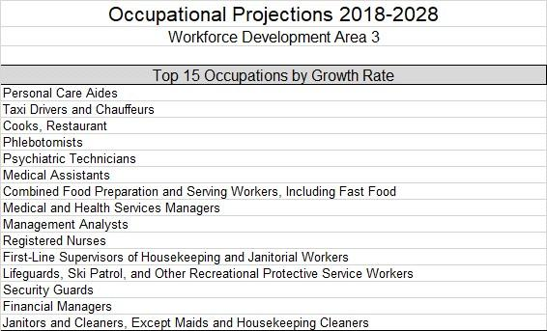
Three of the top five occupations with the greatest growth rate in WDR 3 are healthcare related. These included Personal Care Aides, Phlebotomists, and Psychiatric Technicians. These three occupations require limited training, which may range from a high school diploma or equivalent to more formalized training for a phlebotomist. Other medical occupations projected to have a higher growth rate include Medical Assistants (vocational training to Associate’s degree), Medical and Health Services Managers, and Registered Nurses (requiring an Associate’s degree through advanced post-graduate work)
Workforce Development Region 4 Occupational Employment Projections 2018-2028
Figure 50: WDR 4 Top 15 Occupations by Growth Rate
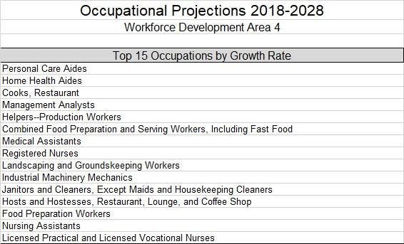
The top five occupations with the greatest projected annual growth in WDR 4 include Personal Care Aides, Home Health Aides, Restaurant Cooks, Management Analysts, and Helpers-Production Workers. Most of these occupations require little formalized education or training. However, Management Analysts require a more advanced training, ranging from post-baccalaureate certificate through a Master’s degree. There are several medical occupations contained on the list, including Medical Assistants, Registered Nurses, Nursing Assistants, and Licensed Practical and Licensed Vocational Nurses, with educational requirements ranging from simple on the job training through an advanced degree.
Workforce Development Region 5 Occupational Projections 2018-2028
Figure 51: WDR 5 Top 15 Occupations by Growth Rate
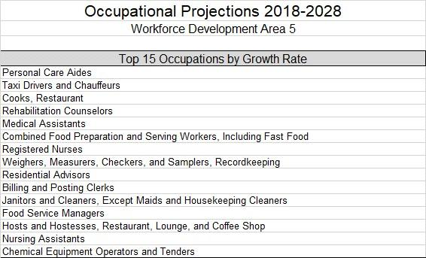
Three of the top five occupations with the greatest projected annual growth rate within WDR 5 are healthcare/social services related. These include Personal Care Aides, Rehabilitation Counselors, and Medical Assistants, requiring a range of education and training, from a high school diploma and on-the-job training through a Master’s degree in some cases. Two of the higher wage occupations on this list are Registered Nurses and Chemical Equipment Operators and Tenders, with a high school diploma and advanced on-the-job training for a Chemical Equipment Operator and Tender. Registered Nurses require at least an Associate’s degree.
Workforce Development Region 6 Occupational Projections 2018-2028
Figure 52: WDR 6 Top 15 Occupations by Growth Rate
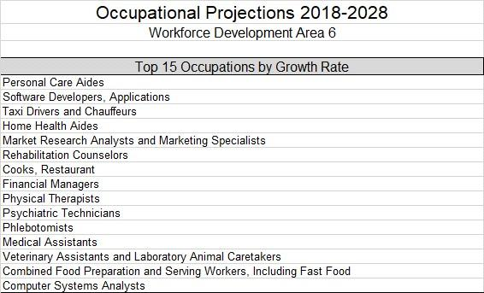
Several healthcare-related occupations in WDR 6 have a high growth rate. These include Personal Care Aides, Home Health Aides, Physical Therapists, Psychiatric Technicians, Phlebotomists, and Medical Assistants. Education and training for these occupations range from a high school diploma and simple on-the-job training to an advanced degree and specialized medical training. Some of the higher wage occupations on this list include Software Developers, Applications; Computer Systems Analysts, and Financial Managers. Most employers require at least a Bachelor’s degree for these occupations, although not all do.
Workforce Development Region 7 Occupational Projections 2018-2028
Figure 53: WDR 7 Top 15 Occupations by Growth Rate
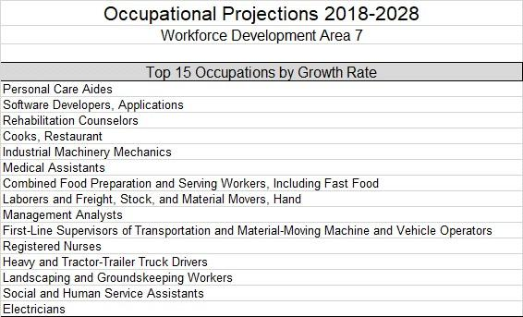
The top five occupations with the greatest projected annual growth rate in WDR 7 include Personal Care Aides; Software Developers, Applications; Rehabilitation Counselors; Restaurant Cooks; and Industrial Machinery Mechanics. Education requirements for these occupations range from a high school diploma and simple on-the-job training for a Personal Care Aide and Restaurant Cook to extensive on the-job training for Industrial Machinery Mechanics, to a Master’s degree for some Rehabilitation Counselors. Some additional high growth rate/high wage occupations include Registered Nurses, Heavy and Tractor-Trailer Truck drivers, and Electricians., all requiring vocational training, certification, or at least an Associate’s degree.
Education and SkiII LeveIs of the Workforce. Provide an analysis of the educational and skiII leveIs of the workforce.
Education
Figure 54: Percent of Population Age 25 Years or Older with a Bachelor's Degree or Higher
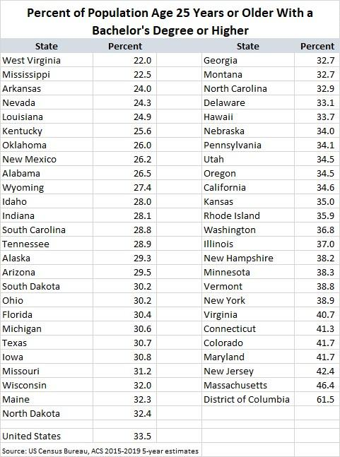
Over the coming decade, West Virginia’s job market will continue its demand for jobs that require postsecondary education. Presently, based on 2019 data from the U.S. Census Bureau’s American Community Survey (ACS), West Virginia ranks last in percent of population age 25 years or older with a Bachelor’s degree or higher. As of 2019, 22.0 percent of West Virginians 25 and older have a Bachelor’s degree or higher compared to 33.5 percent nationally.
Based on WorkForce West Virginia’s employment projections (2018 - 2028), it is expected that occupations requiring a bachelor’s degree or higher will increase by 10,527 (Figure 55). While projected growth in occupations through 2028 is weighted toward jobs requiring a high school diploma or equivalent, growth in occupations requiring postsecondary education is not far behind. Figures 57 and 58 show poverty rates among West Virginians dramatically declining and wages increasing as education levels increase. Occupations requiring a high school diploma or equivalent are anticipated to grow by only 10,168, while jobs requiring formal education beyond high school will increase by 19,039.
Figure 55: West Virginia Occupational Projections by Level of Education
(Figure 55 shows employment projections based on eight education levels for the year 2028)
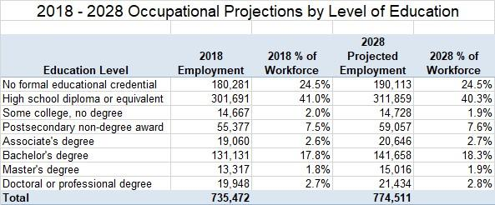
Beyond formal secondary and postsecondary education, some occupations require additional on-the-job training. The greatest growth through 2028 is expected for jobs requiring short-term on-the-job training (14,999). Figure 56 depicts the expected change by job training between 2018 and 2028. For most other categories, the relative share of employment is expected to change only slightly.
Figure 56: West Virginia Occupational Projections by Training Level
(Figure 56 shows projected employment based on six levels of job training for the year 2028)
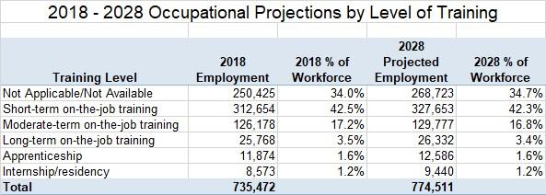
Education attainment scales with both poverty status and median annual earnings. As education levels increase, earnings increase, and, consequently, poverty decreases. In Figure 55, data from the U.S. Census Bureau depict the relative poverty levels by education attainment. Poverty rates are higher for females than for males in every category, although the gap closes considerably for individuals with a bachelor’s degree or higher.
Figure 57: West Virginia Poverty Rate by Education Level
(Figure 57 depicts the poverty rate for West Virginians broken out by sex and four levels of education.)
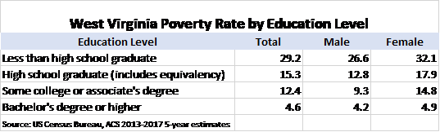
Similarities can be observed when comparing median annual earnings by educational attainment (Figure 56). Again, higher levels of education correlate to higher levels of earnings, with females earning comparatively less in all categories.
Figure 58: Median Annual Earnings by Education Level
(Figure 58 depicts median annual earnings for West Virginians broken out by sex and levels of education.)
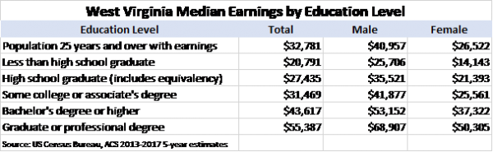
Based on 2019 Census data, levels of employment correlate with levels of education (Figure 57). The higher the level of education, the higher the level of participation in the labor force and, conversely, the lower the rate of unemployment. Individuals with less than a high school diploma had an unemployment rate (12.8%), substantially higher than individuals with a Bachelor’s degree or higher (2.2%), more than twice the unemployment rate of individuals with only some college or an Associate’s degree (5.1%), and nearly twice the unemployment rate of individuals with a high school diploma or equivalent (6.6%).
Figure 59: Employment Status by Education Level
(Figure 59 depicts employment status of West Virginians based on educational attainment.)
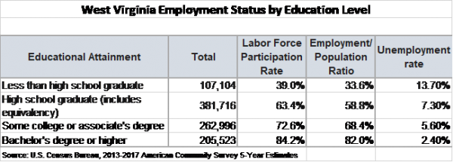
Also, as education levels increase, job turnover rates decrease. Using combined Census and BLS data for years 2015 through 2019, an average turnover rate was calculated (Figure 60).
Figure 60: Turnover Rate by Education Level
(Figure 60 depicts turnover rates for West Virginians based on four levels of educational attainment)
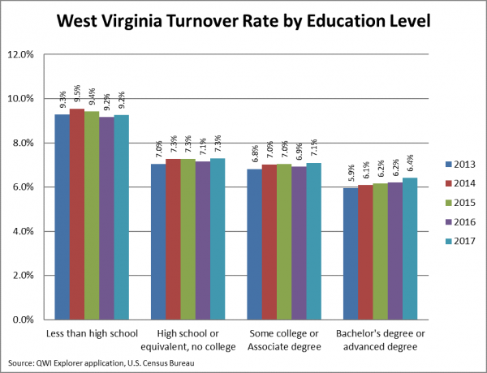
The education levels of West Virginians in the labor force, specifically those who were employed between 2015 and 2019 vary considerably by region of the state. During this five-year period, turnover rates for individuals with less than a high school diploma registered over nine percent each year. Turnover rates for individuals with a high school diploma or equivalent and with no college remained over seven percent during this period, climbing to 7.7 percent in 2019. Turnover rates for job holders with either some college or an Associate degree hovered around the seven percent level, climbing to 7.5 percent in 2019. Job holders with a bachelor’s degree or higher saw turnover rates hovering around the six percent level, although the rate has been steadily climbing during this period and registered at 7.0 percent in 2019.
Skills Gap
The term Skills Gap, defined as “a significant mismatch between the needs of employers for skills and the current capabilities of available workforce”, has been a constant source of conversation and debate for many years. The unemployment rate is relatively high in West Virginia, and businesses have expressed concerns about finding skilled workers to fill vacancies.
Communication Skills
Communication skills are expected to be in greatest demand in West Virginia through 2028. Those specific skills include Active Listening, Speaking, Writing, and Reading Comprehension (Figure 61). Active Listening may be defined as “giving full attention to what other people are saying, taking time to understand the points being made, asking questions appropriately, and not interrupting at inappropriate times." This simple and basic skill is necessary in many occupations, especially in healthcare and other service-related fields that require good communication and comprehension between service provider and customer. By the year 2028, employers will need an additional 34,204 employees with this skill.
Figure 61: Skills Gap 2018-2028
(Figure 61 depicts the current and projected demand for selected skills through 2028)
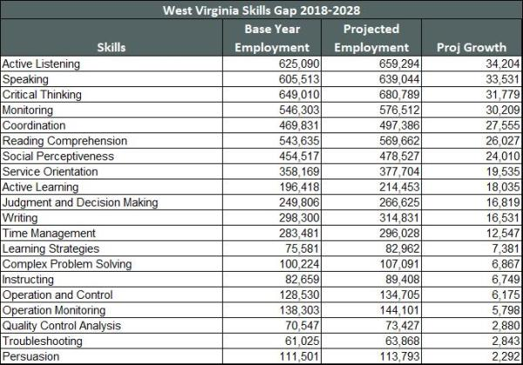
West Virginia's workforce will require more than 95,000 additional employees to develop Speaking, Critical Thinking, and Monitoring skills by 2028. These skills depict a specific need, particularly in the healthcare support industry, in which occupations related to customer services are in high demand. Reading Comprehension is also an issue for many West Virginians in the workforce. This skill refers to the person’s ability to read and understand information presented in written form. Good readers interact with text, making and validating predictions, and connecting the text events to their knowledge and experiences. Generally, this skill, together with Critical Thinking and Writing are acquired during K-12 education.
Figure 62: Skills Gap Distribution
(Figure 62 depicts skill gaps by Workforce Development Regions)
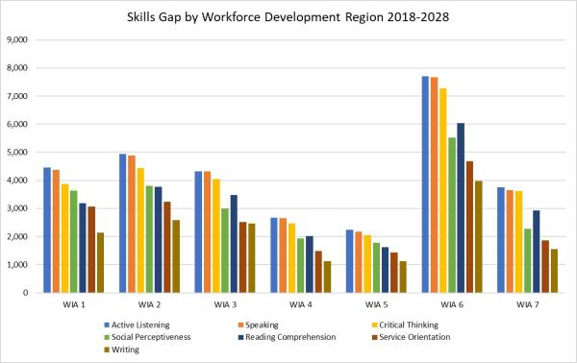
Figure 62 depicts how skill gaps vary by region. The skills of Active Listening and Speaking are the most needed in all Workforce Development regions. The remaining skills in demand vary by region and include Critical Thinking, Social Perceptiveness, Reading Comprehension, Service Orientation, and Writing.
The effect of Knowledge and Ability on Skills Gaps
As we examine skills gaps, it will be important to understand the relationship among Knowledge, Skills, and Abilities. Knowledge is a level of information or experience that an individual must have to be qualified for a position. Skills are learned or trained, and can be developed through the transfer of knowledge. Abilities are the enduring attributes of the individual that influence performance. A person’s ability can affect his or her capacity to perform the job. Many recruiters use KSAs (Knowledge, Skills, and Abilities) to determine who the best applicants are among candidates.
Figure 63: Knowledge Gaps
(Figure 63 depicts projected knowledge gaps for the period 2016 through 2026)
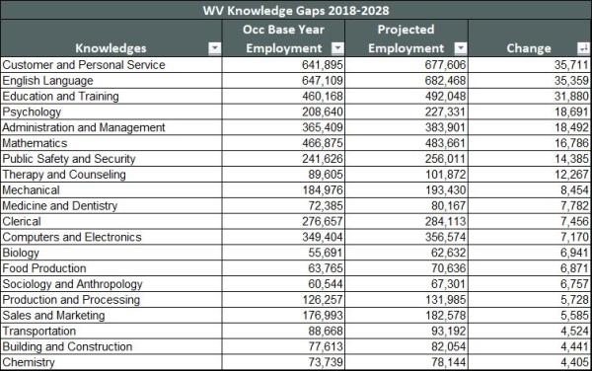
Among West Virginia’s workforce, the greatest Knowledge gaps occur in Customer and Personal Service and in English Language Proficiency (Figure 63). More than 70,000 positions will be needed by 2028 that require competency with the principles and processes for providing customer and personal services, including customer needs assessment and evaluation of customer satisfaction. English Language Proficiency, surprisingly, is the second-highest knowledge gap. By 2028, the growing healthcare sector will need over 20,000 employees who have knowledge in Psychology and Medicine and Dentistry. Growing occupations within the state that require knowledge of medicine, customer and personal service, and English language proficiency include Registered Nurses, Personal Care Aides, Home Health Aides, Respiratory Therapists, Physician Assistants, Nurse Practitioners, Physical Therapists, Physical Therapy Assistants, and Psychiatric Aides.

2. Workforce Development, Education and Training Activities Analysis
The Unified or Combined State Plan must include an analysis of the workforce development activities, including education and training in the State, to address the education and skill needs of the workforce, as identified in (a)(1)(B)(iii) above, and the employment needs of employers, as identified in (a)(1)(A)(iii) above. This must include an analysis of—

A. The State’s Workforce Development Activities
Provide an analysis of the State’s workforce development activities, including education and training activities of the core programs, Combined State Plan partner programs included in this plan, and required ⁶ and optional one-stop delivery system partners.⁷
[6] Required one-stop partners: In addition to the core programs, the following partner programs are required to provide access through the one-stops: Career and Technical Education (Perkins), Community Services Block Grant, Indian and Native American programs, HUD Employment and Training programs, Job Corps, Local Veterans' Employment Representatives and Disabled Veterans' Outreach Program, National Farmworker Jobs program, Senior Community Service Employment program, Temporary Assistance for Needy Families (TANF) (unless the Governor determines TANF will not be a required partner), Trade Adjustment Assistance programs, Unemployment Compensation programs, and YouthBuild.
[7] Workforce development activities may include a wide variety of programs and partners, including educational institutions, faith- and community-based organizations, and human services.

B. The Strengths and Weaknesses of Workforce Development Activities
Provide an analysis of the strengths and weaknesses of the workforce development activities identified in (A), directly above.

C. State Workforce Development Capacity
Provide an analysis of the capacity of State entities to provide the workforce development activities identified in (A), above.
A. The State’s Workforce Development Activities
Provide an analysis of the State’s workforce development activities, including education and training activities of the core programs, Combined State Plan partner programs included in this plan, and required ⁶ and optional one-stop delivery system partners.⁷
The State of West Virginia is comprised of seven local workforce development areas. A minimum of one comprehensive American Job Center of West Virginia (AJCWV) is located in each area.
- Region 1: The Region 1 Workforce Development Board, headquartered in Beckley, administers workforce activities in an eleven-county region covering the southeastern portion of the State.
- Region 2: The Southwestern West Virginia Workforce Development Board, located in Huntington, governs a seven-county region in the southwestern portion of the State.
- Region 3: The Workforce Development Board of Kanawha County oversees activities in the State’s only single-county workforce development region from its office in Charleston.
- Region 4: Nine counties are served by the Workforce Development Board Mid-Ohio Valley, which is located in Parkersburg.
- Region 5: The Northern Panhandle Workforce Development Board provides services in six counties and is based in Wheeling.
- Region 6: The Region 6 Workforce Development Board, located in Fairmont, provides services in a thirteen-county region in the north-central portion of the State.
- Region 7: Eight counties in the easternmost portion of West Virginia are served by the Region 7 Workforce Development Board located in Moorefield.
All core programs are participating either by physical presence or part of a shared electronic referral system. Further, required partners participating include:
- Trade Adjustment Assistance (TAA)- Trade Adjustment Assistance (TAA) helps people who become unemployed due to layoffs as a result of foreign imports or a shift of production out of the United States. TAA eligible workers are provided services and training to assist them in returning to the workforce. Services and training provided ensure that TAA recipients have the skills needed to find reemployment within the industry they were laid off from or to enter a new industry where employment opportunities exist.
- WIOA Title I Adult- The Adult program serves participants age 18 or older in need of employment or career advancement, with priority of service given to participants deemed to be recipients of public assistance, other low-income individuals, and individuals who are basic skills deficient. If a participant is also an eligible Veteran or spouse of a Veteran, the priority of service will be extended to the covered person. Individuals deemed ready for work are provided career services to assist them in finding existing employment opportunities. Individuals not ready for employment or looking for employment in a new field are provided training to prepare them with the skills necessary to meet the needs of employers.
- WIOA Title I Dislocated Worker- The Dislocated Worker program assists workers, who are 18 years or older, before or after a layoff to help facilitate rapid reemployment. Dislocated Workers with requisite skills may be directly referred to employers with hiring needs. Other Dislocated Workers, such as displaced homemakers and spouses of veterans, may require training and other services to meet the skill requirements of employers.
- WIOA Title I Youth- The Youth program serves eligible youth and young adults (ages 14-24) through high-quality case management support toward educational attainment that includes career guidance and exploration, the provision of summer and/or year-round work experience opportunities such as internships and pre-apprenticeships, and skills training along a career pathway for in-demand industries and occupations, along with any necessary supportive services. The attainment of education, skills, and work experience can make youth participants more attractive candidates for employers to hire.
- WIOA Title II Adult Education- Adult Education is a critical partner in establishing career pathways for adults who lack basic skills. Funded programs provide a full range of Adult Education services from beginning level literacy through high adult secondary and transition activities to support college and career readiness, including English language acquisition activities if needed. Programs provide basic skills instruction in the context of work readiness, incorporate workplace preparation activities, and career awareness and planning in instruction and services. Adult Education program administrators and other staff develop relationships and partnerships at the local level to support alignment of Adult Education services with the services of the other programs and workforce development system partners to include working with local Business Service Teams (BSTs). Funded programs provide integrated education and training whenever possible and appropriate. Integrated education and training require three components offered concurrently and contextualized to an occupation or occupational cluster: Adult Education, workforce preparation, and workforce training. Integrated education and training activities will be aligned with local workforce needs, prepare students for realistic, existing employment opportunities, and be developed in consultation with LWDBs, employers, and training providers.
- WIOA Title III Wagner-Peyser- Wagner-Peyser staff provides employment services to both job seekers and employers with the goal of placing individuals in employment and helping employers recruit workers.
- WIOA Title IV Vocational Rehabilitation- The West Virginia Division of Rehabilitation Services (DRS) helps people with disabilities establish and reach their vocational goals. The primary goal for all DRS clients is to become productive working citizens. DRS has specially trained rehabilitation counselors who assist clients with evaluating their skills and interests to obtain vocational success. Rehabilitation counselors work one-on-one with clients to develop a plan for employment that is based on their interests, needs and abilities.
- Jobs for Veterans Grant (LVER/DVOP)- Through the JVSG program, Disabled Veterans Outreach Program (DVOP) Specialists assist veterans with significant barriers to employment including homelessness, previously incarcerated, and low-income status. Another element of the program is carried out by Local Veterans Employment Representatives (LVERs) who meet with employers, plan and participate in job and career fairs, and conduct job development with employers on behalf of job-ready veterans. LVERs work with the BSTs in promoting qualified veterans to employers seeking candidates.
- Job Corps- Job Corps is a free education and training program that helps young people learn a career, earn a high school diploma or GED, and find and keep a good job. For eligible young people at least 16 years of age that qualify as low income, Job Corps provides the all-around skills needed to succeed in a career and in life.
- Community Services Block Grant (CSBG)- To provide resources and support for a community of partners working to improve the lives of West Virginians. Community Services Block Grant is a federal anti-poverty program administered by the Community Advancement and Development office. The purpose in West Virginia is to aid a network of 16 Community Action Agencies (CAAs) and other statewide organizations in the reduction of poverty, revitalization of low-income communities, and to provide economic opportunities for low-income families.
- Temporary Assistance for Needy Families (TANF)- The TANF program provides temporary financial assistance to low income families. While receiving TANF benefits, recipients will look for employment and move towards achieving self-sufficiency. WV's TANF program is called WV WORKS. The purpose of WV WORKS is to help economically dependent, at-risk families become self-supporting. It is a work-oriented, performance-based, time-limited program that emphasizes employment and personal responsibility.
- Supplemental Nutrition Assistance Program (SNAP) - SNAP is administered by the WV DHHR and governed by federal law and regulations of the US Department of Agriculture, Food Nutrition Services. SNAP provides monthly benefits to help eligible households buy food. Eligibility to receive benefits is based on household size, income, assets and some household expenses as determined by the federal government.
- National Farmworker Jobs Program- The National Farmworker Jobs Program (NFJP) provides eligible farmworkers and their dependents with the means to reach self-sufficiency through better employment.
- Senior Community Services Employment Program (SCSEP)- The Senior Community Service Employment Program (SCSEP) is a community service and work-based training program for persons age 55 or older with limited incomes. The SCSEP program is a grant funded program that has a two-fold approach: 1. Helping the communities that they are in, 2. Providing eligible seniors with hands on training experience that will be needed to eventually obtain employment
- Unemployment Compensation- Unemployment insurance benefits provide temporary financial assistance to workers unemployed through no fault of their own that meet West Virginia's eligibility requirements.
- Housing and Urban Development (HUD)- HUD's mission is to create strong, sustainable, inclusive communities and quality affordable homes for all. HUD is working to strengthen the housing market to bolster the economy and protect consumers; meet the need for quality affordable rental homes; utilize housing as a platform for improving quality of life; build inclusive and sustainable communities free from discrimination, and transform the way HUD does business.
- Career and Technical Education (CTE)- Career Technical Education (CTE) programs are changing, evolving and innovating to better serve West Virginia's needs by preparing students to help drive our success and vitality. Further, CTE is creating an educational environment that integrates core academics with real-world relevance. CTE is transforming expectations and making a difference for students, for businesses and industry, for West Virginia and for the global community.
- Indian & Native American Programs- Our purpose is to reduce unemployment among American Indians, traditionally the least serviced and poorest group in the United States.
- Youthbuild- At YouthBuild programs in the United States and across the globe, low-income young people learn construction skills to help build affordable housing and other community assets such as community centers and schools.
The Interagency Collaborative Team (ICT) was established under the state Workforce Investment Act (WIA) to ensure coordination between the agencies engaged in workforce development activities, the Local Workforce Development Boards (LWDBs), and WorkForce West Virginia (WFWV). ICT serves as a forum for the LWDBs to seek information or recommendations to fulfill their responsibilities. WFWV convenes the team at least monthly to provide administrative assistance, information, and other services.
Customers entering the Workforce Development System (WDS) through any of the combined partner’s services will be provided a common intake process that will allow all of the partners to access information and provide referrals. WFWV often serves as the entryway into the WDS. As the provider of unemployment services and Wagner-Peyser services, WFWV is uniquely poised to welcome customers into the WDS via the AJC service delivery model and provide comprehensive and targeted referrals to the other partners.
Customers receive career services through partners within the WDS. If the customer is deemed to be ready for gainful employment after receiving career services, WFWV staff assists the customer with job search and placement. If the customer is deemed to need training services, WFWV staff refers the customer to the other partners based on the needs of the customer. Training services are provided to the customer through WFWV, West Virginia Department of Health and Human Resources (DHHR), West Virginia Division of Rehabilitation Services (DRS), and/or Adult Education Services (Adult Education).
With integration of service delivery, it is anticipated that more WIOA customers will access all partner services. Core partners have gathered data about the current strategies and resources devoted to basic skills development; researched the current and projected need; learned about promising practices for system redesign; and engaged diverse stakeholders in conversations about improving adult learning opportunities and results.
The WIOA partners work, in tandem, on many workforce development activities. The partners all have memorandums of understanding (MOU) at the state and regional levels and also collaborate on specific projects at local levels. WFWV, DRS, and Adult Education collaborate in all workforce development regions as part of WIOA AJCWV Management Partner meetings with local development groups to better identify and facilitate needed services for the local area.
Strategic Planning in Occupational Knowledge for Employment and Success (SPOKES) is a robust partnership between Adult Education and DHHR. DRS works within this partnership to increase efforts to reach potential Vocational Rehabilitation (VR) consumers being served by Adult Education and the SPOKES program.
The State understands the importance of having a recognized postsecondary degree from the perspectives of both employers and job seekers. The partners have always strived for quality, career-based employment outcomes for their customers, when appropriate. A wide range of education and training paths are offered by the partners. DRS for example, offers individuals with disabilities opportunities to prepare them for the West Virginia (WV) economy. Pre-employment transition services, including job exploration counseling; work-based learning experiences; counseling on post-secondary enrollment opportunities; workplace readiness training; and instruction in self-advocacy, are provided to students with disabilities (ages 14-21) who need assistance in finding a career path that matches their interests and abilities. Once a career path has been selected, post-secondary education and training programs are made available with DRS funds to help individuals get the specialized college, apprenticeship, or employment supports they need to be successful in the workplace.
In the Labor Market Information (LMI) analysis section of this plan, the subsection on education presents occupational projections by both level of education and by training through 2028, as well as poverty rate, median earnings, employment status, and turnover rate by education level. Compared with the United States, WV has a much lower percentage of the population aged 25 and older with a Bachelor’s degree or higher. WV ranks last in this category at 19.9 percent, with the national rate of 30.9 percent.
Communication skills, such as Active Listening, and Speaking, along with other skills such as Social Perceptiveness, Service Orientation, and Reading Comprehension are projected to be in the highest demand throughout the decade. It is imperative for the vast majority of the State’s workforce to continuously upgrade, expand, and improve their existing job skills to remain competitive as technology becomes even more entrenched in the workplace environment over the coming years.
Given the low level of formal education in the state, WV will concentrate on training for “middle skill” occupations that require additional training or education beyond high school, but not a four-year college degree. This graduated approach will target certifications, and 12 to 24-month programs in highly transferrable technical skills.
The State will encourage LWDBs to engage in partnerships with local educational entities, businesses, community-based organizations, etc. in order to communicate the benefits of technical training and the development of robust and comprehensive career pathways models.
WFWV partners with Adult Education, CTEs, and the Community and Technical College System (CTCS) to develop and promote streamlined training courses for individuals who already possess some transferable skills. These streamlined programs will have multiple points of entry and lead to nationally recognized credentials in technical occupations and will allow individuals to enter the workforce more quickly.
WFWV promotes technical training through our website and through activities such as workshops, job fairs, rapid response activities, youth programs, social media, informational meetings, etc. We support efforts to better understand the connections between technology-based economic development and education and skills development for existing workers.
B. The Strengths and Weaknesses of Workforce Development Activities
Provide an analysis of the strengths and weaknesses of the workforce development activities identified in (A), directly above.
West Virginia’s WDS partners are historically successful in serving customers and putting its populace to work. These alliances can be amplified at the state and local level to identify and overcome any areas of weakness that emerge. The strength of West Virginia’s WDS is demonstrated by the relationships already formed through the ICT and the identified prospects for coordinated service delivery.
West Virginia’s MACC system provides a powerful tool to assist the workforce development system with the coordination of service delivery. The MACC is an integrated case management, referral, and federal reporting system that supports WIOA, Wagner-Peyser, TAA, Veteran Employment and Training Services (VETS), NDWG, and Rapid Response programs. The MACC’s capacity to support integrated case management, data sharing, and reporting, allows career planners to see the full range of services participants have received from any covered program.
West Virginia's CTCS offers grants and programs that link companies with colleges. Whether it's customized training, skill enhancements, certificate or associate degree programs, if a company needs education or training to get the right workforce, West Virginia's CTCS is prepared to deliver.
Learn & Earn
This program is the leading workforce development, economic development, and educational partnership in the Mountain State. Learn & Earn connects employers with students through colleges, allowing students to take technical courses while gaining paid work experiences. The student pay is shared by the company and the college, and students receive at least $10 per hour to work in the field they are studying.
- 1-year or 2-year degree programs
- Co-op experience must pay no less than $10/hour
- Employer gains a highly qualified employee and a future skilled labor pool
- Students earn valuable OJT while attending school
- 50/50 employer & college matching reimbursement
Rapid Response Advance Grant
This grant is awarded to colleges to partner with industries on projects that address the state's workforce needs - including pre-employment programs, pre-preparation programs, skills upgrades, new and expanding companies, and job retention.
Tech Program Development
This program supports the creation and development of technical programs that are in high demand, lead to high-wage careers, and enhance economic development efforts across the Mountain State. Eligible programs must target high-demand occupations that will result in wages averaging at least $12 per hour with benefits.
Tech Scholars Program
This program provides scholarships to students who enroll in high-demand, applied technology programs.
50/50 employer & community college matching contribution
- Must lead to a Certificate of Applied Science (CAS) or Associate of Applied Science (AAS)
- Employer benefits by investing in a skilled workforce
- Students gain much-needed financial assistance while attending school
While some duplication of services may be necessary in certain cases, the West Virginia WDS recognizes that this should be kept to an absolute minimum. West Virginia will establish a working group composed of all WIOA Combined Plan partners to explore ways to eliminate, as much as possible, the duplication of services and expenditures. This will result in a more financially efficient, streamlined delivery of services that will greatly benefit West Virginia’s citizens.
West Virginia’s WDS partners agree to sustain an integrated comprehensive workforce development system for the delivery of services and information sharing among the core partner programs. The creation of this system will ensure universal access to all customers by providing a program that is uniform, consistent and responsive to job seekers and employers. The system will encourage cross-training of mandated partners to ensure true integration of the core programs within the system. As a result, programs will remain flexible, yet expandable in the American Job Centers (AJCs). Through input from customers and core partners, the program will promote continuous improvement.
Collaboration, coordination, and constant reexamination by partners will ensure continuous improvement of how the system serves customers. Working together to overcome identified issues such as accessibility of network computer systems, better alignment of efforts and policies, community visibility and infrastructure costs will be key to stay ahead of the ever-changing economy and the diverse needs of workers and employers.
C. State Workforce Development Capacity
Provide an analysis of the capacity of State entities to provide the workforce development activities identified in (A), above.
West Virginia’s WDS provides convenient coverage for all 55 counties of the State. Workforce development services are provided from over 100 locations, with higher concentrations in more densely populated areas.
West Virginia has 7 Local Workforce Development Boards. Each region has 1 American Job Center office location for a total of 7 American Job Centers across the state. These centers provide easy access to employment services, such as education and training for workers, and information for economic developers. In addition to the 7 American Job Centers (AJCs), services are provided to workforce customers through 18 affiliate sites statewide. Each affiliate location provides at least one public computer with Internet to provide an access point to all combined partner services. The American Job Centers support West Virginia businesses by offering services including hosting job fairs, posting jobs, screening potential workers, and providing training services at no cost to businesses and workers.
The West Virginia Division of Rehabilitation Services (DRS) provides vocational rehabilitation services statewide through 21 local office locations; 8 offices are co-located with a combined partner and 5 are itinerant offices within the regional American Job Center or affiliate office locations.
The West Virginia Department of Health and Human Resources (DHHR) provides SNAP and TANF services in 54 out of 55 counties. DHHR currently provides services to residents in Brooke County through the Hancock County office location. Information on services and individual referrals are conducted through AJCs and affiliate office sites statewide.
The West Virginia Department of Education has 82 classrooms statewide. Of the 82 classrooms, 6 of the classrooms are co-located in a regional AJC, 8 are co-located on a CTC campus, 5 classrooms are co-located within a public library, and 22 are co-located within a state K-12 facility. There are 41 classrooms located within a stand-alone facility. Regional AJCs provide access to information on services and individual partner referrals through the regional AJC process.
The West Virginia Department of Economic Development, CSBG Division, has 16 Community Action Agencies statewide which provides services through various CSBG grant services to all 55 West Virginia counties. Regional AJCs provide access to information on services and individual partner referrals through regional AJCs. Additionally, itinerant on-site locations are organized within the AJCs and affiliate offices by the individual Community Action Agencies.
The Senior Community Service Employment Program (SCSEP) has 2 National Grantee office locations. The West Virginia Bureau of Senior Services is located in Charleston. The second National Grantee office is the National Council on Aging (NCOA), located in Wheeling. In the wake of the COVID-19 pandemic, SCSEP National Grantees are providing services through virtual options and itinerant on-site locations at regional AJC and affiliate site locations.
The state-funded combined partner program, West Virginia Jobs and Hope, currently employs 20 Transition Agents statewide. The Transition Agents are placed within the local WorkForce West Virginia office locations or co-located within the regional American Job Centers or an affiliate office location. Individual referrals are conducted through the local WorkForce West Virginia office location or regional AJC and affiliate sites.
The Post-Secondary Carl Perkins Vocational and Applied Technology Education Services (Perkins) combined partner has 9 CTC locations throughout the state. Currently, 8 West Virginia Adult Education classrooms are co-located on the campus of the CTCs. Itinerant on-sites are organized through the regional AJCs and affiliate office locations. Individual referrals to CTC training programs are conducted through regional AJC and affiliate sites.
Services
The WDS provides a wide array of career and training services to promote quality employment outcomes to job seekers in WV and assist WV employers with their labor needs. These services are provided not only at AJCs and field offices, but also at homes, in schools, at places of business, and even online.
West Virginia’s WDS provides a number of services to the people of West Virginia, including Job Seeker Services, Veterans Services, Dislocated Workers Services (including TAA, TRA, and ATAA/RTAA), Employer Services, Unemployment Compensation, and Labor Market Information. In addition, the State offers multiple opportunities to assist those who are seeking training such as On-Site Classes, Customized Training (conducted in cooperation with employers), and Technology Training designed to enhance student transition and retention. There are also programs available to provide cash assistance, along with a variety of employment and education related services for low income families with dependent children to help establish self-sufficiency. Finally, West Virginia is fully committed to providing comprehensive vocational rehabilitation services to individuals with disabilities, especially those with significant disabilities, who seek to obtain, retain, or maintain competitive, integrated employment. DRS services, together with pre-employment transition services, cover a spectrum of individualized needs, including Medical, Educational, Employment, Career and Training, and other Support needs.
Business Relations
A key component of the success of West Virginia’s WDS is the success that the system has had in maintaining strong relationships with businesses and employers across the State.
DRS employs nine Employment Specialists who provide statewide coverage in their task of maintaining business relations in the State of West Virginia. These relations entail not only placement of individuals with disabilities into positions, but also the acquisition of labor market information, complementing the information acquired by WFWV. DRS and WFWV work together to provide the most comprehensive labor market information available.
WFWV is able to produce and provide extensive labor market information to its participants, and to the public in general, thanks to communication and the exchange of information with employers regarding opportunities, expected growth, and the knowledge, skills, and abilities that these employers expect from potential employees.
Business Services Unit
In 2019, West Virginia established a Business Services Unit using an approach proposed by Training and Employment Guidance Letter (TEGL) 10-16 WIOA Operating Guidance. WFWV has chosen to focus on “Retention” and “Repeat” as pilot approaches and primary indicators of performance for measuring Effectiveness in Serving Employers.
- Approach 1: Retention with the Same Employer which addresses the programs’ efforts to provide employers with skilled workers. In PY 2020 our retention rate was 62.7 percent.
- Approach 2: Repeat Business Customers which addresses the programs’ efforts to provide quality engagement and services to employers and sectors and establish productive relationships with employers and sectors over extended periods of time. In PY 2020, the repeat rate was 46.3 percent.
In establishing a Business Services Unit, West Virginia is using indicators to show areas needing improvement and focusing on indicators at quarterly meetings. Our members include:
- Employer Representatives from our seven local workforce development boards (LWDBs)
- WFWV Local Veteran Employment Representatives
- State Business Services Unit
- DRS
- Adult Education
- Senior Services
Programs and initiatives offered by the Business Services Unit are available to employers and will enhance the labor force by utilizing the following programs and services:
- Work Opportunity Tax Credit (WOTC)
- Federal Bonding
- On-the-Job Training (OJT) programs
- Apprenticeship promotion
- Recruiting employers to American Job Centers (AJC)
- Connecting jobseekers by facilitating relationships
- Rapid Response
- Veterans Services
- Migrant Seasonal Farm Worker (MSFW)
- Facilities usage for recruiting and interviews
- Assistance with job fairs
- Assistance in providing accommodations for employees (DRS)
- Educational assistance programs
- Labor Market Information
- Employer engagement in unemployment adjudication
- Resume workshops
- Interviewing workshops
- Job Development assistance
- Early intervention strategies for layoff aversions (WV Development Office)
- Industry and Sector Strategies
The West Virginia Workforce Development Board (WVWFDB) is structured to satisfy both federal and state requirements, maintaining a majority of business representation and additional needs set forth by State legislation.
Continued emphasis on the improvement of service delivery through organizations such as the WVWFDB and the ICT will result in a more responsive and responsible system that will meet the needs of its customers. This will also promote increased economic development through the attraction, retention, and growth of businesses by providing properly trained workers who will equip businesses to compete in today’s economy.
The ICT includes policy-making representatives of all State agencies involved in workforce development. Monthly meetings are conducted to discuss new initiatives, collaborations, and provide cross training information on respective partner programs. These regular meetings ensure strong coordination of policies relating to workforce programs and activities.

b. State Strategic Vision and Goals
The Unified or Combined State Plan must include the State’s strategic vision and goals for developing its workforce and meeting employer needs in order to support economic growth and economic self-sufficiency. This must include—

1. Vision
Describe the State’s strategic vision for its workforce development system.

2. Goals
Describe the goals for achieving this vision based on the analysis in (a) above of the State’s economic conditions, workforce, and workforce development activities. This must include—
(A) Goals for preparing an educated and skilled workforce, including preparing youth and individuals with barriers to employment⁸ and other populations.⁹
(B) Goals for meeting the skilled workforce needs of employers.
[8] Individuals with barriers to employment include displaced homemakers; low-income individuals; Indians, Alaska Natives, and Native Hawaiians; individuals with disabilities, including youth who are individuals with disabilities; older individuals; ex-offenders; homeless individuals, or homeless children and youths; youth who are in or have aged out of the foster care system; individuals who are English language learners, individuals who have low levels of literacy, and individuals facing substantial cultural barriers; eligible migrant and seasonal farmworkers (as defined at section 167(i) of WIOA and Training and Employment Guidance Letter No. 35-14); individuals within 2 years of exhausting lifetime eligibility under the Temporary Assistance for Needy Families Program; single parents (including single pregnant women); and long-term unemployed individuals.
[9] Veterans, unemployed workers, and youth and any other populations identified by the State.

3. Performance Goals
Using the tables provided within each Core Program section, include the State's expected levels of performance relating to the performance accountability measures based on primary indicators of performance described in section 116(b)(2)(A) of WIOA. (This Strategic Planning element only applies to core programs.)

4. Assessment
Describe how the State will assess the overall effectiveness of the workforce development system in the State in relation to the strategic vision and goals stated above in sections (b)(1), (2), and (3) and how it will use the results of this assessment and other feedback to make continuous or quality improvements.
1. Vision
Describe the State’s strategic vision for its workforce development system
West Virginia’s Governor Jim Justice understands the vital importance of West Virginia’s employers having a well—trained, workforce—ready labor force. He also is equally aware of the critical need to provide more individuals with the opportunity to be productive members of the state’s labor force and, thereby, to improve the state’s labor participation rate.
As part of this, West Virginia is taking a comprehensive approach to improving its workforce development. In 2019 Governor Justice signed an executive order establishing the Governor’s Downstream Jobs Task Force to build an infrastructure for manufacturing operations in West Virginia to support the anticipated expansion of the petrochemical industry in the region. This Appalachian Petrochemical Renaissance could lead to significant growth in the state with more than 100,000 steady jobs and $28 billion in economic expansion for the State.
Jobs & Hope West Virginia was established by Governor Jim Justice and the West Virginia Legislature to provide a comprehensive response to the substance use disorder crisis in West Virginia by providing residents all-inclusive services to overcome barriers that have impeded their ability to obtain and maintain employment. While the target population is individuals in recovery from substance use disorder, Jobs & Hope West Virginia is open to any eligible participants who wish to eliminate barriers to employment. Jobs & Hope West Virginia plays a critical role in the recovery process as individuals rebuild their lives which ultimately leads to building and sustaining a healthy and thriving state economy. Those who participate in the program are assessed individually to identify employment and education goals, detect barriers and receive support and assistance with reaching those goals and overcoming identified barriers. Participants have access to a wide array of services to include job placement, assistance securing transportation and childcare, reinstatement of driver’s license, and if needed, assistance applying for expungement.
DHHR has petitioned the federal government to allow inclusion of Supported Employment services in the SUD waiver with the aim of supporting individuals through the process of obtaining and maintaining meaningful employment activities that improve chances of sustained recovery. Eligibility for Supported Employment services is specific to Medicaid members with a SUD diagnosis. Aside from clinical needs-based criteria that members must meet to be eligible for services, members must also be expected to benefit from the Supported Employment services they receive. To meet clinical eligibility criteria, an individual must have a diagnosed SUD and must additionally meet criteria for at least one set of risk factors targeting outcomes heavily influenced by social conditions, such as an inability to be gainfully employed for a substantial period due to impairment caused by SUD. Supported Employment services fall into two categories: pre-employment and employment sustaining services. These services will be adapted to meet individual needs, and can be offered either individually or in small group settings.
In June 2021, Governor Justice established the Blue Ribbon Task Force on Aligning the Roles and Missions of the State Community and Technical College System and the Workforce Development System. The primary goal of the Governor’s Blue Ribbon Task Force is to make it easier for West Virginia’s citizens to enter and receive needed services from the state’s workforce development system. Moreover, the Blue Ribbon Task Force seeks a stronger partnership between the workforce development system and West Virginia’s community and technical colleges with the ultimate purpose of improving the state’s labor force participation rate. Ultimately, the Blue-Ribbon Task Force envisions the development of this Combined State Plan for West Virginia that brings in additional workforce development partners such as Perkins V, Temporary Assistance for Needy Families (TANF), the Supplemental Nutrition Assistance Program (SNAP), and others to ensure that all West Virginians can benefit from WIOA services and enter or remain in the state’s workforce.
Some of the overarching goals that are being considered, based on the observations of this Task Force, are: cultivating State and Local Collaboration, reinforcing effective policies and processes across and within each partner, expanding cross training efforts between WDS partners, utilization of Federal and State funds for maximum efficiency and taxpayer benefit, using data-driven decision making, strengthening existing partnerships and looking for opportunities for new partnerships, and promoting a “No Wrong Door” approach to the WDS. Through these efforts, West Virginia can streamline and improve its current methodologies, eliminate redundancies, drive accountability, create efficiencies in budgeting and expenditures, foster a system of cooperation and competency, ensure inclusive and equitable services, and generally serve the citizenry and businesses of West Virginia in a more robust and effective manner.
In 2022, West Virginia will start Empower WV, a pilot program that will provide assistance for graduating high school seniors who do not have a plan after graduation. WorkForce West Virginia (WFWV) will work with local schools to identify those youth who will be served by this program. Participating individuals will be assessed for skills, interests, and work values. Using these assessments, WFWV staff will work with participants to determine their goals and provide a pathway to training or employment. Participants may be referred to partners in the workforce development system to assist with overcoming barriers to education or employment. Empower WV will begin as a pilot program in Region 3 and then expand statewide.
West Virginia’s workforce development goals were developed to benefit all consumers of the West Virginia workforce development system, including veterans, individuals with disabilities, and individuals with other barriers to employment.
2. Goals
Describe the goals for achieving this vision based on the analysis in (a) above of the State’s economic conditions, workforce, and workforce development activities. This must include—
(A) Goals for preparing an educated and skilled workforce, including preparing youth and individuals with barriers to employment⁸ and other populations.⁹
(B) Goals for meeting the skilled workforce needs of employers.
Goal 1: Maximize Efficiency of the Workforce Development System (WDS).
For WIOA to continue to be successful the workforce development system must be seamless, comprehensive, and accessible. Partners in the workforce development system will work together in order to maximize benefits to our customers and improve WV’s labor force participation rate.
Goal 2: Strengthen Relationships with Employers.
West Virginia’s workforce development system will collaborate with employers utilizing a variety of methods to develop solutions to their workforce needs. This will enhance employment opportunities for all consumers.
Goal 3 Overcome Employment Barriers of Individuals.
The workforce development system will seek to identify employment barriers of individuals and develop solutions to help people enter or re-enter the state’s labor force. The removal of barriers is a key component to improving West Virginia’s labor force participation rate. Channeling fiscal and human resources to assist individuals with overcoming their barriers to employment is a direct focus of the workforce development system partners.
Goal 4: Promote Career Pathways.
West Virginia will emphasize career pathways to assist individuals entering and moving within the labor force and to educate employers on the advantages of career pathways. In so doing, West Virginia will allow consumers, including veterans and individuals with barriers to employment, to better navigate with more flexibility in the timing of their educational, training, and employment needs.
Goal 5: Identify and Maximize Postsecondary and Employment Opportunities for Youth.
West Virginia’s workforce development system will work to identify employment challenges faced by youth and provide access to postsecondary training/education and employment opportunities to improve our labor force participation rate. These efforts represent a channeling of personnel and fiscal resources to ensure younger citizens, including youth with disabilities and/or other barriers to employment, have an increased ability to achieve measurable skills gains and recognized postsecondary credentials that will increase the quality of employment outcomes of the youth of West Virginia.
Goal 6: Align WV’s Labor Force Participation Rate with the National Labor Force Participation Rate.
West Virginia has the lowest Labor Force Participation Rate (LFPR) in the United States. Increasing this rate and reducing unemployment rate disparities for people with disabilities, both younger and older workers, and people with lower educational attainment would lead to measurable increases in the size of the state's available labor force. Helping minorities and other groups with barriers to employment is also critical to ensuring that West Virginia’s employers are able to find workers and our economy is able to expand. Working to achieve this goal will reignite the focus of obtaining employment outcomes for West Virginia’s Workforce Development System (WDS) consumers, including veterans and individuals with barriers to employment.
Serving Veterans and Individuals with Barriers to Employment
The WV WDS goals were developed to benefit all consumers of the WV WDS, including veterans, individuals with disabilities, and individuals with other barriers to employment. Goal 1 will allow the WV WDS to increase its efficiency, resulting in additional resources available to serve individuals with barriers to employment. Goal 2 will enhance opportunities for employment for all consumers. Goal 3 is a direct focus of the WV WDS to channel fiscal and human resources to assist individuals with overcoming barriers to employment. Goal 4 allows consumers, including veterans and individuals with barriers to employment, to better navigate with more flexibility in the timing of their educational, training, and employment needs. Goal 5 represents a channeling of personnel and fiscal resources to ensure younger WV WDS consumers, including youth with disabilities and/or other barriers to employment, have an increased ability to achieve measurable skills gains and recognized postsecondary credentials that will increase the quality of employment outcomes of youth consumers. Finally, Goal 6 will reignite the focus of obtaining employment outcomes for WV WDS consumers, including veterans and individuals with barriers to employment.
3. Performance Goals
Using the tables provided within each Core Program section, include the State's expected levels of performance relating to the performance accountability measures based on primary indicators of performance described in section 116(b)(2)(A) of WIOA. (This Strategic Planning element only applies to core programs.)
See table.
4. Assessment
Describe how the State will assess the overall effectiveness of the workforce development system in the State in relation to the strategic vision and goals stated above in sections (b)(1), (2), and (3) and how it will use the results of this assessment and other feedback to make continuous or quality improvements.
The state will assess the overall effectiveness of the workforce system and those educational programs that support and work with it based on their collective ability to produce career pathways leading to industry-valued, recognized postsecondary credentials and apprenticeship enrollments.
To match the supply and demand of the State’s labor market, the West Virginia WDS gathers employment needs data provided by employers and subsequently generates and disseminates Labor Market Information (LMI), both at the statewide and local level. This LMI, published by WorkForce West Virginia (WFWV), provides short- and long-term projections of high demand occupations throughout West Virginia, at both the state and local level. From these projections, the State can recognize the credentials, certifications, and enrollments needed by its citizenry to achieve placement in the labor force in the coming years. Similarly, the State can identify the institutions of such enrollment and credentialing that the citizenry may utilize. One of the goals of West Virginia’s WDS is to develop career pathways for individuals seeking employment, particularly in high demand occupations. To do this, it is vital for the WIOA core partners to provide the following to those individuals: LMI, including information regarding projected high demand occupations; an enhanced sense of informed choice regarding their opportunities for employment; and information about how to obtain qualifications for employment, especially in projected high demand occupations. The WDS will assess effectiveness in this goal by monitoring enrollment and achievement at institutions related to these projected high demand occupations and use this assessment to determine where any underserved areas lie.
An emphasis will be placed on high-demand, job-driven skills attainment. Specifically, the state will emphasize “demand-driven skills attainment” in the policies it sets pertaining to local and regional workforce plans. For example, in setting performance standards for Local Boards, the state will give great weight to WIOA performance measures related to program completion and credential attainment and will validate the labor market value of programs by examining the employment and wage outcomes of the individuals served.
The West Virginia Workforce Development Board (WVWFDB) will work with regionally organized Local Workforce Development Boards (LWDBs) and other state plan partners to determine the extent to which persons receiving training and education services aligned with regional industry needs are obtaining employment in occupations and sectors directly related to their programs of study.
Developing the capacity for tracking employment related to training and education programs of study will require the study and development of an operational plan for collecting the relevant information. The WVWFDB will work with all partners to build this capacity.
General Policy Framework for Program Alignment State Plan Policies
West Virginia will employ and will require state plan partners to adopt or participate in (to the extent appropriate for each program), seven policy strategies that frame, align, and guide program coordination at the state, local, and regional levels. These policies (discussed in further detail in the section on strategies, tactics, and resources) will include the following:
- Sector Strategies: Aligning workforce and education programs with leading and emergent industry sectors’ skills needs.
- Career Pathways: Enabling of progressive skills development through education and training programs, using multiple entry and exit points, so that each level of skills development corresponds with a labor market payoff for those being trained or educated.
- Regional Partnerships: Building partnerships between industry leaders, workforce professionals, education and training providers, and economic development leaders to develop workforce and education policies that support regional economic growth.
- Learn & Earn: Using training and educational best practices that combine applied learning opportunities with material compensation while facilitating skills development in the context of actual labor market participation.
- Supportive Services: Providing ancillary services like childcare, transportation, and counseling to facilitate program completion by those enrolled in training and education courses.
- Creating Cross-System Data Capacity: Using diagnostic labor market data to assess where to invest, and also, the use of performance data to assess the value of those investments.
- Integrated Service Delivery: Braiding resources and coordinating services at the local level to meet client needs.
The State Plan provides the policy framework and direction for day-to-day operations of WIOA funded programs. The role of state agency and state department plan partners is to provide policy direction, program oversight, support, and technical assistance for and to local and regional service providers covered by the plan. State plan partners include the following:
- WorkForce West Virginia (WFWV)
  - Wagner-Peyser Services
  - Migrant and Seasonal Farmworker (MSFW) services
  - WIOA Adult Services
  - WIOA Dislocated Worker Services
  - WIOA Youth Services
  - Trade Adjustment Act (TAA)
  - Jobs for Veterans State Grant (JVSG)
  - Unemployment Insurance (UI)
- West Virginia Local Workforce Development Boards (LWDBs)
- West Virginia Department of Education (WVDE)
  - West Virginia Community and Technical Education (CTE)
  - West Virginia Community and Technical College System (CTCS)
  - West Virginia Adult Education
  - Jobs & Hope WV
- West Virginia State Board of Education (SBE)
- West Virginia Division of Rehabilitation Services (DRS)
- West Virginia Department of Health and Human Resources (DHHR)
- Governor’s Office of Business and Economic Development
- Community Services Block Grant (CSBG)
- Senior Community Service Employment Program (SCSEP)
Regional Plans and “Regional Sector Pathways”
Regional plans and partnerships required by WIOA will function under the State Plan as the primary mechanism for aligning educational and training provider services with regional industry sector needs.
Alignment at the regional level will be accomplished through the regional implementation of three of the seven policy strategies emphasized by the State Plan. These include sector strategies, career pathways, and organized regional partnerships. All three of these policies will be required under the regional planning guidance issued by the State WDB to LWDBs organized into the regional planning units required under WIOA Section 106.
A primary objective and requirement of regional plans will be to work with community colleges and other training and education providers, including the state’s Adult Education Block Grant regional consortia to build “regional sector pathway” programs, by which we mean career pathway programs that result in the attainment of industry-valued and recognized postsecondary credentials aligned to regional industry workforce needs. The WVWFDB, working alongside other state agencies, will provide technical assistance to regional partnerships of industry leaders, workforce professionals, and regional training and education providers to help align programs and services delivered with industry sector workforce needs.
Under the State Plan, the key regional partners involved with the development and implementation of regional plans will include the following:
- Industry sector leaders, associations, and business organizations
- Regionally organized LWDBs
- Local economic development organizations
- Regional consortia of community colleges
- Regional consortia of adult basic education providers (including both WIOA Title II and other state-funded basic education programs)
- Representatives of K-12 CTE programs are funded by either Perkins V funds or various state-specific CTE funding streams, when relevant county offices of education and other local educational agencies determine that participation will benefit the students participating in their CTE programs.
Regional efforts under WIOA are expected to build upon the WVWFDB’s regional Sector Strategies Project discussed later in the State Plan.
Local Plans and American Job Centers of West Virginia
Under the State Plan, the purpose of local workforce plans and partnerships is to facilitate access to workforce services at the local level.
Local workforce development plans will ensure a baseline level of WIOA core program alignment compliant with federal regulations at the local level, in and through the American Job Centers (AJCs), the state’s One-Stop system, so that program services are coordinated, and when appropriate, integrated to make accessible a menu of customizable services available to clients on the basis of client needs.
Under the State Plan and all relevant policies issued by the state concerning One-Stop design, operations, and partnerships, LWDBs will be directed to operate AJCs as an access point for programs that provide for “demand-driven skills attainment.” From this perspective, AJCs will be operated as an “on ramp” or “gateway” to the “Regional Sector Pathways” programs either built-out or identified through the regional planning process described above.
West Virginia’s AJCs will continue to provide the full menu of services that they have historically provided, and the AJCs will continue to function as labor exchanges but there will be much greater emphasis on treating AJCs as an access point for education and training services for those who want and need it. Further detail on AJC design and the operation of the AJCs is provided in the body of the State Plan.

c. State Strategy
The Unified or Combined State Plan must include the State's strategies to achieve its strategic vision and goals. These strategies must take into account the State’s economic, workforce, and workforce development, education and training activities and analysis provided in Section (a) above. Include discussion of specific strategies to address the needs of populations provided in Section (a).

1. Describe the strategies the State will implement, including industry or sector partnerships related to in-demand industry sectors and occupations and career pathways, as required by WIOA section 101(d)(3)(B), (D). “Career pathway” is defined at WIOA section 3(7) and includes registered apprenticeship. “In-demand industry sector or occupation” is defined at WIOA section 3(23)

2. Describe the strategies the State will use to align the core programs, any Combined State Plan partner programs included in this Plan, required and optional one-stop partner programs, and any other resources available to the State to achieve fully integrated customer services consistent with the strategic vision and goals described above. Also describe strategies to strengthen workforce development activities in regard to weaknesses identified in section II(a)(2)
1. Describe the strategies the State will implement, including industry or sector partnerships related to in-demand industry sectors and occupations and career pathways, as required by WIOA section 101(d)(3)(B), (D). “Career pathway” is defined at WIOA section 3(7) and includes registered apprenticeship. “In-demand industry sector or occupation” is defined at WIOA section 3(23).
West Virginia will continue an approach based on the needs of the individual as well as the needs of the employer. Our WDS must examine the needs of the employer, assess the skills and skill gaps of the workforce, and then create solutions to ensure maximum benefit to both customer groups.
Strategy 1.1: Combined partners will collaborate to align program initiatives and processes.
Strategy 1.2: Ensure cross-training of all workforce development system partners.
Strategy 1.3: Communicate with all partners within the workforce development system.
Strategy 1.4: Maintain an integrated state management information system utilized by core partners.
Strategy 2.1: Partner with employers to identify workforce needs.
Strategy 2.2: Provide access to training programs that meet the needs of employers.
Strategy 3.1: Assess the needs of individuals seeking employment and/or training.
Strategy 3.2: Use the Employment First framework to ensure competitive, integrated employment as the priority option for individuals with significant disabilities.
Strategy 3.3: Provide access to training programs that meet the needs of individuals.
Strategy 4.1: Adhere to WIOA career pathways development.
Strategy 4.2: Enhance the current career pathways system.
Strategy 4.3: Educate individuals and employers to encourage career pathways in training and employment environments.
The Goals of West Virginia’s Workforce Development System and our Strategies to Achieve these Goals
Goal 1: Maximize Efficiency of the Workforce Development System (WDS)
For WIOA to continue to be successful, the WDS must be seamless, comprehensive, and accessible. Partners in the WDS will work together to maximize benefits to our customers and improve West Virginia’s Labor Force Participation Rate (LFPR).
Strategy 1.1: Combined partners will collaborate to align program initiatives and processes.
Collaboration in West Virginia begins with regularly scheduled inter-agency meetings to discuss workforce development. The meetings consist of members from each agency subject to the reporting provisions of WIOA. Meetings with partners will promote program integration to eliminate duplication of efforts. The Interagency Collaborative Team (ICT) meets monthly while the West Virginia Workforce Development Board (WVWFDB) meets quarterly to ensure effective alignment among our partners.
Additionally, the WVWFDB, the ICT and the Local Workforce Development Boards annually update Memoranda of Understanding (MOU) with all partners.
Further efforts aimed at collaboration with partners are taking place at the regional level to help decrease duplication of efforts with participant data and information collection and will be similarly modeled at the State Level as part of the recommendations by the Governor’s Blue Ribbon Task Force. All seven LWDBs conduct regular meetings with partners and have in place MOUs with core partners. The West Virginia Division of Rehabilitation Services (DRS) also maintains a presence with each of the seven LWDBs. DRS has signed MOUs and Infrastructure Funding Agreements (IFAs) with each LWDB. Each LWDB has a DRS representative who is active in the Board’s activities and decision-making process.
DHHR is exploring options for transitioning the SNAP E&T program in the next federal fiscal year from its current voluntary program status to a mandatory program for all non-exempt Able-Bodied Adults Without Dependents (ABAWDs) statewide, with supervised job search as the primary qualifying activity under the program. As DHHR works through this process, the agency will strive to ensure any programmatic changes to SNAP E&T align with the broader goals of the West Virginia Workforce system, avoid duplication of services and are implemented with partner agency input.
SNAP E&T case managers will assist clients with the job search process while providing additional supports to program participants to help them overcome barriers to employment. The state is working with other states that have successfully implemented this model to refine this plan for implementation in the upcoming federal fiscal year.
Strategy 1.2: Ensure cross-training of all workforce development system partners.
As data integration across the core partners’ systems is being completed, training will be conducted for all staff that utilize the system. Staff will be able to access relevant consumer data shared from partner programs to coordinate and improve service delivery and employment outcomes for all WDS customers.
Cross-training for partner agencies is conducted at the local level at each AJC across the state. Cross-training sessions typically include various community speakers who familiarize staff with community programs and services and grant funding available. As part of the implementation of the recommendations of the Governor’s Blue Ribbon Task Force, further efforts will be taken among all partner agencies to communicate more effectively, expand services to citizens and businesses, and to provide comprehensive cross training to staff so there will be less duplication of effort, more efficient use of resources, and a more cohesive WDS overall. DHHR will work with partner agencies to provide more detailed knowledge of both SNAP E&T and WV WORKS (TANF) programs. Partner agency staff will gain increased familiarity with SNAP E&T and TANF supportive services, eligibility guidelines and application processes. This will assist low-income clients across the state with information about programs that can help the client become self-sufficient. Also, by providing guidance and clarity to partner agencies, the State will ensure better use of public funding. Additional training elements that may be considered in these efforts could be: Comprehensive exposure to all partner services within the WDS, serving individuals with barriers to employment, promoting a no wrong door approach, and technical assistance on the State’s Management Information System.
Strategy 1.3: West Virginia’s Workforce Development System will communicate with all partners within the workforce development system.
Each of the seven Local Workforce Development Boards across West Virginia conduct regular monthly or quarterly meetings with all partners in the workforce development system. In addition, each LWDB maintains a website providing information on current workforce development activities. Daily communication takes place between each of the seven LWDBs and the partner agencies. The West Virginia Division of Rehabilitation Services (DRS) and Registered Apprenticeship Program staff has maintained regular communication with WorkForce West Virginia (WFWV) to stay abreast of trends in employment, including changes in education and training requirements. The state workforce system has monthly meetings with all partner agencies to provide information and updates about processes, goals and current initiatives. DHHR also holds bi-weekly meetings with all seven Workforce Development Boards to discuss the SNAP E&T program. These meetings typically include partners from other organizations sharing with SNAP E&T staff how their organizations can assist low-income clients. Communication is not limited to recurrent meetings; information is shared via written communications, teleconferences, and other media to ensure everyone has the knowledge necessary to effectively serve customers across West Virginia.
Strategy 1.4: West Virginia’s workforce development system maintains an integrated state management information system utilized by core partners.
The development of a common Information Technology (IT) system to be used by core partners continues to be a priority for WFWV. Representatives from the partners met on a regular basis to create a document outlining the required data elements to be shared and how those elements will be exchanged. WFWV modified the MACC system to extend the integrated registration and case management system to facilitate the sharing of customer information with DRS and Adult Education programs. Each partner can query data in real time to obtain information for the customer to review and correct as necessary prior to program enrollment. In addition, ongoing service delivery can be reflected in all partner systems by utilizing additional real time data exchanges. Each partner integrated the data from the other systems into their current case management system in ways that are familiar to their case managers, thereby reducing the need to retrain front-line staff.
DHHR regularly uses the MACC system in all 55 county offices to check SNAP eligibility based on job seeker registration. On a quarterly basis job seeker registration must be reported to. The Food and Nutrition Service (FNS) uses these numbers to determine state funding for SNAP E&T for the next fiscal year.
West Virginia will continue to provide user training on the integrated state management information system to workforce development staff, both regionally and locally. Additionally, the State will use this information system to monitor and evaluate performance of core partner programs in relation to the six state goals.
Goal 2: West Virginia will strengthen our relationships with employers.
The West Virginia WDS will collaborate with employers utilizing a variety of methods to develop solutions to their workforce needs. For example, DHHR employs four regional job developers throughout the state whose primary focus is to make relationships with employers and educational services to help SNAP E&T and TANF clients become gainfully employed.
DHHR TANF case managers work with employers to create subsidized employment opportunities for low-income clients using the Employer Incentive Program and Employment Subsidy Program. These programs provide funding to employers as an incentive to hire participants of the TANF program.
Strategy 2.1: Partner with employers to identify workforce needs.
The WVWFDB will set policies for providing services to employers through enhanced agency coordination. State agencies will act as intermediaries for organizing outreach to employers on a wider geographical basis than local regions.
West Virginia also enables employers to participate in business-education partnerships. These partnerships connect schools, employers, and community organizations with individuals to provide career-related experiences and employment opportunities such as soft skills development, internships, OJT, workplace shadowing, Registered Apprenticeship Programs, and career mentoring. West Virginia will continue to encourage employers to participate and serve on institutional and programmatic advisory committees to advise, develop, and recommend implementation of industry-driven credentials or degrees in programs of study identified as high demand.
Business Service Teams perform outreach to employers throughout West Virginia by visiting employers and providing them with a full range of information about the WDS. Further illustrating West Virginia’s commitment to maintaining strong partnerships within the WDS, the BSTs consist of representatives from WFWV, Adult Education, DRS, the LWDBs and other entities. These partnerships on the BSTs allow the WDS to maximize the impact of employer visits and ensure that businesses are aware of all resources available through the WDS.
DHHR is currently seeking employer contracts to provide industry needs while focusing on individuals who receive government assistance. The state is actively seeking partnership with organizations that can help individuals in underserved locations throughout West Virginia.
West Virginia also places great importance on helping individuals over the age of 55 to enter or remain in the workforce. Authorized through the Older Americans Act, the Senior Community Services Employment Program (SCSEP) works with non-profit community service companies and small governmental units to provide specially tailored job preparation for unemployed persons aged 55 and older. SCSEP training positions within the non-profit sector and small governmental units enhance the service capacity of those organizations.
Statewide efforts to connect with employers are mirrored at the regional level. The local workforce development boards (LWDBs) conduct comprehensive business visits and collaborate with economic development authorities, local chambers of commerce, community and technical education centers, and community and technical colleges.
DRS has an in–house Employer Services Section that specializes in providing employers with disability–related information, services, and pre–screened job seekers. The DRS Employer Services Section has nine employment specialists that cover all 55 counties in West Virginia. DRS’ team of employment specialists provide business owners and employers with critical business options and assistance in staffing, employee retention strategies, education on disability–related issues, job accommodations, and information about financial incentives for employers who hire individuals with disabilities. DRS also hosts monthly Employer Spotlights that directly connect employers and qualified job seekers. These business relations entail not only placement of individuals with disabilities into positions, but also the acquisition of labor market information, complementing the information acquired by WFWV and input into the MACC. DRS, WFWV, and other partner agencies routinely work together to provide the most comprehensive labor market information available to all WDS partners.
Strategy 2.2: The West Virginia workforce development system will provide access to training programs that meet the needs of employers.
West Virginia maintains partnerships with employers, community colleges, secondary and post- secondary certificate granting schools, and LWDBs to continue micro-credentials that demonstrate skill development. This allows for the attainment of employability skills and measurable skill gains to align career pathways for individuals with barriers to employment, especially those with disabilities.
We also promote the development of Registered Apprenticeship programs that focus on non- traditional industries and occupations.
West Virginia continues to cultivate relationships with the secondary, postsecondary, and adult education systems to ensure that programs of study reflect employer needs.
Lastly, West Virginia encourages employers that receive state funds from economic development and similar programs to utilize the workforce development system.
Goal 3: Overcome Employment Barriers of Individuals.
West Virginia strives to identify employment barriers of individuals and develop solutions. The removal of barriers is a key component to improving West Virginia’s LFPR.
The workforce development system plans to create and maintain partnerships with governmental and other social services, especially antipoverty programs, to assure the effective delivery of and coordination of CSBG services to low-income people and communities and avoid duplication of services (as required by assurances under Sections 676(b)(5) and (b)(6)). The West Virginia Development Office administers CSBG which also administers the Community Development Block Grant, State Tax Credits, Weatherization Assistance Program, Emergency Solutions Grant program, and the Housing Opportunities for Persons with AIDS program. WVDO partners with the WV Department of Health and Human Resources (DHHR) for the LIHEAP non-emergency applications, and LIHEAP weatherization funding, as well as the WV Division of Energy and the WV Workforce Development Office. WVDO also participates in the WV Interagency Council on Homelessness (made up of critical partners across the state including this office) that works to address common barriers to housing with a focus on ending homelessness in WV. The WVDO maintains an active partnership with the West Virginia Community Action Partnership, the West Virginia Coalition to End Homelessness. The WVDO is a member of the Workforce Interagency Collaborative Team, and has encouraged communication between LWDAs CEEs to engage one another and execute formal MOUs for the provision of employment related training and support services across the state. The State also participates on an HMIS (Homeless Management Information System) steering committee made up of representatives from all four WV Continuums of Care, and a representative from the State CSBG/ESG office to promote collaboration and data sharing.
Strategy 3.1: Assess needs of individuals seeking employment and/or training.
West Virginia uses the Individualized Employment Plan (IEP) as the basis for the overall case management strategy to assess an individual’s needs. The IEP is used to update strategies and activities as they occur and to document referral and contact information for services obtained from partner organizations. When reviewing the IEP, career coaches will document a participant’s progress, the activities completed, benchmarks reached, and any other accomplishments.
Additionally, the Individualized Employment Plan should be:
- Developed in partnership with the participant and reflect attainable goals and objectives;
- Used as a tool that can and will change over time, as necessary, to meet the needs of the individual;
- Used as a roadmap to achieve measurable and attainable short-term and long-term goals; and
- Designed to reflect the individual’s interests and incorporate career planning.
The provision of services should be a result of, and consistent with, the customer’s assessment and IEP. Having a well-developed IEP and related documentation is required and is a fundamental part of case management. Once an IEP is developed and approved, it should be used in the ongoing process of monitoring and re-evaluating the participant’s progress toward educational and occupational goals.
The IEP is a “living document” and is reviewed and updated as life changes occur – including the participant’s interests and ambitions – as strategies are updated, as services are obtained from partner organizations, as activities are completed, and as goals are met and benchmarks are reached.
Through SCSEP, West Virginia’s WDS provides specially tailored job preparation for unemployed persons aged 55 and older. Assessment of the individual’s knowledge, skills, and work history and identification of his/her barriers to gainful employment provide the base upon which to guide the participant’s development of an Individual Employment Plan (IEP). Participants are provided opportunities to upgrade job skills, expand work experience, engage in community services, improve reliable work practices, and pursue new vocations. Additionally, participants engage in activities to master their job-seeking skills, preparation for applications and presentation of their skills and knowledge.
Similarly, the West Virginia WDS assesses the needs of individuals with disabilities who are seeking employment or training. Counselors at the Division of Rehabilitation Services (DRS) meet with vocational rehabilitation (VR) applicants to discuss information related to background, career aspirations, preferences, capabilities, limitations, accommodations, and other matters related to employment and/or independence. Upon entry into the VR program, the vocational goal, intermediate objectives, and the nature and scope of rehabilitation services to be included in the client’s Individualized Plan for Employment (IPE) is determined. To prepare the IPE, the DRS counselor conducts a comprehensive assessment of the career goals, unique strengths, resources, priorities, interests, and needs (including the need for supported employment services) of an eligible individual in the most integrated setting possible, consistent with the client’s informed choice.
DRS specializes in individualized service provision to people with disabilities who desire to work. These services include employability/soft skills, training sponsorship, vocational counseling and guidance, and job placement, among several others. DRS acknowledges that because of the individualized nature of services, some consumers will require the services of core partners or auxiliary partners to meet their additional needs. As appropriate, DRS will refer individuals to partners or provide joint services with partners to meet the needs of the workforce development system and its customers.
DHHR provides an assessment for every individual who participates in either SNAP E&T or TANF. This assessment includes identifying and overcoming barriers that keep an individual from meeting their goals. With the assistance of case managers, each client develops both short and long-term goals and benchmarks for meeting goals. DHHR identifies core partners who can help the individual overcome barriers and provide training that aligns with the client’s unique goals. SNAP E&T and TANF partner with the state Department of Education to provide the TABE (test of adult basic education) and Work Keys testing. These tests assist case managers with meeting the individual where they are and where they want to be. DHHR refers individuals affected by substance abuse to Jobs and Hope. Jobs and Hope along with other workforce partners provide DHHR with participant updates.
Finally, but just as importantly, West Virginia provides counseling to ascertain the service needs of individuals to determine the skills necessary for desired employment. We also coordinate cross-program services for job preparation activities to develop employability skills, adult basic education, and occupational training. When appropriate, individuals will be co-enrolled between two or more core programs to accomplish this goal. An effort will be made to expand the case management services of the Jobs & Hope personnel by providing training to case managers to be familiar with the SNAP, TANF, federal and state financial aid, and the core workforce programs.
Strategy 3.2: West Virginia will use the Employment First framework to ensure competitive, integrated employment as the priority option for individuals with significant disabilities.
West Virginia officially adopted the Employment First Policy in 2021 after the passage and signing of House Bill 2290. The West Virginia Employment First Policy initiative is intended to promote the expectation that individuals with intellectual, developmental, and other disabilities are valued members of the workforce and can often meet the same employment standards, responsibilities, and expectations as other working-age adults when provided the proper education, reasonable accommodations, and support. The legislation also created the Employment First Taskforce and requires representatives from a number of agencies represented in the West Virginia Combined State Plan including DRS and WorkForce West Virginia. The Taskforce is charged with developing and implementing a state Employment First Policy. The Taskforce will continue to meet, plan, and develop policies and reports, as outlined in the legislation.
West Virginia’s workforce development system strives to engage individuals with disabilities by offering realistic entry points into career pathways. Through integrated efforts, the partners will increase awareness and access to services to individuals with disabilities. These efforts include maximizing resources, co-enrollment, cross referrals, outreach, and service delivery which will allow for successful employment outcomes.
Our workforce development system will ensure the implementation of the “Employment First” framework that is centered on the premise that all individuals, including individuals with significant disabilities, are capable of full participation in available employment activities and community life.
To achieve the Employment First goal, West Virginia’s workforce development system will provide work experiences for individuals with significant disabilities that include full-time job opportunities paid directly by employers at prevailing wages with commensurate benefits occurring in a typical work setting. The employee with a disability will be able to interact continuously with co-workers who do not have disabilities and have the opportunity for advancement and job mobility. Moreover, West Virginia will mainstream job seekers with barriers to employment, especially those with disabilities, to the maximum extent possible by offering realistic entry points into career pathways and by ensuring that necessary supportive services are in place and coordinated across agencies, so that those individuals with the most significant barriers to employment are successful in accessing and navigating career pathways. When appropriate, job seekers will be co-enrolled between core and other partner programs in order to provide the most comprehensive services possible.
Examples of West Virginia’s efforts to mainstream job seekers with significant disabilities include working with entities such as Job Squad and Pace to support the entry of persons with disabilities into the workforce through transitional jobs and on-the-job training (OJT) programs, including support services for those who have been assessed to need them. DHHR’s ADA Coordinator strives to ensure that SNAP E&T and TANF services are available equitably to all clients regardless of disability status.
Strategy 3.3: Provide access to training programs that meet the needs of individuals.
It is imperative that the WDS provides education and training for skills that lead to quality employment in high-demand jobs or entry-level occupations that lead to high demand jobs. Career pathways must be diverse with multiple entry and exit points allowing individuals of varying abilities, including low-skilled adults and youth with multiple barriers to employment, especially those with disabilities, to have realistic access to pathways. The State will support career pathways that help adults and youth enter the labor force and/or advance among multiple occupations, advance within an occupation or move to a new occupation that has similar skills to a previous occupation.
The West Virginia workforce development system will maintain partnerships with employers, community colleges, secondary and post- secondary certificate granting schools, and the LWDBs to continue assisting individuals to acquire micro-credentials that demonstrate skill development. This allows for the attainment of employability skills and measurable skill gains to align career pathways for individuals with barriers to employment, especially those with disabilities.
West Virginia also promotes access to Registered Apprenticeship programs focusing on non-traditional industries and occupations and will continue to refer individuals to training programs that lead to self-sufficiency.
More specifically, the Career Pathways System encompasses education and training strategies that go from the acquisition of skills and credentials to the advancement of higher levels of employment within high-demand industries. Career Pathways Services are linked to the State’s Eligible Training Provider List (ETPL) through the Individualized Training Account (ITA) Program to help individuals understand that there are viable training options available to them. The Career Pathways System provides a road map for individuals that detail certificate or degree requirements and the employment outlook that will lead them to obtain desired education and employment goals. Individuals can also access work-based training options such as OJT, Customized Training and Incumbent Worker Training. Individuals who do not meet a training program’s entrance requirements and/or eligibility requirements are offered alternate services.
DHHR is in partnership with the state CTC system to connect client’s to training and education programs that best fit their individual interests and needs. DHHR provides a student services specialist to a majority of CTC’s throughout the state. The student services specialist guides the client through the CTC program, providing the individual with services needed to complete their educational programming. The specialists are dedicated resources specifically trained to help TANF clients navigate the community college experience.
DHHR is in partnership with SPOKES/Excel to offer job readiness, customer services certification, high school equivalency prep, resume writing, interviewing skills, etc.
West Virginia also works closely with Adult Education, the secondary and post-secondary schools, the community college system and with employers to promote micro-credentials that establish job readiness, the achievement of employability skills and measurable skills gains which align to career pathways for individuals with challenges to employment.
Goal 4: Promote Career Pathways.
West Virginia emphasizes career pathways to assist individuals entering and moving within the labor force and to educate employers on the advantages of career pathways.
Strategy 4.1: Adhere to WIOA career pathways development.
Career pathway programs being developed within Adult Education, Career and Technical Education (CTE), and the Community and Technical College System (CTCS) will be utilized to assist individuals in achieving their educational and employment goals. This integrated system will allow participants to enter their career pathway at any level in addition to entering at the postsecondary level.
The delivery of career pathways services is diverse depending on the individual’s skill level and if they have barriers to employment. Career pathways services are based on high demand occupations that connect education, training, support services and credentials in a way that optimizes the progress and success for individuals with varying levels of abilities and needs. The Career Pathways System provides individuals most at risk of dropping out of school or failing to graduate college with the opportunities they need to obtain or build upon existing credentials.
Career pathways include, but are not limited to, intake, assessment, advising, instruction and individual learning plans. Partnerships are in place between the local workforce development system, DRS, post-secondary institutions and supportive services. DRS, for example, continues to inform its consumers about available career pathway programs available through Adult Education, CTE, the CTCS, and four-year colleges. In 2021, DRS assisted 924 consumers with four-year college training, 180 consumers with junior/community college training and 139 consumers with other types of occupational/vocational training.
Besides the delivery of career pathways services, other Adult Education and Literacy activities may be offered that include basic literacy instruction or instruction in English as a second language, High School Equivalency Diploma (HSED), Fast TRACK, contextualized career cluster Fast TRACK, College Transition Fast TRACK and integrated education. Career pathways services are linked to the State’s Eligible Training Provider List (ETPL) via the regional ITA Program, in an effort to help job seekers understand the viable training options that are available to them and how training can be leveraged for success.
The Career Pathways system is diverse with multiple entry and exit points that allow individuals with varying degrees of ability to have realistic access to different pathways. Individuals can be assured that anytime they enter the local workforce development system, there will be a clear pathway that ensures referrals are made to appropriate programs and services, and ultimately, successful outcomes are achieved. Any point of entry will provide an individual access to the full continuum of programs and services.
Strategy 4.2: Enhance West Virginia’s current Career Pathways system.
To enhance the Career Pathways system, West Virginia will maintain a comprehensive system that combines education, training, counseling, and support services from multiple programs, including secondary and postsecondary CTE, Adult and Literacy Education (Adult Education), Temporary Assistance for Needy Families (TANF), Supplemental Nutrition Assistance Program Employment and Training (SNAP E&T), the CTCS of West Virginia and higher education.
DHHR has partnered with ACF and the Federal Reserve Bank of Atlanta to implement a suite of tools to help case workers and clients identify career pathways, plan for potential loss of public benefits due to increased income and prepare for household budgeting needs. After the initial pilot phase with DHHR, the State plans to make this suite of tools more broadly available to partner agencies.
Our workforce development system will ensure that career pathways are aligned to in-demand occupations likely to pay sustaining wages. The LWDBs will engage employers as well as local education providers, such as the Career and Technical schools and Community Colleges, to accomplish this goal.
West Virginia will also place individuals with barriers to employment, especially those with disabilities, into quality entry-level jobs that provide the work experience and non-technical skills necessary to lead to employment in high-demand jobs. OJT and incumbent worker training will continue to be tied to a career pathway.
Strategy 4.3: Educate individuals and employers to encourage career pathways in training and employment environments.
West Virginia’s workforce development system (WDS) provides a wealth of information regarding career pathways to both individuals and employers primarily through websites maintained by WorkForce West Virginia, the seven regional Workforce Development Boards, and partner-agency websites such as DRS’s PathwaysWV.org. These sites provide job seekers and employers information about the workforce services provided in West Virginia including, but not limited to, career counseling, how to gain access to education and training programs, labor market information, and job services. These websites also provide links to other sites maintained by all partners in West Virginia’s workforce development system. Employers and individuals alike can access these websites or visit one of West Virginia’s AJCs or a local One-Stop office to learn about and gain access to career pathways.
DHHR’s TANF program utilizes a “Bridge Model” that helps participants identify career goals, breaking goals down into smaller steps. For example, an individual may begin training as a phlebotomist and next receive training as a certified nursing assistant. This model provides certifications and a pathway to self-sufficiency.
The West Virginia WDS will keep information on the workforce development website up to date regarding career pathways and information provided by the Department of Education and the Community and Technical College System around initiatives such as Classroom 2 Career.
The Classroom 2 Career Navigator is a collaboration between K-12, higher education, and the West Virginia Department of Commerce that highlights college and career pathway options for West Virginia students. This website provides access to useful information about colleges, the military, entrepreneurship, work based learning and other resources to help guide post-secondary decisions and career pathway options beyond high school. Furthermore, the Classroom 2 Career initiative has developed a statewide system to track and manage a student’s work-based learning activities, such as community service projects, clinicals, and internships/apprenticeships.
Goal 5: Identify and Maximize Postsecondary and Employment Opportunities for Youth.
West Virginia will continue to identify the employment challenges faced by youth and provide access to postsecondary training/education and employment opportunities to improve our state’s Labor Force Participation Rate (LFPR).
Strategy 5.1: Execution of WIOA regulations regarding youth.
Recognizing the priority on Out of School Youth (OSY), West Virginia continues to utilize models and effective practices such as recruitment and flexible enrollment (e.g., self-attestation, co-enrollment, career pathways and retention) to help local workforce development staff successfully meet the needs of those individuals.
West Virginia will also partner with the U.S. Departments of Labor and Education and with the LWDBs to ensure that statistical models and negotiated performance levels are established and calibrated to accurately reflect the profiles of youth being served within the State and in each local area.
To be eligible to participate in youth programs and services, youth must be between the ages of 14 and 24 and meet eligibility requirements. At least 20 percent of youth funds are spent on paid and unpaid work experiences.
WIOA funding enables delivery of a comprehensive array of youth services that prepare youth for post-secondary educational and employment opportunities, the attainment of educational and/or skills training credentials, and WIOA funding assists youth with gaining employment with career opportunities. This is accomplished by assessing the participant’s skills, interests, needs and personal goals; creating customized service plans in collaboration with the participant; and expanding the participant’s connection to and understanding of the local economy, educational opportunities, and available community services. This process is organized and coordinated around 14 WIOA Youth program elements, which must be made available to every participant: 1) Tutoring, Study Skills Training, Instruction and Drop-Out Prevention; 2) Alternative Secondary School Services/Dropout Recovery Services; 3) Paid and Unpaid Work Experiences; 4) Occupational Skill Training; 5) Educational Training Opportunities; 6) Leadership Development; 7) Supportive Services; 8) Adult Mentoring; 9) Follow-Up Services; 10) Comprehensive Guidance & Counseling; 11) Financial Literacy Education; 12) Entrepreneurial Skills Training; 13) Labor Market and Employment Information; and, 14) Access to Post-Secondary Education and Training.
Strategy 5.2: Coordination of youth services within the workforce development system.
The coordination of youth services across all WIOA partners is key to the successful delivery of services to the youth of our state. To that end, West Virginia’s workforce development system co-enrolls high-risk individuals, ages 18 to 24, as both WIOA Adult and WIOA Youth participants to leverage funds and provide necessary services. Co-enrollment can occur in Title II adult basic education services, EARN, TANF, or other partner programs. West Virginia also uses Individual Training Accounts (ITA) for 18- to 24-year-olds in combination with work-based learning opportunities.
Empower WV is a program that will provide assistance for graduating high school seniors who do not have a plan after graduation. WorkForce West Virginia (WFWV) will work with local schools to identify those youth who will be served by Empower WV. Individuals participating in the program will be assessed for skills, interests, and work values. Using these assessments, WFWV staff will work with participants to determine their goals and provide a pathway to training or employment. Participants may be referred to partners to assist with overcoming barriers to education or employment. Empower WV will begin as a pilot program in Workforce Development Region 3, and then expand statewide.
West Virginia will continue to expand opportunities for youth to acquire post-secondary skills and credentials needed for high wage jobs through increased access to career and technical education programs and work-based learning experiences. The West Virginia Department of Education (WVDE) and the CTCS will work cooperatively to explore and develop appropriate connections between WIOA youth activities and Strengthening Career and Technical Education Act for the 21st Century (Perkins V) postsecondary and state-funded programming.
The WVDE will support the transformation and modernization of Career and Technical Education (CTE) and align it with the career pathways recognized by the State.
The Local Workforce Development Boards (LWDB) will collaborate with YouthBuild, JobCorps, and AmeriCorps sites, identifying partnerships in local plans.
Additionally, the Division of Rehabilitation Services (DRS) hosts summer Career Exploration Opportunity (CEO) Summits for students entering their senior year of high school. The four-day summits provide tools and information to support students in obtaining long-term career success. The curriculum includes career planning and preparation, self-assessments, completing job applications, interviewing skills, how to dress for employment, work ethic, cell phone and internet safety, and self-advocacy. DRS also offers the Positive Outcomes within Education and Rehabilitation (POWER) job shadowing program that provides students who are interested in professional careers an opportunity to spend a few hours or a day with a skilled worker in the student’s vocational field of interest, allowing the student to explore a specific career interest by observing an employee perform his or her work duties at his or her place of employment.
West Virginia’s Local Workforce Development Boards (LWDBs) also offer a number of opportunities for youth to explore career interests, find educational or training programs, or to gain employment. One of the goals is to ensure youth participants graduate high school, or successfully pass its equivalent, and pursue some form of post-secondary training or education in a viable career pathway or successfully gain employment in a “high demand” occupation. Each LWDB also maintains strong partnerships with post-secondary institutions, the Community and Technical College System, and with institutions of higher education to serve local youth.
Strategy 5.3: Provide youth a clear pathway to success.
West Virginia’s workforce development system will work to identify on-ramps, access points, and support services which enable youth participants to enter and successfully complete training and enter employment. Programs such as YouthReady and Youth Services Systems (YSS) provide individualized services to youth that will help them to explore their career interests, obtain needed education or training, and ultimately assist youth in entering the labor force with good-paying careers. Again, collaboration with all WIOA partners is essential to providing the youth of West Virginia with a clear pathway to success.
Goal 6: Closer Align West Virginia’s Labor Force Participation Rate with the National Labor Force Participation Rate (LFPR).
West Virginia has the lowest LFPR in the United States. Increasing labor force participation rates and reducing unemployment rate disparities for people with disabilities, both younger and older workers, and people with lower educational attainment would lead to measurable increases in the size of the state's available labor force. Helping minorities and other groups with barriers to employment is critical to ensuring that West Virginia’s employers are able to find workers and our economy is able to expand.
Strategy 6.1: Match individuals to basic education.
To increase the labor force participation rate, it is essential for West Virginia to provide individuals with access to basic education so they can acquire the skills necessary to enter the workforce. To this end, West Virginia’s workforce development system has a variety of programs available to provide basic education and skills to individuals seeking our services.
Individuals without a high school equivalency, or those who have a basic skills deficiency, will be referred through an existing referral system to Adult Education to provide options for high school equivalency and basic skills testing and training.
Coordinating services with Adult Education places more emphasis on serving low-skilled adults; those with low levels of literacy skills or those who are English language learners. Adult Education services enable individuals to acquire the basic skills and English language services that are necessary to complete a secondary school education. Adult Education services include work readiness, workplace preparation, career planning and case management services. Adult Education staff help individuals access employment and/or post-secondary education or training opportunities to prepare and plan for entry into a career pathway. Adult Education staff also help assist individuals in the preparation for the high school equivalency exam at various sites. Individuals are also connected to needed support services like childcare, transportation, housing, and health care.
DHHR’s TANF program enrolls all participants under the age of 22 in a high school equivalency activity (who did not otherwise graduate high school); SNAP E&T enrolls all participants under 30 in a high school equivalency activity. Any participant of these programs who wants their high school equivalency may request to be placed in this activity. DHHR strives to ensure all program participants have access to basic education.
Core WIOA partners also assist individuals by offering the Test of Adult Basic Education (TABE). This test identifies those areas where an individual may be skills-deficient, which allows West Virginia’s workforce development system to help the individual obtain training to improve their basic skills.
Strategy 6.2: Match individuals to postsecondary training or education.
West Virginia’s workforce development system continues to assist individuals to identify career pathways that provide skills needed for high demand occupations that lead to higher wages. We match individuals to postsecondary training or education via the intake process, determined by the individual’s stated goals. If a referral is necessary to meet their employment goals, or if, in conversation, furthering education or training interest is expressed or implied, a career planner makes an appropriate referral to a partner for services, education, and/or training.
Moreover, West Virginia encourages, supports, and funds programs at post-secondary institutions that train individuals for high demand occupations. To prepare and inform individuals about post-secondary education opportunities, American Job Center staff carefully review and interpret the most current labor market data for individuals, along with average earnings per occupation and the types and lengths of training or degrees required for high demand employment opportunities. Training programs must lead to a recognized post-secondary credential, secondary school diploma or its equivalent; employment; or measurable skill gains that can lead to a credential or to employment.
Training services are available for individuals who, after an interview, evaluation or assessment and case management, are determined to be unlikely or unable to obtain or retain employment that leads to self-sufficiency or higher wages from previous employment through career services alone. The participant must be determined to need training services and possess the skills and qualifications to successfully participate in the selected program.
The WIOA list of training services is not all-inclusive and additional training services may be provided. Training services may include, for example, occupational skills training, on-the-job training (OJT), or a registered apprenticeship that incorporates both OJT and classroom training, Incumbent Worker Training, pre-apprenticeship training, workplace training with related instruction, training programs offered by the private sector, skill upgrading and retraining, entrepreneurial training, and Transitional Jobs.
Some participants may need additional services to assist their vocational training, such as job readiness training, literacy activities including English language training, and customized training. The WIOA training services must be provided when other sources of grant assistance are unavailable to the individual.
Strategy 6.3: Utilize career pathways when working with the population age 16-24.
WIOA combined partners will continue to collaborate to ensure that youth have clear career pathways and the partners will work together to eliminate barriers to employment for West Virginia’s youth. Paid work experience will provide youth with relevant experience and training to help them achieve their employment goals.
Additionally, the local workforce development boards (LWDBs) will work with the WIOA partners to provide work experience, soft skills training, career counseling, and other related services to West Virginia’s youth in order to enhance their ability to successfully enter the workforce.
West Virginia’s workforce development system will help ensure that young individuals gain access to training that develops their basic skills, occupational skills, and work-readiness skills. The needs of each individual are determined during the intake process and each person is referred to partner-agency services as needed.
Strategy 6.4: Improve the job matching rate.
Making better job matches between individuals and employers reduces an individual’s time between jobs and minimizes delays to entering the workforce.
Job orders from businesses describing open positions are entered into WorkForce’s Mid-Atlantic Career Consortium (MACC) system. Partners in the workforce development system have access to the MACC, thus all job orders in the MACC database are visible to all partners.
The MACC is also used to help match available job seekers with open positions. Individuals seeking services from West Virginia’s workforce development system have their employment and educational backgrounds entered into the MACC which allows WorkForce’s Wagner-Peyser staff to match individuals to open employment opportunities.
In addition, partner agencies such as the Division of Rehabilitation Services (DRS) collect employment information from their business contacts. This information is then shared with the workforce development system through the MACC.
Finally, entities such as WorkForce West Virginia, DRS, Adult Education and the local workforce development boards participate in Business Service Teams that provide a full range of workforce development services to both individuals and employers that better facilitates job matching.
Strategy 6.5: The State will expand opportunities for youth to acquire post-secondary skills and credentials needed for high wage jobs through increased access to career and technical education programs and work-based learning experiences. The Department of Education and the Community Technical College System will work cooperatively to explore and develop appropriate connections between WIOA youth activities and Perkins postsecondary and state-funded programming.
DRS will continue to provide Pre-Employment Transition Services (ETS) to students with disabilities (ages 14-21), including work-based learning experiences and counseling on post-secondary education/training opportunities, including career and technical education programs, to acquire additional skills and credentials.
In addition, DRS provides the following opportunities to students with disabilities:
- Postsecondary Education Opportunities (PSEOs) – Provides participants with counseling on post-secondary educational opportunities by coordinating structured day visits (up to 8 hours) to campuses of Colleges and Universities, Career and Technical Education, or other Vocational/Adult Educational Facilities.
- Work-Based Learning Experiences – Provided in conjunction with CRPs to pair students with disabilities with local employers willing to provide short-term work experiences to assist in developing an understanding of the demands of paid work, improvement of soft skills needed to be successful in any employment setting and assist in better understanding of career choices. Students complete the experience after a maximum of 40 work hours, over the course of 60 days, earning no less than minimum wage. The CRPs are paid to arrange and monitor the experience, as well as pay the students.
- Positive Outcomes Within Education and Rehabilitation (POWER) program – This is DRS’ job shadowing program. POWER offers DRS transition students who are interested in professional careers an opportunity to spend a few hours or a day with a skilled worker in the student’s vocational field of interest, allowing the student to explore a specific career of interest by observing an employee perform his or her work duties at his or her place of employment. The experience should provide realistic career information that will aid the student in making career choices.
Strategy 6.6: The Department of Education will explore the transformation and modernization of career and technical education (CTE) and evaluate the opportunity to align CTE with the career pathways recognized by the State.
Strategy 6.7: Explore opportunities to establish Career Development in K-12 education curriculum starting with eight (8th) grade to include career orientation, workforce development information and promote career pathways for youth.
DRS will continue to partner with the West Virginia Department of Education (WVDE) and county boards of education to provide outreach, information, and services to students with disabilities (ages 14-21). DRS and the WVDE have jointly developed Pre-ETS materials for use by students with disabilities, parents, and teachers to explore potential careers and post-secondary opportunities.
- To complement the Pathways to the Future Pre-ETS website (www.PathwaysWV.org), DRS and the WVDE developed Sample Lessons for Life After High School. Special Education teachers across the state have been trained on the use of the 244-page manual to provide students with multiple, detailed lessons on job exploration/career counseling, work-based learning experiences, counseling on post-secondary education/training opportunities, workplace readiness training, and instruction in self-advocacy.
- This manual demonstrates the “how to” for shared services, particularly for students in grades 9 and 10, through lessons designed for groups or individuals that are co-taught by Rehabilitation and Education staff or independently. They have been matched to WVDE College and Career Readiness Standards for English Language Arts and Health Education. The initial unit format utilizes the backward design process formalized by Wiggins and McTighe. The Understanding by Design Planning Template was utilized to develop a plan for each of the five Pre-ETS goal areas: Job Exploration/Career Counseling, Work-Based Learning, Counseling on Post-Secondary Education, Workplace Readiness Training, and Self-Advocacy. Beginning with the “end in mind” guides attention on goal and assessment outcomes which leads to the development of individual lessons to achieve them. Sample lesson topics were selected from a comprehensive ideas list for each goal area that was generated from direct providers. The sample lesson plans are developed within a template familiar to classroom instructors. The intent of this manual is to bring professionals together to share expertise that improves outcomes for youth with challenges.
- In FY 2019, DRS and the WVDE updated this manual, as well as additional Pathways to the Future materials, and distributed them to students with disabilities across the state during the 2019-2020 school year. The additional materials include:
  - Pre-ETS transition slide guide
  - Parent/student guide
  - Transition Services Planner
  - Special Education teachers across the state continue to receive training on the use of these materials and use of the Pathways to the Future website. The materials and website provide students, parents, and teachers information about career development, labor market information, career pathways, workforce development system resources, and post-secondary training opportunities.
- In an effort to promote STEM fields, DRS sponsored a Build It, Keep It, Share It (BIKISI) program in the summer of 2019. In a one-week training program, students receive the knowledge, tools, and components they need to build a computer. At the end of the training, they take the knowledge–and the computer–home with them. The program is designed to develop student interest in the sciences through computers to promote interest in high-paying jobs in high-demand job sectors. In 2019, the program was held in 12 locations and served 363 students with disabilities.
Strategy 6.8: Local WorkForce Development Boards will explore opportunities to increase their focus on developing and establishing summer youth programs providing work experience and soft skills to youth.
Combined partners are represented on the State’s Inter-agency Collaborative Team (ICT), a group centered around WorkForce West Virginia (WFWV) to provide ongoing attention to addressing issues that will build and continually improve the overall workforce development system (WDS). The team is the State-level interagency group for addressing issues or concerns regarding building and maintaining the most effective and efficient implementation of the overall WDS in West Virginia. All partner agencies participate in regular, monthly meetings of the ICT, and are signatories of the ICT Memorandum of Understanding (MOU), which is drafted annually. The ICT membership includes:
- WorkForce West Virginia (WFWV)
  - West Virginia Employment Service–Chapter 41 of Title 38 - Local Veterans employment representatives & Disabled Veteran outreach program
  - Jobs for Veterans State Grants (JVSG)
  - Employment Service–Wagner-Peyser
  - Unemployment Compensation
  - WIOA Adult, Dislocated Worker, and Youth Grants
  - Trade Adjustment Assistance (TAA)
- Bureau of Senior Services
- West Virginia Department of Education (WVDE)
  - Office of Diversion and Transition Programs (ODTP)
  - Office of Adult Education and Workforce Development
  - Council for Community and Technical College Education
- Department of Commerce-West Virginia Division of Rehabilitation Services (DRS)
- Department of Health and Human Resources (DHHR)
  - Bureau for Family Assistance Temporary Assistance for Needy Families (TANF)
  - Food Stamp Employment & Training, US Department of Agriculture
  - Supplemental Nutrition Assistance Program (SNAP)
- West Virginia Development Office
  - Business and Industrial Development
  - Community Development Division (Community Services Block Grant Act)
In addition, DRS will work to partner with LWDBs to provide and expand opportunities for work-based learning experiences and workplace readiness training (including soft skills) for students with disabilities (ages 14-21).
Alignment of Program Activities to Implement State Strategy
Each WIOA agency has roles and responsibilities in serving customers and employers through the American Job Centers (AJC). These partners collaborate to better serve customers utilizing these one-stop employment centers by sharing resources, reducing redundancies, and optimizing service delivery. Depending on the needs of individuals and the available services and resources from the programs (depending on eligibility), one or more agencies may provide services. All partners work with other agencies, in various capacities, to ensure alignment with other WIOA programs.
To ensure the alignment of activities across programs, partners maintain ongoing communication to maintain awareness of the activities of others. In order to best serve customers, state and local level staff are kept well-informed of the services and other resources available from partner agencies. This communication occurs in several ways. At the state level, and in the AJCs, daily interaction with partner agency staff occurs. Cross-training is also mandatory. These activities result in better services to all customers since they are provided the most appropriate services while preserving resources for future needs.
Further alignment of services will be conducted at the individual level. As appropriate, customers may be referred to any of the combined partners. When this occurs and an individual is served by more than one WIOA agency (co-enrolled), the benefits of West Virginia’s integrated Information Technology (IT) system become available to the customer and to front line staff.
The integrated system updates daily to inform service providers of the services that other agencies are providing to a co-enrolled customer. This knowledge allows each agency to coordinate services while also avoiding the duplication of services. In addition, partners will host and participate in community forums targeting special populations and provide public service announcements about services available. This system is in the process of being developed and in the initial stage of implementation. Core and other required partner programs will collaborate to ensure that resources are leveraged, and services are not duplicated. Integration among partners enables the WDS to remain flexible and adaptable while operating in an efficient and cost-effective manner.
AJC services will provide improved access and efficiency, along with value-added services to customers of the WDS. Partners are responsible for the delivery of workforce education and training programs and related services, as well as education programs that support career preparation and advancement. Strategically, the programs and agencies serve either a common customer or are charged with achieving similar employment and education outcomes for their targeted customer groups, including those most in need and those with disabilities. These services will include:
- Providing services that facilitate the match between high-demand jobs, employers and job seekers;
- Providing employment, training, and retention services for eligible WIOA participants and prioritizing services to recipients of public assistance and other low-income individuals and individuals who are disabled and/or basic skills deficient, to spur financial self-sufficiency;
- Developing adult education and family literacy programs that ensure all adults have the basic education skills they need to contribute to their families and communities;
- Providing employment, training, and retention services to individuals with barriers to employment, including veterans, individuals with disabilities, trade-affected individuals, older individuals, ex- offenders, homeless individuals, long-term unemployed individuals, and youth;
- Encouraging the use of training services that provide portable, stackable and transferable credit and credentials;
- Providing “wrap around” support services, such as childcare, unemployment insurance, and transportation to enable eligible individuals to work or participate in employment and training activities;
- Monitoring and evaluating compliance of local area service delivery for fiscal accountability and program effectiveness; and
- Providing technical assistance to LWDBs and training providers to ensure the most effective delivery of workforce services.
The state will take further actions to coordinate services between WIOA core programs and non-core programs and services to create an effective career pathway system. These actions will include the following:
- The education agencies and educational institutions will work with the WVWFDB and LWDBs to build career pathways that include secondary and postsecondary career and technical education programs of study.
- The state will expand skill-building services funded through SNAP E&T, including leveraging federal funding available through SNAP E&T 50/50 funds for employment, training, and related support services, and coordinate those services with WIOA core programs.
- The state will increase the integration of TANF employment and training services with WIOA core programs.
- The state will design career pathways to have an entry point along the pathway that meets the adult education and workforce program alignment requirements in the “ability to benefit” provision of Title IV of the federal Higher Education Act, to enable eligible participants without a high school diploma to qualify for Pell Grants and other federal student financial assistance.

III. Operational Planning Elements
The Unified or Combined State Plan must include an Operational Planning Elements section that supports the State’s strategy and the system-wide vision described in Section II(c) above. Unless otherwise noted, all Operational Planning Elements apply to Combined State Plan partner programs included in the plan as well as to core programs. This section must include—

a. State Strategy Implementation
The Unified or Combined State Plan must include–

1. State Board Functions
Describe how the State board will implement its functions under section 101(d) of WIOA (i.e., provide a description of Board operational structures and decision making processes to ensure such functions are carried out).
Training of the State Board Members
Training will be continual and will be in-person, virtually, and electronically delivered. Orientation will be provided to all new members. Resources will be provided by WorkForce West Virginia (WFWV) and combined partners to enable the board to carry out key functions.
The Board shall assist in implementing and overseeing a comprehensive state workforce development system that prepares West Virginia citizens for employment opportunities offered by West Virginia businesses. The Board shall make recommendations and/or create policy regarding program implementation, operation, and modifications to all state agencies administering workforce development programs.
The Governor appoints the members of the State Workforce Development Board (SWDB) and designates one of the business representatives to serve as the Chairperson. The SWDB gives the Chairperson authority through the bylaws to create or dissolve committees and the task forces to accomplish the state board functions of the Board as required under section 101 (d) of WIOA. The general Board meetings are scheduled to occur every quarter. Significant decisions are made with the approval of a simple majority of a Board quorum. Status updates on any current initiatives are given, as appropriate, to the full Board during regular meetings and if action is required, the Board is able to act accordingly. Public notice of regular Board meetings will be provided to all members no less than seven days before the day of the meeting. All meetings of the Board will be publicly announced in advance and open and accessible to the public.

2. Implementation of State Strategy
Describe how the lead State agency with responsibility for the administration of each core program or a Combined Plan partner program included in this plan will implement the State’s Strategies identified in Section II(c). above. This must include a description of—

A. Core Program Activities to Implement the State’s Strategy
Describe the activities the entities carrying out the respective core programs will fund to implement the State’s strategies. Also, describe how such activities will be aligned across the core programs and Combined State Plan partner programs included in this plan and among the entities administering the programs, including using co-enrollment and other strategies, as appropriate.
***Below describes how the State will implement the strategies discussed in II(c) above.
Goal 1: Maximize Efficiency of the Workforce Development System (WDS).
For WIOA to continue to be successful the WDS must be seamless, comprehensive, and accessible. Partners in the workforce development system will work together in order to maximize benefits to our customers and improve WV’s LFPR.
Strategy 1.1: Combined partners will collaborate to align program initiatives and processes.
- Annually update MOU with all partners.
- Conduct regularly scheduled meetings to discuss workforce development. The meetings consist of members from each agency subject to the reporting provisions of WIOA. Meetings with partners will promote program integration to eliminate duplication of efforts.
- ICT (monthly)
- WVWFDB (quarterly)
Strategy 1.2: Ensure cross-training of all workforce development system partners.
- Deploy a comprehensive on-line training program to provide exposure to WDS services.
- Engage in team-based system management for the customers at our American Job Centers of West Virginia (AJCWV).
- Train staff to serve individuals with barriers to employment, including individuals with disabilities and lacking adult basic education.
  - DRS will train partner staff regarding service to individuals with disabilities, including etiquette, accessibility, accommodations, resources, and other relevant topics, as appropriate.
- Technical assistance and training will be provided on the state management information system to all workforce development staff, both regionally and locally.
Strategy 1.3: Communicate with all partners within the workforce development system.
- Workforce development news and notices are updated on the WorkForce West Virginia (WFWV) website www.workforcewv.org.
- The state convenes monthly meetings with local workforce development board directors.
Strategy 1.4: Maintain integrated state management information system utilized by core partners.
- Provide user training on the integrated state management information system to workforce development staff, both regionally and locally.
- Maintain the integrated state management information system for co-enrollment of individuals receiving services from partners.
- Utilize the integrated state management information system to monitor and evaluate performance of partner programs in relation to the six state goals.
Goal 2: Strengthen Relationships with Employers.
Collaborate with employers utilizing a variety of methods to develop solutions to their workforce needs.
Strategy 2.1: Partner with employers to identify workforce needs.
- Solicit employer feedback to identify the skills and competencies necessary for employment.
- Promote and develop sector strategies based on labor market information and employer needs.
- The WVWFDB will set policies for providing services to employers through enhanced agency coordination. State agencies will act as intermediaries for organizing outreach to employers on a wider geographical basis than local regions.
- Connect employers to participate in business-education partnerships. These partnerships connect schools, employers, and community organizations with individuals to provide career-related experiences and employment opportunities such as soft skills development, internships, OJT, workplace shadowing, and career mentoring.
Strategy 2.2: Provide access to training programs that meet the needs of employers.
- Maintain partnerships with employers, community colleges, secondary and post-secondary certificate granting schools, and LWDBs to continue micro-credentials that demonstrate skill development. This allows for the attainment of employability skills and measurable skill gains to align career pathways for individuals with barriers to employment, especially those with disabilities.
- Promote the development of Registered Apprenticeship programs focusing on non-traditional industries and occupations.
- Maintain relationships with the secondary, postsecondary, and adult education systems to ensure that programs of study reflect employer needs.
- Encourage employers that receive state funds from economic development and similar programs to utilize the public workforce development system.
To demonstrate WFWV’s encouragement of co-enrollment, the following numbers were queried from the MACC from July 1, 2016 through December 31, 2021:
- WP and WIOA Adult- 2,023
- WP and WIOA DW- 3,064
- WIOA DW and TAA- 657
- WIOA DW and NDWG- 2,047
- WIOA Adult and NDWG- 665
Goal 3: Overcome Employment Barriers of Individuals.
Strategy 3.1: Assess needs of individuals seeking employment and/or training.
- Provide counseling to ascertain service needs of individuals to determine skills necessary for desired employment.
- Coordinate cross-program services for job preparation activities to develop employability skills, adult basic education, and occupational training. When appropriate, individuals will be co-enrolled between two or more programs to accomplish this goal.
Strategy 3.2: Use the Employment First framework to ensure competitive, integrated employment as the priority option for individuals with significant disabilities.
- Engage individuals with disabilities by offering realistic entry points into career pathways.
- Through integrated efforts, the combined partners will increase awareness and access to services to individuals with disabilities. These efforts include maximizing resources, co-enrollment, cross referrals, outreach, and service delivery which will allow for successful employment outcomes.
Strategy 3.3: Provide access to training programs that meet the needs of individuals.
- Maintain partnerships with employers, community colleges, secondary and post-secondary certificate granting schools, and LWDBs to continue micro-credentials that demonstrate skill development. This allows for the attainment of employability skills and measurable skill gains to align career pathways for individuals with barriers to employment, especially those with disabilities.
- Promote access to Registered Apprenticeship programs focusing on non-traditional industries and occupations.
- Refer individuals to training programs that lead to self-sufficiency.
Goal 4: Promote Career Pathways.
Emphasize career pathways to assist individuals entering and moving within the labor force and to educate employers on the advantages of career pathways.
Strategy 4.1: Adhere to WIOA career pathways development.
- West Virginia Adult Education, Career and Technical Education (CTE), and the Community and Technical College System (CTCS) of West Virginia will continue strategies to integrate career pathway programs. This integrated system will permit individuals to enter the pathway at any level.
- In accordance with the recommendations of Governor Justice's Blue Ribbon Commission, the WVWFDB will be forming a committee around the creation and implementation of career pathways. CTCS and WVDE will be represented on this committee and work with the State Workforce Board to implement these changes.
Strategy 4.2: Enhance current career pathways system.
- Maintain a comprehensive career pathway system that combines education, training, counseling, and support services from multiple programs, including secondary and postsecondary CTE, Adult Education and Family Literacy Education (Adult Education), Temporary Assistance for Needy Families (TANF), Supplemental Nutrition Assistance Program (SNAP) Employment and Training, the CTCS of West Virginia and higher education.
- Ensure career pathways are aligned to in-demand occupations likely to pay sustaining wages. The LWDBs will engage employers to accomplish this goal.
- Place individuals with barriers to employment, especially those with disabilities, into quality entry-level jobs that provide the work experience and non-technical skills necessary to lead to employment in high-demand jobs.
- Require OJT and incumbent worker training be tied to a career pathway.
Strategy 4.3: Educate individuals and employers to encourage career pathways in training and employment environments.
- Promote and support the creation of pre-apprenticeship and Registered Apprenticeship programs in non-traditional occupations as part of a relevant career pathway model. Apprenticeship opportunities within the workforce development system will be promoted as job training options to individuals.
- Provide career guidance to individuals with barriers, especially those with disabilities, about programs and services that provides an effective pathway to their career goals.
- The WV WDS will keep information on the workforce development website up to date regarding career pathways and information provided by the Department of Education around initiatives.
Goal 5: Identify and Maximize Postsecondary and Employment Opportunities for Youth.
Identify employment challenges faced by youth and provide access to postsecondary training/education and employment opportunities to improve WV’s labor force participation rate.
Strategy 5.1: Execution of WIOA regulations regarding youth.
- Recognizing the new priority on OSY, the State will identify models and effective practices, including for recruitment, flexible enrollment (e.g. self-attestation, co-enrollment, career pathways and retention) to help local area staff successfully meet the needs of those individuals.
- Identify models and effective practices for youth, including recruitment and flexible enrollment, to help local area staff successfully meet the needs of those individuals.
- Partner with the U.S. Departments of Labor and Education and LWDBs ensuring statistical models and negotiated performance levels are established and calibrated to accurately reflect the profiles of youth being served within the State and in each local area.
Strategy 5.2: Coordination of youth services within the workforce development system.
- Develop transitional jobs, social enterprises, and other work experience strategies to help OSY with limited work histories develop the skills needed for workplace success.
- Co-enroll high-risk individuals, ages 18 to 24, as both WIOA Adult and WIOA Youth participants to leverage funds and provide necessary services. Co-enrollment can occur in Title II adult basic education services, EARN, TANF, or other partner programs. Continue the use of ITAs for 18 to 24-year olds in combination with work-based learning opportunities.
- The State will expand opportunities for youth to acquire post-secondary skills and credentials needed for high wage jobs through increased access to career and technical education programs and work-based learning experiences. The WVDE and the CTCS will work cooperatively to explore and develop appropriate connections between WIOA youth activities and Perkins postsecondary and state-funded programming.
- The WVDE will support the transformation and modernization of CTE and align CTE with the career pathways recognized by the State.
- LWDB will collaborate with YouthBuild, JobCorps, and AmeriCorps sites, identifying partnerships in local plans.
Strategy 5.3: Provide youth a clear pathway to success.
- Collaborate with LWDBs to identify access points which enable individuals to complete training and enter a successful career pathway.
- DRS has re-aligned its resources to increase and improve services to youth with disabilities, especially high school students with disabilities. DRS has MOUs with all 55 county boards of education and has a vocational rehabilitation counselor assigned to each high school in the state. These counselors provide pre-employment transition services to students with disabilities to ensure students, and their parents, and school personnel are aware of available services, training, education, and employment options. Through the POWER program, students with disabilities have opportunities for job shadowing experiences. Through STEP, students may receive services from teachers outside of the classroom, including job coaching and job placement. Youth may also continue to receive services from DRS after exiting high school. This often includes additional training and education required to achieve their chosen employment goal.
- Leverage resources providing effective and efficient services to youth. This includes cross referrals and co-enrollment of individuals in addition to joint projects and activities at the state and regional level.
- Utilize the Office of Apprenticeship to promote apprenticeship and pre-apprenticeship opportunities for youth.
- Transcripted EDGE credit can be earned by students to matriculate from secondary career technical education to CTCS. The West Virginia EDGE was established in 2001 in Senate Bill 436. EDGE is an acronym for Earn a Degree-Graduate Early and is a result of the seamless curriculum initiative that focuses on curriculum alignment between educational levels. The alignment process identifies curriculum gaps, eliminates curriculum duplication and sets curriculum mastery levels to pre-determined standards while saving tuition money for students.
Goal 6: Align WV’s Labor Force Participation Rate with the National Labor Force Participation Rate (LFPR).
WV has the lowest LFPR in the United States. Increasing labor force participation rates and reducing unemployment rate disparities for people with disabilities, both younger and older workers, and people with lower educational attainment would lead to measurable increases in the size of the state's available labor force. Helping minorities and other groups with barriers to employment is critical to ensuring that West Virginia’s employers are able to find workers and our economy is able to expand.
Strategy 6.1: Match individuals to adult basic education.
- Individuals will be assessed and referred to adult basic education to obtain skills needed for their career pathway.
- Adult Education will track referral source and Education and Career Plan (ECP) utilization in its Management Information System (MIS).
Strategy 6.2: Match individuals to postsecondary training or education.
- Combined partners will refer individuals to postsecondary training or education leading to employment.
- Capture data match with WFWV and Higher Education Policy Commission on individuals who enter postsecondary education or employment.
Strategy 6.3: Utilize career pathways when working with youth.
- Partners will provide youth opportunities for academic enrichment and employment.
Strategy 6.4: Improve the ability of partners to match individuals with employers.
- Making better job matches between individuals and employers reduces an individual’s time between jobs and minimizes delays to entering the workforce.
- DRS employment specialists continuously collect employment information from their business contacts. This information, including job orders for open positions, is immediately input into the WFWV’s online MACC system and shared within the WDS.
- DRS will continue to serve on Business Service Teams (BSTs) with WFWV, Adult Education, LWDBs, and other related entities. Through training and standardizing informational materials, when possible, these teams provide a full range of WDS information when making visits to employers. This will allow the WDS to maximize the impact of employer visits and ensure that businesses are aware of all resources available through the WDS.
- Enhance State MIS to ensure information gathered is complete and accurate.
- Improve accuracy of occupational classification among employer postings, training program, and participant work histories.
Strategy 6.5: The State will expand opportunities for youth to acquire post-secondary skills and credentials needed for high wage jobs through increased access to career and technical education programs and work-based learning experiences. The WVDE and CTCS will work cooperatively to explore and develop appropriate connections between WIOA youth activities and Strengthening Career and Technical Education Act for the 21st Century (Perkins V) postsecondary and state funded programming.
Strategy 6.6: The Department of Education will explore the transformation and modernization of CTE and evaluate the opportunity to align CTE with the career pathways recognized by the State.
Strategy 6.7: Explore opportunities to establish Career Development in K-12 education curriculum starting with eight (8th) grade to include career orientation, workforce development information and promote career pathway for youth.
Strategy 6.8: LWDBs will explore opportunities to increase their focus on developing and establishing summer youth programs providing work experience and soft skills to youth.
Program Activities to Implement State Strategy
Each WIOA agency has roles and responsibilities in serving individuals and employers through the AJCWV. These partners collaborate to better serve West Virginians utilizing these American Job Centers by sharing resources, reducing redundancies, and optimizing service delivery. Depending on the needs of individuals and the available services and resources from the programs (depending on eligibility), one or more agencies may provide services to a customer.
To ensure the alignment of activities across programs, partners maintain ongoing communication to foster awareness of the activities of other programs. In order to best serve consumers, state and local level staff are kept well-informed of the services and other resources available from partner agencies. This communication occurs at the state level, as well as in the AJCs, where daily interaction with partner agency staff occurs. Cross-training of staff is mandatory and results in better service provision to AJC customers while preserving resources for future needs.
Further alignment of services will be conducted at the individual level. As appropriate, customers may be referred to any of the partners. When this occurs and an individual is served by more than one WIOA agency (co-enrolled), the benefits of WV’s integrated IT system become available to the consumer and front line staff.
The integrated system will update daily to inform service providers of the services that other agencies are providing a co-enrolled customer. This knowledge will allow each agency to coordinate services while also avoiding the duplication of services. In addition, partners will host and participate in community forums targeting special populations and provide public service announcements about services available. This system is in the process of being developed and in the initial stage of implementation. Core and other required partner programs will collaborate to ensure that resources are leveraged and services are not duplicated. Integration among partners enables the WDS to remain flexible and adaptable while operating in an efficient and cost-effective manner.
AJC services will provide improved access and efficiency, along with value- added services to customers of the WDS. Partners are responsible for the delivery of workforce education and training programs and related services, as well as education programs that support career preparation and advancement. Strategically, the programs and agencies serve either a common customer or are charged with achieving similar employment and education outcomes for their targeted customer groups, including those most in need and those with disabilities. These services will include:
- Providing services that facilitate the match between high-demand jobs, employers and job seekers;
- Providing employment, training, and retention services for eligible WIOA participants and prioritizing services to recipients of public assistance and other low-income individuals and individuals who are disabled and/or basic skills deficient, to spur financial self-sufficiency;
- Developing adult education and family literacy programs that ensure all adults have the basic education skills they need to contribute to their families and communities;
- Providing employment, training, and retention services to individuals with barriers to employment, including veterans, individuals with disabilities, trade-affected individuals, older individuals, ex-offenders, homeless individuals, long-term unemployed individuals, and youth;
- Encouraging the use of training services that provide portable, stackable and transferable credit and credentials;
- Providing “wrap around” support services, such as childcare, unemployment insurance, and transportation to enable eligible individuals to work or participate in employment and training activities;
- Monitoring and evaluating compliance of local area service delivery for fiscal accountability and program effectiveness; and
- Providing technical assistance to LWDBs and training providers to ensure the most effective delivery of workforce services.
The state will take further actions to coordinate services between WIOA core programs and non— core programs and services to create an effective career pathway system. These actions will include the following:
- The education agencies and educational institutions will work with the WVWFDB and LWDBs to build career pathways that include secondary and postsecondary career and technical education programs of study.
- The state will expand skill-building services funded through SNAP E&T, including leveraging federal funding available through SNAP E&T 50/50 funds for employment, training, and related support services, and coordinate those services with WIOA core programs.
- The state will increase the integration of TANF employment and training services with WIOA core programs.
- The state will design career pathways to have an entry point along the pathway that meets the adult education and workforce program alignment requirements in the “ability to benefit” provision of Title IV of the federal Higher Education Act, to enable eligible participants without a high school diploma to qualify for Pell Grants and other federal student financial assistance.

B. Alignment with Activities Outside the Plan
Describe how the activities identified in (A) will be aligned with programs and activities provided by required one-stop partners and other optional one-stop partners and activities provided under employment, training (including Registered Apprenticeships), education (including career and technical education), human services and other programs not covered by the plan, as appropriate, assuring coordination of, and avoiding duplication among these activities.
The West Virginia workforce development system (WDS) extends beyond the core programs to include programs administered by numerous state agencies and quasi-governmental entities.
With a market-based and customer-focused plan, the Local Workforce Development Boards (LWDBs) continue to refine and improve West Virginia’s structure for aligning core and optional programs under WIOA and other available resources to realize the state’s vision and achieve its goals.
The West Virginia Workforce Development Board (WVWFDB) works diligently to promote alignment and collaboration across programs. The core partners and all required partners are represented on the Board and attend meetings. The WVWFDB is focused on promoting greater connections between LWDBs and community organizations.
There are numerous examples of specific collaborations among partner programs beyond the high level strategic and planning efforts taking place through the interagency work group and WVWFDB including:
- The Division of Rehabilitation Services (DRS) works extensively with education partners including Local Education Agencies (LEAs) to coordinate the provision of pre-employment and other transition services for students with disabilities.
- WIOA Youth service providers coordinate with LEAs, adult education agencies, county human service offices, county assistance office income maintenance caseworkers, EARN contractors, juvenile justice and local law enforcement agencies, local housing authorities, DRS, economic development entities and other community and faith-based organizations to ensure participants have access to all the services they need to be successful in training activities and find employment.
- DHHR strives to achieve dual participation in SNAP E&T/TANF and WIOA. Case managers work directly with WIOA career specialists to provide aligned resources and avoid duplication of services. WIOA Youth will be notified of opportunities to co-enroll in the TANF program and will also be referred to the Adult Education program as appropriate.
- The braiding of WIOA funded programs with other youth-directed state and local entities allows comprehensive services to be offered to all eligible low-income populations under WIOA. Available TANF funding will continue to support WIOA year-round services and summer employment activities.
- DHHR is in the process of issuing 37 grants for the creation and development of Family Support Centers (FSC) across the state. These centers will serve families with children regardless of income with a variety of services designed to help families overcome barriers to employment, enhance life skills, connect with services such as SNAP E&T. The goal of the centers will be for families to obtain self-sufficiency.
- Adult Education applicants are required to describe how they will align services with local workforce development plans and how they will coordinate with other available education, training, and social services in the community.
- Strengthening Career and Technical Education Act for the 21st Century (Perkins V) providers assist job seekers in identifying their interests and abilities and aligning these skills needs with training and financial resources to assist with training. Training is linked to the state’s high-demand jobs and is designed to lead to credential attainment. Both credential attainment and high-demand jobs alignment assist job seekers in securing employment with family-sustaining wages.
- The state co-enrolls all trade-impacted workers in the WIOA Dislocated Worker program to ensure all individuals receive the full range of available services and benefits to dislocated workers. Co-enrollment of WIOA/DW and TAA individuals maximizes the use of partner resources, improves the availability and consistency of services, and increases the opportunity for positive outcomes.
- The Office of Adult Education will work with representatives from the West Virginia Schools of Diversion & Transition Programs (WV SDT), the West Virginia Department of Corrections (DOC) and other education stakeholders to identify best practices to support the requirements of Section 225 of Title II.
- WV SDT is working closely with CTE, CTCS, DHHR and WVDE and other partners to align its career pathways and reentry initiatives with on-going efforts in the workforce and education systems. These partnerships can provide opportunities for offenders to enhance skills and earn post-secondary credentials.
- The MACC is an integrated data platform that links human service, workforce, and wage record data to measure the outcomes of workforce development programs and identifies the supply of skilled workers in relation to employer demand.
- DRS continues to build new and strengthen existing partnerships with the DOC, regarding increasing and improving the agency’s involvement in re-entry employment training to assist individuals with disabilities in the correctional system.
- WorkForce West Virginia (WFWV) will establish and participate in partnerships with other agencies and programs that are focused on combating veteran unemployment. WFWV recognizes that the emerging needs of veterans and their families are unique. Eligible veterans are entitled to priority services. Public Law 107-288, Title 38, U.S. Code and State Legislation mandates that qualified veterans receive priority in all employment and training programs including: referral to jobs and job training programs; counseling, testing and job development assistance. Co-enrollment of veterans in core partner services is a priority.
- DRS strives to align its activities and services with other agencies, including WIOA partners. Because DRS provides services under an IPE, many alignment activities occur on the individual consumer level. DRS’ Client Services Manual Section 2501.3 requires VR counselors to assess and utilize, if appropriate, any third-party comparable benefits and services. One example of this alignment occurs with DRS consumers that choose to receive four-year and/or community college training; consumers must utilize grants and other non-loan resources prior to DRS providing financial support.
- DRS is mandated not only to coordinate services and resources with comparable services and benefits providers, but also to collect and report these data (any involvement with a comparable services benefits provider in approximately 30 service categories) to the federal Rehabilitation Services Administration at the individual consumer level. The collection, monitoring, and evaluation of these data allow DRS to ensure coordination and alignment is taking place across the state.
- Registered Apprenticeship Program staff continue to participate in monthly meetings and WVWFDB meetings to ensure partners and employers are aware of their apprentice success. This key resource affords WV the opportunity to better align and leverage the workforce development system’s activities and funding to serve individuals and employers; providing more dimension and value to an already robust menu of services.
Also, to ensure mandatory partners remain aligned and are actively involved in the progress of this plan, West Virginia has included the following statute in State Code:
WV State Code: §5B-2B-9. Coordination between agencies providing workforce investment programs, local workforce development boards and the Executive Director of WorkForce West Virginia-
- To provide ongoing attention to addressing issues that will build and continually improve the overall workforce investment system, the Workforce Investment Interagency Collaborative Team is hereby created. The team shall be the single state interagency source for addressing issues or concerns related to building and maintaining the most effective and efficient implementation of the federal Workforce Investment Act and the overall workforce development system in West Virginia. The team shall focus on how best to collaborate between and among the state agencies directly involved in workforce investment activities and shall develop a strategic plan to that end. The team shall serve as a forum for the board to seek information or recommendations in furtherance of its responsibilities under this article. Workforce West Virginia is the entity which shall convene the team at least monthly and shall provide administrative and other services to the team as the team requires.
- The team shall consist of members from each agency subject to the reporting provisions of section five of this article. Each agency shall appoint two representatives to the team consisting of the chief official of the department or division and the official within that department or division who is directly responsible for overseeing the workforce investment program or activities at the state level. A designee may be selected to represent a member appointed to the team: Provided, that the designee has policy-making decision authority regarding workforce investment activities including program and fiscal issues. The team members have authority to make decisions on behalf of the agency at the level required for the team to address issues and advance system improvements.
- The team shall coordinate the development of a self-sufficiency standard study for the State of West Virginia. The self-sufficiency standard is to measure how much income is needed for a household of a given composition in a given place to adequately meet its basic needs without public or private assistance. Beginning on the first day of November, two thousand four, and every year thereafter, this study is to be reported to the Speaker of the House of Delegates, the President of the Senate, the Workforce Development Board and the Legislative Oversight Commission on Workforce Investment for Economic Development.
- Beginning the first day of January, two thousand three, in order to lawfully continue any workforce investment activities, any agency subject to the reporting provisions of section five of this article shall enter into a memorandum of understanding with the Executive Director of WorkForce West Virginia and any local workforce Development Board representing an area of this state in which the agency is engaged in workforce investment activities. To the extent permitted by federal law, the agreements are to maximize coordination of workforce investment activities and eliminate duplication of services on both state and local levels.
- No memorandum of understanding may be effective for more than one year without annual reaffirmation by the parties.
- Any state agency entering a memorandum of understanding shall deliver a copy thereof to both the West Virginia Workforce Development Board (WVWFDB) and the legislative oversight commission.

C. Coordination, Alignment and Provision of Services to Individuals
Describe how the entities carrying out the respective core programs, Combined State Plan partner programs included in this plan, and required and optional one-stop partner programs will coordinate activities and resources to provide comprehensive, high-quality, customer-centered services, including supportive services (e.g. transportation), to individuals, including those populations identified in section II(a)(1)(B), and individuals in remote areas. The activities described shall conform to the statutory requirements of each program.
Coordination of activities occurs at the state, regional, and local levels. The state-level Interagency Collaborative Team (ICT) meets monthly to share information and discuss past, present, and future activities among the partner agencies. At the regional level, West Virginia Workforce Development Board (WVWFDB) meetings are attended by partner staff; these meetings are particularly beneficial to “front line” staff members. Staff receive cross-training to learn about other programs and share examples of integrated service provision for customers co-enrolled in more than one WIOA program.
The core partners have developed an interface that allows the sharing of common data elements for the enrollment of individuals. This allows case management services throughout the entire process and will also allow for follow up, performance and additional needs. The core partners will share common data elements through the interface.
As previously described, the WIOA partner programs collaborate in numerous ways to coordinate activities and provide comprehensive, high-quality services, including supportive services to ACJWV consumers. The WIOA partner agencies meet at the state, regional, and local level to share activities, concerns, and solutions related to the West Virginia Workforce Development System (WDS). These meetings and cross training result in coordinated service delivery. Service delivery is further enhanced at the customer level using the integrated IT system for co-enrolled individuals. The services that a individual receives are based on need and program eligibility requirements and resources. Though each agency may specialize in a specific area or serve a specific population (e.g., individuals with disabilities for Vocational Rehabilitation or individuals not in high school for Adult Education), the combined efforts and shared human and fiscal resources greatly benefit customers, including employers, of the West Virginia WDS.
While some services may overlap, each WIOA program has specific roles, target populations, responsibilities, and areas of expertise within the WDS. For example, WorkForce West Virginia (WFWV) maintains the largest collection of job listings in the state; the Division of Rehabilitation Services (DRS) specializes in serving individuals, including high school students, with the most significant disabilities; and Adult Education provides educational programs to individuals aged 16 years or older who are not required to be enrolled in the public school system. By coordinating activities at the state and local levels, a comprehensive service delivery system can be developed and strengthened to provide customers with the highest quality services.
All partners attend mandatory monthly meetings established by state statute where the discussion and collaboration of efforts will transpire. Reports will be provided, and successes will be shared.

D. Coordination, Alignment and Provision of Services to Employers
Describe how the entities carrying out the respective core programs, any Combined State Plan partner program included in this plan, required and optional one-stop partner programs will coordinate activities and resources to provide comprehensive, high-quality services to employers to meet their current and projected workforce needs and to achieve the goals of industry or sector partners in the state. The activities described shall conform to the statutory requirements of each program.
While WFWV has always offered and continues to offer many and varied services to employers, 2019 saw the implementation of a new approach to offering these services by establishing a Business Service Unit. The Unit consists of representatives from WFWV, Business Services Unit, the LWDBs, DRS, Adult Education, and Senior Services.
The WVWFDB is business-driven and provides much needed input into the direction of workforce programs. Falling directly in line are the local workforce development boards which are also business-driven but at the local level. The WVWFDB will implement a model to standardize the delivery of products and services to businesses. Regional business service teams will be developed to coordinate needs and provide contacts to local employers. The State realizes the importance of capacity building that supports the service to provide timely solutions and connections to available resources to meet business needs. Collected information can be tracked and shared on the statewide data system to minimize duplication.
On-the-job training (OJT) providers throughout the state will also be contacting employers and advising them of the services provided through the workforce system.
WFWV is a One-Stop center for workforce resources, including the state’s largest online database of job seekers, assistance with worker training, and unemployment processing.
Employers can post job listings, search for qualified employees, analyze Labor Market Information (LMI), and locate business services.
LVERs are fully integrated into Business Services which affords them the opportunity to build strong relationships with employers in their local areas, develop standard team business service knowledge and practices across participating partner agencies; and coordinate and link resources and information with the ultimate goal of ensuring more employers are aware of, and utilize services and incentives while serving as capacity builders to boost the effectiveness of AJC colleagues who assist veterans. They promote awareness and appreciation of the unique qualities and skills that veterans possess by explaining how military experience and training translates into civilian competencies.
DRS will continue to provide leadership for accessibility standards, disability talent recruitment, and accessibility issues.
DRS employment specialists continuously collect employment information from their business contacts. This information, including job orders for open positions, is immediately input into the WFWV’s online MACC system, and shared within the WDS.
DRS will continue to serve on Business Service Teams (BSTs) with WFWV, LWDBs, and other related entities. Through training and standardizing informational materials, when possible, these teams provide a full range of WDS information when making visits to employers. This will allow the WDS to maximize the impact of employer visits and ensure that businesses are aware of all resources available through the WDS.
West Virginia Adult Education will develop, and support, career pathways identified by employers and the workforce system. This support will be provided by developing and implementing bridge and pre-bridge programs to assist youth and adults to achieve success by accommodating academic readiness through postsecondary education training. This will help ensure employment in high growth and high demand occupations.
Adult Education partners with several community colleges and CTE programs to offer credentials that demonstrate measurable skill gains and are part of a clearly defined career pathway for individuals with barriers to employment. Achieving industry recognized credentials is paramount for securing sustainable employment. The Career Pathway Programs collaborate with all core and required WIOA partners, numerous additional state agencies, local educational authorities, workforce development boards, community colleges, career and technical education centers, and business and industry. When appropriate, Integrated Education and Training Program opportunities are implemented to allow participants to develop their adult education and literacy, and other workplace skills simultaneously while training for an in-demand occupation.
Our goal is to strengthen West Virginia’s business climate by supporting employers and helping job seekers gain the skills and knowledge required to obtain employment, remain employed, and advance in their careers.
Career Technical Education (CTE) Program Advisory Councils and Clinical Sites
All West Virginia Department of Education (WVDE) CTE programs at each school must have an advisory council in compliance with Perkins V. The majority of members must represent business/industry to identify local labor market demand, program curriculum and certification needs, and guide program improvements. Advisory employers also provided onsite clinical experiences for high school CTE students enrolled in health therapeutics and adult CTE students in Practical Nursing programs. For more information on Advanced Career Education (ACE) visit https://wvace.us/.
Business and industry representatives inspect Simulated Workplace classrooms to ensure alignment with the industry needs. These representatives evaluate the career technical education program facilities, safety, equipment, space, tools, supplies, technology, professional skills, customer service, and teaching materials using a scorecard. Results are communicated to the administrators and teachers. Information about CTE Simulated Workplaces can be found at https://wvde.us/simulated-workplace/.
Learn & Earn
With the Learn & Earn program, the community and technical colleges have a 50/50 partnership with employers where the students actually work on-site 50 percent of their time and spend the other 50 percent in a classroom setting.
Business Surveys
West Virginia plans to design and conduct business surveys in order to gather information on business needs and aims to make the statewide business survey a regular exercise in order to ensure that service and workforce training is relevant and responsive to the needs of the business community.
Customers of the state’s American Job Centers (AJC), including those with disabilities, frequently require additional training in order to meet employer needs and reach their employment goal. Often, this training is provided by community colleges and vocational/technical training schools located throughout the state. West Virginia’s Community and Technical College System (CTCS) has an excellent track record of training individuals to have the skills that employers need to fill high quality jobs.
Through its employer partnership programs, West Virginia’s CTCS can provide the training an individual needs while leveraging a company’s training dollars to maximize worker productivity. The CTCS delivers training to hundreds of employers across the state and can provide customized training, skill enhancements, certificate, and associate degree programs.
Employer Partnership Programs Learn & Earn
Provides students in high-demand applied technology programs with paid cooperative (co-op) educational experiences:
- 50/50 employer & CTC matching contribution
- Co-op experience must pay no less than $10/hr.
- Employer gains a highly qualified employee and a future skilled labor pool
- Students earn valuable OJT and a living wage while attending school
Tech Scholars Program
- Provides scholarships to students who enroll in high demand, applied technology programs
- 50/50 employer & CTC matching contribution
- Must lead to a Certificate of Applied Science (CAS) or Associate of Applied Science (AAS)
- Employer benefits by investing in a skilled workforce
- Students gain much-needed financial assistance while attending school through the WV Advance Grant
- A rapid-response grant for CTCs to help employers meet an immediate training need.
- Training can include skills upgrades, customized training, or pre-employment training through the HB 3009 Workforce Development Grant.
- A grant program to help CTCs deliver training to business and industry
- Company cash-match is required
- Business and CTC collaboration in training delivery
Programs like these bring together employers, individuals, and WIOA partner agencies. By identifying the needs of employers and sharing resources to train individuals, the state as a whole benefits from the West Virginia WDS. Community colleges and technical schools have a unique ability to specialize programs across the state depending on the demands of the local economy, including the needs of employers and job seekers.
As described, the West Virginia WDS benefits greatly from its partnership with community colleges and technical schools. This partnership has enhanced access to WDS services and allowed more individuals and employers to reach their goals.

E. Partner Engagement with Educational Institutions
Describe how the State’s Strategies will engage the State’s community colleges and area career and technical education schools, as partners in the workforce development system to create a job-driven education and training system. WIOA section 102(b)(2)(B)(iv).
In West Virginia, our workforce development system (WDS) begins with the secondary school system which includes career and technical schools through post-secondary education which include community colleges and the higher education system. All core programs work on a regular basis with all sectors of education – in particular, CTEs and CTCs. Our goals are to work even closer in the future and develop stronger relationships.
As employers and the WDS develop career pathways, the core programs will work with the education system to support them. WFWV already partners with the CTE in their simulated workplace program.
The partners understand the importance of having a recognized postsecondary degree from the perspectives of both employers and job seekers. The state strives for quality, career- based employment outcomes for its consumers, when appropriate. In this aim, the state has a long history of providing consumers with the necessary training that leads to a recognized postsecondary credential. In FY 2019, over $6 million in DRS funding went toward training. Of this amount, the majority was for four-year college/university and junior/community college tuition.
Core partners have a liaison with postsecondary institutions across the state including 44 colleges, universities, community and technical colleges. Furthermore, cross-training between agencies is routinely conducted at state meetings and conferences. The Higher Education Policy Commission (HEPC) is an example of an agency that cross-trains with the core partners. HEPC develops and oversees a public policy agenda for West Virginia’s four-year colleges and universities.
West Virginia Division of Rehabilitation Services (DRS)
Since the enactment of WIOA, DRS has focused on providing services, particularly Pre-Employment Transition Services (Pre-ETS), to high school students with disabilities starting in the 9th grade. To accomplish this, 53 counselors work with students with disabilities. Pre-ETS are mandated under WIOA and include the following:
- Job exploration counseling
- Work-based learning experiences, which may include in-school or after school opportunities or experience outside the traditional school setting (including internships), that is provided in an integrated environment to the maximum extent possible
- Counseling on opportunities for enrollment in comprehensive transition or postsecondary educational programs at institution of higher education
- Workplace readiness training to develop social skills and independent living
- Instruction in self-advocacy, which may include peer mentoring
DRS will continue to work closely with the West Virginia Office of Special Education to ensure that special education teachers, parents, and students with disabilities are aware of the availability of Pre-ETS. This work will continue through joint-training conferences with special education staff from across the state. Additional, intensive training on the Pathways to the Future Pre-ETS website will also continue to be provided to special education teachers in upcoming years. As part of its outreach campaign, DRS will continue to place large Pathways to the Future banners in high schools and distribute Pre-ETS materials to students with disabilities across the state. Additional outreach using large posters will target eighth grade, career and technical education, and post-secondary students at locations across the state.
In addition to Pre-ETS, DRS debuted the POWER program in 2015. POWER is a job shadowing program that offers transitioning students, who may be having a difficult time choosing a career path, the opportunity to experience an occupation by spending time with a professional working in the students’ vocational goal/career field of interest, including STEM. The POWER program allows the student the opportunity to experience an occupation prior to committing to training. It guides the student to take a serious, realistic look at the occupation, allowing the student to make a more informed choice.
Another DRS activity is STEP. This program utilizes school personnel to facilitate a more seamless transition from high school to post-secondary activities (employment or training) for students with disabilities. By allowing the student to continue working with an individual who has provided them with classroom instruction and/or transition services while in high school, they are working with people who are most familiar with their interests, skills, and barriers to employment. In addition, STEP will also include the use of science and math teachers to provide appropriate students with further career exploration opportunities in STEM fields. These teachers may also provide college preparation activities, such as ACT test preparation, and work-based experiences.
By engaging students with disabilities earlier and providing them with activities such as Pre-ETS, STEP, and POWER, DRS expects recipient students will have a better understanding of the labor market and the value of obtaining a postsecondary credential. Students with disabilities who are eligible for Vocational Rehabilitation services may, in accordance with their IPE, receive assistance from DRS in obtaining postsecondary training.
The combined partners will meet on a monthly basis to discuss all aspects of the system. Based on future directives from federal guidelines and procedures developed by the WVWFDB, the other mandatory partners will enter into MOUs at the local level as to how they will coordinate and provide services to customers at the local level.

F. Partner Engagement with Other Education and Training Providers
Describe how the State’s Strategies will engage the State’s other education and training providers, including providers on the state’s eligible training provider list, as partners in the workforce development system to create a job-driven education and training system.
West Virginia’s workforce development strategy is integrally tied to education, starting with the secondary school system, including Career and Technical Education (CTE) centers, and continuing through postsecondary education to include community colleges as well as public and private colleges and universities. Adult Education as a core partner is fully engaged with all levels of education within the state.
In West Virginia, Secondary CTE is delivered through comprehensive high schools, county CTE centers, and multi-county CTE centers. Post-secondary CTE is delivered through the State’s Community and Technical College System (CTCS). County CTE centers also provide postsecondary CTE instruction.
The combined programs will work with the education system to support and develop career pathways identified by employers and the workforce system. The state will be partnering with several community colleges to develop micro-credentials that demonstrate measurable skill gains and are part of a clearly defined career pathway for individuals with barriers to employment. Because the community colleges are Strengthening Career and Technical Education Act for the 21st Century (Perkins V) postsecondary recipients, the model developed by these community colleges will serve as a model that can be replicated by all of the Perkins V postsecondary recipients across the state. In addition, many of the approved secondary CTE programs of study will offer badges to recognize incremental attainment of skills. Badges are earned when a student achieves a minimum score on the technical assessment. A digital badge is an electronic indicator of one’s skills, performance, and achievement.
In collaboration with WVDE, providers of CTE programs of study have worked to align industry credentials to high-demand occupations. Secondary career and technical centers make appropriate credentials and micro-credentials available through end-of-program assessment.
Another key area of collaboration and cooperation is the transition from the workforce development program to postsecondary education. Title II program managers, DRS counselors, SPOKES career development consultants and WIOA and Wagner-Peyser employment specialists are establishing relationships with educational staff in Adult Education programs to support the successful transition of their customers to postsecondary programs. The postsecondary programs include those offered by Perkins V postsecondary recipients.
All West Virginians exiting Adult Education services will be prepared to participate successfully in postsecondary level instruction. To support this vision, adult education providers have implemented the College and Career Readiness Standards for Adult Education. At the local level, many adult education providers have developed relationships with postsecondary education providers in the CTE centers and community colleges. Students who do not earn a high enough score on placement tests at the postsecondary institution are referred to a local adult education program for remedial work. After the student has demonstrated sufficient academic progress at the local adult education program, as determined by an approved standardized test, the student is referred back to the postsecondary institution. The state will build on best practices developed through these relationships. For example, in the most successful partnerships, both the adult education program and the postsecondary institution have points of contact for referrals. Also, the adult education and postsecondary programs are working together to identify key content areas for the adult education program to cover to support successful transition to the post-secondary program.
The State will strive to connect youth and adults seeking postsecondary education with available financial aid. The State will also encourage those students without a high school diploma or recognized equivalent deemed eligible under Ability to Benefit for financial assistance to enroll in eligible career pathway programs. Contextualized instruction will also be used as a mechanism for encouraging students without a high school diploma or recognized equivalent to enroll in eligible career pathway programs in providing integrated basic education and skills training for adults with basic skill deficiencies, and a proven skills-building strategy. Post-secondary career and technical education programs will work with adult basic education programs to establish integrated education and training programs throughout the state.
In serving individuals with disabilities, DRS will continue to work collaboratively with local community colleges, career and technical schools to explore the development of training programs that are implemented with universal design to train individuals with disabilities for competitive, integrated employment in jobs that meet local labor market demand. This will include working to replicate successful programs and to expand postsecondary education options for youth with disabilities. DRS will also work to develop and implement interagency agreements with community colleges and career and technical schools to fill unmet needs within the local WDS.
In serving veterans, DRS will continue to work closely with the WVDE and student veteran organizations at colleges, universities, trade schools and other institutions of higher learning to create “veteran friendly” learning environments. The state will continue to support partners in education with focused outreach and coordination with community partners while supporting veterans and their family members to take full advantage of educational benefits that they have earned. This alignment of services will leverage these education and training platforms to focus on job skills that meet the needs of employers within the regions. Education will coordinate with partners to link employers to these educational institutions and programs to ensure that we graduate skilled applicants who have the greatest potential to move successfully into employment.
Coordinating with Economic Development Strategies
Through its Employer Partnership Programs, West Virginia’s CTCS provides the training that workers need while leveraging the company’s training dollars to maximize worker productivity.

G. Leveraging Resources to Increase Educational Access
Describe how the State’s strategies will enable the State to leverage other Federal, State, and local investments that have enhanced access to workforce development programs at the above institutions, described in section (E).
West Virginia is leveraging investments to enhance access to workforce development programs through various initiatives. Some examples are below:
CTE plays a critical role in the state’s economy. West Virginia is fortunate to have an adult career technical system that produces highly skilled students who will be the face of West Virginia’s trained workforce. Adult Education is collaborating with CTE to address the issues of increasing successful postsecondary enrollment of adult students in CTE programs and improving persistence toward completion once successfully enrolled. This collaboration will include shared intake and assessment as well as dual enrollment in linked basic skills and occupational courses, integrated, contextualized instruction and wrap-around services for students. These programs will combine basic skills and career-technical content, including general workforce readiness skills, academic and English language skills, and specific occupational knowledge and skills, supported by comprehensive student services along a well-defined career pathway.
Adult Education has a successful history of collaboration with the State’s Department of Health and Human Resources (DHHR). Through a cooperative relationship built on trust and commitment to serving economically disadvantaged West Virginians, the two State agencies work together to respond to the mandates of welfare reform. SPOKES, an academic and job preparation skills program, was created by Adult Education under a contract between the WVDE, Office of Adult Education and DHHR, as well as in collaboration with some of the Local Workforce Development Boards (LWDBs). The SPOKES program model was also designed to provide intense daily activities that would address academic and soft skills necessary for adults to pursue gainful employment. In addition, students may select certification training from a list of state-approved and industry recognized certifications as a part of this program.
In partnership with workforce education and adult education, training delivered through West Virginia Advanced Technology Grants at BridgeValley Community College is market-driven and focused on providing employers with a highly trained workforce and complementing the economic development efforts of the state. The intent is to provide training services to employers that have a positive economic outcome on the State as determined by the West Virginia Development Office.

H. Improving Access to Postsecondary Credentials
Describe how the State’s strategies will improve access to activities leading to recognized postsecondary credentials, including Registered Apprenticeship certificates. This includes credentials that are industry-recognized certificates, licenses or certifications, and that are portable and stackable.
As discussed in the Strategic section of this plan, the State will use data and work with employers to identify the skills and competencies necessary to attain family-sustaining employment and will offer high quality training to individuals to obtain those skills. The state will also work closely with employers, Industry Partnerships, Registered Apprenticeship Programs, and LWDBs to identify or develop the badges, micro-credentials, certifications, and other credentials that adequately represent attainment of those skills. Registered Apprenticeship Programs are an effective model providing structured, paid on-the-job learning experiences combined with job-related technical instruction with a mentor that leads to a nationally recognized credential.
The State will work to identify and align credentials to career pathways for high-demand and priority occupations. Adult Education is also exploring the use of micro-credentials, particularly for individuals with barriers to employment, as a means to allow for the attainment of skills in shorter segments and the receipt of an industry-recognized credential to demonstrate skill competency to potential employers. In addition, students enrolled in WVDE-approved CTE programs will soon be able to earn badges. Badges are earned when a student achieves a minimum score on the technical assessment. A digital badge is an electronic indicator of one’s skills, performance, and achievement.
In accordance with the Strengthening Career and Technical Education Act for the 21st Century (Perkins V), West Virginia requires postsecondary institutions receiving Perkins V funding, including the nine community colleges, to articulate with secondary schools that offer WVDE-approved CTE programs of study.
These articulation agreements allow qualified students enrolled in an approved career and technical Program of Study to receive college credit toward a diploma, certificate or degree in a similar program at a postsecondary institution. These programs serve as a seamless pathway from secondary to postsecondary education and ensure students transition from one level to another without delays or duplication of learning.
The state will promote the attainment of postsecondary credentials through a number of programs and initiatives. Examples include:
- All training providers will be required to describe the credential(s) to be earned. All Perkins V postsecondary recipients report on credential, certificate or degree earned as part of their required accountability measures.
- Business and industry partners encourage/collaborate training that results in a postsecondary credential by requiring all proposals to identify credentials/certifications to be obtained and making credentials a required outcome measure.
- DRS will continue to analyze labor market demand and model service delivery systems to identify opportunities for industry-recognized certificates that lead to increased and improved employment outcomes for individuals with disabilities.
- Education programs, including secondary and postsecondary Perkins V and adult basic education, will provide professional development opportunities to help providers understand and navigate the full credentialing spectrum and develop expertise in occupational counseling.
All postsecondary institutions with Perkins V funding have advanced credit offerings aligned with at least one approved CTE program of study and offer additional advanced credit opportunities. Students can earn between two and 22 college credits for their secondary technical coursework, before high school graduation, as permitted in the specific CTE approved program of study and the Perkins V Statewide Articulation Agreement.
Since the enactment of WIOA, DRS has focused on providing services, particularly Pre-ETS, to high school students with disabilities starting in the 9th grade. To accomplish this, 53 counselors work with students with disabilities. Pre-ETS are mandated under WIOA and include the following:
- Job development counseling
- Work—based learning experiences, which may include in-school or after school opportunities or experience outside the traditional school setting (including internships), that is provided in an integrated environment to the maximum extent possible
- Counseling on opportunities for enrollment in comprehensive transition or postsecondary educational programs at institution of higher education
- Workplace readiness training to develop social skills and independent living
- Instruction in self-advocacy, which may include peer mentoring
In addition to Pre-ETS, DRS debuted the Positive Outcomes within Education and Rehabilitation (POWER) program in 2015. POWER is a job shadowing program that offers transitioning students, who may be having a difficult time choosing a career path, the opportunity to experience an occupation by spending time with a professional working in the students’ vocational goal/career field of interest, including STEM. The POWER program allows the student the opportunity to experience an occupation prior to committing to training. It guides the student to take a serious, realistic look at the occupation, allowing the student to make a more informed choice.
Another DRS activity is STEP. This program utilizes school personnel to facilitate a more seamless transition from high school to post-secondary activities (employment or training) for students with disabilities. By allowing the student to continue working with an individual who has provided them with classroom instruction and/or transition services while in high school, they are working with people who are most familiar with their interests, skills, and barriers to employment, especially those with disabilities. In addition, STEP will also include the use of science and math teachers to provide appropriate students with further career exploration opportunities in STEM fields. These teachers may also provide college preparation activities, such as ACT test preparation, and work- based experiences.
By engaging students with disabilities earlier and providing them with activities such as Pre-ETS, STEP, and POWER, DRS expects recipient students will have a better understanding of the labor market and the value of obtaining a postsecondary credential. Students with disabilities that are eligible for VR services may, in accordance with their IPE, receive assistance from DRS in obtaining postsecondary training.

I. Coordinating with Economic Development Strategies
Describe how the activities identified in (A) will be coordinated with economic development entities, strategies, and activities in the State.
Economic development strategies are primarily developed and implemented by the West Virginia Development Office. The Development Office works closely with WFWV, CTCs, CTEs, and Higher Education in evaluating labor market resources to present to current and potential business entities.
West Virginia has local economic and community development offices throughout the state. The WDS works closely with these local entities in an effort to promote economic development.
Furthermore, these entities all participate in West Virginia’s business service model. This model is a collaborative effort to identify and address the needs of the business community in each Workforce region. The Workforce Development System, the MACC, is the repository of data available to coordinate the service delivery.

b. State Operating Systems and Policies
The Unified or Combined State Plan must include a description of the State operating systems and policies that will support the implementation of the State strategy described in section II Strategic Elements. This includes—

1. The State operating systems that will support the implementation of the State’s strategies. This must include a description of–

A. State operating systems that support coordinated implementation of State strategies (e.g., labor market information systems, data systems, communication systems, case-management systems, job banks, etc.)
The WorkForce West Virginia (WFWV) MACC system is a comprehensive case management system that incorporates many of the programs available under WIOA, including Wagner-Peyser, Adult, Dislocated Workers, Youth, Trade Act, National Dislocated Worker Grants, Rapid Response, Jobs for Veterans State Grants, Migrant and Seasonal Farm Workers, Jobs & Hope WV, and the Eligible Training Provider List.
The core partners have developed interfaces between the WFWV MACC system, the Adult Education MIS system, and the Division of Rehabilitation Services (DRS) iECM system that allows co-enrollment of individuals under three core partners and the real-time sharing of participant activities in the respective systems. This allows case managers to immediately know what services are being provided to the participant as well as follow up, performance and other informational needs. The core partners will share common data elements with other core partners through the interface system.
Labor market information is provided to data seekers through the WFWV website. Data seekers can go directly to the website at lmi.workforcewv.org or can gain access to it through the Agency website.

B. Data-collection and reporting processes used for all programs and activities, including those present in one-stop centers
Data-collection and reporting processes used for all programs and activities, including those present in one-stop centers.¹⁰
[10] For the PY 2016 state plan, descriptions of data collection and reporting processes need only include currently known indicators.
The Division of Research, Information and Analysis meets the needs of data seekers by completing specific data requests, as well as by offering specific data such as In-Demand Occupations and Occupational Projections and Wages on the website.
West Virginia has an integrated data collection and performance management system (MACC) that covers the following programs:
- WIOA Adult, Dislocated Worker, Youth
- National Dislocated Worker Grants
- Migrant and Seasonal Farmworkers
- Wagner-Peyser
- Trade Adjustment Assistance
- Jobs for Veterans State Grants
- Jobs & Hope WV
- West Virginia’s Unemployment Compensation Management Information System interfaces with MACC
All other partners have management information systems that are customized to meet the needs of their programs. WFWV, DRS, and Adult Education have made the necessary changes to their systems to collect the required data elements.
Common data elements are shared among the partners through a regular file exchange; to allow partners to access the information in real time. Employment and wage data will be shared with partners to the extent allowed by the State Wage Interchange System (SWIS) agreements.
To ensure alignment and integration, all core programs have mutual memorandums of understanding that help facilitate an integrated service delivery system. Staff members of each core partner will be cross-trained and knowledgeable about each core program in order to make appropriate customer referrals. The core partners will continue to maintain communication at the state and local levels on a regular basis. Common customer information and service provision data will be collected and stored in a data warehouse.
This information will be shared among the partners in order to provide better and more efficient services to individuals enrolled in one or more programs and to employers served by the system.

2. The State policies that will support the implementation of the State’s strategies (e.g., co-enrollment policies and universal intake processes where appropriate). In addition, provide the State’s guidelines for State-administered one-stop partner programs’ contributions to a one-stop delivery system
In compliance with WIOA, the Governor has established the West Virginia Workforce Development Board (WVWFDB) to assist in the development of this Combined State Plan that will enhance the capacity and performance of the workforce development system (WDS), align and improve the workforce programs and investments, and promote economic growth. The WVWFDB assists the Governor in achieving the State’s strategic and operational vision by developing and aligning policies.
Action Plan for Policy Development
WorkForce West Virginia (WFWV) establishes policy guidance for the WDS. Moving forward, WFWV plans to implement an 8- step process for policy development.
West Virginia’s 8 Step Process for WIOA Policy Development:
- Determine policy need
- Meet with subject matter experts
- Policy drafting
- Review and comment period
- Updates to draft
- Final approval
- Policy dissemination
- Policy modification when applicable
Strategic Functions
- Develop and align policies
- Develop and implement state plans and performance measures
- Develop career pathway strategies
- Develop and expand strategies for partnerships in in-demand sectors/occupations
System Alignment and Effective Operations
- Develop policies and guidance on AJC partner roles and resource contributions
- Develop strategies for aligning technology and data systems
- Develop local area allocation formulas
- Develop a statewide Labor Market Information system
- Develop strategies to support staff training and awareness
- Disseminate best practices
- Develop and continue improving the AJC system
- Support effective local boards
The State of West Virginia has been pursuing policies of coordinated and integrated workforce development since the enactment of the Workforce Investment Act (WIA). The policies embedded in the WV State Code §5B-2B-9 for the implementation of WIA still remain valid in the implementation of WIOA.
To solidify the commitment and collaborative efforts of the WIOA core and other participating state agencies at the state level, the WDS has a Memorandum of Understanding (MOU) with the Interagency Collaborative Team (ICT). This MOU details the state-level WDS vision, goals, processes, and system-wide commitments from each agency of the ICT. In conjunction with the WVWFDB, the ICT MOU delineates the State’s processes for developing guidelines for the WDS, including guidelines for contributions, benchmarks, and equitable methods of infrastructure funding. All signatories to the ICT MOU agree to participate in a common referral system and all AJCs utilize a common intake/referral form. Having a universal intake process increases service availability for West Virginia WDS consumers and allows partner agencies to maximize resources and improve outcomes. Partner agencies and co-enrolled consumers also benefit from the interoperability of the core partner agencies’ MIS (for additional information, please see section III.b.6.A.i). The WDS is in the process of updating the ICT MOU, to embody State policies that will support the implementation of the State’s strategies set forth in this WIOA Combined State Plan. The ICT MOU will serve to support the implementation of the State’s goals of: 1) Maximize Efficiency of the WDS 2) Strengthen Relationships with Employers 3) Overcome Employment Barriers of Individuals 4) Promote Career Pathways 5) Identify and Maximize Postsecondary and Employment Opportunities for Youth 6) Closer Align West Virginia’s Labor Force Participation Rate with the National Labor Force Participation Rate.
WFWV also provides guidance to assist local boards, chief elected officials, and AJCWV partner programs in determining equitable and stable methods of funding infrastructure outlined WIOA policy 06-17 titled Memorandum Of Understanding/Infrastructure Guidance https://workforcewv.org/images/files/PublicInfo/guidance-notices/WIOA_Policy_6-17_Memorandum_of_Understanding_-_Infrastructure_Guidance.pdf.

3. State Program and State Board Overview

A. State Agency Organization
Describe the organization and delivery systems at the State and local levels for the programs covered in the plan, including the organizational structure. Include an organizational chart.
WorkForce West Virginia (WFWV) is the state agency responsible for the administration and oversight of all WIOA programs under Title I and III. The West Virginia Division of Rehabilitation Services (DRS) is the state agency responsible for the administration and oversight of WIOA programs under Title IV. Title II Adult Education is administered under the West Virginia Department of Education (WVDE). The combined partners and their programs are as follows:
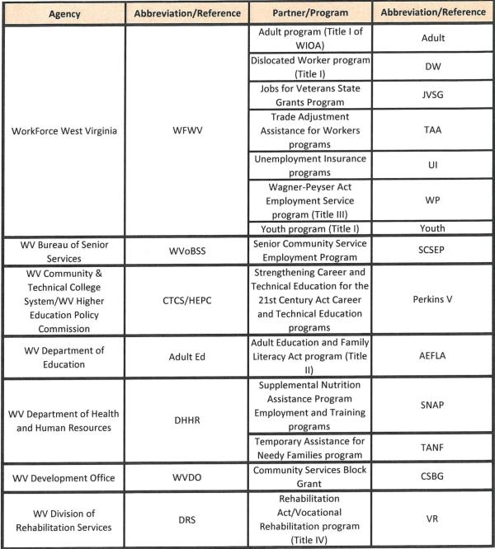
All agencies work closely with the state workforce development board: the West Virginia Workforce Development Board (WVWFDB). The WVWFDB advises the Governor on workforce priorities and initiatives while also overseeing workforce activities managed regionally by Local Workforce Development Boards (LWDBs). A few of the many responsibilities the WVWFDB is charged with includes developing opportunities for West Virginians to gain employment and earn competitive wages, developing and implementing workforce solutions based on the input of representatives and LWDBs around the state, addressing West Virginia’s workforce needs through efficient workforce training and development programs. The WVWFDB works with the combined partners in developing and implementing the federally mandated state plan under WIOA. At the regional level, West Virginia has a total of seven designated local regions with a LWDB in each. LWDBs are responsible for the oversight of WIOA funds and activities, delivering career assessment, job search, and education and training related services through organizations identified and established by the board.
The Executive Branch of West Virginia’s State Government is headed by the State’s elected Governor, who directly oversees several State Departments, Bureaus, Commissions, and other Boards and Councils. The implementation of WIOA in the State of West Virginia is carried out by two departments: The Department of Commerce and The Department of Education.
The Department of Commerce consists of nine agencies, including the Development Office; Division of Forestry; Geological and Economic Survey; Division of Labor; Office of Miners’ Health, Safety, and Training; Division of Natural Resources; West Virginia Tourism Office; the West Virginia Division of Rehabilitation Services; and WorkForce West Virginia. WFWV provides workforce development services statewide at American Job Centers distributed through seven geographic regions.
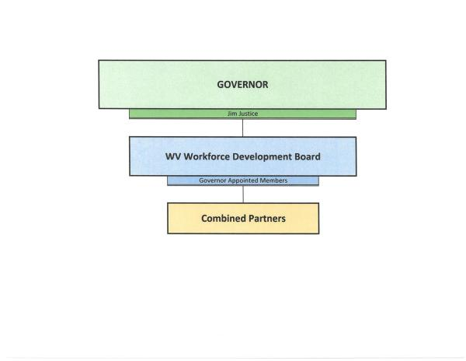

B. State Board
Provide a description of the State Board, including—
The Board shall assist in implementing and overseeing a comprehensive state workforce system that prepares West Virginia citizens for employment opportunities offered by West Virginia businesses. The Board shall make recommendations regarding program implementation, operation, and modifications to all state agencies administering workforce investment programs. The Board shall also assist and encourage West Virginia's educational institutions and public assistance systems to improve their ability to prepare people for gainful employment.
The Governor appoints the members of the WVWFDB and designates one of the business representatives to serve as the Chairperson. The WVWDB gives the Chairperson authority through the bylaws to create or dissolve committees and the task forces in order to accomplish the state board functions of the WVWDB as required under section 101 (d) of WIOA. The general WVWFDB meetings are scheduled to occur every quarter. Significant decisions are made with the approval of a simple majority of a Board quorum. Status updates on any current initiatives are given, as appropriate, to the full Board during regular meetings and if action is required, the Board is able to act accordingly. Public notice of regular Board meetings will be provided to all members no less than seven days before the day of the meeting. All meetings of the Board will be publicly announced in advance and open and accessible to the general public.
All agencies work closely with the state workforce development board, referred to in West Virginia as the WVWFDB. The WVWFDB advises the Governor on workforce priorities and initiatives while also overseeing workforce activities managed regionally by WVDE and DRS in developing and implementing the federally mandated state plan under WIOA. LWDBs are responsible for the oversight of funds and activities, delivering career assessment, job search, and education and training related services through organizations identified and established by the board.

i. Membership Roster
Provide a membership roster for the State Board, including members’ organizational affiliations.
West Virginia's State Board, provided in the table below, consists of the following required membership types:
- State Government
  - Governor
  - Representatives of State Legislature
- Business Representative
- Workforce Representatives
  - Labor Organizations
  - Joint Labor/Management Registered Apprenticeship Program
  - Other Workforce Representatives
- Representatives of Government with Responsibility Over the Core Programs
  - Lead State Official for Adult, Dislocated Worker, and Youth (Title I) and Wagner-Peyser (amended by Title III)
  - Lead State Official for Adult Education and Family Literacy Act program (Title II)
  - Lead State Official for the Vocational Rehabilitation program (amended by Title IV)
- Representatives of Local Government
  - Chief Elected Officials
- Optional Representation
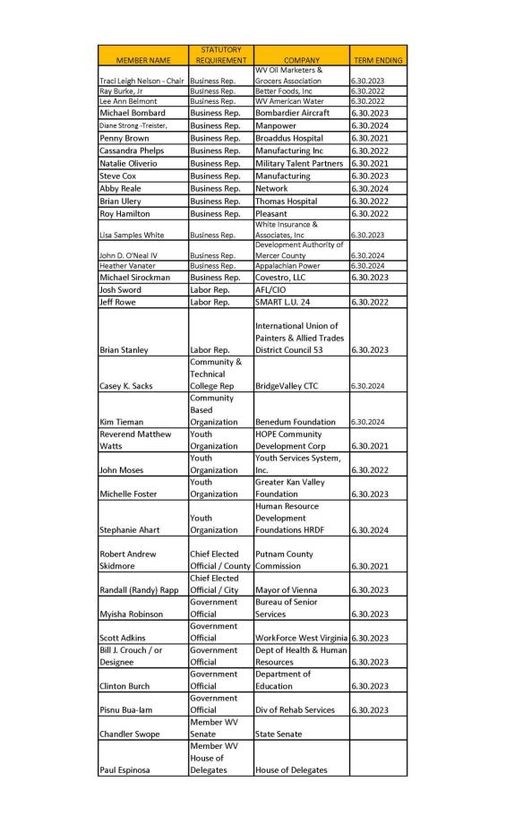

ii. Board Activities
Provide a description of the activities that will assist State Board members and staff in carrying out State Board functions effectively.
The Governor appoints members of the WVWFDB (the Board) and designates the Chairperson. The Board through its bylaws may establish working committees to assist the Governor and the full Board in carrying out the functions and responsibilities in Section 101(d) of WIOA. These working committees include, but will not be necessarily limited to, an Executive Committee, advisory committees, and various standing committees for focused topic areas that advance the work of the Board and ensure adequate attention is given to priority issues.
The Board shall assist in implementing and overseeing a comprehensive state workforce system that prepares West Virginia citizens for employment opportunities offered by West Virginia businesses. The Board shall make recommendation regarding program implementation, operation, and modifications to all state agencies administering workforce investment programs. The Board shall also assist and encourage West Virginia's educational institutions and public assistance systems to improve their ability to prepare people for gainful employment.
The Board shall meet at least quarterly and as such other times as the Chairperson deems necessary. All meetings of the Board will be publicly announced in advance and shall be open and accessible to the general public. Special meetings of the Board may be called by the Chairperson upon notice to the Board two working days prior to the meeting. Notice of each special meeting shall state the date, time, and location (within the State of West Virginia) of the meeting, and an agenda will be included stating the purpose of the meeting. Such special meetings will comply with the West Virginia Open Meetings law. At any special meeting of the Board, no business other than the stated agenda shall be transacted.
Additional board activities include:
- Work in the development of and continuous improvement of the workforce system in West Virginia to include the removing barriers to employment, enhance existing strategies to support career pathways, provide outreach to employers to educate them on workforce services, enhance current sector partnerships to serve the needs of employer and job seekers.
- Recommend improvements to the AJC system through the local workforce regions to support enhanced delivery of services to individuals and employers.
- Disseminate best practices related to effective operation of the AJC system and training programs that respond to real time labor market analysis to assist in placement into employment.
- The review of statewide policies that affect the provision of services in the AJC system, roles of mandated partners and guidance for allocation of funds to support the system.
- Recommend enhancements and technological improvements for better access to services and activities delivered in the AJC system.
- Recommend strategies for aligning technology and data systems among the mandated partner programs to improve the capacity to produce the desired results in reporting performance accountability measures.
- Recommend enhancements to the statewide LMI system under the Wagner-Peyser Act.
- Recommendations for other policies that promote unified initiatives to improve the WDS.

4. Assessment and Evaluation of Programs and One-Stop Program Partners

A. Assessment of Core Programs
Describe how the core programs will be assessed each year based on State performance accountability measures described in section 116(b) of WIOA. This State assessment must include the quality, effectiveness, and improvement of programs broken down by local area or provider. Such state assessments should take into account local and regional planning goals.
Each of the core partners, including WFWV, DRS, and Adult Education will be assessed based on the performance accountability measures to assess the quality, effectiveness and improvements of the programs by local area or provider. Core programs will be assessed each year primarily through the State performance accountability measures described in section 116(b) of WIOA. The assessments will be conducted at the state, local, and regional levels, while taking into account local/regional planning goals, as appropriate. The WV WDS "data warehouse" ensures that the state will have the capability to conduct assessments at various levels across programs in addition to assessments of the system as a whole. Assessments will help the state maintain focus on service quality, progress towards its goals, identify promising practices, and pinpoint areas in need of improvement.
Each core program will be assessed on the following performance measures from section 116(b) of WIOA:
- Employment (second quarter after exit)
- Employment (fourth quarter after exit)
- Median earnings (second quarter after exit)
- Credential attainment rate
- Measurable skills gains
- Effectiveness in serving employers
Additional assessments may be conducted utilizing other measures, as appropriate.

B. Assessment of One-Stop Partner Programs
Describe how other one-stop delivery system partner program services and Combined State Plan partner programs included in the plan will be assessed each year. Such state assessments should take into account local and regional planning goals.
The West Virginia AJC system partner programs include the following:
- Alien Labor Certification Program
- Work Opportunity Tax Credit (WOTC)
- Adult Basic Education
- Trade Adjustment Assistance (TAA)
- Career and Technical Adult Education
- Higher Education Adult Part-time Student
- Workforce Development Initiative Grant
- West Virginia Advance Grant and Technical Program Development Initiative
- WIOA Title I Adult
- WIOA Title I Youth
- WIOA Dislocated Worker
- Governor’s Discretionary Fund
- Division of Rehabilitation Services (DRS)
- Senior Community Service Employment Program
- Veterans Programs
- Labor Exchange
- Community Services Block Grant
- Unemployment Compensation
- Governor’s Guaranteed Workforce Program (Including Small Business Workforce Development)
- National Dislocated Worker Grants (including Opioid and COVID)
Each year, WFWV issues an assessment of the West Virginia workforce development system-the Workforce Development System Report. This serves as the primary assessment of one-stop partner program services in the state. This report includes the State of the AJC System, the Funding Stream Report, performance requirements, positive practices, and the Interagency Collaborative Team (ICT) Memorandum of Understanding (MOU). This report is a summary document that gives a public account and assessment of the current operations, structures, activities, finances, and future direction of West Virginia’s American Job Centers (AJCWV). The report is published annually, as required by the West Virginia Legislature, and reported to the Legislative Oversight Commission on Workforce Investment for Economic Development.
The purpose of the Funding Stream Report is to quantify the level of both fiscal and programmatic (service delivery) involvement of all the entities involved either directly or tangentially with workforce development in West Virginia. The data collected for the report is critical to conducting an assessment of the AJCWV system. With the original passage of House Bill 4083 in 2002, the West Virginia Legislature required this annual report regarding the source, use and outcomes of all funds received for workforce development activities in the state.
Specifically, this reporting requirement includes:
- Source and amount of federal, state, and other funds received for workforce development activities;
- Purpose of each of the above funds;
- Services provided in each of the seven regional workforce development areas;
- The measure used to evaluate program performance (including current and baseline performance data) and any other information the council requests.
All of the publicly funded workforce development programs operating in the state are to include:
- Amount of federal funds expended by each program,
- Amount of state funds expended by each program,
- How the funds are spent,
- The resulting improvement in the workforce.
The purpose, beyond identifying sources and uses of funds, is to focus on the outcomes of workforce development. Holding agencies and programs accountable for results is vitally important. Getting the most value from the dollars invested, be it federal, state or independent grants, is critical to the success of West Virginia’s workforce development system.
For each workforce development program or activity, the report includes the following:
- State Organization
- Funding Unit
- Operations Unit
- Program
- Program Type
- Program Purpose
- Target Population
- Service Level (number of individuals served)
- Evaluation Measurement (specific to each program)
- Outcome
- Service Locations
- Funds, by source
- Percentage of funds used for Workforce Development
Local and Regional Planning Data are collected from the local one-stops within each region. The report also aggregates data by workforce development region and includes data from the previous two years for comparison and assessment purposes. A sample of the data includes:
- The number of individuals receiving services in each region, by program
- Contributions of each partner agency and non-mandated partner programs at each one-stop and region
- Program performance for the most recent three years, including negotiated benchmarks and actual performance
To ensure system and program oversight is communicated and analyzed properly, the Workforce Development System Report is provided to the Legislative Oversight Commission on Workforce Investment for Economic Development to assess the activities and outcomes of the WV WDS. The report allows the governor, legislators, agency and program administrators, and other stakeholders to assess performance and develop appropriate, data-driven planning goals. Due to the comprehensive data collection, activities are being reported at the local, regional, and state levels to facilitate administrators’ ability to examine and compare performances at various levels and across areas.
WFWV has overall responsibility for the process to collect the Funding Stream Report information and provide to the West Virginia Workforce Development Council the information needed to report to the legislature, Governor’s Office, and others.
In addition to the oversight described above, DHHR assesses the effectiveness of SNAP E&T and TANF on a quarterly basis. Participation rates for both programs are reported to the state and federal government(s). The agency works to set benchmarks to satisfy the local labor market. Both SNAP E&T and TANF receive Legislative oversight in designing programs that are both effective and efficient.
Program improvement is based on pre and post-employment skill testing. Case managers monitor client success in partner agency activities on a regular basis. DHHR provides employment related services including information about local education and training services. DHHR policy makers actively seek new and innovative processes to improve the overall experience for low-income clients.

C. Previous Assessment Results
Beginning with the state plan modification in 2018 and for subsequent state plans and state plan modifications, provide the results of assessments of the effectiveness of the core programs and other one-stop partner programs and Combined State Plan partner programs included in the Unified or Combined State plan during the preceding 2-year period (i.e. the 2-year period of the plan modification cycle). Describe how the State is adapting its strategies based on these assessments.
The Governor and the West Virginia Secretary of Commerce created a taskforce to assess the West Virginia WDS and related areas such as business and workforce climates, workforce participation rates, training and educational needs, skill gaps, workforce development strategies, and how the West Virginia Combined State Plan can effectuate positive change in areas that adversely affect business. The taskforce is composed of representatives of all core partner agencies, the state legislature, business owners, community partners, and other stakeholders. Prior to the development of the West Virginia Combined State Plan, the taskforce conducted a review of West Virginia WDS activities, including surveys of stakeholders and economic analyses. Based on their findings, the taskforce assisted the West Virginia WDS with both the development of new and the revision of existing goals and strategies. The 2022 State Plan modification incorporated/reinforced the Task Force recommendations (aka ‘Blueprint’ for the Combined State Plan). The Task Force’s review determined Combined State Plan partners will:
- Make it Easier for Citizens to be Successful
- Get State Agencies on the Same Page
- Eliminate Duplication
- Improve Outreach to Business and Industry
During the Combined State Plan modification process, the team was introduced to two types of studies/evaluations to be implemented over the course of the next few months. The two studies/evaluations agreed upon are:
- Cross-Sectional Study
- Logic Model Development
In order to assess the quality, effectiveness, and improvement of programs, WV will utilize the performance measurement system outlined in section 116 of WIOA as well as additional metrics for federal and state workforce programs. Establishing additional metrics will help the workforce development system dig into the data to find out where initiatives would be beneficial, or what populations/areas need extra support, or even what combination of services seem to work better together or sequentially. Additional Performance Measures/Metrics for the Workforce Development System agreed upon are:
- Number of program participants served
- Number of program participants exited
- Number of participants completed program/achieved goal(s)
- Percentage of program participants served with barriers to employment as follows:
  - Disability
  - Ex–offender
  - No high school diploma
  - Previously or currently in foster care
  - Homeless
  - Limited English Proficiency or Low Level Literacy
  - Long–Term Unemployed
  - Public Assistance customer
- Percentage of program participants responding to survey who are satisfied with their training/counseling/services after exiting from the program
In addition to overall WDS assessments, individual agencies conduct evaluations on the effectiveness of their programs and use the findings to make improvements. For example, DRS conducts various assessments of the effectiveness of its program, including the Comprehensive Statewide Needs Assessment (CSNA) and the Consumer Satisfaction Survey. The latest CSNA and Consumer Satisfaction Survey results are available in the VR Section of this Combined State Plan. DRS also maintains its commitment to meeting WIOA Performance Indicator benchmarks and continues to establish baseline levels of performance on five of the six WIOA Performance Indicators. For the Measurable Skills Gains performance indicator, DRS has a negotiated level of performance of 41% for Program Year (PY) 2020 and 42% for PY 2021. DRS expects to submit expected levels of performance on the remaining performance indicators (with the exception of Effectiveness in Serving Employers) in the Combined State Plan submitted prior to PY 2022.

D. Evaluation
Describe how the State will conduct evaluations and research projects on activities under WIOA core programs; how such projects will be coordinated with, and designed in conjunction with, State and local boards and with State agencies responsible for the administration of all respective core programs; and, further, how the projects will be coordinated with the evaluations provided for by the Secretary of Labor and the Secretary of Education under WIOA.
Selected research/evaluations and improvement projects will be aligned to strategies in this plan and monitored by the core program planning workgroup. This workgroup will consist of members appointed by each of the core partner directors. To select projects, the core and combined program partners will utilize the WVWFDB to recommend areas for analysis or improvements. These projects would be approved by the leadership of the core and combined program partner agencies and coordinated with the Secretaries of the Departments of Labor and Education.
Prior to conducting the evaluations, the workgroup is currently gathering data and identifying an initial set of research questions which will lead to the evaluation’s purpose and scope, so stakeholders, partners, and customers understand what is being researched and why. Research questions considered are:
- What are the program processes used for the services provided?
- Does the menu of services provided meet the intended program objectives or goals (for example, employment and increased wages for customers)?
- Do particular services result in better outcomes than other services (for example, do participants who receive an “extra” package of services have higher earnings or longer retention rates than those who receive the “standard” package of services)?
- Is a statewide career pathways system helping or hindering institutions in making a difference for students and workers?
Once the purpose and scope have been determined, and designed in conjunction with the State board, Core and Combined Partner State agencies, and Local Boards, the ongoing evaluations of state programs can be conducted effectively to include analysis of the WV workforce development system’s customer feedback, as well as additional outcome and process metrics/measures.
The results of the following studies will be documented and presented through formal reports and made public:
- The Cross-Sectional Study was chosen because it documents program operation or compares it against goals, across locations, or over time. It describes and analyzes “what happened and why” in the design, implementation, administration, and operation of programs. It analyzes the characteristics and outcomes for a population at a specific, single point in time and may involve comparisons to goals or across programs, population subsets, or locations.
- The Logic Model Development evaluates a specific program and considers program flow, service delivery, roles and responsibilities of partners, and data sharing activities.
Because WV’s workforce development system is so vast, measuring the collaboration/effectiveness of workforce development system partners is necessary to ensure services are coordinated and effective, federal and state funding are leveraged, and activities are accurately assessed to determine whether individuals and employers are being served according to how WIOA and WV’s Governor has envisioned.

5. Distribution of Funds for Core Programs
Describe the methods and factors the State will use in distributing funds under the core programs in accordance with the provisions authorizing such distributions.

A. For Title I Programs
Provide a description of the written policies that establish the State's methods and factors used to distribute funds to local areas for—

i. Youth Activities in Accordance with WIOA Section 128(b)(2) or (b)(3)
Once the TEGL has been issued and WFWV has received the Notice of Obligation (NOO) from the USDOL information is gathered from our Research, Information, and Analysis (RIA) to begin the allocation process. The data received from RIA breaks out the unemployment numbers and ‘economically disadvantaged youths’ by county and region.
Each region is guaranteed to receive no less than 90 percent of the average allocation percentage of the local area for the prior two years. Per the guidance in the TEGL and WIOA Regulations the remaining funds after the ‘hold harmless’ portion of the allocation has been calculated, the remaining funds are broken down by unemployed, excess, unemployed, and economically disadvantaged youth.

ii. Adult and Training Activities in Accordance with WIOA Section 133(b)(2) or (b)(3)
WFWV follows the same guidelines for allocating Adult funds as used in Youth funds except for ‘economically disadvantaged adult’ versus ‘economically disadvantaged youth.’ Each region is guaranteed to receive no less than 90% of the average allocation percentage of the local area for the prior two years.

iii. Dislocated Worker Employment and Training Activities in Accordance with WIOA Section 133(b)(2) and Based on Data and Weights Assigned
The funds distributed for the Dislocated Worker are based on different factors than utilized for Youth and Adult. The ‘hold harmless’ provision is not taken into account for the dollars distributed.
Each region is guaranteed to receive no less than 90% of the average allocation percentage of the local area for the prior two years.
The entirety of the DW funds are distributed based on the categories and the percentages for each category as listed below:
- Insured unemployment data 20.0%
- Unemployment concentrations 20.0%
  - Annual average count of unemployed
  - Annual average unemployment rates
  - Index to state rates
- Plant closings and mass layoff data: 0.0%*
  - Initial claims in MLS
  - Exhaustees involved in MLS
- Declining industries data 5.0%
- Farmer-rancher economic hardship data
  - Percentage of delinquent loans to the estimated number of farms. Base data provided by FHA and US Department of Commerce Census of Agriculture.
- Long-term unemployment data: 40%
  - Last pays from UC 217 report
*Update to Workforce West Virginia's (WFWV) Allocation Formula for PY22 for Dislocated Worker. The software where WFWV has been obtaining the Plant Closing and Mass Layoff Data is no longer an available data source. WFWV will apply a zero weight to this data source in the formula for PY22. After reviewing the warn notices/monthly rapid response reports submitted by the Local Workforce Development Areas in addition to discussing the formula change with the individual Executive Directors of each LWDA, WFWV has determined that the impact this will have on the formula is immaterial.

B. For Title II

i. Describe how the eligible agency will award multi-year grants or contracts on a competitive basis to eligible providers in the State, including how eligible agencies will establish that eligible providers are organizations of demonstrated effectiveness
Methods and Factors for Title II
West Virginia Adult Education will conduct a competition for new Adult Education and Family Literacy Act (AEFLA), Corrections Education and Integrated English Literacy and Civics (IELCE) Education grants. In accordance with 34 CFR part 463, Subpart C, a multi- year grant will be awarded through a Request for Proposal (RFP) process; the first year being the grant award with subsequent renewal years. All eligible applicants will respond to the statewide RFP announcement and will be expected to address the thirteen considerations and seven requirements established in Section 231 (e) of WIOA.
Section 231 (e) CONSIDERATIONS. -In awarding grants or contracts under this section, the eligible agency shall consider-
- the degree to which the eligible provider would be responsive to-
  - regional needs as identified in the local plan; and
  - serving individuals in the community who were identified in such plan as most in need of adult education and literacy activities, including individuals who have low levels of literacy skills; or who are English language learners;
- the ability of the eligible provider to serve eligible individuals with disabilities, including eligible individuals with learning disabilities;
- past effectiveness of the eligible provider in improving the literacy of eligible individuals, to meet State-adjusted performance levels, especially with respect to eligible individuals who have low levels of literacy;
- the extent to which the eligible provider demonstrates alignment between proposed activities and services and the strategy and goals of the local plan, as well as the activities and services of the one-stop partners;
- whether the eligible provider’s program-
  - is of sufficient intensity and quality, and based on the most rigorous research available so that participants achieve substantial learning gains; and
  - uses instructional practices that include the essential components of reading instruction;
- whether the eligible provider’s activities, including whether reading, writing, speaking, mathematics, and English language acquisition instruction delivered by the eligible provider, are based on the best practices derived from the most rigorous research available and appropriate, including scientifically valid research and effective educational practice;
- whether the eligible provider’s activities effectively use technology services and delivery systems including distance;
- whether the eligible provider’s activities provide learning in context, including through integrated education and training, so that an individual acquires the skills needed to transition to and complete postsecondary education and training programs, obtain and advance in employment leading to economic self-sufficiency, and to exercise the rights and responsibilities of citizenship;
- whether the eligible provider’s activities are delivered by well-trained instructors, counselors, and administrators who meet any minimum qualifications established by the State, where applicable, and who have access to high quality development, including through electronic means;
- whether the eligible provider’s activities coordinate with other available education, training, and social service resources in the community, such as by establishing strong links with postsecondary educational institutions, institutions of higher education, local workforce investment boards, one-stop centers, job training programs, and social service agencies, business, industry, labor organizations, community-based organizations, nonprofit organizations, and intermediaries, for the development of career pathways;
- whether the eligible provider’s activities offer flexible schedules and coordination with Federal, State, and local support services (such as child care, mental health services, and career planning) that are necessary to enable individuals, including individuals with disabilities or other special needs, to attend and complete programs;
- whether the eligible provider maintains a high-quality information management system that has the capacity to report measurable participant outcomes and to monitor program performance; and
- whether the local areas in which the eligible provider is located have a demonstrated need for additional English language acquisition programs and civics education programs.
Section 232 of the act states that each eligible provider desiring a grant or contract from an eligible agency shall submit an application to the eligible agency containing such information and assurances as the eligible agency may require, including-
- a description of how funds awarded under this title will be spent consistent with the requirements of this title;
- a description of any cooperative arrangements the eligible provider has with other agencies, institutions, or organizations for the delivery of adult education and literacy activities;
- a description of how the eligible provider will provide services in alignment with the local plan under section 108, including how such provider will promote concurrent enrollment in programs and activities under title I, as appropriate;
- a description of how the eligible provider will meet the State adjusted levels of performance described in section 116(b)(3), including how such provider will collect data to report on such performance indicators;
- a description of how the eligible provider will fulfill one-stop partner responsibilities as described in section 121(b)(1)(A), as appropriate;
- a description of how the eligible provider will provide services in a manner that meets the needs of eligible individuals; and
- information that addresses the considerations described under section 231(e), as applicable
The RFP is the mechanism through which Adult Education will identify, assess, and award multi-year grants to eligible providers throughout the state that have demonstrated effectiveness in providing adult education activities to eligible individuals. An eligible individual is identified as an individual who has attained 16 years of age; who is not enrolled or required to be enrolled in secondary school under state law; and who is basic skills deficient; does not have a secondary school diploma or its recognized equivalent, and has not achieved an equivalent level of education; or is an English language learner.
Programs previously funded by Adult Education will be evaluated for their ability to meet designated state performance measures. Applicants not previously funded by Adult Education will be required to provide data that demonstrate their past ability to achieve success in comparable measures. For both groups, these measures include effectiveness in helping students develop their academic skills, achieve high school equivalency, and transition into employment and/or postsecondary education and training.
Eligible providers submitting applications to Adult Education may include:
- a local education agency;
- a community-based or faith-based organization;
- a volunteer literacy organization;
- an institution of higher education;
- a public or private nonprofit agency;
- a library;
- a public housing authority;
- a nonprofit institution with the ability to provide adult education and literacy services;
- a consortium or coalition of agencies, organizations, institutions, libraries, or authorities described above; and
- a partnership between an employer and an entity described above.
Local grants will be distributed based on the ability to meet the requirements of AEFLA purposes outlined in WIOA:
- Assist adults to become literate and obtain the knowledge and skill necessary for employment and economic self-sufficiency;
- Assist adults who are parents or family members become a full partner in the education development of their children;
- Promote transition from adult education to post-secondary education and training through career pathways;
- Assist immigrants and English language learners improve reading, writing, math, speaking and comprehending the English language and acquire understanding of American government, individual freedom, and responsibilities of citizenship.
As part of the application process, applicants will be required to submit applications to LWDB for review to ensure that the applications align with the local plan. Adult Education will consider the review and any recommendations made by the LWDBs when scoring the related sections of the applications.
Following is a timeline for the RFP process:
- Statewide announcement
- Release of application
- Technical assistance webinar
- Applications due
- LWDB reviews
- Review committee evaluates applications
- Award notifications released
- Grant awards distributed

ii. Describe how the eligible agency will ensure direct and equitable access to all eligible providers to apply and compete for funds and how the eligible agency will ensure that it is using the same grant or contract announcement and application procedure for all eligible providers
Adult Education will ensure that the same grant announcement is made available to all eligible providers. When the RFPs are ready for release, official press release containing information about the availability of funds and the application process will be published as a legal notice in compliance with the WVDE Office of Communication’s approved policies and procedures. The RFPs will be posted on the WVDE website for download.
Submissions from eligible applicants will be reviewed for completeness, adherence to grant guidelines, content development, and overall quality. A review committee will score each application and make funding recommendations. Final funding decisions will be made by Adult Education staff based on the review committee’s recommendations.

C. Vocational Rehabilitation Program
In the case of a State that, under section 101(a)(2)(A)(i) of the Rehabilitation Act designates a State agency to administer the part of the Vocational Rehabilitation (VR) services portion of the Unified or Combined State Plan under which VR services are provided for individuals who are blind, describe the process and the factors used by the State to determine the distribution of funds among the two VR agencies in the State.
Not Applicable.

6. Program Data

A. Data Alignment and Integration
Describe the plans of the lead State agencies with responsibility for the administration of the core programs, along with the State Board, to align and integrate available workforce and education data systems for the core programs, unemployment insurance programs, and education through postsecondary education, and to the extent possible, the Combined State Plan partner programs included in this plan. The description of the State’s plan for integrating data systems should include the State’s goals for achieving integration and any progress to date.

i. Describe the State’s plans to make the management information systems for the core programs interoperable to maximize the efficient exchange of common data elements to support assessment and evaluation
The State board is fully committed to the goal of aligning technology and data systems across required one-stop partner programs. The board will continue to make this a priority at its quarterly meetings to ensure progress is being made toward the governor’s vision for data alignment.
West Virginia has an integrated data collection and performance management system (MACC) that covers the following programs:
- WIOA Adult, Dislocated Worker, Youth
- National Dislocated Worker Grants (NDWG)
- Migrant and Seasonal Farmworkers
- Wagner-Peyser
- Trade Adjustment Assistance (TAA)
- Jobs for Veterans State Grants
- Jobs & Hope WV
- West Virginia’s Unemployment Compensation MIS interfaces with MACC
Other partners have management information systems that are customized to meet the needs of their programs. WorkForce West Virginia (WFWV), Rehabilitation Services (DRS), and Adult Education have each made the necessary changes to their systems to collect the required data elements. As previously mentioned in this plan, WV's workforce development system is collecting data elements, developing research questions, and identifying additional metrics so proper studies and evaluations can be conducted to assess partner services and performance.
For front line staff and leadership, linkages have been put in place to allow partners, such as DHHR, to access the information in real time. Employment and wage data are shared with partners to the extent allowed by the State Wage Interchange System (SWIS) agreement.
While each partner agency does have their own MIS, they are all interoperable and are able to send and retrieve data to and from each other in real time. All individuals served by the West Virginia WDS are assigned a unique identifier that is used by each partner agency. This unique identifier is used for data sharing and reporting purposes (i.e., co-enrollment with other core programs).
WV is working on a no wrong door approach initiative. Basically, this initiative’s purpose is to create a common application to make it easier for citizens to enroll in services across organizations. At this stage of planning, the State seeks a vendor solution incorporating a phased implementation approach. A phased approach enables the State to evaluate the effectiveness of the solution at each stage to validate intended outcomes and deliverables. Additionally, a phased approach enables the State to enact cost control measures. Phases are anticipated to consist of Planning and Account Set Up, Data Processing and Preparation, Application Build, Testing and Iteration, Rollout, and Post-Project work. WV's also intends for staff working with customers to take more of 'generalist' role in their day to day work so shared customers, and those who should be shared, can be served with the most coordinated, appropriate, and successful way possible. The generalist concept simply seeks to prevent a 'silo' approach from occurring, ultimately removing additional barriers placed on individuals and employers seeking services, as well as, preventing the provision of duplicated or unnecessary services, and avoiding missed opportunities.
In addition to “behind-the-scenes” data sharing and reporting, front-end users also benefit from shared data. For example, the DRS MIS, iECM (Internet-based Electronic Case Management System), has a link in each case for “WIOA Partner Data.” When a DRS Counselor clicks this link, iECM sends a request for data (using the unique identifier) to the WorkForce WV and WV Adult Education MIS. If available, the information is transmitted in real time and displayed. Information provided by partner agencies includes current and previous employment goals, services received, and assessment results. This information is then used by DRS Counselors to optimize service delivery with the goal of improving the participant’s employment outcome.

ii. Describe the State’s plans to integrate data systems to facilitate streamlined intake and service delivery to track participation across all programs included in this plan
The MACC is WFWV’s management information system that covers all U.S. Department of Labor (USDOL) programs that we manage, except for the Unemployment Compensation systems where an interface allows for the immediate transfer of registration data from the UC benefits payment system to the MACC. All partners have added interfaces to their information system that allow the real time exchange of participant tracking information among all systems partners. The system allows case managers to streamline the intake process by eliminating the need to duplicate data that is already available in the partner systems. It also allows the tracking of an individual’s participation in all programs, including what services have been given or are scheduled to be given, development plans, outcomes, and other pertinent information.
To further WV’s vision to integrate systems, the no wrong door approach initiative, set forth by the Blue Ribbon Task Force will develop a roadmap for integration of the State Community and Technical College Development systems and provide a strategic vision for our State to afford all West Virginians equitable opportunities for lifelong learning and increased personal economic mobility, as well as to provide current and prospective employers and industries in West Virginia with individuals who have the particular skill sets, knowledge, and education necessary to grow their businesses and provide additional career opportunities. Additionally, DHHR continues the implementation of its WV People's Access to Help (WV PATH) Integrated Eligibility System (IES) for serving SNAP, TANF, Medicaid, Child Support, and Child Welfare Clients. The full implementation of this IES offers enhanced opportunities for systems integration with other partners across the Workforce system in order to improve tracking of and outcomes for our shared clients.

iii. Explain how the State board will assist the governor in aligning technology and data systems across required one-stop partner programs (including design and implementation of common intake, data collection, etc.) and how such alignment will improve service delivery to individuals, including unemployed individuals
WorkForce West Virginia, Rehabilitation Services, and Adult Education have already come to a general agreement on aligning technologies and data systems. The West Virginia State Workforce Development Board will continue to work within the framework of the WIOA legislation and federal guidance to improve service delivery.

iv. Describe the State’s plans to develop and produce the reports required under section 116, performance accountability system. (WIOA section 116(d)(2))
WFWV’s MACC system has always been able to produce the required reports for USDOL programs in the past and we do not anticipate any difficulty in complying with the section 116 reports. While the requirement to produce reports on WIOA training performance, the MACC system has been able to track performance for participants for years. The MACC system has limited fiscal information available, which could be the basis of a fiscal management system once the requirements are established.
The WIOA core partners in West Virginia, including WFWV, DRS, and Adult Education have implemented a practical and effective system to fulfill the data alignment and integration requirements of WIOA. Each program has a unique system of data collection that is tailored to meet its unique needs. To maximize the efficient exchange of data to support assessment and evaluation, the core partners have collaborated to develop and implement a system for data sharing. This system operates as follows:
- Each consumer in the system is assigned a unique participant identifier upon entering the system (WFWV, DRS, Adult Education). The date each consumer enters and exits each program is recorded. The unique participant identifier and program entry/exit dates are used to identify common consumers across the core programs and provide access to the common data elements collected by other partners in the AJC system.
- To ensure effectiveness and efficiency in the AJC system, data collected by each program on new consumers are made available for each program to track service delivery of common consumers. This process ensures that service delivery for each consumer can be tracked across all programs.
- The data collected is used to generate reports required under section 116, performance accountability system.
Alignment of each partner’s system of data collection has improved service delivery to individuals at the AJC including individuals with barriers to employment, especially those with disabilities, by providing the three core partners with more information about how consumers are being assisted across programs in the AJCWV. This information enables the core partners to have a greater understanding of how the needs of their consumers are being met across programs, to track their progress, and to minimize duplication of service. Alignment and integration of data across programs in a data sharing system supports a consumer-focused approach to service delivery that generates quality employment outcomes for consumers in the AJC.

B. Assessment of Participants’ Post-program Success
Describe how lead State agencies will use the workforce development system to assess the progress of participants who are exiting from core programs in entering, persisting in, and completing postsecondary education, or entering or remaining in employment. States may choose to set additional indicators of performance.
To the extent possible, the State uses data matches with other state systems to track participants’ entry and progress in post-secondary education or employment, for example using the WV Department of Education’s P20 system. In cases where a data match is not possible or is inadequate, case managers will work with participants, training providers, and employers to gather the needed information.

C. Use of Unemployment Insurance (UI) Wage Record Data
Explain how the State will meet the requirements to utilize quarterly UI wage records for performance accountability, evaluations, and as a source for workforce and labor market information, consistent with Federal and State law. (This Operational Planning element applies to core programs.)
WFWV is the state agency that houses the Unemployment Compensation programs in WV and has access to Unemployment Compensation wage data. WV is also a member of WRIS, WRIS2 and SWIS. Wage records will be shared when possible and aggregated performance data shared when the actual wages records cannot be shared.

D. Privacy Safeguards
Describe the privacy safeguards incorporated in the State’s workforce development system, including safeguards required by section 444 of the General Education Provisions Act (20 U.S.C. 1232g) and other applicable Federal laws.
Scope
WorkForce West Virginia is an agency within the West Virginia Department of Commerce. This Privacy Notice Summary is based on the West Virginia Department of Commerce Privacy Policy; however, it is specific to WorkForce West Virginia.
Personal Information
- We need certain personal and non-personal information to assist you with your employment, unemployment and training needs.
- The Personally Identifiable Information (PII) we collect may include your name, address, social security number, date of birth and more.
Uses of Information
- By West Virginia law and the Privacy Act of 1974, we must collect certain PII to assist you. Without certain PII, we may not be able to determine the services for which you are eligible, such as Unemployment Insurance benefits.
- The information we collect may be combined with information obtained from other Executive Branch Departments’ websites and services.
- We use personal information for purposes that relate to the reason you provide it. If information is used for another purpose, we will obtain your permission.
- For purposes matching the reason you provided, we may share your information with other state and federal agencies for the limited purpose of data processing or storage.
- In certain cases, we may share your information when required by state or federal law.
- Your information may be shared with others we have hired to assist us; however, all staff and contractors are bound by a West Virginia Executive Branch Confidentiality Agreement.
- We do not sell or rent your PII to third parties for marketing purposes.
- We may share non-personal, aggregated, or de-identified data for purposes related to improving our business practices.
Your Rights and Choice
- You have the right to review the personal information you provide us and to update or correct that information.
- If you have consented to an electronic exchange of information, you may cancel that consent by following the instructions in the email you receive.
- If you provide any information to any of our agency websites, you may choose to remove it at any time, except where such information is required by state or federal regulation.
Security
- WorkForce West Virginia computer systems are constructed and maintained by WorkForce West Virginia agency staff, the West Virginia Office of Technology, and/or WorkForce West Virginia and state approved contractors.
- Regardless of the system or personnel responsible for it, multiple techniques and technologies are used to protect your PII. This means we use industry standards and several in-house safeguards to protect your information.
How to Contact Us
- For more information on our privacy requirements and practices, please call 800-252- 5627 and your call will be directed to the WorkForce West Virginia Privacy Officer for response.
Sharing Your Information
By enrolling with WorkForce West Virginia, you agree that WorkForce West Virginia and its mandated partners may access and use all of the information contained within your application in order to best assist you in obtaining employment and in determining your eligibility for training and other services. These services may include testing, assessment, placement services and career counseling, and we may share test scores and job eligibility data with our partners to best serve you. Personal information such as race, ethnicity, sex and disability status is being requested for federal record keeping and reporting requirements and is kept confidential; however, it may be shared with the partners to determine your eligibility for specific programs.
WorkForce West Virginia Partner Agencies
- Adult Education and Literacy Services
- Vocational Rehabilitation Services
- Post-Secondary Carl Perkins Vocational and Applied Technology Education Services
- Welfare-to-Work Funded Under Social Security Act
- Senior Community Service
- Veterans Workforce Programs
- Community Services Block Grant (Community Action)
- Housing & Urban Development (HUD) Employment & Training Programs
- Job Corps
- Migrant & Seasonal Farmworker (MSFW) Services
- Temporary Assistance to Needy Families (TANF)
- Food Stamp Employment & Training
- Navigator Program
Civil Rights Statement-Equal Opportunity is the Law!
It is against the law for this recipient of Federal financial assistance to discriminate on the following basis:
- Against any individual in the United States, on the basis of race, color, religion, sex (including pregnancy, childbirth and related medical conditions, sex stereotyping, transgender status, and gender identity), national origin (including limited English proficiency), age, disability, political affiliation or belief;
OR,
- Against any beneficiary of, applicant to, or participant in programs financially assisted under Title I of the Workforce Innovation and Opportunity Act (WIOA), on the basis of the beneficiary’s citizenship status or participation in any WIOA I-financially assisted program or activity.
The recipient must not discriminate in any of the following areas:
Deciding who will be admitted, or have access, to any WIOA Title I-financially assisted program or activity; providing opportunities in, or treating any person with regard to, such a program or activity; or making employment decisions in the administration of, or in connection with, such program or activity; or making decisions in the administration of, or in connection with, such a program or activity. Recipients of federal financial assistance must take reasonable steps to ensure that communications with individuals with disabilities are as effective as communications with others. This means that, upon request and at no cost to the individual, recipients are required to provide appropriate auxiliary aids and services to qualified individuals with disabilities.
If you think that you have been subjected to discrimination under WIOA Title I-funded program or activity, you may file a complaint within 180 days from the date of the alleged violation with either the recipient: Equal Opportunity Officer, WorkForce West Virginia, 1900 Kanawha Boulevard, East, Charleston, WV 25305, 304-558-1600; WV Relay 7-1-1 (TDD)
The Director, Civil Rights Center, (CRC), U.S. Department of Labor, 200 Constitution Avenue NW, Room N-4123, Washington, DC 20210, 202-693-6502; 202-693-6515 (TTY).
If you file a complaint with the recipient, you must wait either until the recipient issues a written Notice of Final Action, or until 90 days have passed (whichever is sooner), before filing with the Civil Rights Center (see address above). If the recipient does not give you a written Notice of Final Action within 90 days of the day on which you filed your complaint, you do not have to wait for the recipient to issue that Notice before filing a complaint with the CRC. However, you must file your CRC complaint within 30 days of the 90-day deadline (in other words, within 120 days after you filed your complaint with the recipient). If the recipient does give you a written Notice of Final Action on your complaint, but you are dissatisfied with the decision or resolution, you may file a complaint with CRC. You must file your CRC complaint within 30 days of the date on which you received the Notice of Final Action.
To apply for jobs you must be a United States citizen, a permanent resident alien, or be authorized to work in the United States.
WV DIVISION OF REHABILITATION
West Virginia Division of Rehabilitation Services staff are required to complete a confidentiality agreement. The agreement is utilized to ensure that all West Virginia Division of Rehabilitation Services staff with access to protected information or any other information deemed confidential, fully understand their obligations to limit their use of such information and to protect such information from disclosure. The agreement also details special attention items, as well as definitions of different types of information including personal health information (PHI), personally identifiable information (PII), sensitive personally identifiable information (SPII), and non-public personal information (NPII). The confidentiality agreement pertains to information in all forms, including electronic and paper.
WV ADULT EDUCATION
Handling Confidential Information
If a student discloses any of the following types of information (verbally or in writing), legally that information is to be considered confidential and therefore “private”:
- Disclosure of a diagnosed learning disability
- Disclosure of previous status as a "special education" student
- Disclosure of any other type of diagnosed physical or mental disability
- Disclosure of a diagnosed medical condition
- Disclosure of use of any prescription drugs
- Disclosure of history of drug/alcohol abuse and/or treatment
- Disclosure of status as HIV positive or of having the AIDS virus
- Official transcripts
Filing cabinets or drawers containing confidential information must be labeled as “Confidential.” They must remain locked, must not be accessible to students or support staff, and must have a log filed foremost in each locked drawer to indicate when confidential files are accessed by any instructional or administrative staff person.
Confidential information files should be maintained at the local program level for a period of not less than five years and must be shredded when discarded.
Confidential information regarding a student cannot be discussed, nor can any record be shared without a written release of information.
Instructors sign the Adult Education Personnel Confidentiality Agreement and it is maintained by the administrator in the personnel file.

7. Priority of Service for Veterans
Describe how the State will implement and monitor the priority of service provisions for veterans in accordance with the requirements of the Jobs for Veterans Act, codified at section 4215 of 38 U.S.C., which applies to all employment and training programs funded in whole or in part by the Department of Labor. States should also describe the referral process for veterans determined to have a significant barrier to employment to receive services from the Jobs for Veterans State Grants (JVSG) program’s Disabled Veterans’ Outreach Program (DVOP) specialist.
Priority of service for veterans is implemented by WorkForce West Virginia in accordance with Title 38 part III Ch. 42. 4215 via American Job Centers (AJCs) located throughout the state, by using clear and concise guidelines, and by trained staff knowledgeable with state guidelines. To ensure access to services for covered persons, the state has established formal guidance regarding priority of service that all Wagner-Peyser and WorkForce staff must follow which includes determination of veteran’s status and eligibility. WIOA guidance notice 4-16 referencing Workforce Innovation & Opportunity Act of 2014 section 3(63) (A), 38 U.S.C 4215, and 20 CFR 1010 provides this guidance.
Covered persons obtain information concerning priority of service through WorkForce's website, flyers posted in AJCs, banners, and/or in person from appropriate staff in work groups, unemployment compensation groups, during the job seeker enrollment process, and during the provision of services. WorkForce provides staff information, training, and assistance regarding available employment programs, training opportunities, services, eligibility requirements, and veteran’s priority of service.
WorkForce provides covered person’s priority of service under all state and federally funded employment and training programs. "Veterans priority of service" means that an otherwise covered person shall be given priority over non-veterans for the receipt of employment, training, and placement services provided under that program, notwithstanding any other provision of the law. When services are limited due to available funding, priority of service should be applied. For example, if there are only sufficient funds to provide services to one individual and a veteran is in the pool, the veteran must receive priority.
Wagner-Peyser staff are eligible veterans and eligible persons first point of contact in the AJCs. At this point, eligible veterans and eligible persons are enrolled into the workforce development system, if necessary, where they receive priority of service. The enrollment process is utilized to identify and determine veterans’ eligibility. All WorkForce staff, including managers, are trained on implementation of priority of service and integrating it into the service delivery process. Eligibility for priority of service is identified within the state’s management information system by symbols which indicate that a covered person has been verified by staff or the covered person has self-attested concerning eligibility status. These symbols serve to easily identify individuals that may be eligible for priority of service. Eligible veterans and eligible persons who have a Significant Barrier to Employment (SBE) or are a member of an additional population designated by USDOL VETS in accordance with Veterans' Program Letter (VPL) 03-19 and are in need of Individualized Career Services (ICS) are referred to Disabled Veterans’ Outreach Program (DVOP) specialists.
Veterans who are identified with a Significant Barrier to Employment (SBE) should be referred to the DVOP specialist for service. The DVOP specialist will conduct a comprehensive assessment. If eligible, they will place the veteran or eligible person into case management and create a Veterans Development Plan. The DVOP specialist will provide consistent contact with each SBE and provide information about a wide range of resources available.
Priority of service is monitored periodically to ensure that management receives information and that they are made aware of the operations and actions taken to provide priority of service to covered persons as written by law. West Virginia’s Director of Veterans Employment and Training works with the State Veterans Coordinator to ensure that priority of service is administered in accordance with the law. Additional oversight of the provision of priority of service is provided by DOL’s Employment and Training Administration.

8. Addressing the Accessibility of the One-Stop Delivery System for Individuals with Disabilities
Describe how the one-stop delivery system (including one-stop center operators and the one-stop delivery system partners), will comply with section 188 of WIOA (if applicable) and applicable provisions of the Americans with Disabilities Act of 1990 (42 U.S.C. 12101 et seq.) with regard to the physical and programmatic accessibility of facilities, programs, services, technology, and materials for individuals with disabilities. This also must include a description of compliance through providing staff training and support for addressing the needs of individuals with disabilities. Describe the State’s one-stop center certification policy, particularly the accessibility criteria.
Section 188 of WIOA ensures nondiscrimination and equal opportunity for various categories of persons, including persons with disabilities, who apply for and participate in programs and activities operated by recipients of WIOA Title I financial assistance. WFWV will use the "Promising Practices in Achieving Universal Access and Equal Opportunity: A Section 188 Disability Reference Guide'' as a boilerplate in assuring compliance with Section 188 of WIOA. The Guide is designed to ensure meaningful participation of people with disabilities in programs and activities operated by recipients of financial assistance under WIOA, including those that are part of the AJCWV.
The Guide outlines promising practices in the provision of universal access and equal opportunity to programs and activities under WIOA. WFWV will use the guide in coordination with the Governor’s WIOA Non-Discrimination Plan to monitor its own compliance, and that of its recipients, regarding the aspects of Section 188 and its implementing regulations that pertain to persons with disabilities.
The West Virginia workforce development system (WDS) is committed to ensuring physical and programmatic accessibility at its locations, including those at one-stop centers (AJCs). Policies and procedures have been developed at the state and local levels to certify one-stop locations, based in part on an assessment of accessibility.
At the state level, WFWV has developed WIOA Policy 05-16 to address accessibility and reasonable accommodations. WIOA stresses physical and programmatic accessibility, including the use of accessible technology to increase access to high quality workforce services to individuals with disabilities. Title I of WIOA assigns responsibilities at the local, State, and Federal levels to ensure the creation and maintenance of an American Job Center (AJC) system that enhances the range and quality of workforce development services that are accessible to individuals seeking assistance.
To afford individuals with disabilities an equal opportunity to participate in and enjoy the benefits of the WIOA Title I program or activity, a recipient must furnish appropriate auxiliary aids or services where necessary. In determining what type of auxiliary aid or service is appropriate and necessary, recipients must give primary consideration to the requests of the individual with a disability. Primary consideration means honoring the choice unless the agency can demonstrate that another equally effective means of communication is available, or that using the means chosen would result in a fundamental alteration in the service, program, activity, or undue financial and administrative burdens. There are many forms of reasonable accommodations and the individual with a disability and the AJC should work together to identify the most effective reasonable accommodation for each individual through informal discussions known as the “interactive process” whereby the individual is provided the opportunity to articulate their needs and the AJC is able to determine how best to meet those needs.
To provide guidance to Local Boards, Chief Elected Officials, and one-stop system partners concerning the criteria to be used to evaluate and certify one-stop centers, WFWV developed WIOA Policy 05-17. This establishes what the State Workforce Development Board (WDB) considers the baseline, or minimum, requirements for AJC certification. Among numerous other requirements are the requirements regarding programmatic and physical accessibility, such as providing reasonable accommodations and completing regular accessibility reviews.
At the local level, local workforce development boards (LWDBs) have policies and procedures to ensure accessibility and certify one-stop locations. For example, Region 4 WIOA Policy: #23 - Accessibility and Accommodation, establishes that programs, services (including services using technology and the Internet), and facilities of the AJCs in the LWDB region are accessible to all.
The Region 4 Equal Opportunity (EO) officer conducts ADA assessments annually for all offices of WFWV in Region 4. In addition, an inclusion team has been created as a subset of the One Stop Managers and is charged with making sure the AJCs are accessible and can accommodate all customers regardless of disability or limitations. The inclusion team will conduct “secret shopper” walk-throughs by individuals with various barriers, at least annually to help determine areas that need improvement and highlight the areas that are working well. Technology will be used to provide access to documents in an accessible manner to customers who may need them in a larger format, different language, etc. The lobby of the AJC is laid out to be friendly to persons with various barriers; staff can access an office to accommodate persons as necessary. AJC staff will be provided with training at least annually to assist them in understanding how best to provide services to customers with various barriers to employment/training (for example: Welcoming Customers with Disabilities from the ADA website.) All WIOA staff at the AJC have completed this training, and it has been recommended to partner staff. The inclusion team meets monthly to discuss issues and determine how to meet any needs to be addressed, using partner resources, technology and other appropriate means. Additional sources of training include the Job Accommodation Network and the Civil Rights Center.
As the vocational rehabilitation core partner agency, the Division of Rehabilitation Services (DRS) is readily available to provide disability-related technical assistance, provide one-stop staff training, and other related assistance in AJCs across the state. DRS’ Rehabilitation Technology Unit is also available statewide to provide detailed ADA assessments, recommendations for rehabilitation technology, and engineering plans/drawings. DRS also provides training and technical assistance relating to assistive technology, including various hardware and software options. The DRS Information Technology Unit is available to provide assessments and technical assistance relating to websites, electronic documents, etc. to ensure accessibility and Section 508 compliance. An example of these services can be found in Region 5, where DRS staff regularly meet with AJC staff to identify opportunities for improvements at regional AJCs, conduct cross-training, provide technology assistance for AJCs, and coordinate programs and services to better address the diverse needs of job seekers with disabilities. As a result, staff are better able to identify advanced opportunities for individuals with disabilities, as well as the possibility for co-enrollment in other programs.

9. Addressing the Accessibility of the One-Stop Delivery System for Individuals who are English Language Learners
Describe how the one-stop delivery system (including one-stop center operators and the one-stop delivery system partners) will ensure that each one-stop center is able to meet the needs of English language learners, such as through established procedures, staff training, resources, and other materials.
The State will coordinate with AJCWV partners to meet the needs of the non-English speaking customers. WFWV Guidance Notice 2-17, “Communication with Persons with Limited English Proficiency (LEP)” details some methods that will be used, such as having vital documents translated into Spanish (and other languages, as needed) and providing interpreters when requested.

IV. Coordination with State Plan Programs
Describe the methods used for joint planning and coordination among the core programs, and with the required one-stop partner programs and other programs and activities included in the Unified or Combined State Plan.
The Interagency Collaborative Team (ICT) was established under the state Workforce Investment Act to ensure coordination between the agencies engaged in workforce development activities, the Local Workforce Development Boards (LWDBs) and WorkForce West Virginia (WFWV).
The ICT continues to operate as a state interagency source for addressing issues or concerns related to building and maintaining the most effective and efficient implementation of WIOA and the overall workforce development system in West Virginia. The team’s focus is on how best to collaborate between and among the state agencies directly involved in workforce development activities. The ICT serves as a forum for the LWDBs to seek information or recommendations to fulfill their responsibilities. WFWV convenes the team at least monthly and provides administrative and other services.

V. Common Assurances (For All Core Programs)
The Unified or Combined State Plan must include assurances that:
The State Plan must include | Include
1. The State has established a policy identifying circumstances that may present a conflict of interest for a State Board or local board member, or the entity or class of officials that the member represents, and procedures to resolve such conflicts; | Yes
2. The State has established a policy to provide to the public (including individuals with disabilities) access to meetings of State Boards and local boards, and information regarding activities of State Boards and local boards, such as data on board membership and minutes; | Yes
3. The lead State agencies with optimal policy-making authority and responsibility for the administration of core programs reviewed and commented on the appropriate operational planning elements of the Unified or Combined State Plan, and approved the elements as serving the needs of the populations served by such programs; | Yes
4. (a) The State obtained input into the development of the Unified or Combined State Plan and provided an opportunity for comment on the plan by representatives of local boards and chief elected officials, businesses, labor organizations, institutions of higher education, the entities responsible for planning or administrating the core programs, required one-stop partners and the other Combined Plan programs (if included in the State Plan), other primary stakeholders, including other organizations that provide services to individuals with barriers to employment, and the general public, and that the Unified or Combined State Plan is available and accessible to the general public;  (b) The State provided an opportunity for review and comment on the plan by the State Board, including State agency official(s) for the Unemployment Insurance Agency if such official(s) is a member of the State Board; | Yes
5. The State has established, in accordance with WIOA section 116(i), fiscal control and fund accounting procedures that may be necessary to ensure the proper disbursement of, and accounting for, funds paid to the State through allotments made for the core programs to carry out workforce development activities; | Yes
6. The State has taken appropriate action to secure compliance with uniform administrative requirements in this Act, including that the State will annually monitor local areas to ensure compliance and otherwise take appropriate action to secure compliance with the uniform administrative requirements under WIOA section 184(a)(3); | Yes
7. The State has taken the appropriate action to be in compliance with WIOA section 188, Nondiscrimination, as applicable; | Yes
8. The Federal funds received to carry out a core program will not be expended for any purpose other than for activities authorized with respect to such funds under that core program; | Yes
9. The State will pay an appropriate share (as defined by the State board) of the costs of carrying out section 116, from funds made available through each of the core programs; | Yes
10. The State has a one-stop certification policy that ensures the physical and programmatic accessibility of all one-stop centers with the Americans with Disabilities Act of 1990 (ADA); | Yes
11. Service providers have a referral process in place for directing Veterans with Significant Barriers to Employment (SBE) to DVOP services, when appropriate; and | Yes
12. Priority of service for veterans and eligible spouses is provided in accordance with 38 USC 4215 in all workforce preparation, development or delivery of programs or services funded directly, in whole or in part, by the Department of Labor. | Yes

VI. Program-Specific Requirements for Core Programs
The State must address all program-specific requirements in this section for the WIOA core programs regardless of whether the State submits either a Unified or Combined State Plan.

Program-specific Requirements for Adult, Dislocated Worker, and Youth Activities under Title I-B
The Unified or Combined State Plan must include the following with respect to activities carried out under subtitle B—

a. General Requirements

1. Regions and Local Workforce Development Areas

A. Identify the regions and the local workforce development areas designated in the State
Local Regions:
The State of West Virginia is divided into seven local workforce development areas. While the attached map shows the geographic breakdown of the seven areas/regions, a brief description of each follows:
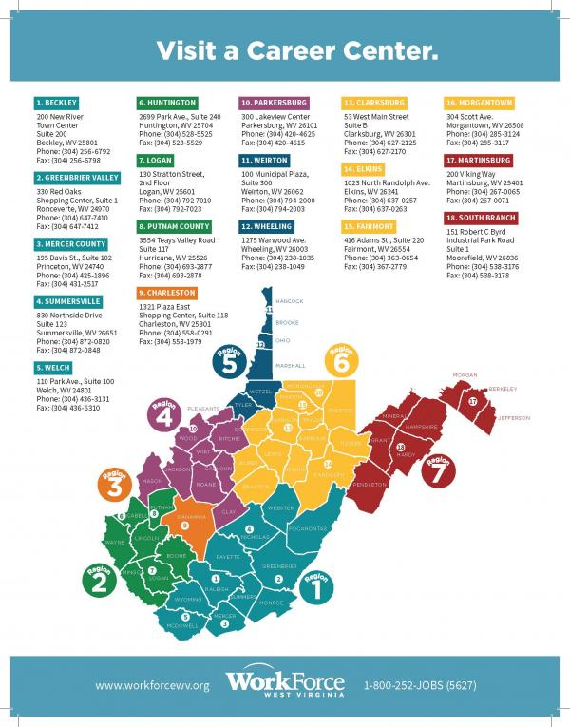
Region 1: The Region 1 Workforce Development Board, headquartered in Beckley, administers workforce activities in an eleven-county region covering the southeastern portion of the State.
Region 2: The Southwestern West Virginia Workforce Development Board, located in Huntington, governs a seven-county region in the southwestern portion of the State.
Region 3: The Workforce Development Board of Kanawha County oversees activities in the State’s only single-county workforce development region from its office in Charleston.
Region 4: Nine counties are served by the Workforce Development Board Mid-Ohio Valley, which is located in Parkersburg.
Region 5: The Northern Panhandle Workforce Development Board provides services in six counties and is based in Wheeling.
Region 6: The Region 6 Workforce Development Board, located in Fairmont, provides services in a thirteen-county region in the north-central portion of the State.
Region 7: Eight counties in the easternmost portion of West Virginia are served by the Region 7 Workforce Development Board located in Moorefield.

B. Describe the process used for designating local areas, including procedures for determining whether the local area met the criteria for “performed successfully” and “sustained fiscal integrity” in accordance with 106(b)(2) and (3) of WIOA. Describe the process used for identifying regions and planning regions under section 106(a) of WIOA. This must include a description of how the State consulted with the local boards and chief elected officials in identifying the regions
The state issued the following Guidance Notice regarding Designation/Re-Designation
WIOA Guidance Notice No. 01-15, Change 1 Designation/Re-Designation
TO: Workforce Development Boards
FROM: WorkForce WV West Virginia
CATEGORY: WorkForce Innovation and Opportunity Act
SUBJECT: Designation/Re-Designation of Workforce Development Areas and the Appeals Process
SOURCE: Federal/State
DISTRIBUTION: Managers, Workforce Development Programs Staff, Workforce Region Directors and Staff
EFFECTIVE DATE: July 1, 2015
CHANGE 1 EFFECTIVE DATE: May, 11, 2022
REFERENCE(S):
Title I of the Workforce Innovation and Opportunity Act (WIOA) of 2014, WIOA Section 106.
PURPOSE:
To provide guidance and process for the designation and re-designation of Workforce Development Areas in West Virginia along with the process for appealing designation decisions.
BACKGROUND:
The Workforce Innovation and Opportunity Act (WIOA) mandates that the West Virginia Workforce Development Board (SWDB) shall assist the Governor in designation of Workforce Areas, as required in section 106, and that an appeals process is in place.
The Governor of the State shall designate local workforce development areas within the State:
(i) Through consultation with the State board; and (ii) After consultation with chief elected officials and after consideration of comments received through the public comment process as described in section 102(b)(2)(E)(iii)(II).
WIOA further states that the considerations should include the following:
(i) The extent to which the areas are consistent with the labor market areas in the State; (ii) The extent to which the areas are consistent with regional economic development areas in the State; and (iii) The extent to which the areas have available the Federal and non-Federal resources necessary to effectively administer activities under subtitle B and other applicable provisions of this Act, including whether the areas have the appropriate education and training providers, such as institutions of higher education and area career and technical education schools.
WIOA states that a unit of general local government (including a combination of such units) or grant recipient that requests, but is not granted designation of an area as a local area, may submit an appeal to the State board under an appeal process established in the State plan.
DEFINITIONS:
PERFORMED SUCCESSFULLY-The term “performed successfully”, used with respect to a local area, means the local area met or exceeded the adjusted levels of performance for primary indicators of performance described in section 116(b)(2)(A) (or, if applicable, core indicators of performance described in section 136(b)(2)(A) of the Workforce Investment Act of 1998, or the Common Measures, as allowed by a USDOL approved waiver of the core indicators of performance, as in effect the day before the date of enactment of this Act) for each of the last 2 consecutive years for which data are available preceding the determination of performance under this paragraph.
SUSTAINED FISCAL INTEGRITY-The term “sustained fiscal integrity”, used with respect to a local, means that the Secretary, or the State in place of the Secretary, has not made a formal determination, during either of the last 2 consecutive years preceding the determination regarding such integrity, that either the grant recipient or the administrative entity of the area misexpended funds provided under subtitle B (or, if applicable, title I of the workforce investment Act of 1998 as in effect prior to the effective date of such subtitle B) due to willful disregard of the requirements of the provision involved, gross negligence, or failure to comply with accepted standards of administration.
BUSINESS LEADER-A business member of the Local Workforce Development Board or representative of other business organization, such as a chamber of commerce.
COMMUNITY LEADER-An officer or director of an association, community, or civic organization whose focus or activities are related to the services provided by the one— stop delivery system.
DESIGNATION AND RE-DESIGNATION POLICY:
WIOA requires that existing federally recognized workforce areas are designated during the first two programs years, which is referred to as Initial Designation, and again after the first two program years, which is referred to as Subsequent Designation. Units of general local government that desire to become a new local workforce area should follow the New Area designation requirements in section B.
INITIAL WIOA DESIGNATION FOR EXISTING REGIONS: Existing workforce regions operating in accordance with the Workforce Investment Act of 1998 may request initial designation as a Local Workforce Development Area if they have performed successfully.
WIOA DESIGNATION FOR NEW AREAS: Any unit of general local government may request designation as a Local Workforce Development Area under WIOA. New local area designations will only become effective on July 1 of the next program year. In order for designation to be approved for the start of the next program year, the following steps and timeline must be met.
- A statement of intent to request designation must be submitted to the West Virginia SWDB no later than February 15th through email. The SWDB will work with the requesting area to determine the deadline for the full request. Submitted materials will be made available for public comment as a part of the review process. The full request for designation as Local Workforce Development Area (“local area”) must include the following components and steps: Submit the request in writing to the Chairperson of the West Virginia Workforce Development Board through email to and . Receipt of the request must be documented by electronic return confirmation. If the requestor does not receive confirmation, it is their responsibility to contact WorkForce West Virginia to ensure that the notice has been received.
- This request must clearly state the circumstances for the request of designation.
- The request must also address and explain how the following criteria are met:
  - Consistency with natural labor market areas.
  - Consistency with regional economic development areas
  - Existence of education and training providers, such as institutions of higher education and career and technical education schools in the area.
  - Submission of a service delivery plan that includes a description of resources that would be available to the area to provide services.
  - Coordination of multiple resources within areas that are based on labor markets and natural travel patterns of local residents.
  - Local support of the implementation strategies to provide quality services to employers and individuals by county commissioners, municipal elected officials including mayors and/or city council members where appropriate, and business or community leaders within the area as demonstrated by letters of support or a vote of support by a city council or other applicable board.
  - Local ownership exhibited by strong involvement of local elected officials and community leaders on the Local Workforce Development Board.
  - Local capacity to manage funds, provide oversight of programs, and provide for the proper stewardship of public funds
  - Evidence that the area, in the two program years for which data is available prior to the request, met or exceeded the adjusted levels of performance for primary indicators of performance or the Common Measures and was not subject to the sanctions process resulting from missing the same measure two years in a row, if applicable.
  - Assurance that during the two program years prior to the request, the U.S. Secretary of Labor, or the State in place of the Secretary, has not made a formal determination that the
  - grant recipient or administrative entity for the local area has misexpended funds due to willful disregard, gross negligence, or failure to comply with accepted standards of administration, if applicable.
- The request must address how the proposed new area designation will impact those other workforce areas from which it is withdrawing. It should be understood by any unit of general local government or combination of such seeking designation, that the new area will only secure the formula allocated funds for each WIOA funding stream based on the formula factors as defined by WIOA. If the area in question becomes part of a consortium, the consortium will determine the distribution of WIOA funds with its region(s).
- If opposition to the request is voiced by municipalities or counties within the area seeking designation, then the requesting entity will address their request at a public hearing. The requesting entity will have the opportunity to respond to the concerns and questions at the hearing, and all comments will be recorded and used to inform the SWDB’s action on the request. If a hearing is necessary, it will be held within 45 days of receipt of the request. Time and place is to be determined by the SWDB Chair.
- The Chair will take the request and comments from the public as well as from a public hearing, if applicable and make a recommendation to the full SWDB.
- The SWDB will submit its recommendation to the Governors within five (5) business days of the State board vote.
- The final decision rests with the Governor and shall be made prior to May 29th, four weeks prior to the beginning of the fiscal and program year (July 1st).
APPEALS PROCESS POLICY:
An area or areas seeking to be designated or re—designated, as a Local Workforce Development Area, which has requested but has been denied its request for designation or re—designation as a Local Area, may appeal the decision to the West Virginia Workforce Development Board.
- An appeal must be in writing and filed with the West Virginia Workforce Development Board within fourteen (14) days after notification of the decision. Submit the appeal to the Chairperson of the West Virginia Workforce Development Board by sending an email to wioa@wv.gov.
- The appeal must contain a specific statement of the grounds upon which the appeal is sought.
- Pursuant to 20 CFR 679.290 (b) and 20 CFR 683.630 (a), the State Board will provide the parties with the opportunity for a hearing, review the appeal, and the State board will have 60 days to review the appeal and make a recommendation to the Governor. The review will take into account the information in the original request and supplemental information provided in the appeal to determine if the criteria set in this policy has been met.
- The final decision rests with the Governor.
- If the appeal is connected to a request for initial or subsequent designation under section V. A. or section V. B. of this policy, and if the appeal does not result in designation, the entity may request review by the Secretary of Labor to determine if procedural rights were granted or if the minimum criteria of WIOA Section 106(b)(2) or Section 106(b)(3) were met. This second level of appeal must be sent within 14 days to: Assistant Secretary of Employment and Training U.S. Department of Labor 200 Constitution Avenue, N.W. Washington, DC 20210. A copy of the appeal must be simultaneously provided to the: ETA Regional Administrators U.S. Department of Labor The Curtis Center, Suite 825 East 170 South Independence Mall West Philadelphia PA 19106-3315. In addition, a copy must be sent to WorkForce West Virginia at1900 Kanawha Boulevard East, Building 3, Suite 300, Charleston, WV 25305.
- If the final decision of any appeal reverses the prior decision, it will become effective July 1st of the following year.
Definition: Where the term “days” appears, it shall be defined as calendar days, not working days.
IMPLEMENTATION DATE: Immediately upon receipt.
INQUIRIES: Please direct all inquiries to: WorkForce West Virginia

C. Provide the appeals process referred to in section 106(b)(5) of WIOA relating to designation of local areas
**Addressed in preceding question; appeals process updated May 11, 2022.

D. Provide the appeals process referred to in section 121(h)(2)(E) of WIOA relating to determinations for infrastructure funding
Upon receipt of the specific terms of an SFM, any Local WDB or one-stop required partner may appeal for cause, within 21 calendar days, in writing (electronic or hardcopy), WFWV’s (with the Governor’s approval) determination regarding the portion of funds (or non-cash contributions) it is to provide. To be officially received, an appeal must fully contain and evidence the following:
- Addressed to the attention of the Deputy Executive Director of Federal Programs or his/her designee.
- An introduction identifying the appellant and designating the letter as a formal appeal.
- Full citations from WIOA or the WIOA Final Rules in Title 29 or Title 34 of the Code of Federal Regulations (CFR)that support the appeal.
- Identify the basis for the appeal. WIOA stipulates that a State Funding Mechanism (SFM) allocation determination may be appealed only if the determination is inconsistent with the requirements of WIOA sec. 121(h)(2)(E). The Final Rule at 20 CFR 678.750 further limits admissible grounds for an appeal to three possibilities. The petitioner must make a case that the State’s determination is inconsistent with:
- the proportionate-share requirements in 20 CFR 678.737, or
- the cost-contribution limitations in 20 CFR 678.730(c), or
- the cost-contribution caps in 20 CFR 678.738
- The letter must be signed (electronic signature is acceptable) and dated.
WFWV will have 10 days to acknowledge the appeal. WFWV then has 30 business days to convene and hear testimony from all parties involved. After hearing testimony, WFWV, under the designated authority and approval of the Governor, has an additional 30 business days to issue a formal resolution for the issue. Until the appeals process is completed, the appellant will remain liable for its contribution as originally determined in the SFM. If a one-stop partner’s appeal to WFWV using the process described in 20 CFR 678.750 is successful and results in a change to the one-stop partner’s infrastructure-cost contributions, then the Local Area’s MOU must be updated to reflect the final one-stop partner infrastructure cost contributions.
WIOA Policy No. 06-17 - Memorandum of Understanding/Infrastructure Guidance, Change 1 can be found at: https://workforcewv.org/public-information/guidance-notices-and-policies or directly at: https://workforcewv.org/images/files/PublicInfo/public-notices/Policy_No_6-17_MOU_and_Infrastructure_Guidance_Change_1.pdf. Appeals Process can be found on page 8.

2. Statewide Activities

A. Provide State policies or guidance for the statewide workforce development system and for use of State funds for workforce investment activities
State policies or guidance for the statewide WDS can be found at: https://workforcewv.org/public-information/guidance-notices-and-policies

B. Describe how the State intends to use Governor’s set aside funding. Describe how the State will utilize Rapid Response funds to respond to layoffs and plant closings and coordinate services to quickly aid companies and their affected workers. States also should describe any layoff aversion strategies they have implemented to address at risk companies and workers
The LWDBs have the option of requesting additional funding other than their formula distribution, to ensure that dislocated workers remain a priority for the WDS. This allows LWDBs to create partnerships with employers for On-the-Job Training Programs, Transitional Jobs, and ITAs. When the LWDB exhausts or becomes low on formula funds, or collaborates with businesses and partners to produce a comprehensive program, they may request additional funds. Awards are made based on the amount of funds requested and the proposal documentation submitted. West Virginia supports innovation by reviewing the results of current and recent projects to identify those that show positive results and could benefit from additional resources.
Programs awarded from the state set aside fund include the following examples:
- In Region 1, the Transitional Jobs program targets individuals in recovery, most of whom are in residential recovery homes. Transitional Jobs offer participants the opportunity to learn the routine of work, acquire work-task skills, establish an employment record, and generate references for future employment. Transitional Jobs provide the participants case management, wages, and comprehensive career and support services with the goal of transitioning to full-time employment.
- The Empowered Employment Pilot Program is designed to assist individuals in obtaining a time-limited work experience that is wage-paid, subsidized up to 100%, and is in the public, private, or not-profit sectors.
- The “RE-Building One’s Opportunities Together” (REBOOT) program, developed by Region 5, provides re-employment activities to those participants, who are, or have been, impacted by the Opioid Crisis. The program is designed to create employment and/or training opportunities that help target secure sustainable jobs and/or needed training as participants work to turn their lives around and become contributing members of their communities.
West Virginia uses WIOA funds to support a state Rapid Response unit, called the State Dislocated Worker Services (DWS) Unit. The unit conducts rapid response activities to dislocated workers through employer outreach which is coordinated as a joint rapid response team approach between the State Dislocated Worker Services Unit and the LWDB. The Trade Act unit is also part of the State Dislocated Worker Services section to provide information on the Trade Adjustment Assistance (TAA) program. When a rapid response meeting is conducted, research begins with the TAA state office and the Peer Support Labor Liaison office to determine if a company meets the eligibility criteria for TAA and a petition can be filed. If a petition is filed and certified prior to a rapid response meeting, a coordinated meeting is conducted emphasizing all the benefits and services provided through WFWV and partner agencies.
Each rapid response meeting includes representatives from the AJCWV explaining services and benefits to assist dislocated workers, including, but not limited to unemployment, job services, career planners for training eligibility purposes, DRS, DHHR, and LWDBs. For dislocations, all WFWV processes are discussed. After the meeting is conducted, the individual is registered in the MACC and a questionnaire is completed highlighting the individual’s employment/training objectives and goals. These questionnaires assist in serving the individual in a timely and more effective manner by following the career pathway of their choosing and involving partner agencies in achieving these objectives and goals.
Businesses who will be experiencing layoffs or closure come to WFWV through various communication methods: AJC staff, Worker Adjustment and Retraining Notices (WARNs), news outlets, employees, and unemployment reports showing noticeable claims, which are then investigated by the Rapid Response coordinator.
Additional services are organized at Rapid Response meetings such as special sessions with unemployment to answer more in-depth questions, resume writing, and interviewing skills workshops either on-site or at an AJC. Sometimes these workshops are incorporated into the Rapid Response meeting. WFWV’s integrated system provided employment, partner, and resource information to Constellium Rolled Products and Homer Laughlin China Company in 2020 and to Mylan Pharmaceuticals in 2021 for workers receiving rapid response informational packets. The dissemination of information included questionnaires to assist in identifying individual goals and objectives and to provide job search and training activities for dislocated workers. Ongoing communication with workers conducted by the rapid response team was conducted through emails, telephone calls, and follow up letters.
Rapid Response provides a comprehensive array of services to offer transitional assistance in the form of community resource lists and contact information and reemployment services available through the AJCWVs, such as job search and training opportunities as well as unemployment services to accelerate the reemployment process. Other Rapid Response activities include community resource fairs, job fairs, training provider fairs, etc. that may be conducted in conjunction with Rapid Response Informational Meetings or separately. While most of the effort is usually expended in the early stages of a dislocation event or an impending dislocation, it is important to continue Rapid Response services until all worker and employer needs are met.
The State coordinates layoff aversion strategies through the direct and immediate efforts of the Governor’s Office in connection with the West Virginia Development Office’s Business and Industrial Development representatives, who mobilize concentrated efforts to salvage at-risk companies or entities through incumbent worker training through the Governor’s Guaranteed Workforce Program, etc. When companies advise the State they are experiencing difficulties, there is timely sharing of all pertinent information of at-risk companies between the State Dislocated Worker Services Unit and the Business and Industry Development representatives so the layoff aversion strategies can be quickly implemented. In the event the strategies have not been shared at all local and State levels because of the sensitivity and confidentiality of some of the processes involved in averting a layoff, the State Dislocated Worker Services Unit communicates directly with the Secretary of the West Virginia Department of Commerce with a notification of a need for the provision of Rapid Response services. This occurs often for the majority of dislocations anywhere in the state and, usually, results in receiving clearance to proceed with Rapid Response services.

C. In addition, describe the State policies and procedures to provide Rapid Responses in cases of natural disasters including coordination with FEMA and other entities
WorkForce West Virginia has specific procedures in place to provide Rapid Response services in case of a Natural Disaster as stated in Part 687 of the WIOA Public Law. In such a case, the State immediately applies for a National Dislocated Worker Grant (NDWG) for a temporary work program for disaster clean-up activities which would be coordinated with FEMA and State Homeland Security and Office of Emergency Services. In addition to applying for a NDWG, dislocated workers experiencing displacement due to a natural disaster, such as flooding, would be covered under the State’s Rapid Response coordination of services and would be a call to address more than just a quick return to work. Therefore, a State Rapid Response Team in conjunction with local Rapid Response Team members and partners could be deployed to the disaster site to conduct Rapid Response Informational Meetings and related Rapid Response activities, if necessary.
Rapid Response would coordinate with FEMA, SBA, and other relief organizations to make sure the affected workers have a full array of resources to assist them in recovering from a natural disaster. If a natural disaster occurred followed by a FEMA disaster declaration, the availability of the temporary work program would also be highlighted at Rapid Response meetings. If the magnitude of the disaster resulted in mass layoffs/plant closures, and there was not enough WIOA formula funding or Governor’s Discretionary funding available at the state level, then the State would apply accordingly for a mass layoff NDWG. If the disaster led to a sizeable mass layoff NDWG being awarded to the State, the Governor’s Office would take the lead in implementing a state emergency plan mobilizing a host of state and federal resources, which include close coordination of the mass layoff NDWG with the efforts of FEMA and State Homeland Security and Office of Emergency Services, as well as other State agencies.
Partner Services as part of our response team may be comprised of Wagner-Peyser, DHHR, DRS, LWDBs, Healthcare navigators for those who have lost their insurance due to loss of job, SBA, a FEMA Partner, FEMA representative, Veteran Representative, and Union representatives to assist those represented by a union.

D. Describe how the State provides early intervention (e.g., Rapid Response) to worker groups on whose behalf a Trade Adjustment Assistance (TAA) petition has been filed. (Section 134(a)(2)(A).) This description must include how the State disseminates benefit information to provide trade-affected workers in the groups identified in the TAA petitions with an accurate understanding of the provision of TAA benefits and services in such a way that they are transparent to the trade-affected dislocated worker applying for them (Trade Act Sec. 221(a)(2)(A) and Sec. 225; Governor-Secretary Agreement). Describe how the State will use funds that have been reserved for Rapid Response to provide services for every worker group that files a TAA petition.
Rapid Response operates in the same manner regardless of whether a TAA petition is involved and provides timely information to dislocated workers with the goal of returning workers back to the labor market in sustainable employment.
West Virginia’s early intervention to worker groups, on whose behalf a TAA petition has been filed, is in conjunction with our WIOA Rapid Response activities. In most cases, by the time a TAA petition is filed, WIOA rapid response activities have already taken place and basic and individual services are being provided.
After a TAA petition has been filed by the State TAA Unit, additional information specific to TAA is explained, through a TAA/TRA Benefit Rights Informational Meeting (BRIM) to thoroughly explain the TAA program. Since the impacted workers have already received critical information at a previous Rapid Response meeting, the BRIM Meeting focuses specifically on TAA benefits and services and required deadlines.
West Virginia continues to strive for improvements and increased coordination between the TAA and WIOA programs by mandating co-enrollment, providing necessary services and data sharing to create a seamless and effective process for dislocated workers. All TAA paperwork and documentation is imaged into the MACC and WIOA /TAA staff have access to all WIOA/TAA services to eliminate the duplication of services and to strengthen the ability to share accessible data benefiting the dislocated workers.

b. Adult and Dislocated Workers Program Requirements

1. Work-Based Training Models
If the State is utilizing work-based training models (e.g. on-the-job training, incumbent worker training, transitional jobs, and customized training) as part of its training strategy and these strategies are not already discussed in other sections of the plan, describe the State’s strategies for how these models ensure high quality training for both the participant and the employer.
Transitional Jobs, On-the-Job Training, and Incumbent Workers
West Virginia will increase training opportunities to individuals via alternative training models such as Transitional Jobs, On-the-Job training (OJT), and Incumbent Worker Training (IWT). The LWDBs are encouraged to leverage current, and develop new, local partnerships with community businesses and industry to support economic development in their areas. AJCWVs will provide access to training services aligned with in-demand occupations, which may include occupational skills training, OJT, IWT programs that combine workforce training with related instruction, skill upgrading and retraining, entrepreneurial training, transitional jobs training, job readiness training provided in combination with other training, Adult Education and Literacy activities, and customized training (customized training is designed to provide local areas with flexibility to ensure that training meets the unique needs of the job seekers and employers or groups of employers). The underlying advantage of work-based learning is that by definition, it incorporates skill competencies needed by the business. There is no doubt participants are learning the specific skills needed, and furthermore they are learning to apply skills in the way the employer prefers. These arrangements practically guarantee that individuals who complete training are positioned to immediately add value in the workplace and have marketable skills to provide upward mobility in a career pathway.
Transitional Jobs
Transitional jobs are reserved for those chronically unemployed and provide real life work experience when it is greatly needed to be successful in the workplace. Transitional jobs is an employment strategy that seeks to overcome employment barriers and transition people with labor market barriers into work using wage-paid, short-term employment that combines real work, skill development and supportive services. Transitional Jobs program participants earn a paycheck, learn skills, may become eligible for the Earned Income Tax Credit, and receive intensive mentoring and support.
The Transitional Jobs program should have at a minimum the following three components:
- Paid work experience (i.e. three days per week)
- Classroom training (i.e. soft skills, occupational skills, etc.)
- Supportive services
Each LWDB must submit a Transitional Jobs Plan to WFWV for approval. Collaborative partnerships will be an essential piece of a transitional jobs plan and are highly encouraged. LWDBs may allocate up to 10 percent of local Adult and Dislocated Worker funds to transitional jobs for individuals with barriers to employment.
On-the-Job Training
OJT ensures high quality training for both the participant and the employer because both have a vested interest in the success of the program. The employer has the unique opportunity of training potential candidates in the correct and most efficient way to perform tasks for their company, at a subsidized cost. The participant has the opportunity to receive direct training and experience that increases their current skill set. Participants also gain new skills to meet the requirements of a new occupation or industry and are better equipped to compete for available jobs. All OJT experiences are provided through contracts between local employers and the LWDB. OJT is primarily designed to hire the participants and provide them with the knowledge and skills necessary for the full performance of the job. Both training providers and employers providing OJT opportunities must be providing the highest quality training to participants. OJT contracts must be continually monitored so that the WIOA funds allocated are providing participants the training to retain employment successfully. It is imperative that OJTs provide participants with the relevant skills and opportunities for career advancement and provides employers with a skilled workforce.
Incumbent Worker Training
WV also supports Incumbent Worker Training. To qualify as an incumbent worker, the worker needs to be employed, meet the Fair Labor Standards Act requirements for an employer-employee relationship, and have an established employment history with the employer for six months or more. The training must satisfy the requirements in WIOA Section 134(d)(4) and §680.790 and increase the competitiveness of the employee and/or employer. An incumbent worker does not necessarily have to meet the eligibility requirements for career and training services for adults and dislocated workers under WIOA. LWDBs may reserve and expend up to 20 percent of their combined adult and dislocated worker formula allotments for IWT. States may use state Rapid Response funds [WIOA Section 134(a)(3)(A)(i))] for layoff aversion and WIOA Governor’s discretionary funds for statewide incumbent worker training activities.
LWDBs must consider the following factors when determining the eligibility of employers to receive the WIOA share of funds to provide training to incumbent workers using either, local Adult and/or Dislocated Worker formula funds or WIOA statewide discretionary funds provided by the Governor:
- The characteristics of the incumbent workers to be trained, specifically the extent to which they historically represent individuals with barriers to employment as defined in WIOA Section 3(24), and how they would benefit from retention or advancement;
- The quality of the training (e.g., industry-recognized credentials, advancement opportunities);
- The number of participants the employer plans to train or retrain;
- The wage and benefit levels of participants (before and after training);
- The employer must not have laid off workers within 12 months and must have a commitment to retain or avert the layoffs of the incumbent worker(s) being trained;
- The employer must not be delinquent in unemployment insurance or workers’ compensation taxes, penalties, and/or interest.
- LWDBs must document these factors in approving an incumbent worker training project with an employer.
Employers participating in incumbent worker training are required to pay the non-WIOA (non-federal) share of the cost of providing training to their incumbent workers. Employers will be reimbursed the WIOA (federal) share. The employer share is based on the size of the workforce (wages paid to the participant while in training can be included as part of that share) as follows:
- At least 10 percent of the cost for employers with 50 or fewer employees.
- At least 25 percent of the cost for employers with 51 to 100 employees.
- At least 50 percent of the cost for employers with more than 100 employees.
Incumbent worker training is designed to either assist workers in obtaining the skills necessary to retain employment or to avert layoffs and must increase both a participant’s and a company’s competitiveness. The Incumbent Worker training policy allows local Boards the flexibility to provide Incumbent Worker Training to employers when needed. Local areas may use up to 20 percent of their local adult and dislocated worker funds for incumbent worker training. Incumbent worker training is targeted to improving the skills and competitiveness of the participant and increasing the competitiveness of the employer. The training should, wherever possible, allow the participant to gain industry-recognized training experience and ultimately should lead to an increase in wages. To receive incumbent worker funding under WIOA, an incumbent worker must have an employer-employee relationship, and an established employment history, with the employer. Incumbent workers are employed at the time of their participation, and the contract funds are paid to the employer for training provided to the incumbent worker either to avert a lay-off or otherwise retain employment. A “model” incumbent worker training would be one where a participant acquires new skills allowing him or her to move into a higher skilled and higher paid job within the company, thus permitting the company to hire a job seeker to backfill the incumbent worker’s pre-training position.
Work-based training can be an effective training strategy that can provide additional opportunities for participants and employers in both finding high quality work and in developing a highly skilled workforce. Each of these work-based models can be effectively used to meet a variety of job seeker and employer needs. To ensure high quality training for both the participant and the employer, priority consideration will be given to training programs that are related to an in-demand occupation, aligned with career pathways and industry sectors and result in a recognized postsecondary credential. LWDBs must not continue to contract with employers who fail to provide participants long term employment opportunities, with wages and benefits, and working conditions comparable to other employees who have worked a similar amount of time, doing the same type of work. LWDBs will monitor employer onsite contracts to ensure training, wages, hours, benefits, and working conditions are provided in accordance with the contract. Training participants’ performance and progress will be monitored during the training to determine supportive service needs, the appropriateness of the training activity and if placement in unsubsidized employment has occurred. WFWV will pursue the following strategies to ensure work-based training models are of high quality:
- Promote and develop sector strategies based on labor market information and employer needs.
- Connect employers to participate in business-education partnerships. These partnerships connect schools, employers, and community organizations with individuals to provide career-related experiences and employment opportunities such as soft skills development, internships, OJT, workplace shadowing, and career mentoring.
- Emphasize career pathways to assist individuals entering and moving within the labor force and to educate employers on the advantages of career pathways.
- Ensure career pathways are aligned to in-demand occupations likely to pay sustaining wages. The LWDBs will engage employers to accomplish this goal.
- Require OJT and IWT to be tied to a career pathway.
Policies governing Incumbent Worker Training are currently being updated. Once the revisions are complete, copies of these policies will be available on the WorkForce West Virginia website.
Current WIOA Policy 3-16 Transitional Jobs Policy and WIOA Policy 01-16 Incumbent Worker can be found at: https://workforcewv.org/public-information/guidance-notices-and-policies or directly at: https://workforcewv.org/images/files/PublicInfo/guidance-notices/WIOA_Policy_3-16_Transitional_Jobs_Policy.pdf and https://workforcewv.org/images/files/PublicInfo/guidance-notices/WIOA_Policy_No_01-16_Incumbent_Worker_Policy.pdf.
Along with the work-based trainings discussed so far, Registered Apprenticeships also prove to be a valuable strategy serving both individuals and employers. Examples follow of how the workforce development system intends to further integrate activities:
- Partners taking applications and conducting assessments as necessary
- Office of Apprenticeship (OA) representatives serve as members of State Board and ICT
- OA collaborating on State Plan development
- Workforce development system partnering and supporting apprenticeship initiatives through Title I funding
More information can be found in the following section.

2. Registered Apprenticeship
Describe how the State will incorporate Registered Apprenticeship into its strategy for service design and delivery (e.g., job center staff taking applications and conducting assessments).
The State will continue to incorporate Registered Apprenticeships into its strategies and services by requiring American Job Center (AJC) staff to seek out and assist Registered Apprenticeship Programs (RAPs) with recruitment into their individual training programs.
Recruitment will include posting and advertisement of Registered Apprenticeship statewide announcements, job orders, phone notifications of apprenticeship openings, veteran priority of service, pre-application testing, initial screening of eligibility requirements and referral. Referral not only includes referral to the job order but to our partners for orientation and eligibility determination for WIOA funding for training. Not only will AJC staff taking applications and conducting assessments support better service design and delivery for partners, employers, and individuals, alike, but also ensure all customers receive access to all services available across the workforce development system. Additional strategies and services will include making space available to the apprenticeship programs for onsite job fairs for recruitment, advertising space for apprenticeship marketing items, space for onsite interviews and assistance, as needed, with testing applicants at offsite locations.
Since the plan's initial submission, WV has continued to support RAPs in AJCs across the State, facilitated relationships across partners, to include LWDAs, as well as other State agencies, and revitalized the relationship between Office of Apprenticeship and workforce development system partners. RAPs active participation on State and Local Boards, and inclusion in Combined State Plan activities will be more evident in the coming months. There are several initiatives and stronger partnerships, being developed currently which will be reflected in the PY21 Annual Report Narrative.

3. Training Provider Eligibility Procedure
Provide the procedure, eligibility criteria, and information requirements for determining training provider initial and continued eligibility, including Registered Apprenticeship programs (WIOA Section 122).
WFWV’s Policy No. 01-15, Change 3* regarding its Eligible Training Provider List (ETPL) consists of training programs that are approved by WFWV and LWDBs to provide training services to eligible WIOA Title 1-B participants. All training providers must submit information and criteria as established under WIOA §122(d) through (g). Training providers use the MACC to provide all required information for initial eligibility, which includes Assurances, as well as the required applications for each program of study offered. MACC doubles as WFWV’s program certification system and the Statewide List of Eligible Training Providers, as required by WIOA §122 (a)(3). All approved programs are available to the public and to WIOA partners in the MACC. WFWV and the LWDBs share the responsibility of managing the ETPL, including approving programs for initial and continued eligibility, ensuring training provider compliance, and ensuring accuracy of information, removing training providers or programs, and monitoring of training providers. Upon receipt of completed application and program data, WFWV shall attempt to make an initial determination of statewide eligibility within 15 business days. Training providers will be contacted via email if the completed application and/or program data requires clarification. The Local Workforce Development Board (LWDB) will then have 10 business days to review and make comments to the state prior to the official determination of eligibility and placement on the ETPL. Subsequent eligibility determinations take place on a biennial basis, where performance data is again evaluated based on the standards. Once the training provider is approved, each training program is evaluated to determine if training programs meet ETPL requirements, including initial performance data standards, resulting in a federally or locally recognized credential and being related to an in-demand sector or occupation in West Virginia. The State ETPL Coordinator reviews required ETPL program information on the application including the following: a detailed description of the program, the total cost of the program, including the cost of tuition, books, and any fees, credential information, and labor market information for the related occupation, including the minimum entry level wage and demand for the occupation in the local area, and initial performance data.
LWDBs are encouraged to target training programs that support industry sectors and prepare participants for jobs in identified career pathways. Using Labor Market Information (LMI), LWDBs are able to determine higher paying jobs, in-demand industry sectors, and occupations in the local area enabling them to work with local employers to determine the minimum requirements for these jobs and the types of training and certification requirements for these positions. Using this information, LWDBs are better equipped to reach out to local training providers to encourage them to add their training program to the ETPL.
The State ETPL Coordinator will review the training provider’s program performance based on the performance accountability measures, using data on all WIOA Title I-B participants who participated in the training program during the performance period. Each program’s performance will be evaluated against state performance standards to determine if the program will remain on the list.
As policy stands now, training providers, who currently have programs listed on the ETPL and want to have their programs remain on the ETPL, must follow the procedures for continuing eligibility determination as follows: 1. Submit a completed Providers of Training Services Renewal Application for processing to WFWV via https://public.workforcewv.org/ForgotPassword.asp?. Application must include: a. updated provider information; b. updated information on each program pertaining to alignment of training with in-demand occupations; and c. updated program data. 2. Submit student data as referenced in WIOA sections 116 and 122 for calculation of State Performance Information by September 30th for the previous academic year defined as July 1 through June 30 (i.e. on September 30, 2016, data will be due for students who completed by June 30, 2015). This data will be included on the ETPL for the upcoming calendar year (CY). 3. Submit ETP performance on WIOA performance indicators (employment 2nd & 4th Quarter after exit, median earnings, credential attainment) as well as: a. Total number of participants enrolled in the program. b. Total number of participants completing the program. c. Total number of participants exiting the program. 4 d. Information regarding the completion rate of participants. 4. Description of how the provider will ensure access to training services throughout the State, including rural areas and through the use of technology. 5. Information reported to State agencies on Federal and State training programs other than programs within WIOA title 1B, including partner programs, (i.e. Adult basic education and literacy, Division of Vocational Rehabilitation, etc.) that are used to provide additional information about overall effectiveness, quality, and utilization of programs. 6. Address ETP's ability to offer industry-recognized certificates and credentials. 7. Information on recognized post-secondary credentials received by program participants. 8. Describe quality of the program of training services including a program that leads to a recognized postsecondary credential. 9. Description of ETP's ability to provide trainings that are physically and programmatically accessible for individuals who are employed and individuals with barriers to employment, including individuals with disabilities. 10.Timeliness and accuracy of ETP's performance reports. 11.Upon receipt of completed application and student data, WFWV will make a determination of continuing statewide eligibility based on completeness of submitted information. 12.The Local Workforce Development Board (LWDB) will then have 10 business days to review and make comments to the state prior to the official determination of continuing eligibility and placement on the ETPL. 13.The statewide ETPL will be published at: https://public.workforcewv.org/JobSeeker/TrainingCourseSearch.asp 14.Continued eligibility will be reviewed by the state biennially.
Change 3 states it is a substantial violation of the requirements to timely and accurately submit all of the information required for completion of the eligible training provider performance reports required under WIOA sec. 116(d)(4) if the provider knowingly supplies false performance information, misrepresents costs or services, or violates requirements of WIOA law or regulations. Providers who substantially violate the requirements of providing appropriate, accurate, and timely information for participants receiving training under WIOA title 1, subtitle B, will be removed from the ETPL. Such providers are liable to repay all adult, dislocated worker and youth funds received during the period of non-compliance. WFWV will take into account exceptional circumstances beyond the provider’s control, such as natural disasters, unexpected personnel transitions, and unexpected technology-related issues when determining appropriate action.
Training Providers who currently have programs listed on the ETPL and want to have their programs remain on the ETPL must submit student data as referenced in WIOA Sections 116 and 122 for calculation of State Performance Information for the previous academic year defined as July 1 through June 30. In lieu of answering questions/when data cannot be provided in full from the ETP for all students, training providers may upload information into MACC for exited students during the performance period. Information must include the following: Name, SSN and exit date (exit defined as completion, withdraw, dropout or transfer) - preferably in an excel format.
Regarding the role of registered apprenticeship programs, the Final Rule emphasizes the key role WIOA envisions for registered apprenticeship programs by highlighting these programs as a training service for both Individual Training Accounts (ITAs) and as On the Job Training (OJT). The Final Rule allows apprenticeship programs that are not registered to go through the eligible training provider (ETP) process if they want to be on the ETP list (ETPL); the rule does not provide apprenticeship programs that are not registered special access to the ETPL. The Department also clarifies in this Final Rule that registered apprenticeship programs are automatically eligible for the ETPL and the State is required to notify them of their automatic eligibility and allow the registered apprenticeship program an opportunity to consent to be on the State ETPL (see § 680.470). This mechanism must be minimal burden to registered apprenticeship programs and must comply with Federal guidance. The State periodically communicates this information via available contact information (mail and/or email) to RAP Sponsors and provides the State MIS (MACC) link for their enrollment. The following information is also requested to complete a partial, staff-assisted enrollment onto the ETPL: Registered Apprenticeship Number; Federal Tax ID Number; Provider Name; Mailing and/or Campus Street Address, City/State/Zip/County; Phone Number; Contact Person Name/Information; Course/Program Name; Brief Course Description. RAP Sponsors are encouraged to enroll themselves and their course into the MACC for full enrollment, but it is not required. RAP Sponsors are periodically informed they will remain on the ETPL as long as they remain registered or until we are notified they would like to be removed.
WIOA Policy 01-15 - ETPL Change 3 can be found at: https://workforcewv.org/public-information/guidance-notices-and-policies or directly at: https://workforcewv.org/images/files/PublicInfo/public-notices/WIOA_Policy_01-15_-_ETPL_Change_3.pdf.
*Change 4, reflecting the information above, as well as TEGL 08-19, will be added to the website link(s) listed above once Plan is finalized.

4. Describe how the State will implement and monitor the priority for public assistance recipients, other low-income individuals, and individuals who are basic skills deficient in accordance with the requirements of WIOA sec. 134(c)(3)(E), which applies to individualized career services and training services funded by the Adult Formula program
West Virginia established Policy 2-16 addressing priority of service*. Priority of service for individualized career services and training services funded with Title I Adult funds will be as follows:
- First Priority: Veterans and eligible spouses (covered persons) who are low-income or recipients of public assistance or who are basic skills deficient.
- Second Priority: Individuals (non-covered persons) who are low-income or recipients of public assistance or individuals who are basic skills deficient.
- Third Priority: Veterans and eligible spouses who are not low-income and are not recipients of public assistance or basic skills deficient.
- Fourth Priority: Individuals who do not meet the above priorities.
Each WDB Region has the flexibility, when creating their own policies, to include a process that also gives priority to other individuals, as long as priority for those individuals comes after the first four groups described above. An example of how priority of service is defined and applied to each participant-priority of service does not mean that only those individuals who meet the criteria listed above will be served. It means that if there are individuals who meet those criteria who are registered for service and deemed in need of career and training services, they will be enrolled before other individuals are considered. Intake and career planning services inform decision making on who will be enrolled, essentially using the rule that if individuals who meet the priority of service definition are available, they will receive consideration for training services (i.e. ITA) and work-based experience programs (i.e. OJT) over others.
Individuals eligible for priority of service shall be identified at the point of entry. Upon identification they shall be notified of their entitlement to priority of service; the full array of programs and services available to them; and any applicable eligibility requirements for those programs and services. LWDB staff must ensure individuals who qualify for priority of service receive individualized career and training services before other non-covered individuals and receive first priority on any waiting lists that are maintained for training slots. However, once a participant is enrolled in a workshop, training, or service, he or she may not be displaced by an individual qualified for priority of service.
Each WDB Region will document priority in the State MIS/participant file. State MIS provides career planners with the appropriate data fields to record eligibility (data fields include, but are not limited to: Veteran status, eligible spouse, low income, public assistance, basic skills deficient, case notes) and either upload appropriate documents into State MIS or place in the participant’s file. On-site monitoring will determine if each WDB Region is in compliance with Federal regulations, as well as all State and Local policies. WFWV staff will review the Participant Individual Record Layout and any other available federal report data elements and performance metrics to test for compliance with the priority of service rule, and ensure that priority of service is provided to veterans/eligible spouses, public assistance recipients, other low-income individuals, and individuals who are basic skills deficient.
Through cross-training, technical assistance, labor market information, monitoring review results, MACC edits, and promoting a 'generalist' mindset across the workforce development system, there has already been signs of progress, even before the Task Force's assessment and subsequent recommendations. Evidenced even by this very document-WV's State Plan changing from a Unified to Combined type of plan has set the stage for integrating service delivery to support priority populations.
WIOA Policy 2-16 Priority of Service Policy for Adult Title 1 Funding can be found at: https://workforcewv.org/public-information/guidance-notices-and-policies or directly at: https://workforcewv.org/images/files/PublicInfo/guidance-notices/WIOA_Policy_2-16_Priority_of_Service_Policy.pdf.
*WFWV implemented TEGL 07-20 into practice upon receipt. WIOA Policy 2-16 is currently being revised to reflect the TEGL's information. WFWV intends to complete this specific policy no later than October 1st, 2022 due to the restructuring of the WVWFDB and Partner Committees who are integral to policy development and issuance. WFWV expects to remove unintended barriers (either by further defining or removing unclear language), convey more streamlined processes, incorporate and promote diversity, equity, inclusion, and apprenticeships, all the while maintaining compliance with DOL's guidance. The reinforced partnerships within WV's workforce development system, and no wrong door approach, will provide more value added substance as we move forward not only updating this policy, but others as well.

5. Describe the State’s criteria regarding local area transfer of funds between the adult and dislocated worker programs
West Virginia recognizes that WIOA allows up to 100% of funds between programs with prior approval from the Governor. The state will ensure that any transfer of funds between WIOA programs complies with the WIOA law. LWDBs will also be required to record and document the use and application of local funds in accordance with instructions set forth in the grantee- subgrantee agreement. Workforce Innovation and Opportunityies Act Policy 01-17
To: Local Workforce Development Boards (LWDBs), Chief Elected Officials, Regional Executive Directors
From: WorkForce West Virginia
Subject: TRANSFER OF FUNDS BETWEEN ADULT AND DISLOCATED WORKER LOCAL FORMULA FUNDS
Effective Date: January 18, 2017
WV State Workforce Development Board
Review Date: January 18, 2017
I. PURPOSE
The purpose of this policy is to provide the guidance and parameters for transferring up to 100 percent of a program year allocation for adult employment and training activities, and up to 100 percent of a program allocation for dislocated worker employment and training services between the two programs.
II. EFFECTIVE DATE BY WIOA
July 1, 2015
III. BACKGROUND
Section 133 (b)(4) of the Workforce Innovation and Opportunity Act (WIOA) allows the Local Workforce Development Board (LWDB) to transfer, if such a transfer is approved by the state, up to and including 100 percent of a program year allocation between the local adult and local dislocated worker programs. This transfer provides flexibility to the local workforce development area to provide services in the areas of greatest need.
IV. REQUIREMENTS
Funds should not be transferred from the dislocated worker program to the adult program without regard to demands for dislocated worker services. The state may question and, if sufficient justification is not provided by the area, may deny any application for rapid response funds to address a need if a transfer has occurred from the dislocated worker program to the adult program. A LWDB cannot transfer youth funds under WIOA.
Request for Transfer
For transfers of funds the LWDB must make a request to the state for approval of such transfer for a specific appropriation of adult or dislocated worker funding (i.e., program year or fiscal year of appropriation). The request must specify the type of funding (whether adult or dislocated worker) to be transferred to the other program.
There are short-term and long-term effects on program operations that could result from transfers of funds. The LWDB and the fiscal agent should examine the following considerations when deciding to transfer:
- Are there adequate funds to maintain services to currently enrolled participants?
- What is prompting the request?
- How will you respond to unforeseen events?
All requests for transfer must include a written justification addressing each of the above-mentioned considerations and the reasons such transfer is necessary to provide adult or dislocated worker employment and training activities.
Requests are to be scanned to WorkForce West Virginia (WFWV) with "Fund Transfer Request" in the subject line. WFWV will respond to all requests. This transfer pertains only to a program (adult or dislocated worker) and program year or fiscal year of appropriation and will continue to apply for the life of the funds. The request must be signed by the Chief Elected Official, LWDB Chair and Local Executive Director. The State Deputy Executive Director of Field Operations and Deputy Executive Director of Fiscal Management will review, with the Executive Director of WFWV for approval.
Transfer of Funds
A LWDB should instruct the fiscal agent of the amount to transfer, up to 100 percent of local workforce development area formula allocations, based upon the state's approval, if the percentage being transferred required approval.
Funds will retain the year of appropriation identity (e.g., program year allocation) and must be reported and accounted for accordingly.
To transfer funds, the LWDB will use the transfer-related expenditure codes of the program from which funds are being transferred, in the state's financial system to report costs incurred by the program receiving funding.
The transfer limit of up to 100 percent, with approval from the state, shall apply to new allocations of adult and dislocated worker funding issued in the fiscal year beginning on or after July 1, 2015. This higher transfer limit does not apply to funds received in a prior fiscal year that may be carried into the new fiscal year. The level of transfer authority that existed at the time the funding was awarded shall continue to apply to those funds for their period of availability at the local level.
V. MONITORING
At the local level, the LWDB and/or the fiscal agent must conduct oversight of the transfer of WIOA adult and dislocated worker funds to ensure the transfer is being completed per this policy.
Through the state’s monitoring system, fiscal monitors will review the area’s transfer of adult and dislocated worker funds during the annual onsite monitoring review for compliance with federal and state laws and regulations. Any issues will be handled through the state’s monitoring resolution process.
VI. TECHNICAL ASSISTANCE
For additional information, you may send your questions to WorkForce WV, WIOA Unit.
VII. REFERENCES
Workforce Innovation and Opportunity Act, § 133(b)(4), Public Law 113-128. NPRM § 683.130 found at 80 Fed. Reg. 20877 (April 16, 2015) (to be codified at 20 C.F.R. § 683.130). O.A.C. 5101:9-31-02, Workforce Investment Act (WIA) formulary allocation methodology. (July 24, 2014).

c. With respect to youth workforce investment activities authorized in section 129 of WIOA—
With respect to youth workforce investment activities authorized in section 129 of WIOA—

1. Identify the State-developed criteria to be used by local boards in awarding grants or contracts for youth workforce investment activities and describe how the local boards will take into consideration the ability of the providers to meet performance accountability measures based on primary indicators of performance for the youth program as described in section 116(b)(2)(A)(ii) of WIOA in awarding such grants or contracts.[11]
[11] Sec. 102(b)(2)(D)(i)(V)
The LWDBs follow the State’s procurement policies when awarding grants for workforce development system (WDS) activities. The following clause is included in a Workforce Grant Agreement:
Sub-granting:
The Grantee shall not enter into a sub-grant agreement for any of the work performed under this grant agreement without obtaining the prior written approval of Workforce West Virginia (WFWV). If sub-grant agreements are approved, they shall contain, at a minimum, sections of this grant agreement pertaining to indemnity, conflicts of interest, lobbying, nondiscrimination, audit requirements, public notice and any other state and/or federal requirements. Sub- grantee program performance accountability measures are assessed by program staff.
Examples of how local boards will take into consideration the ability of the providers to meet performance accountability are listed below-
- Utilize a RFP Request for Proposal (RFP) process for youth services. When the rating committee reviews the RFP, performance is one of the key factors in scoring.
- RFPs specifically address USDOL required performance measures as a requirement for any proposals that are submitted and/or accepted.
- Reference checks are completed on all proposals received, including USDOL performance in other contracts operated by the proposing organization
- During the course of the year, if a performance measure is not met, the contractor will be part of any corrective action plans developed.
- Setting real time outcome goals for proposers to meet. Meeting the real time outcome goals would be financially tied to contract renewal for the option year(s). Real time outcome goals could be:
  - Providers will be required to hold two recruitment events targeting Out-of-School youth (OSY) during the program year.
  - Providers should enroll a minimum of 80% of their youth (80% Out-of-School and 80% In- School) in a work experience activity during the program year.
  - Providers will be in contact with every active youth during the program year at a minimum of 2 times a month, with one contact being in person. The other contact may be by phone or social media. The contacts will be documented in the youth files and in the MACC as case notes for verification at scheduled file review visits by LWDB staff.
- The criteria for an award(s) of funding is based on: past performance, cost effectiveness, demonstrated overall program effectiveness, youth group(s) targeted for services, placement and retention efforts in offered education or employment programs, ability of the subcontractor(s) to meet and/or exceed performance goals and ability to meet administrative and fiscal grant responsibilities, to name a few.
- Subcontractor(s) are made aware of performance measures for the region and the importance of meeting/exceeding them via a contractual agreement. Specific language about meeting and/or exceeding performance measures is included in contractual agreements signed with subcontractor(s). Performance-based contracts are used for all subcontractor(s). Identified performance measures serve as benchmarks in the contractual agreement and are used for measuring progress.
- Subcontractor(s) are monitored no less than five (5) times per program year to review and evaluate the delivery of program curriculum, program performance, etc. and address any issues that arise. A corrective action plan, along with technical assistance, is provided to the subcontractor(s) should program performance not be met.
- Programs for in-school and out-of-school youth will focus on measurable skill gains.

2. Describe the strategies the State will use to achieve improved outcomes for out-of-school youth as described in 129(a)(1)(B), including how it will leverage and align the core programs, any Combined State Plan partner programs included in this Plan, required and optional one-stop partner programs, and any other resources available.
West Virginia will adhere to WIOA regulations regarding youth;
- Identify models and effective practices for youth, including recruitment and flexible enrollment, to help local area staff successfully meet the needs of those individuals.
- Partner with the U.S. Departments of Labor and Education and with LWDBs ensuring statistical models and negotiated performance levels are established and calibrated to accurately reflect the profiles of youth being served within the State and in each local area. Continue serving youth as a priority within the WDS;
- Develop transitional jobs, social enterprises, and other work experience strategies to help out-of-school youth (OSY) with limited work histories to develop the skills needed for workplace success.
- Co-enroll high-risk individuals, ages 18 to 24, as both WIOA Adult and WIOA Youth participants to leverage funds and provide necessary services. Co-enrollment can occur in Title II adult basic education services, EARN, TANF, or other partner programs. Continue the use of Individual Training Accounts (ITAs) for 18 to 24-year olds in combination with work-based learning opportunities.
- The State will expand opportunities for youth to acquire post-secondary skills and credentials needed for high wage jobs through increased access to career and technical education programs and work-based learning experiences. The Department of Education (WVDE) and the Community Technical College System (CTCS) will work cooperatively to explore and develop appropriate connections between WIOA Youth activities and Strengthening Career and Technical Education Act for the 21st Century (Perkins V) and state-funded programming.
- The WVDE will support the transformation and modernization of career and technical education (CTE) and align CTE with the career pathways recognized by the State.
- LWDBs will collaborate with YouthBuild, JobCorps, and AmeriCorps sites, identifying partnerships in local plans. Collaborate with LWDBs to identify access points which enable individuals to complete training and enter a successful career pathway.
- The West Virginia Division of Rehabilitation Services (DRS) has made concerted efforts, in conjunction with the State’s Client Assistance Program (Disability Rights of West Virginia), to provide outreach and services to non-traditional settings for youth with disabilities, such as juvenile centers and facilities, Youth Reporting Centers, and other similar locations. The youth in these settings are afforded the same opportunity to receive Vocational Rehabilitation (VR) services, as well as information (e.g., career information and labor market information, as found on the Pathways to the Future website) and referrals, as youth in traditional settings, as appropriate. Community leaders in Charleston have also utilized DRS resources, such as materials from the Pathways website to impact the lives of “disconnected youth.”
- Utilize the Office of Apprenticeship to promote apprenticeship and pre-apprenticeship opportunities for youth.

3. Describe how the state will ensure that all 14 program elements described in WIOA section 129(c)(2) are made available and effectively implemented, including quality pre-apprenticeship programs under the work experience program element. [12]
[12] Sec. 102(b)(2)(D)(i)(I)
The State will contract with each of the LWDBs to ensure that each of the 14 program elements are administered in their local area.
State monitors will utilize the MACC to determine the availability and provision of the 14 program elements prior to the annual on-site reviews. Supporting evidence will be obtained to ensure that each LWDB has complied with the requirements of WIOA section 129 (c) (2).
Each LWDB will be notified of any deficiency and a corrective action plan will be required. The 14 program elements, listed below, will be added to the statement of work that is included in the grant agreement LWDBs are required to sign.
PROGRAM ELEMENTS - In order to support the attainment of a secondary school diploma or its recognized equivalent, entry into postsecondary education, and career readiness for participants, programs shall provide elements consisting of:
- Tutoring, study skills training, instruction, and evidence-based dropout prevention and recovery strategies that lead to completion of the requirements for a secondary school diploma or its recognized equivalent (including a recognized certificate of attendance or similar document for individuals with disabilities) or for a recognized postsecondary credential;
- Alternative secondary school services, or dropout recovery services, as appropriate;
- Paid and unpaid work experiences that have as a component academic and occupational education, which may include:
- summer employment opportunities and other employment opportunities available throughout the school year;
- pre-apprenticeship programs;
- internships and job shadowing; and
- on-the-job training opportunities
4. Occupational skill training, which shall include priority consideration for training programs that lead to recognized postsecondary credentials that are aligned with in-demand industry sectors or occupations in the local area involved, if the local board determines that the programs meet the quality criteria described in section 123;
5. Education offered concurrently with and in the same context as workforce preparation activities and training for a specific occupation or occupational cluster;
6. Leadership development opportunities, which may include community service and peer- centered activities encouraging responsibility and other positive social and civic behaviors, as appropriate;
7. Supportive services;
8. Adult mentoring for the period of participation and a subsequent period, for a total of not less than 12 months;
9. Follow-up services for not less than 12 months after the completion of participation, as appropriate;
10. Comprehensive guidance and counseling, which may include drug and alcohol abuse counseling and referral, as appropriate;
11. Financial literacy education;
12. Entrepreneurial skills training;
13. Services that provide labor market and employment information about in-demand industry sectors or occupations available in the local area, such as career awareness, career counseling, and career exploration services; and
14. Activities that help youth prepare for and transition to postsecondary education and training.

4. Provide the language contained in the State policy for “requiring additional assistance to enter or complete an educational program, or to secure and hold employment” criterion for out-of-school youth specified in WIOA section 129(a)(1)(B)(iii)(VIII) and for “requiring additional assistance to complete an education program, or to secure and hold employment” criterion for in-school youth specified in WIOA section 129(a)(1)(C)(iv)(VII). If the state does not have a policy, describe how the state will ensure that local areas will have a policy for these criteria.
An individual must meet the following criteria in order to be identified as a youth who needs additional assistance:
- Must be between the ages of 14 and 24, and
- Require additional assistance to complete an educational program or secure and hold employment, and
- Meet one or more of the following conditions:
a. Youth at risk of dropping out of school. Students at risk for dropping out display certain easily identifiable characteristics, some of which are demographic and some of which are related to their performance in school.
Factors associated with dropping out of high school:
- Comes from a low-income family and has a lack of credits earned
- Poor attendance
- Members of a racial or ethnic minority group
- Poor grades (especially in core courses)
- Older than the average student in their grade
- Pregnant/Parenting
- Substance Abuse
- Youth offender
b. Immigrant Youth.
c. Youth with limited English proficiency.
d. Youth deficient in basic skills. Basic skills deficient means the individual computes or solves problems, reads, writes, or speaks English at or below the eighth grade level or is unable to compute or solve problems, read, write, or speak English at a level necessary to function on the job, in the individual’s family, or in society. In addition, states, and grantees have the option of establishing their own definition, which must include the above language. In cases where states or grantees establish such a definition, that definition will be used for basic skills determination.
e. Youth who reside in areas with high rates of poverty, crime and/or unemployment.
f. Youth who have serious barriers to employment, including but not necessarily limited to, stated current or past substance abuse, truancy, absence of positive adult role models, and diagnosed emotional disorders.
By expanding the definition of “youth who need additional assistance” the Local Workforce Development Boards (LWDBs) will be able to serve at-risk youth in a more equitable manner. The following is a list of acceptable source documents required to support an eligibility staff person/case manager identifying a youth as needing additional assistance (clearly identifying which condition the youth met):
- Individual Service Strategy (ISS).
- Case Note.
- WIOA intake of registration form.
- State MIS.
- Self-Attestation
Services for Youth (Rehabilitation Specific)
Youth to be served fall into two separate groups: in-school and out-of-school. Both groups are served by different partner agencies, though any individual served by the WDS might be served by all partners, perhaps simultaneously, if eligibility requirements are met. Out-of-school youth are primarily served by WFWV and Adult Education, while in-school youth are primarily served by the State’s education system and DRS, for those eligible students with disabilities. Adult Education is prohibited from providing direct services to in-school youth.
In-School Youth
Primary responsibility for services to in-school youth falls, in a general sense, to West Virginia’s education system. The primary workforce development needs of all in-school youth is a quality, high school-level education, provided by the teachers in the public and private school systems. Because of this need’s precedence, the role of WFWV regarding in-school youth is diminished. Among the WIOA core partners, DRS plays the largest role in the development of in-school youth, albeit only for students with disabilities. Students seeking employment who do not qualify for vocational rehabilitation (e.g., not disabled, does not meet order of selection requirements) are referred from DRS to WFWV as needed. WFWV distributes funding to each of the LWDBs, which are allowed to spend up to 25 percent of their youth funds on WDS activities for in-school youth.
DRS has a long-standing partnership with West Virginia’s education system, at both the State and local level. As such, DRS has cooperative agreements with the State Education Agency and each of the 55 Local Education Agencies (County-level Boards of Education) in West Virginia. These cooperative agreements between DRS and the Education Agencies, assure that each student with a disability in the state who needs special education, vocational education, and/or vocational rehabilitation services is identified and that the appropriate services are made available to the individual.
Since the enactment of WIOA, DRS has focused on providing services, particularly Pre-Employment Transition Services (Pre-ETS), to students with disabilities starting in the 9th grade. DRS is now required to reserve at least 15 percent of its budget for the provision of Pre-ETS to students with disabilities. The expected benefits from this include increased counselor presence in schools, increased Individualized Educational Program meeting attendance, increased provision of Pre-Employment Transition Services (Pre-ETS), and an increase in outreach and awareness of VR services to students with disabilities. Counselors will also stay in contact with educators to discuss and attempt to resolve educational difficulties as they arise.
Pre-employment transition services are mandated under WIOA and include the following:
- Job exploration counseling
- Work-based learning experiences, which may include in-school or after school opportunities or experience outside the traditional school setting (including internships), that is provided in an integrated environment to the maximum extent possible
- Counseling on opportunities for enrollment in comprehensive transition or postsecondary educational programs at an institution of higher education
- Workplace readiness training to develop social skills and independent living
- Instruction in self-advocacy, which may include peer mentoring
In addition to Pre-ETS, DRS debuted the Positive Outcomes within Education and Rehabilitation (POWER) program in 2015, which is a job shadowing program that offers transitioning students, who may be having a difficult time choosing a career path, the opportunity to experience an occupation by spending time with a professional working in the students’ vocational goal/career field of interest, including STEM. The POWER program allows the student the opportunity to experience an occupation prior to committing to training. It guides the student to take a serious, realistic look at the occupation, allowing the student to make a more informed choice.
Another DRS activity is STEP. This program utilizes school personnel to facilitate a more seamless transition from high school to post-secondary activities (employment or training) for students with disabilities. By allowing the student to continue working with an individual who has provided them with classroom instruction and/or transition services while in high school, they are working with people who are most familiar with their interests, skills, and barriers to employment. In addition, STEP will also include the use of science and math teachers to provide appropriate students with further career exploration opportunities in STEM fields. These teachers may also provide college preparation activities, such as ACT test preparation, and work-based experiences.
By engaging students with disabilities earlier and providing them with activities such as Pre-ETS, POWER, and STEP, DRS expects recipient students will have a better understanding of the labor market and the value of obtaining a postsecondary credential. Students with disabilities that are eligible for VR services may, in accordance with their IPE, receive assistance from DRS in obtaining postsecondary training.
DRS counselors are also invited to participate in Individualized Education Plan (IEP) meetings. During these meetings the counselor describes DRS policies, and procedures as appropriate, and determines the student’s eligibility and order of selection category utilizing information generated from the school, the student, and West Virginia Division of Rehabilitation Services. Prior to or shortly after the student’s IEP transition meeting occurs, Individualized Plan for Employment (IPE) development begins so both the student and counselor have an idea of what rehabilitation services will be necessary to meet the student’s vocational goal.
Out-of-School Youth
All core partners are able to serve out-of-school youth who qualify for services. Adult Education works exclusively with out-of-school populations, many of whom are ages 24 and under. The core partners work, in tandem, on many workforce development activities. The partners all have memorandums of understanding (MOU) at the state and regional levels and also collaborate on specific projects at local levels.
The State understands the importance of having a recognized postsecondary degree from the perspectives of both employers and job seekers. Through a combination of partner collaborations, the WDS strives for quality, career-based employment outcomes for its consumers.
For youth with disabilities who do not graduate from high school, DRS works closely with Adult Education, referring individuals as needed, to ensure that these individuals have an adequate opportunity to obtain a completed high school level education. DRS provides assistance, as needed, to Vocational Rehabilitation consumers in Adult Education programs to ensure that individuals have the means to progress through and complete these programs if doing so requires the circumnavigation of functional limitations based on the consumers’ disabilities.
West Virginia’s adult basic education programs address the needs of adult learners as they strengthen local communities and businesses. Adults who lack the skills and knowledge to fully participate in, contribute to, and benefit from West Virginia’s postsecondary education system and economy are eligible to access adult education services in a variety of settings across the state. Core services are offered at all locations to adult learners who meet the federal eligibility requirements for enrollment. These learners:
- Have attained 16 years of age;
- Are not enrolled or required to be enrolled in secondary school under state law;
- Lack sufficient mastery of basic educational skills to function effectively in society; do not have a secondary school diploma or its recognized equivalent, or have not achieved an equivalent level of education; and/or
- Are unable to speak, read, or write the English language.
Beginning in July 2015 under WIOA, adult education and literacy activities were expanded to include adult education, literacy, workplace adult education and literacy activities, family literacy activities, English language acquisition activities, integrated English literacy and civics education, workforce preparation activities, and integrated education and training.
Comprehensive interventions are designed to address skill and knowledge deficits across the levels defined in Title II of the Workforce Investment Act of 1998 and Title II of the Workforce Innovation and Opportunity Act of 2014. Building on policies and initiatives created through this comprehensive system of advising, coordination, and support, providers leverage success using innovative processes. These processes unify and inform the delivery of Adult Basic Education (ABE) courses, English as a Second Language (ESL) instruction, and high school credential programs. Following are examples of research-based innovative practices that support the implementation and scaling of college and career pathways that accelerate student completion and foster economic growth.
- FastTrack Programs-Increasing Transitions from Levels 1, 2 and 3
Funded providers will use key elements of research-based programs, e.g. contextualization, team teaching, and enhanced student services to increase the speed at which students master basic and ESL skills at federal levels 1, 2, and 3.
These condensed courses feature managed intake and managed enrollment and are typically a six to twelve week accelerated program. FastTrack options include, but are not limited to:
Basic Skills FastTrack:
- Programs focused on either English/Language Arts, Mathematics and Numeracy, Science or Writing in Response to Text Career Cluster FastTrack:
- Programs focused on career immersion and career clusters
- Partnerships with Career and Technical Centers
- Partnership efforts between community colleges and community-based organizations and LWDBs
- Workplace projects that partner providers, employers and LWDBs ESL FastTrack:
- Flipped classroom models for ESL
FastTrack students acquire the skills needed to transition to basic skills education classes at federal levels 4-6 and/or Professional/Technical or Academic pathways.
2. Professional/Technical Transitions-Moving Students from Levels 4, 5, and 6 to Postsecondary Success in Professional/Technical Programs
Students who function primarily at federal levels 4-6 can be served in Professional/Technical Transition programs that result in recognized certificates leading to progression along a defined educational and career pathway. It is our hope to make these programs available at every West Virginia community and technical college, and to encourage partnerships with local community based organizations and as part of the education services at state correctional facilities.
- Programs focused on career immersion and career clusters
- Partnerships with Career and Technical Centers
- Partnership efforts between community colleges and community-based organizations and local WDBs
- Workplace projects that partner providers, employers and LWDBs
- Flipped classroom models for ESL
- Developmental and Academic Transition Programs-Moving Students from Levels 4, 5, and 6 to Postsecondary Success in Academic Programs
3. Developmental and Academic Transition programs will employ the same strategies as professional technical transition programs. They will apply these strategies to credit-bearing classes along 2-year degree pathways and ensure accelerated student progress through higher levels of adult education and precollege education and transition into 2-year degree programs.
Expanding Options for High School Credentials, Certificates and Diplomas
In light of changes to options for acquiring high school credentials made by the federal government and the growing importance of these certificates and high school diplomas, West Virginia has expanded the options available to adults. Our goal is to ensure that adult learners acquire the necessary credentials by gaining the knowledge and skills demanded in the workforce and required for postsecondary success. Toward that end, West Virginia will continue to award state certificates linked to the recognized high school equivalency state exam (HSED).
Welfare Reform Initiative
Adult Education has a successful history of collaboration with the State’s human services agency. Through a cooperative relationship built on trust and commitment to serving economically disadvantaged West Virginians, the two State agencies work together to respond to the mandates of welfare reform.
SPOKES
In 2003, an academic and job preparation skills program entitled SPOKES was created by Adult Education under a contract between the WVDE Office of Adult Education and Workforce Development and DHHR, and in collaboration with some LWDBs.
The SPOKES program model was also designed to provide intense daily activities that would address academic and soft skills necessary for adults to pursue gainful employment.
Although the program is designed for participants functioning at or above the 4th grade level (FFL 3 and above), there is some flexibility about including participants who score at lower levels. This 4 to 10 week program allows WV WORKS participants to be referred to the program and receive services at the start of each work week. Referrals can be made for the start-up of any week.
The SPOKES program consists of:
- Assessment
- A six-week repeating cycle of modules related to the following components:
  - Employability Skills
  - Job Readiness
  - Work Process Skills
  - Technology Skills-which may include Internet and Computing Core Certification (IC3) ® work
  - Workplace Academic Skills
- Vocational Training starting Week 5 that may include the following:
  - Customer Service Part 1
  - Customer Service Part 2
  - Microsoft® Office Specialist (MOS)
  - Internet and Computing Core Certification (IC3)
  - Work-based Academic Skills (if applicable in region)
- An additional 2-4 week job readiness component, which includes intense job search. SPOKES participants prepare to take the WorkKeys assessment. A variety of certificates may be earned by participants who complete the program. Participants officially referred to and enrolled in SPOKES classes must have an identified need for instruction and/or enhancement in one or more of the module areas that prevents them from getting employment or advancing in a job. Individualized, computer-aided, small/whole group, and work-based/site instructional techniques are utilized within the program delivery of services.
In addition to having a certified full-time Adult Education SPOKES instructor, and in some cases a part time Adult Education SPOKES instructor, the SPOKES program may have access to a career development consultant (CDC) and share a blended classroom with an Adult Education instructor.
Programs are encouraged to pilot and implement additional evidence and research-based strategies for college and career pathways that meet the goals of this plan.
Pursuant to WIOA, WFWV is required to allocate 75 percent of its local area youth funds to OSY. These funds are used to carry out programs that provide the following elements:
- Tutoring, study skills training, instruction, and evidence-based dropout prevention and recovery strategies that lead to completion of the requirements for a secondary school diploma or its recognized equivalent;
- Alternative secondary school services, or dropout recovery services, as appropriate;
- Paid and unpaid work experiences, including summer employment opportunities and other employment opportunities available throughout the school year; pre-apprenticeship programs; internships and job shadowing; and OJT opportunities;
- Occupational skill training;
- Education offered concurrently with and in the same context as workforce preparation activities and training for a specific occupation or occupational cluster;
- Leadership development opportunities;
- Supportive services;
- Adult mentoring;
- Follow-up services for not less than 12 months after the completion of participation, as appropriate;
- Comprehensive guidance and counseling;
- Financial literacy education;
- Entrepreneurial skills training;
- Services that provide labor market and employment information about in-demand industry sectors or occupations available in the local area; and
- Activities that help youth prepare for and transition to postsecondary education and training.

5. Include the State definition, as defined in law, for not attending school and attending school as specified in WIOA Section 129(a)(1)(B)(i) and Section 129(a)(1)(C)(i). If State law does not define “not attending school” or “attending school,” indicate that is the case and provide the state policy for determining whether a youth is attending or not attending school.
For the purpose of determining whether an individual is an ISY or OSY, school status is based on a determination of school attendance on the date of eligibility determination. Once the school status of a youth is determined, that school status remains the same throughout the youth’s current participation.
- A youth is “not attending” school if the youth:
- has had at least 10 consecutive days of unexcused absences and on the date of eligibility determination has not returned to school;
- is not attending postsecondary school on the date of eligibility determination;
- has not registered for postsecondary school classes on the date of the eligibility determination; or
- is enrolled only in non-credit-bearing postsecondary classes.
Additionally, participation in the following programs is not considered being “in school” for the purpose of determining ISY/OSY status:
- Adult education programs provided under Title II of WIOA
- YouthBuild programs
- Job Corps programs
- High School Equivalency programs (not funded by the public K–12 system)
- Dropout reengagement programs (not funded by the public K–12 system)
Note: School attendance and school status determine which eligibility definition (ISY or OSY) may apply.
A youth is “attending school” if the youth:
- is enrolled in any of the following schools:
- Public school
- Charter school
- Private school
- Alternative education program;
- is homeschooled;
- is attending high school equivalency programs, including those considered to be dropout reengagement programs, funded by the public K–12 system;
- is a high school graduate who has registered for postsecondary classes, even if not yet attending postsecondary classes;
- is attending postsecondary classes; or
- is in between postsecondary school semesters and has registered for classes for a future semester or has paid all or part of the tuition for a future semester.
Note: A youth with fewer than 10 consecutive unexcused absences, or with 10 or more non-consecutive unexcused absences is still considered “attending school.”

6. If using the basic skills deficient definition contained in WIOA Section 3(5)(B), include the State definition which must further define how to determine if an individual is unable to compute or solve problems, or read, write, or speak English, at a level necessary to function on the job, in the individual’s family, or in society. If not using the portion of the definition contained in WIOA Section 3(5)(B), indicate that is the case.
Basic Skills Deficient- An individual unable to compute or solve problems, read, write, or speak English, at a level necessary to function on the job, in the individual’s family, or in society. For WIOA purposes, the State further defines Basic Skills Deficient as an individual who:
- Lacks a high school diploma or high school equivalency and is not enrolled in secondary education.
- Enrolled in a Title II Adult Education/Literacy program.
- Reading and/or Math assessment at an 8.9 or below grade level.
- Determined to be Limited English Skills proficient through staff-documented observations.
- Other objective criteria, determined to be appropriate by the local area and documented in its required policy.

d. Single-area State Requirements
In States where there is only one local workforce investment area, the governor serves as both the State and local chief elected official. In such cases, the State must submit any information required in the local plan (WIOA section 106(d)(2)). States with a single workforce area must include—

1. Any comments from the public comment period that represent disagreement with the Plan. (WIOA section 108(d)(3).)

2. The entity responsible for the disbursal of grant funds, as determined by the governor, if different from that for the State. (WIOA section 108(b)(15).)

3. A description of the type and availability of WIOA title I Youth activities and successful models, including for youth with disabilities. (WIOA section 108(b)(9).)
Not Applicable.

4. A description of the roles and resource contributions of the one-stop partners.
Not Applicable.

5. The competitive process used to award the subgrants and contracts for title I activities.
Not Applicable.

6. How training services outlined in section 134 will be provided through individual training accounts and/or through contracts, and how such training approaches will be coordinated. Describe how the State will meet informed customer choice requirements regardless of training approach.
Not Applicable.

7. How the State Board, in fulfilling Local Board functions, will coordinate title I activities with those activities under title II. Describe how the State Board will carry out the review of local applications submitted under title II consistent with WIOA secs. 107(d)(11)(A) and (B)(i) and WIOA sec. 232.
Not Applicable.

8. Copies of executed cooperative agreements which define how all local service providers will carry out the requirements for integration of and access to the entire set of services available in the one-stop delivery system, including cooperative agreements with entities administering Rehabilitation Act programs and services.
Not Applicable.

e. Waiver Requests (optional)
States wanting to request waivers as part of their title I-B Operational Plan must include a waiver plan that includes the following information for each waiver requested:

1. Identifies the statutory or regulatory requirements for which a waiver is requested and the goals that the State or local area, as appropriate, intends to achieve as a result of the waiver and how those goals relate to the Unified or Combined State Plan;

2. Describes the actions that the State or local area, as appropriate, has undertaken to remove State or local statutory or regulatory barriers;

3. Describes the goals of the waiver and the expected programmatic outcomes if the request is granted;

4. Describes how the waiver will align with the Department’s policy priorities, such as:

A. Supporting employer engagement;

B. Connecting education and training strategies;

C. Supporting work-based learning;

D. Improving job and career results, and

E. Other guidance issued by the department.

5. Describes the individuals affected by the waiver, including how the waiver will impact services for disadvantaged populations or individuals with multiple barriers to employment; and

6. Describes the processes used to:

A. Monitor the progress in implementing the waiver;

B. Provide notice to any local board affected by the waiver;

C. Provide any local board affected by the waiver an opportunity to comment on the request;

D. Ensure meaningful public comment, including comment by business and organized labor, on the waiver.

E. Collect and report information about waiver outcomes in the State’s WIOA Annual Report.

7. The Secretary may require that States provide the most recent data available about the outcomes of the existing waiver in cases where the State seeks renewal of a previously approved waiver.

Title I-B Assurances
The State Plan must include assurances that:
The State Plan must include | Include
1. The State has implemented a policy to ensure Adult program funds provide a priority in the delivery of training services and individualized career services to individuals who are low income, public assistance recipients and basic skills deficient; | Yes
2. The State has implemented a policy to ensure local areas have a process in place for referring veterans with significant barriers to employment to career services provided by the JVSG program’s Disabled Veterans’ Outreach Program (DVOP) specialist; | Yes
3. The State established a written policy and procedure that set forth criteria to be used by chief elected officials for the appointment of local workforce investment board members; | Yes
4. The State established written policy and procedures to ensure local workforce investment boards are certified by the governor every two years in accordance with WIOA section 107(c)(2); | Yes
5. Where an alternative entity takes the place of a State Board, the State has written policy and procedures to ensure the alternative entity meets the definition under WIOA section 101(e) and the legal requirements for membership; | Yes
6. The State established a written policy and procedure for how the individuals and entities represented on the State Workforce Development Board help to determine the methods and factors of distribution, and how the State consults with chief elected officials in local areas throughout the State in determining the distributions; | Yes
7. The State will not use funds received under WIOA Title I to assist, promote, or deter union organizing in accordance with WIOA section 181(b)(7); | Yes
8. The State distributes adult and youth funds received under WIOA equitably throughout the State, and no local area suffers significant shifts in funding from year-to-year during the period covered by this plan; | Yes
9. If a State Workforce Development Board, department, or agency administers State laws for vocational rehabilitation of persons with disabilities, that board, department, or agency cooperates with the agency that administers Wagner-Peyser services, Adult and Dislocated Worker programs and Youth Programs under Title I; | Yes
10. The State agrees to report on the impact and outcomes of its approved waivers in its WIOA Annual Report. | Yes
11. The State has taken appropriate action to secure compliance with the Uniform Guidance at 2 CFR 200 and 2 CFR 2900, including that the State will annually monitor local areas to ensure compliance and otherwise take appropriate action to secure compliance with the Uniform Guidance under section WIOA 184(a)(3); | Yes

Adult Program Performance Indicators
Performance Goals for the Core Programs
Each state submitting a Unified or Combined State Plan is required to identify expected levels of performance for each of the primary indicators of performance for the first two years covered by the plan. The state is required to reach agreement with the Secretary of Labor, in conjunction with the Secretary of Education, on state-negotiated levels of performance for the indicators for each of the first two years of the plan.
For Program Year (PY) 2016-2019 plans, the Departments used the transition authority under section 503(a) of WIOA to designate certain primary indicators of performance as “baseline” indicators to ensure an orderly transition from the requirements of the Workforce Investment Act of 1998 to those under WIOA. A “baseline” indicator was one for which states did not propose an expected level of performance and did not come to agreement with the Departments on negotiated levels of performance because sufficient data was not available to establish such performance levels. As a result, “baseline” indicators were not used in the end of the year adjustment of performance levels and were not used to determine failure to meet adjusted levels of performance for purposes of sanctions. The Departments designated indicators as “baseline” based on the likelihood of a State having insufficient data with which to make a reasonable determination of an expected level of performance.
For PYs 2020-2023 Plans, Title I programs (Adult, Dislocated Worker, and Youth) and the Title II program (Adult Education and Family Literacy Act) will have two full years of data available to make reasonable determinations of expected levels of performance for the following indicators for PY 2020 and PY 2021:
- Employment (Second Quarter after Exit);
- Employment (Fourth Quarter after Exit);
- Median Earnings (Second Quarter after Exit);
- Credential Attainment Rate; and
- Measurable Skill Gains
The Wagner-Peyser Act Employment Service program, authorized under the Wagner-Peyser Act, as amended by title III of WIOA, will have two full years of data available to make a reasonable determination of expected levels of performance for the following indicators for PY 2020 and PY 2021:
- Employment (Second Quarter after Exit);
- Employment (Fourth Quarter after Exit); and
- Median Earnings (Second Quarter after Exit)
The Credential Attainment Rate and Measurable Skill Gains indicators do not apply to the Wagner-Peyser Act Employment Service program; therefore, this program will not submit expected levels of performance for these indicators.
For the first two years of PYs 2020-2023 Plans, the Vocational Rehabilitation (VR) program, authorized under title I of the Rehabilitation Act of 1973, as amended by title IV of WIOA, will have two full years of data available for the Measurable Skill Gains indicator only. Therefore, the Departments will designate the following indicators as “baseline” for the VR program for PY 2020 and PY 2021:
- Employment (Second Quarter after Exit);
- Employment (Fourth Quarter after Exit);
- Median Earnings (Second Quarter after Exit); and
- Credential Attainment Rate
VR agencies must continue to collect and report on all indicators, including those that have been designated as “baseline, pursuant to section 116(d) of WIOA.” The actual performance data reported by these programs for indicators designated as “baseline” for PY 2020 and PY 2021 will serve as baseline data in future years. The Departments will require VR agencies to submit expected levels of performance for these indicators for PY 2022 and PY 2023.
The Departments determined that the Effectiveness in Serving Employers indicator will be measured as a shared outcome across all six core programs within each state to ensure a holistic approach to serving employers. The Departments will continue piloting approaches for measuring this indicator for the first two years of PY 2020-2023 plans. Therefore, states are not required to submit an expected level of performance for the Effectiveness in Serving Employers indicator for PY 2020 and PY 2021. However, core programs are expected to collect data and report on this indicator for PY 2020 and PY 2021 as they did for PYs 2016-2019 plans.
Each core program must submit an expected level of performance for all of the other indicators, as applicable, with the exception of the four indicators designated as “baseline” for the VR program in PY 2020 and PY 2021. The Departments will work with states during the negotiation process to establish negotiated levels of performance for each of the primary indicators for the core programs not listed as “baseline.” Each state must update its plan to include the agreed-upon negotiated levels of performance before the Departments approve a state’s plan.
States may identify additional indicators in the plan, including additional approaches to measuring Effectiveness in Serving Employers, and may establish levels of performance for each of the state indicators. Please identify any such state indicators under Additional Indicators of Performance.
Performance Indicators | PY 2022 Expected Level | PY 2022 Negotiated Level | PY 2023 Expected Level | PY 2023 Negotiated Level
Employment (Second Quarter After Exit) | 72.0% | 72.0% | 72.0% | 72.5%
Employment (Fourth Quarter After Exit) | 70.0% | 70.0% | 70.0% | 70.5%
Median Earnings (Second Quarter After Exit) | $6,200 | $6,300.00 | $6,200 | $6,400.00
Credential Attainment Rate | 81.0% | 81.0% | 81.0% | 81.5%
Measurable Skill Gains | 38.0% | 45.0% | 38.0% | 45.5%
Effectiveness in Serving Employers | Not Applicable ¹ | Not Applicable ¹ | Not Applicable ¹ | Not Applicable ¹
¹
The Departments have not issued the final rule defining Effectiveness in Serving Employers. As a result, states will not submit expected levels of performance for this indicator and the Departments will not establish negotiated levels of performance for PYs 2022 and 2023.

Dislocated Program Performance Indicators
Performance Goals for the Core Programs
Each state submitting a Unified or Combined State Plan is required to identify expected levels of performance for each of the primary indicators of performance for the first two years covered by the plan. The state is required to reach agreement with the Secretary of Labor, in conjunction with the Secretary of Education, on state-negotiated levels of performance for the indicators for each of the first two years of the plan.
For Program Year (PY) 2016-2019 plans, the Departments used the transition authority under section 503(a) of WIOA to designate certain primary indicators of performance as “baseline” indicators to ensure an orderly transition from the requirements of the Workforce Investment Act of 1998 to those under WIOA. A “baseline” indicator was one for which states did not propose an expected level of performance and did not come to agreement with the Departments on negotiated levels of performance because sufficient data was not available to establish such performance levels. As a result, “baseline” indicators were not used in the end of the year adjustment of performance levels and were not used to determine failure to meet adjusted levels of performance for purposes of sanctions. The Departments designated indicators as “baseline” based on the likelihood of a State having insufficient data with which to make a reasonable determination of an expected level of performance.
For PYs 2020-2023 Plans, Title I programs (Adult, Dislocated Worker, and Youth) and the Title II program (Adult Education and Family Literacy Act) will have two full years of data available to make reasonable determinations of expected levels of performance for the following indicators for PY 2020 and PY 2021:
- Employment (Second Quarter after Exit);
- Employment (Fourth Quarter after Exit);
- Median Earnings (Second Quarter after Exit);
- Credential Attainment Rate; and
- Measurable Skill Gains
The Wagner-Peyser Act Employment Service program, authorized under the Wagner-Peyser Act, as amended by title III of WIOA, will have two full years of data available to make a reasonable determination of expected levels of performance for the following indicators for PY 2020 and PY 2021:
- Employment (Second Quarter after Exit);
- Employment (Fourth Quarter after Exit); and
- Median Earnings (Second Quarter after Exit)
The Credential Attainment Rate and Measurable Skill Gains indicators do not apply to the Wagner-Peyser Act Employment Service program; therefore, this program will not submit expected levels of performance for these indicators.
For the first two years of PYs 2020-2023 Plans, the Vocational Rehabilitation (VR) program, authorized under title I of the Rehabilitation Act of 1973, as amended by title IV of WIOA, will have two full years of data available for the Measurable Skill Gains indicator only. Therefore, the Departments will designate the following indicators as “baseline” for the VR program for PY 2020 and PY 2021:
- Employment (Second Quarter after Exit);
- Employment (Fourth Quarter after Exit);
- Median Earnings (Second Quarter after Exit); and
- Credential Attainment Rate
VR agencies must continue to collect and report on all indicators, including those that have been designated as “baseline, pursuant to section 116(d) of WIOA.” The actual performance data reported by these programs for indicators designated as “baseline” for PY 2020 and PY 2021 will serve as baseline data in future years. The Departments will require VR agencies to submit expected levels of performance for these indicators for PY 2022 and PY 2023.
The Departments determined that the Effectiveness in Serving Employers indicator will be measured as a shared outcome across all six core programs within each state to ensure a holistic approach to serving employers. The Departments will continue piloting approaches for measuring this indicator for the first two years of PY 2020-2023 plans. Therefore, states are not required to submit an expected level of performance for the Effectiveness in Serving Employers indicator for PY 2020 and PY 2021. However, core programs are expected to collect data and report on this indicator for PY 2020 and PY 2021 as they did for PYs 2016-2019 plans.
Each core program must submit an expected level of performance for all of the other indicators, as applicable, with the exception of the four indicators designated as “baseline” for the VR program in PY 2020 and PY 2021. The Departments will work with states during the negotiation process to establish negotiated levels of performance for each of the primary indicators for the core programs not listed as “baseline.” Each state must update its plan to include the agreed-upon negotiated levels of performance before the Departments approve a state’s plan.
States may identify additional indicators in the plan, including additional approaches to measuring Effectiveness in Serving Employers, and may establish levels of performance for each of the state indicators. Please identify any such state indicators under Additional Indicators of Performance.
Performance Indicators | PY 2022 Expected Level | PY 2022 Negotiated Level | PY 2023 Expected Level | PY 2023 Negotiated Level
Employment (Second Quarter After Exit) | 77.0% | 77.0% | 77.0% | 77.5%
Employment (Fourth Quarter After Exit) | 79.0% | 79.0% | 79.0% | 79.5%
Median Earnings (Second Quarter After Exit) | $9,500 | $9,500.00 | $9,500 | $9,600.00
Credential Attainment Rate | 84.0% | 84.0% | 84.0% | 84.5%
Measurable Skill Gains | 43.0% | 43.0% | 43.0% | 43.5%
Effectiveness in Serving Employers | Not Applicable ¹ | Not Applicable ¹ | Not Applicable ¹ | Not Applicable ¹
¹
The Departments have not issued the final rule defining Effectiveness in Serving Employers. As a result, states will not submit expected levels of performance for this indicator and the Departments will not establish negotiated levels of performance for PYs 2022 and 2023.

Youth Program Performance Indicators
Performance Goals for the Core Programs
Each state submitting a Unified or Combined State Plan is required to identify expected levels of performance for each of the primary indicators of performance for the first two years covered by the plan. The state is required to reach agreement with the Secretary of Labor, in conjunction with the Secretary of Education, on state-negotiated levels of performance for the indicators for each of the first two years of the plan.
For Program Year (PY) 2016-2019 plans, the Departments used the transition authority under section 503(a) of WIOA to designate certain primary indicators of performance as “baseline” indicators to ensure an orderly transition from the requirements of the Workforce Investment Act of 1998 to those under WIOA. A “baseline” indicator was one for which states did not propose an expected level of performance and did not come to agreement with the Departments on negotiated levels of performance because sufficient data was not available to establish such performance levels. As a result, “baseline” indicators were not used in the end of the year adjustment of performance levels and were not used to determine failure to meet adjusted levels of performance for purposes of sanctions. The Departments designated indicators as “baseline” based on the likelihood of a State having insufficient data with which to make a reasonable determination of an expected level of performance.
For PYs 2020-2023 Plans, Title I programs (Adult, Dislocated Worker, and Youth) and the Title II program (Adult Education and Family Literacy Act) will have two full years of data available to make reasonable determinations of expected levels of performance for the following indicators for PY 2020 and PY 2021:
- Employment (Second Quarter after Exit);
- Employment (Fourth Quarter after Exit);
- Median Earnings (Second Quarter after Exit);
- Credential Attainment Rate; and
- Measurable Skill Gains
The Wagner-Peyser Act Employment Service program, authorized under the Wagner-Peyser Act, as amended by title III of WIOA, will have two full years of data available to make a reasonable determination of expected levels of performance for the following indicators for PY 2020 and PY 2021:
- Employment (Second Quarter after Exit);
- Employment (Fourth Quarter after Exit); and
- Median Earnings (Second Quarter after Exit)
The Credential Attainment Rate and Measurable Skill Gains indicators do not apply to the Wagner-Peyser Act Employment Service program; therefore, this program will not submit expected levels of performance for these indicators.
For the first two years of PYs 2020-2023 Plans, the Vocational Rehabilitation (VR) program, authorized under title I of the Rehabilitation Act of 1973, as amended by title IV of WIOA, will have two full years of data available for the Measurable Skill Gains indicator only. Therefore, the Departments will designate the following indicators as “baseline” for the VR program for PY 2020 and PY 2021:
- Employment (Second Quarter after Exit);
- Employment (Fourth Quarter after Exit);
- Median Earnings (Second Quarter after Exit); and
- Credential Attainment Rate
VR agencies must continue to collect and report on all indicators, including those that have been designated as “baseline, pursuant to section 116(d) of WIOA.” The actual performance data reported by these programs for indicators designated as “baseline” for PY 2020 and PY 2021 will serve as baseline data in future years. The Departments will require VR agencies to submit expected levels of performance for these indicators for PY 2022 and PY 2023.
The Departments determined that the Effectiveness in Serving Employers indicator will be measured as a shared outcome across all six core programs within each state to ensure a holistic approach to serving employers. The Departments will continue piloting approaches for measuring this indicator for the first two years of PY 2020-2023 plans. Therefore, states are not required to submit an expected level of performance for the Effectiveness in Serving Employers indicator for PY 2020 and PY 2021. However, core programs are expected to collect data and report on this indicator for PY 2020 and PY 2021 as they did for PYs 2016-2019 plans.
Each core program must submit an expected level of performance for all of the other indicators, as applicable, with the exception of the four indicators designated as “baseline” for the VR program in PY 2020 and PY 2021. The Departments will work with states during the negotiation process to establish negotiated levels of performance for each of the primary indicators for the core programs not listed as “baseline.” Each state must update its plan to include the agreed-upon negotiated levels of performance before the Departments approve a state’s plan.
States may identify additional indicators in the plan, including additional approaches to measuring Effectiveness in Serving Employers, and may establish levels of performance for each of the state indicators. Please identify any such state indicators under Additional Indicators of Performance.
Performance Indicators | PY 2022 Expected Level | PY 2022 Negotiated Level | PY 2023 Expected Level | PY 2023 Negotiated Level
Employment (Second Quarter After Exit) | 60.0% | 64.5% | 60.0% | 65.0%
Employment (Fourth Quarter After Exit) | 61.0% | 61.0% | 61.0% | 61.5%
Median Earnings (Second Quarter After Exit) | $3,400 | $3,400.00 | $3,400 | $3,500.00
Credential Attainment Rate | 61.0% | 61.0% | 61.0% | 61.5%
Measurable Skill Gains | 36.0% | 43.5% | 36.0% | 44.0%
Effectiveness in Serving Employers | Not Applicable ¹ | Not Applicable ¹ | Not Applicable ¹ | Not Applicable ¹
¹
The Departments have not issued the final rule defining Effectiveness in Serving Employers. As a result, states will not submit expected levels of performance for this indicator and the Departments will not establish negotiated levels of performance for PYs 2022 and 2023.

Program-Specific Requirements for Wagner-Peyser Program (Employment Services)
All Program-Specific Requirements provided for the WIOA core programs in this section must be addressed for either a Unified or Combined State Plan.

a. Employment Service Staff

1. Describe how the State will staff the provision of labor exchange services under the Wagner-Peyser Act, such as through State employees, including but not limited to state merit staff employees, staff of a subrecipient, or some combination thereof.
West Virginia will continue to use state merit staff employees for all programs.

2. Describe how the State will utilize professional development activities for Employment Service staff to ensure staff is able to provide high quality services to both jobseekers and employers
WDS will work with the WVWFDB to establish a structure to upgrade WDS staff skills so jobseekers and employers are provided a high quality service. WFWV developed an online assessment focused on Employment and Sector Partnering to establish a certificate system that must be completed by all Employment Service (ES) staff. The use and development of this tool will strengthen staff knowledge of Employment Services and partner services which would allow for a well trained staff to assist the customer in obtaining the proper services needed for employment. This development would also give staff insight into industry and business in their local area and surrounding local regions.
WFWV will continue to use established professional development activities in order to meet goals, develop staff skills, and ensure a competent Employment Service staff. In addition, we will enhance training curricula that incorporates policies, processes, and input from Wagner-Peyser, Unemployment Insurance (UI), and/or core partner agency staff. Experts in the fields of UI, WIOA, Employment Service and core partner staff will recommend related topics. WFWV will continue to train employees on the pertinent skills needed in the AJC through peer and management direction.

3. Describe strategies developed to support training and awareness across core programs and the Unemployment Insurance (UI) program and the training provided for Employment Services and WIOA staff on identification of UI eligibility issues and referral to UI staff for adjudication
As training needs are identified, WFWV will develop curriculum and conduct instructional sessions. Self-paced UI process training tutorials are available via the intranet. These tutorials will be enhanced to incorporate the identification of eligibility issues and appropriate referral for UI adjudication. Training will also be available locally across partner agencies to ensure system cross-training objectives are met. Core partners will be utilizing the same management information system and trained to identify then record UI adjudication issues for further review by UI staff.

b. Explain how the State will provide information and meaningful assistance to individuals requesting assistance in filing a claim for unemployment compensation through one-stop centers, as required by WIOA as a career service
WFWV’s UI and ES staff are fully cross trained to assist individuals access a full range of services. The State maintains a UI presence in each AJC to ensure that customers meet the eligibility requirements during the initial application process and to offer support throughout the entire claim cycle. Eligibility information and claimant rights and responsibilities is also available on the website in a mobile friendly environment.
Claimants are provided an opportunity to gather information and apply timely for benefits in remote itinerant sites staffed by well trained staff.

c. Describe the State’s strategy for providing reemployment assistance to UI claimants and other unemployed individuals
West Virginia claimants are profiled at the time the initial claim is filed to determine the level of assistance and support necessary to return to work. New and additional claims are taken online, and the information is reviewed for UI eligibility. Courtesy calls are attempted for each new claim filed where center services are reviewed, labor market information is examined, and labor exchange (ES) services are required. Every claimant is advised of the requirement to be able, available, and actively seeking full time work for each week UI is claimed and must attest to the number of job contacts made during the week claimed. They are advised they must apply and accept suitable work, based on their work experience, training and claim duration. UI eligibility requirements and the consequences for failing to meet them are reviewed during benefit rights section and are available for further review online or through handout materials by visiting a local office or itinerant site.
In addition, those selected to participate in UI Reemployment Services and Eligibility Assessment (RESEA) will receive all of the mandatory program components to include the creation of an Individualized Education Plan and additional services such as job search workshops, job search assistance or referrals to other partner programs. The RESEA workshop is designed to motivate and encourage those likely to exhaust benefits by exploring previous work experience, accomplishments and unique skill sets and how to effectively use while job searching. During the workshop individuals identify strengths and skill sets, set short and long term goals, begin developing a job search plan, and effectively network both in person and using social media.

d. Describe how the State will use W-P funds to support UI claimants, and the communication between W-P and UI, as appropriate including the following:

1. Coordination of and provision of labor exchange services for UI claimants as required by the Wagner-Peyser Act;
WFWV’s UI and ES staff are fully cross trained to assist individuals access a full range of services. Concentrated, individualized and group services including reemployment assessment, continuing eligibility and job placement are provided to claimants identified as either most or least likely to exhaust benefits. Regionalized claimant-centered labor market information is available through handouts or via https://workforcewv.org/.

2. Registration of UI claimants with the State’s employment service if required by State law;
WFWV applies an early-intervention approach to delivering services to unemployment compensation recipients. Claimants are dual enrolled from day one for Wagner-Peyser reemployment services and provided an orientation to all available One-Stop services. Information is provided to claimants who file online where detailed information is conveyed about available partner services and WIOA training eligibility and available opportunities. Common data is uploaded daily from the UI mainframe to the ES registration system.

3. Administration of the work test for the State unemployment compensation system, including making eligibility assessments (for referral to UI adjudication, if needed), and providing job finding and placement services for UI claimants; and
The State administers the unemployment insurance work test as required. Claimants who fail to participate or report to suitable opportunities are held ineligible until issues are resolved. The UI management information system identifies potential eligibility issues by the claimant’s responses to weekly certification questions and by assessing the data entered by staff during eligibility assessments. Any job referral made is reconciled either by claimant or the employer or both. The management information system (MACC) generates a follow—up form to the employer every 15 days after the last referral. When returned, the results are populated to the UI system and a stop placed on payments of claimants who failed to report.

4. Provision of referrals to and application assistance for training and education programs and resources.
WFWV ES/UI staff will coach and direct claimants to educational opportunities if training is advisable to the desired employment outcome. Income test information will be provided to assist the customer apply for available financial aid. Cost and performance data, when available, will be available for review so customers will be able to make informed decisions on schooling. Joint partner staff training sessions will provide information and resource tools for staff to guide their referrals.

e. Agricultural Outreach Plan (AOP). Each State agency must develop an AOP every four years as part of the Unified or Combined State Plan required under sections 102 or 103 of WIOA. The AOP must include an assessment of need. An assessment need describes the unique needs of farmworkers in the area based on past and projected agricultural and farmworker activity in the State. Such needs may include but are not limited to: employment, training, and housing.

1. Assessment of Need. Provide an assessment of the unique needs of farmworkers in the area based on past and projected agricultural and farmworker activity in the State. Such needs may include but are not limited to: employment, training, and housing.
Farmworker Unique Needs
These items listed below are based upon comments from employers, association members, community agencies/partners, and outreach workers
Generally, those farmworkers traveling into the state for work may have limited money and may need information from community resources, such as those listed below:
- language assistance/translation services and ESL classes;
- career assessment /counseling for family members;
- legal assistance in applying for available or new citizenship or visa programs;
- transportation and/or driver’s education/training to obtain a valid driver’s license;
- housing and shelters for the homeless;
- assistance obtaining personal loans to purchase housing and land to meet family needs;
- assistance from local food pantries;
- additional work clothing and/or clothing for family members;
- education and training to operate new advanced farming equipment;
- job training/job shadowing which is connected to educational credit;
- computer classes;
- health assessments;
- dental services;
- information/referrals for self-care-mental health, control of medical issues such as diabetes, high blood pressure, drug and alcohol counseling and heat related illnesses;
- families may need-education assistance such as tutors
- housing that is appropriate to meet the privacy needs of women and children;
- assistance understanding their farmworker rights;
- assistance recognizing contract violations and filing complaints.

2. An assessment of the agricultural activity in the State means: 1) Identifying the top five labor-intensive crops, the months of heavy activity, and the geographic area of prime activity; 2) Summarize the agricultural employers’ needs in the State (i.e. are they predominantly hiring local or foreign workers, are they expressing that there is a scarcity in the agricultural workforce); and 3) Identifying any economic, natural, or other factors that are affecting agriculture in the State or any projected factors that will affect agriculture in the State
1. The current identified top five labor-intensive crops, the months of heaviest activity, and geographic locations are:
- Hay and hay products: May through September- Jackson, Greenbrier, Preston, Hampshire and Mason counties
- Grain, dry beans and peas: April through October- Mason, Jefferson, Hardy, Preston, Pendleton, Wood, Randolph, Berkeley and Monroe counties
- Nursery, greenhouse, floriculture and sod: February through June-Mason, Putnam, Mercer and Raleigh counties
- Fruits and berries: May through October -Jefferson, Berkeley and Morgan counties
- Vegetables, melons, potatoes and sweet potatoes: July through early September- Jefferson, Mason and Cabell counties
2. As the scarcity of farm workers persists, agricultural employers continue to utilize family and friends at small to medium farms. However, large agricultural employers rely on the limited local domestic farm workers, many of whom are older and may choose to work on a part-time schedule. Additionally, it is getting more difficult for employers to obtain foreign workers at the time they need them. There are tighter border controls and delayed processing times for H2-A workers. Employers complain that the delayed arrivals of foreign workers and some early departure times are interfering with the employer’s ability to ensure that all required work is completed. Although some of the large farms are equipped with advanced technology to assist in day-to-day operations, most farm work remains labor intensive and requires the “hands on” application.
Each year some agricultural employers must rely on acquiring agents to file their applications for foreign labor certification with the Department of Labor and the process is costly. Therefore, the employer must determine if it is financially prudent to invest in getting foreign workers who may or may not arrive when they are needed. Their major concern is how investing in obtaining foreign workers will impact their bottom line or return on investment.
3. Current or projected economic, natural and other factors affecting agriculture:
- Climate change will continue to impact state agricultural production. Extreme temperatures have been experienced in the Eastern Panhandle where the fruit matured early and there was an insufficient number of available workers to harvest the fruit. Employers lost their products and associated revenue.
- Agricultural employers realize that to be competitive they must extend the growing season using high and low tunnels which will allow them to grow their products inside with protection from the weather changes. This is an additional expense for equipment and more workers are needed.
- A few agricultural employers found a way to increase revenue by adding hemp to their farm products and have started growing the plant legally for medical research purposes.
- The Migrant and Seasonal Farmworker (MSFW) population contains an increased number of foreign visa workers who are employed under the United States Department of Labor H-2A program.
- The aging MSFW population is an issue because they comprise the bulk of reliable, knowledgeable farm workers.
- The lack of domestic workers means that employers will need to maintain approved housing and safe reliable transportation to meet the needs of foreign workers.

3. An assessment of the unique needs of farmworkers means summarizing Migrant and Seasonal Farm Worker (MSFW) characteristics (including if they are predominantly from certain countries, what language(s) they speak, the approximate number of MSFWs in the State during peak season and during low season, and whether they tend to be migrant, seasonal, or year-round farmworkers). This information must take into account data supplied by WIOA Section 167 National Farmworker Jobs Program (NFJP) grantees, other MSFW organizations, employer organizations, and State and/or Federal agency data sources such as the U.S. Department of Agriculture and the U.S. Department of Labor (DOL) Employment and Training Administration
The MSFWs coming into West Virginia are primarily from Florida, Haiti and Mexico. Their languages include Spanish, Creole, and Haitian while many speak limited English as a second language.
The Eastern Panhandle has seen an influx in farm workers from Ethiopia who speak Amharic as well as agricultural workers from Myanmar (Burma) whose primary language is Burmese.
However, many of them found work at a local poultry plant. Also, there has been a decrease in the number of Haitian workers coming to the state due to visa related problems.
During the peak season statewide, there are up to 500 MSFW workers employed in the state. This includes year-round workers, seasonal workers and migrant seasonal workers (with H2-A foreign workers).
Many of the farm workers at peak season are migrants from the southeastern United States as well as H2-A workers. During the slower agricultural period, domestic year-round workers may be as low as 100 to 200 workers performing essential farming tasks.

4. Outreach Activities
The local offices outreach activities must be designed to meet the needs of MSFWs in the State and to locate and contact MSFWs who are not being reached through normal intake activities. Describe the State agency's proposed strategies for:
- The local offices outreach activities must be designed to meet the needs of MSFWs in the State and to locate and contact MSFWs who are not being reached through normal intake activities. Describe the State agency's proposed strategies for:
- The State Workforce Agency (SWA) works with partner agency staff to assist in locating and contacting MSFWs who do not come into the local WorkForce West Virginia (WFWV) offices. These workers may seek assistance from Telamon Corporation staff, Catholic Charities or from Shenandoah Valley Health Services. These agencies have staff who are familiar with the employment services offered at WFWV offices and we have planned quarterly meetings to review services available to this special population.
- Technical assistance is ongoing for WFWV staff and some training is open to partner agency staff such as reporting complaints. All outreach staff are provided training and some may attend special training offered by the U.S. Department of Labor (DOL) designed to assist MSFWs. Virtual and in-person training is provided using the MSFW manual.
- Training has been provided to outreach staff on Unemployment Insurance (UI) benefits and will be included on the regular training agenda for updates.
- Professional development is included in the schedule of ongoing training.
- WFWV collaborates with the National Farmworker Jobs Program (NFJP) grantee and we have a memorandum of understanding that defines our level of cooperation. However, the NFJP grantee, Telamon Corporation, is not a subrecipient for WFWV to provide outreach.

WFWV provides the full range of employment and training services to both the farmworkers and the agricultural employers, through the one-stop delivery system.
In the field, MSFW outreach staff utilize the following strategies to provide services via personal contact and/or translators to communicate with workers. At the American Job Center and in the field, staff use written materials such as brochures and fact sheets printed in the language familiar to the workers in order to inform MSFW workers about all of the services available to them at no charge. Outreach workers have laptop computers and/or iPads to complete orientation and registration of applicants and to aid them in meeting their need for supportive services, counseling and job development.
Additionally, there are computers which contain Spanish language registration instructions. Should any MSFW worker require or request career and training services which are available under WIOA Title I to enhance their skill level or to transfer into another career, services are adapted to meet the needs of that specific customer by sending a staff person to assist him in the field or to provide transportation into the American Job Center for assistance.
Agricultural employers are given written information about the full array of services available to them through the local American Job Center and they are encouraged to visit the facility. Each year local American Job Center staff and outreach workers are encouraged to add new agricultural employers to their visitation list. The State Monitor Advocate (SMA) attends annual conferences sponsored by university agricultural departments and agricultural associations to promote WFWV services. The SMA, MSFW outreach staff and local office staff attend local fairs and special community events such as the Apple Harvest, Peach, Blackberry and Strawberry Festivals, etc. to inform the agricultural employers about the full range of employment and training services offered at the local American Job Center. Each year, the agricultural associations, employers and public/private agencies involved with agriculture are invited to provide information for inclusion in the state Agricultural Outreach Plan.
The complaint system is marketed to employers and other farmworker advocacy groups as a tool to assist the employer in meeting state and federal compliance. All printed materials relative to the program include information on how to obtain materials and include contact information for staff assistance to file Employment Service complaints.
The marketing of the Agricultural Recruitment System to employers helps provide more visibility for their business which may attract more workers. Representatives from WFWV routinely make site visits to discuss a full array of services available to the employer.
The NFJP grantee memorandum of understanding (MOU) is reviewed and updated as needed. The MSFW Partner Agency group will continue to meet quarterly and work toward joint community event planning and to increase our outreach capacity via the partners. The state will continue to collaborate with the National Farmworker Jobs Program grantees and the Local Workforce Development Board (LWDB). The state will work toward identifying the two National Farmworker Jobs Program grantees and their respective directors who are operating components of this program in West Virginia and work with them to streamline and coordinate services in a seamless manner.

A. Contacting farmworkers who are not being reached by the normal intake activities conducted by the employment service offices
West Virginia has developed a new service delivery strategy within the last four years. The State Monitor Advocate (SMA) and WorkForce West Virginia (WFWV) staff trained outreach workers in each WFWV office to be able to assist agricultural employers, farmworker living areas, and places where farmworkers meet to provide printed materials to farmworkers in a language they understand. These materials contain the full array of services such as employment, training, education, unemployment benefits and support services. Each local WFWV office manager and one other staff person have been trained to serve as outreach staff. The development and distribution of a comprehensive MSFW Handbook occurred in July 2017 with the Field Management Team and will be updated as needed. Staff will continue to be trained during the quarterly meetings.

B. Providing technical assistance to outreach staff. Technical assistance must include trainings, conferences, additional resources, and increased collaboration with other organizations on topics such as one-stop center services (i.e. availability of referrals to training, supportive services, and career services, as well as specific employment opportunities), the Employment Service and Employment-Related Law Complaint System (“Complaint System” described at 20 CFR 658 Subpart E), information on the other organizations serving MSFWs in the area, and a basic summary of farmworker rights, including their rights with respect to the terms and conditions of employment.

Technical assistance continues to be provided to outreach workers which may include training sessions, conferences, additional resources, and increased collaboration with other organizations on topics such as American Job Center services, the employment service complaint system, information on other organizations serving MSFWs, and a basic summary of farmworker rights, including their rights with respect to the terms and conditions of employment. Additionally, this information is shared among the MSFW Partnership group which meets quarterly and involves agencies that offer services to farmworkers. The MSFW Partners include representatives from the following organizations: National Farmworker Jobs Program, Telamon Corporation, Job Corps, Community Colleges and Higher Education, Catholic Social Services, Shenandoah Valley Health Services, Occupational Health and Safety Agency, Department of Health and Human Resources and WFWV.

C. Increasing outreach worker training and awareness across core programs including the Unemployment Insurance (UI) program and the training on identification of UI eligibility issues
Technical assistance and training are available for WFWV merit staff at all American Job Centers for professional development activities to ensure they can provide high quality services to both jobseekers and employers. Such training will include information regarding the availability of core programs including the Unemployment Insurance (UI) program and training on identifying unemployment eligibility issues.
UI staff trained the MSFW outreach staff to explain unemployment services and benefits as well as the process for MSFWs to access the system. A printed brochure was developed to outline the unemployment program and easy access steps for obtaining assistance.

D. Providing State merit staff outreach workers professional development activities to ensure they are able to provide high quality services to both jobseekers and employers
The state will utilize the continuous training sessions and seminars offered by the National Monitor Advocate (NMA) and the Regional Monitor Advocate (RMA) to enhance the train-the-trainer services that are offered to the statewide employment service workers including outreach staff. The plan is to ensure that all staff understand the necessity for providing all customers, including MSFWs, with the full array of quality services. In order to comply with this requirement, employment service workers, outreach workers and management staff view MSFW services as a continuation of services that must be provided such as job referrals, training, education, supportive services, labor market information, complaint services and unemployment insurance. In the train-the-trainer format, the local WFWV office manager is responsible for training local office staff.

E. Coordinating outreach efforts with NFJP grantees as well as with public and private community service agencies and MSFW groups
WorkForce West Virginia (WFWV) staff maintain coordination with our community partners on housing inspections, field checks, field visits and some community events. WFWV staff will continue to exchange printed materials which are written in the various languages spoken by Migrant Seasonal Farm Workers. Staff continues to explore ways to ensure that Migrant Seasonal Farm Workers are personally contacted or that they receive employment services information and materials through our partner agencies.

5. Services provided to farmworkers and agricultural employers through the one-stop delivery system
Describe the State agency's proposed strategies for:

A. Providing the full range of employment and training services to the agricultural community, both farmworkers and agricultural employers, through the one-stop delivery system. This includes:

i. How career and training services required under WIOA Title I will be provided to MSFWs through the one-stop centers

ii. How the State serves agricultural employers and how it intends to improve such services
In the field, MSFW outreach staff provide services via personal contact and/or translators or translation devices to communicate with farmworkers. At the American Job Center and in the field, staff use written materials such as brochures, flowcharts and fact sheets printed in the language familiar to the workers in order to inform MSFWs about the core, intensive, training and career services available to them at no charge. Outreach workers have laptop computers and cellphones to complete orientation and registration as well as to aid them in meeting the customer’s needs for supportive services, counseling and job development.
Additionally, there are computers including laptops which contain Spanish language registration instructions. Should any MSFWs require or request career and training services which are available under WIOA Title I to enhance their skill level or to transfer into another career, services are adapted to meet the needs of that specific customer by sending a staff person to assist him in the field or to provide transportation into the American Job Center for assistance.
Agricultural employers are given written information about the full array of services available to them through the local American Job Center and they are encouraged to visit the facility. Each year local American Job Center staff and outreach workers are encouraged to add new agricultural employers to their visitation list. When available, the State Monitor Advocate (SMA) or outreach workers attend annual conferences sponsored by university agricultural departments and agricultural associations to promote WorkForce West Virginia (WFWV) services. Each year the agricultural associations, employers and public/private agencies involved with agriculture are invited to provide information for inclusion in the state Agricultural Outreach Plan.
a. HOW CAREER AND TRAINING SERVICES REQUIRED UNDER WIOA TITLE I WILL BE PROVIDED TO MSFWS THROUGH THE ONE-STOP CENTERS;
The career and training services required under WIOA Title I will be provided by using trained staff, translators/translation devices and brochures which outline all employment services and training programs, register customers, assess their needs, refer customers for supportive services, inform customers of their rights, etc. utilizing available technology.
b. HOW THE STATE SERVES AGRICULTURAL EMPLOYERS AND HOW IT INTENDS TO IMPROVE SUCH SERVICES.
WFWV is committed to continuous improvement and actively seeks feedback from employers and farm workers regarding their needs and suggestions for improvement. WFWV in conjunction with the NFJP staff re-designed the agricultural forums offered to employers by having a pre-harvest and post-harvest meeting. WFWV has utilized the new agricultural employer forum format starting in 2020 to communicate with employers and to conduct on-site visits. In February 2020, Wage and Hour staff agreed to conduct ongoing pre-harvest visits and to work with employers on compliance during their discussions at the employer forum.

B. Marketing the employment service complaint system to farmworkers and other farmworker advocacy groups
The Complaint System is marketed to employers and other farmworker advocacy groups as a tool to assist the employer in meeting the needs of their workers and meeting state and federal compliance while maintaining consistency in these areas. All printed materials relative to the MSFW program include information on how to obtain forms and instructions related to the Employment Services Complaint System. The complaint packet includes staff contact information for assistance to file complaints with Employment Services, instructions and addresses regarding other enforcement entities responsible for processing complaints. Outreach workers and the SMA provide on-site visits and check for the required complaint posters on bulletin boards and ask workers about their knowledge of the complaint system and how to use it.

C. Marketing the Agricultural Recruitment System for U.S. Workers (ARS) to agricultural employers and how it intends to improve such publicity.
Marketing the Agricultural Recruitment System to employers’ entails educating them on how this online system offers more visibility for their businesses which may attract more domestic workers; and this would save them money. Business Services staff and from the American Job Center routinely make site visits to discuss the full array of services available to the employer. Information on services include program changes, wage and hour updates, OHSA news, and topics of interest are shared via a variety of formats (face-to-face visits, electronic resources, and conference calls)
The State Workforce Agency has joined with other Migrant Seasonal Farm Worker service providers including National Farmworkers Jobs Program grantees to ensure we do not duplicate services but offer wrap around services, whenever possible. And we strive to evaluate the customer’s needs in order to offer continuous relevant services.

6. Other Requirements

A. Collaboration
Describe any collaborative agreements the state workforce agency (SWA) has with other MSFW service providers including NFJP grantees and other service providers. Describe how the SWA intends to build upon/increase collaboration with existing partners and in establishing new partners over the next four years (including any approximate timelines for establishing agreements or building upon existing agreements).
The state will continue to collaborate with our National Farmworker Jobs Program (NFJP) grantees and other service providers. The MSFW Partner Agency group will continue to meet quarterly and work toward joint community event planning and to increase our outreach capacity via the partners. The state will continue to collaborate with the NFJP grantees and the Local Workforce Development Board (LWDB). The state will exchange information with these groups and seek inclusion in the establishment of the LWDB and NFJP Memorandum of Understanding. The state will work toward identifying the two NFJP grantees and their respective directors who are operating components of this program in West Virginia and work with them to streamline and coordinate services in a seamless manner.

B. Review and Public Comment
In developing the AOP, the SWA must solicit information and suggestions from NFJP grantees, other appropriate MSFW groups, public agencies, agricultural employer organizations, and other interested organizations. In addition, at least 45 calendar days before submitting its final AOP, the SWA must provide a proposed plan to NFJP grantees, public agencies, agricultural employer organizations, and other organizations expressing an interest and allow at least 30 days for review and comment. The SWA must: 1) Consider any comments received in formulating its final proposed AOP; 2) Inform all commenting parties in writing whether their comments have been incorporated and, if not, the reasons therefore; and 3) Transmit the comments and recommendations received and its responses with the submission of the AOP.
The AOP must include a statement confirming NFJP grantees, other appropriate MSFW groups, public agencies, agricultural employer organizations and other interested employer organizations have been given an opportunity to comment on the AOP. Include the list of organizations from which information and suggestions were solicited, any comments received, and responses to those comments.

The WIOA State Plan was posted on our website at workforecewv.org in January 2020. All agricultural employers, associations, public agencies, MSFW partners and interested parties were sent an email to go to https://www.workforcewv.gov to review the 2020 Agricultural Outreach Plan. The SWA received comments from two (2) Local Workforce Investment Board Directors and four (4) agricultural employers have provided information; two (2) gave written statements and two (2) gave verbal information, during field visits, that were posted on the 2020 Agricultural Outreach Plan.

C. Data Assessment
Review the previous four years Wagner-Peyser data reports on performance. Note whether the State has been meeting its goals to provide MSFWs quantitatively proportionate services as compared to non-MSFWs. If it has not met these goals, explain why the State believes such goals were not met and how the State intends to improve its provision of services in order to meet such goals.
Based upon Wagner-Peyser reports, the SWA has all but two (2) required data elements.
- Placement in long-term non-agricultural employment for MSFWs – Most MSFWs are domestic workers that are seeking seasonal work only; and they are not interested in receiving employment services.
- Job development MSFWs – Most workers tend to be in their mid-twenties up to middle-aged males who already have secured work with employers before they left during the last agricultural season. They return to work for the same employer each year or quickly find a new employer based upon information from family or friends.
Plan: The SWA is working with agricultural employers and partner agency staff offering MSFWs the full array of employment services and emphasizing sustainable employment.

D. Assessment of Progress
The plan must include an explanation of what was achieved based on the previous AOP, what was not achieved and an explanation as to why the State believes the goals were not achieved, and how the State intends to remedy the gaps of achievement in the coming year.
The SWA met the goals listed below:
- Added video conferencing as a training tool
- The SWA created and maintains a statewide MSFW Operations Handbook.
- Field translation services to assist our workers outside of the office
The SWA did not meet the goal of adding additional community partners, as indicated in the last AOP document. The focus will be to engage partners to receive assistance in providing education/consultation services to our Agricultural employers. Our hope is to attract these agencies to join our efforts to serve MSFWs and increase community visibility as well as cooperation among the partners. It is our intent to continue moving forward in creating and maintaining a MSFW Partnership program which meets the needs of MSFWs and their families.

E. State Monitor Advocate
The plan must contain a statement confirming the State Monitor Advocate has reviewed and approved the AOP.
The State Monitor Advocate is the author of this Agricultural Outreach Plan and reviewed and approved the AOP.

Wagner-Peyser Assurances
The State Plan must include assurances that:
The State Plan must include | Include
1. The Wagner-Peyser Act Employment Service is co-located with one-stop centers or a plan and timeline has been developed to comply with this requirement within a reasonable amount of time (sec 121(e)(3)); | Yes
2. If the State has significant MSFW one-stop centers, the State agency is complying with the requirements under 20 CFR 653.111, State Workforce Agency staffing requirements; | Yes
3. If a State Workforce Development Board, department, or agency administers State laws for vocational rehabilitation of persons with disabilities, that board, department, or agency cooperates with the agency that administers Wagner-Peyser Act services, Adult and Dislocated Worker programs and Youth Programs under Title I; and | Yes
4. SWA officials:  1) Initiate the discontinuation of services;  2) Make the determination that services need to be discontinued;  3) Make the determination to reinstate services after the services have been discontinued;  4) Approve corrective action plans;  5) Approve the removal of an employer’s clearance orders from interstate or intrastate clearance if the employer was granted conditional access to ARS and did not come into compliance within 5 calendar days;  6) Enter into agreements with State and Federal enforcement agencies for enforcement-agency staff to conduct field checks on the SWAs’ behalf (if the SWA so chooses); and  7) Decide whether to consent to the withdrawal of complaints if a party who requested a hearing wishes to withdraw its request for hearing in writing before the hearing. | Yes

Wagner Peyser Program Performance Indicators
Performance Goals for the Core Programs
Each state submitting a Unified or Combined State Plan is required to identify expected levels of performance for each of the primary indicators of performance for the first two years covered by the plan. The state is required to reach agreement with the Secretary of Labor, in conjunction with the Secretary of Education, on state-negotiated levels of performance for the indicators for each of the first two years of the plan.
For Program Year (PY) 2016-2019 plans, the Departments used the transition authority under section 503(a) of WIOA to designate certain primary indicators of performance as “baseline” indicators to ensure an orderly transition from the requirements of the Workforce Investment Act of 1998 to those under WIOA. A “baseline” indicator was one for which states did not propose an expected level of performance and did not come to agreement with the Departments on negotiated levels of performance because sufficient data was not available to establish such performance levels. As a result, “baseline” indicators were not used in the end of the year adjustment of performance levels and were not used to determine failure to meet adjusted levels of performance for purposes of sanctions. The Departments designated indicators as “baseline” based on the likelihood of a State having insufficient data with which to make a reasonable determination of an expected level of performance.
For PYs 2020-2023 Plans, Title I programs (Adult, Dislocated Worker, and Youth) and the Title II program (Adult Education and Family Literacy Act) will have two full years of data available to make reasonable determinations of expected levels of performance for the following indicators for PY 2020 and PY 2021:
- Employment (Second Quarter after Exit);
- Employment (Fourth Quarter after Exit);
- Median Earnings (Second Quarter after Exit);
- Credential Attainment Rate; and
- Measurable Skill Gains
The Wagner-Peyser Act Employment Service program, authorized under the Wagner-Peyser Act, as amended by title III of WIOA, will have two full years of data available to make a reasonable determination of expected levels of performance for the following indicators for PY 2020 and PY 2021:
- Employment (Second Quarter after Exit);
- Employment (Fourth Quarter after Exit); and
- Median Earnings (Second Quarter after Exit)
The Credential Attainment Rate and Measurable Skill Gains indicators do not apply to the Wagner-Peyser Act Employment Service program; therefore, this program will not submit expected levels of performance for these indicators.
For the first two years of PYs 2020-2023 Plans, the Vocational Rehabilitation (VR) program, authorized under title I of the Rehabilitation Act of 1973, as amended by title IV of WIOA, will have two full years of data available for the Measurable Skill Gains indicator only. Therefore, the Departments will designate the following indicators as “baseline” for the VR program for PY 2020 and PY 2021:
- Employment (Second Quarter after Exit);
- Employment (Fourth Quarter after Exit);
- Median Earnings (Second Quarter after Exit); and
- Credential Attainment Rate
VR agencies must continue to collect and report on all indicators, including those that have been designated as “baseline, pursuant to section 116(d) of WIOA.” The actual performance data reported by these programs for indicators designated as “baseline” for PY 2020 and PY 2021 will serve as baseline data in future years. The Departments will require VR agencies to submit expected levels of performance for these indicators for PY 2022 and PY 2023.
The Departments determined that the Effectiveness in Serving Employers indicator will be measured as a shared outcome across all six core programs within each state to ensure a holistic approach to serving employers. The Departments will continue piloting approaches for measuring this indicator for the first two years of PY 2020-2023 plans. Therefore, states are not required to submit an expected level of performance for the Effectiveness in Serving Employers indicator for PY 2020 and PY 2021. However, core programs are expected to collect data and report on this indicator for PY 2020 and PY 2021 as they did for PYs 2016-2019 plans.
Each core program must submit an expected level of performance for all of the other indicators, as applicable, with the exception of the four indicators designated as “baseline” for the VR program in PY 2020 and PY 2021. The Departments will work with states during the negotiation process to establish negotiated levels of performance for each of the primary indicators for the core programs not listed as “baseline.” Each state must update its plan to include the agreed-upon negotiated levels of performance before the Departments approve a state’s plan.
States may identify additional indicators in the plan, including additional approaches to measuring Effectiveness in Serving Employers, and may establish levels of performance for each of the state indicators. Please identify any such state indicators under Additional Indicators of Performance.
Performance Indicators | PY 2022 Expected Level | PY 2022 Negotiated Level | PY 2023 Expected Level | PY 2023 Negotiated Level
Employment (Second Quarter After Exit) | 57.0% | 57.0% | 57.0% | 57.5%
Employment (Fourth Quarter After Exit) | 53.0% | 56.0% | 53.0% | 56.5%
Median Earnings (Second Quarter After Exit) | $5,200 | $5,300.00 | $5,200 | $5,400.00
Credential Attainment Rate | Not Applicable | Not Applicable | Not Applicable | Not Applicable
Measurable Skill Gains | Not Applicable | Not Applicable | Not Applicable | Not Applicable
Effectiveness in Serving Employers | Not Applicable ¹ | Not Applicable ¹ | Not Applicable ¹ | Not Applicable ¹
¹
The Departments have not issued the final rule defining Effectiveness in Serving Employers. As a result, states will not submit expected levels of performance for this indicator and the Departments will not establish negotiated levels of performance for PYs 2022 and 2023.

Program-specific Requirements for Adult Education and Family Literacy Act Programs
The Unified or Combined State Plan must include a description of the following as it pertains to adult education and literacy programs and activities under title II of WIOA, the Adult Education and Family Literacy Act (AEFLA).

a. Aligning of Content Standards
Describe how the eligible agency has aligned its content standards for adult education with State-adopted challenging academic content standards, as adopted under section 1111(b)(1) of the Elementary and Secondary Education Act of 1965, as amended (20 U.S.C. 6311(b)(1)).
West Virginia Adult Education adopted the College and Career Readiness Standards (CCRS) for Adult Education. Thereafter the West Virginia Board of Education implemented West Virginia College- and Career-Readiness Standards for English Language Arts and Mathematics which were developed through the collaborative efforts of West Virginia teachers, parents, and business and community stakeholders-that address the learning needs of West Virginia’s students. West Virginia Adult Education has continued to use the CCRS for Adult Education, as they are aligned with the WVCCR standards.

b. Local Activities
Describe how the State will, using the considerations specified in section 231(e) of WIOA, fund each eligible provider to establish or operate programs that provide any of the following adult education and literacy activities identified in section 203 of WIOA, including programs that provide such activities concurrently. The Unified or Combined State Plan must include at a minimum the scope, content, and organization of these local activities.

Adult Education and Literacy Activities (Section 203 of WIOA)
- Adult education;
- Literacy;
- Workplace adult education and literacy activities;
- Family literacy activities;
- English language acquisition activities;
- Integrated English literacy and civics education;
- Workforce preparation activities; or
- Integrated education and training that—
- Provides adult education and literacy activities, concurrently and contextually with both, workforce preparation activities, and workforce training for a specific occupation or occupational cluster, and
- Is for the purpose of educational and career advancement.
Special Rule. Each eligible agency awarding a grant or contract under this section shall not use any funds made available under this title for adult education and literacy activities for the purpose of supporting or providing programs, services, or activities for individuals who are under the age of 16 and are enrolled or required to be enrolled in secondary school under State law, except that such agency may use such funds for such purpose if such programs, services, or activities are related to family literacy activities. In providing family literacy activities under this title, an eligible provider shall attempt to coordinate with programs and services that are not assisted under this title prior to using funds for adult education and literacy activities under this title for activities other than activities for eligible individuals.
West Virginia Adult Education expects to award grants on a multi-year cycle with an annual continuation grant submitted. Each year’s renewal will be based on evidence of success in provision of the contracted services and subject to the availability of funds. West Virginia Adult Education will use the following process to distribute funds to approved applicants: 1. shall use not less than 82.5 percent of the grant funds to award grants and contracts under Section 231 and to carry out Section 225, Programs for Corrections Education and Other Institutionalized Individuals, of which up to 20 percent of such amount shall be available to carry out Section 225; 2. shall use not more than 12.5 percent of the grant funds to carry out State leadership activities under Section 223; and 3. shall use not more than 5 percent of the grant funds, for administrative expenses of the eligible agency.
As part of the application process West Virginia Adult Education will collect basic information from the eligible provider (e.g., location, service area, scope of the program, demographics served, demonstrated need, data collection, and fiscal management procedures). Additionally, each applicant will be required to submit a proposed budget and program design information. Applicants will be expected to respond to West Virginia Adult Education priorities and the Title II considerations for funding Adult Education and Family Literacy Act (AEFLA) programs. The requirements to be considered include:
1. NeedsAssessment: The degree to which the provider is responsive to (A) regional needs as identified in the local plan under section 108; and (B) serving individuals in the community who are identified in such plan as most in need of adult education and literacy activities, including individuals who have low levels of literacy skills and who are English language learners.
2. Individuals with Disabilities: The degree to which the provider is able to serve eligible individuals with disabilities, including eligible individuals with learning disabilities.
3. Past Effectiveness: The degree to which the provider demonstrates past effectiveness in improving the literacy of eligible individuals, to meet state-adjusted levels of performance for the primary indicators of performance described in section 116, especially with respect to eligible individuals who have low levels of literacy.
4. Alignment with One-Stop Partners: The degree to which the eligible provider is responsive to, and demonstrates alignment between, proposed activities and services and the strategy and goals of the local plan under section 108, as well as the activities and services of the One-Stop partners.
5. Intensity, Quality, and Instructional Practices: The degree to which the eligible provider’s program is of sufficient intensity and quality and based on the most rigorous research available so that participants achieve substantial learning gains; and uses instructional practices that include the essential components of reading instruction.
6. Research-Based Educational Practices: The degree to which the eligible provider’s activities, including reading, writing, speaking, mathematics, and English language acquisition instruction, are based on the best practices derived from the most rigorous research available and appropriate, including scientifically valid research and effective educational practice.
7. Effective Use of Technology: The degree to which the eligible provider’s activities effectively use technology, services, and delivery systems, including distance education in a manner sufficient to increase the amount and quality of learning and how such technology, services, and systems lead to improved performance.
8. Integrated Education and Training: The degree to which the eligible provider’s activities offer learning in context, including through integrated education and training, so that an individual acquires the skills needed to transition to and complete postsecondary education and training programs, obtain and advance in employment leading to economic self-sufficiency, and to exercise the rights and responsibilities of citizenship.
9. Qualified Staff: The degree to which the eligible provider’s activities are delivered by well- trained instructors, counselors, and administrators who meet minimum qualifications established by the state, where applicable, and who have access to high quality professional development, including through electronic means.
10. Partnerships and Development of Career Pathways: The degree to which the eligible provider’s activities coordinate with other available education, training, and social service resources in the community, postsecondary educational institutions, institutions of higher education, Local Boards, One-Stop centers, job training programs, and social service agencies, business, industry, labor organizations, community-based organizations, nonprofit organizations, and intermediaries, for the development of career pathways.
11. Flexible Schedules and Coordination with Support Services: The degree to which the eligible provider’s activities offer flexible schedules and coordination with federal, state, and local support services (such as child care, transportation, mental health services, and career planning) that are necessary to enable individuals, including individuals with disabilities or other special needs, to attend and complete programs.
12. Data Collection: The degree to which the eligible provider maintains a high-quality information management system that has the capacity to report measurable participant outcomes (consistent with section 116) and to monitor program performance.
13. English Language Acquisition and Civics Education: The degree to which the eligible provider has a demonstrated need for additional English language acquisition programs and civics education programs.
West Virginia’s adult education and literacy programs assist adults in becoming literate and obtaining the knowledge and skills necessary for employment and self-sufficiency, assists adults who are parents in obtaining the educational skills necessary to become full partners in the educational development of their children, and assists adults in completing a secondary school education. Adult education and literacy programs provide direct and comprehensive services to enrolled adult students.
According to the Workforce Innovation and Opportunity Act (WIOA), Title II, the Adult Education and Family Literacy Act, adult education services are to be targeted for:
- adults who are 16 years of age or older;
- adults who are not enrolled or required to be enrolled in secondary school under State law; and who...
- are basic skills deficient
- do not have a secondary school diploma or its recognized equivalent and have not achieved an equivalent level of education or
- are English language learners.
West Virginia law mandates that students must attend school until age 17, unless they have a specific waiver. Certain counties have additional rules. All young adult students under age 18 must present official documentation of withdrawal from school or documentation of an exemption.
Students who are enrolled in post-secondary education or job training programs (e.g., colleges, apprenticeship programs, vocational/technical schools, etc.) may be co-enrolled in West Virginia Adult Education programs. In addition, the instruction provided by West Virginia Adult Education in reading, writing, math, or English language acquisition must be designed to help students meet the requirements for enrollment in nonremedial, for-credit courses in postsecondary educational institutions.
Federal adult education legislation does not specify the need to prove legal status of ELLs as a condition for enrollment in adult education classes. Thus, it is not necessary for foreigners to present passports, visas, work permits, or Social Security cards to prove legal status in order to enroll. However, foreign students (with F-1 Visas) enrolled in universities or private English language institutes may not simultaneously enroll in publicly funded adult education programs. ELLs in this country as nannies or au pairs on a J-1 Exchange Visitor Visa are required to participate in college level academic classes, not in adult education or literacy classes; therefore, per West Virginia Adult Education policy these persons should not be admitted to adult basic education classes.
English language learners (ELLs) who have completed post-secondary education in another couELLs in this country as nannies or au pairs on a J-1 Exchange Visitor Visa are required to participate in college level academic classes, not in adult education or literacy classes; therefore, per West Virginia Adult Education policy these persons should not be admitted to adult basic education classes. ntry but lack English language skills MAY enroll in West Virginia Adult Education programs as long as they do not have an F-1 (or J-1 Visa in certain categories).
West Virginia Adult Education programs require that all persons shall have equal access to its programs, facilities, and services without regard to:
- race
- color
- religion
- national origin
- sex
- age
- marital status
- disability
- or sexual orientation
It does not discriminate in admission to its programs, services, or activities, in access to them; in treatment of individuals with disabilities; or in any aspect of their operations. Individuals with documented disabilities may request reasonable accommodations for assessment and instruction.

c. Corrections Education and other Education of Institutionalized Individuals
Describe how the State will establish and operate programs under section 225 of WIOA for corrections education and education of other institutionalized individuals, including how it will fund, in accordance with the requirements of title II subtitle C, any of the following academic programs for:
- Adult education and literacy activities;
- Special education, as determined by the eligible agency;
- Secondary school credit;
- Integrated education and training;
- Career pathways;
- Concurrent enrollment;
- Peer tutoring; and
- Transition to re-entry initiatives and other post release services with the goal of reducing recidivism.
Each eligible agency using funds provided under Programs for Corrections Education and Other Institutionalized Individuals to carry out a program for criminal offenders within a correctional institution must give priority to serving individuals who are likely to leave the correctional institution within 5 years of participation in the program.
The West Virginia Office of Adult Education will ensure that the same grant announcement, application process and review process is made available to all eligible providers, including correctional education and education programs providing services to institutionalized participants. These measures will ensure that West Virginia Office of Adult Education meets requirements to provide (1) all eligible providers with direct and equitable access to apply and compete for grants or contracts under this section; and (2) the same grant or contract announcement process and application process will be used for all eligible providers in the State.
Each eligible agency using funds provided under Programs for Corrections Education and Other Institutionalized Individuals to carry out a program for criminal offenders within a correctional institution must give priority to serving individuals who are likely to leave the correctional institution within 5 years of participation in the program. The West Virginia Department of Education Office of Adult Education will use no more than 20 percent of the 82.5 percent of the state grant that must be allotted to local programs for activities under Section 225. West Virginia adult education and family literacy sub-grant recipients use funds, as allowable, to provide educational programs for criminal offenders in correctional institutions and other institutionalized individuals. The Adult Education office will give priority to programs serving individuals who are likely to leave the correctional institution within five years of participation in the program. Local activities include adult basic education, workplace adult education and literacy activities, family literacy activities, and/or English language acquisition.
The West Virginia Schools of Diversion and Transition (WV SDT) will also offer co-enrollment in CTE programs, where available. It is anticipated that these programs will take place, at a minimum, in State Prisons
West Virginia Schools of Diversion and Transition (WV SDT)prepares incarcerated adults for successful transition to school, employment, and to life in their communities as responsible and productive citizens.
This is done by:
- offering innovative, research-based educational opportunities, best practices and approaches
- teaching the content, skills and attitudes for success in school, community and the workplace
- providing the appropriate academic, social and vocational skills development and transitional services
- collaborating with others vested in achieving the same outcomes
- employing and encouraging dedicated, quality staff throughout the organization
- acting as a role model and mentor for students to learn positive attitudes and behaviors and high standards of ethical and moral conduct
- being accountable and fostering performance improvement
- reducing recidivism through education
- advocating the value of each individual's re-entry into the community
- promoting successful reintegration into school, community and the workplace
- encouraging participation in educational opportunities, including career technical education co-enrollment
- supporting all aspects of classroom operations to ensure a quality environment for teaching and learning

d. Integrated English Literacy and Civics Education Program
Describe how the State will establish and operate Integrated English Literacy and Civics Education programs under Section 243 of WIOA, for English language learners who are adults, including professionals with degrees and credentials in their native countries, including how the Integrated English Literacy and Civics Education program under section 243(a) of WIOA will be delivered in combination with integrated education and training activities.
Describe how the State will fund, in accordance with the requirements of title II, subtitle C, an Integrated English Literacy and Civics Education program and how the funds will be used for the program.
Describe how the Integrated English Literacy and Civics Education program under section 243(a) of WIOA will be designed to prepare adults who are English language learners for, and place such adults in, unsubsidized employment in in-demand industries and occupations that lead to economic self-sufficiency.
Describe how the Integrated English Literacy and Civics Education program under section 243(a) of WIOA will be designed to integrate with the local workforce development system and its functions to carry out the activities of the program.
West Virginia Adult Education will consider whether an eligible provider has demonstrated the need for these types of services through its use of data sources that may include tables from the U.S. Census Bureau, reports from the Office of Immigration Services, and documentation of prior participation in these types of services, or other data. West Virginia Adult Education will award grants for a multi-year period with yearly grant contracts. Renewal of the grant for the continuation years will be based on evidence of success and subject to the availability of funds.
Programs applying for IELCE funds under Section 243 will be required to provide IELCE instruction that includes integrated education and training activities. Educational services will be provided for English Language Learners, including professionals with degrees and credentials in their native countries, that enables them to achieve competency in the English language and acquire the basic and more advanced skills needed to function effectively as parents, workers and citizens in the United States. Applicants will be required to provide extensive data to demonstrate the need and potential for success of IELCE activities in conjunction with integrated education and training in the proposed service area. Such data will include, but not be limited to, immigration trends, demographics of the English language learners in the area where the program will be provided, and employment and labor market statistics for the area. In addition, applicants will be asked to provide evidence that they have developed or will be able to develop in a timely fashion, partnerships that support the purpose of the program. Applicants will be required to provide assurances that the occupational training included as part of the program will be provided by qualified providers. Funding under this title will be awarded based upon the criteria for evaluation of program applications contained in Section 231(e) of WIOA.
West Virginia Adult Education will ensure that the same grant announcement, application process and review process is made available to all eligible providers. These measures will ensure that West Virginia Adult Education meets requirements to provide all eligible providers with direct and equitable access to apply and compete for grants or contracts under this section. Through a competitive Request for Proposal (RFP), the West Virginia Adult Education will award grants on a multi-year basis.
IELCE program(s) use regional labor market information showing in-demand industries and occupations from which employer partnership are established. In cooperation with the employer, a specific educational pathway will be determined. Elements that may be included: workplace employability skills, contextualized English workplace vocabulary, and industry-recognized stackable credentials.
IELCE program(s) work with local workforce development boards to provide training on online job search skills and resume writing. Workforce provides weekly on-the-job training opportunities and individuals are referred whom may be qualified for these positions. Regional labor market results are used to develop integrated training opportunities.

e. State Leadership

1. Describe how the State will use the funds to carry out the required State Leadership activities under section 223 of WIOA
Required: Alignment of adult education and literacy activities with other core programs and one-stop partners to implement strategies identified in the unified or combined State plan
West Virginia collaborates with other core programs and one-stop partners to implement strategies of the Combined Plan. All funded providers will be required to detail the process that will be used to collaborate with all stakeholders. All providers will describe how they will fulfill one-stop responsibilities in their region. All providers have representation with their Regional Adult Education Coordinator as members of local Workforce Development Boards to participate in ongoing plan development and implementation of WIOA.
Career pathways offer a clear sequence, or pathway, of education coursework and/or training credentials aligned with employer-validated work readiness standards and competencies and include wrap around support services to assist students along their career path. Career pathways often include “stackable” credentials and accelerated courses offered at flexible times that support student entry and exit along the pathway. These accelerated courses are referred to as Bridge programs.
Bridge programs, one of the first steps in a career pathway for low-skill adults, impact the streamlined transition from adult education to the next step in an occupational pathway. By connecting adult education programs to higher education adult occupational programs, Bridge programs seek to increase the rates at which low-skill adults move into post-secondary occupational programs, persist in these programs, and obtain credentials in industries offering family-sustaining wages, employment, and career advancement. State and local labor market information is used to align Bridge programs focused on industry sectors/occupations with data driven high demand for employees. These programs are designed to prepare individuals for productive futures and meet the State's need for well-trained and industry-certified workers.
Integrated Education and Training (IET) Bridge programs are a comprehensive and integrated approach to help adult students identify career and education goals and develop the adult education and workplace preparation skills, and specific occupational knowledge they need to enter and succeed in post-secondary education and employment. They combine basic skill instruction in reading, math, writing, and English language, including preparation for the high school equivalency assessment, with occupational content, employment skills, and higher education and employment success strategies. Adult Education collaborates very closely with CTE and additional partners to create IET Bridge programs that align and prepare students for adult programs offered in many of the CTE and other higher education centers.

Required: Establish or operate high quality professional development programs to improve adult education instruction including:

- incorporating essential components of reading instruction
- instruction related to specific needs of adult learners
- instruction provided by volunteers or other personnel
- dissemination of information about models and promising practices
The goal of a good professional development program is to support and continuously improve adult education programs. West Virginia Adult Education continues to design, implement, and operate a large-scale, statewide professional development system to increase program outcomes.
The professional development team carries out this vision by using state leadership funds to plan, coordinate, and continue implementation of the College and Career Readiness Standards (CCRS) for all eligible providers in the state. The professional development team provides support in the form of in-depth training for the implementation of standards-based instruction both in English language arts and mathematics. State leadership funds are used to hold conferences and trainings to ensure ongoing professional development in standards-based instruction and other West Virginia Adult Education priority areas. Additionally, state leadership funds are used to design, facilitate, and offer access to online courses covering the areas of competency-based reading instruction, writing, numeracy, basic and multilevel ESOL classes, ABE instruction, ASE instruction, and other research-based practices which lead to program improvement.
Required: Provision of technical assistance to local providers receiving funds including –
- Development and dissemination of instructional and programmatic practices based on best available research in reading, writing, speaking, mathematics, English language acquisition, distance education, and staff training
- Role of local providers as one-stop partners
- Assistance in use of technology including staff training and improving efficiencies
State leadership funds are used to develop and maintain the West Virginia Adult Education Teacher Group within Schoology for the purpose of disseminating instructional and programmatic practices to eligible providers. In addition, funds are used to maintain the West Virginia Adult Education website with information for interested parties in need of adult education resources. The West Virginia Adult Education shares resources such as publications; CCRS; distance education software; digital media; and information on career pathways information, program management, assessments, and special populations. On-site technical assistance is available to all programs.
West Virginia Adult Education has Technology Integration Specialists (TIS) who provide training and support to staff on technology integration. They assist programs in the use of technology to enhance learning, model and explain the use of blended learning to increase student participation in distance education, ensure all instructional staff are proficient in the use of Microsoft Office for productivity and communication, provide guidance for the proctoring of industry recognized credential exams, and support instructional staff with basic technology troubleshooting techniques.
Required: The monitoring and evaluation of the quality of, and the improvement in, adult education and literacy activities and the dissemination of information about models and proven or promising practices within the State.
West Virginia Adult Education uses state leadership funding to support monitoring and evaluation activities. All adult education programs are monitored to ensure compliance with the National Reporting Standards (NRS), as well as state standards. West Virginia Adult Education does this several ways, monthly Desktop Monitoring (DTM), Data Quality Audits (DQA) and On-Site Monitoring (OSM) visits. One hundred percent of programs are monitored monthly using the Desktop Monitoring (DTM) tool. A minimum of 15% are monitored annually via Data Quality Audits (DQA) and On-Site Monitoring (OSM) visits. All programs will be monitored on a recurring cycle. The programs identified for on-site monitoring are selected using a Class Ranking Report (CRR) that utilizes and applies performance data across a broad range of performance metrics. Findings from the monthly and quarterly reviews of the Desktop Monitoring (DTM) may result in a further course of action to ensure meeting overall program and state determined goals.
Data Quality Audits (DQA) ensure local programs are administering file checks and reviewing program data for the purpose of technical assistance and improved program performance outcomes. A DQA also ensures the accuracy of data input, data integrity, and processes are followed according to NRS and state policy. It allows the program an opportunity to analyze data and check their progress.
On-Site Monitoring ensure a program is meeting grant requirements. Programs which do not meet federal and/or state performance measures or fall in the bottom 20% on the Class Ranking Report are subject to an on-site monitoring visit.
A typical monitoring visit will include the following:
- Interview the local Administrator/Director, discussing areas of concern, including NRS performance, staffing, budget, and grantee expenditures to date.
- Discuss Desk Monitoring tool, Data Quality Audit, NRS Tables, and other forms previously submitted.
- Interview instructional staff
- Review pertinent student and class files
- Financial Reports
- Closing interviews with all staff to review findings, commendations, and recommendations.
Upon receipt of the final report, the Grantee will:
- Respond in writing to all findings contained within the Final Report
- Formulate a Corrective Action Plan (CAP) utilizing the approved West Virginia Adult Education template
- Request technical assistance
Technical assistance will be available for all low-performing programs, but continued failure to meet minimum state performance measures may result in decreased funding or program cancellation. Any local program or regional coordinator may request an on-site visitation for purposes of program improvement or technical assistance.

2. Describe how the State will use the funds to carry out permissible State Leadership Activities under section 223 of WIOA, if applicable
PERMISSIBLE ACTIVITIES.—Each eligible agency may use funds made available under section 222(a)(2) for 1 or more of the following adult education and literacy activities:
(A) The support of State or regional networks of literacy resource centers.
(B) The development and implementation of technology applications, translation technology, ordistance education, including professional development to support the use of instructionaltechnology.
(C) Developing and disseminating curricula, including curricula incorporating the essentialcomponents of reading instruction as such components relate to adults.
West Virginia Adult Education provides new instructional staff with extensive CCRS training for English Language Arts and Mathematics. In cooperation with LINCS, a sustainability plan will be developed to continue this effort moving forward.
(D) Developing content and models for integrated education and training and career pathways.
West Virginia Adult Education Career Pathways Program continues to implement bridge programs offering participants multiple entry and exit points to accommodate academic readiness and employment opportunities based on their Education and Career Plan. These bridge programs have led to entry into postsecondary education and achieving industry-recognized credentials. The Career Pathways Program collaborates with all core and required partners, numerous additional state agencies, local educational authorities, workforce development boards, community colleges, career and technical education centers, and business and industry. As appropriate, Integrated Education and Training opportunities will be implemented to allow participants to develop their adult education and workplace/workforce related skills while simultaneously training for an in-demand occupation.
(E) The provision of assistance to eligible providers in developing and implementing programs that achieve the objectives of this title and in measuring the progress of those programs in achievingsuch objectives, including meeting the State adjusted levels of performance described in section 116(b)(3).
West Virginia Adult Education provides technical assistance to aid eligible providers in measuring progress to meet state adjusted levels of performance.
(F) The development and implementation of a system to assist in the transition from adult education to postsecondary education, including linkages with postsecondary educationalinstitutions or institutions of higher education.
West Virginia Adult Education works to leverage connections with other state partners and existing memorandums of understanding (MOU) between third-party vendors and state partners. West Virginia Adult Education is actively pursuing pathways with community and technical college(s) which would allow students to use specified work completed in adult education classrooms to seamlessly transfer as credit completion for identified programs. This streamlines an adult education student movement into postsecondary education by recognizing prior work, thereby increasing the potential success rate for adult students. An added benefit of a third-party memorandum of understanding (MOU) and community and technical colleges in WV allows West Virginia Adult Education to offer a curriculum, free of charge to the student, that upon successful completion will earn the student completion of a general math credit for specific programs at the nine community and technical colleges in West Virginia.
(G) Integration of literacy and English language instruction with occupational skill training,including promoting linkages with employers.
The professional development team provides resources, training, and professional development to eligible providers for integrating literacy and English language instruction with occupational skill training, and linkages with employers.
(H) Activities to promote workplace adult education and literacy activities.
West Virginia Adult Education partnered with CTE to access the National Occupational Competency Testing Institute (NOCTI) assessments for the purpose demonstrating workforce employability skills and obtaining industry-recognized credentials.
(I) Identifying curriculum frameworks and aligning rigorous content standards that—
(i) specify what adult learners should know and be able to do in the areas of reading and language arts, mathematics, and English language acquisition; and
(ii) take into consideration the following:
- State adopted academic standards.
- The current adult skills and literacy assessments used in the State or outlying area.
- The primary indicators of performance describedin section 116.
- Standards and academic requirements for enrollment in non-remedial, for-credit courses in postsecondary educational institutions or institutions of highereducation supported by the State or outlying area.
- Where appropriate, the content of occupational and industry skill standards widely used by business and industry in the State oroutlying area.
(J) Developing and piloting of strategies for improving teacher quality and retention.
West Virginia Adult Education developed and continuously reviews the on-line Pre-Service Training course for all new instructional staff. All new full-time instructional staff lacking a professional teaching certification must complete a state-approved alternative education program which results in a CTE teaching certification with adult education endorsement. West Virginia Adult Education partners with an association to provide instructional staff with low-cost college credit opportunities to maintain their certification.
(K) The development and implementation of programs and services to meet the needs of adultlearners with learning disabilities or English language learners, which may include new andpromising assessment tools and strategies that are based on scientifically valid research, whereappropriate, and identify the needs and capture the gains of such students at the lowest achievementlevels.
(L) Outreach to instructors, students, and employers.
West Virginia Adult Education provides outreach via a toll-free hotline number for individuals seeking information about high school equivalency or services in their local area. West Virginia Adult Education has developed a statewide awareness campaign to promote the availability of adult basic education services in the local communities
(M) Other activities of statewide significance that promote the purpose of this title.
West Virginia Adult Education has adopted Landau Eugene Murphy, Jr as our “Adult Education Ambassador” to partner in increasing awareness of adult education services having achieved his High School Equivalency Diploma. Mr. Murphy is Season 6 winner of America’s Got Talent who still calls West Virginia home.

f. Assessing Quality
Describe how the eligible agency will assess the quality of providers of adult education and literacy activities under title II and take actions to improve such quality, including providing the activities described in section 223(a)(1)(B) of WIOA.
West Virginia Adult Education strives to focus professional development on skills instructors require to address student’s needs and challenges to help students learn and raise achievements. The quality of professional development provided will be assessed by reviewing various data reports and the student achievement reports available in the state management information system. Student outcomes, achievements, successes, and measurable skill gains will be monitored for each class by regional adult education staff.
All professional development training sessions, online courses, and conferences are evaluated. Presenters and training teams review the evaluations, consider feedback, and adjust as needed. A comprehensive statewide needs assessment is utilized to determine professional development areas of need and/or improvement. Those identified areas are addressed regionally and at the annual West Virginia Adult Education Association, Inc. (WVAEA) statewide conference where guest speakers and selected instructional staff present creative and innovative research-based practices such as the essential components of reading instruction. Providers and instructional staff are encouraged to attend state and national conferences relating to adult education to further enhance their knowledge-base and program. All professional development is tracked via the state management information system, where reports can be generated to identify non-compliance with state mandated requirements.
Each month instructors are required to complete a Desktop Monitoring Report which reflects classroom data and performance indicators. This report, along with classroom visits, identifies areas of strengths and weaknesses. Instructors are also evaluated yearly by their program director. To address areas of improvement one of the following may be recommended: targeted technical assistance, review of the appropriate instructor training modules, peer visits or instructor mentoring. Instructors who have demonstrated a promising practice, innovation, or service that met a particular need of their local program are recognized at the annual awards celebration.

Adult Education and Family Literacy Act Program Certifications
States must provide written and signed certifications that:
The State Plan must include | Include
1. The plan is submitted by the State agency that is eligible to submit the plan; | Yes
2. The State agency has authority under State law to perform the functions of the State under the program; | Yes
3. The State legally may carry out each provision of the plan; | Yes
4. All provisions of the plan are consistent with State law; | Yes
5. A State officer, specified by title in the certification, has authority under State law to receive, hold, and disburse Federal funds made available under the plan; | Yes
6. The State officer who is submitting the plan, specified by the title in the certification, has authority to submit the plan; | Yes
7. The agency that is submitting the plan has adopted or otherwise formally approved the plan; and | Yes
8. The plan is the basis for State operation and administration of the program; | Yes

Adult Education and Family Literacy Act Program Assurances
The State Plan must include assurances that:
The State Plan must include | Include
1. The eligible agency will expend funds appropriated to carry out title II of the Workforce Innovation and Opportunity Act (WIOA) only in a manner consistent with fiscal requirements under section 241(a) of WIOA (regarding the supplement-not-supplant requirement); | Yes
2. The eligible agency will ensure that there is at least one eligible provider serving each local area, as defined in section 3(32) of WIOA; | Yes
3. The eligible agency will not use any funds made available under title II of WIOA for the purpose of supporting or providing programs, services, or activities for individuals who are not “eligible individuals” within the meaning of section 203(4) of WIOA, unless it is providing programs, services or activities related to family literacy activities, as defined in section 203(9) of WIOA; | Yes
4. Using funds made available under title II of WIOA to carry out a program for criminal offenders within a correctional institution, the eligible agency will give priority to serving individuals who are likely to leave the correctional institution within five years of participation in the program. | Yes
5. The eligible agency agrees that in expending funds made available under Title II of WIOA, the eligible agency will comply with sections 8301 through 8303 of the Buy American Act (41 U.S.C. 8301-8303). | Yes

Authorizing or Certifying Representative
CERTIFICATION REGARDING LOBBYING
Certification for Contracts, Grants, Loans, and Cooperative Agreements
The undersigned certifies, to the best of his or her knowledge and belief, that:
(1) No Federal appropriated funds have been paid or will be paid, by or on behalf of the undersigned, to any person for influencing or attempting to influence an officer or employee of an agency, a Member of
Congress, an officer or employee of Congress, or an employee of a Member of Congress in connection with the awarding of any Federal contract, the making of any Federal grant, the making of any Federal loan, the entering into of any cooperative agreement, and the extension, continuation, renewal, amendment, or modification of any Federal contract, grant, loan, or cooperative agreement.
(2) If any funds other than Federal appropriated funds have been paid or will be paid to any person for
influencing or attempting to influence an officer or employee of any agency, a Member of Congress, an
officer or employee of Congress, or an employee of a Member of Congress in connection with this Federal contract, grant, loan, or cooperative agreement, the undersigned shall complete and submit Standard Form-LLL, ''Disclosure of Lobbying Activities,'' in accordance with its instructions.
(3) The undersigned shall require that the language of this certification be included in the award documents for all subawards at all tiers (including subcontracts, subgrants, and contracts under grants, loans, and cooperative agreements) and that all subrecipients shall certify and disclose accordingly. This certification is a material representation of fact upon which reliance was placed when this transaction was made or entered into. Submission of this certification is a prerequisite for making or entering into this transaction imposed by section 1352, title 31, U.S. Code. Any person who fails to file the required certification shall be subject to a civil penalty of not less than $10,00 0 and not more than $100,000 for each such failure.
Statement for Loan Guarantees and Loan Insurance
The undersigned states, to the best of his or her knowledge and belief, that:
If any funds have been paid or will be paid to any person for influencing or attempting to influence an officer or employee of any agency, a Member of Congress, an officer or employee of Congress, or an employee of a Member of Congress in connection with this commitment providing for the United States to insure or guarantee a loan, the undersigned shall complete and submit Standard Form-LLL, ''Disclosure of Lobbying Activities,'' in accordance with its instructions. Submission of this statement is a prerequisite for making or entering into this transaction imposed by section 1352, title 31, U.S. Code. Any person who fails to file the required statement shall be subject to a civil penalty of not less than $10,000 and not more than $100,000 for each such failure.
Please download and sign the forms below. Please scan and return the forms to wioa@ed.gov at the same time you submit your State Plan via the portal.
- SF424B - Assurances – Non-Construction Programs (http://www2.ed.gov/fund/grant/apply/appforms/appforms.html)
- Grants.gov - Certification Regarding Lobbying (http://www2.ed.gov/fund/grant/apply/appforms/appforms.html)
- SF LLL Form – Disclosure of Lobbying Activities (required, only if applicable) (http://www2.ed.gov/fund/grant/apply/appforms/appforms.html)
APPLICANT’S ORGANIZATION | Enter information in this column
Applicant’s Organization | West Virginia Department of Education
PRINTED NAME AND TITLE OF AUTHORIZED REPRESENTATIVE | Enter information in this column
First Name | W. Clayton
Last Name | Burch
Title | State Superintendent of Schools
Email | wburch@k12.wv.us

Section 427 of the General Education Provisions Act (GEPA)
In the text box below, describe the steps the applicant proposes to take to ensure equitable access to, and participation in, its Federally-assisted program for students, teachers, and other program beneficiaries with special needs provide the information to meet the requirements of Section 427 of the General Education Provisions Act (GEPA), consistent with the following instructions posted at https://www2.ed.gov/fund/grant/apply/appforms/gepa427.doc.
West Virginia Adult Education programs provide equal access to services without regard to race, color, creed, religion, national origin, sex, age, marital status, disability or sexual orientation. It does not discriminate in admission to its programs, services or activities; in access to them; in treatment of individuals with disabilities; or any aspect of their operations. State leadership funds cover all aspects to provide opportunities to equal access regarding diversity, inclusion, and accessibility.
Upon employment, instructors are provided face-to-face professional development pre-service sessions related to discrimination and disability accommodations. They also are responsible for assignments in Schoology geared toward these topics.
All students are required to follow a Code of Conduct and Dress Code which explains the expectations regarding appropriate behavior, attendance, progress, and dress code. This provides a starting point for a stable safe environment for all students. No violence or abuse of any kind is tolerated within the program classroom.
Materials available for students with disabilities include Braille TABE, Large Print TABE, Audio TABE, Large Print CASAS and a talking calculator.
West Virginia Adult Education is prepared to provide an interpreter for those students who are hearing impaired. This is through a partnership with the West Virginia Division of Rehabilitation Services. Interpreters are contracted on an as needed basis.
Distance Education opportunities for ELL students as well as literacy level students includes Burlington English software. This online courseware can be accessed outside of an adult education classroom as an additional learning resource.
West Virginia Adult Education has access to multiple literacy programs located across the state who can provide trained volunteers to work with low level literacy individuals. Some programs provide both ESL and basic literacy services.
Recruitment of students into programs includes PSAs to local television, radio, newspaper outlets, and social media. This insures that students with limited reading skills can hear about the program. The public has access to the West Virginia Department of Education website which is ADA compliant.
All class locations are considered diverse learning centers. All students are connected by interest and need rather than limited by gender, age, race, sexual orientation or culture.
West Virginia Adult Education monitors local program compliance using our on-site instrument to ensure that all individuals regardless of gender, race, national origin, color, disability, or age are receiving appropriate services. Program intake forms are designed to identify barriers which may exist in order for the local program to assist with equal access to services. Additionally, the West Virginia Adult Education management information system collects student demographic information which is used by the state to monitor program compliance. Further, the on-site monitoring tool includes a financial review to monitor compliance with applicable county, state, and federal policies.
West Virginia ranks 47th among the 50 states for broadband connectivity. Thirty percent of residents have no access to high-speed reliable internet. This lack felt most severely in rural places (where nearly half of people have no access), limits education, economic development, tourism, business creation and expansion. State leadership funds are used to provide a technology loan program and Study Buddy devices to ensure all students have access to learning opportunities. To further assist classrooms with virtual instruction, Verkada cameras were purchased and installed to support teachers and students with additional option for distance education.
Because a significant portion of our students are at or below the poverty level, state leadership funds were expended for Ruby Payne training to assist staff in understanding poverty and how to adapt teaching strategies for low income students.
West Virginia Adult Education Accountability Team monitor local program compliance and, where necessary, issue a formal correction action plan to ensure equal access to services as required by law.

Adult Education and Literacy Program Performance Indicators
Performance Goals for the Core Programs
Each state submitting a Unified or Combined State Plan is required to identify expected levels of performance for each of the primary indicators of performance for the first two years covered by the plan. The state is required to reach agreement with the Secretary of Labor, in conjunction with the Secretary of Education, on state-negotiated levels of performance for the indicators for each of the first two years of the plan.
For Program Year (PY) 2016-2019 plans, the Departments used the transition authority under section 503(a) of WIOA to designate certain primary indicators of performance as “baseline” indicators to ensure an orderly transition from the requirements of the Workforce Investment Act of 1998 to those under WIOA. A “baseline” indicator was one for which states did not propose an expected level of performance and did not come to agreement with the Departments on negotiated levels of performance because sufficient data was not available to establish such performance levels. As a result, “baseline” indicators were not used in the end of the year adjustment of performance levels and were not used to determine failure to meet adjusted levels of performance for purposes of sanctions. The Departments designated indicators as “baseline” based on the likelihood of a State having insufficient data with which to make a reasonable determination of an expected level of performance.
For PYs 2020-2023 Plans, Title I programs (Adult, Dislocated Worker, and Youth) and the Title II program (Adult Education and Family Literacy Act) will have two full years of data available to make reasonable determinations of expected levels of performance for the following indicators for PY 2020 and PY 2021:
- Employment (Second Quarter after Exit);
- Employment (Fourth Quarter after Exit);
- Median Earnings (Second Quarter after Exit);
- Credential Attainment Rate; and
- Measurable Skill Gains
The Wagner-Peyser Act Employment Service program, authorized under the Wagner-Peyser Act, as amended by title III of WIOA, will have two full years of data available to make a reasonable determination of expected levels of performance for the following indicators for PY 2020 and PY 2021:
- Employment (Second Quarter after Exit);
- Employment (Fourth Quarter after Exit); and
- Median Earnings (Second Quarter after Exit)
The Credential Attainment Rate and Measurable Skill Gains indicators do not apply to the Wagner-Peyser Act Employment Service program; therefore, this program will not submit expected levels of performance for these indicators.
For the first two years of PYs 2020-2023 Plans, the Vocational Rehabilitation (VR) program, authorized under title I of the Rehabilitation Act of 1973, as amended by title IV of WIOA, will have two full years of data available for the Measurable Skill Gains indicator only. Therefore, the Departments will designate the following indicators as “baseline” for the VR program for PY 2020 and PY 2021:
- Employment (Second Quarter after Exit);
- Employment (Fourth Quarter after Exit);
- Median Earnings (Second Quarter after Exit); and
- Credential Attainment Rate
VR agencies must continue to collect and report on all indicators, including those that have been designated as “baseline, pursuant to section 116(d) of WIOA.” The actual performance data reported by these programs for indicators designated as “baseline” for PY 2020 and PY 2021 will serve as baseline data in future years. The Departments will require VR agencies to submit expected levels of performance for these indicators for PY 2022 and PY 2023.
The Departments determined that the Effectiveness in Serving Employers indicator will be measured as a shared outcome across all six core programs within each state to ensure a holistic approach to serving employers. The Departments will continue piloting approaches for measuring this indicator for the first two years of PY 2020-2023 plans. Therefore, states are not required to submit an expected level of performance for the Effectiveness in Serving Employers indicator for PY 2020 and PY 2021. However, core programs are expected to collect data and report on this indicator for PY 2020 and PY 2021 as they did for PYs 2016-2019 plans.
Each core program must submit an expected level of performance for all of the other indicators, as applicable, with the exception of the four indicators designated as “baseline” for the VR program in PY 2020 and PY 2021. The Departments will work with states during the negotiation process to establish negotiated levels of performance for each of the primary indicators for the core programs not listed as “baseline.” Each state must update its plan to include the agreed-upon negotiated levels of performance before the Departments approve a state’s plan.
States may identify additional indicators in the plan, including additional approaches to measuring Effectiveness in Serving Employers, and may establish levels of performance for each of the state indicators. Please identify any such state indicators under Additional Indicators of Performance.
Performance Indicators | PY 2022 Expected Level | PY 2022 Negotiated Level | PY 2023 Expected Level | PY 2023 Negotiated Level
Employment (Second Quarter After Exit) | 28.0% | 30.1% | 28.0% | 30.1%
Employment (Fourth Quarter After Exit) | 36.0% | 36.0% | 36.0% | 36.0%
Median Earnings (Second Quarter After Exit) | $2,700.00 | $2,700.00 | $2,700.00 | $2,700.00
Credential Attainment Rate | 40.0% | 40.0% | 40.0% | 40.0%
Measurable Skill Gains | 50.0% | 50.0% | 50.0% | 50.0%
Effectiveness in Serving Employers | Not Applicable ¹ | Not Applicable ¹ | Not Applicable ¹ | Not Applicable ¹
¹
The Departments have not issued the final rule defining Effectiveness in Serving Employers. As a result, states will not submit expected levels of performance for this indicator and the Departments will not establish negotiated levels of performance for PYs 2022 and 2023.

Program-Specific Requirements for Vocational Rehabilitation (Combined or General)
The Vocational Rehabilitation (VR) Services Portion of the Unified or Combined State Plan [13] must include the following descriptions and estimates, as required by section 101(a) of the Rehabilitation Act of 1973, as amended by title IV of WIOA:
__________
[13] Sec. 102(b)(2)(D)(iii) of WIOA

a. Input of State Rehabilitation Council
All agencies, except for those that are independent consumer-controlled commissions, must describe the following:

1. Input provided by the State Rehabilitation Council, including input and recommendations on the VR services portion of the Unified or Combined State Plan, recommendations from the Council's report, the review and analysis of consumer satisfaction, and other Council reports that may have been developed as part of the Council’s functions;
The West Virginia Division of Rehabilitation Services (DRS) received input from the West Virginia State Rehabilitation Council (SRC) members and chairperson regarding the Unified State Plan to be submitted by the Workforce Innovation and Opportunity Act (WIOA) partners in 2022. The input and the agency responses are reported below.
Observation 1: The partnership between WV DRS and the Department of Education is imperative for the successful Pre-Employment Transition Services (Pre-ETS) of high school students evolving into the workforce. To reinforce this partnership, there is a profound need for preserving open communication. This will assure students are referred to vocational rehabilitation at a younger age and have a more informed understanding of community-based services offered by WV DRS.
Recommendation: The WV SRC recommends this component be continued to strengthen knowledge of policies, referral processes, as well as emerging trends and practices on an annual basis.
Observation 2: A priority for Vocational Rehabilitation is reaching students during their secondary education (9th – 12th grades.) This is imperative for our youth as they start early in identifying their career paths. The creating of an Individual Plan for Employment (IPE) early to outline a student’s vocational goal area and necessary services needed to support this goal is important. This It provides a direction for a student’s success when transitioning from high school to the next phase of life whether continuing their education or entering the workforce. The agency has VR counselors assigned to all secondary schools in West Virginia with offices physically located in several high schools in West Virginia the State.
Once students are preparing to leave the secondary school system and move forward into higher education the students, their parents and advisors/counselors may not be fully aware of services available through WV DRS. Placing Pathways banners at all West Virginia high schools has helped to increase awareness of available transition resources for students.
Recommendation: The WV SRC recommends that WV DRS continue working with high schools and/or vocational schools to establish VR offices to be physically located on within additional school campuses of our schools. DRS will continue to improve outreach and access to services for children in non-traditional educational settings. This would to provide access to VR counselors for assistance to for those students and their families to secure who need services at an earlier age, as funding allows.
Observation 3: The Council is very impressed with the success of the Career Exploration Opportunities (CEO) Program for youth between the ages of 14 and 21 that was conducted throughout West Virginia during the summer of 2019 for youth between the ages of 14 and 21. Based on the Pre-ETS concept, the summer program provided students with the tools and information in seeking long-term career success. The program provided students with Job Exploration Counseling, Workplace Readiness Training, Counseling on Postsecondary Education Opportunities, and Instruction in Self-Advocacy. Vendors provided and/or completed all training materials, space, training, participant pre- and post-assessments, attendance logs, and summary report at completion.
Recommendation: The WV SRC recommends the CEO Program be continued, as funds allow, to provide transitioning students with the opportunity to become educated and experience their career paths. This will also provide WV DRS additional resources while developing relationships and growing referral networks with employers throughout the State.
Observation 4: Identifying Community Rehabilitation Programs (CRPs) and other service providers who can optimize an individual’s independence and provide supports in helping someone maximize their employment opportunities is a valuable resource. These programs can help individuals achieve their employment goals, aid in career choices & advancements and help in overcoming obstacles.
Recommendation: The WV SRC recommends WV DRS assure current lists of CRPs and service providers are available for students and/or their supports to make an informed, individual choice to aid them in future planning be available on the Agency website, from school counselors or VR counselors.
Observation 5: Integrating and coordinating with WIOA partners in the Workforce Development System is a priority to achieve unified goals. The Agency participates and organizes meetings and events to demonstrate a common mission and vision between partners to increase opportunities for employment for people with disabilities.
Recommendation: The WV SRC recommends continuing to participate in the joint functions and provide educational and networking opportunities whenever the occasion arises. Disseminating brochures, signage and/or informational materials is suggested.
Observation 6: Business owners and managers are continually seeking employees who want to work; however, businesses may not know how to remove barriers. In many instances, businesses are not aware of the technical assistance, ADA training, on the job accommodations, supported employment options and financial benefits that might be available through the Workforce Development System.
Recommendation: The WV SRC recommends educating businesses on the advantages their company may experience having hired a person with a disability is the foremost important detail when considering hiring a person. Conducting workshops, having power point/video presentations, disseminating quality brochures and resource guides for a company’s management & staff is paramount. Creating an email blast for a concise one- or two-page monthly newsletter for West Virginia businesses, highlighting success stories, training incentives and recognizing businesses who have hired or been long time supporters for hiring people with disabilities is an effective tool to market WV DRS.
Observation 7: Educating the general public regarding the WV DRS to ensure knowledge and the continuum of agency services and programs is crucial. The agency utilizes their website, newspaper articles, statewide magazine advertisements, community events, social media and public broadcasting to bolster awareness of WV DRS in all areas of the state.
Recommendation: The WV SRC recommends this practice be continued with an increased emphasis directed to on our underserved areas of the State.
Observation 8: West Virginia’s demographics and cultural backgrounds can be challenging; therefore, communication must be innovative. Finding the most efficient avenue to educate students and their families regarding available WV DRS services and programs is an ongoing obstacle. Effective, beneficial communication is a key factor.
Recommendation: The WV SRC recommends that WV DRS:
- continue to keep students and their families abreast about services and programs offered by the agency using more social media and community transition events: and,
- increase the visibility and access of VR staff assigned to their respective schools by making school presentations, using VR displays, exhibiting posters in prominent locations and having an increased presence at Individual Education Plans (IEPs) and other transition planning meetings.
Observation 9: The agency expects an influx of youth who have drug and/or alcohol related issues and will need services in the future. The agency is not only concerned about the youth having substance related disorders of their own, but also the long-term effects of prenatal opiate exposure. This will be an area that will require VR staff to have more diverse training in these specialized programs and skill sets.
Recommendation: The WV SRC recommends that the Agency continues to provide staff with the training and technical assistance needed to expand their knowledge of drug addiction related diseases and adverse childhood experiences that will affect transition services (ACES
Observation 10: The national trend focusing on working more closely with disabled individuals who are within the corrections system, WV DRS has implemented a position for a Behavioral Health and Corrections Specialist. The focus will be on individuals with mental illness and/or other cognitive disabilities.
Recommendation: The WV SRC recommends that the Agency continue to strengthen and expand relationships with the behavioral health and corrections communities for individuals with disabilities who are served in the correctional system.
Observation 11: Transportation issues are persistent not only in WV, but nationally. The lack of personal and public transportation in many areas of West Virginia continues to be an ongoing challenge. WV DRS offers varying opportunities for instruction in learning to drive when barriers are present. All West Virginia high schools currently offer their students driver’s education classes. For adults who have lost their driver’s license, regaining them may be difficult due to the law and their ability to reimburse the system the required fees.
Recommendation: Individual Plans for Employment (IPEs) should include driver’s education assessments for students with disabilities who may require accommodations in order to drive. This may require:
- occupational, developmental visual evaluations;
- driver education instructors in the state being supplied with the information available outlining the agency’s driving program that offers technical and adaptive support or training; and,
- ensuring WV DRS counseling staff are knowledgeable of advocacy resources available to individuals who need assistance in regaining provisional licenses for driving privileges and continuing to provide transportation assistance when necessary for employment purposes.
Observation 12: As funding allowed, WV DRS has conducted VR State Conferences. Speakers from a myriad of areas have been brought to these conferences to expand knowledge, update staff on new regulations, changes in the law, motivate employees and bring new creative ideas for program and service delivery. These conferences also provided the opportunity for the VR staff from throughout the state to spend several days sharing experiences, hearing state and national issues, talking with guest speakers while networking with administrative staff and their peers to have a better understanding of Agency workings.
Recommendation: The Council encourages promoting team building and giving the opportunity for an educational experience to enhance job performances. This is vital to the continuing success of the Agency and enriching staff. The Agency Quality Assurance (QA) professionals should keep staff well advised of ongoing emerging practices, policy changes and trends in the respective districts. Partnering with other agencies for joint conferences will also strengthen VR best practices.
CONSUMER SATISFACTION
As part of its program improvement efforts, DRS continues to support the implementation of consumer satisfaction surveys of its clients to ensure quality services for DRS consumers. WV SRC conducts the consumer satisfaction surveys (with full DRS assistance and cooperation). WV SRC is primarily responsible for completion of the consumer satisfaction survey for VR consumers. DRS continues to provide and supplement fiscal and human resources needed for its successful completion.
WV SRC members selected a survey method that allows former DRS clients and individuals who were not accepted for VR services to be contacted via mail surveys as soon as they exit DRS from various VR statuses throughout the fiscal year. Selected highlights of the 2021 Consumer Satisfaction Survey of DRS Clients as reported by WV SRC are presented below.
The latest consumer satisfaction report, entitled, Consumer Satisfaction: Report of Survey Findings, was prepared by the WV SRC in November 2021. The findings were based on consumer satisfaction information gathered from 120 responses across the six DRS districts. Respondents to the consumer satisfaction survey were asked to rate their agreement with statements about their interactions with DRS. The ratings were "strongly agree," "agree," "neutral," "disagree," and "strongly disagree.” Respondents were provided an option to indicate replies that were neutral or that the survey item was not applicable.
Responses for the 2020-21 survey, overall, are slightly higher than the reported satisfaction in previous years. The mean rating across the ten satisfaction items is 86% for 2020-21 compared to 86% for 2019-2020, 80% for 2018-2019, 78% mean rating for 2017-18 and 76% for 2016-17.
Major findings of the consumer satisfaction survey include: (1) respondents felt that their rehabilitation counselor treated them with respect (95%), (2) their questions were answered clearly by DRS (90%), (3) they were involved in their plan development (76%), (4) their counselor stayed in contact, so they knew what was happening (89%), and (5) they received the services they needed (84%). Respondents also reported that they knew what each step of their IPE would be (82%) and their counselors told them about job opportunities (72%). Consumers also reported high ratings ("Above Average" or "Excellent") for accessibility of local offices (93%), their counselors (91%), and the overall experience with DRS (90%).
The consumers were asked to recall which client’s rights information had been explained to them. There were 99 individuals who responded that at least one right had been explained (83% of the sample). Most individuals indicated that they had received several rights explanations. The most commonly explained rights to consumers were (1) their participation in developing the rehabilitation plan (91%) and (2) choice of how services were provided (83%). When asked about needs that were not met by rehabilitation services, 63 of the 86 consumers who responded to this question reported that they had no additional service needs (73%). Consumers who did report additional needs most commonly requested education/training, employment–related services, training, transportation, and other service needs.
The survey participants were asked for comments on their experience with DRS. A total of 60 people provided feedback to this question. Of these, 38 expressed praise or gratitude for DRS services, 9 made other statements of explanation or inquiry, 7 offered criticism, and 9 provided suggestions. Overall, the level of satisfaction reported for the period continues to be high, as the overall satisfaction remains at 86%. To maintain high quality of services and promote a greater satisfaction level for our consumers, DRS welcomes and considers compliments, complaints, suggestions, and recommendations that our clients reported in the consumer satisfaction survey.
Consumer Satisfaction: Transitional Youth
The WV SRC and DRS were also interested in examining the pattern of responses for transitioning youth (clients who were age 24 or younger). Youth surveys were color–coded so the participants could be isolated. Their responses formed a subset of 38 returned surveys. Overall, youth satisfaction dipped slightly dipped to 76% compared to the previous year (2019-20) of 83%. Transitioning youth respondents felt that: (1) their rehabilitation counselor treated them with respect (91%), (2) their questions were answered clearly by DRS (82%), (3) their counselor stayed in contact, so they knew what was happening (79%), (4) and they received the services they needed (70%). Youth respondents also reported that (5) they knew what each step of their IPE would be (70%), (6) DRS counselors helped them develop a plan to get a job (71%), and (7) their counselors told them about job opportunities (54%). Transitioning youth also reported fairly high ratings for accessibility of local offices (81% gave an "Above Average" or "Excellent" rating), their counselors (85%), and the overall experience with DRS (79%).
STRATEGIC PLANNING
Strategic planning discussions occur on a regular basis at DRS Executive Management Group meetings, which include representatives of the SRC and Statewide Independent Living Council (SILC), as appropriate. Needs assessment results are shared with the SRC and SILC. DRS Goals and Priorities were presented at meetings of the SRC, where the SRC has opportunities for input. The SRC meetings include a variety of stakeholders, including representatives from the Client Assistance Program, SILC, other state agencies, and stakeholders.
In February 2022, DRS held a virtual public “Q and A” Session to receive comments and questions from VR stakeholders pertaining to the Vocational Rehabilitation section of the Unified State Plan.
To ensure transparency and public awareness regarding the Program Year (PY) 2022 VR section of the WV Unified State Plan, DRS posted a draft version on the agency’s website for review.

2. The designated State unit's response to the Council’s input and recommendations; and
DRS Response to Observation/Recommendation 1:
DRS agrees that its partnership with the WV Department of Education (WVDE) is vital to the success of the provision of Pre-ETS to high school students with disabilities. In Program Year (PY) 2019, DRS hosted a joint conference with the Office of Special Education within WVDE which was attended by both DRS counselors and Special Education Staff and Teachers statewide. Though the COVID-19 pandemic has limited in person statewide cross training events since March 2020, DRS and WVDE continue to work together virtually and in smaller settings. Once appropriate, DRS anticipates joint conferences, like the one held in 2019, to resume. Special Education Teachers have also been trained at the local level to use the Pathways to the Future website with their students, as well as instructional materials regarding Pre-ETS to be used in the classroom. Additionally, because a DRS counselor is assigned to every WV high school, they are in frequent communication with teachers, students, and other educational staff at the local level.
DRS Response to Observation/Recommendation 2:
DRS agrees that it is important for transitioning youth (TY) with disabilities to begin the vocational rehabilitation process as early as appropriate. DRS is open to the recommendation and has requested that counselors identify any possible opportunities for embedded VR offices within high schools. DRS now has an on-campus office at the West Virginia Schools for the Deaf and Blind where DRS counseling staff are available to provide services, including Pre-ETS, in an expeditious manner. If additional opportunities arise, DRS will move forward to establish offices where appropriate and agreed upon by both parties.
In support of this aim, DRS currently has fifty-three (53) vocational rehabilitation counselors assigned to serve TY, including a counselor assigned to each high school in the state. Eighteen (18) counselors are assigned exclusively to TY territories, allowing for more time and resources to provide outreach and services, particularly Pre-ETS to high school students. These counselors are also beginning outreach to students in the ninth grade to ensure sufficient time to provide Pre-ETS and develop and implement a plan for the student’s transition from high school to post–secondary employment or training.
Additionally, DRS has made concerted efforts to provide outreach and services to non-traditional education settings for youth with disabilities, such as juvenile mental health and correctional-based facilities including the West Virginia Schools of Diversion and Transition, Youth Reporting Centers, and other similar locations. The youth in these settings are afforded the same opportunity to receive Pre-ETS and other VR services as individuals in traditional settings, as appropriate.
DRS Response to Observation/Recommendation 3:
DRS agrees that the CEO Summit program should be continued, as funds allow. Since the onset of the COVID-19 pandemic, DRS and CRPs across the state have offered CEO Summits in both virtual and in-person formats, as appropriate This allowed a greater number of students to be reached by the program, even during the COVID-19 pandemic, and have content presented that was more geographically relevant. DRS plans to continue to implement CRP efforts in the future to continue the CEO Summits that provide a tremendous benefit to West Virginia’s students with disabilities.
DRS Response to Observation/Recommendation 4:
DRS agrees that CRPs are a valuable resource to consumers with disabilities in pursuit of their employment goals. As such, DRS makes consistent efforts to maintain and improve relationships with CRPs, including maintenance of an up-to-date listing of all CRPs providing each of the acknowledged CRP services. In doing so, DRS counselors are better able to inform consumers of the CRP services that are available to them in their geographic area. Additionally, CRP information can be found on the Pathways to the Future website (www.pathwayswv.org), under the Employers tab.
DRS Response to Observation/Recommendation 5:
DRS agrees that integration and coordination with WIOA partners of Workforces WV and WV Adult Education is highly important. Since the implementation of WIOA, DRS has worked diligently to coordinate its efforts with its WIOA core partners in order to more effectively and efficiently serve the workforce of the state, including employers and job seekers, especially those with disabilities. At the state level, DRS representatives meet with WIOA partners on a monthly basis at minimum. Additionally, many DRS staff are co-located with other WIOA partners at American Job Centers to facilitate services to its customers, including individuals with disabilities. DRS will continue, as appropriate, to disseminate information to its WIOA partners to inform them of events, best practices, and other relevant information, in the most accessible means available.
DRS Employment Specialists continuously collect employment information from their business contacts. This information, including job orders for open positions, is immediately submitted into the Workforces WV’s online Mid Atlantic Career Consortium (MACC) system and shared within the Workforce Development System (WDS).
DRS will continue to serve on Business Service Teams with workforces WV, Adult Education, local workforce development boards, and other related entities. Through training and standardizing informational materials, when possible, these team members, including DRS Employment Specialists, provide a full range of WDS information when making visits to employers. This will allow the WDS to maximize the impact of employer visits and ensure that businesses are aware of all resources available through the WDS.
DRS Response to Observation/Recommendation 6:
DRS agrees that educating businesses and employers, including their management, is an important step toward competitive, integrated employment for individuals with disabilities. True to this idea, DRS has an in–house Employer Services Section that specializes in providing employers with disability–related information, services, and pre–screened job seekers. The DRS Employer Services Section has nine Employment Specialists that cover all 55 counties in West Virginia. DRS’ team of Employment Specialists provide business owners and employers with critical business options and assistance in staffing, employee retention strategies, education on disability–related issues, job accommodations, and information about financial incentives for employers who hire individuals with disabilities. DRS will continue to utilize these Employment Specialists to promote the connection of employers to job seekers with disabilities. Since 2020, DRS has also provided virtual networking services, called Employer Spotlights, that provide employers an opportunity to connect with job seekers with disabilities. DRS will consider the use of newsletters to businesses, highlighting success stories and training incentives in order to increase employers’ awareness.
DRS Response to Observation/Recommendation 7:
DRS agrees with the recommendation to continue efforts to inform the general public about the availability of DRS services. In recent years, the agency has focused on reaching out to stakeholders of vocational rehabilitation (VR) services, including potentially underserved/unserved consumers with disabilities from minority backgrounds. DRS utilizes the latest technology for this purpose, such as a web map that includes turn–by–turn directions to each office to help potential consumers more easily find DRS field offices. DRS strives to maintain a constituency that is similarly proportioned to the state as a whole regarding race and ethnicity and is well represented by individuals with disabilities from minority backgrounds.
Additional activities include the sponsoring of community events and statewide radio advertisements. In 2022, DRS will identify and execute new and effective methods to ensure consumers with disabilities, including potentially underserved/unserved populations are reached/recruited/contacted. Additionally, with the ongoing implementation of WIOA, an additional focus for DRS is to reach out to high school students, including their parents and service providers in the community.
DRS Response to Observation/Recommendation 8:
DRS agrees that effective, good communication is a key factor in making sure that students and their families are aware of DRS services and programs that are available for eligible individuals as they begin preparing for post–secondary school goals. DRS engages in a variety of outreach activities to ensure widespread information dissemination that is beneficial for students with disabilities preparing to leave the school setting. These activities include large banners in high schools, digital media ads, billboards, sponsoring community events, attending job fairs, passing out brochures, and speaking to classrooms.
Additionally, the agency has a counselor assigned to each high school in West Virginia as well as liaisons assigned to institutions of higher education around the state. This on–site presence assists the agency in developing and maintaining working relationships, on a personal level, with students and school staff. Counselors provide outreach materials, including a specialized brochure for transition students. The brochure highlights transition services offered by DRS and eligibility requirements for the vocational rehabilitation program. The brochure also refers readers to the agency’s website for additional information about what DRS can provide. DRS will continue to explore new, effective methods of information dissemination to secondary schools and institutions of higher education.
In the agency’s effort to educate parents, DRS utilizes the West Virginia Parent Training and Information, Inc (WVPTI). The WVPTI is the only organization in West Virginia charged by the U.S. Department of Education/Office of Special Education Programs to serve as the state's Parent Training and Information Center. As mandated in the Individuals with Disabilities Education Act, the WVPTI provides parents of children with disabilities with the information and skills necessary to become effective partners in their children's provisions for special education and related services, including vocational rehabilitation services provided by DRS.
Furthermore, DRS will continue to consult with state and local education officials regarding the use of newsletters and registration packets to inform students and their families about DRS services. DRS counselors and special education teachers across the state also emphasize the use of the Pathways to the Future website to students with disabilities. Many high schools have banner displays promoting the use of the website as well. Finally, DRS counselors attend Individualized Education Programs (IEPs) and other transition planning meetings when they are invited and will continue to do so, in accordance with the law.
DRS Response to Observation/Recommendation 9:
DRS agrees with the issues raised by the SRC regarding the potential increase in the number of consumers having drug and/or alcohol related issues. In addition to the implementation of a Behavioral Health and Corrections Specialist at the state level, DRS has been proactive in this area in recent years by providing training to counselors. Training has occurred at the State Training Conference in the past and will continue to take place at future conferences, as appropriate. This training will assist counselors in enhancing their service provision to individuals with addiction by providing an overview of the disease of addiction and an examination of historic, current, and future treatment modalities.
DRS Response to Observation/Recommendation 10:
DRS agrees with the SRC about the importance of working with organizations and individuals with behavioral health issues and previous incarcerations, including individuals in juvenile detention programs and Youth Reporting Centers (YRCs). As mentioned, the agency has implemented a Behavioral Health and Corrections Specialist to focus on outreach and comprehensive service provision to these individuals. The specialist will maintain working relationships with related national and state organizations, assist in the training of counselors in these specialized areas, and ensure that the agency is providing quality and timely services to these individuals.
DRS Response to Observation/Recommendation 11:
DRS agrees that driving and transportation in general are often a barrier to employment for West Virginians with disabilities of all ages. DRS continues to seek solutions to transportation issues and maintains this as an agency goal and priority. During the initial phase of the vocational rehabilitation process, DRS counselors discuss transportation–related issues with consumers. Counselors work with consumers to address and resolve any identified disability–related employment barriers; services to circumvent barriers are included in Individualized Plans for Employment (IPE) and may include transportation services. DRS also emphasizes individualized transportation services, including driver training, bioptic training, vehicle modification, and vehicle purchase, when necessary. DRS agrees that counselors need to stay abreast of resources available to consumers with disabilities regarding driving licensure, including provisional licensure, in order to best meet their needs for employment-necessary transportation.
DRS Response to Observation/Recommendation 12:
DRS agrees that training conferences are extremely valuable for agency staff members. In the past, these conferences have provided expert speakers, training sessions, and networking opportunities for field staff from across the state. Additionally, it is an enriching experience for staff members to meet others from across the state. The conference promotes cohesiveness among VR staff, as well as promoting team building, in order to serve consumers with disabilities statewide. In PY 2019, DRS and WVDE held a joint conference, bringing DRS counselors and special education teachers across the state together. Though the COVID-19 pandemic has limited in person statewide cross training events since March 2020, DRS and WVDE continue to work together virtually and in smaller settings. Once appropriate, DRS anticipates similar joint conferences, like the one held in 2019, to resume.

3. The designated State unit’s explanations for rejecting any of the Council’s input or recommendations.
The agency is in agreement with the input and recommendations provided by the SRC. Please see the previous section for the full DRS responses to the SRC input and recommendations.

b. Request for Waiver of Statewideness
When requesting a waiver of the statewideness requirement, the designated State unit must identify the types of services to be provided by the program on a non-statewide basis. The waiver request must also include written assurances that:

1. A local public agency will provide the non-Federal share of costs associated with the services to be provided in accordance with the waiver request;
This agency has not requested a waiver of statewideness

2. The designated State unit will approve each proposed service before it is put into effect; and
This agency has not requested a waiver of statewideness

3. Requirements of the VR services portion of the Unified or Combined State Plan will apply to the services approved under the waiver.
This agency has not requested a waiver of statewideness

c. Cooperative Agreements with Agencies Not Carrying Out Activities Under the Statewide Workforce Development System
Describe interagency cooperation with and utilization of the services and facilities of agencies and programs that are not carrying out activities through the statewide workforce development system with respect to:

1. Federal, State, and local agencies and programs;
The West Virginia Division of Rehabilitation Services (DRS) maintains cooperation and coordination with various agencies and entities. This section describes DRS association with agencies or entities that are not in the statewide workforce development system, education officials, private non–profit vocational rehabilitation service providers, and supported employment and extended services providers for individuals with the most significant disabilities.
DRS continues to maintain strong relationships with many agencies and organizations that are not in the statewide workforce development system and whose functions, in some capacity, involve the provision of services to individuals with disabilities. The association with other organizations occurs with varying degrees of involvement depending upon joint initiatives that may be planned and/or that may occur within any given year. Generally, DRS representatives may be included in advisory functions for other agencies, as are other agencies with the strategic planning that occurs within DRS. Some examples include:
– A DRS representative is actively involved with the West Virginia Behavioral Health Planning Council in the monitoring and oversight of behavioral health services in the state. The DRS representative participates in quarterly Council meetings and serves on various subcommittees.
– DRS representatives participate with the West Virginia Developmental Disabilities Council. DRS maintains a close working relationship with the staff and members of this Council and has provided support and received effective feedback for its work.
– DRS is represented on the State’s Interagency Collaborative Team (ICT), a group (including agencies not under the state workforce development system) centered around WorkForce WV to provide on–going attention to addressing issues that will build and continually improve the statewide Workforce Development System (WDS). The team is the single State–level interagency group for addressing issues or concerns regarding building and maintaining the most effective and efficient implementation of the overall WDS in WV. DRS participates in and hosts regular, monthly meetings of the ICT, and is one of the signatories of the ICT Memorandum of Understanding, which is drafted annually. The ICT membership includes:
- Department of Commerce – WorkForce WV – WV Employment Service
- Department of Commerce – Division of Rehabilitation Services
- Department of Commerce – Development Office – Community Development Division
- Department of Commerce – Development Office – Business Industry Development
- Bureau of Senior Services – State Unit on Aging
- Council for Community and Technical College Education
- Department of Education – Office of Adult Education and Workforce Development
- Department of Education – Office of Diversion and Transition Programs
- Department of Health and Human Resources – Bureau of Children and Families,
- Department of Health and Human Resources –Temporary Assistance for Needy Families
- Department of Health and Human Resources – Food Stamp Employment and Training, United States Department of Agriculture
– DRS has a good working relationship with the Department of Veterans Affairs (VA) at the district level, which allows direct referrals of appropriate veterans from VA facilities to its rehabilitation technology unit for assistive technology and rehabilitation engineering services. Furthermore, DRS maintains liaisons for all VA offices in WV.

2. State programs carried out under section 4 of the Assistive Technology Act of 1998;
With respect to state programs carried out under section 4 of the Assistive Technology Act of 1998, DRS has a memorandum of understanding with the West Virginia Assistive Technology System (WVATS) of the West Virginia University Center for Excellence in Disabilities (CED). The purpose of this MOU is to delineate the working relationship between DRS and the CED in order to provide effective services to individuals with disabilities and their families, ensuring statewide coverage of assistive technology needs.
CED provides free services, statewide, to individuals of all ages and abilities. Device demonstrations are available, in the CED office and in the community, for individuals to receive hands-on guidance from knowledgeable CED staff. Device loans are also available to allow individuals to try-out a device before purchasing or to use during a short-term disability (up to 30 days). CED provides technical assistance to government agencies, institutes of higher education, industry, and other entities. This technical assistance includes consultation on AT related programs and service design. When appropriate, CED provides information and referrals to ensure individuals are connected with available resources relating to disability needs, assistive technology (AT) devices, and funding options.
CED also provides professional development and group training around the state. These trainings are customized to increase knowledge, skills, and competencies in AT devices and service delivery. Popular training topics include:
- Creating accessible documents
- Creating accessible PowerPoint presentations
- AT and transition
- Switch access basics
- iPads as AT
- AT for recreation
- AT for aging
CED WVATS activities are overseen by a Consumer Advisory Council, of which a DRS representative is a member. Similarly, the CED is represented on the West Virginia State Rehabilitation Council, which works closely with DRS to help ensure that all West Virginians with disabilities are provided with an equal opportunity to receive the vocational rehabilitation (VR) service(s) for which they are eligible.
The CED also receives partial funding from DRS in exchange for direct services to eligible individuals in need of AT that is unavailable directly from DRS. DRS has an AT unit, which provides AT solutions to eligible individuals with AT needs statewide. With the additional assistance of the CED, assurances are made that high-quality AT solutions can be provided statewide at any time. Additionally, both parties agree to consult with each other on an as-needed basis for atypical cases.
Individuals and families receiving AT services at the CED who are 14 years of age or older will also receive information on the eligibility requirements for DRS and the vocational rehabilitation services they provide. If an eligible individual in the VR system requests AT services from the CED, DRS staff will make the proper referral. DRS will also refer eligible individuals to the CED in the event that DRS is unable to provide, through their AT unit, the necessary AT.

3. Programs carried out by the Under Secretary for Rural Development of the Department of Agriculture;
Although DRS does not maintain a formal agreement with the U.S. Department of Agriculture (USDA) through the office of the Under Secretary for Rural Development, it provides rehabilitation services as necessary to eligible migrant and seasonal farm workers with disabilities. Another available resource is the WV AgrAbility Project, a USDA–funded program established to assist farmers and farm families who need to find ways to accommodate their disabilities in order to remain active in agriculture.
DRS shares the vision of WV AgrAbility that is to enhance quality of life for farmers, ranchers, and other agricultural workers with disabilities, so that they, their families, and their communities continue to succeed in rural America. More specifically, “success” may include: gainful employment in production agriculture or a related occupation; access to appropriate assistive technology needed for work and daily living activities; evidence-based information related to the treatment and rehabilitation of disabling conditions; and targeted support for family caregivers of WV AgrAbility customers. WV AgrAbility addresses a wide variety of disabling conditions in agriculture, including, but not limited to:
- Arthritis
- Spinal cord injuries/paralysis
- Back impairments
- Amputations
- Brain injury
- Visual impairments
- Hearing impairments
- Disabling diseases
- Cerebral palsy
- Respiratory impairments
- Head injury
WV AgrAbility continues to work with DRS in advocating for services for WV farmers. WV AgrAbility also provides training for allied health professionals on farm culture, how to tailor treatments to the farmer, and using assistive technology on the farm for Vocational Rehabilitation Counselors, Physical Therapists, and Occupational Therapists. WV AgrAbility continues advocacy efforts with DRS, positively impacting DRS’ view on agriculture in WV as a viable self-employment option.
If a WV AgrAbility participant becomes a DRS consumer, they may receive vocational rehabilitation services to help them reach their employment goal. Services may include:
- Evaluation and assistance in purchasing recommended adaptive devices
- Assistive technology
- Rehabilitation technology
- Home, business and/or vehicle modification
- Assistance for vocational training
- Physical or mental health restoration
- Self-employment and business-related services, if applicable

4. Non-educational agencies serving out-of-school youth; and
DRS works with a variety of non–educational agencies serving out–of–school youth. The primary coordinated activities serving this population are with Workforce Innovation and Opportunity Act (WIOA) partners – WorkForce WV and the regional workforce development boards. DRS strives to coordinate referrals and services to eligible out–of–school youth served by the WIOA youth programs that are overseen by WorkForce WV and the regional workforce development boards. These partnerships allow for improved service delivery through the blending of resources and expertise among the agencies. For example, sharing costs allows DRS and other agencies to enhance outreach efforts, serve increased numbers of out–of– school youth, and improve outcomes for participants.
In addition to DRS’ reliance on WIOA partners in serving out–of–school youth, the agency continues to use community rehabilitation programs (CRPs) that have become a DRS–acknowledged vendor, to support the needs of this population across the state.
DRS also maintains communication and works with other non–educational agencies that serve out– of–school youth in order to introduce and provide VR services. These agencies include Youth Reporting Centers under the WV Division of Juvenile Services and Peer Support Centers, funded by the WV Bureau for Behavioral Health. Youth Reporting Centers are community–based centers that provide intervention programs for at–risk youth and also provide reintegration services for youth returning to the community. The Peer Support Centers provide a variety of support services for qualifying youth with behavioral health conditions.

5. State use contracting programs.
West Virginia’s State Use Program was created by the legislature in 1984 and strengthened in 1989. The program allows employment opportunities to be created for citizens with disabilities through nonprofit Community Rehabilitation Programs. The State Use Law allows these programs and their clients to produce commodities and perform services for various state agencies without requiring competitive bidding. Prices charged for these special commodities and services are established by the governor–appointed Committee for the Purchase of Commodities and Services from the Handicapped.
The Governor’s Committee consists of six (6) members appointed by the Governor with the advice and consent of the Senate. One member is selected by the Governor to serve as chairperson. Members represent the following:
– a private citizen who is conversant with the problems incidental to the employment of persons with disabilities,
– a representative of a producing nonprofit workshop,
– a representative of the Division of Rehabilitation Services,
– a representative of the Department of Administration who is knowledgeable in the purchasing requirements of the state,
– a representative of private business who is knowledgeable in the activities involved in the sale of commodities or services to governmental entities, and
– a representative of organized labor who is knowledgeable in matters relating to employment of people with disabilities.
Members serve two-year terms. There is also an ex–officio, non–voting member of the committee who is appointed by the Director of the Purchasing Division. This person serves as the Executive Secretary. There are no geographical or political party constraints on who may be appointed.
The state network of CRPs is critical to the effective and efficient delivery of vocational rehabilitation services to individuals with significant disabilities. As of October 2019, there are 72 DRS–acknowledged parent company CRPs in West Virginia located at 80 service sites. Many of these CRPs participate in state use contracting programs. DRS maintains working relationships with non–profit CRPs in West Virginia that provide supported and direct employment, community–based assessment, and/or work skills assessment. CRPs also provide employment readiness services such as life skills and work adjustment, job site training, and trial work experience. While respecting freedom of choice, DRS encourages work center programs to expand community–based programs for these individuals. Any CRP meeting the DRS acknowledgment process will be permitted under a written Vendor Acknowledgment to bill for services provided to DRS consumers. In order to become a DRS–acknowledged vendor, an applicant must request, complete, and return a Vendor Acknowledgment Packet. Upon receipt of the completed packet, a recommendation to acknowledge or not acknowledge will be made to the DRS Director.
The Vendor Acknowledgment Packet contains an application for Vendor Acknowledgment to provide supported employment services, an annual data summary that provides the agency’s name, address, contact information, a checklist of those DRS services they will be providing, and a Vendor Acknowledgment form addressing conditions of and payment for services rendered to DRS consumers.
A signed Vendor Acknowledgment indicates that the vendor agrees to follow conditions set forth regarding standards, anti–discrimination, indemnification, and conditions/standards of operation. The acknowledgment is good for three years.

d. Coordination with Education Officials
Describe:

1. The designated State unit's plans, policies, and procedures for coordination with education officials to facilitate the transition of students with disabilities from school to the receipt of VR services, including pre-employment transition services, as well as procedures for the timely development and approval of individualized plans for employment for the students
The West Virginia Division of Rehabilitation Services (DRS) has cooperative agreements with the West Virginia Department of Education (WVDE) Office of Special Education, the WVDE Division of Technical and Adult Education, Office of Adult Education and Workforce Development, local education agencies (county boards of education), and the West Virginia Schools for the Deaf and the Blind. The current cooperative agreement between DRS and WVDE (the state education agency) went into effect on July 17, 2019. The cooperative agreements between DRS and WVDE, both at the state and the local levels, assure that each student with a disability in the state who needs special education, vocational education, and/or vocational rehabilitation services is identified and that the appropriate services, including pre–employment transition services (Pre-ETS), are made available to the individual. The cooperative agreements cover:
- Determination of agency responsibility;
- Transition and Pre-ETS planning;
- Outreach and identification;
- Financial responsibility of education;
- Financial responsibility of rehabilitation;
- Consultation and technical assistance;
- Confidentiality of information/sharing of information;
- The duration of the agreement;
- Local agreements;
- Dispute resolution;
- Modification of the agreement; and
- Subminimum wage employment.
The following excerpt from the current formal agreement between DRS and WVDE outlines the coordination and documentation requirements, including the provision of Pre-ETS and transition services, for students seeking subminimum wage employment:
“SUBMINIMUM WAGE EMPLOYMENT
Section 511 of the WIOA imposes requirements on Education and Rehabilitation with regard to youth with disabilities seeking subminimum wage employment. Rehabilitation and Education shall work cooperatively to ensure that the individual, before beginning work that is compensated at a subminimum wage, has completed, and produces documentation indicating completion of, each of the following actions:
- The individual has received pre-employment transition services that are available to the individual under section 113, or transition services under the Individuals with
Disabilities Education Act (20 U.S.C. 1400 et seq.) such as transition services available to the individual under section 614(d) of that Act (20 U.S.C. 1414(d)).
- The individual has applied for vocational rehabilitation services under title I, with the result that-
  - the individual has been found ineligible for such services pursuant to that title and has documentation consistent with section 102(a)(5)(C) regarding the determination of ineligibility; or
  - the individual has been determined to be eligible for vocational rehabilitation services;
  - the individual has an individualized plan for employment under section 102;
  - the individual has been working toward an employment outcome specified in such individualized plan for employment, with appropriate supports and services, including supported employment services, for a reasonable period of time without success; and
  - the individual's vocational rehabilitation case is closed; and
  - the individual has been provided career counseling, and information and referrals to Federal and State programs and other resources in the individual 's geographic area that offer employment-related services and supports designed to enable the individual to explore, discover, experience, and attain competitive integrated employment; and
  - such counseling and information and referrals are not for employment compensated at a subminimum wage provided by an entity described in this subsection, and such employment-related services are not compensated at a subminimum wage and do not directly result in employment compensated at a subminimum wage provided by an entity described in this subsection.
Any student considering subminimum wage employment upon exiting high school should be referred to Rehabilitation. When appropriate, Rehabilitation may request documentation from Education for purposes related to this section. Rehabilitation will collect and document the necessary prerequisites, corresponding services, and information (described above) required of individuals (aged 24 and younger) seeking subminimum wage employment. This documentation will be provided to the individual within 45 days after the completion of services, or 90 days if a longer period of time is needed due to extenuating circumstances.
Furthermore, this agreement assures, pursuant to 34 CFR 397.31, that Rehabilitation and Education agree not to enter into a contract or other arrangement with an entity for purposes of operating a program in which youth with disabilities are employed at subminimum wage.”
DRS has a long history of closely working with the state and local education agencies. Since the implementation of the Workforce Innovation and Opportunity Act (WIOA), DRS has further strengthened these working relationships. DRS has worked with the WV Office of Special Education to align WV Department of Education policy with aspects of WIOA, particularly the provision of Pre-ETS. Education and DRS have jointly developed materials that are distributed to special education students and teachers across the state.
During FY 2019, DRS held a joint training conference with the WV Office of Special Education. This conference, the WV Capacity Building Institute, provided cross-training to over 200 staff from education and over 125 staff from DRS to ensure that services are provided more effectively and efficiently. Attendees gained an enhanced understanding of the roles and responsibilities of DRS and WVDE, and how to better serve WV students with disabilities. Due to the success of this training conference, future joint conferences are being planned with the WV Office of Special Education.
Also, during FY 2019, in-depth training was provided to special education teachers in 19 counties across the state, including the WV Schools for the Deaf and the Blind. The training covered DRS’ “Pathways to the Future” Pre-ETS website. In upcoming years, special education teachers from remaining counties and the Office of Diversion and Transition Programs will receive the training.
DRS’ Pathways to the Future materials were updated in FY 2019 and distributed to students with disabilities across the state during the 2019-2020 school year. The materials include:
- Pre-ETS transition slide guide
- Parent/student guide
- Transition Services Planner
- Sample Lessons for Life After High School
As part of its ongoing outreach activities, DRS developed new Pathways to the Future banners and posters during FY 2019. These are being distributed to all high schools in the state to ensure that students, parents, and teachers are aware of the availability of Pre-ETS. Additional outreach using large posters will target eighth grade, career and technical education, and postsecondary students at locations across the state to ensure that students ages 14-21 are aware of the availability of Pre-ETS. The banners are also used by DRS during job fairs, transition fairs, and other activities involving students with disabilities.
As part of the Comprehensive Statewide Needs Assessment (CSNA), DRS attempted a one-on-one Pre- ETS needs assessment discussion with teachers and administrators in all of West Virginia’s 55 counties. DRS was able to get participation from 110 high schools in 54 (out of 55) counties in 2019. While all six DRS districts were represented, no schools from Jefferson County (in District 6) participated in this particular part of the CSNA, despite repeated requests. However, DRS does have information regarding Pre-ETS need from different sources (e.g., consumers and DRS counselors) in all 55 WV counties. DRS continues to ensure that Pre-ETS are available to students with disabilities on a statewide basis. Details and results of this assessment are provided in the Statewide Assessment section of the state plan.
To better serve students, DRS has offices located in some of the state’s largest schools, as well as the WV Schools for the Deaf and the Blind. Additionally, counselors visit every high school in the state to initiate rehabilitation services needed for transition from school to work. This allows the counselor to develop a collaborative relationship and assist the student in identifying goals, services, and service providers related to employment options prior to transition. In FY 2019, there were 73 rehabilitation counselors assigned to work with the state’s 55 local education agencies and the West Virginia Schools for the Deaf and Blind.
School rehabilitation counselors also are invited to participate in Individualized Education Program (IEP) meetings. During these meetings the counselor describes DRS services, policies, and procedures as appropriate. The DRS counselor determines the student’s eligibility and order of selection category utilizing information generated from the school, the student, and DRS. Prior to or shortly after the student’s IEP transition meeting occurs, development begins on the student’s Individual Plan for Employment (IPE) so both the student and counselor have an idea of what rehabilitation services will be necessary to meet the student’s vocational goal. Therefore, if the student needs additional training or assessment prior to vocational goal determination, this information is already collected so that planned rehabilitation services may begin. IPE development and approval for students with disabilities, including those able to be served if DRS is on an order of selection, will begin as early as appropriate during the transition process, but before the student, determined to be eligible, leaves the school setting.
DRS also assists WVDE with Graduation 20/20, a West Virginia initiative that uses a data driven intervention framework developed by the National Dropout Prevention Center for Students with Disabilities (NDPC–SD) to address issues that have negatively impacted school completion. Graduation 20/20 utilizes the innovation configuration on evidence–based transition practices and predictors of post school success to guide professional learning which was published by the Collaboration for Effective Educator, Development, Accountability, and Reform (CEEDAR) Center. The program, using tools from NDPC–SD and CEEDAR, trains local school–based teams and team leaders to diagnose the causes of dropout and develop site–specific improvement plans and strategies.
Information about the DRS school program is widely disseminated to education professionals, as well as students and their parents. An updated fact sheet and new brochure explaining DRS transition services is available. DRS has negotiated an agreement with the West Virginia Higher Education Policy Commission for its consumers who attend in–state public colleges and universities. The agreement describes the financial responsibility of DRS and the appropriate public institution of higher education, provides procedures to resolve interagency disputes, and coordinates policies and procedures to ensure timely delivery of vocational rehabilitation services. To better serve individuals in post–secondary school, DRS has liaisons assigned to 43 post–secondary community/technical colleges, 4–year colleges, and universities across the state.
DRS also coordinates with the WVDE Office of Adult Education and Workforce Development, a WIOA core partner, to better serve individuals receiving adult education. The agencies have a formal Memorandum of Understanding (MOU) and collaborate at the state and local level. The MOU includes screening students for potential disabilities, including learning disabilities, and the collaboration between WVDE and DRS to provide necessary accommodations (e.g., assistive technology, interpreters) for eligible individuals. DRS will evaluate the disability or disabilities and provide specific recommendations regarding testing accommodations, recommendations for instructional accommodations and recommendations for job accommodations. If it is found that the student requires assistive technology (which includes information technology products such as software application, operating systems, web–based information applications, web accessibility, video equipment, multimedia products, and office equipment) then WVDE and DRS will share, as appropriate, the cost for this technology. If it is determined that the person has a hearing disability and it is deemed necessary that an interpreter, CART (Communication Access Realtime Translation), note–taker, or other appropriate accommodations be provided, then WVDE and DRS will share the cost. WVDE will only hire qualified interpreters who are registered through the West Virginia Commission for the Deaf and Hard of Hearing.

2. Information on the formal interagency agreement with the State educational agency with respect to:

A. Consultation and technical assistance to assist educational agencies in planning for the transition of students with disabilities from school to post-school activities, including VR services;
The formal agreement includes the following:
CONSULTATION AND TECHNICAL ASSISTANCE
Rehabilitation agrees to provide consultation and technical assistance services to Education, as well as to LEAS, in order to aid them in the planning for the transition of students with disabilities from school to post-school activities, including pre-employment transition services and other vocational rehabilitation services. Rehabilitation will provide Education and LEAs with information, as appropriate, regarding disability awareness, disability etiquette, accommodations and assistive technology, eligibility for Rehabilitation and the application process, vocational rehabilitation services, the availability of community-based services, independent living, competitive integrated employment, and career pathways. Additionally, Rehabilitation will provide consultation and technical assistance to Education and LEAs regarding pre-employment transition services including job exploration and labor market information, opportunities for work-based learning experiences, post-secondary enrollment opportunities, work place readiness training opportunities, and self-advocacy.
Rehabilitation assures that communication with Education officials shall be done in the most meaningful and convenient manner possible. To that end, Rehabilitation will provide consultation and technical assistance through a variety of methods, including face-to-face contact, phone calls, e-mail, conference calls, and video conferencing.

B. Transition planning by personnel of the designated State agency and educational agency that facilitates the development and implementation of their individualized education programs;
The formal agreement includes the following:
TRANSITION AND PRE-EMPLOYMENT TRANSITION SERVICES PLANNING
It is important that Education and Rehabilitation work together to determine logistics for providing transition and pre-employment transition services. The IEP and the IPE must be developed with coordinated goals, objectives and planned services for effective and successful transition to post-school settings. Each agency will cooperate to provide referral, support, relevant documentation, and assistance to the agency with responsibility for services.
IDEA 2004 and WIOA require the individual's participation in the development of the IEP and IPE, respectively, and emphasize informed choice. Identification of transition services for the IEP is focused on a coordinated set of activities which considers the student's preferences and interests. Likewise, the IPE is developed by a rehabilitation counselor and the individual by identifying goals through reviewing assessments, individual strengths, resources, interests, and needs. Education and Rehabilitation provide both awareness and exploration activities in the areas of living, learning, and work to support decisions about post school outcomes. This interagency cooperation assures the provision of transition and pre-employment transition services that prepare the student to pursue adult goals.
The participation of Rehabilitation counselors in the IEP process will help students and parents understand the differences in and facilitate the provision of educational and rehabilitation services. To this end, Rehabilitation counselors should be invited to IEP meetings, when appropriate, to provide information on available services and eligibility requirements. The Rehabilitation counselor may also assist in the development and coordination of the IEP and the IPE. Both Education and Rehabilitation should document any coordinated services outlined in both the IEP and the IPE. Planning, coordinating and providing transition and pre- employment transition services for students with disabilities may be conducted at the state and local level to maximize service provision and individual choice.
Professional development activities between Education and Rehabilitation, when and where appropriate, shall be provided and facilitated by Education and/or Rehabilitation staff, including support of regional transition teams, participating in topic specific learning events and book studies.

C. Roles and responsibilities, including financial responsibilities, of each agency, including provisions for determining State lead agencies and qualified personnel responsible for transition services;
The formal agreement includes the following:
DETERMINATION OF AGENCY RESPONSIBILITY
Education, through participation in IDEA 2004, has assured the USDE that it has established general supervisory authority over all education programs administered within the State. General supervisory authority means that:
- All programs serving eligible students meet all requirements of IDEA 2004;
- All programs serving eligible students within the state must meet State standards; and
- Funds which support services to eligible school age students with disabilities, including state and local education funds and funds under Title V, Title VI, Title IX, and Title XX of the Social Security Act, will continue to provide any and all services provided by these funds prior to the passage of IDEA 2004; and no program will alter eligibility requirements for participating in federal, state, and local programs in order to increase the financial responsibility of agencies receiving IDEA 2004 funds. Part B of IDEA does not limit the responsibility of agencies other than educational agencies for providing for and paying for some or all of the costs of FAPE to students with disabilities in the State.
The State Education Agency (SEA) and Local Education Agencies (LEAs) have responsibility for providing appropriate special education and related services for each eligible student with a disability, ages 3 to 21, enrolled in the public-school system. For each eligible student with a disability at age 16 or younger, if determined appropriate, the transition service needs of the student must be identified, including interagency linkages. From the perspective of the SEA and LEAs, students with disabilities shall have equal access to services that are normally provided by public schools for non-disabled individuals, provided that reasonable accommodations or modifications can be made.
Transition services are defined in IDEA 2004 as a coordinated set of activities for a student with an exceptionality that are designed within a results-oriented process focused on improving the academic and functional achievement of the student to facilitate movement from school to post- school activities including postsecondary education; vocational education; competitive, integrated employment; continuing and adult education; adult services; independent living or community participation.
Rehabilitation is mandated by WIOA, in collaboration with local education agencies (LEAs), including the county-level Boards of Education in each of West Virginia's 55 counties, to provide or arrange for the provision of pre-employment transition services to students with disabilities (ages 14-21) in need of such services who are eligible or potentially eligible for Rehabilitation services - specifically, those students with an IEP and those students with a disability for the purposes of section 504. The five required pre-employment transition service activities are: 1) job exploration counseling; 2) work-based learning experiences; 3) counseling on opportunities for enrollment in comprehensive transition or postsecondary educational programs; 4) workplace readiness training; and 5) instruction in self-advocacy.
Rehabilitation is required to conduct, at a local level, a CSNA to determine the need for the five required Pre-ETS activities. The CSNA will be used to determine: 1) the level of need for each of the required Pre-ETS activities, statewide; 2) the amount of service provision delivered by the Education system regarding these five required activities; and 3) the amount of service gap that remains for Rehabilitation to provide. Those Pre-ETS activities not provided by Education will be supplemented by Rehabilitation, as appropriate, and based on the availability of resources.
For students with disabilities, the responsibility for vocational services rests with Rehabilitation. Rehabilitation will provide services, which are legally the responsibility of Rehabilitation, for those individuals determined to be eligible for Rehabilitation services
Eligibility for Rehabilitation services is determined by the following criteria:
- An individual must have a physical or mental impairment which, for that individual, constitutes or results in a substantial impediment for employment; and
- The individual can benefit in terms of an employment outcome from vocational rehabilitation services.
FINANCIAL RESPONSIBILITY OF EDUCATION
Education assumes responsibility for all expenses incurred in the provision of special education and related services to achieve FAPE when those services, including assistive technology devices and services, are necessary for the student's educational program or course of study, as well as participation in school activities and during the pendency of any interagency dispute.
Private Insurance Funds: With regard to services required to provide FAPE to an eligible student under this part, Education may access a parent's private insurance only if the parent provides informed consent consistent with federal regulations pursuant to IDEA 2004. Each time Education proposes to access the parent's private insurance, it must:
- Obtain written parental consent; and
- Inform the parent that their refusal to permit the school district to access the private insurance does not relieve the school district of its responsibility to ensure that all required services are provided at no cost.
Public Insurance Funds: Education may use the Medicaid or other public insurance benefits programs in which a student participates to provide or pay for services required. With regard to services required to provide FAPE to an eligible student under this part, Education may not:
- Require parents to sign up for or enroll in public benefits or insurance programs in order for their child to receive FAPE under IDEA regulations;
- Require parents to incur an out-of-pocket expense, such as the payment of a deductible or co-pay included in filing a claim for services provided pursuant to this part, but may pay the cost that the parent otherwise would be required to pay; and
- Use a student's benefits under a public benefits or insurance program if that use would (a) decrease available lifetime coverage or any other insured benefit; (b) result in the family paying for services that would otherwise be covered by the public benefits or insurance program and that are required for the child outside of the time the child is in school; (c) increase premiums or lead to the discontinuation of benefits or insurance; or (d) risk loss of eligibility for home and community-based waivers, based on aggregate health-related expenditures.
To access a student's public insurance (e.g., Medicaid reimbursement), the school district must obtain and maintain documentation of parent/adult student consent specifying the records to be disclosed, the services to be provided, and the extent, frequency, and duration of the services. The school district must also obtain parent/adult student consent if billable services (i.e., type, amount and/or duration) are revised at any time. The parents must be informed that their refusal to consent to the release of information does not relieve the school district of its responsibility to ensure that all services are provided at no cost to the parents.
If Education is unable to obtain parental consent to use the parent's private insurance, or public benefits or insurance when the parents would incur a cost for a service specified on their child's IEP, the school district may use Part B funds to pay for services to ensure FAPE. To avoid a financial cost to parents who otherwise would consent to use private insurance or public benefits or insurance if the parent would incur a cost, the school district may use its Part B funds to pay the cost the parents otherwise would have to pay to use the parents' benefits insurance (e.g., the deductible or co-pay amounts).
Proceeds from public or private insurance will not be treated as program income as pursuant to 34 CFR 580.25(2). If a school district spends reimbursements from Federal funds (e.g., Medicaid) for services under this part, those funds will not be considered "State or local" funds for purposes of the maintenance of effort provisions of Part B of IDEA 2004.
FINANCIAL RESPONSIBILITY OF REHABILITATION
Rehabilitation may be responsible for services that occur outside of the school environment that are vocationally oriented and are specifically intended to prepare students with disabilities to transition into postsecondary training or work, including pre-employment transition services, in accordance with the CSNA. Rehabilitation is not otherwise responsible for payment of any service that has not been directly agreed to during the development of a student's IEP and is not included as a service on a student's IPE for Rehabilitation services. Rehabilitation is not responsible for career development activities that are part of a School to Work initiative within the school system. The responsibility for implementing the requirements of Department of Education Policy 2510 remains with the school system.
The transference to the student of assistive technology devices that have been purchased by an LEA will occur consistent with the surplus equipment policies and regulations in existence within each LEA. After the student has exited the school system, Rehabilitation may reimburse the LEA at a rate in accordance with the surplus equipment policy, dependent upon the student's continued need or desire for the equipment, the condition of the equipment, and its future usefulness.

D. Procedures for outreach to and identification of students with disabilities who need transition services.
At present, DRS has representation in all high schools in all 55 WV counties. DRS counselors/staff regularly communicate with local school personnel to promote the awareness and usage of VR services. When permitted, DRS school counselors maintain an office in high schools to strengthen the DRS resolve to serve students with disabilities (ages 14-21). DRS continually sponsors grants and activities to educate all stakeholders in high schools about VR services and employment opportunities for students with disabilities.
The State Education Agency (SEA) and Local Education Agencies (LEAs) have responsibility for providing appropriate special education and related services for each eligible student with a disability, ages 3 to 21, enrolled in the public-school system. For each eligible student with a disability at age 16 or younger, if determined appropriate, the transition service needs of the student must be identified, including interagency linkages. From the perspective of the SEA and LEAs, students with disabilities shall have equal access to services, which are normally provided by public schools for non–disabled individuals, provided that reasonable accommodations or modifications can be made.
It is important that Education and Rehabilitation work together to determine logistics for providing transition services. The IEP and the IPE must be developed with coordinated goals, objectives, and planned services for effective and successful transition to post–school settings. Each agency will cooperate to provide referral, support, and assistance to the agency with responsibility for services.
The formal agreement includes the following:
OUTREACH AND IDENTIFICATION
Rehabilitation and Education will continue to utilize a variety of activities to provide outreach to and identification of students with disabilities who are in need of transition and pre-employment transition services. These activities will be conducted both jointly and individually for students with IEPs, students with 504 plans, and other potentially eligible students with disabilities not currently receiving services. Activities may include, but are not limited to, participation in career/job fairs, presentations to students and parents, website links, brochures, surveys, conferencing between Rehabilitation School Counselors and School Counselors, and regularly scheduled contact with individual schools.
Outreach activities and student identification will be conducted as early as possible, preferably during the students' 10th grade year and shall include information regarding (1) the purpose of the Rehabilitation program; (2) the eligibility requirements of the Rehabilitation program; (3) the application procedures of the Rehabilitation program; and (4) the scope of services that may be provided by the Rehabilitation program.

e. Cooperative Agreements with Private Nonprofit Organizations
Describe the manner in which the designated State agency establishes cooperative agreements with private non-profit VR service providers.
Cooperative Agreements with Private Non–Profit Vocational Rehabilitation Service Providers
The state network of Community Rehabilitation Programs (CRPs) is critical to the effective and efficient delivery of vocational rehabilitation (VR) services to individuals with significant disabilities. CRPs also provide services, including pre–employment transition services (Pre-ETS), to students with disabilities. As of October 2019, there are 72 DRS–acknowledged parent company CRPs in West Virginia located at 80 service sites. There are also an additional 67 Student Transition to Employment Program (STEP) vendors that focus on serving students with disabilities.
DRS maintains working relationships with non–profit CRPs in West Virginia that provide supported and direct employment, community–based assessment, and/or work skills assessment. CRPs also provide employment readiness services such as life skills and work adjustment, job site training, and extended employment assessment. While respecting freedom of choice, DRS encourages work center programs to expand community–based programs for these individuals.
Any CRP meeting the DRS acknowledgment process will be permitted under a written Vendor Acknowledgment to bill for services provided to DRS consumers. In order to become a DRS– acknowledged vendor, an applicant must request, complete, and return a Vendor Acknowledgment Packet. Upon receipt of the completed packet, a recommendation to acknowledge or not acknowledge will be made to the DRS Director.
The Vendor Acknowledgment Packet contains an application for Vendor Acknowledgment to provide supported employment services, an annual data summary that provides the agency’s name, address, contact information, a checklist of those DRS services they will be providing, and a Vendor Acknowledgment form addressing conditions of and payment for services rendered to DRS consumers.
A signed Vendor Acknowledgment indicates that the vendor agrees to follow conditions set forth regarding standards, anti–discrimination, indemnification, and conditions/standards of operation. The acknowledgment is good for three years.
CRPs can also supplement work exploration activities and provide opportunities for VR consumers, especially students, statewide. DRS also utilizes school personnel as CRP vendors as part of STEP. These teacher/vendors work with students outside of school hours to provide them with CRP services such as community-based assessment, work skills assessment, work adjustment training, job placement, and job coaching. The students benefit from working with a trusted adult who is already familiar with the student’s strengths and weaknesses. This eliminates the need for new and/or additional assessment by the service provider. Furthermore, this program allows DRS to ensure services are available in rural areas. DRS has made it an agency goal and priority to expand CRP service availability.

f. Arrangements and Cooperative Agreements for the Provision of Supported Employment Services
Describe the designated State agency’s efforts to identify and make arrangements, including entering into cooperative agreements, with other State agencies and other appropriate entities in order to provide supported employment services and extended employment services, as applicable, to individuals with the most significant disabilities, including youth with the most significant disabilities.
The West Virginia Division of Rehabilitation Services (DRS) continues to concentrate efforts on educating interested parties regarding the process of becoming a non–traditional provider source for supported employment services. A variety of supported employment provider choices are needed, particularly due to the rural nature of the state.
DRS continues to focus on providing technical assistance and coordinating training for vendors of supported employment services, DRS staff members, and staff members of other public and private agencies. DRS keeps current on changes and advances in supported employment through documented research, literature, and reviews of best practices.
Other agencies with which DRS collaborates for the provision of time–limited supported employment services are:
- West Virginia Developmental Disabilities Council funds;
- West Virginia Title XIX––Home and Community–Based Waiver Program for intellectual/developmental disabilities (I/DD) recipients; and
- Social Security Administration work incentives programs.
In implementing school–to–work transition services for individuals exiting the school system, DRS also collaborates with family resource networks.
Through a combined effort with other disability organizations, $78,000 was appropriated (annually since 2017) by the West Virginia Legislature for supported employment follow–along services (extended supported employment services). DRS serves as the fiscal agent for these funds. DRS has created program guidelines governing the use of state–appropriated funds for extended services under the supported employment program created by state statute in 1993. The sole use of the state funds attached to this program is to provide extended services for individuals not eligible from any other funding source. All providers of supported employment services may access these funds for individuals who are eligible under the guidelines. At the end of Program Year 2019, DRS had sponsored 37 individuals in the extended supported employment program so they could maintain and retain their jobs within the community. This figure represents the cooperative efforts of 10 CRPs.
Agreements between DRS and all acknowledged providers of supported employment services document collaboration for extended services. Each agreement details the time–limited and extended services that DRS will secure through the vendor.
Extended services specified in the agreement will be provided by the vendor and include, at minimum, monitoring two hours per month (no more than eight) at the job site of each individual unless the individual can be better served through off–site monitoring. If off–site monitoring is determined to be appropriate, it must, at a minimum, consist of two hours per month with the individual and at least one contact with the employer during those hours. The vendor also agrees to provide other support services as needed and specified in the Individualized Plan for Employment.
In addition to the basic vendor agreement identifying the time–limited and extended services to be mutually provided by DRS and the vendor, DRS has attempted to collaborate with other agencies and organizations to provide funding for extended services.
These sources of extended supported employment services are:
- West Virginia Title XIX––Homes and Community–Based Waiver Program for I/DD recipients;
- DRS program funds for persons receiving extended services at DRS–acknowledged CRP work centers; and
- Social Security Administration programs such as Impairment Related Work Expenses and Plan To Achieve Self Support for approved Social Security recipients.
DRS continues its efforts to expand the number of acknowledged vendors of supported employment services, particularly in areas underserved and unserved within the current system. As of September 2019, the number of supported employment service providers was 61, an increase of 23 providers since Fiscal Year 2006.

g. Coordination with Employers
Describe how the designated State unit will work with employers to identify competitive integrated employment and career exploration opportunities in order to facilitate the provision of:

1. VR Services; and
The West Virginia Division of Rehabilitation Services (DRS) believes that coordination with employers is integral to improving the workforce development system. Gathering/collecting information about employer needs, which will also be shared with other Workforce Innovation and Opportunity Act (WIOA) partners, allows DRS to provide training and other services to vocational rehabilitation (VR) consumers in order to meet business needs and expectations of current and future workers. To optimize its coordination with employers to identify competitive integrated employment and career exploration opportunities for consumers with disabilities, DRS takes a multi–faceted approach. DRS utilizes its own personnel in addition to partnering with WorkForce WV to coordinate with employers across the state. Additionally, DRS has specific programs/strategies to identify employment and career exploration opportunities for students with disabilities, including the provision of pre–employment transition services (Pre-ETS). The strategies that DRS uses are described below.
DRS has an in–house Employer Services Section that specializes in providing employers with disability–related information, services, and pre–screened job seekers. The DRS Employer Services Section has nine employment specialists that cover all 55 counties in West Virginia. DRS’ team of employment specialists provide business owners and employers with critical business options and assistance in staffing, employee retention strategies, education on disability–related issues, job accommodations, and information about financial incentives for employers who hire individuals with disabilities. In the previous fiscal year, employment specialists provided 814 services to 529 employers, attended 60 job fairs, coordinated with WorkForce WV, attended statewide and local Business Services Team meetings, participated in rapid response events, attended local workforce development board (WDB) meetings, provided Job Clubs for students with disabilities, and participated in opportunities for collaboration with community colleges, community rehabilitation programs, and other organizations responsive to workforce needs of businesses.
Sample of services provided to employers:
– Pre–screened qualified applicants to reduce employers’ cost of recruitment and hiring.
– Consultation, recommendation, and training for retention of employees who acquire a disability.
– Technical assistance on the Americans with Disability Act (ADA).
– Accessibility options and solutions.
– Employer on–site disability awareness training.
– Information on tax credits available to employers.
Direct contact with employers is a key strategy to identify competitive integrated employment and career exploration opportunities for VR consumers, including students with disabilities. Employment Specialists contact employers to identify current and future job openings. To complement this, DRS utilizes labor market information provided by WorkForce WV to identify the top employers in each county; contact is always made with the top ten employers in each county. When meeting with employers, employment specialists provide valuable information, including the DRS Employer Resource Guide. The resource guide provides the following information:
– Staffing services;
– Training programs and incentives for hiring people with disabilities;
– Financial incentives;
– Accessibility assessments;
– Accommodating employees with disabilities;
– Basic disability etiquette;
– Attitudinal barriers;
– Americans with Disabilities Act;
– Locating a DRS office; and
– Where to find additional resources.
The Employer Services Section maintains a database of each DRS–employer interaction with employment specialists. The information collected includes the business name, contact person, and current job openings by occupation. If needed, a referral to the DRS Rehabilitation Technology Unit is made to address workplace accommodations. This list is distributed to field staff to potentially match a job–ready VR consumer with a current job opening. Through positive working relationships, 47 employers, including some of the largest in the state, now send job postings directly to DRS’ Employer Services Section.
DRS also coordinates with employers through participation and membership in various community and regional organizations. These activities range from employer–specific organizations to public– private partnerships and allow DRS to better understand the needs of employers while jointly developing employment–related activities. Some of these partnerships include:
- Regional WDBs;
- Tri-State Society for Human Resource Management;
- Cabell County Family Resource Network;
- Greater Wheeling Reentry Policy Council;
- Chamber of Commerce of the Mid-Ohio Valley;
- Workforce Business Services Units – Fayette, Greenbrier, Mercer, Monroe, Nicholas, Pocahontas, Raleigh, Summers, and Webster counties; and
- Employment Specialists attend Community Relations Board meetings at the Federal Prisons in Alderson and Beckley.
Another key strategy to coordinate with employers is through collaboration with WorkForce WV, a WIOA core partner. WorkForce WV is the state agency that oversees numerous U.S. Department of Labor programs. This partnership takes place at all levels, including local offices, regional workforce development boards, and state level Interagency Collaboration Team meetings. These partnerships have been of great benefit for West Virginians with disabilities seeking training and employment.
Because of the services it provides, WorkForce WV has the largest database of both job seekers and job openings in the state. DRS is able to tap into these resources to identify current employment opportunities for VR consumers, identify needs of employers across the state, and utilize detailed labor market information to assist individuals (including students) with disabilities in identifying future career opportunities. This allows VR consumers to identify potential employment opportunities and any training or other VR services that are required for the job. Additionally, job–ready VR consumers can create an account with WorkForce WV to match with employers seeking workers with specific skills they already possess.

2. Transition services, including pre-employment transition services, for students and youth with disabilities.
In addition to the previously described activities, the Employer Services Section also works with employers to better serve transitioning youth with disabilities, including providing career exploration opportunities for students with disabilities. In 2015, DRS debuted the Positive Outcomes Within Education and Rehabilitation (POWER) program. POWER is a job shadowing program that offers transitioning students, who may be having a difficult time choosing a career path, the opportunity to experience an occupation by spending time with a professional working in the students’ vocational goal/career field of interest. The POWER program allows the student the opportunity to experience an occupation prior to committing to training. It guides the student to take a serious, realistic look at the occupation, allowing the student to make a more informed choice. As of November 2019, 85 employers have agreed to host job shadowing experiences with DRS’ POWER program.
Employment specialist services, including Pre-ETS, provided to students with disabilities:
- POWER job shadowing program;
- Transition fairs;
- Job readiness workshops;
- Job clubs;
- Interviewing;
- Resume preparation;
- Application assistance;
- Dressing for an interview/employment;
- Job retention and good work habits;
- Job search and employer contacts;
- Assist students in locating employment opportunities and assisting with applying to openings; and
- Advocating on the student’s behalf to employers when requested by the student.

h. Interagency Cooperation
Describe how the designated State unit will collaborate with the State agency responsible for administering each of the following programs to develop opportunities for competitive integrated employment, to the greatest extent practicable:

1. The State Medicaid plan under title XIX of the Social Security Act;
DRS maintains a memorandum of understanding (MOU) with the West Virginia Department of Health and Human Resources, Bureau for Medical Services (BMS), the state agency responsible for the State Medicaid plan under the title XIX of the Social Security Act; this is also known as the Waiver program. An advisory group for the program is constituted with the WV Developmental Disability Council (WVDDC). DRS has a position on the council. DRS and BMS interact as part of this advisory group through the WVDDC. The primary involvement of the title XIX Medicaid Waiver program in fostering competitive, integrated employment outcomes through vocational rehabilitation is by mandating referral to DRS and providing ongoing support funding for those cases closed by DRS in Supported Employment. The WVDDC also advises BMS on policy development and meeting unmet needs of those participating in the title XIX Medicaid Waiver program.
In addition to interacting with title XIX Medicaid Waiver staff as part of the WVDDC meetings, DRS participates in two subcommittees; Employment First and Medley Management. The Employment First committee focuses on promoting employment for intellectually/developmentally disabled (IDD) individuals as a first option among services providers, legislators, state policy makers, and the community at large. The Medley Management committee provides oversight and advice to the Bureau for Behavioral Health on the state’s Medley program, which serves a specific group of IDD individuals that are at risk of institutionalization. These are often individuals that are also title XIX Medicaid Waiver eligible. On both of these committees, DRS promotes a focus on competitive, integrated employment outcomes.
DRS counselors will, at the time of application, gather information regarding an individual’s third- party resources, including Medicaid. If it is determined that the individual receives Medicaid benefits, BMS will provide all Medicaid–covered services to the individual, regardless of that individual’s continued status with DRS. If an individual is approved to receive services from DRS and begins to receive Medicaid benefits at a later time, BMS will provide all Medicaid–covered services to the individual from that time forward.
Individuals receiving services from BMS will receive information on the eligibility requirements for DRS and the services DRS provides. If an individual receiving services from BMS expresses a desire to work, he or she will be referred to DRS at that time. Similarly, DRS consumers who are Medicaid–eligible will be referred to BMS.
DRS also maintains an MOU with the Division of Intellectual and Developmental Disabilities (DIDD), within the West Virginia Department of Health and Human Services, Bureau for Behavioral Health (BBH), the State agency with primary responsibility for providing services and supports for individuals with intellectual disabilities and individuals with developmental disabilities. DRS interacts with both BBH and its subsidiary, DIDD.
DRS, BBH, and DIDD agree to collaborate to facilitate delivery of services, including extended services, to individuals with the most significant disabilities in the following ways:
– The DIDD program manager and DRS will interact regularly as part of the WVDDC meetings, as well as on the Employment First and Medley Management committees. The Employment First committee focuses on promoting employment for IDD individuals as a first option among services providers, legislators, state policy makers, and the community at large. The Medley Management committee provides oversight and advice to the BBH on the state’s Medley program, which serves a specific group of IDD individuals that are at risk of institutionalization. On both of these committees, DRS promotes a focus on competitive, integrated employment outcomes.
– The BBH administers several Customized Employment grants with vendors of DRS. BBH and DRS will jointly train the Community Rehabilitation Programs receiving these grants as well as DRS staff working with these programs.
– BBH and DRS will work together in mediating problems in cases being served jointly in the programs.
– DRS will meet monthly with BBH staff to review applicants for an Unmet Needs funding program to foster assistance to IDD individuals where traditional funding sources do not provide needed supports.
– Individuals receiving services from BBH or DIDD will receive information on the eligibility requirements for DRS and the services DRS provides. If an individual receiving services from BBH or DIDD expresses a desire to work, he or she will be referred to DRS at that time.
DRS collaborates with the BBH and its partners, in order to provide quality and timely vocational rehabilitation services to West Virginians with behavioral health conditions who qualify.
DRS and BBH staff regularly attend various meetings to receive program updates which allows for collaboration whenever possible. Examples of meetings include:
- The Olmstead Council – DRS and BBH are both state agencies that are required to participate in quarterly Olmstead Council meetings. Olmstead v. L.C. (1999) is a landmark United States Supreme Court decision upholding the civil rights of people with disabilities (including those with behavioral health conditions that result in disability) to receive services and supports in the most integrated setting in the community.
- BBH and DRS are two of the principal state agencies that must have membership on the West Virginia Behavioral Health Planning Council (WVBHPC) and attend quarterly meetings working together and with others to accomplish the goals of the council. The WVBHPC is a unified voice that promotes wellness, recovery, and resiliency for all West Virginians. The primary purpose of the WVBHPC is to advocate for and evaluate the provision of community–based behavioral health services.
- DRS and BBH are two of the principal state agencies that must have membership on the West Virginia Statewide Independent Living Council (SILC) and attend quarterly meetings allowing each agency to get program updates and collaborate wherever possible. The West Virginia SILC’s mission is to ensure persons who have disabilities have access to community-based resources that promote personal choice and facilitate the achievement of their independent living goals.

2. The State agency responsible for providing services for individuals with developmental disabilities; and
DRS maintains an MOU with the West Virginia Department of Health and Human Resources, BMS, the state agency responsible for the State Medicaid plan under the title XIX of the Social Security Act; this is also known as the Waiver program. An advisory group for the program is constituted with the WVDDC. DRS has a position on the council. DRS and BMS interact as part of this advisory group through the WVDDC. The primary involvement of the title XIX Medicaid Waiver program in fostering competitive, integrated employment outcomes through vocational rehabilitation is by mandating referral to DRS and providing ongoing support funding for those cases closed by DRS in Supported Employment. The WVDDC also advises BMS on policy development with the goal of meeting unmet needs of those participating in the title XIX Medicaid Waiver program.
In addition to interacting with title XIX Medicaid Waiver staff as part of the WVDDC meetings, DRS participates in two subcommittees, Employment First and Medley Management. The Employment First committee focuses on promoting employment for IDD individuals as a first option among services providers, legislators, state policy makers, and the community at large. The Medley Management committee provides oversight and advice to the Bureau for Behavioral Health on the state’s Medley program, which serves a specific group of IDD individuals that are at risk of institutionalization. These are often individuals that are also title XIX Medicaid Waiver eligible. On both committees, DRS promotes a focus on competitive, integrated employment outcomes.

3. The State agency responsible for providing mental health services.
The West Virginia Department of Health and Human Services, Bureau for Behavioral Health is the federally designated State Authority for mental health and substance abuse, as well as the lead agency for intellectual and developmental disabilities and provides planning, direction, training and funding for prevention, treatment and recovery services throughout the state. DRS also maintains an MOU with the Division of Intellectual and Developmental Disabilities (DIDD), within the West Virginia Department of Health and Human Services, Bureau for Behavioral Health (BBH). DRS interacts with both BBH and its subsidiary, DIDD.
DRS, BBH, and DIDD agree to interact in the following ways to facilitate delivery of services, including extended services, to individuals with the most significant disabilities:
- The BBH administers several Customized Employment grants with vendors of DRS. BBH and DRS will jointly train the Community Rehabilitation Programs receiving these grants as well as DRS staff working with these programs.
- BBH and DRS will work together in mediating problems in cases being served jointly in the programs.
- Individuals receiving services from BBH or DIDD will receive information on the eligibility requirements for DRS and the services DRS provides. If an individual receiving services from BBH or DIDD expresses a desire to work, he or she will be referred to DRS at that time.
DRS collaborates with the BBH and its partners in order to provide quality and timely vocational rehabilitation services to West Virginians with behavioral health conditions who qualify.
DRS and BBH regularly attend various meetings together to receive program updates which allows for collaboration whenever possible. Examples of meetings include:
- The Olmstead Council – DRS and BBH are required state agencies that participate in quarterly Olmstead Council meetings. Olmstead v. L.C. (1999) is a landmark United States Supreme Court decision upholding the civil rights of people with disabilities (including those with behavioral health conditions that result in disability) to receive services and supports in the most integrated setting in the community.
- BBH and DRS are two of the principal state agencies that must have membership on the West Virginia Behavioral Health Planning Council (WVBHPC) and attend quarterly meetings working together and with others to accomplish the goals of the council. The WVBHPC is a unified voice that promotes wellness, recovery, and resiliency for all West Virginians. The primary purpose of the WVBHPC is to advocate for and evaluate the provision of community–based behavioral health services.
- DRS and BBH are two of the principal state agencies that must have membership on the West Virginia Statewide Independent Living Council (SILC) and attend quarterly meetings allowing each agency to get program updates and collaborate wherever possible. The West Virginia SILC’s mission is to ensure persons who have disabilities have access to community-based resources that promote personal choice and facilitate the achievement of their independent living goals.

i. Comprehensive System of Personnel Development; Data System on Personnel and Personnel Development
Describe the designated State agency's procedures and activities to establish and maintain a comprehensive system of personnel development designed to ensure an adequate supply of qualified State rehabilitation professional and paraprofessional personnel for the designated State unit, including the following:

1. System on Personnel and Personnel Development

A. Qualified Personnel Needs
Describe the development and maintenance of a system for collecting and analyzing on an annual basis data on qualified personnel needs with respect to:

i. The number of personnel who are employed by the State agency in the provision of VR services in relation to the number of individuals served, broken down by personnel category;
DRS is committed to providing a comprehensive system of personnel development (CSPD) that complies with Section 101(a)(7)(A) of the Rehabilitation Act Amendments of 1998 and Section 721(a)(7)(A) of the Rehabilitation Act, as amended by the Workforce Innovation and Opportunity Act (WIOA) of 2014. Members of the State Rehabilitation Council are afforded the opportunity to review and comment upon this entire section, particularly the DRS plan for recruitment, preparation, and retention of qualified personnel, agency personnel standards, and staff development needs and activities.
Provisions of this section should assist in recruiting and retaining qualified staff members to ensure skilled personnel are available to provide rehabilitation services to individuals with disabilities. Furthermore, these endeavors will help ensure an improved level of competence and expand and improve vocational rehabilitation services for individuals with disabilities, especially those with the most significant disabilities, allowing them to reach employment.
The Human Resources Unit is primarily responsible for performing DRS personnel administration activities in keeping with guidance from the West Virginia Division of Personnel (WVDOP), Rehabilitation Services Administration, Social Security Administration, and other appropriate bodies. The Quality Assurance (QA) Unit also works closely with the Field Services Unit to ensure quality and timely training for new field counselors and rehabilitation services associates (RSAs).
The following narrative describes the DRS CSPD and policies, procedures, and activities relating to the establishment and maintenance of standards to ensure that personnel needed within DRS are appropriately and adequately prepared and trained for DRS operations.
DRS Data System on Personnel and Personnel Development Needs
Statistics and information utilized for personnel planning are maintained within the Human Resources Unit. DRS administrators have the ability to review salary, pay grade, job title, reporting unit, and personal employee information. Such information is available to DRS Assistant Directors and District Managers who use it for planning, hiring negotiations, and pay equity. DRS retiree information may also be obtained from these databases.
The Human Resources Senior Manager periodically (at least monthly) maintains and provides statistical data to the DRS Director. The data are a list of the number of individuals under various classifications who are employed by DRS in the provision of rehabilitation services. This includes a ratio of the number of counselors to the number of consumers served each year. DRS estimates the ratio of consumers served (10,652) to the number of counselors (86) will be 124 in Program Year (PY) 2022.
Each year, the DRS Director receives a summary report that estimates and projects the number of such personnel that will be needed during the next five–year period. In February 2022, DRS had 86 counselors in various offices across the state. Of the 86 counselors, DRS had 34 Rehabilitation Counselors, 25 Senior Rehabilitation Counselors, 15 Certified Rehabilitation Counselors and 12 Rehabilitation Counselor Trainees. DRS believes its existing counselors and field staff members are needed to provide services to consumers who are currently in the DRS system.
DRS had several unfilled positions as of February 2022: 14 Rehabilitation Counseling positions, 15 Senior Rehabilitation Counselor positions, 1 Certified Rehabilitation Counselor positions and 13 Rehabilitation Counselor Trainee positions. Each unfilled position is being used to expand the number of field counselors when needed.
A breakdown by personnel category, including the number of personnel in relation to the estimated number of individuals served in PY 2022, is as follows (information current as of February 2022):
– Rehabilitation Counselors: 48 total positions, 14 vacancies, and 17 projected vacancies over the next five years. The number of Rehabilitation Counselors in relation to the number of individuals served is 222.
– Senior Rehabilitation Counselors: 40 total positions, 15 vacancies, and 8 projected vacancies over the next five years. The number of Senior Rehabilitation Counselors in relation to the number of individuals served is 266.
– Certified Rehabilitation Counselors: 16 total positions, 1 vacancy, and 9 projected vacancies over the next five years. The number of Certified Rehabilitation Counselors in relation to the number of individuals served is 666.
– Rehabilitation Counselor Trainee: 25 total positions, 13 vacancies, and 6 projected vacancies over the next five years. The number of Rehabilitation Counselors in relation to the number of individuals served is 426.
– Fiscal personnel: 18 total positions, 4 vacancies, and 4 projected vacancies over the next five years. The number of Fiscal personnel in relation to the number of individuals served is 592.
– Administrative Services personnel 25 total positions: 2 vacancies, and 4 projected vacancies over the next five years. The number of Administrative Services personnel in relation to the number of individuals served is 426.
– Field Services personnel: 111 total positions, 39 vacancies, and 14 projected vacancies over the next five years. The number of Field Services personnel in relation to the number of individuals served is 96.
– Support Services personnel (e.g., human resources, rehabilitation technology unit): 54 total positions, 16 vacancies, and 5 projected vacancies over the next five years. The number of Support Services personnel in relation to the number of individuals served is 155.
– Information Technology personnel: 12 total positions, 1 vacancy, and 3 projected vacancies over the next five years. The number of Information Technology personnel in relation to the number of individuals served is 888.
– Other personnel (e.g., vocational instructors, technical analysts): 25 total positions, 1 vacancy, and 16 projected vacancies over the next five years. The number of other personnel in relation to the number of individuals served is 426.

ii. The number of personnel currently needed by the State agency to provide VR services, broken down by personnel category; and
Each year, the DRS Director receives a summary report that estimates and projects the number of such personnel that will be needed during the next five–year period. In February 2022, DRS had 86 counselors in various offices across the state. Of the 86 counselors, DRS had 34 Rehabilitation Counselors, 25 Senior Rehabilitation Counselors, 15 Certified Rehabilitation Counselors and 12 Rehabilitation Counselor Trainees. DRS believes its existing counselors and field staff members are needed to provide services to consumers who are currently in the DRS system.
DRS had several unfilled positions as of February 2022: 14 Rehabilitation Counseling positions, 15 Senior Rehabilitation Counselor positions, 1 Certified Rehabilitation Counselor position and 13 Rehabilitation Counselor Trainee positions. Each unfilled position is being used to expand the number of field counselors when needed.

iii. Projections of the number of personnel, broken down by personnel category, who will be needed by the State agency to provide VR services in 5 years based on projections of the number of individuals to be served, including individuals with significant disabilities, the number of personnel expected to retire or leave the field, and other relevant factors.
DRS expects to see an increase in the number of consumers in its caseload system, from 10,652 individuals in PY 2022 to a projected 12,426 individuals in PY 2027. DRS administrators believe that the expected future caseload size will be managed by existing counseling personnel and the gradual filling of the 43 vacant counselor positions over the next five years. Additionally, DRS employs 32 RSAs to assist Counselors with their caseloads, in order to more efficiently meet the needs of the increasing numbers of consumers.
The following information presents a range of the number of counselors and other agency personnel projected to leave DRS employment after becoming eligible for early retirement under the West Virginia Public Employees Retirement System by PY 2027. Of the 20 counselors who will be eligible, there will be 1 Senior Rehabilitation Counselor and 2 Certified Rehabilitation Counselors; no Rehabilitation Counselors or Rehabilitation Counselor Trainees are projected to retire by PY 2027. DRS continues to experience a gradual retirement of counselors and other personnel. The agency expects this trend will continue over the coming years.

B. Personnel Development
Describe the development and maintenance of a system for collecting and analyzing on an annual basis data on personnel development with respect to:

i. A list of the institutions of higher education in the State that are preparing VR professionals, by type of program;
DRS annually collects information from higher education institutions that provide training to prospective rehabilitation personnel. Based on information provided by West Virginia University (WVU) and Marshall University, WVU reports 96 students enrolled in the Clinical Rehabilitation and Mental Health Counseling graduate programs in the Fall 2021 semester and 37 graduates in the Spring and Fall semesters of 2021. For the Counseling graduate program, WVU reports 20 enrolled students and 7 graduates during the Spring and Fall semesters of 2021. For the Social Work graduate program, WVU has an approximate enrollment of 132 students in Fall 2021 and 91 graduates in the 2020–2021 period.
Marshall University has approximately 174 students in Fall 2021 and 31 graduates in Counseling graduate programs for 2020-2021. Marshall also has approximately 97 students in Fall 2021 and 27 graduates in Psychology graduate programs for 2020-2021.

ii. The number of students enrolled at each of those institutions, broken down by type of program; and
DRS annually collects information from higher education institutions that provide training to prospective rehabilitation personnel. Based on information provided by West Virginia University (WVU) and Marshall University, WVU reports 96 students enrolled in the Clinical Rehabilitation and Mental Health Counseling graduate programs in the Fall 2021 semester and 37 graduates in the Spring and Fall semesters of 2021. For the Counseling graduate program, WVU reports 20 enrolled students and 7 graduates during the Spring and Fall semesters of 2021. For the Social Work graduate program, WVU has an approximate enrollment of 132 students in Fall 2021 and 91 graduates in the 2020–2021 period.
Marshall University has approximately 174 students in Fall 2021 and 31 graduates in Counseling graduate programs for 2020-2021. Marshall also has approximately 97 students in Fall 2021 and 27 graduates in Psychology graduate programs for 2020-2021.

iii. The number of students who graduated during the prior year from each of those institutions with certification or licensure, or with the credentials for certification or licensure, broken down by the personnel category for which they have received, or have the credentials to receive, certification or licensure.
DRS annually collects information from higher education institutions that provide training to prospective rehabilitation personnel. Based on information provided by West Virginia University (WVU) and Marshall University, WVU reports 96 students enrolled in the Clinical Rehabilitation and Mental Health Counseling graduate programs in the Fall 2021 semester and 37 graduates in the Spring and Fall semesters of 2021. For the Counseling graduate program, WVU reports 20 enrolled students and 7 graduates during the Spring and Fall semesters of 2021. For the Social Work graduate program, WVU has an approximate enrollment of 132 students in Fall 2021 and 91 graduates in the 2020–2021 period.
Marshall University has approximately 174 students in Fall 2021 and 31 graduates in Counseling graduate programs for 2020-2021. Marshall also has approximately 97 students in Fall 2021 and 27 graduates in Psychology graduate programs for 2020-2021.

2. Plan for Recruitment, Preparation and Retention of Qualified Personnel
Describe the development and implementation of a plan to address the current and projected needs for qualified personnel including, the coordination and facilitation of efforts between the designated State unit and institutions of higher education and professional associations to recruit, prepare, and retain personnel who are qualified, including personnel from minority backgrounds and personnel who are individuals with disabilities.
DRS Recruitment Efforts
DRS will continue its efforts to recruit and advance employees of traditionally under–represented groups such as people with disabilities, seniors, women, and members of racial or ethnic minority groups.
In 2021, DRS enhanced its recruitment efforts with several postsecondary institutions in West Virginia. Through a partnership with WVU, DRS is providing internship opportunities for graduate students in several programs of study, including Clinical Rehabilitation and Mental Health Counseling. DRS is also working with West Virginia State University, one of the state’s Historically Colleges and Universities, to provide internship opportunities for its students. In addition to offering internships, DRS is working with postsecondary institutions to increase applicants to rehabilitation counselor job postings through outreach at career service centers and job fairs hosted by colleges and universities.
DRS Re–training Efforts for Existing Rehabilitation Professionals
DRS is in full compliance with the CSPD requirement and its standard to employ only rehabilitation counselors who (1) possess a master’s degree in rehabilitation counseling or a counseling–related field, or (2) are employees who have two years of full–time or equivalent part–time paid experience in the position of Rehabilitation Counselor Trainee. As stated above, DRS makes no exceptions to the state standard when hiring new rehabilitation counselors. Therefore, the agency provides for existing personnel to receive the training necessary to meet requirements of the state standard.
As part of its non–discriminatory employment practices, DRS ensures that all personnel are selected for employment without regard to race, color, national origin, gender, age, or disability. The DRS affirmative action plan is updated annually, and the agency has formally adopted this policy of non–discriminatory employment practices.

3. Personnel Standards
Describe the State agency's policies and procedures for the establishment and maintenance of personnel standards consistent with section 101(a)(7)(B) to ensure that designated State unit professional and paraprofessional personnel are adequately trained and prepared, including:

A. Standards that are consistent with any national or State-approved or -recognized certification, licensing, registration, or other comparable requirements that apply to the profession or discipline in which such personnel are providing VR services; and
To ensure a high standard of competency and credentials for its qualified rehabilitation professionals, DRS has established job classifications. The lowest standard for Rehabilitation Counselors requires a master’s degree in rehabilitation counseling, counseling and guidance, social work, or closely related behavioral science field; or two years of experience as a Rehabilitation Counselor Trainee. Senior Rehabilitation Counselors require: (1) a master’s degree in rehabilitation counseling or counseling–related field; and (2) two years of full–time or equivalent part–time paid professional experience in vocational rehabilitation counseling. Certified Rehabilitation Counselors require: (1) a master’s degree in rehabilitation counseling or counseling–related field; (2) current national certification as a Certified Rehabilitation Counselor or Certified Vocational Evaluator or current West Virginia licensure as a Licensed Professional Counselor; and (3) at least three years of full–time or equivalent part–time paid professional experience as a rehabilitation counselor.
DRS has established the position of Rehabilitation Counselor Trainee. An employee in this position is under direct supervision and performs work at the entry level in a probationary, training capacity which is intended to qualify the employee for specific duties for this position. The employee may become eligible for the position of Rehabilitation Counselor after two years of full–time or equivalent part–time paid experience in the position of Rehabilitation Counselor Trainee. Minimum qualifications for the Rehabilitation Counselor Trainee position are a bachelor’s degree from a regionally accredited college or university in counseling and guidance, social work, nursing, special education, or related behavioral science or human service field; or a bachelor’s degree from a regionally accredited college or university with three years of full–time or equivalent part–time experience in the position of Rehabilitation Services Associate.
DRS strives to recruit graduates of accredited master’s degree programs in rehabilitation like the one at WVU, but it does not require the Certified Rehabilitation Counselor (CRC) credential as the minimum qualification for a new counselor. Graduates of accredited master’s degree programs in rehabilitation counseling are eligible for certification by the Commission on Rehabilitation Counselor Certification (CRCC), which sets the national standards for quality rehabilitation counseling services in the U.S. DRS encourages the achievement of CRC by existing counselors and gives special preference to applicants with the CRC credential and qualified applicants with disabilities and from minority backgrounds.
The DRS standard is specific to rehabilitation counselors only and is consistent with registration requirements of WVDOP—the WV state hiring authority. WVDOP administers and scores unassembled examinations to potential rehabilitation counselor candidates.
To ensure that counselors and other personnel remain up to date with evolving labor force needs and the needs of individuals with disabilities, DRS provides ongoing training opportunities for its field staff in group and individual settings. This occurs through educational activities such as the State training conference, periodic district–level training sessions, continuing education credit opportunities (Certified Rehabilitation Counselor), and training sessions by DRS Quality Assurance Specialists and DRS Employment Specialists. These activities allow DRS counselors and field staff to enhance their knowledge of labor force needs and ultimately better serve individuals with disabilities.
Individuals not meeting the above personnel standards for rehabilitation professionals are ineligible to interview for vacant rehabilitation counseling positions. Classification specifications for each position utilized by DRS are available through the WVDOP website: https://www.governmentjobs.com/careers/wv/classspecs.
When employing new rehabilitation counselors, DRS makes no exceptions to its standard and provides the training necessary to meet requirements of the state standard only to existing personnel. These efforts are described later in this section.
Should qualified candidates be unavailable, the DRS Director, Assistant Directors, Human Resources Manager, and the Unit Manager or District Manager may re–assess staffing/consumer needs and re–assign qualified employees to assume duties of the vacant position. Qualified DRS retirees may also be re–hired on a contractual/intermittent basis until permanent qualified employees can be hired.
The career ladder for advancement within the rehabilitation counseling ranks requires additional experience and credentials as well as increased responsibilities.
DRS Requirements for Qualified Rehabilitation Paraprofessionals
In order to more efficiently meet the needs of its consumers, DRS upgraded several clerical positions to paraprofessional status. A Rehabilitation Services Associate must be a high school (or equivalent) graduate and have at least four years of full–time or equivalent part–time paid experience in paraprofessional or responsible clerical office support work, which requires familiarity with casework procedures and delivery of direct consumer services in a state vocational rehabilitation services agency. A bachelor’s degree from an accredited four-year college or university may be substituted for the required experience. The WVDOP specification for the Rehabilitation Services Associate position may be accessed at https://www.governmentjobs.com/careers/wv/classspecs.
A Rehabilitation Services Associate assists qualified rehabilitation counselors in several ways: providing information about the rehabilitation process and services available to interested applicants and members of the general public; obtaining information needed to complete the application process; initiating vocational diagnostic interviews; arranging medical, psychological, and vocational evaluations for DRS consumers; and assisting consumers in applying for student financial aid.
DRS employed 32 Rehabilitation Services Associates as of February 2022. These paraprofessionals are assigned to DRS offices throughout West Virginia. To ensure statewide coverage, at least one is located within each DRS district.
System of Staff Evaluation
DRS requires that each permanent employee receive an annual job performance evaluation. Work performance of probationary employees is reviewed upon completion of the third and sixth (and for certain job classifications, twelfth) months during a probationary period. This evaluation system enables DRS to monitor the job performance of all staff members and identify areas of weakness and skill deficiencies that need training or remediation, as well as areas of strong performance. The evaluation also provides a systematic method of determining training needs for all staff members.

B. The establishment and maintenance of education and experience requirements, in accordance with section 101(a)(7)(B)(ii) of the Rehabilitation Act, to ensure that the personnel have a 21st century understanding of the evolving labor force and the needs of individuals with disabilities.
To ensure a high standard of competency and credentials for its qualified rehabilitation professionals, DRS has established job classifications. The lowest standard for Rehabilitation Counselors requires a master’s degree in rehabilitation counseling, counseling and guidance, social work, or closely related behavioral science field; or two years of experience as a Rehabilitation Counselor Trainee. Senior Rehabilitation Counselors require: (1) a master’s degree in rehabilitation counseling or counseling–related field; and (2) two years of full–time or equivalent part–time paid professional experience in vocational rehabilitation counseling. Certified Rehabilitation Counselors require: (1) a master’s degree in rehabilitation counseling or counseling–related field; (2) current national certification as a Certified Rehabilitation Counselor or Certified Vocational Evaluator or current West Virginia licensure as a Licensed Professional Counselor; and (3) at least three years of full–time or equivalent part–time paid professional experience as a rehabilitation counselor.
DRS has established the position of Rehabilitation Counselor Trainee. An employee in this position is under direct supervision and performs work at the entry level in a probationary, training capacity which is intended to qualify the employee for specific duties for this position. The employee may become eligible for the position of Rehabilitation Counselor after two years of full–time or equivalent part–time paid experience in the position of Rehabilitation Counselor Trainee. Minimum qualifications for the Rehabilitation Counselor Trainee position are a bachelor’s degree from a regionally accredited college or university in counseling and guidance, social work, nursing, special education, or related behavioral science or human service field; or a bachelor’s degree from a regionally accredited college or university with three years of full–time or equivalent part–time experience in the position of Rehabilitation Services Associate.
DRS strives to recruit graduates of accredited master’s degree programs in rehabilitation like the one at WVU, but it does not require the CRC credential as the minimum qualification for a new counselor. Graduates of accredited master’s degree programs in rehabilitation counseling are eligible for certification by the CRCC, which sets the national standards for quality rehabilitation counseling services in the U.S. DRS encourages the achievement of CRC by existing counselors and gives special preference to applicants with the CRC credential and qualified applicants with disabilities and from minority backgrounds.
The DRS standard is specific to rehabilitation counselors only and is consistent with registration requirements of WVDOP—the DRS state hiring authority. WVDOP administers and scores unassembled examinations to potential rehabilitation counselor candidates.
To ensure that counselors and other personnel remain up to date with evolving labor force needs and the needs of individuals with disabilities, DRS provides ongoing training opportunities for its field staff in group and individual settings. This occurs through educational activities such as the State training conference, periodic district–level training sessions, continuing education credit opportunities (Certified Rehabilitation Counselor), and training sessions by DRS Quality Assurance Specialists and DRS Employment Specialists. These activities allow DRS counselors and field staff to enhance their knowledge of labor force needs and ultimately better serve individuals with disabilities.
Individuals not meeting the above personnel standards for rehabilitation professionals are ineligible to interview for vacant rehabilitation counseling positions. Classification specifications for each position utilized by DRS are available through the WVDOP website: https://www.governmentjobs.com/careers/wv/classspecs.
When employing new rehabilitation counselors, DRS makes no exceptions to its standard and provides the training necessary to meet requirements of the state standard only to existing personnel. These efforts are described later in this section.
Should qualified candidates be unavailable, the DRS Director, Assistant Directors, Human Resources Manager, and the Unit Manager or District Manager may re–assess staffing/consumer needs and re–assign qualified employees to assume duties of the vacant position. Qualified DRS retirees may also be re–hired on a contractual/intermittent basis until permanent qualified employees can be hired.
The career ladder for advancement within the rehabilitation counseling ranks requires additional experience and credentials as well as increased responsibilities.
DRS Requirements for Qualified Rehabilitation Paraprofessionals
In order to more efficiently meet the needs of its consumers, DRS upgraded several clerical positions to paraprofessional status. A Rehabilitation Services Associate must be a high school (or equivalent) graduate and have at least four years of full–time or equivalent part–time paid experience in paraprofessional or responsible clerical office support work, which requires familiarity with casework procedures and delivery of direct consumer services in a state vocational rehabilitation services agency. A bachelor’s degree from an accredited four-year college or university may be substituted for the required experience. The WVDOP specification for the Rehabilitation Services Associate position may be accessed at https://www.governmentjobs.com/careers/wv/classspecs.
A Rehabilitation Services Associate assists qualified rehabilitation counselors in several ways: providing information about the rehabilitation process and services available to interested applicants and members of the general public; obtaining information needed to complete the application process; initiating vocational diagnostic interviews; arranging medical, psychological, and vocational evaluations for DRS consumers; and assisting consumers in applying for student financial aid.
DRS employed 32 Rehabilitation Services Associates as of February 2022. These paraprofessionals are assigned to DRS offices throughout West Virginia. To ensure statewide coverage, at least one is located within each DRS district.
System of Staff Evaluation
DRS requires that each permanent employee receive an annual job performance evaluation. Work performance of probationary employees is reviewed upon completion of the third and sixth (and for certain job classifications, twelfth) months during a probationary period. This evaluation system enables DRS to monitor the job performance of all staff members and identify areas of weakness and skill deficiencies that need training or remediation, as well as areas of strong performance. The evaluation also provides a systematic method of determining training needs for all staff members.

4. Staff Development
Describe the State agency's policies, procedures, and activities to ensure that, consistent with section101(a)(7)(C) of the Rehabilitation Act, all personnel employed by the designated State unit receive appropriate and adequate training in terms of:

A. A system of staff development for professionals and paraprofessionals within the designated State unit, particularly with respect to assessment, vocational counseling, job placement, and rehabilitation technology, including training implemented in coordination with entities carrying out State programs under section 4 of the Assistive Technology Act of 1998; and
Staff Development and Training Activities
The selection of DRS participants for training activities is based upon documented organizational, unit, or individual training needs. Training programs will be provided for all classes and types of staff members on an internally assessed priority basis. Particular emphasis is placed on programs addressing assessment, vocational counseling, job placement, policy and procedure, ethics, and rehabilitation technology. DRS does not discriminate in the selection of trainees for these programs based on age, sex, religion, disability, and national or ethnic origin.
DRS is committed to utilizing only institutions or training facilities that are accessible programmatically and architecturally free of other barriers with respect to trainees with disabilities. In addition, DRS will ensure that program materials are accessible in the most appropriate format for all participants with disabilities (assistive communication devices, interpreters, large print, audio tapes, Braille material, etc.). The technology to ensure these accommodations is available through various support units within DRS. Moreover, to promote equal access for individuals with disabilities in facilities of higher education, DRS houses a rehabilitation counselor on campus at Marshall University.
Typically, the majority of the training needs are met through local training and the agency’s annual State Training Conference. Due to the COVID-19 pandemic, large in-person conferences have not been an option, so the agency has provided training virtually, at the state and district levels. DRS staff also participate in other training opportunities, when appropriate, through institutions of higher education, particularly those receiving funds from the Rehabilitation Services Administration to train rehabilitation professionals. This is to ensure that personnel needed within DRS are appropriately and adequately prepared for employment. As of January 2022, 20 DRS staff are participating in Pre-ETS training provided by West Virginia University Research Corporation through an RSA Innovative Training program grant.
Throughout PYs 2020 and 2021, DRS continued to utilize a group training approach for newly hired counselors and RSAs; 11new counselors and RSAs were trained during PY 2020 and 30 new counselors and RSAs were trained during PY 2021 through April 2022. The training, currently held virtually due to the COVID-19 pandemic, is led by QA Unit staff members and consists of multiple sessions, provided on an as-needed basis for new hires (minimum of 2 new hires per cohort). The training begins with introductory materials as well as training on case management and agency policies and procedures. Later sessions cover Decision Tree Training, detailing appropriate case work practices from referral to closure. In addition to the training, new hires receive a CRP services overview and information about the agency’s Rehabilitation Services Programs, including the Rehabilitation Technology Unit. This approach ensures that all rehabilitation counselors and paraprofessionals receive standardized and accurate training.
QA Unit staff members and branch office managers conduct regular case record reviews to ensure compliance with federal, state, and agency casework standards. Any deficiencies identified from the reviews are addressed through appropriate training.
All DRS–sponsored programs provide continuing education credits that assist DRS CRCs, Licensed Professional Counselors, and members of other certified groups to maintain or obtain their certification. DRS has received approval authority from the CRCC to provide CRC continuing education credits for training programs meeting CRCC criteria.
DRS managers and supervisors also attend management training events to meet the requirements for the West Virginia Division of Personnel Policy 18, which mandates specialized training for all supervisors and managers. New managers and supervisors are required to take eight classes in the first two years. Ten managers and supervisors participated in these training events during PY 2021. Due to the COVID-19 pandemic, training opportunities through the Division of Personnel have been limited relative to pre-pandemic offerings.
During PY 2021, the agency held several virtual training sessions and provided staff with the opportunity to attend virtual training, whenever appropriate. Prior to the COVID-19 pandemic, DRS regularly held in-person training conferences and plans to resume when appropriate to do so. The agency held three such conferences in 2019. In July 2019, 80 staff members participated in the Blind/Visually Impaired Conference to improve services to that population. In August 2019, 160 rehabilitation staff members participated in the agency’s Pre-Employment Transition Services (Pre-ETS) Training Conference and 94 staff members attended the agency’s Clerical Conference. The agency also held a joint training conference, the WV Capacity Building Institute, with the WV Department of Education, Office of Special Education. These conferences help ensure that all staff members are connected to the overall mission and vision of the agency.
DRS staff confront the challenge of refining and improving their skills and knowledge while dealing with the current explosion of knowledge, technology, and treatment modalities. The agency will continue to make intensive efforts to provide ongoing information that will ensure the skills of DRS employees are responsive to the needs of the people they serve.
With respect to training implemented in coordination with entities carrying out State programs under section 4 of the Assistive Technology Act of 1998, DRS maintains a working relationship and a formal memorandum of understanding with the West Virginia Assistive Technology System (WVATS). In West Virginia, the WVATS, under the Center for Excellence in Disabilities at West Virginia University, is the administrator of the assistive technology grant. DRS is also represented on the West Virginia Assistive Technology Board and works with WVATS in a number of ways, including:
– Maintain an updated resource database for Assistive Technology services in West Virginia.
– Participate in special projects (i.e., finding and advocating for accessible recreational resources).
– Provide information resources, awareness and training for consumers and professionals in assistive technology services and devices.
– Provide information to WVATS partners regarding DRS and other disability related subjects; and
– Participate as a member on an interagency team, Partnerships in Assistive Technologies, with a focus of interagency collaboration for the provision of Assistive Technology training and conferences.

B. Procedures for the acquisition and dissemination of significant knowledge from research and other sources to designated State unit professionals and paraprofessionals.
Staff Development and Training Activities
The selection of DRS participants for training activities is based upon documented organizational, unit, or individual training needs. Training programs will be provided for all classes and types of staff members on an internally assessed priority basis. Particular emphasis is placed on programs addressing assessment, vocational counseling, job placement, policy and procedure, ethics, and rehabilitation technology. DRS does not discriminate in the selection of trainees for these programs based on age, sex, religion, disability, and national or ethnic origin.
DRS is committed to utilizing only institutions or training facilities that are accessible programmatically and architecturally free of other barriers with respect to trainees with disabilities. In addition, DRS will ensure that program materials are accessible in the most appropriate format for all participants with disabilities (assistive communication devices, interpreters, large print, audio tapes, Braille material, etc.). The technology to ensure these accommodations is available through various support units within DRS. Moreover, to promote equal access for individuals with disabilities in facilities of higher education, DRS houses a rehabilitation counselor on campus at Marshall University.
Typically, the majority of the training needs are met through local training and the agency’s annual State Training Conference. Due to the COVID-19 pandemic, large in-person conferences have not been an option, so the agency has provided training virtually, at the state and district levels. DRS staff also participate in other training opportunities, when appropriate, through institutions of higher education, particularly those receiving funds from the Rehabilitation Services Administration to train rehabilitation professionals. This is to ensure that personnel needed within DRS are appropriately and adequately prepared for employment. As of January 2022, 20 DRS staff are participating in Pre-ETS training provided by West Virginia University Research Corporation through an RSA Innovative Training program grant.
Throughout PYs 2020 and 2021, DRS continued to utilize a group training approach for newly hired counselors and RSAs; 11 new counselors and RSAs were trained during PY 2020 and 30 new counselors and RSAs were trained during PY 2021 through April 2022.1.The training, currently held virtually due to the COVID-19 pandemic, is led by QA Unit staff members and consists of multiple sessions, provided on an as-needed basis for new hires (minimum of 2 new hires per cohort). The training begins with introductory materials as well as training on case management and agency policies and procedures. Later sessions cover Decision Tree Training, detailing appropriate case work practices from referral to closure. In addition to the training, new hires receive a CRP services overview and information about the agency’s Rehabilitation Services Programs, including the Rehabilitation Technology Unit. This approach ensures that all rehabilitation counselors and paraprofessionals receive standardized and accurate training.
QA Unit staff members and branch office managers conduct regular case record reviews to ensure compliance with federal, state, and agency casework standards. Any deficiencies identified from the reviews are addressed through appropriate training.
All DRS–sponsored programs provide continuing education credits that assist DRS CRCs, Licensed Professional Counselors, and members of other certified groups to maintain or obtain their certification. DRS has received approval authority from the CRCC to provide CRC continuing education credits for training programs meeting CRCC criteria.
DRS managers and supervisors also attend management training events to meet the requirements for the West Virginia Division of Personnel Policy 18, which mandates specialized training for all supervisors and managers. New managers and supervisors are required to take eight classes in the first two years. Ten managers and supervisors participated in these training events during PY 2021. Due to the COVID-19 pandemic, training opportunities through the Division of Personnel have been limited relative to pre-pandemic offerings.
During PY 2021, the agency held several virtual training sessions and provided staff with the opportunity to attend virtual training, whenever appropriate. Prior to the COVID-19 pandemic, DRS regularly held in-person training conferences and plans to resume when appropriate to do so. The agency held three such conferences in 2019. In July 2019, 80 staff members participated in the Blind/Visually Impaired Conference to improve services to that population. In August 2019, 160 rehabilitation staff members participated in the agency’s Pre-Employment Transition Services (Pre-ETS) Training Conference and 94 staff members attended the agency’s Clerical Conference. The agency also held a joint training conference, the WV Capacity Building Institute, with the WV Department of Education, Office of Special Education. These conferences help ensure that all staff members are connected to the overall mission and vision of the agency.
DRS staff confront the challenge of refining and improving their skills and knowledge while dealing with the current explosion of knowledge, technology, and treatment modalities. The agency will continue to make intensive efforts to provide ongoing information that will ensure the skills of DRS employees are responsive to the needs of the people they serve.
With respect to training implemented in coordination with entities carrying out State programs under section 4 of the Assistive Technology Act of 1998, DRS maintains a working relationship and a formal memorandum of understanding with the West Virginia Assistive Technology System (WVATS). In West Virginia, the WVATS, under the Center for Excellence in Disabilities at West Virginia University, is the administrator of the assistive technology grant. DRS is also represented on the West Virginia Assistive Technology Board and works with WVATS in a number of ways, including:
– Maintain an updated resource database for Assistive Technology services in West Virginia.
– Participate in special projects (i.e., finding and advocating for accessible recreational resources).
– Provide information resources, awareness and training for consumers and professionals in assistive technology services and devices.
– Provide information to WVATS partners regarding DRS and other disability related subjects; and
– Participate as a member on an interagency team, Partnerships in Assistive Technologies, with a focus of interagency collaboration for the provision of Assistive Technology training and conferences.

5. Personnel to Address Individual Communication Needs
Describe how the designated State unit has personnel or obtains the services of other individuals who are able to communicate in appropriate modes of communication with or in the native language of applicants or eligible individuals who have limited English speaking ability.
Describe how the designated State unit has personnel or obtains the services of other individuals who are able to communicate in appropriate modes of communication with or in the native language of applicants or eligible individuals who have limited English speaking ability.
West Virginia does not have large populations of ethnic groups who speak a language other than English. Consequently, DRS has not experienced difficulties making its programs accessible and available statewide. In rare instances where non-English language interpreters are needed, DRS has obtained those services from interpreters at the local level. An additional resource for non-English language interpreters is through the Job Accommodation Network (JAN) housed at West Virginia University. If needed, there are interpreters registered with the State of West Virginia who also offer interpreting services for languages other than English.
The agency’s main language accessibility needs concern people who are deaf, and each DRS district is staffed with a specialist counselor providing full access to programs and services for people who have deafness or hearing impairments.
DRS continues to work with the West Virginia Commission for the Deaf and Hard of Hearing to train and certify interpreters in order to strengthen the network of providers for people who are deaf, hard of hearing, or deaf–blind. Numerous workshops and seminars are conducted to increase the number of interpreters, improve their communication skills, and provide better statewide coverage. These coordinated efforts will continue as needed.
DRS also ensures that its employees and consumers with blindness or visual impairments receive information and materials in their preferred mode of communication through various accommodations. Upon request, various DRS support units provide such services as assistive communication devices, large print and/or Braille materials, audiotapes, and electronic (computer) copies.

6. Coordination of Personnel Development Under the Individuals with Disabilities Education Act
As appropriate, describe the procedures and activities to coordinate the designated State unit's comprehensive system of personnel development with personnel development under the Individuals with Disabilities Education Act.
DRS will continue to coordinate its system of personnel development with the West Virginia Department of Education’s (WVDE) personnel development under the Individuals with Disabilities Education Act/No Child Left Behind Act of 2001. This coordination will include collaborative efforts to share information, liaison activities, and cooperative training endeavors for DRS school counselors, teachers, and WVDE employees, particularly those assigned to the Office of Special Education.
The DRS state level liaison attends WVDE training functions related to special education and disseminates information about education policy or law changes to DRS school counselors as needed. DRS school counselors also receive information during their annual meeting. DRS school counselors also participate in cross–training efforts. In some areas of the state, DRS school counselors and managers participate in local interagency planning groups where training issues are discussed and planned.

j. Statewide Assessment

1. Provide an assessment of the rehabilitation needs of individuals with disabilities residing within the State, particularly the VR services needs of those:

A. With the most significant disabilities, including their need for supported employment services;
To comply with provisions of Title I, Section 101, State Plans, of the Rehabilitation Act Amendments of 1998 and Section 721, State Plans, of the Rehabilitation Act as amended by the Workforce Innovation and Opportunity Act (WIOA), the West Virginia Division of Rehabilitation Services (DRS) and the West Virginia State Rehabilitation Council (WV SRC) conducted a three–year comprehensive statewide assessment of the vocational rehabilitation (VR) services needs of individuals with disabilities in West Virginia. The WV SRC established a sub-committee on the Comprehensive Statewide Needs Assessment (CSNA), which includes a representative from the Client Assistance Program (CAP), to work with the State Plan and Program Evaluation (SPPE) Unit of DRS in conducting the needs assessment study in 2021. The WV SRC–DRS Joint Committee on Needs Assessment was established in Fiscal Year (FY) 2021 to oversee the needs assessment activity. Joint committee members including those selected by WV SRC and DRS personnel were fully committed to the needs assessment study and ensuring successful completion of its objectives. The CSNA was conducted in conjunction with full WV SRC, which was fully involved from inception to the reporting of the results.
Four major objectives of the comprehensive statewide needs assessment study included examination of the rehabilitation needs of: (1) individuals with significant and most significant disabilities, including their needs for supported employment services; (2) individuals with disabilities who are minorities and individuals with disabilities who have been unserved or underserved by the VR program; (3) individuals with disabilities served through other components of the statewide workforce development system; and (4) youth with disabilities, and students with disabilities, including their need for pre–employment transition services or other transition services. The role of community rehabilitation programs (CRPs) as service providers was reviewed to address the need to establish, develop, or improve CRPs in West Virginia.
To maintain effective and comprehensive service delivery programs for West Virginians with disabilities, the needs assessment identified various service needs of individuals with significant and most significant disabilities. Some needed services such as transportation, housing, and personal assistance are beyond the scope of the state VR program and thus, require coordination and cooperation among a diverse range of public and private agencies and other organizations serving West Virginians with disabilities. In addition to consumer input, the needs assessment recognized the service providers’ perceptions of the needs of consumers with disabilities, including rehabilitation services associates, counselors, supervisors and managers of DRS, CRPs, and Workforce Development Board members throughout West Virginia.
THE STATEWIDE NEEDS ASSESSMENT OF CONSUMERS WITH SIGNIFICANT DISABILITIES RESULTS OF THE ANALYSIS OF THE REPORTED SERVICE NEEDS OF PERSONS WITH SIGNIFICANT DISABILITIES
To identify the service needs of consumers with significant disabilities, the SPPE Unit of WVDRS used the same, valid method utilized for the previous CSNA conducted in FY 2018. As part of WVDRS’ intake process for VR services, a question regarding service needs was posed to potential consumers at the time of application. The reported service needs (hereafter called needs comments) were then recorded in the WVDRS electronic case management system (iECM). In 2021, using data from iECM, SPPE staff members conducted a qualitative analysis of the needs comments of 675 persons with significant disabilities of various age and disability groups statewide in pre-service statuses. These individuals represent a good sample of consumers with significant disabilities that will continue to seek assistance from agencies in coming years, ceteris paribus. The qualitative analysis of the needs comments of persons with significant disabilities included 675 statewide applicants with significant disabilities across all WVDRS districts. Fifty-four out of 55 counties in West Virginia were represented in the sample (excluding Gilmer); the sample otherwise resembles population proportions, by county. Also included in the sample were the expressed VR service needs across the state of transitioning youth (aged 24 years or under) with significant disabilities (including students with disabilities), consumers with significant disabilities from minority backgrounds, and consumers with significant disabilities aged 65 years or older.
SPPE staff members conducted a qualitative analysis of the needs comments of the 675 consumers. The needs comments were analyzed and grouped into one or more of five general themes: Education, Training, Health, Employment/CRP, and Support. Needs comments were further sub-grouped by more specific types of service (e.g., Life Skills Training, Job Placement, Hearing/Audiological Service, etc.). Additionally, the needs comments of a subset of 348 students with disabilities were analyzed separately and grouped into one or more of six categories of Pre-Employment Transition Services (Pre-ETS): Job Exploration Counseling, Work-Based Learning Experiences, Counseling on Post-Secondary Opportunities, Workplace Readiness Training, Instruction in Self-Advocacy, and General Pre-ETS.
The following report presents the results of the qualitative analysis on the needs comments of these 675 consumers. Results will first be presented regarding the entire sample of consumers with significant disabilities. This will be followed by results regarding transitioning youth with significant disabilities, consumers with significant disabilities from minority backgrounds, and consumers with significant disabilities aged 65 years or older. Finally, the Pre-ETS needs of students with disabilities will be discussed.
Findings – Consumers with Significant Disabilities
The demographics profile of these individuals with significant disabilities consists of the following characteristics:
– Gender (n = 675): 56.1% male, 43.9% female;
– Race (n = 675): 91.3% White, 7.9% Other (African American/Hispanic Latino/ American Indian or Alaska Native/Asian/Pacific Islander), 0.8% Unspecified;
– Age (n = 675): 57.9% under 22 years old, 11.6% 22-34 years, 10.8% 35-44 years, 16.1% 45-64 years, 3.6% 65 years or older;
– Primary Impairment (n = 334): 8.1% Sensory/Communicative Impairments (including blindness, other visual impairments, deafness – primary communication visual, deafness – primary communication auditory, hearing loss – primary communication visual, hearing loss – primary communication auditory, other hearing impairments, deaf-blindness, and communicative impairments), 12.0% Physical Impairments (including mobility orthopedic/neurological impairments, manipulation/dexterity orthopedic/neurological impairments, both mobility and manipulation/dexterity orthopedic/neurological impairments, other orthopedic impairments, respiratory impairments, general physical debilitation, and other physical impairments), 79.9% Mental Impairments (including cognitive impairments, psychosocial impairments, and other mental impairments);
– Referral Source (n = 675): 0.9% Adult Education and Literacy Programs, 0.3% Child Protective Services, 1.3% Community Rehabilitation Programs, 0.3% Consumer Organizations or Advocacy Groups, 1.2% Corrections/Other, 37.3% Educational Institutions (elementary/secondary), 2.8% Educational Institutions (post-secondary), 0.2% Employers, 0.2% Faith Based Organizations, 11.1% Family/Friends, 0.2% Intellectual and Developmental Disabilities Providers, 0.4% Jobs and Hope, 5.3% Medical Health Provider (Public or Private), 5.3% Mental Health Provider (Public or Private), 0.6% One-stop Employment/Training Centers, 0.2% Other State Agencies, 0.3% Other VR State Agencies, 29.6% Self-referral, 0.3% Social Security Administration (Disability Determination Service or District Office), 0.2% Veteran’s Administration, 0.2% Welfare Agency (State or local government), 0.2% Worker’s Compensation, 0.2% WV Division of Corrections and Rehabilitation, 1.6% Other Sources;
– Employment Status at Application (n = 675): 13.5% Employed, 86.5% Employment not reported;
– Primary Source of Support (n = 675): 12.9% Personal Income, 68.1% Family and Friends, 16.4% Public Support (SSI, SSDI, TANF, etc.), 2.5% Other (Private disability insurance, Private charities).
Service Needs Reported by Consumers with Significant Disabilities
Education
Education needs were identified by 134 (19.9%) of the needs comments. Of these 134, education needs identified were categorized as other (n = 84, 62.7%), 2-yr. or 4-yr. college (n = 48, 35.8%), high school education (n = 4, 3.0%), graduate degree education (n = 3, 2.2%), and vocational education (n = 1, 0.7%).
Most Frequently Reported Education Needs
Other (n = 84, 62.7%; approx. 12.4% of consumers with significant disabilities)
This category included responses by consumers with significant disabilities who indicated a need for education, or assistance with education, but were not much more specific than that. Additionally, this category included responses related to transition services. A typical need comment in this category may have included phrases such as “transition from HS to college to employment,” or “help with school.”
2-yr. or 4-yr.College (n = 48, 35.8%; approx. 7.1% of consumers with significant disabilities)
Many of the consumers with significant disabilities who expressed needs regarding education were particularly interested in attending and completing college. While some needs comments were rather general (e.g., “seeking assistance with college classes”) others were relatively specific, indicating a particular school of interest or a particular major.
Training
Training needs were identified with 212 (31.4%) of the needs comments. Of these 212, training needs identified were categorized as business/vocational training (n = 162, 76.4%), job search training/assistance (n = 44, 20.8%), other (n = 11, 5.2%), drive training/licensing (n = 8, 3.8%), independent living skills (n = 2, 0.9%), career planning training (n = 1, 0.5%), and instruction in reading Braille (n = 1, 0.5%).
Most Frequently Reported Training Needs
Business/Vocational Training (n = 162, 76.4%; approx. 24.0% of consumers with significant disabilities)
By far, the most identified training need was training for employment. Within this category, responses varied from the general (e.g., “training and placement”) to the rather specific (e.g., “Assistance with cosmetology training”).
Job Search Training/Assistance (n = 44, 20.8%; approx. 6.5% of consumers with significant disabilities)
Some consumers with significant disabilities identified the need for assistance with job searching. This was referred to as either “job search assistance” specifically, or something akin to the term, such as “assistance with finding new employment.”
Other (n = 11, 5.2%; approx. 1.6% of consumers with significant disabilities)
Some consumers comments identified a need for training but failed to be more specific or attach the training to employment. The most common example of this was “Skills training.”
Health
Health needs were identified by 96 (14.2%) of the needs comments. Of these 96, health needs identified were categorized as hearing/audiological services (n = 79, 82.3%), psychological/psychiatric (n = 12, 12.5%), eye care (n = 3, 3.1%), hospital services (n = 1, 1.0%), physical therapy (n = 1, 1.0%), and other (n = 1, 1.0%).
Most Frequently Reported Health Needs
Hearing/Audiological Services (n = 79, 82.3%; approx. 11.7% of consumers with significant disabilities)
The most common health needs for consumers with significant disabilities were related to hearing. Most of these needs comments specifically stated the need for hearing aids.
Psychological/Psychiatric (n = 12, 12.5%; approx. 1.8% of consumers with significant disabilities)
Needs comments in this category indicated the need for mental health services of some type. However, the specific need varied. Some consumers with significant disabilities expressed the need for “mental restoration,” while others were interested in psychological evaluations, sometimes for specific diagnoses, such as ADHD.
Employment/CRP
Employment/CRP service needs were the most frequently identified, noted in 65.9% (n = 445) of the needs comments. Of these 445, employment/CRP service needs identified were categorized as job placement (n = 271, 60.9%), vocational counseling and guidance (n = 138, 31.0%), job retention (n = 28, 6.3%), other (n = 25, 5.6%), life skills training (n = 7, 1.6%), work-related tools or equipment (n = 5, 1.1%), supported employment (SE) (n = 4, 0.9%), vocational evaluation (n = 3, 0.7%), worksite modification or accommodation (n = 3, 0.7%), psychological evaluation (n = 2, 0.4%), job development (n = 2, 0.4%), trial work experience (n = 1, 0.2%), job coaching other than SE (n = 1, 0.2%), and labor market information (n =1, 0.2%).
Most Frequently Reported Employment/CRP Needs
Job Placement (n = 271, 60.9%; approx. 40.1% of consumers with significant disabilities)
A large portion of consumers with significant disabilities were primarily interested in finding a job. Many of these consumers with significant disabilities simply needed placement in a job, already having the requisite skills and abilities to work. Needs comments that specifically included the word “placement” fit into this category. However, many may have stated the need to “find employment” or “getting a job.” Some consumers with significant disabilities expressed an interest in a specific occupation or field of work, such as “becoming a medical assistant” or “placement in the field of cyber security.”
Vocational Counseling and Guidance (n = 138, 31.0%; approx. 20.4% of consumers with significant disabilities)
Some consumers with significant disabilities indicated a need for vocational counseling and guidance. Key phrases in this category include “vocational guidance,” “job exploration,” and “determining a vocational goal.”
Job Retention (n = 28, 6.3%; approx. 4.1% of consumers with significant disabilities)
Some consumers with significant disabilities expressed interest in keeping the job they already had. This was frequently tied to the acquisition of hearing aids, but not necessarily. Key phrases in this category included “job retention” and “maintain employment,” among others.
Other (n = 25, 5.6%; approx. 3.7% of consumers with significant disabilities)
Some consumers with significant disabilities indicated a need for services related to employment, but the need indicated was either too general to be classified (e.g., “job services”) or otherwise didn’t fit in one of the sub-categories (e.g., “Help with community job integration.”).
Support
Support needs were identified by 102 (15.1%) of the 675 consumers. Of these 102, support needs identified were categorized as financial assistance (n = 97, 95.1%), assistive technology (n = 2, 2.0%), interpreter services (n = 1, 1.0%), transportation (n = 1, 1.0%), orientation/mobility services (n = 1, 1.0%), assistive devices (n = 1, 1.0%), home modification (n = 1, 1.0%), and other (n = 1, 1.0%).
Most Frequently Reported Support Needs
Financial Assistance (n = 97, 95.1%; approx. 14.4% of consumers with significant disabilities)
Most consumers with significant disabilities identified the need for financial assistance, usually for hearing aids, education, or other training. Key words and phrases for this category include “education funding,” “sponsorship,” and “purchase of hearing aids,” among others.
Findings – Transitioning Youth with Significant Disabilities
Of the statewide total of 675 persons with significant disabilities at the time of their WVDRS application, 418 persons (61.9%) were determined to be of transition status (age 24 and under). The demographic profile of this subset of transition status individuals with significant disabilities consists of the following characteristics:
– Gender (n = 418): 58.1% male, 41.9% female;
– Race (n = 418): 92.3% White, 7.2% Other (African American/Hispanic Latino/American Indian or Alaska Native/Asian/Pacific Islander), 0.5% Unspecified;
– Age (n = 418): 84.9% under 20 years old, 15.1% 20-34 years;
– Primary Impairment (n = 235): 5.5% Sensory/Communicative Impairments (including blindness, other visual impairments, deafness – primary communication visual, deafness – primary communication auditory, hearing loss – primary communication visual, hearing loss – primary communication auditory, other hearing impairments, deaf-blindness, and communicative impairments), 8.5% Physical Impairments (including mobility orthopedic/neurological impairments, manipulation/dexterity orthopedic/neurological impairments, both mobility and manipulation/dexterity orthopedic/neurological impairments, other orthopedic impairments, respiratory impairments, general physical debilitation, and other physical impairments), 86.0% Mental Impairments (including cognitive impairments, psychosocial impairments, and other mental impairments);
– Referral Source (n = 418): 0.7% Adult Education and Literacy Programs, 0.2% Child Protective Services, 0.5% Community Rehabilitation Programs, 0.2% Corrections, 60.3% Educational Institutions (elementary/secondary), 2.9% Educational Institutions (post-secondary), 12.7% Family/Friends, 1.7% Medical Health Provider (Public or Private), 1.9% Mental Health Provider (Public or Private), 0.7% One-stop Employment/Training Centers, 1.4% Other Sources, 16.3% Self-referral, 0.2% Social Security Administration (Disability Determination Service of District Office), 0.2% Welfare Agency (State or local government);
– Employment Status at Application (n = 418): 3.3% Employed, 96.7% Employment not reported;
– Primary Source of Support (n = 418): 3.3% Personal Income, 88.0% Family and Friends, 8.6% Public Support (SSI, SSDI, TANF, etc.).
Service Needs Reported by Transitioning Youth with Significant Disabilities
Education
Education needs were identified in 111 (26.6%) of the needs comments of transitioning youth with significant disabilities. Of these 111, education needs identified were categorized as other (n = 72, 64.9%), 2-yr or 4-yr college (n = 39, 35.1%), high school education (n = 5, 4.5%), vocational education (n = 1, 0.9%), and graduate education (n = 1, 0.9%).
Most Frequently Reported Education Needs
Other (n = 72, 64.9%; approx. 17.2% of transitioning youth with significant disabilities)
Many responses by transitioning youth with significant disabilities indicated a need for education, or assistance with education, but were not much more specific than that. Other responses also included assistance with obtaining a GED/TASC or transition from school to work. A typical response in this manner may have included phrases such as “help with passing school” or “assistance with transition goals.”
2-yr. or 4-yr. College (n = 39, 35.1%; approx. 9.3% of transitioning youth with significant disabilities)
Several of the transitioning youth with significant disabilities who expressed needs regarding education were interested in attending and completing college. Many of these needs comments were general (e.g., “help with college”), but some others were specific, indicating a particular school of interest or a particular major.
Training
Among transitioning youth with significant disabilities, 157 of 418 (37.6%) needs comments involved training. Of these 157, training needs identified were categorized as business/vocational training (n = 126, 80.3%), job search training/assistance (n = 25, 15.9%), other (n = 10, 6.4%), drive training/licensing (n = 6, 3.8%), independent living skills (n = 2, 1.3%), and career planning training (n = 1, 0.6%).
Most Frequently Reported Training Needs
Business/Vocational Training (n = 126, 80.3%; approx. 30.1% of transitioning youth with significant disabilities)
The most identified training need by transitioning youth with significant disabilities, by a substantial margin, was training for employment. Within this category, responses varied from the general (e.g., “training and placement”) to the specific (e.g., “cosmetology training”).
Job Search Training/Assistance (n = 25, 15.9%; approx. 6.0% of transitioning youth with significant disabilities)
Some transitioning youth with significant disabilities identified the need for assistance with job searching. This was referred to as either “job search” specifically, or something akin to the term, such as “help with finding work.”
Other (n = 10, 6.4%; approx. 2.4% of transitioning youth with significant disabilities)
Some transitioning youths’ comments identified a need for training but failed to be more specific or attach the training to employment. Examples include, “job skills” (taken to mean soft skills) or “possibly CRP or other training.”
Health
Among transitioning youth with significant disabilities, 9 of 418 (2.2%) needs comments involved health. Of these 9, health needs identified were categorized as psychological/ psychiatric (n = 7, 77.7%), hearing/audiological services (n = 1, 11.1%), other (n = 1, 11.1%), and eye care (n = 1, 11.1%).
Most Frequently Reported Health Needs
Psychological/Psychiatric (n = 7, 77.7%; approx. 1.7% of transitioning youth with significant disabilities)
Needs comments in this category indicated the need for mental health services of some type. However, the specific need varied. Some transitioning youth with significant disabilities expressed the need for “mental restoration,” while others were interested in psychological evaluations, sometimes for specific diagnoses, such as ADHD.
Employment/CRP
Among transitioning youth with significant disabilities, 270 of 418 (64.6%) needs comments involved employment/CRP services. Of these 270, employment/CRP service needs identified were categorized as job placement (n = 169, 62.6%), vocational counseling and guidance (n = 109, 40.4%), other (n = 14, 5.2%), life skills training (n = 5, 1.9%), vocational evaluation (n = 2, 0.7%), psychological evaluation (n = 2, 0.7%), worksite modification or accommodation (n = 1, 0.4%), work-related tools or equipment (n = 1, 0.4%), supported employment (SE) (n = 1, 0.4%), and job coaching other than SE (n = 1, 0.4%).
Most Frequently Reported Employment/CRP Needs
Job Placement (n = 169, 62.6%; approx. 40.4% of transitioning youth with significant disabilities)
A large percentage of transitioning youth with significant disabilities were primarily interested in placement in a job. Needs comments that specifically included the word “placement” fit into this category. However, many stated the need for “work” or “employment.”
Vocational Counseling and Guidance (n = 109, 40.4%; approx. 26.1% of transitioning youth with significant disabilities)
Some transitioning youth with significant disabilities indicated a need for vocational counseling and guidance. Key phrases in this category include “vocational counseling and guidance,” “vocational exploration,” and “determining a vocational goal.”
Other (n = 14, 5.2%; approx. 3.3% of transitioning youth with significant disabilities)
Some transitioning youth with significant disabilities indicated a need for services related to employment, but the need indicated was either too general to be classified (e.g., “job services”) or otherwise didn’t fit in one of the sub-categories (e.g., “career development”).
Support
Among transitioning youth with significant disabilities, 50 of 418 (12.0%) needs comments involved support. Of these 50, support needs identified were categorized as financial assistance (n = 49, 98.0%) and transportation (n = 1, 2.0%).
Most Frequently Reported Support Needs
Financial Assistance (n = 49, 98.0%; approx. 11.7% of transitioning youth with significant disabilities)
Many transitioning youths with significant disabilities identified the need for financial assistance, usually for education or other training. Key words and phrases for this category include “education funding,” “sponsorship,” and “financial assistance,” among others.
Findings – Consumers with Significant Disabilities from Minority Backgrounds
Of the statewide total of 675 persons with significant disabilities at the time of their WVDRS application, 53 persons (7.9%) were determined to be of minority status. The demographic profile of this subset of minority status individuals with significant disabilities consists of the following characteristics:
– Gender (n = 53): 58.5% male, 41.5% female;
– Race (n = 53): 3.8% American Indian or Alaska Native, 3.8% Asian, 81.1% African American, 9.4% Hispanic Latino, 1.9% Pacific Islander;
– Age (n = 53): 49.1% under 20 years old, 13.2% 20-34 years, 9.4% 35-44 years, 22.6% 45-64 years, 5.7% 65 years or older;
– Primary Impairment (n = 32): 6.3% Sensory/Communicative Impairments (including blindness, other visual impairments, deafness – primary communication visual, deafness – primary communication auditory, hearing loss – primary communication visual, hearing loss – primary communication auditory, other hearing impairments, deaf-blindness, and communicative impairments), 12.5% Physical Impairments (including mobility orthopedic/neurological impairments, manipulation/dexterity orthopedic/neurological impairments, both mobility and manipulation/dexterity orthopedic/neurological impairments, other orthopedic impairments, respiratory impairments, general physical debilitation, and other physical impairments), 81.3% Mental Impairments (including cognitive impairments, psychosocial impairments, and other mental impairments);
– Referral Source (n = 53): 1.9% Community Rehabilitation Programs, 34.0% Educational Institutions (elementary/secondary), 3.8% Educational Institutions (post-secondary), 20.8% Family/Friends, 1.9% Medical Health Provider (Public or Private), 7.5% Mental Health Provider (Public or Private), 28.3% Self-referral, 1.9% Social Security Administration (Disability Determination Service or District Office);
– Employment Status at Application (n = 53): 11.3% Employed, 88.7% Employment not reported;
– Primary Source of Support (n = 53): 9.4% Personal Income, 62.3% Family and Friends, 22.6% Public Support (SSI, SSDI, TANF, etc.), 5.7% Other (Private disability insurance, Private charities).
Service Needs Reported by Consumers with Significant Disabilities from Minority Backgrounds
Education
Among consumers with significant disabilities from minority backgrounds, 12 of 53 (22.6%) needs comments involved education. Of these 12, education needs identified were categorized as 2-yr or 4-yr college (n = 5, 41.7%), other (n = 5, 41.7%), high school education (n = 1, 8.3%), and graduate degree education (n = 1, 8.3%).
Most Frequently Reported Education Needs
2-yr. or 4-yr. College (n = 5, 41.7%; approx. 9.4% of consumers with significant disabilities from minority backgrounds)
Some of the consumers with significant disabilities from minority backgrounds who expressed needs regarding education were particularly interested in attending and completing college.
This was expressed in a number of ways, such as “interested in higher education,” “want to get a Bachelor's degree in Nursing,” or “interested in going to college.”
Other (n = 5, 41.7%; approx. 9.4% of consumers with significant disabilities from minority backgrounds)
This category included responses by consumers with significant disabilities from minority backgrounds who indicated a need for education, or assistance with education, but were not much more specific than that. Additionally, this category included responses related to transition services. A need comment in this category may have included phrases such as “assistance transitioning from high school,” or “wants help with school.”
Training
Among consumers with significant disabilities from minority backgrounds, 17 of 53 (32.1%) needs comments involved training. Of these 17, training needs identified were categorized as business/vocational training (n = 15, 88.2%), job search training/assistance (n = 5, 29.4%), and instruction in reading Braille (n = 1, 5.9%).
Most Frequently Reported Training Needs
Business/Vocational Training (n = 15, 88.2%; approx. 28.3% of consumers with significant disabilities from minority backgrounds)
The most identified training need by consumers with significant disabilities from minority backgrounds was training for employment. Within this category, responses were typically of the general sort (e.g., “training and placement”), although one response specifically targeted cosmetology training.
Job Search Training/Assistance (n = 5, 29.4%; approx. 9.4% of consumers with significant disabilities from minority backgrounds)
A few consumers with significant disabilities from minority backgrounds identified the need for assistance with job searching. This was referred to as “job search” or “finding a job”, etc.
Health
Among consumers with significant disabilities from minority backgrounds, 4 of 53 (7.5%) key words and phrases involved health. All four of these identified health needs were categorized as hearing/audiological services (n = 4, 100.0%).
Most Frequently Reported Health Needs
Hearing/Audiological Services (n = 4, 100.0%; approx. 7.5% of consumers with significant disabilities from minority backgrounds)
All of the identified health needs for consumers with significant disabilities from minority backgrounds were related to hearing. Most of these needs comments specifically stated the need for hearing aids.
Employment/CRP
Among consumers with significant disabilities from minority backgrounds, 37 of 53 (69.8%) needs comments involved employment/CRP services. Of these 37, employment/CRP service needs identified were categorized as job placement (n = 20, 54.1%), vocational counseling and guidance (n = 15, 40.5%), job retention (n = 2, 5.4%), trial work experience (n = 1, 2.7), and other (n = 1, 2.7%).
Most Frequently Reported Employment/CRP Needs
Job Placement (n = 20, 54.1%; approx. 37.7% of consumers with significant disabilities from minority backgrounds)
A little over one-third of consumers with significant disabilities from minority backgrounds were primarily interested in placement in a job. Needs comments that specifically included the word “placement” fit into this category. However, some simply stated the need for “employment” or a “job.”
Vocational Counseling and Guidance (n = 15, 40.5%; approx. 28.3% of consumers with significant disabilities from minority backgrounds)
Some consumers with significant disabilities indicated a need for vocational counseling and guidance. Key phrases in this category include “career exploration,” and “determining a vocational goal.”
Support
Among consumers with significant disabilities from minority backgrounds, 7 of 53 (13.2%) needs comments involved support. Of these seven, support needs identified were categorized as financial assistance (n = 6, 85.7%), orientation/mobility services (n = 1, 14.3%), interpreter services (n = 1, 14.3%), and home modification (n = 1, 14.3%).
Most Frequently Reported Support Needs
Financial Assistance (n = 6, 85.7%; approx. 11.3% of consumers with significant disabilities from minority backgrounds)
Some consumers with significant disabilities from minority backgrounds identified the need for financial assistance, specifically for hearing aids, education, or other training. Key words and phrases for this category include “hearing aid purchase” and “financial assistance.”
Findings – Consumers with Significant Disabilities Aged 65 Years or Older
Of the statewide total of 675 persons with significant disabilities at the time of their WVDRS application, 24 persons (3.6%) were determined to be aged 65 years or older. The demographic profile of this subset of individuals with significant disabilities aged 65 years or older consists of the following characteristics:
– Gender (n = 24): 66.7% male, 33.3%% female;
–Race (n =24): 87.5% White, 12.5% Other (African American/Hispanic Latino/American Indian or Alaska Native/Asian/Pacific Islander);
– Age (n = 24): 100% 65 years or older;
– Primary Impairment (n = 2): 100.00% Sensory/Communicative Impairments (including blindness, other visual impairments, deafness – primary communication visual, deafness – primary communication auditory, hearing loss – primary communication visual, hearing loss – primary communication auditory, other hearing impairments, deaf-blindness, and communicative impairments);
– Referral Source (n = 24): 8.3% Family/Friends, 25.0% Medical Health Provider (Public or Private), 58.3% Self-referral, 4.2% WV Division of Corrections, 4.2% Other Sources;
– Employment Status at Application (n = 24): 70.8% Employed, 29.2% Employment not reported;
– Primary Source of Support (n = 24): 70.8% Personal Income, 4.2% Family and Friends, 25.0% Public Support (SSI, SSDI, TANF, etc.).
Service Needs Reported by Consumers with Significant Disabilities Aged 65 Years or Older
Education
Among consumers with significant disabilities aged 65 years or older, none of the 24 needs comments involved education.
Training
Among consumers with significant disabilities aged 65 years or older, none of the 24 needs comments involved education.
Health
Among consumers with significant disabilities aged 65 years or older, 23 of 24 (95.8%) needs comments involved health. The sole health need identified in all 23 comments was hearing/audiological services (n = 23, 100%), typically for hearing aids specifically.
Employment/CRP
Among consumers with significant disabilities aged 65 years or older, 8 of 24 (33.3%) needs comments involved employment/CRP services. All 8 of these needs comments were categorized as job retention (n = 8, 100.0%).
Support
Among consumers with significant disabilities aged 65 years or older, 24 of 24 (100.0%) needs comments involved support. Of these 24, support needs identified were categorized as assistive technology (n = 22, 91.7%), financial assistance (n = 11, 45.8%) and home modification (n = 1, 4.2%).
Most Frequently Reported Support Needs
Assistive Technology (n = 22, 91.7%; approx. 91.7% of consumers with significant disabilities aged 65 years or older)
Most consumers with significant disabilities aged 65 years or older identified the need for assistive technology, specifically for “hearing aids” or “hearing amplification.”
Financial Assistance (n = 11, 45.8%; approx. 45.8% of consumers with significant disabilities aged 65 years or older)
Many consumers with significant disabilities aged 65 years or older identified the need for financial assistance, specifically for hearing aids. Key words and phrases for this category include “hearing aid purchase” and “financial assistance.”
Pre-Employment Transition Services
Pursuant to the Rehabilitation Act, as amended by WIOA, VR agencies are mandated to provide for the delivery of Pre-Employment Transition Services (Pre-ETS) to students with disabilities. As part of the CSNA, agencies are required to assess the needs of students with disabilities, including their need for Pre-ETS. To meet this requirement, WVDRS’ SPPE Unit analyzed the needs comments of a subset of students with disabilities to assess their need for the five required Pre-ETS activities: 1) Job Exploration Counseling, 2) Work-Based Learning Experiences, 3) Counseling on Post-Secondary Opportunities, 4) Workplace Readiness Training, and 5) Instruction in Self-Advocacy. Additionally, needs comments that expressed a need for Pre-ETS without identifying a specific type of activity were grouped separately as “General Pre-ETS.”
Findings – Pre-ETS needs of Students with Disabilities
Of the statewide total of 675 persons with significant disabilities at the time of their WVDRS application, 333 persons (49.3%) were determined to be students. The demographic profile of this subset of individuals with significant disabilities who are students consists of the following characteristics:
– Gender (n = 333): 56.5% male, 43.5% female;
– Race (n =333): 92.2% White, 7.5% Other (African American/Hispanic Latino/American Indian or Alaska Native/Asian/Pacific Islander) 0.3% Unspecified;
– Age (n = 333): 97.6% under 20 years old, 2.4% 20-34 years;
– Primary Impairment (n = 178): 7.3% Sensory/Communicative Impairments (including blindness, other visual impairments, deafness – primary communication visual, deafness – primary communication auditory, hearing loss – primary communication visual, hearing loss – primary communication auditory, other hearing impairments, deaf-blindness, and communicative impairments), 9.6% Physical Impairments (including mobility orthopedic/neurological impairments, manipulation/dexterity orthopedic/neurological impairments, both mobility and manipulation/dexterity orthopedic/neurological impairments, other orthopedic impairments, respiratory impairments, general physical debilitation, and other physical impairments), 83.1% Mental Impairments (including cognitive impairments, psychosocial impairments, and other mental impairments);
– Referral Source (n = 333): 0.3% Child Protective Services, 74.5% Educational Institutions (elementary/secondary), 3.0% Educational Institutions (postsecondary), 9.3% Family/Friends, 0.9% Medical Health Provider (Public or Private), 1.2% Mental Health Provider (Public or Private), 0.6% Other One-stop Partner, 9.3% Self-referral, 0.3% Welfare Agency (State or local government), 0.6% Other Sources;
– Employment Status at Application (n = 333): 2.7% Employed, 97.3% Employment not reported;
– Primary Source of Support (n = 333): 1.8% Personal Income, 94.0% Family and Friends, 4.2% Public Support (SSI, SSDI, TANF, etc.).
Pre-ETS Needs Reported by Students with Disabilities
Among students with disabilities, 199 of 333 (59.8%) needs comments indicated the need for Pre-ETS. These 199 comments either addressed Pre-ETS in general terms or addressed a specific type of Pre-Employment Transition Service.
Job Exploration Counseling
Among students with disabilities indicating the need for Pre-ETS, 112 of 199 (56.3%) needs comments involved job exploration counseling, by far the most requested Pre-ETS category. These comments included key words and phrases such as “career exploration,” “job exploration,” and “determining a vocational goal,” among others.
Work-Based Learning Experiences
Among students with disabilities indicating the need for Pre-ETS, 18 of 199 (9.0%) needs comments involved work-based learning experiences. These comments typically included phrases like, “work-based learning” and “work experience.”
Counseling on Post-Secondary Opportunities
Among students with disabilities indicating the need for Pre-ETS, 31 of 199 (15.6%) needs comments involved counseling on post-secondary opportunities. These comments included a variety of key words and phrases, such as, “post-secondary education counseling” and “help with college training.”
Workplace Readiness Training
Among students with disabilities indicating the need for Pre-ETS, 23 of 199 (11.6%) needs comments involved workplace readiness training. These comments expressed the need for “help with preparing for work,” “help learning job skills,” and “work skills,” and other similar ideas.
Instruction in Self-Advocacy
Among students with disabilities indicating the need for Pre-ETS, 11 of 199 (5.5%) needs comments involved instruction in self-advocacy. These comments typically included the phrase “self-advocacy” specifically.
General Pre-ETS
Among students with disabilities indicating the need for Pre-ETS, 63 of 199 (31.7%) needs comments involved a general need for Pre-Employment Transition Services, without specifying a type of service. These comments usually included key words and phrases such as, “Pre-ETS,” “Pre-Employment Transition,” or “Summer services,” which refers to the Career Exploration Opportunity Summit conducted by WVDRS that provides Pre-ETS to high school students during a week-long summer internship.
RESULTS OF THE SURVEY OF DRS FIELD STAFF ON THE NEEDS OF PERSONS WITH SIGNIFICANT DISABILITIES
To comply with provisions of the Workforce Innovation and Opportunity Act, the West Virginia Division of Rehabilitation Services (WVDRS) must conduct a triennial comprehensive statewide assessment (CSNA) of the vocational rehabilitation (VR) service needs of individuals with disabilities in West Virginia. Major objectives of the comprehensive statewide needs assessment (CSNA) study include examination of the rehabilitation needs of 1) individuals with significant and most significant disabilities, including their needs for supported employment services, 2) individuals with disabilities who are minorities and individuals with disabilities who have been unserved or underserved by the VR program, 3) individuals with disabilities served through other components of the statewide workforce investment system, and 4) youth with disabilities (24 years old and younger), and students with disabilities (14-21 years old and enrolled in an education/training program), including their need for pre-employment transition services (Pre-ETS). The role of community rehabilitation programs (CRPs) as service providers is also reviewed to address the need to establish, develop, or improve CRPs in West Virginia. The CSNA also requires the agency to work with employers to identify competitive integrated, employment and career exploration opportunities.
A component of the fiscal year (FY) 2021 CSNA includes input from WVDRS field staff (District Managers, Branch Office Managers, Supervisors, VR Counselors, and Rehabilitation Service Associates) on the service needs and service gaps of their consumers. Given that field staff interact directly with WVDRS consumers, they are a key resource on the service needs and service gaps in specific service areas statewide. Analysis will provide insight into service needs and gaps, from a statewide perspective down to district, branch office, and counselor territory levels. This will assist WVDRS in making appropriate, targeted, and effective data-driven decisions.
Method
The State Plan and Program Evaluation (SPPE) Unit developed a multiple-choice and open-ended response survey for WVDRS field staff to provide feedback on the service needs and service gaps of their consumers. Fillable PDF surveys were distributed to field staff for them to complete and return via email.
Field staff were given approximately one month for survey completion and were told to contact SPPE Unit staff with any questions regarding the survey.
Respondent Information
The survey collected information about the respondent for use in data analyses and to assist WVDRS in making targeted and necessary changes based on the service needs and service gaps by office and district.
Respondents were asked to provide information about their primary caseload by selecting from: General Field, Blind/Visually Impaired, School/Transition, Deaf/Hearing Impairment. Respondents could select ‘Other’ and write-in a caseload not listed.
Respondents were asked to provide their WVDRS office location(s) and which county or counties in the state they covered.
Respondents were asked to provide the number of years they have worked in field services. Respondents were also asked to indicate job titles they have held at WVDRS by selecting from the following: Rehabilitation Counselor Trainee, Rehabilitation Counselor, Senior Rehabilitation Counselor, Certified Rehabilitation Counselor, Branch Office Manager/Supervisor, District Manager, or Rehabilitation Services Associate. Respondents could also select ‘Other’ and write-in their job title if not listed.
Assessing Service Needs and Service Gaps
The main objective of the survey was to assess the service needs and service gaps for WVDRS consumers with significant or most significant disabilities. Seventy-one services were placed into six categories: Educational, Training, Health, Employment and CRP, Support, and Pre-Employment Transition Services (Pre-ETS). Each service was accompanied by checkboxes in two columns: Need and Gap. Respondents were asked to “For each service, please indicate (check the box in the Need column) whether most of the consumers you serve in your area can benefit from the service.” Additionally, respondents were asked to “indicate whether you feel there is a service gap (i.e., services are needed, but not available in sufficient quantities) for each service by checking the box in the Gap column.” In each category (with the exception of Pre-ETS), respondents were also given the opportunity to include an “other” service by writing in and acknowledging whether a need or gap existed for that service.
Services from the survey are listed below by category:
Educational Services— High School Education, Special Education Service, Vocational Education, Adult Basic Education, 2-yr or 4-yr College, Graduate Education, Tutoring, and Literacy Instruction.
Training Services— Work Adjustment Training, Business/Vocational Training, Job Search Training/Assistance, On-The-Job Training/Job Trial, Career Planning Training, Training on Disability Rights, Training in Sign Language, Independent Living Skills, Life Skills Training, Drive Training/Licensing, Job Club Skills Training, Instruction in Reading Braille, and Instruction in Lip Reading.
Health Services— Physician's Services, Speech/Communication Therapy, Substance Abuse Treatment, Eye Care, Dental Care, Hospital Services, Occupational Therapy, Physical Therapy, Hearing/Audiological Services, and Psychological/Psychiatric Treatment.
Employment and CRP Services— Labor Market Information, Extended Assessment, Work Adjustment Training, Community Based Assessment, Trial Work Experience, Psychological Evaluation, Vocational Evaluation, Vocational Counseling and Guidance, Job Placement, Small Business Development, Worksite Modification or Accommodation, Work Skills Assessment, Life Skills Training, Direct Placement by CRPs, Job Development, Supported Employment (SE), Job Coaching Other than SE, Extended Supported Employment Service (ESES), and Work-related Tools or Equipment.
Support Services— Personal Assistant/Attendant Services, Reader Services, Orientation/Mobility Services, Housing Assistance, Assistive Devices (e.g., cane, wheelchair), Services to Family Members, Child Care, Peer Support, Post-Employment Services (follow-up), Transportation, Vehicle Maintenance/Repair, Financial Assistance, Assistive Technology Services, Interpreter Services, Home Modification, and Vehicle Modification.
Pre-Employment Transition Services—Job Exploration Counseling, Work-Based Learning Experiences, Counseling on Post-Secondary Opportunities, Work Place Readiness Training, and Self-Advocacy Training.
Overall Service Needs for WVDRS Consumers
The survey included five questions where respondents were asked to list UP TO FIVE services that consumers need in their service area. The question was repeated for 1) consumers with disabilities in WVDRS general territories, 2) transitioning youth with disabilities (age 24 and younger), 3) individuals who are deaf/hearing impaired, 4) individuals who are blind/visually impaired, and 5) minority individuals with disabilities. Respondents were also asked to indicate if they did not have experience working with consumers described in each question.
Barriers to Employment
Respondents were asked to “indicate (with an ‘X’) whether any of the following are substantial barriers, preventing the consumers you serve from gaining and/or maintaining employment.”
Respondents were provided a list of the following 17 potential barriers:
* Slow Job Market
* Employer Attitudinal Barriers
* Consumer Attitudinal Barriers
* Lack of Long-Term Support after Job Placement
* Lack of Qualified Service Providers
* Loss of Disability Benefits and/or Food Assistance
* Family Support
* Lack of Available Rehabilitation Services from CRPs
* Lack of Physical Access to Employer or Services (e.g., ramps, etc.)
* Adequate Housing
* Lack of Information Regarding Disability Resources
* Lack of Personal Care Attendant Services
* Child Care
* Transportation
* Inadequate Medical Care and/or Medical Insurance
* Lack of Time Spent with VR Counselor
* WVDRS Budget Restriction
Space was provided to write-in and rate an additional barrier not found on the list, if needed.
Integration with Core Partners
The survey included three open-ended response questions regarding service provision during the COVID-19 pandemic:
1) During the pandemic, several WVDRS services were made available to consumers virtually. In the space below, please indicate the services that were most beneficial to consumers by virtue of being provided in a virtual environment.
2) In the space below, please indicate the services that became less effective by virtue of being provided in a virtual environment.
3) In the space below, please indicate up to three services that you believe would greatly benefit WVDRS consumers if they were able to be provided virtually.
Integration with Core Partners
The survey included three open-ended response questions regarding respondents’ familiarity, experience, and recommendations on integrating services with Workforce Development System Core Partners of WorkForce WV and WV Adult Education:
4) In the space below, please describe your familiarity with the services that WorkForce WV and WV Adult Education provide and the level of need that our consumers with significant disabilities have for those services.
5) Please comment on your experiences with integrating service with WorkForce WV and WV Adult Education (e.g., using Labor Market Information, referrals to and from WorkForce WV, co-serving a client with Adult Education). In addition to your experiences, please discuss other activities that WVDRS could conduct with our core partners to further help our consumers with significant disabilities.
6) Please provide recommendations on how to better facilitate our partnerships with WorkForce WV and WV Adult Education (e.g., specific cross-trainings, co-location, etc.).
Other Comments
The survey concluded with two open-ended response questions: 1) “What can WVDRS provide you to better serve our consumers and help you perform your job more effectively and efficiently?” and 2) “Please provide any additional comments regarding unmet service needs of individuals with significant or most significant disabilities with whom you work.”
Results
Results are based on 112 surveys that were completed and submitted by WVDRS field staff.
Respondent Information
Primary Caseload
General Field caseloads were reported as the primary caseload by 22 (19.6% of the 112 respondents) respondents, while 29 (25.9%) reported a primary caseload of School/Transition. Three (2.7%) reported Blind/Visually Impaired primary caseloads and Deaf/Hearing Impaired primary caseloads were reported by three (2.7%) respondents. Twenty-eight (25.0%) respondents indicated a primary caseload of “Other.” These were generally managers with a specialty caseload, but also included some Rehabilitation Service Associates (RSAs) and Employment Specialists who indicated that they did not have a caseload.
Office Location
The total number of respondents by district and office location are as follows:
District 1 (19 Respondents)— Charleston-8, Point Pleasant-4, Ripley-1, Teays Valley-6.
District 2 (15)— Clarksburg-4, Elkins-2, Morgantown-4, Fairmont-1, Weston-2.
District 3 (18)— Parkersburg-6, New Martinsville-1, Weirton-5, Wheeling-6.
District 4 (19)— Beckley-7, Lewisburg-5, Princeton-4, Summersville-3.
District 5 (28)— Huntington-14, Logan-7, Mullens-3, Welch-4.
District 6 (13)— Keyser-4, Martinsburg-4, Moorefield-4, Romney-1.
Years of Experience in WVDRS Field Services
All of the 112 respondents reported the number of years worked in WVDRS Field Services. Respondents had varying amounts of experience working in Field Services, from less than one year to 35 years (mean = 11.0 years). Thirteen respondents (11.6%) reported four or fewer years of Field Services experience.
Titles Held
All 112 respondents reported having held at least one title in Field Services. Some respondents have held more than one title in Field services. Of the 100 respondents, 21 reported having been Rehabilitation Counselor Trainees, 79 had been Rehabilitation Counselors, 52 had been Senior Rehabilitation Counselors, and 28 had been Certified Rehabilitation Counselors. There were 36 current/former Rehabilitation Services Associates (RSAs), 25 current/former Branch Office Managers/Supervisors, and 6 current/former District Managers.
Service Need/Use
Service need/use for each service was assessed to allow respondents to indicate which services their consumers need/use most often. This was done independently of the service gap assessment as some services may be highly needed/used, but are readily available and therefore do not require an increase in availability.
Services that were identified as needed by 50% or more of the total respondents are listed for each service category below with the percentage of respondents in parentheses:
Educational Services
- Vocational Education (82%)
- 2-year or 4-year College (68%)
- Tutoring (66%)
- High School (65%)
- Special Education (61%)
- Adult Basic Education (57%)
Training Services
- Job Search Training/Assistance (83%)
- Life Skills Training (74%)
- Career Planning (73%)
- Business Vocational (71%)
- Drive Training/Licensing (71%)
- On-the-job Training/Job Trial (70%)
- Work Adjustment Training (69%)
- Independent Living Skills (66%)
- Training on Disability Rights (62%)
- Job Club Skills Training (56%)
Health Services
- Psychological/Psychiatric Treatment (71%)
- Substance Abuse Treatment (54%)
- Physician’s Services (52%)
Employment and CRP Services
- Vocational Evaluation (75%)
- Job Placement (75%)
- Life Skills (74%)
- Vocational Counseling and Guidance (72%)
- Work Skills Assessment (71%)
- Labor Market Information (67%)
- Community Based Assessment (67%)
- Job Development (66%)
- Psychological Evaluation (64%)
- Work Adjustment Training (63%)
- Trial Work Experience (58%)
- Work-related tools or equipment (57%)
- Supported Employment (53%)
Support Services
- Transportation (79%)
- Financial Assistance (58%)
- Housing (54%)
- Vehicle Maintenance/Repair (52%)
Pre-ETS Services
- Job Exploration Counseling (81%)
- Work-Based Learning Experiences (81%)
- Self-Advocacy Training (81%)
- Counseling on Post-Secondary Opportunities (80%)
- Work-Place Readiness Training (79%)
Service Gaps
Respondents that indicated a perceived service gap were totaled for each service. The top five service gaps are listed for each service category below with percentage of respondents in parentheses:
Educational Services
- Tutoring (48%)
- Literacy Instruction (26%)
- Vocational Education (21%)
- Graduate Degree Education (15%)
- Adult Basic Education (11%)
Training Services
- Training in Sign Language (34%)
- Drive Training/Licensing (34%)
- On-The-Job Training/Job Trial (34%)
- Independent Living Skills (31%)
- Instruction in Reading Braille (26%)
Health Services
- Dental Care (34%)
- Psychological/Psychiatric (31%)
- Substance Abuse Treatment (26%)
- Speech/Communication Therapy (20%)
- Occupational Therapy (15%)
- Hearing/Audiological Services (15%)
Employment/CRP Services
- Small Business Development (29%)
- Vocational Evaluation (24%)
- Trial Work Experience (23%)
- Psychological Evaluation (23%)
- Job Development (20%)
- Extended Supported Employment Services (20%)
Support Services
- Transportation (62%)
- Housing Assistance (37.5%)
- Vehicle Maintenance/Repair (33%)
- Child Care (32%)
- Services to Family Members (29%)
Pre-ETS Services
- Work-based Learning Experience (16%)
- Self-Advocacy Training (12%)
- Workplace Readiness Training (10%)
- Job Exploration Counseling (8%)
- Counseling on Postsecondary Opportunities (8%)
Overall Service Needs for West Virginians with Disabilities
Respondents were asked to identify the top five overall service needs for different consumer groups with which they have experience with providing VR services. Respondents were asked to indicate if they did not have experience working with the consumer group. The number and percentage of respondents who indicated a gap for the service are in parentheses followed by the number of responses by WVDRS office location. Some respondents identified more than one office.
Note: New categories were created to incorporate answers that were not specific to a pre-existing service category from the survey. For example, the “Overall Training” category was created to include a number of open-ended responses where the respondent indicated a need for training, but not a specific type; for example, “Training options” and “Training services.” The Miscellaneous category contains individual responses that were not clear in meaning or otherwise could not be grouped into a particular theme.
General Territories
The survey asked participants to “Please list the top five services that our consumers with disabilities in DRS general territories need within your service area.” There were 92 respondents to this question. The most commonly reported service needs were:
- Transportation (46%)
- Overall Training (45%)
- Job Coaching/Supported Employment (23%)
- Job Placement (22%)
- Vocational Counseling and Guidance (21%)
Transitioning Youth
The survey asked, “From your experience with transitioning youth with disabilities, please list the TOP FIVE services that you feel these consumers need in your service area.” There were 99 respondents to this question. The most commonly reported service needs were:
- Transportation (50%)
- Life Skills Training (29%)
- Work Based Learning Experiences (25%)
- Job Exploration Counseling (24%)
- Vocational Counseling and Guidance (21%)
Deaf/Hard of Hearing
Respondents were asked, “From your experience with individuals who are deaf/hard of hearing with disabilities, please list the TOP FIVE services that you feel these consumers need in your service area.” There were 42 respondents to this question. The most commonly reported service needs were:
- Assistive Technology/Devices (43%)
- Interpreter Services (21%)
- ENT/Audiological Services (36%)
- Transportation (21%)
- Vocational Counseling and Guidance (12%)
Blind/Visually Impaired
Respondents were asked, “From your experience with individuals who are blind/visually impaired with disabilities, please list the TOP FIVE services that you feel these consumers need in your service area.” There were 33 respondents to this question. The most commonly reported service needs were:
- Orientation and Mobility Training (40%)
- Transportation (40%)
- Vocational Counseling and Guidance (40%)
- Assistive Technology (30%)
- Life Skills Training (18%)
Minority Individuals
The survey asked, “From your experience with minority individuals with disabilities, please list the TOP FIVE services that you feel these consumers need in your service area.” There were 65 respondents to this question. The most commonly reported service needs were:
- Transportation (51%)
- Overall Training (42%)
- Vocational Counseling and Guidance (31%)
- Life Skills Training (20%)
- Job Placement (17%)
Barriers to Employment
The survey asked respondents to indicate substantial barriers that are preventing the consumers they serve from gaining and/or maintaining employment. There were 111 responses to this question. The top five most frequently indicated barriers to employment were:
- Transportation (97%)
- Family Support (61%)
- Slow Job Market (58%)
- Employer Attitudinal Barriers (51%)
- Child Care (47%)
Service Provision During COVID-19 Pandemic
WVDRS Field Staff members were asked three open-ended response questions regarding their experiences and recommendations with providing services to consumers in a virtual environment, due to restrictions stemming from the COVID-19 pandemic.
During the pandemic, several WVDRS services were made available to consumers virtually. In the space below, please indicate the services that were most beneficial to consumers by virtue of being provided in a virtual environment.
There were 101 responses to this prompt. Some respondents provided comments that highlighted multiple services. The most common responses involved meetings (with consumers, providers, partners, or in general), with 26 (25.74%) responses followed by vocational counseling and guidance (20, 19.80%), job clubs (17, 16.83%), life skills (15, 14.85%), employer spotlights (13, 12.87%), CEO Summits (12, 11.88%), applications (12, 11.88%), and instruction in self-advocacy (10, 9.90%). A total of 2 responses (1.98%) indicated that all services became more effective due to virtual provision.
In the space below, please indicate the services that became less effective by virtue of being provided in a virtual environment.
There were 97 responses to this prompt. Some respondents provided comments that highlighted multiple services. The most common responses involved meetings (13, 13.40%), job placement (13, 13.40%) life skills (12, 12.37%), CEO Summits (9, 9.28%), and applications (9, 9.28%). A total of 4 responses (4.12%) indicated that all services became less effective due to virtual provision.
In the space below, please indicate up to three services that you believe would greatly benefit WVDRS consumers if they were able to be provided virtually.
There were 88 responses to this prompt. The most common responses involved life skills (14, 15.91%), vocational counseling and guidance (11, 12.50%), meetings (7, 7.95%), job clubs (7, 7.95%), tutoring (7, 7.95%), driver’s training (7, 7.95%), job exploration (7, 7.95%), and interview skill training (7, 7.95%). A total of 3 responses (3.41%) indicated that all services would greatly benefit if provided virtually.
Integration with Core Partners
WVDRS Field Staff members were asked three open-ended response questions regarding their familiarity, experience, and recommendations on integrating services with Workforce Development System Core Partners of WorkForce WV and WV Adult Education.
In the space below, please describe your familiarity with the services that WorkForce WV and WV Adult Education provide.
There were 105 responses to this prompt. Responses were judged to express either high familiarity, some familiarity, or no familiarity. Fifty responses (47.62%) expressed high familiarity. Forty-seven responses (44.76%) indicated some familiarity. Eight (7.62%) responses suggested no familiarity.
In the space below, please describe the level of need that our consumers with significant disabilities have for the services that WorkForce WV and WV Adult Education provide…
There were 98 responses to this prompt. Responses were judged to express either high need, some need, or no indication of need. Forty-three responses (43.43%) expressed high need. Twenty-six responses (26.26%) indicated some need. Three (3.03%) responses provided no indication of need. In addition, 26 responses (26.26%) provided responses that did not clearly relate to the prompt.
Please comment on your experiences with integrating service (not including referral) with WorkForce WV and WV Adult Education (e.g., using Labor Market Information, referrals to and from WorkForce WV, co-serving a client with Adult Education). In addition to your experiences, please discuss other activities that WVDRS could conduct with our core partners to further help our consumers with significant disabilities.
There were 96 responses to this prompt. Responses were categorized on two dimensions: 1) whether the field staff had experience with integrating services with WorkForce WV and WV Adult Education and 2) whether other activities that WVDRS could conduct with core partners were discussed.
The responses of 35 field staff (36.46%) indicated experience with integrating services with core partners. Among the remaining responses, 17 field staff (17.70%) mentioned that they had referred consumers to partners or had received referrals from partners. Other field staff explicitly stated that they had limited or no experience with integrating services.
The responses of 14 field staff (14.58%) discussed activities that WVDRS could conduct with core partners. Among the remaining responses, six field staff (6.25%) discussed activities that core partners could conduct (e.g., forward labor market research information with a client’s referral) to make things easier. Several others gave no recommendations.
Please provide recommendations on how to better facilitate our partnerships with WorkForce WV and WV Adult Education (e.g., specific cross-trainings, co-location, etc.).
There were 90 responses to this prompt. Suggestions with similar themes were grouped and some respondents provided comments that spanned multiple themes. The most common recommendation theme involved training or cross-training (generally focusing on learning what other partners provide), with 42 (46.67%) responses. Having meetings between the partners was the next most common theme (13, 14.44%), followed by co-locations (10, 11.11%) and improved communication (9, 10.00%). An additional 17 responses (18.89%) indicated no recommendation (e.g., “N/A” or “No comment”).
Comments and Suggestions
What can WVDRS provide you to better serve our consumers with significant disabilities and help you perform your job more effectively and efficiently?
There were 90 respondents to this prompt. Suggestions with similar themes were grouped and some respondents provided comments that spanned several themes. The most common response themes were Technology (19 respondents, 21.11%), Budget/Staffing (17, 18.88%), Training (16, 17.77%), and Service Provision (13, 14.44%).
Based on your experience, what services can WVDRS provide to employers to increase the employment of individuals with significant disabilities?
There were 90 respondents to this prompt. Suggestions with similar themes were grouped and some respondents provided comments that spanned several themes. The most common response themes were Employer education (53 respondents, 58.89%), increasing rapport (18, 20.00%), and On-the-job Training (14, 15.56%).
Please provide any additional comments regarding unmet service needs of individuals with significant or most significant disabilities with whom you work.
There were 56 respondents that provided additional comments which were grouped into major themes. Some respondents provided comments that spanned multiple themes Twenty responses (35.71%) were related to service provision. The next most common responses were for Transportation (15 respondents, 26.79%), Policy changes (2, 3.57%), Budget/staffing issues (2, 3.57%), and Outreach (1, 1.79%). An additional 26 responses (46.43%) indicated no topic (e.g., “N/A” or “None”).
Discussion
As part of the FY 2021 CSNA, WVDRS field staff members were surveyed on the VR service needs and gaps for West Virginians with significant disabilities. The responses will be used in conjunction with other CSNA activities to develop future Unified State Plans, including agency goals and priorities, and related strategies. A total of 112 WVDRS field staff members provided detailed insight into the perceived service needs and gaps throughout the state. The current survey responses echo previous CSNA results, with many of the same service needs and gaps being reported. Overall, the most commonly reported service needs for the FY 2021 CSNA were for Transportation, Overall Training, Job Coaching/Supported Employment Services, Job Placement, and Vocational Counseling and Guidance. Transportation has consistently been the most often reported barrier for West Virginians with significant disabilities. WVDRS continues to implement and monitor various strategies to improve transportation availability.
Minority Populations
In compliance with the Rehabilitation Act, the survey asked respondents to identify the service needs of individuals from minority backgrounds. The most commonly reported service needs were Transportation, Overall Training, Vocational Counseling and Guidance, Life Skills Training, and Job Placement.
CRP Services
As required by the WIOA, the survey asked respondents to identify any need for CRP services, including SE. The top reported CRP service needs were Community Based Assessment, Work Skills Assessment, Direct Placement, Work Adjustment Training, and Life Skills Training. In recent years, WVDRS has adopted goals and priorities to improve access to CRP services. Through successful strategies, WVDRS now utilizes a statewide network of 72-DRS acknowledged CRPs in 80 locations across the state. These CRPs provide valuable services throughout the state, benefiting West Virginians with significant disabilities. Transitioning youth also benefit from CRP services through the provision of pre-employment transition services, including career exploration and work-based learning experiences.
Transitioning Youth
Respondents were asked to provide the top service needs for TY with significant disabilities. The top five reported service needs for TY were Transportation, Life Skills Training, Work Based Learning Experiences, Job Exploration Counseling, and Vocational Counseling and Guidance. WVDRS will continue to partner with state and local school systems to ensure access to VR and other pre-employment transition services for students with disabilities. Through these partnerships and shared resources, TY will have increased opportunities to achieve competitive, integrated employment.
ADDITIONAL CSNA FINDINGS
In addition to various CSNA activities, data collection, and assessments, DRS received several reports from staff, consumers, and advocacy groups that indicate an increase in the amount of time it takes for consumers to receive needed assistive technology (AT) equipment. This delay can, at times, impact consumers who are in education, training or who may be ready to start employment. While the cause of the delay is often external (e.g., supply chain issues, shortages on equipment, etc.), DRS is working on proactive measures to reduce this delay whenever possible to ensure its consumers can proceed with education, training and employment with the AT equipment they need.
DRS is working on maintaining its own supply of commonly used AT equipment to have on-hand when needed by a consumer. This will enable consumers (especially students with disabilities) to continue towards successfully completing their individualized plans for education, training and/or employment without interruption. DRS will maintain this AT equipment supply at different strategic locations in the state.

B. Who are minorities;
Findings – Consumers with Significant Disabilities from Minority Backgrounds
In 2021, SPPE staff members, under guidance of the WVSRC–DRS Joint Committee on Needs Assessment, conducted a qualitative analysis of the reported service needs of 675 persons with significant disabilities of various age and disability groups statewide.
Of the statewide total of 675 persons with significant disabilities at the time of their WVDRS application, 53 persons (7.9%) were determined to be of minority status. The demographic profile of this subset of minority status individuals with significant disabilities consists of the following characteristics:
– Gender (n = 53): 58.5% male, 41.5% female;
–Race (n = 53): 3.8% American Indian or Alaska Native, 3.8% Asian, 81.1% African American, 9.4% Hispanic Latino, 1.9% Pacific Islander;
– Age (n = 53): 49.1% under 20 years old, 13.2% 20-34 years, 9.4% 35-44 years, 22.6% 45-64 years, 5.7% 65 years or older;
– Primary Impairment (n = 32): 6.3% Sensory/Communicative Impairments (including blindness, other visual impairments, deafness – primary communication visual, deafness – primary communication auditory, hearing loss – primary communication visual, hearing loss – primary communication auditory, other hearing impairments, deaf-blindness, and communicative impairments), 12.5% Physical Impairments (including mobility orthopedic/neurological impairments, manipulation/dexterity orthopedic/neurological impairments, both mobility and manipulation/dexterity orthopedic/neurological impairments, other orthopedic impairments, respiratory impairments, general physical debilitation, and other physical impairments), 81.3% Mental Impairments (including cognitive impairments, psychosocial impairments, and other mental impairments);
– Referral Source (n = 53): 1.9% Community Rehabilitation Programs, 34.0% Educational Institutions (elementary/secondary), 3.8% Educational Institutions (post-secondary), 20.8% Family/Friends, 1.9% Medical Health Provider (Public or Private), 7.5% Mental Health Provider (Public or Private), 28.3% Self-referral, 1.9% Social Security Administration (Disability Determination Service or District Office);
–Employment Status at Application (n = 53): 11.3% Employed, 88.7% Employment not reported;
– Primary Source of Support (n = 53): 9.4% Personal Income, 62.3% Family and Friends, 22.6% Public Support (SSI, SSDI, TANF, etc.), 5.7% Other (Private disability insurance, Private charities).
Service Needs Reported by Consumers with Significant Disabilities from Minority Backgrounds
Education
Among consumers with significant disabilities from minority backgrounds, 12 of 53 (22.6%) needs comments involved education. Of these 12, education needs identified were categorized as 2-yr or 4-yr college (n = 5, 41.7%), other (n = 5, 41.7%), high school education (n = 1, 8.3%), and graduate degree education (n = 1, 8.3%).
Most Frequently Reported Education Needs
2-yr. or 4-yr. College (n = 5, 41.7%; approx. 9.4% of consumers with significant disabilities from minority backgrounds)
Some of the consumers with significant disabilities from minority backgrounds who expressed needs regarding education were particularly interested in attending and completing college.
This was expressed in a number of ways, such as “interested in higher education,” “want to get a Bachelor's degree in Nursing,” or “interested in going to college.”
Other (n = 5, 41.7%; approx. 9.4% of consumers with significant disabilities fromminority backgrounds)
This category included responses by consumers with significant disabilities from minority backgrounds who indicated a need for education, or assistance with education, but were not much more specific than that. Additionally, this category included responses related to transition services. A need comment in this category may have included phrases such as “assistance transitioning from high school,” or “wants help with school.”
Training
Among consumers with significant disabilities from minority backgrounds, 17 of 53 (32.1%) needs comments involved training. Of these 17, training needs identified were categorized as business/vocational training (n = 15, 88.2%), job search training/assistance (n = 5, 29.4%), and instruction in reading Braille (n = 1, 5.9%).
Most Frequently Reported Training Needs
Business/Vocational Training (n = 15, 88.2%; approx. 28.3% of consumers with significant disabilities from minority backgrounds)
The most identified training need by consumers with significant disabilities from minority backgrounds was training for employment. Within this category, responses were typically of the general sort (e.g., “training and placement”), although one response specifically targeted cosmetology training.
Job Search Training/Assistance (n = 5, 29.4%; approx. 9.4% of consumers with significant disabilities from minority backgrounds)
A few consumers with significant disabilities from minority backgrounds identified the need for assistance with job searching. This was referred to as “job search” or “finding a job”, etc.
Health
Among consumers with significant disabilities from minority backgrounds, 4 of 53 (7.5%) key words and phrases involved health. All four of these identified health needs were categorized as hearing/audiological services (n = 4, 100.0%).
Most Frequently Reported Health Needs
Hearing/Audiological Services (n = 4, 100.0%; approx. 7.5% of consumers with significant disabilities from minority backgrounds)
All of the identified health needs for consumers with significant disabilities from minority backgrounds were related to hearing. Most of these needs comments specifically stated the need for hearing aids.
Employment/CRP
Among consumers with significant disabilities from minority backgrounds, 37 of 53 (69.8%) needs comments involved employment/CRP services. Of these 37, employment/CRP service needs identified were categorized as job placement (n = 20, 54.1%), vocational counseling and guidance (n = 15, 40.5%), job retention (n = 2, 5.4%), trial work experience (n = 1, 2.7), and other (n = 1, 2.7%).
Most Frequently Reported Employment/CRP Needs
Job Placement (n = 20, 54.1%; approx. 37.7% of consumers with significant disabilities from minority backgrounds)
A little over one-third of consumers with significant disabilities from minority backgrounds were primarily interested in placement in a job. Needs comments that specifically included the word “placement” fit into this category. However, some simply stated the need for “employment” or a “job.”
Vocational Counseling and Guidance (n = 15, 40.5%; approx. 28.3% of consumers with significant disabilities from minority backgrounds)
Some consumers with significant disabilities indicated a need for vocational counseling and guidance. Key phrases in this category include “career exploration,” and “determining a vocational goal.”
Support
Among consumers with significant disabilities from minority backgrounds, 7 of 53 (13.2%) needs comments involved support. Of these seven, support needs identified were categorized as financial assistance (n = 6, 85.7%), orientation/mobility services (n = 1, 14.3%), interpreter services (n = 1, 14.3%), and home modification (n = 1, 14.3%).
Most Frequently Reported Support Needs
Financial Assistance (n = 6, 85.7%; approx. 11.3% of consumers with significant disabilities from minority backgrounds)
Some consumers with significant disabilities from minority backgrounds identified the need for financial assistance, specifically for hearing aids, education, or other training. Key words and phrases for this category include “hearing aid purchase” and “financial assistance.”
Service Needs of Consumers with Significant Disabilities from Minority Backgrounds as Reported by WVDRS Field Staff
In compliance with the Rehabilitation Act, the survey asked respondents to identify the service needs of individuals from minority backgrounds. The most commonly reported service needs were Transportation, Overall Training, Vocational Counseling and Guidance, Life Skills Training, and Job Placement.
Service Gaps for Consumers with Significant Disabilities from Minority Backgrounds as Reported by WVDRS Field Staff
The percentage of respondents who indicated a gap for the service are in parentheses.
Note: New categories were created to incorporate answers that were not specific to a pre-existing service category from the survey. For example, the “Overall Training” category was created to include a number of open-ended responses where the respondent indicated a need for training, but not a specific type; for example, “Training options” and “Training services.” The
The survey asked, “From your experience with minority individuals with disabilities, please list the TOP FIVE services that you feel these consumers need in your service area.” There were 65 respondents to this question. The most commonly reported service needs were:
- Transportation (51%)
- Overall Training (42%)
- Vocational Counseling and Guidance (31%)
- Life Skills Training (20%)
- Job Placement (17%)

C. Who have been unserved or underserved by the VR program;
IDENTIFYING INDIVIDUALS WITH DISABILITIES WHO HAVE BEEN UNSERVED OR UNDERSERVED BY DRS
According to newly released data from the US Census Bureau’s 2020 Decennial Census, there are approximately 182,967 racial minorities (including multi-racial) in West Virginia, making up 10.2% of the state’s total population. This is a 3.5 percentage point increase from the 2017 American Community Survey (ACS) 5-Year Estimates which were used in the PY 2020 WV Unified State Plan.
Based on the 2017 data, DRS exceeded the minority percentage in terms of minority consumers served (7.8%, 8.1%, and 8.1% for PY 2017, PY2018, PY 2019, respectively), indicating overall equal access to services. However, based on the most recent 2020 Census data, DRS did not exceed the minority percentage in terms of minority consumers served for PY 2020 (8.3%) and PY 2021 (8.5%), perhaps due to significant demographic and economic changes within counties as well as throughout the state.
2017 ACS 5-Year Estimates data revealed nine counties in West Virginia had minority populations that exceeded 3,000: Berkeley (14,229, 12.7% of total county population); Cabell (8,680, 9.0%); Jefferson (6,947, 12.5%); Kanawha (21,557, 11.5%); Marion (3,452, 6.1%); Mercer (5,364, 8.8%); Monongalia (10,424, 10.1%); Raleigh (9,200, 11.9%); and Wood (3,110, 3.6%).
The updated 2020 Census Bureau data now reveal a total of 14 counties in West Virginia that have minority populations that exceed 3,000: Berkeley (23,795, 19.5% of total county population); Cabell (11,685, 12.4%); Fayette (4,005, 9.9%); Harrison (5,587, 8.5%); Jefferson (10,876, 18.8%); Kanawha (27,108, 15.0%); Marion (5,627, 10.0%); Mercer (7,110, 11.9%); Monongalia (15,810, 14.9%); Ohio (4,656, 11.0%); Preston (3,384, 9.9%); Putnam (4,076, 7.1%); Raleigh (10,566, 14.2%); and Wood (6,126, 7.3%).
In each year since PY 2019, the DRS minority service percentage has exceeded the county minority population percentage in only three of the 14 aforementioned counties: Fayette, Jefferson, and Kanawha. The counties Mercer, Cabell, and Kanawha had a DRS minority service percentage that met or exceeded the county minority population percentage in at least one PY since 2019. The DRS minority service percentage was below the county minority population percentage in each year since PY 2019 for the counties of Berkeley, Harrison, Monongalia, Preston, Putnam, and Wood.
Below is a list of each of these 14 counties (with its respective minority population and percentage in parentheses), followed by the DRS minority service percentage for each county in PY 2019, PY 2020, and PY 2021.
Berkeley (23,795, 19.5%): PY 2019 – 16.4%; PY 2020 – 10.0%; PY 2021 – 19.7%
Cabell (11,685, 12.4%): PY 2019 – 14.3%; PY 2020 – 10.8%; PY 2021 11.5%
Fayette (4,005, 9.9%): PY 2019 – 14.0%; PY 2020 – 18.5%; PY 2021 – 12.6%
Harrison (5,587, 8.5%): PY 2019 – 4.0%; PY 2020 – 3.2%; PY 2021 – 3.4%
Jefferson (10,876, 18.8%): PY 2019 – 23.7%; PY 2020 – 17.2%; PY 2021 – 17.9%
Kanawha (27,108, 15.0%): PY 2019 – 16.9%; PY 2020 – 18.6%; PY 2021 – 18.2%
Marion (5,627, 10.0%): PY 2019 – 8.3%; PY 2020 – 11.5%; PY 2021 – 11.2%
Mercer (7,110, 11.9%): PY 2019 – 12.0%; PY 2020 – 13.7%; PY 2021 – 13.0%
Monongalia (15,810, 14.9%): PY 2019 – 11.7%; PY 2020 – 12.4%; PY 2021 – 14.6%
Ohio (4,656, 11.0%): PY 2019 – 8.0%; PY 2020 – 7.6%; PY 2021 – 11.8%
Preston (3,384, 9.9%): PY 2019 – 2.6%; PY 2020 – 6.8%; PY 2021 – 2.4%
Putnam (4,076, 7.1%): PY 2019 – 5.2%; PY 2020 – 4.4%; PY 2021 – 5.0%
Raleigh (10,566, 14.2%): PY 2019 – 11.8%; PY 2020 – 14.0%; PY 2021– 16.3%
Wood (6,126, 7.3%): PY 2019 – 4.4%; PY 2020 – 3.4%; PY 2021 – 6.1%
The past 2017 ACS 5-Year Estimates data indicated five additional counties in West Virginia that had a minority population under 3,000 and a county minority population percentage greater than the State’s previous minority population percentage of 6.7%: Gilmer (1,484; 17.9%), McDowell (2,132; 10.8%), Ohio (2,930; 6.8%), Preston (2,274; 6.7%), and Summers (968; 7.3%).
The most recent 2020 Decennial Census data indicated only three counties in West Virginia with a minority population under 3,000 and a county minority population percentage equal to or greater than the State’s minority population percentage of 10.2%: Gilmer (1,484; 17.9%), Hardy (1,464, 10.2%), and McDowell (2,132; 10.8%). Of these three counties, only one county had a DRS minority service percentage higher than its county minority population percentage (10.8%) since PY 2019: McDowell County. Below is a list of each of these three counties (with its respective minority population and percentage in parentheses), followed by the DRS minority service percentage for each county in PY 2019, PY 2020, and PY 2021.
Gilmer (1,484; 17.9%): PY 2019 – 16.7%; PY 2020 – 11.1%; PY 2021 – 0.0%
Hardy (1,464, 10.2%): PY 2019 – 4.8% ; PY 2020 – 2.5%; PY 2021 – 4.7%
McDowell (2,132; 10.8%): PY 2019 – 13.0%; PY 2020 – 11.7%; PY 2021 – 12.4%
To determine potentially underserved areas, the average DRS minority service percentage for the three–year period (PY 2019 – PY 2021) for each county was compared to that county’s total minority population percentage. Counties with mean DRS minority service percentages that are lower than their minority population percentage are considered to be potentially underserved. Of the 17 aforementioned counties, 15 counties met this criterion: Berkeley, Cabell, Gilmer, Hardy, Harrison, Jefferson, Kanawha, Marion, Mercer, Monongalia, Ohio, Preston, Putnam, Raleigh, and Wood. It is important to note that as previously described, some of these counties had a minority service percentage that exceeded the county’s minority population percentage in select fiscal years.
DRS will expand and enhance its outreach activities, particularly in the counties identified through this process, to ensure awareness of and access to its services in potentially underserved areas and among potentially underserved populations. DRS will continue to work with community partners and stakeholders to maximize the impact of outreach activities and increase referrals.
As has been the case for many years, DRS’ direct client services units located at DRS’ Nitro location will continue to be critical for DRS to meet the needs of individuals with disabilities who would otherwise be unserved and/or underserved, including individuals with disabilities who live in the rural part of the State, blind and visually impaired individuals, and the deaf and hard of hearing. The DRS Environmental Modifications Unit provides consumer services to assure they have the highest level of independence in and around their home and work by providing evaluations, technical assistance, and modifications.

D. Who have been served through other components of the statewide workforce development system; and
PROGRAM YEAR 2021 COMPREHENSIVE STATEWIDE NEEDS ASSESSMENT OF THE WEST VIRGINIA WORKFORCE DEVELOPMENT SYSTEM
Introduction
One requirement of the CSNA is an assessment of the rehabilitation needs of individuals with disabilities served through other components of the statewide workforce development system. In West Virginia, this system is overseen at the state level by the State Workforce Development Board (WDB) and the Interagency Collaborative Team (ICT) and locally by seven Local Workforce Development Boards (LWDBs) that preside over localized workforce development system activities. The State and Local WDBs are comprised of representatives from business, labor, and public agencies.
As part of the PY 2021 Comprehensive Statewide Needs Assessment, the West Virginia Division of Rehabilitation Services (WVDRS) emailed a survey to all members of the ICT in May of 2021. In addition to the seven regional Workforce Development Board (WDB) directors, ICT membership includes the following WV state agencies:
- Bureau of Senior Services
  - State Unit on Aging
- Council for Community and Technical College
- Department of Education
  - Office of Adult Education and Workforce Development
  - Office of Diversion and Transition Programs
- Department of Commerce
  - WVDRS
  - WorkForce WV
    - WV Employment Service
  - Development Office
    - Community Development Division
    - Business Industry Development Representatives
- Department of Health and Human Resources
  - Bureau of Children and Families
  - Temporary Assistance for Needy Families
  - Food Stamp Employment and Training
Workforce Development Board Regions
American Job Centers are physical locations where consumers, including those with disabilities, can utilize services provided by partner agencies operating under the Workforce Innovation and Opportunity Act. WorkForce WV is the agency, within the WV Department of Commerce, that operates American Job Centers across the seven workforce development regions across the state. DRS’ involvement in the State WDB, ICT, and LWDBs in addition to its presence at American Job Centers ensures that people with disabilities are considered for employment training needs and services are identified.
Please note that there are seven workforce development regions in West Virginia, whereas DRS has six regions. The following provides the breakdown of American Job Centers by type and workforce development region:
- Region One consists of two comprehensive centers and four affiliate centers. The Local Workforce Development Board (LWDB) oversees service delivery in 11 counties of southeastern WV: Fayette, Greenbrier, McDowell, Mercer, Monroe, Nicholas, Pocahontas, Raleigh, Summers, Webster, and Wyoming. The region is mountainous and rural in nature. The coal industry continues to fluctuate throughout the region with extensive layoffs and hiring taking place on a frequent basis. The dynamics of the workforce have drastically changed because of the COVID-19 pandemic. Employers are now hiring, but job seekers are not applying for jobs and re-entering the workforce as rapidly as employers need. Virtual job fairs, promotion of positions available, and partner services are being offered to aid employers with hiring needs. On a positive note, program participation increased during the pandemic. Career and employability services are offered to assist job seekers who seek aid with resumes, job search, and other employment activities. Industry expected growth in the area includes but is not limited to: Ambulatory Health Care Services, Social Assistance, Waste Management and Remediation Service, Heavy and Civil Engineering Construction, and Construction of Buildings.
- Region Two consists of one comprehensive center, two satellite sites, and six affiliate sites-including four Community and Technical College (CTC) sites throughout the counties of Boone, Cabell, Logan, Mingo, Putnam, and Wayne. The affiliate sites provide Workforce Innovation and Opportunity Act (WIOA) and Temporary Assistance for Needy Families (TANF) services in all locations. Medical related occupations make up 16 of the top 25 occupations in the region. Non-Medical occupations are led by: Market Research Analysts, Photographers, Personal Financial Advisors, Nonfarm Animal Caretakers, Hair Stylists, Plumbers, CDL Truck Drivers, and Computer and Information.
- Region Three consists of Kanawha County with a population of approximately 180,745 people, making it West Virginia’s most populous county. Its county seat is Charleston, the state capital. Kanawha County is part of the Charleston, West Virginia Metropolitan Statistical Area, the state's business, financial, medical, and governmental center. Kanawha County encompasses 902 square miles. Within Kanawha County there are 8 cities, 8 towns and 12 unincorporated communities. 75% of the county is urban; 25% rural. Kanawha County serves as the central employment location for a nine-county area. More than 11,000 people commute from neighboring Putnam County, while more than 2,000 people commute from Boone and Lincoln counties combined. Adjustments were made to how Region III provides services to employers and participants during the Covid-19 pandemic, including the use of a virtual platform that allowed staff to provide services, connect participants with our partner agencies, and host job fairs.
- Region Four consists of nine counties that comprises a region of rural and urban populations. It is served by one comprehensive center and six affiliate centers. Those counties are Calhoun, Clay, Jackson, Mason, Pleasants, Ritchie, Roane, Wirt, and Wood. The population of the combined nine counties is just under 200,000 individuals.
- Region Five has two comprehensive AJCs in the cities of Weirton and Wheeling and one satellite AJC in the city of New Martinsville. The LWDB’s region of services includes Hancock, Brooke, Ohio, Marshall, Wetzel, and Tyler Counties. WIOA, Supplemental Nutrition Assistance Program (SNAP) and National Health Emergency Grant (NHEG) funds are used to assist eligible individuals and area employers with their training, support and hiring needs. Long term occupations by industry in the region include Health Care & Social Assistance, Ambulatory Health Care Services, Nursing and Residential Care Facilities, Construction, Hospitals and Educational Services. High demand occupations for a ten-year period in the region include Registered Nurses, Home Health Aides, Nursing Assistants, Clergy, Construction Laborers, Light Truck and Tractor Trailer Operators and Secondary School teachers.
- Region Six consists of one comprehensive center and three affiliate centers that serve the following 13 counties in North Central West Virginia: Barbour, Braxton, Doddridge, Gilmer, Harrison, Lewis, Marion, Monongalia, Preston, Randolph, Taylor, Tucker, and Upshur. The public sector is still the main feature of North Central WV’s economic development with the presence of many higher education institutions, correctional facilities, and the U.S. Federal Bureau of Investigation (FBI) in Harrison County. Healthcare services represents another cornerstone to the North Central Region 6 economy with the presence of several hospitals and various other healthcare facilities, most namely WVU Medicine who is supposed to increase their footprint in the area with the forthcoming opening of WVU Children’s Hospital in Monongalia County. Region 6 will share the spotlight, along with Region 7, with the $500 Million development project centered around the construction of the Virgin Hyperloop located on an 800-acre tract that encompasses both Grant and Tucker counties. The construction of the high-speed pod-and-tub transportation loop is projected to bring thousands of construction jobs and millions of dollars in economic impact to the State.
- Region Seven consists of two comprehensive centers. Eight counties are served by the LWDB. The region offers a contrast of the rural in western counties and fast-paced suburban sprawl of the eastern counties, part of the Washington D.C. Metropolitan Statistical Area. The region expects the population in the easternmost counties to continue to show rapid growth. The western counties are also anticipated to show growth, albeit at a slower pace. Healthcare, Transportation, Agriculture, Cyber Security, Computer Science, Warehousing, Advanced Manufacturing, Professional Services, as well as Leisure and Hospitality are all primary contributors to the expanding regional economy.
Survey
The survey consisted of eight questions to collect information about the respondent, the agency they represent, and their perception of the rehabilitation service needs and gaps of the individuals with significant disabilities that they serve, as well as employers. The questions were as follows:
- Name
- Title
- Agency
- Approximately how many consumers with significant disabilities are served by your agency per year?
- Please identify the vocational rehabilitation services most often needed by consumers with significant disabilities served by your agency (up to five services).
- Please identify any vocational rehabilitation service gaps (i.e., services that are needed, but not available in sufficient quantities, if at all) for consumers with significant disabilities served by your agency (up to five services).
- What disability-related services do employers need?
- How can WVDRS assist your agency to better serve your consumers with significant disabilities? Please add any additional comments you wish to provide.
Results
Five surveys were returned via email. Respondents represented WV Adult Education and WDB Regions 1, 2, and 5.
Number of Individuals with Disabilities Served
The approximate number of consumers with disabilities served by each agency varied from 0 to 10. One respondent was unable to provide a number, stating only that it was less than 1% of the total agency roll.
Services Most Often Needed
All five respondents responded to this prompt, although two of the respondents indicated that they could not answer the question, considering the lack of clients. The most commonly reported service needs were job search, transportation, financial assistance, and soft skills/ employability skills training.
Service Gaps
Three respondents provided service gap information. The responses included assessment, transportation, financial assistance, and utility assistance.
Services to Employers
All five respondents provided services to employer information. The most commonly reported service needs were disability etiquette training and information regarding accommodations and equipment/assistive technology.
WVDRS Assistance and Additional Comments
Four respondents provided comments in response to this prompt. Most responses encouraged a continuation of the services and partnership that WVDRS provides. One response suggested training on how to recruit and best serve individuals with disabilities and employers.
Discussion
The West Virginia Division of Rehabilitation Services takes the input of its partners seriously and plans to use the information provided to make well informed decisions regarding policy and service provision moving forward. As WVDRS continues to provide vocational rehabilitation services to individuals with the most significant disabilities, the agency will continue to collaborate, as needed, with its core WIOA partners of WorkForce WV and WV Adult Education, as well as with fellow ICT members. This collaboration will ensure that individuals with the most significant disabilities receive maximized service provision in their mission to obtain competitive, integrated employment.

E. Who are youth with disabilities and students with disabilities, including, as appropriate, their need for pre-employment transition services or other transition services.
RESULTS OF THE ANALYSIS OF THE REPORTED SERVICE NEEDS OF STUDENTS WITH DISABILITIES
SPPE staff members in 2021, under guidance of the WV SRC–DRS Joint Committee on Needs Assessment, conducted a qualitative analysis of the reported service needs of 675 persons with significant disabilities of various age and disability groups statewide. These individuals represent a good sample of consumers with significant disabilities that will continue to seek assistance from agencies in coming years, ceteris paribus. Fifty-four of 55 counties in West Virginia were represented in the sample (Gilmer County was not represented). SPPE staff members separately analyzed the needs comments of the 418 transitioning youth with disabilities included in the sample.
Of the statewide total of 675 persons with significant disabilities at the time of their WVDRS application, 418 persons (61.9%) were determined to be of transition status (age 24 and under). The demographic profile of this subset of transition status individuals with significant disabilities consists of the following characteristics:
– Gender (n = 418): 58.1% male, 41.9% female;
– Race (n = 418): 92.3% White, 7.2% Other (African American/Hispanic Latino/American Indian or Alaska Native/Asian/Pacific Islander), 0.5% Unspecified;
– Age (n = 418): 84.9% under 20 years old, 15.1% 20-34 years;
– Primary Impairment (n = 235): 5.5% Sensory/Communicative Impairments (including blindness, other visual impairments, deafness – primary communication visual, deafness – primary communication auditory, hearing loss – primary communication visual, hearing loss – primary communication auditory, other hearing impairments, deaf-blindness, and communicative impairments), 8.5% Physical Impairments (including mobility orthopedic/neurological impairments, manipulation/dexterity orthopedic/neurological impairments, both mobility and manipulation/dexterity orthopedic/neurological impairments, other orthopedic impairments, respiratory impairments, general physical debilitation, and other physical impairments), 86.0% Mental Impairments (including cognitive impairments, psychosocial impairments, and other mental impairments);
– Referral Source (n = 418): 0.7% Adult Education and Literacy Programs, 0.2% Child Protective Services, 0.5% Community Rehabilitation Programs, 0.2% Corrections, 60.3% Educational Institutions (elementary/secondary), 2.9% Educational Institutions (post-secondary), 12.7% Family/Friends, 1.7% Medical Health Provider (Public or Private), 1.9% Mental Health Provider (Public or Private), 0.7% One-stop Employment/Training Centers, 1.4% Other Sources, 16.3% Self-referral, 0.2% Social Security Administration (Disability Determination Service or District Office), 0.2% Welfare Agency (State or local government);
– Employment Status at Application (n = 418): 3.3% Employed, 96.7% Employment not reported;
– Primary Source of Support (n = 418): 3.3% Personal Income, 88.0% Family and Friends, 8.6% Public Support (SSI, SSDI, TANF, etc.).
Service Needs Reported by Transitioning Youth with Significant Disabilities
Education
Education needs were identified in 111 (26.6%) of the needs comments of transitioning youth with significant disabilities. Of these 111, education needs identified were categorized as other (n = 72, 64.9%), 2-yr or 4-yr college (n = 39, 35.1%), high school education (n = 5, 4.5%), vocational education (n = 1, 0.9%), and graduate education (n = 1, 0.9%).
Most Frequently Reported Education Needs
Other (n = 72, 64.9%; approx. 17.2% of transitioning youth with significant disabilities)
Many responses by transitioning youth with significant disabilities indicated a need for education, or assistance with education, but were not much more specific than that. Other responses also included assistance with obtaining a GED/TASC or transition from school to work. A typical response in this manner may have included phrases such as “help with passing school” or “assistance with transition goals.”
2-yr. or 4-yr. College (n = 39, 35.1%; approx. 9.3% of transitioning youth with significant disabilities)
Several of the transitioning youth with significant disabilities who expressed needs regarding education were interested in attending and completing college. Many of these needs comments were general (e.g., “help with college”), but some others were specific, indicating a particular school of interest or a particular major.
Training
Among transitioning youth with significant disabilities, 157 of 418 (37.6%) needs comments involved training. Of these 157, training needs identified were categorized as business/vocational training (n = 126, 80.3%), job search training/assistance (n = 25, 15.9%), other (n = 10, 6.4%), drive training/licensing (n = 6, 3.8%), independent living skills (n = 2, 1.3%), and career planning training (n = 1, 0.6%).
Most Frequently Reported Training Needs
Business/Vocational Training (n = 126, 80.3%; approx. 30.1% of transitioning youth with significant disabilities)
The most identified training need by transitioning youth with significant disabilities, by a substantial margin, was training for employment. Within this category, responses varied from the general (e.g., “training and placement”) to the specific (e.g., “cosmetology training”).
Job Search Training/Assistance (n = 25, 15.9%; approx. 6.0% of transitioning youth with significant disabilities)
Some transitioning youth with significant disabilities identified the need for assistance with job searching. This was referred to as either “job search” specifically, or something akin to the term, such as “help with finding work.”
Other (n = 10, 6.4%; approx. 2.4% of transitioning youth with significant disabilities)
Some transitioning youths’ comments identified a need for training but failed to be more specific or attach the training to employment. Examples include, “job skills” (taken to mean soft skills) or “possibly CRP or other training.”
Health
Among transitioning youth with significant disabilities, 9 of 418 (2.2%) needs comments involved health. Of these 9, health needs identified were categorized as psychological/ psychiatric (n = 7, 77.7%), hearing/audiological services (n = 1, 11.1%), other (n = 1, 11.1%), and eye care (n = 1, 11.1%).
Most Frequently Reported Health Needs
Psychological/Psychiatric (n = 7, 77.7%; approx. 1.7% of transitioning youth with significant disabilities)
Needs comments in this category indicated the need for mental health services of some type. However, the specific need varied. Some transitioning youth with significant disabilities expressed the need for “mental restoration,” while others were interested in psychological evaluations, sometimes for specific diagnoses, such as ADHD.
Employment/CRP
Among transitioning youth with significant disabilities, 270 of 418 (64.6%) needs comments involved employment/CRP services. Of these 270, employment/CRP service needs identified were categorized as job placement (n = 169, 62.6%), vocational counseling and guidance (n = 109, 40.4%), other (n = 14, 5.2%), life skills training (n = 5, 1.9%), vocational evaluation (n = 2, 0.7%), psychological evaluation (n = 2, 0.7%), worksite modification or accommodation (n = 1, 0.4%), work-related tools or equipment (n = 1, 0.4%), supported employment (SE) (n = 1, 0.4%), and job coaching other than SE (n = 1, 0.4%).
Most Frequently Reported Employment/CRP Needs
Job Placement (n = 169, 62.6%; approx. 40.4% of transitioning youth with significant disabilities)
A large percentage of transitioning youth with significant disabilities were primarily interested in placement in a job. Needs comments that specifically included the word “placement” fit into this category. However, many stated the need for “work” or “employment.”
Vocational Counseling and Guidance (n = 109, 40.4%; approx. 26.1% of transitioning youth with significant disabilities)
Some transitioning youth with significant disabilities indicated a need for vocational counseling and guidance. Key phrases in this category include “vocational counseling and guidance,” “vocational exploration,” and “determining a vocational goal.”
Other (n = 14, 5.2%; approx. 3.3% of transitioning youth with significant disabilities)
Some transitioning youth with significant disabilities indicated a need for services related to employment, but the need indicated was either too general to be classified (e.g., “job services”) or otherwise didn’t fit in one of the sub-categories (e.g., “career development”).
Support
Among transitioning youth with significant disabilities, 50 of 418 (12.0%) needs comments involved support. Of these 50, support needs identified were categorized as financial assistance (n = 49, 98.0%) and transportation (n = 1, 2.0%).
Most Frequently Reported Support Needs
Financial Assistance (n = 49, 98.0%; approx. 11.7% of transitioning youth with significant disabilities)
Many transitioning youth with significant disabilities identified the need for financial assistance, usually for education or other training. Key words and phrases for this category include “education funding,” “sponsorship,” and “financial assistance,” among others.
AS REPORTED BY DRS FIELD STAFF
WIOA requires that the comprehensive statewide needs assessment include an assessment of the vocational rehabilitation service needs of “youth with disabilities, and students with disabilities, including their need for pre–employment transition services.” DRS field staff that serve transitioning youth are one key resource in identifying the service needs of youth with disabilities in West Virginia. Therefore, needs assessment surveys completed by 100 DRS field staff were analyzed in order to identify students’ needs for Pre-ETS.
Overall Service Needs for Transitioning Youth (ages 14-24)
The survey asked, “From your experience with transitioning youth with disabilities, please list the TOP FIVE services that you feel these consumers need in your service area.” There were 99 respondents to this question. The most commonly reported service needs were:
- Transportation (50%)
- Life Skills Training (29%)
- Work Based Learning Experiences (25%)
- Job Exploration Counseling (24%)
- Vocational Counseling and Guidance (21%)
Pre-ETS Service Needs for Students with Disabilities (ages 14-21)
Services that were identified as needed by 50% or more of the total respondents are listed for each service category below with the percentage of respondents in parentheses:
- Job Exploration Counseling (81%)
- Work-Based Learning Experiences (81%)
- Self-Advocacy Training (81%)
- Counseling on Post-Secondary Opportunities (80%)
- Workplace Readiness Training (79%)
Pre-ETS Service Gaps
Respondents that indicated a perceived service gap were totaled for each service. The top five service gaps are listed for each service category below with percentage of respondents in parentheses:
- Work-based Learning Experience (16%)
- Self-Advocacy Training (12%)
- Workplace Readiness Training (10%)
- Job Exploration Counseling (8%)
- Counseling on Postsecondary Opportunities (8%)
RESULTS OF THE ANALYSIS OF THE REPORTED PRE-EMPLOYMENT TRANSITION SERVICES PROVISION BY WEST VIRGINIA HIGH SCHOOLS TO STUDENTS WITH DISABILITIES
In November 2019, as part of the Comprehensive Statewide Needs Assessment, DRS conducted an assessment of the need and availability of Pre-ETS for students with disabilities at high schools across the state. The five required Pre-ETS activities (as mandated by WIOA) for students with disabilities are:
- Job exploration counseling
- Work-based learning experiences
- Counseling on opportunities for transitioning from school to work or into postsecondary training or education programs, including college, university (Counseling on Postsecondary Opportunities)
- Workplace readiness training to develop social skills and independent living skills
- Instruction in self-advocacy
To assess the availability of Pre-ETS for students with disabilities at high schools, DRS counselors held formal meetings with school principals, vice principals, counselors, special education teachers, and other related staff. During these meetings, DRS counselors asked school staff, for each of the five required Pre-ETS activities, whether the service was currently available to the school’s students with disabilities and if so, how the service was provided.
The SPPE Unit rated each of the responses to the five Pre-ETS questions using a 1-3 Likert scale.
A rating of 1 indicated that the school does not provide the service (or has a very limited capacity) to its students with disabilities. A rating of 2 indicated that the school was providing services to some students with disabilities but not all, or by providing a minimal level of service to all students with disabilities, suggesting remaining unmet need/demand. Finally, a rating of 3 indicates that the school was sufficiently providing the service to its students with disabilities.
Results
In total, 110 high schools from 54 of the 55 counties participated. No schools from Jefferson County participated, despite requests. All six DRS districts were represented.
Total scores for each school’s responses were calculated by adding the scores for each required Pre-ETS activity. A total score of 5 would indicate that none of the services were being provided by the school, while a total score of 15 would indicate that all five required activities of Pre-ETS were provided sufficiently by the school. One school had a total score of 5 (Morgantown) and no school had a total score of 15. Total scores ranged from 5 to 13, with a mean of 9.8 and a mode of 10.
For each service, statewide average scores were calculated, ranging from 1 (indicating no provision of service in high schools across the state) to 3 (indicating sufficient service provision by all high schools in the state). The most sufficiently provided Pre-ETS statewide was Counseling on Post- Secondary Opportunities (2.15), followed by Job Exploration Counseling (2.11), Work Based Learning Experiences (2.04), Workplace Readiness Training (1.88) and Instruction in Self-Advocacy (1.66). Across all five Pre-ETS categories, the statewide average score was 1.97.
Across all five required Pre-ETS activities statewide, a rating of 1 was scored for a total of 106 responses (Job Exploration Counseling – 16; Work Based Learning Experiences – 10; Counseling on Postsecondary Opportunities – 19; Workplace Readiness Training – 20; and Instruction in Self Advocacy – 41), a rating of 2 was scored for a total of 356 responses (Job Exploration Counseling – 66; Work Based Learning Experiences – 86; Counseling on Postsecondary Opportunities – 56; Workplace Readiness Training – 83; and Instruction in Self Advocacy – 65), and a rating of 3 was scored for a total of 88 responses (Job Exploration Counseling – 28; Work Based Learning Experiences – 14; Counseling on Postsecondary Opportunities – 35; Workplace Readiness Training – 7; and Instruction in Self Advocacy – 4).
The results of the survey indicate that most high schools in West Virginia are providing some level of required Pre-ETS activity. However, there are locations within the state in which Pre-ETS are not provided or are provided minimally by the school. To ensure that Pre-ETS are available to students with disabilities in high schools statewide, as well as eliminate duplication of services, DRS will prioritize and emphasize Pre-ETS provision in categories and high schools which were rated as 1, with secondary priority to those high schools and Pre-ETS categories which were rated as 2. Additionally, DRS will continue to explore and expand options for Pre-ETS provision and best practices statewide.

2. Identify the need to establish, develop, or improve community rehabilitation programs within the State; and
As described above, DRS’ direct client services units located at DRS’ Nitro location will continue to be critical for DRS to meet the needs of individuals with disabilities identified under the unserved and underserved portion of this assessment, including individuals with disabilities who live in the rural part of the State, blind and visually impaired individuals, and the deaf and hard of hearing. The DRS Environmental Modifications Unit provides consumer services to assure they have the highest level of independence in and around their home and work by providing evaluations, technical assistance, and modifications. The continual maintenance and improvement of direct client services units located at DRS’ Nitro location will be necessary to maintain its operation in the most efficient and cost-effective manner possible.
SURVEY OF CRPS/CSPS
As part of the PY 2021 CSNA, DRS conducted a survey of CRPs/community service providers (CSPs) with acknowledged vendor status to provide services (including supported–employment services) to DRS consumers across the state.
Approximately 66 CRPs were sent a survey, via email, requesting these service providers to indicate the types of services provided for WVDRS consumers and the counties in which those services are provided. CRPs were asked to indicate the service types from a list, with an additional option to include an “other” service. CRPs were also asked to indicate which Pre-Employment Transition Services they provided to students with disabilities. CRPs were then asked which of those service types were made more effective as a result of being provided virtually due to the COVID-19 pandemic, as well as which service types were made less effective. CRPs were then asked for comments regarding virtual service provision, including what WVDRS could do to assist with virtual service delivery.
CRPs were also asked to rate their communication with WVDRS personnel using a 5-point Likert scale, ranging from Excellent to Very Poor, and whether the WVDRS liaison counselor was in contact on a regular basis. Finally, CRPs were given the opportunity to provide comments on 1) their communication with WVDRS, 2) specific things WVDRS could do to improve services or service delivery, and 3) what, if anything, the CRP urgently needed to better serve West Virginians with significant disabilities. The full survey is as follows:
This survey is part of the 2021 West Virginia Division of Rehabilitation Services’ (WVDRS) Comprehensive Statewide Needs Assessment and your provided responses are critical to on-going program improvement and expansion to better serve West Virginians with significant disabilities.
- Name of your CRP/CSP:
- Your name and title:
- Please indicate the types of services your CRP/CSP provides for WVDRS consumers and the counties in which you are providing those services.
Service types for WVDRS consumers:
___ Community-based Assessment
___ Supported Employment (SE) – Long Term
___ Work Skills Assessment
___ Direct Placement
___ Work Adjustment Training
___ Life Skills
___ Extended Assessments
___ Extended Supported Employment (ESES)
___ Job Coaching (Other than SE) – Short Term
___ Other
Counties served:
- Please indicate, by checking the box(es), which Pre-Employment Transition Services (Pre-ETS) listed below you provide to students with disabilities (i.e., enrolled in school and under the age of 21).
___ Job exploration counseling
___ Work-based learning experience
___ Counseling on post-secondary enrollment opportunities
___ Workplace readiness training
___ Self-advocacy training
- Since the outbreak of the COVID-19 pandemic, many services have made the transition to being provided virtually. Of the previously mentioned services, which services do you believe were made more effective as a result of providing them virtually?
___ Community-based Assessment
___ Supported Employment (SE) – Long Term
___ Work Skills Assessment
___ Direct Placement
___ Work Adjustment Training
___ Life Skills
___ Extended Assessments
___ Extended Supported Employment (ESES)
___ Job Coaching (Other than SE) – Short Term
___ Job exploration counseling
___ Work-based learning experience
___ Counseling on post-secondary enrollment opportunities
___ Workplace readiness training
___ Self-advocacy training
___ Other
- Which services do you believe were made less effective as a result of providing them virtually?
___ Community-based Assessment
___ Supported Employment (SE) – Long Term
___ Work Skills Assessment
___ Direct Placement
___ Work Adjustment Training
___ Life Skills
___ Extended Assessments
___ Extended Supported Employment (ESES)
___ Job Coaching (Other than SE) –Short Term
___ Job exploration counseling
___ Work-based learning experience
___ Counseling on post-secondary enrollment opportunities
___ Workplace readiness training
___ Self-advocacy training
___ Other
- Please provide any additional comments you may have regarding virtual service provision, including how WVDRS can assist your CRP/CSP to improve virtual service delivery:
- Communication between your CRP/CSP and WVDRS personnel – how is it today? (Check only one)
___ Excellent
___ Very Good
___ Good
___ Poor
___ Very Poor
- Does your WVDRS liaison counselor contact you on a regular basis? (Check only one)
___ Yes
___ No
- Please provide additional comments regarding your responses on communication with WVDRS personnel:
- Please identify specific things that WVDRS can do to improve services or service delivery for West Virginians with significant disabilities:
- What else does your CRP/CSP urgently need to better serve West Virginians with significant disabilities?
Results
Service Provision
Forty-two CRPs responded to the survey. In each of the six WVDRS districts, all nine categories of services were reported as being provided. Services were also reported as being provided in all 55 counties in West Virginia. All nine services were reported as being provided in 41 out of 55 counties (74.5%). The remaining counties were reported to be provided with between three and eight CRP services. Additionally, in several counties, various services were reported as provided by multiple CRPs. However, based on records in the WVDRS CRP directory, all nine categories of CRP services are provided in all 55 counties. District-wise tables, highlighting the occurrence of reporting CRPs providing the different services per county can be found in Appendix B. Response counts for provision of each of the service categories is presented in Table 1.
Pre-Employment Transition Services
All five categories of Pre-ETS were reported as being provided by CRPs in all six WVDRS districts. Services were also reported as being provided by CRPs in all 55 counties in West Virginia, with all five categories of Pre-ETS being reported as provided in 46 of 55 counties (83.6%). The remaining counties were provided with between one and four categories of Pre-ETS. Additionally, in some counties, various Pre-ETS were provided by multiple CRPs. District-wise tables, highlighting the occurrence of reporting CRPs providing the different Pre-ETS per county can be found in Appendix C. Response counts for provision of each of the Pre-ETS service categories is presented in Table 2.
Table 1. CRP Response Counts for Provision of Service Categories
Service | Number of Respondents Reporting Provision | Percentage of Respondents (N = 42)
CBA | 36 | 85.7%
SE | 20 | 47.6%
WSA | 31 | 73.8%
DP | 32 | 76.2%
WAT | 28 | 66.7%
LS | 34 | 81.0%
EA | 13 | 31.0%
ESES | 22 | 52.4%
JCOTHER | 31 | 73.8%
OTHER | 17 | 40.5%

Table 2. CRP Response Counts for Provision of Pre-ETS Service Categories
Pre-ETS Service | Number of Respondents Reporting Provision | Percentage of Respondents (N = 42)
JEC | 24 | 57.1%
WBLE | 28 | 66.7%
CPSO | 20 | 47.6%
WRT | 30 | 71.4%
SAT | 17 | 40.5%
Virtual Service Provision
CRPs were asked which services (including Pre-ETS) were made more effective (as well as less effective) as a result of being provided virtually during the COVID-19 pandemic. Response counts are shown in Table 3. Difference scores (responses of more effective minus responses of less effective) are provided in the table to indicate a net effect of virtual provision for each service, with positive scores suggesting that the service was made more effective on a virtual platform, while negative scores suggest that the service was less effective virtually.
Table 3. CRP Response Counts Regarding Effectiveness of Virtual Services
Service | More Effective Virtually | Percentage of Respondents (N = 42) | Less Effective Virtually | Percentage of Respondents (N = 42) | Difference
CBA | 7 | 16.7% | 11 | 26.2% | -4
SE | 2 | 4.8% | 4 | 9.5% | -2
WSA | 7 | 16.7% | 7 | 16.7% | 0
DP | 5 | 11.9% | 7 | 16.7% | -2
WAT | 5 | 11.9% | 9 | 21.4% | -4
LS | 11 | 26.2% | 3 | 7.1% | 8
EA | 2 | 4.8% | 2 | 4.8% | 0
ESES | 3 | 7.1% | 5 | 11.9% | -2
JCOTHER | 5 | 11.9% | 6 | 14.3% | -1
JEC* | 6 | 14.3% | 3 | 7.1% | 3
WBLE* | 8 | 19.0% | 7 | 16.7% | 1
CPSO* | 5 | 11.9% | 5 | 11.9% | 0
WRT* | 8 | 19.0% | 5 | 11.9% | 3
SAT* | 7 | 16.7% | 2 | 4.8% | 5
OTHER | 11 | 26.2% | 10 | 23.8% | 1
* = Pre-ETS service category
Virtual Service Comments
Thirty-six out of the 42 CRPs provided comments regarding the provision of virtual services, including what WVDRS could do to assist in this form of service delivery. Nearly half of these (17, 47.2%) either indicated that they did not provide virtual services or made no specificity in the comment (e.g., “N/A”). Of the remaining comments, the most common theme was that of a need for greater technology in order to enable virtual service provision. All of the CRP comments regarding virtual services are listed in full in Appendix D.
Communication and Liaison Contact
Forty out of the 42 CRPs provided a rating of their communication with WVDRS. Options ranged from Excellent to Very Poor. No CRP gave a rating of Very Poor and 35 of the 40 CRPs (87.5%) gave a response of Good or better. Table 4 shows the breakdown of responses.
Table 4. CRP Responses Regarding Communication with WVCRS
Response Option | Number (percentage) | Cumulative Percentage
Excellent | 15 (37.5%) | 37.5%
Very Good | 9 (22.5%) | 60.0%
Good | 11 (27.5%) | 87.5%
Poor | 5 (12.5%) | 100.0%
Very Poor | 0 (0.0%) | 100.0%
When asked whether a WVDRS liaison counselor was in contact on a regular basis, 30 of 42 CRPs responded yes, while 10 CRPs responded no (71.4% and 23.8%, respectively). Two CRPs (4.8%) did not respond to this question.
Communication
Thirty-six of the 42 CRPs gave additional comments regarding communication with WVDRS. Most of these comments were positive (e.g., “Our communication with all WVDRS personnel is wonderful….”), but a few negative comments were noted as well. These comments varied in their focus, from a general lack of communication to uncertainty regarding whom their liaison was. Several responses indicated difficulties due to the COVID-19 pandemic (e.g., “Prior Covid communication with counselor on-going and excellent,” or “The pandemic has made it difficult for both CRP and DRS staff.” All of the CRP comments regarding communication are listed in full in Appendix E.
WVDRS Improvement
Thirty-one of the 42 CRPs gave comments regarding specific things that WVDRS could do to improve services or service delivery. The most common themes found in the comments were increases/improvements in referrals (e.g., “Quicker response on referral approvals”) and in communication (e.g., “Better communication between DRS and the CRP offices”; “Provide opportunities for CRPs/DRS to meet in person or virtually”). Other recurring themes included transportation (e.g., “I think transportation for clients is always a barrier especially in the more rural areas”) and service provision issues (e.g., “I think we would benefit from longer WBLE’s”; “Provide help with what people actually need without months of meetings”). Some of the comments acknowledged difficulties due to the COVID-19 pandemic (e.g., “Reaching the population has been difficult throughout [sic] the COVID shutdowns [sic]….”). All of the CRP comments regarding WVDRS improvement are listed in full in Appendix F.
CRP Needs
Thirty-one of the 42 CRPs gave comments on what the CRP urgently needed to better serve West Virginians with disabilities. Referrals and authorizations (which generate funding for CRPs) were the most reported needs. These comments ranged from the convenient (e.g., “Referrals would help tremendously.”) to the necessary (e.g., “Referrals. We need clients….”). Other themes that could be found in the comments included increases/improvements in service provision, transportation, and improved willingness of employers to facilitate placement. Other topics were mentioned as well, and some comments merely stated that there were no pressing needs at this time. All of the CRP comments regarding CRP needs are listed in full in Appendix G.
Discussion
No less than three services were reported, by CRPs, as being provided in each of West Virginia’s counties. All nine CRP services were reported as being provided in all six WVDRS districts and in 74.5% of all West Virginia counties. At least one Pre-ETS service was reported, by CRPs, as being provided in each of West Virginia’s counties, with all five categories of Pre-ETS being reported as provided in all six WVDRS districts and in 83.6% of all West Virginia counties.
Over 85% of CRPs reported a Good or better rating of communication with WVDRS and no CRP rated communication with WVDRS as being Very Poor. This contradicts the claim that only 71.4% of the CRPs claimed that a WVDRS liaison counselor was in contact on a regular basis. This is counter-intuitive to the notion that communication does not have to be frequent, or even regularly occurring, in order to be good. Comments regarding communication (which were provided by nearly all of the respondents) reflected this at times, suggesting that communication was good when it occurred. At other times, comments indicated that the lack of regular communication was indeed a problem.
Comments on WVDRS improvement focused on referrals and improved communication. Transportation and service provision were also highlighted. Comments on CRP needs generally emphasized referrals, but also addressed service provision, transportation, and employer education.
Moving forward, as WVDRS continues providing services to individuals with the most significant disabilities, CRP services will continue to be a vital resource in helping these individuals attain their goal of competitive, integrated employment. WVDRS takes the feedback of its acknowledged vendors seriously, and aims to make improvements, as needed, to facilitate relationships and performances with CRPs statewide.
CRP SERVICE RESPONSES FROM DRS FIELD STAFF SURVEY
CRP Service Need/Use
Service need/use for each service was assessed to allow respondents to indicate which services their consumers need/use most often. This was done independently of the service gap assessment as some services may be highly needed/used, but are readily available and therefore do not require an increase in availability.
Employment and CRP services that were identified as needed by 50% or more of the total respondents are listed for each service category below with the percentage of respondents in parentheses:
- Vocational Evaluation (75%)
- Job Placement (75%)
- Life Skills (74%)
- Vocational Counseling and Guidance (72%)
- Work Skills Assessment (71%)
- Labor Market Information (67%)
- Community Based Assessment (67%)
- Job Development (66%)
- Psychological Evaluation (64%)
- Work Adjustment Training (63%)
- Trial Work Experience (58%)
- Work-related tools or equipment (57%)
- Supported Employment (53%)
Service Gaps
Respondents that indicated a perceived service gap were totaled for each service. The top five employment and CRP service gaps are listed for each service category below with percentage of respondents in parentheses:
- Small Business Development (29%)
- Vocational Evaluation (24%)
- Trial Work Experience (23%)
- Psychological Evaluation (23%)
- Job Development (20%)
- Extended Supported Employment Services (20%)

3. Include an assessment of the needs of individuals with disabilities for transition career services and pre-employment transition services, and the extent to which such services are coordinated with transition services provided under the Individuals with Disabilities Education Act
RESULTS OF THE ANALYSIS OF THE REPORTED PRE-EMPLOYMENT TRANSITION SERVICES PROVISION BY WEST VIRGINIA HIGH SCHOOLS TO STUDENTS WITH DISABILITIES
In November 2019, as part of the Comprehensive Statewide Needs Assessment, DRS conducted an assessment of the need and availability of Pre-ETS for students with disabilities at high schools across the state. The five required Pre-ETS activities (as mandated by WIOA) for students with disabilities are:
- Job exploration counseling
- Work-based learning experiences
- Counseling on opportunities for transitioning from school to work or into postsecondary training or education programs, including college, university (Counseling on Postsecondary Opportunities)
- Workplace readiness training to develop social skills and independent living skills
- Instruction in self-advocacy
To assess the availability of Pre-ETS for students with disabilities at high schools, DRS counselors held formal meetings with school principals, vice principals, counselors, special education teachers, and other related staff. During these meetings, DRS counselors asked school staff, for each of the five required Pre-ETS activities, whether the service was currently available to the school’s students with disabilities and if so, how the service was provided.
The SPPE Unit rated each of the responses to the five Pre-ETS questions using a 1-3 Likert scale. A rating of 1 indicated that the school does not provide the service (or has a very limited capacity) to its students with disabilities. A rating of 2 indicated that the school was providing services to some students with disabilities but not all, or by providing a minimal level of service to all students with disabilities, suggesting remaining unmet need/demand. Finally, a rating of 3 indicates that the school was sufficiently providing the service to its students with disabilities.
Results
In total, 110 high schools from 54 of the 55 counties participated. No schools from Jefferson County participated, despite requests. All six DRS districts were represented.
Total scores for each school’s responses were calculated by adding the scores for each required Pre-ETS activity. A total score of 5 would indicate that none of the services were being provided by the school, while a total score of 15 would indicate that all five required activities of Pre-ETS were provided sufficiently by the school. One school had a total score of 5 (Morgantown) and no school had a total score of 15. Total scores ranged from 5 to 13, with a mean of 9.8 and a mode of 10.
For each service, statewide average scores were calculated, ranging from 1 (indicating no provision of service in high schools across the state) to 3 (indicating sufficient service provision by all high schools in the state). The most sufficiently provided Pre-ETS statewide was Counseling on Post- Secondary Opportunities (2.15), followed by Job Exploration Counseling (2.11), Work Based Learning Experiences (2.04), Workplace Readiness Training (1.88) and Instruction in Self-Advocacy (1.66). Across all five Pre-ETS categories, the statewide average score was 1.97.
Across all five required Pre-ETS activities statewide, a rating of 1 was scored for a total of 106 responses (Job Exploration Counseling – 16; Work Based Learning Experiences – 10; Counseling on Postsecondary Opportunities – 19; Workplace Readiness Training – 20; and Instruction in Self Advocacy – 41), a rating of 2 was scored for a total of 356 responses (Job Exploration Counseling – 66; Work Based Learning Experiences – 86; Counseling on Postsecondary Opportunities – 56; Workplace Readiness Training – 83; and Instruction in Self Advocacy – 65), and a rating of 3 was scored for a total of 88 responses (Job Exploration Counseling – 28; Work Based Learning Experiences – 14; Counseling on Postsecondary Opportunities – 35; Workplace Readiness Training – 7; and Instruction in Self Advocacy – 4).
The results of the survey indicate that most high schools in West Virginia are providing some level of required Pre-ETS activity. However, there are locations within the state in which Pre-ETS are not provided or are provided minimally by the school. To ensure that Pre-ETS are available to students with disabilities in high schools statewide, as well as eliminate duplication of services, DRS will prioritize and emphasize Pre-ETS provision in categories and high schools which were rated as 1, with secondary priority to those high schools and Pre-ETS categories which were rated as 2. Additionally, DRS will continue to explore and expand options for Pre-ETS provision and best practices statewide.

k. Annual Estimates
Describe:

1. The number of individuals in the State who are eligible for services
The West Virginia Division of Rehabilitation Services (DRS) calculated its estimate of individuals with disabilities who are eligible for services in FY 2023 under this State Plan by applying the state incidence of disability rate for individuals ages 18–64 (17.1%) to the state general population figure for non-institutionalized individuals who are ages 18–64 (1,076,873). Both statistics are from the U.S. Census Bureau’s 2015-2019 American Community Survey 5–year estimates.
Based on an estimate from the American Community Survey (as of 2019), there are 181,520 people with a disability in WV between ages 18–64 who would be eligible during FY 2023. If DRS authorizes a Fiscal Year (FY) 2021 average of $2,491 of services per consumer in a fiscal year, then over $452 million would be needed to purchase vocational rehabilitation (VR) services for these potentially eligible individuals to move them toward competitive employment outcomes.

2. The number of eligible individuals who will receive services under:

A. The VR Program;
In FY 2023, the Division expects to serve 11,404 consumers with disabilities (excluding potentially eligible students with disabilities), obligating $28 million of Title I funds for purchasing services for consumers. This estimate is based on historical data and current trends in caseload levels, Order of Selection, the current and projected impact of COVID-19, and the availability of fiscal and personnel resources. The agency increased the number of consumers it served during FY 2021 compared to FY 2020 and anticipates that the number of individuals in the VR system will continue to increase during FY 2023. The COVID-19 pandemic continues to have a negative impact on VR service delivery by creating barriers that reduce VR counselors’ ability to provide and the consumers’ ability to immediately receive face to face services in some circumstances. The COVID-19 pandemic also presents a challenge for potential VR consumers to obtain information about DRS services, especially for students with disabilities who may also find web-based, virtual learning, and information gathering a more challenging experience. These students with disabilities may be in need of additional supports from schools and DRS.
As the agency continues to implement the Workforce Innovation and Opportunity Act, there will continue to be dynamic forces and multiple factors that contribute to the estimated number of consumers served by the agency. One factor is the agency continuing to experience a high level of turnover among its vocational rehabilitation counselors. This contributes to lower service levels due to the learning curve for new counselors. Another contributing factor to the estimates is the provision of pre-employment transition services. The agency has shifted fiscal and human resources to better serve students with disabilities.

B. The Supported Employment Program; and
In FY 2023, the Division expects to serve 299 consumers with most significant disabilities (i.e., OS category 1) in supported employment, using Title VI-B (for youth and adults with most significant disabilities) funds and Title I funds, as needed. This estimate is based on historical data and current trends in caseload levels, Order of Selection, the current and projected impact of COVID-19 (e.g., face to face service provision and job coaching opportunities), and the availability of fiscal and personnel resources. Additionally, DRS is working with the WV Developmental Disabilities Council and the WV Department of Education, Office of Special Education, to identify and serve more students with the most significant disabilities. While the agency has experienced a decrease in its number of consumers in recent years, the trend is expected to reverse, and the agency anticipates that the number of individuals in the VR system will increase in future years.
DRS plans to continue using three prevalent models of supported employment services: individual placement, mobile work crews, and enclaves. Additionally, DRS will encourage and support development of affirmative industries that integrate workers with disabilities and workers without disabilities throughout the community rehabilitation program (CRP) network. DRS considers each placement on an individualized, case-by-case basis to ensure the placement setting meets the definition of an integrated employment setting. For consumers with the most significant disabilities in supported employment, DRS strives for each consumer to achieve a competitive, integrated employment outcome.
DRS policies defining competitive employment settings promote linking CRPs with federal and state work contracts that may exist within the community. Such links expand job opportunities for individuals receiving SE, particularly those who reside in rural locations. This approach also directs Title VI–B and Title I funds into placement–related services and activities.
As of January 2022, DRS has acknowledged vendor agreements with 63 CRPs with 73 service locations to provide services to DRS consumers, including individuals with the most significant disabilities in supported employment. In FY 2021, DRS authorized $161,100 in SE services for 79 adults with disabilities and $128,550 in SE services for 73 youth with disabilities.
As the agency continues to implement the Workforce Innovation and Opportunity Act, there will continue to be dynamic forces and multiple factors that contribute to the estimated number of consumers served by the agency. One factor is the agency continuing to experience a high level of turnover among its vocational rehabilitation counselors. This contributes to lower service levels due to the learning curve for new counselors. Another contributing factor to the estimates is the provision of pre-employment transition services. The agency has shifted fiscal and human resources to better serve students with disabilities.

C. Each priority category, if under an order of selection.
In Fiscal Year 2023, it is estimated that:
– 4,616 individuals will be served in OS Category 1, using an estimated $11,290,736 of Title I funds (average of $2,446 per year). Additionally, out of the 4,616 individuals served in OS Category 1, DRS will serve 287 youth and adults with the most significant disabilities in supported employment utilizing $300,000 in Title VI-B funds, as appropriate.
– 5,666 individuals will be served in OS Category 2, using an estimated $12,816,492 of Title I funds (average of $2,262 per year).
– 1,122 individuals will be served in OS Category 3, using an estimated $4,642,836 of Title I funds (average of $4,138 per year).

3. The number of individuals who are eligible for VR services, but are not receiving such services due to an order of selection; and
All OS Categories will be open during Federal Fiscal Year 2023, as long as sufficient fiscal and personnel resources remain available to provide VR services to all eligible applicants.

4. The cost of services for the number of individuals estimated to be eligible for services. If under an order of selection, identify the cost of services for each priority category.
In Fiscal Year 2023, it is estimated that:
– 4,616 individuals will be served in OS Category 1, using an estimated $11,290,736 of Title I funds (average of $2,446 per year). Additionally, out of the 4,616 individuals served in OS Category 1, DRS will serve 299 youth and adults with the most significant disabilities in supported employment utilizing $300,000 in Title VI-B funds, as appropriate.
– 5,666 individuals will be served in OS Category 2, using an estimated $12,816,492 of Title I funds (average of $2,262 per year).
– 1,122 individuals will be served in OS Category 3, using an estimated $4,642,836 of Title I funds (average of $4,138 per year).

l. State Goals and Priorities
The designated State unit must:

1. Identify if the goals and priorities were jointly developed and agreed to by the State VR agency and the State Rehabilitation Council, if the State has a Council, and jointly agreed to any revisions
The West Virginia Division of Rehabilitation Services (DRS) employs many goals to meet the needs of individuals with disabilities, particularly those individuals with the most significant disabilities. Furthermore, DRS recognizes those services essential to needs identified in the comprehensive assessment, evaluation of the Designated State Unit’s performance on the Workforce Innovation and Opportunity Act (WIOA) common performance measures to ensure quality services for individuals with significant disabilities, and services vital to the operation and effectiveness of the vocational rehabilitation (VR) program in West Virginia.
For the development of agency goals and priorities, DRS followed WIOA guidance in the development of the Unified State Plan. DRS worked closely with the WIOA core partners including WorkForce WV and the WV Adult Education. The DRS goals and priorities were developed to support the overall state goals and priorities in achieving a well–integrated workforce development system that provided customer–focused services to job seekers in West Virginia.
The West Virginia State Rehabilitation Council (SRC) maintained involvement throughout the development and assessment of agency goals and priorities in a variety of ways and provided DRS with valued input and recommendations. DRS executive managers, representatives of SRC, the West Virginia Statewide Independent Living Council (SILC), and the Client Assistance Program (CAP) were invited to discuss DRS goals and priorities for carrying out the VR and supported employment programs. The Executive Directors of the SRC and SILC attend monthly DRS Executive Management Group (EMG) meetings to discuss various ongoing issues affecting the agency and are privy to the current goals, objectives, and strategies pertaining to specific agency issues. Additional involvement occurs through DRS staff members attending SRC and SILC meetings to share information regarding agency performance, needs assessment, and State Plan activities. The SRC was afforded electronic access to the Program Year (PY) 2020 State Plan for review. Additionally, the SRC formed a subcommittee on needs assessment and the State Plan. The SRC members discuss DRS activities at regularly scheduled meetings and provide input to DRS.

2. Identify the goals and priorities in carrying out the VR and Supported Employment programs
The workforce development system (WDS) of West Virginia believes that all of its successful activities positively contribute to the ongoing mission of increasing the labor force participation rate. To maximize its ability to achieve this mission, the WDS has identified the following goals for Program Years 2020–2023:
Goal 1: Maximize Efficiency of the WDS
For WIOA to continue to be successful the workforce development system must be seamless, comprehensive, and accessible. Partners in the workforce development system will work together in order to maximize benefits to our customers and improve WV’s labor force participation rate.
Goal 2: Strengthen Relationships with Employers
Collaborate with employers utilizing a variety of methods to develop solutions to their workforce needs.
Goal 3: Overcome Employment Barriers of Individuals
Identify employment barriers of individuals and develop solutions. The removal of barriers is a key component to improving WV’s labor force participation rate.
Goal 4: Promote Career Pathways
Emphasize career pathways to assist individuals entering and moving within the labor force and to educate employers on the advantages of career pathways.
Goal 5: Identify and Maximize Postsecondary and Employment Opportunities for Youth
Identify employment challenges faced by youth and provide access to postsecondary training/education and employment opportunities to improve WV’s labor force participation rate.
Goal 6: Align WV’s Labor Force Participation Rate with the National Labor Force Participation Rate
WV has the lowest Labor Force Participation Rate in the United States. Increasing labor force participation rates and reducing unemployment rate disparities for people with disabilities, both younger and older workers, and people with lower educational attainment would lead to measurable increases in the size of the state's available labor force. Helping minorities and other groups with barriers to employment is critical to ensuring that West Virginia’s employers are able to find workers and our economy is able to expand.
DRS is fully committed to coordinate its activities and services with core and community partners to ensure successful completion of the aforementioned goals. The following goals highlight specific focus areas for DRS that will also contribute to the overall goals of the West Virginia WDS:
DRS Goal 1 – Provide integrated vocational rehabilitation services to West Virginians with disabilities to promote attainment of a high school education or greater, in order to increase their ability to move through meaningful career pathways. Compared to the national average of 30.9%, West Virginia has a much lower percentage of individuals 25 years and older having attained a bachelor’s degree (19.9%; from https://www.census.gov/quickfacts/fact/table/WV,US/PST045218). For individuals with disabilities, the percentage is much lower, at 5.8% (from the Annual Disability Statistics Compendium: 2018). While a majority (75.6%) of West Virginians with disabilities age 25 or over have a high school education or higher, nearly a fourth (24.4%) of this population does not, compared to only 8.6% of the State’s population of 25 or older without a disability (Annual Disability Statistics Compendium: 2018). Close relationships with the WV Adult Education Program (Adult Ed) and the WV Higher Education Policy Commission, as well as State and Local Education Agencies, will help to close this education gap.
DRS Goal 2 – Provide Pre–Employment Transition Services (Pre-ETS) to students with disabilities. Pursuant to requirements of WIOA and findings from the 2018 CSNA, DRS will, in cooperation with State and Local Education Agencies, provide Pre-ETS to students with disabilities, focusing on students 21 years or younger while still in high school. The provision of Pre-ETS offers students with disabilities information about careers, career opportunities, education and training programs, and self–advocacy. This information and work–based experiences can lead to more well–informed career decision making and can empower students with disabilities to become more educated and skilled, moving toward a career that meets their needs.
DRS Goal 3 – Provide integrated vocational rehabilitation services to West Virginians with disabilities, committing to the use of the Employment First framework, to enable them to obtain competitive, integrated employment, especially in occupations and careers within emerging industries statewide. From a Bureau of Labor Statistics’ October 2019 report, West Virginia had the lowest workforce participation rate (all individuals, with and without disabilities) among all the states and the District of Columbia, with 55.3% compared to the national average of 63.3%. Individuals with barriers to employment, including those with disabilities, have lower employment/workforce participation rates. Labor force participation among persons with disabilities in West Virginia has been steadily declining in recent years. Since 2010, labor force participation among these individuals is estimated to have fallen from 31.7% (63,609) to 26.1% (49,199) in 2018. As of 2018, labor force participation for persons with disabilities in West Virginia was almost 11 percentage points below the national rate of 37.0%. West Virginia has a high poverty rate, with 17.8% of residents below the poverty level compared to 11.8% nationally (https://www.census.gov/quickfacts/fact/table/US/IPE120218). The poverty rate is especially high for individuals with disabilities, with estimates that 34.5% of West Virginians with disabilities above the age of 18 (64,907 of 187,988) were living in poverty in 2017, the highest rate in the nation. excluding Puerto Rico. Even among those employed, there are still significant numbers of West Virginians who earn below the poverty line.
Workforce WV expects the largest numeric change in employment growth (from 2016 to 2026) to occur in the industries of Health Care and Social Assistance (+19,026; 14.94%), Ambulatory Health Care Services (+9,675; 23.90%), Educational Services (+4,498; 7.52%), Government (+3,996; 5.40%), Construction (+3,701; 12.36%), and Social Assistance (+3,507; 19.67%).
Findings from the 2018 Comprehensive Statewide Needs Assessment (CSNA) indicated the need to improve VR services in specific ways to warrant the creation of two additional DRS goals.
DRS Goal 4 – Improve access and availability of transportation options for DRS consumers who need transportation assistance to achieve or maintain competitive, integrated employment. FY 2018 CSNA findings from field staff surveys indicate a need for continued efforts to increase the availability of transportation throughout the state. Based on responses by stakeholders across the state, including observations and recommendations by the WV State Rehabilitation Council, transportation continues to be an issue and a perceived barrier to employment/training. DRS continues to focus on individualized transportation solutions (ITS) to help alleviate the transportation gap while taking into account the wide array of circumstances that West Virginians with disabilities experience. DRS counselors also encourage consumers’ family members to assist with reimbursable transportation. DRS will continue to make sure that consumers are aware of these options and continue to identify targeted solutions to the varied transportation issues for West Virginians with disabilities, focusing specifically on ITS.
DRS Goal 5 – Continue to build collaborative relationships with community providers [including community rehabilitation programs (CRPs), Independent Living, and other community providers] to enhance the availability of services to DRS consumers. VR consumers require specialized services provided by CRPs statewide to achieve an integrated, competitive employment outcome. Responses from the CSNA indicate there still is a need for DRS to continue to improve collaborative relationships with all community providers. Findings from the CSNA point to a need to focus efforts on specific geographic areas within the state where miscommunication between community providers and DRS counselors continues.

3. Ensure that the goals and priorities are based on an analysis of the following areas:

A. The most recent comprehensive statewide assessment, including any updates;
For the development of agency goals and priorities, DRS followed WIOA guidance in the development of the Unified State Plan. DRS worked closely with the WIOA core partners including WorkForce WV and WV Adult Education. The DRS goals and priorities were developed to support the overall state goals and priorities in achieving a well–integrated workforce development system that provided customer–focused services to job seekers in West Virginia.
The West Virginia SRC maintained involvement throughout the development and assessment of agency goals and priorities in a variety of ways and provided DRS with valued input and recommendations. DRS executive managers, representatives of SRC, the West Virginia SILC, and the CAP were invited to discuss DRS goals and priorities for carrying out the VR and supported employment programs. The Executive Directors of the SRC and SILC attend monthly DRS EMG meetings to discuss various ongoing issues affecting the agency and are privy to the current goals, objectives, and strategies pertaining to specific agency issues. Additional involvement occurs through DRS staff members attending SRC and SILC meetings to share information regarding agency performance, needs assessment, and State Plan activities. The SRC was afforded electronic access to the PY 2020 State Plan for review. Additionally, the SRC formed a subcommittee on needs assessment and the State Plan. The SRC members discuss DRS activities at regularly scheduled meetings and provide input to DRS.
Findings from the 2018 CSNA indicated the need to improve VR services in specific ways to warrant the creation of two additional DRS goals.
DRS Goal 4 – Improve access and availability of transportation options for DRS consumers who need transportation assistance to achieve or maintain competitive, integrated employment. FY 2018 CSNA findings from field staff surveys indicate a need for continued efforts to increase the availability of transportation throughout the state. Based on responses by stakeholders across the state, including observations and recommendations by the WV State Rehabilitation Council, transportation continues to be an issue and a perceived barrier to employment/training. DRS continues to focus on ITS to help alleviate the transportation gap while taking into account the wide array of circumstances that West Virginians with disabilities experience. DRS counselors also encourage consumers’ family members to assist with reimbursable transportation. DRS will continue to make sure that consumers are aware of these options and continue to identify targeted solutions to the varied transportation issues for West Virginians with disabilities, focusing specifically on ITS.
DRS Goal 5 – Continue to build collaborative relationships with community providers (including CRPs, Independent Living, and other community providers) to enhance the availability of services to DRS consumers. VR consumers require specialized services provided by CRPs statewide to achieve an integrated, competitive employment outcome. Responses from the CSNA indicate there still is a need for DRS to continue to improve collaborative relationships with all community providers. Findings from the CSNA point to a need to focus efforts on specific geographic areas within the state where miscommunication between community providers and DRS counselors continues.

B. The State’s performance under the performance accountability measures of section 116 of WIOA; and
DRS acknowledges the legal requirement to report on the performance accountability indicators under Section 116 of WIOA. However, data collection on the performance accountability indicators is only beginning, making a full report of DRS performance impossible at this time. As DRS moves forward in its task to place individuals with disabilities into competitive, integrated employment in PY 2020, it will continue to collect and monitor participant data in order to generate reports on:
– The percentage of program participants who are in unsubsidized employment during the second quarter after exit from the program;
– The percentage of program participants who are in unsubsidized employment during the fourth quarter after exit from the program;
– The median earnings of program participants who are in unsubsidized employment during the second quarter after exit from the program;
– The percentage of program participants who obtain a recognized postsecondary credential, or a secondary school diploma or its recognized equivalent, during participation in or within 1 year after exit from the program;
– The percentage of program participants who, during a program year, are in an education or training program that leads to a recognized postsecondary credential or employment and who are achieving measurable skill gains toward such a credential or employment; and
– The indicators of effectiveness in serving employers.
For PY 2018, DRS achieved the following performance on the performance accountability indicators under section 116 of WIOA:
– The percentage of program participants who are in unsubsidized employment during the second quarter after exit from the program – 61.8%
– The median earnings of program participants who are in unsubsidized employment during the second quarter after exit from the program – $4,595.70
– The percentage of program participants who, during a program year, are in an education or training program that leads to a recognized postsecondary credential or employment and who are achieving measurable skill gains toward such a credential or employment – 56.8%

C. Other available information on the operation and effectiveness of the VR program, including any reports received from the State Rehabilitation Council and findings and recommendations from monitoring activities conducted under section 107.
For the development of agency goals and priorities, DRS followed WIOA guidance in the development of the Unified State Plan. DRS worked closely with the WIOA core partners including WorkForce WV and the WV Adult Education. The DRS goals and priorities were developed to support the overall state goals and priorities in achieving a well–integrated workforce development system that provided customer–focused services to job seekers in West Virginia.
The West Virginia SRC maintained involvement throughout the development and assessment of agency goals and priorities in a variety of ways and provided DRS with valued input and recommendations. DRS executive managers, representatives of SRC, the West Virginia SILC, and the CAP were invited to discuss DRS goals and priorities for carrying out the VR and supported employment programs. The Executive Directors of the SRC and SILC attend monthly DRS EMG meetings to discuss various ongoing issues affecting the agency and are privy to the current goals, objectives, and strategies pertaining to specific agency issues. Additional involvement occurs through DRS staff members attending SRC and SILC meetings to share information regarding agency performance, needs assessment, and State Plan activities. The SRC was afforded electronic access to the PY 2020 State Plan for review. Additionally, the SRC formed a subcommittee on needs assessment and the State Plan. The SRC members discuss DRS activities at regularly scheduled meetings and provide input to DRS.

m. Order of Selection
Describe:

1. Whether the designated State unit will implement and order of selection. If so, describe:

A. The order to be followed in selecting eligible individuals to be provided VR services
The Division’s Director will determine whether resources will be available to provide vocational rehabilitation services to all eligible individuals throughout the program year. If not, consistent with state and federal laws and regulations, the Director will establish restrictions regarding priority categories for selecting the order in which otherwise eligible individuals may be served. Only the Director may establish an order of selection.
The West Virginia Division of Rehabilitation Services (DRS) will be operating under an order of selection (OS) with all OS categories open, as long as sufficient fiscal and personnel resources remain available to provide services to all eligible consumers.
Description of Priority categories Priority Categories
Following are the order of selection categories currently applicable to the Division’s vocational rehabilitation program:
Category 1: Eligible applicants with the most significant disabilities.
Category 2: Eligible applicants with significant disabilities.
Category 3: Eligible applicants with non–significant disabilities.
The Counselor will determine the significance of an individual’s disability after conducting a diagnostic study that allows for assessing the permanency of the disability, the number of functional capacities limited by the disability, the number of vocational rehabilitation (VR) services needed, and the time in service required to complete those services. These criteria are used when determining whether the individual’s disability is non–significant, significant, or most significant.
Definitions
Individual with a Most Significant Disability (MSD).
An individual who:
- Has a permanent physical or mental impairment which seriously limits three or more functional capacities (mobility, communication, self–care, self–direction, interpersonal skills, work tolerances, or work skills) in terms of an employment outcome; and
- Will require multiple vocational rehabilitation services over an extended period of time.
Alternatively, any individual who will be receiving services under an individualized supported employment plan for employment will be determined to be MSD.
Individual with Significant Disability (SD).
An individual who:
- Has a permanent physical or mental impairment which seriously limits one or more functional capacities (mobility, communication, self–care, self–direction, interpersonal skills, work tolerances, or work skills) in terms of an employment outcome; and
- Will require multiple vocational rehabilitation services over an extended period of time.
Individual with Non–Significant Disability.
An individual with a non-significant disability is an individual who:
- Has a permanent disability that results in a substantial impediment to employment; and
- Will not require multiple vocational rehabilitation services over an extended period of time.
Time in Service
For the purpose of determining significance of disability, “time in service” is considered to begin upon implementation of the Individualized Plan for Employment (IPE) and end upon entering Status 22 (in employment).
Automatic Classification as an Individual with Significant Disability
An individual who is a Social Security Disability Insurance (SSDI) beneficiary or Supplemental Security Income (SSI) recipient will be coded automatically as SD. However, if the individual meets MSD criteria, that designation will apply.
Recertification
An individual may be recertified from SD to MSD if all MSD criteria are met. In such instances, the Counselor will note appropriate circumstances in the Action Statement/Details section of the consumer’s case record.
DRS Responsibilities when Implementing an Order of Selection
An OS has no impact on the DRS obligation for case finding and referrals. DRS has a continuing responsibility to make the public and referral sources aware of the services it has to offer individuals with disabilities, especially those with the most significant disabilities. Furthermore, DRS shall ensure its funding arrangements for providing services, including third party arrangements and establishment projects, are consistent with the OS. Any funding arrangements that are inconsistent with the OS will be renegotiated.
Priority of categories to receive VR services under the order OS Administration Process
All OS Categories will be open during Federal Fiscal Year 2023, as long as sufficient fiscal and personnel resources remain available to provide VR services to all eligible applicants with most significant, significant, and non-significant disabilities.
Services necessary for determination of eligibility and assessment of rehabilitation needs are provided to all DRS applicants. Any individual notified by the Counselor of classification as a member of an open priority category shall continue to receive services should that category later be closed.
Plan for Implementing the Order of Selection
All OS Categories will be open during Federal Fiscal Year 2023, as long as sufficient fiscal and personnel resources remain available to provide VR services to all eligible applicants with most significant, significant, and non-significant disabilities.
DRS will strictly adhere to federal regulations in administering its OS. DRS will continue to: (1) implement the order on a statewide basis; (2) notify all eligible persons of their assignment to a particular priority category and their right to appeal this assignment; (3) assure continuity of services to all persons who were receiving services under an (IPE) prior to the effective date of the closure order; and (4) assure that funding arrangements are consistent with the OS [34 CFR 361.36(e)].
When the order of selection is implemented, DRS will continue to ensure that an eligible individual who is not assigned to an open OS category has access to services provided under the information and referral system [Section 101(a)(5)(D) of the Act]. Information and referral services include: (1) providing VR information and guidance to assist the individual to achieve employment and (2) appropriately referring the individual to other federal and state programs, including other statewide workforce development programs, that are best suited to meet the individual’s specific employment needs [Section 101(a)(20)(A) of the Act].
When making a referral, DRS will provide the individual with:
– a notice of the referral;
– information about a specific point of contact within the program to which the individual is being referred; and
– information and advice about the most suitable service for assisting the individual to prepare for, secure, retain, or regain employment [Section 101(a)(20)(B)(ii) of the Act and 34 CFR 361.37(b)(2)].
DRS will continue to maintain the individual’s service record to include documentation on the nature and scope of the information and referral services it provides to the individual and documentation on the referral itself [34 CFR 361.47(a)(13)].
DRS will open and close priority categories as needed, so long as the order of the categories is maintained and continuity of services to all individuals selected for services is assured.
DRS will use the individual’s date of application to rank individuals within a priority category. This equitable and reasonable factor provides a method of selecting individuals from a waiting list when DRS has enough resources to serve some, but not all, individuals in that OS priority category.

B. The justification for the order
All OS Categories will be open during Federal Fiscal Year 2023, as long as sufficient fiscal and personnel resources remain available to provide VR services to all eligible applicants with most significant, significant, and non-significant disabilities. However, while DRS currently has the capacity to serve all eligible individuals with disabilities who apply for services, DRS will continue to implement an OS due to an expected continuation of an increased number of applicants and potentially eligible students with disabilities as the impacts of the COVID-19 pandemic subside. This potential inundation of applicants and students may overwhelm the agency’s human resource capacity to serve all eligible individuals who apply for services. At that time, it would necessitate the need to close one or more OS Categories to ensure priority of services to individuals with the most significant disabilities. DRS will continue to monitor caseload size, vacancies, and other related measures to ensure proactive measures are taken, if needed.
In recent years, DRS has experienced difficulties in hiring new vocational rehabilitation counselors in specific geographical areas, as well as barriers resulting from the State’s hiring policies and procedures (e.g., non-competitive salary, processing times, etc.). DRS often has competition from bordering states, county school boards, and private employers that offer higher salaries to potential DRS employees. In the meantime, the agency continues to seek additional vocational rehabilitation counselors and works with the state hiring agency to increase the number of applicants to DRS job postings.

C. The service and outcome goals
In FY 2023, the agency plans to serve 11,404 individuals with an expected outcome goal of 1,274 rehabilitants within a service time frame of 8 and 36 months and at a cost of $28.7 million for all priority categories.

D. Time within which these goals may be achieved for individuals in each priority category within the order; and
In FY 2023, it is projected that:
– 4,616 individuals in OS Category 1 will be served. Approximately 427 individuals in this OS Category will exit with employment after receiving services. Approximately 583 individuals in this OS Category will exit without employment after receiving services. The time within which the goal of employment is to be achieved for individuals in this OS Category is estimated to be 36 months. The cost of services for all individuals in this OS Category is estimated to be $11,290,736 during FY 2023.
– 5,666 individuals in OS Category 2 will be served. Approximately 524 individuals in this OS Category will exit with employment after receiving services. Approximately 437 individuals in this OS Category will exit without employment after receiving services. The time within which the goal of employment is to be achieved for individuals in this OS Category is estimated to be 32 months. The cost of services for all individuals in this OS Category is estimated to be $12,816,492 during FY 2023.
– 1,122 individuals in OS Category 3 will be served. Approximately 323 individuals in this OS Category will exit with employment after receiving services. Approximately 27 individuals in this OS Category will exit without employment after receiving services. The time within which the goal of employment is to be achieved for individuals in this OS Category is estimated to be 8 months. The cost of services for all individuals in this OS Category is estimated to be $4,642,836 during FY 2023.

E. How individuals with the most significant disabilities are selected for services before all other individuals with disabilities
All OS Categories will be open during Federal Fiscal Year 2023, as long as sufficient fiscal and personnel resources remain available to provide VR services to all eligible applicants with most significant, significant, and non-significant disabilities.
DRS’ Client Services Manual clearly outlines OS Categories to ensure priority services for persons with MSD throughout the state. Priority is given to individuals with the most significant disabilities (OS 1), then to individuals with significant disabilities (OS 2), then to individuals with non-significant disabilities (OS 3). Furthermore, DRS has budgeted sufficient resources to serve all consumers with disabilities in all open OS Categories with priority given to persons with MSD. DRS utilizes data and caseload management reports to monitor and ensure services to OS Category 1, persons with MSD, are maintained through the FY.
DRS will open or close OS Categories as needed; these actions will be included in an amendment to the State Plan. DRS will assess the agency’s fiscal and personnel resources and ability to maintain continuous VR services prior to opening or closing each OS Category. DRS will ensure that individuals with MSD are being served, with no individuals with MSD on the waitlist prior to opening the next OS Category.
When a closed category is reopened for services, individuals in that category will be notified in writing by DRS that they can now receive services. DRS will ensure all individuals selected for services will continue to receive those services without interruption.

2. If the designated State unit has elected to serve eligible individuals, regardless of any established order of selection, who require specific services or equipment to maintain employment
DRS has not elected to serve eligible individuals regardless of any established order of selection, who require specific services or equipment to maintain employment.

n. Goals and Plans for Distribution of title VI Funds

1. Specify the State's goals and priorities for funds received under section 603 of the Rehabilitation Act for the provision of supported employment services
The methodology of the West Virginia Division of Rehabilitation Services (DRS) for distribution of Title VI–B funds is based exclusively on a fee–for–service authorization process with approved vendors of supported employment (SE) services. DRS uses no Title VI–B funds for administrative costs. Utilizing the DRS fee schedule for SE services, rehabilitation counselors utilize Title VI–B and Title I funds to provide needed SE services for eligible individuals with the most significant disabilities.
DRS established a statewide fee–for–service funding approach for job development services for SE– eligible individuals. This structure provides vendors an effective and efficient way of meeting the costs of this critical element of the job placement process. The process provides reimbursement for employment outcomes and brings increased energy and vendor resources to support job development activities.
In Program Year 2020, DRS authorized $308,970 of its Title VI–B funds to serve individuals with the most significant disabilities in its SE program through community rehabilitation program (CRP) services. When Title VI–B funds ($300,000 total per year with $150,000 available only for youth with disabilities) are exhausted, DRS defrays supported employment program service costs with Title I funds for individuals who require the services or who qualify and have not yet been served under the supported employment program. In Program Year 2020, DRS authorized $161,100 in SE services for 76 adults with disabilities and $147,870 in SE services for 71 youth with disabilities.
DRS plans to continue using three prevalent models of supported employment services: individual placement, mobile work crews, and enclaves. Additionally, DRS will encourage and support development of affirmative industries that integrate workers with disabilities and workers without disabilities throughout the CRP network. DRS considers each placement on an individualized, case-by-case basis to ensure the placement setting meets the definition of an integrated employment setting. For consumers with the most significant disabilities in supported employment, DRS strives for each consumer to achieve a competitive, integrated employment outcome.
DRS policies defining competitive employment settings promote linking CRPs with federal and state work contracts that may exist within the community. Such links expand job opportunities for individuals receiving SE, particularly those who reside in rural locations. This approach also directs Title VI–B and Title I funds into placement–related services and activities.
As appropriate, DRS will use the State funds allocated ($78,000) for ESES to expand employment opportunities for youth with the most significant disabilities (MSD). DRS will continue to educate the legislature regarding ESES for youth with MSD to ensure continued funding for ESES.

2. Describe the activities to be conducted, with funds reserved pursuant to section 603(d), for youth with the most significant disabilities, including:

A. The provision of extended services for a period not to exceed 4 years; and
DRS continues to strongly promote and support training and support services for youth with disabilities, especially those with the most significant disabilities. DRS uses its fiscal and case management systems to continuously monitor resources (especially reserved funds to be used with youth with the most significant disabilities) being used for Extended Services for Youth (ESY) with the most significant disabilities (e.g., job coaching for supported employment). The agency’s policy regarding ESY is as follows:
Extended Services for Youth (ESY). Under the Workforce Innovation and Opportunity Act (WIOA), a youth with the most significant disabilities, under an Individualized Plan for Employment with supported employment, who has achieved stability in supported employment (up to 24 months), may receive ESY. These extended services may last up to 48 months or until the individual turns 25 and no longer meets the definition of a youth with a disability, whichever occurs first. The branch office manager will be alerted once the ESY option is initially selected. On a yearly basis, the counselor and the branch office manager will be alerted for annual review of ESY. ESY, while identical in function to ESES, are different in that:
a. they involve the use of federal funds and
b. they are exclusively provided to youth in an open case status. ESY may be provided to youth with the most significant disabilities for a period not to exceed four years, or at such time that a youth reaches age 25 and no longer meets the definition of a youth with a disability, whichever occurs first. For these individuals, the case will remain open until the individual reaches age 25 or has received ESY for 48 months, whichever occurs first. The rehabilitation counselor will document in the Actions/Details alternative sources of provision and/or funding of extended supports, including Medicaid Waiver and natural supports (e.g., employer support, co-workers, family members, teachers, mentors). The provision of ESY will require administrative approval through supervisory channels to the assistant director, client services, initially and on a yearly basis.

B. How the State will leverage other public and private funds to increase resources for extended services and expanded supported employment opportunities for youth with the most significant disabilities.
Through a combined effort with other disability organizations, $78,000 was appropriated by the West Virginia Legislature for supported employment follow–along services (extended supported employment services; ESES). DRS serves as the fiscal agent for these funds. DRS has created program guidelines governing the use of state–appropriated funds for extended services under the supported employment program created by state statute in 1993. The sole use of the state funds attached to this program is to provide extended services for individuals not eligible from any other funding source. All providers of supported employment services may access these funds for individuals who are eligible under the guidelines. During Program Year 2020, DRS sponsored 29 individuals in the extended supported employment program so they could maintain and retain their jobs within the community. This figure represents the cooperative efforts of 8CRPs.
As appropriate, DRS will use the State funds allocated ($78,000) for ESES to expand employment opportunities for youth with the most significant disabilities (MSD). DRS will continue to educate the legislature regarding ESES for youth with MSD to ensure continued funding for ESES.
Additional leveraging of funds includes the West Virginia Title XIX–Home and Community–Based Waiver Program for intellectual/developmental disabilities (I/DD) recipients. The primary involvement of the Title XIX Medicaid Waiver program in fostering competitive, integrated employment outcomes through vocational rehabilitation is by mandating referral to DRS and providing ongoing support funding for those cases closed by DRS in Supported Employment. Additionally, in the most recent Waiver Manual, vocationally related services of pre-vocational training, job development, and job placement have been added to supplement DRS resources.
Finally, additional resources are provided by the WV Bureau for Behavioral Health through its Customized Employment Grants to 6 CRPs around the state.

o. State's Strategies
Describe the required strategies and how the agency will use these strategies to achieve its goals and priorities, support innovation and expansion activities, and overcome any barriers to accessing the VR and the Supported Employment programs (See sections 101(a)(15)(D) and (18)(B) of the Rehabilitation Act and section 427 of the General Education Provisions Act (GEPA)):

1. The methods to be used to expand and improve services to individuals with disabilities
West Virginia Division of Rehabilitation Services (DRS) Goal 1 – Provide integrated vocational rehabilitation (VR) services to West Virginians with disabilities to promote attainment of a high school education or greater, in order to increase their ability to move through meaningful career pathways.
DRS will continue to monitor the educational achievement of all of its consumers, especially those in the transition youth (TY) population. Youth have become a primary focus in vocational rehabilitation and DRS will work closely and diligently with State and Local Education Agencies to ensure that its TY population receives the services that it needs, including pre–employment transition services (Pre- ETS) for students with disabilities. Each high school in WV has a DRS counselor assigned to it to guarantee the service provision of students with disabilities. A greater emphasis is now being placed for counselors to do outreach with these students and their parents/guardians during their freshman and sophomore years (rather than their junior year, as was formerly practiced) in order to maximize the counseling opportunities.
DRS counselors will continue to take part in the Individualized Education Program (IEP) development of students with disabilities when they are invited to do so. Counselors will also stay in contact with educators to discuss and resolve educational difficulties as they arise. DRS will also work closely with WV Adult Education, referring consumers as needed, to ensure that individuals with disabilities have an adequate opportunity to obtain a completed high school level education.
DRS Goal 2 – Provide Pre-ETS to students with disabilities.
The 2021 comprehensive statewide needs assessment (CSNA) indicated that job exploration counseling was the most frequently reported pre–employment transition service need. In accordance with this, and per the requirements of the Workforce Innovation and Opportunity Act (WIOA), DRS counselors in high schools will provide Pre-ETS to students with disabilities, especially job exploration counseling, in order to give students with disabilities and their parents/guardians a better understanding of labor market conditions, current and emerging career opportunities, and the necessary education and training requirements related to those opportunities.
DRS will continue to work closely with the WV Office of Special Education to ensure that special education teachers, parents, and students with disabilities are aware of the availability of Pre-ETS. This work will continue through joint-training conferences with special education staff from across the state. Additional, intensive training on the Pathways to the Future Pre-ETS website will also continue to be provided to special education teachers in upcoming years. As part of its outreach campaign, DRS will continue to place large banners in high schools and distribute Pre-ETS materials to students with disabilities across the state. Additional outreach using large posters will target eighth grade, career and technical education, and postsecondary students at locations across the state.
In addition to ongoing program activities, DRS will continue to sponsor the Career Exploration Opportunity (CEO) Summits, four-day summer workshops students with disabilities statewide. The CEO Summits will be held in multiple locations across the state to ensure statewide coverage. DRS will utilize the assistance of Community Rehabilitation Programs (CRPs) to conduct the Summit activities. Class size for each of the Summits will be approximately 20 students. Students will earn a stipend for the time that they attend. DRS will also request WorkForce WV and WV Adult Education to participate in the Summits to provide additional information to the students.
Topics to be covered:
– Career planning
– Career preparation
– SSI/SSDI Information
– Understanding the importance of necessary personal documents (e.g., social security card, driver’s license, birth certificate, pay stubs).
– Communication
– Conflict Management
– Employer Expectations
– Attendance and Punctuality
– Timeliness of task completion
– Be able to work without supervision
– Positive work ethic
– Manage multiple tasks
– High–growth Jobs
– Personal Brand
– Job Hunting Tools – resumes, cover letters, interviews, and digital profiles
DRS Goal 3 – Provide integrated vocational rehabilitation services to West Virginians with disabilities, committing to the use of the Employment First framework, to enable them to obtain competitive employment, especially in occupations and careers within emerging industries statewide.
Collaboration with WorkForce WV
DRS will maintain regular communication with WorkForce WV to stay abreast of trends in employment, including changes in education and training requirements. This will be accomplished through regular meetings of the workforce development system (WDS), written communications, teleconferences, and other media, as appropriate. DRS, particularly through its employment specialists, will also stay informed of emerging careers and occupations via WorkForce WV’s Labor Market Information website. DRS employment specialists continuously collect employment information from their business contacts. This information, including job orders for open positions, is immediately input into the WorkForce WV’s online Mid Atlantic Career Consortium (MACC) system and shared within the WDS.
DRS will continue to serve on Business Service Teams (BSTs) with WorkForce WV, Adult Education, local workforce development boards, and other related entities. Through training and standardizing informational materials, when possible, these teams provide a full range of WDS information when making visits to employers. This will allow the WDS to maximize the impact of employer visits and ensure that businesses are aware of all resources available through the WDS.
Use of DRS Employment Specialists
DRS will continue to use its employment specialists to gather information regarding employers at the local level, including information regarding job placements for individuals with disabilities and regarding current and expected employer needs.
DRS has an in–house Employer Services Section that specializes in providing employers with disability–related information, services, and pre–screened job seekers. The DRS Employer Services Section has 9 employment specialists that cover all 55 counties in West Virginia. DRS’ team of employment specialists provide business owners and employers with critical business options and assistance in staffing, employee retention strategies, education on disability–related issues, job accommodations, and information about financial incentives for employers who hire individuals with disabilities.
Direct contact with employers is a key strategy to identify competitive integrated employment and career exploration opportunities for VR consumers, including students with disabilities. Employment specialists therefore contact employers directly to identify current and future job openings. To facilitate this, DRS utilizes labor market information provided by WorkForce WV to identify the top employers in each county; contact is always made with the top ten employers in each county. When meeting with employers, employment specialists provide valuable information, including the DRS Employer Resource Guide and employment-related WorkForce WV information. The DRS Employer Resource Guide provides the following information:
– Staffing services
– Training programs and incentives for hiring people with disabilities
– Financial incentives
– Accessibility assessments
– Accommodating employees with disabilities
– Basic disability etiquette
– Attitudinal barriers
– Americans with Disabilities Act
– Locating a DRS office
– Where to find additional resources
The Employer Services Section maintains a database of each DRS–employer interaction with VR employment specialists. The information collected includes the business name, contact person, and current job openings by occupation. If needed, a referral to the DRS Rehabilitation Technology Unit is made to address workplace accommodations. This list is distributed to field staff to potentially match a job–ready VR consumer with a current job opening. Through positive working relationships, 47 employers, including some of the largest in the state, now send job postings directly to DRS’ Employer Services Section.
The Employer Services Section also works with employers to better serve transitioning youth with disabilities, including providing career exploration opportunities for students with disabilities. In 2015, DRS debuted the Positive Outcomes within Education and Rehabilitation (POWER) program. POWER is a job shadowing program that offers transitioning students, who may be having a difficult time choosing a career path, the opportunity to experience an occupation by spending time with a professional working in the students’ vocational goal/career field of interest. The POWER program allows the student the opportunity to experience an occupation prior to committing to training. It guides the student to take a serious, realistic look at the occupation, allowing the student to make a more informed choice.
Assistive Technology
DRS will continue to provide rehabilitation technology solutions to individuals with disabilities as needed so that those individuals can become employed or maintain employment. DRS has developed working relationships and agreements for the coordination of activities with the West Virginia Assistive Technology System (WVATS) of the West Virginia University Center for Excellence in Disabilities. The WVATS’ role is to provide access to and help with the acquisition of assistive technology (AT) devices and services for individuals with disabilities. WVATS also provides device demonstrations, device loans, training, AT information, and technical assistance.
DRS has a rehabilitation technology unit which provides AT consultations and solutions to eligible VR consumers with AT needs statewide. With the coordination of services between DRS and WVATS, assurances are made that needed AT solutions can be provided to individuals with disabilities.
DRS Goal 4 – Improve access and availability of transportation options for DRS consumers who need transportation assistance to achieve or maintain competitive, integrated employment.
Transportation is an ongoing issue for West Virginians with disabilities, due to the rural nature of the state. A large proportion of the State’s inhabitants live far away from jobs, agency offices, and other resources. DRS continues its commitment to reduce transportation barriers for consumers with disabilities and focuses on individual transportation solutions (ITS) to satisfy immediate transportation needs. To help reduce these barriers, DRS counselors will encourage planning for transportation needs early in the development of a consumer’s rehabilitation program. At application, counselors will identify transportation issues and focus on finding solutions to include in the consumer’s Individualized Plan for Employment (IPE). This will ensure that the ability of consumers to reach their vocational goal is not impeded by preventable transportation barriers. Transportation issues also will be addressed by the standard instrument prescribed for routine use by supervisors and quality assurance staff in case reviews. Beyond ITS, DRS will continue to assign responsibility to a staff member in each branch office to maintain a list and working knowledge of local transportation options and will continue to participate in local and state initiatives to coordinate and expand transportation resources.
DRS Goal 5 – Continue to build collaborative relationships with community providers (including CRPs, Independent Living, and other community providers) to enhance the availability of services to DRS consumers. A large amount of the success that DRS has in its mission to enable and empower individuals with disabilities to work and to live independently hinges on its relationships with CRPs. In general, DRS has good working relationships with the various CRPs throughout the State. However, CSNA results suggest that improvements can be made, particularly in specific geographic areas. To facilitate this improvement, DRS has established a number of strategies to put into action:
- Continue to educate field staff, especially the new counselors, about CRPs and their services. Use of the new ‘CRP Locator’ tool (a web–based, user–friendly vendor guide) and counselor CRP site visits will increase awareness of available service options, which will help to maintain collaborative relationships with CRPs and enhance the availability of services to DRS consumers.
- Continue to maintain regular communications between DRS and community providers in each district and at the state level. Each DRS district will continue to host joint meetings with DRS district and branch office staff and CRPs in those districts to provide opportunities for CRP representatives and DRS personnel to discuss local service needs of DRS consumers. Subsequent to each meeting, the local DRS office will be required to send a brief report to the CRP Program Manager. This process will allow all parties involved in the expansion of community–based services to be kept informed of progress and issues. The Division will continue to examine the information and recommendations collected from various meetings between CRP and DRS staff members.
Progress on communication will continue to be made as the Division acquires more understanding of the issues and barriers facing the CRP and DRS staff members in their service provision to persons with significant disabilities in WV. Ongoing communication activities with CRPs also will include:
- An e–mail list–serv with all current vendors that will be updated periodically and utilized to send out training opportunities, policy changes, and general updates when needed.
- DRS counselors in each district will continue to be assigned as liaisons to each CRP and will continue to be required to complete a monthly update regarding the CRP. They will collect this information by visits and/or phone calls. Having CRP liaisons that regularly discuss service–related issues specific to the local service area(s) will aid in maintaining collaborative working relationships and enhancing the availability of services to consumers.
- Two rehabilitation specialists covering all districts in the state will provide technical assistance to CRPs and DRS staff. They will make site visits to CRP and DRS district and branch offices. During these visits, they will provide technical assistance and schedule training and other meetings that need to occur. They will serve as a communication link when issues arise and make themselves available to attend the communication meetings and transition team meetings.
- Conduct site visits to ensure that community providers continue to meet DRS standards and requirements.
- Increase the service provision of acknowledged vendors and work with community providers to expand their service areas to enhance the availability of community services within needed areas.
- Continue to conduct Transition Team meetings at the district level with DRS, WV Department of Education, and CRP staff members. The meetings will be held to promote interagency collaboration by allowing staff from each agency/CRP to become familiar with the different eligibility requirements and service definitions across agencies.
- Continue to conduct cross training and face–to–face meetings with community partners at the local level.
- Continue to assign liaison responsibilities to staff members and provide them guidance about the purpose of DRS participation in community events.
- Monitor the DRS counselors/supervisors/managers’ perception of the quality of CRP services through a survey instrument.
- Monitor and assess the impact of the Quality Assurance unit on the counselor’s case management practices by using data generated from the quality assurance specialists’ review of cases.

2. How a broad range of assistive technology services and devices will be provided to individuals with disabilities at each stage of the rehabilitation process and on a statewide basis
DRS will continue to provide rehabilitation technology solutions to individuals with disabilities as needed so that those individuals can become employed or maintain employment. DRS has developed working relationships and agreements for the coordination of activities with the WVATS of the West Virginia University Center for Excellence in Disabilities. The WVATS’ role is to provide access to and help with the acquisition of AT devices and services for individuals with disabilities. WVATS also provides device demonstrations, device loans, training, AT information, and technical assistance.
DRS has a rehabilitation technology unit which provides AT consultations and solutions to eligible VR consumers with AT needs statewide. With the coordination of services between DRS and WVATS, assurances are made that needed AT solutions can be provided to individuals with disabilities.

3. The outreach procedures that will be used to identify and serve individuals with disabilities who are minorities, including those with the most significant disabilities, as well as those who have been unserved or underserved by the VR program
DRS has approximately 26 Branch office locations, providing statewide coverage. These offices are able to serve individuals with disabilities, including those individuals from minority backgrounds, in all areas of the state. Many cities within WV which have a relatively high proportion of minorities in the population (e.g., Charleston, Huntington, and Beckley) have a DRS branch office located within.
Additionally, DRS will continue to utilize tools and techniques which have allowed the agency to have success in its outreach to minority populations, such as:
– DRS will continue to use geographic information systems (GIS), as appropriate, to pinpoint geographic locations with potentially underserved minority populations in the State. This will allow for more effective and efficient outreach to those populations.
– DRS will continue to depend on local outreach efforts by branch office field staff to bring individuals with disabilities, including those individuals from minority backgrounds, into the VR system.

4. The methods to be used to improve and expand VR services for students with disabilities, including the coordination of services designed to facilitate the transition of such students from school to postsecondary life (including the receipt of VR services, postsecondary education, employment, and pre-employment transition services)
DRS Goal 1 – Provide integrated vocational rehabilitation services to West Virginians with disabilities to promote attainment of a high school education or greater, in order to increase their ability to move through meaningful career pathways.
DRS will continue to monitor the educational achievement of all of its consumers, especially those in the TY population. Youth have become a primary focus in vocational rehabilitation and DRS will work closely and diligently with State and Local Education Agencies to ensure that its TY population receives the services that it needs, including Pre-ETS for students with disabilities. Each high school in WV has a DRS counselor assigned to it to guarantee the service provision of students with disabilities. A greater emphasis is now being placed for counselors to do outreach with these students and their parents/guardians during their freshman and sophomore years (rather than their junior year, as was formerly practiced) in order to maximize the counseling opportunities.
DRS counselors will continue to take part in the IEP development of students with disabilities when they are invited to do so. Counselors will also stay in contact with educators to discuss and resolve educational difficulties as they arise. DRS will also work closely with WV Adult Education, referring consumers as needed, to ensure that individuals with disabilities have an adequate opportunity to obtain a completed high school level education.
DRS Goal 2 – Provide Pre-ETS to students with disabilities.
The 2021 CSNA indicated that job exploration counseling was the most frequently reported Pre-ETS need. In accordance with this, and per the requirements of WIOA, DRS counselors in high schools will provide Pre-ETS to students with disabilities, especially job exploration counseling, in order to give students with disabilities and their parents/guardians a better understanding of labor market conditions, current and emerging career opportunities, and the necessary education and training requirements related to those opportunities.
DRS will continue to work closely with the WV Office of Special Education to ensure that special education teachers, parents, and students with disabilities are aware of the availability of Pre-ETS. This work will continue through joint-training conferences with special education staff from across the state. Additional, intensive training on the Pathways to the Future Pre-ETS website will also continue to be provided to special education teachers in upcoming years. As part of its outreach campaign, DRS will continue to place large banners in high schools and distribute Pre-ETS materials to students with disabilities across the state.
In addition to ongoing program activities, DRS will continue to sponsor the CEO Summits, four-day summer workshops for students with disabilities statewide. The CEO Summits will be held in multiple locations across the state to ensure statewide coverage. DRS will utilize the assistance of CRPs to conduct the Summit activities. Class size for each of the Summits will be approximately 20 students. Students will earn a stipend for the time that they attend. DRS will also request WorkForce WV and WV Adult Education to participate in the Summits to provide additional information to the students.
Topics to be covered:
– Career planning
– Career preparation
– SSI/SSDI Information
– Understanding the importance of necessary personal documents (e.g., social security card, driver’s license, birth certificate, pay stubs).
– Communication
– Conflict Management
– Employer Expectations
– Attendance and Punctuality
– Timeliness of task completion
– Be able to work without supervision
– Positive work ethic
– Manage multiple tasks
– High–growth Jobs
– Personal Brand
– Job Hunting Tools – resumes, cover letters, interviews, and digital profiles

5. If applicable, plans for establishing, developing, or improving community rehabilitation programs within the State
As described in Description J, DRS’ direct client services units located at DRS’ Nitro location will continue to be critical for DRS to meet the needs of individuals with disabilities identified under the unserved and underserved portion of this assessment, including individuals with disabilities who live in the rural part of the State, blind and visually impaired individuals, and the deaf and hard of hearing. The DRS Environmental Modifications Unit provides consumer services to assure they have the highest level of independence in and around their home and work by providing evaluations, technical assistance, and modifications. The continual maintenance and improvement of direct client services units located at DRS’ Nitro location will be necessary to maintain its operation in the most efficient and cost-effective manner possible.
A large amount of the success that DRS has in its mission to enable and empower individuals with disabilities to work and to live independently hinges on its relationships with CRPs. In recent years, DRS has worked closely with CRPs across the state to increase the availability of Pre-ETS, including CEO summits. Because of the positive working relationship, DRS and CRPs were able to conduct CEO summits in 60 locations across the state. Improvements in efficiency of service delivery has also resulted in reduced costs for services while also expanding availability across the state.
In general, DRS has good working relationships with the various CRPs throughout the State. However, CSNA results suggest that improvements can be made, particularly in specific geographic areas. To facilitate this improvement, DRS has established a number of strategies to put into action:
- Continue to educate field staff, especially the new counselors, about CRPs and their services. Use of the new ‘CRP Locator’ tool (a web–based, user–friendly, vendor guide) and counselor CRP site visits will increase awareness of available service options, which will help to maintain collaborative relationships with CRPs and enhance the availability of services to DRS consumers.
- Continue to maintain regular communications between DRS and community providers in each district and at the state level. Each DRS district will continue to host joint meetings with DRS district and branch office staff and CRPs in those districts to provide opportunities for CRP representatives and DRS personnel to discuss local service needs of DRS consumers. Subsequent to each meeting, the local DRS office will be required to send a brief report to the CRP Program Manager. This process will allow all parties involved in the expansion of community–based services to be kept informed of progress and issues. The Division will continue to examine the information and recommendations collected from various meetings between CRP and DRS staff members.
Progress on communication will continue to be made as the Division acquires more understanding of the issues and barriers facing the CRP and DRS staff members in their service provision to persons with significant disabilities in WV. Ongoing communication activities with CRPs also will include:
- An e–mail list–serv with all current vendors that will be updated periodically and utilized to send out training opportunities, policy changes, and general updates when needed.
- DRS counselors in each district will continue to be assigned as liaisons to each CRP and will continue to be required to complete a monthly update regarding the CRP. They will collect this information by visits and/or phone calls. Having CRP liaisons that regularly discuss service–related issues specific to the local service area(s) will aid in maintaining collaborative working relationships and enhancing the availability of services to consumers.
- Two rehabilitation specialists covering all districts in the state will provide technical assistance to CRPs and DRS staff. They will make site visits to CRP and DRS district and branch offices. During these visits, they will provide technical assistance and schedule training and other meetings that need to occur. They will serve as a communication link when issues arise and make themselves available to attend the communication meetings and transition team meetings.
- Conduct site visits to ensure that community providers continue to meet DRS standards and requirements.
- Increase the service provision of acknowledged vendors and work with community providers to expand their service areas to enhance the availability of community services within needed areas.
- Continue to conduct Transition Team meetings at the district level with DRS, WV Department of Education, and CRP staff members. The meetings will be held to promote interagency collaboration by allowing staff from each agency/CRP to become familiar with the different eligibility requirements and service definitions across agencies.
- Continue to conduct cross training and face–to–face meetings with community partners at the local level.
- Continue to assign liaison responsibilities to staff members and provide them guidance about the purpose of DRS participation in community events.
- Monitor the DRS counselors/supervisors/managers’ perception of the quality of CRP services through a survey instrument.
- Monitor and assess the impact of the Quality Assurance unit on the counselor’s case management practices by using data generated from the quality assurance specialists’ review of cases.

6. Strategies to improve the performance of the State with respect to the performance accountability measures under section 116 of WIOA
DRS acknowledges the legal requirement to report on the performance accountability indicators under Section 116 of WIOA. However, data collection on the performance accountability indicators is only beginning, making a full report of DRS performance impossible at this time. As DRS moves forward in its task to place individuals with disabilities into competitive, integrated employment in program year (PY) 2020, it will continue to collect and monitor participant data in order to generate reports on:
– The percentage of program participants who are in unsubsidized employment during the second quarter after exit from the program;
– The percentage of program participants who are in unsubsidized employment during the fourth quarter after exit from the program;
– The median earnings of program participants who are in unsubsidized employment during the second quarter after exit from the program;
– The percentage of program participants who obtain a recognized postsecondary credential, or a secondary school diploma or its recognized equivalent, during participation in or within 1 year after exit from the program;
– The percentage of program participants who, during a program year, are in an education or training program that leads to a recognized postsecondary credential or employment and who are achieving measurable skill gains toward such a credential or employment; and
– The indicators of effectiveness in serving employers.
For PY 2018, DRS achieved the following performance on the performance accountability indicators under section 116 of WIOA:
– The percentage of program participants who are in unsubsidized employment during the second quarter after exit from the program – 61.8%
– The median earnings of program participants who are in unsubsidized employment during the second quarter after exit from the program – $4,595.70
– The percentage of program participants who, during a program year, are in an education or training program that leads to a recognized postsecondary credential or employment and who are achieving measurable skill gains toward such a credential or employment – 56.8%

7. Strategies for assisting other components of the statewide workforce development system in assisting individuals with disabilities
Jobs and Hope West Virginia
Jobs & Hope West Virginia is the State’s comprehensive response to the substance use disorder crisis. Established by Governor Jim Justice and the West Virginia Legislature, this program offers support through a statewide collaboration of agencies that provide West Virginians in recovery the opportunity to obtain career training and to ultimately secure meaningful employment. DRS is a proud Jobs and Hope partner agency and will continue to provide referrals, information, and services, as appropriate. As of December 2019, in addition to DRS, other Jobs and Hope West Virginia partner agencies include the:
- WV Department of Education;
- WV Department of Health and Human Resources;
- WorkForce WV;
- WV Community and Technical College System;
- WV National Guard;
- WV Higher Education Policy Commission;
- WV Department of Transportation;
- WV Office of Technology;
- WV Department of Military Affairs and Public Safety;
- WV Division of Motor Vehicles;
- WV Supreme Court of Appeals;
- Herbert Henderson Office of Minority Affairs;
- WV State Policy;
- WV Department of Commerce; and the
- WV Department of Veterans Assistance Collaboration with WorkForce WV
DRS will maintain regular communication with WorkForce WV to stay abreast of trends in employment, including changes in education and training requirements. This will be accomplished through regular meetings of the WDS, written communications, teleconferences, and other media, as appropriate. DRS, particularly through its employment specialists, will also stay informed of emerging careers and occupations via WorkForce WV’s Labor Market Information website. DRS employment specialists continuously collect employment information from their business contacts. This information, including job orders for open positions, is immediately input into the WorkForce WV’s online MACC system and shared within the WDS.
DRS will continue to serve on BSTs with WorkForce WV, Adult Education, local workforce development boards, and other related entities. Through training and standardizing informational materials, when possible, these teams provide a full range of WDS information when making visits to employers. This will allow the WDS to maximize the impact of employer visits and ensure that businesses are aware of all resources available through the WDS.
Use of DRS Employment Specialists
DRS will continue to use its employment specialists to gather information regarding employers at the local level, including information regarding job placements for individuals with disabilities and regarding current and expected employer needs.
DRS has an in–house Employer Services Section that specializes in providing employers with disability–related information, services, and pre–screened job seekers. The DRS Employer Services Section has 9 employment specialists that cover all 55 counties in West Virginia. DRS’ team of employment specialists provide business owners and employers with critical business options and assistance in staffing, employee retention strategies, education on disability–related issues, job accommodations, and information about financial incentives for employers who hire individuals with disabilities.
Direct contact with employers is a key strategy to identify competitive integrated employment and career exploration opportunities for VR consumers, including students with disabilities. Employment specialists therefore contact employers directly to identify current and future job openings. To facilitate this, DRS utilizes labor market information provided by WorkForce WV to identify the top employers in each county; contact is always made with the top ten employers in each county. When meeting with employers, employment specialists provide valuable information, including the DRS Employer Resource Guide. The resource guide provides the following information:
– Staffing services
– Training programs and incentives for hiring people with disabilities
– Financial incentives
– Accessibility assessments
– Accommodating employees with disabilities
– Basic disability etiquette
– Attitudinal barriers
– Americans with Disabilities Act
– Locating a DRS office
– Where to find additional resources
The Employer Services Section maintains a database of each DRS–employer interaction with VR employment specialists. The information collected includes the business name, contact person, and current job openings by occupation. If needed, a referral to the DRS Rehabilitation Technology Unit is made to address workplace accommodations. This list is distributed to field staff to potentially match a job–ready VR consumer with a current job opening. Through positive working relationships, 47 employers, including some of the largest in the state, now send job postings directly to DRS’ Employer Services Section.
The Employer Services Section also works with employers to better serve transitioning youth with disabilities, including providing career exploration opportunities for students with disabilities. In 2015, DRS debuted the POWER program. POWER is a job shadowing program that offers transitioning students, who may be having a difficult time choosing a career path, the opportunity to experience an occupation by spending time with a professional working in the students’ vocational goal/career field of interest. The POWER program allows the student the opportunity to experience an occupation prior to committing to training. It guides the student to take a serious, realistic look at the occupation, allowing the student to make a more informed choice. As of November 2019, 85 employers have agreed to host job shadowing experiences with DRS’ POWER program.

8. How the agency's strategies will be used to:

A. Achieve goals and priorities by the State, consistent with the comprehensive needs assessment;
DRS Goal 1 – Provide integrated vocational rehabilitation services to West Virginians with disabilities to promote attainment of a high school education or greater, in order to increase their ability to move through meaningful career pathways.
DRS will continue to monitor the educational achievement of all of its consumers, especially those in the TY population. Youth have become a primary focus in vocational rehabilitation and DRS will work closely and diligently with State and Local Education Agencies to ensure that its TY population receives the services that it needs, including Pre-ETS for students with disabilities. Each high school in WV has a DRS counselor assigned to it to guarantee the service provision of students with disabilities. A greater emphasis is now being placed for counselors to do outreach with these students and their parents/guardians during their freshman and sophomore years (rather than their junior year, as was formerly practiced) in order to maximize the counseling opportunities.
DRS counselors will continue to take part in IEP development of students with disabilities when they are invited to do so. Counselors will also stay in contact with educators to discuss and resolve educational difficulties as they arise. DRS will also work closely with WV Adult Education, referring consumers as needed, to ensure that individuals with disabilities have an adequate opportunity to obtain a completed high school level education.
DRS Goal 2 – Provide Pre-ETS to students with disabilities.
The 2021 CSNA indicated that job exploration counseling was the most frequently reported Pre-ETS need. In accordance with this, and per the requirements of WIOA, DRS counselors in high schools will provide Pre-ETS to students with disabilities, especially job exploration counseling, in order to give students with disabilities and their parents/guardians a better understanding of labor market conditions, current and emerging career opportunities, and the necessary education and training requirements related to those opportunities.
DRS will continue to work closely with the WV Office of Special Education to ensure that special education teachers, parents, and students with disabilities are aware of the availability of Pre-ETS. This work will continue through joint-training conferences with special education staff from across the state. Additional, intensive training on the Pathways to the Future Pre-ETS website will also continue to be provided to special education teachers in upcoming years. As part of its outreach campaign, DRS will continue to place large banners in high schools and distribute Pre-ETS materials to students with disabilities across the state.
In addition to ongoing program activities, DRS will continue to sponsor the CEO Summits, four-day summer workshops for students with disabilities statewide. The CEO Summits will be held in multiple locations across the state to ensure statewide coverage. DRS will utilize the assistance of CRPs to conduct the Summit activities. Class size for each of the Summits will be approximately 20 students. Students will earn a stipend for the time that they attend. DRS will also request WorkForce WV and WV Adult Education to participate in the Summits to provide additional information to the students.
Topics to be covered:
– Career planning
– Career preparation
– SSI/SSDI Information
– Understanding the importance of necessary personal documents (e.g., social security card, driver’s license, birth certificate, pay stubs).
– Communication
– Conflict Management
– Employer Expectations
– Attendance and Punctuality
– Timeliness of task completion
– Be able to work without supervision
– Positive work ethic
– Manage multiple tasks
– High–growth Jobs
– Personal Brand
– Job Hunting Tools –resumes, cover letters, interviews, and digital profiles
DRS Goal 3 – Provide integrated vocational rehabilitation services to West Virginians with disabilities, committing to the use of the Employment First framework, to enable them to obtain competitive, integrated employment, especially in occupations and careers within emerging industries statewide.
Collaboration with WorkForce WV
DRS will maintain regular communication with WorkForce WV to stay abreast of trends in employment, including changes in education and training requirements. This will be accomplished through regular meetings of the WDS, written communications, teleconferences, and other media, as appropriate. DRS, particularly through its employment specialists, will also stay informed of emerging careers and occupations via WorkForce WV’s Labor Market Information website. DRS employment specialists continuously collect employment information from their business contacts. This information, including job orders for open positions, is immediately input into the WorkForce WV’s online MACC system and shared within the WDS.
DRS will continue to serve on BSTs with WorkForce WV, Adult Education, local workforce development boards, and other related entities. Through training and standardizing informational materials, when possible, these teams provide a full range of WDS information when making visits to employers. This will allow the WDS to maximize the impact of employer visits and ensure that businesses are aware of all resources available through the WDS.
Use of DRS Employment Specialists
DRS will continue to use its employment specialists to gather information regarding employers at the local level, including information regarding job placements for individuals with disabilities and regarding current and expected employer needs.
DRS has an in–house Employer Services Section that specializes in providing employers with disability–related information, services, and pre–screened job seekers. The DRS Employer Services Section has 9 employment specialists that cover all 55 counties in West Virginia. DRS’ team of employment specialists provide business owners and employers with critical business options and assistance in staffing, employee retention strategies, education on disability–related issues, job accommodations, and information about financial incentives for employers who hire individuals with disabilities.
Direct contact with employers is a key strategy to identify competitive integrated employment and career exploration opportunities for VR consumers, including students with disabilities. Employment specialists therefore contact employers directly to identify current and future job openings. To facilitate this, DRS utilizes labor market information provided by WorkForce WV to identify the top employers in each county; contact is always made with the top ten employers in each county. When meeting with employers, employment specialists provide valuable information, including the DRS Employer Resource Guide. The resource guide provides the following information:
– Staffing services
– Training programs and incentives for hiring people with disabilities
– Financial incentives
– Accessibility assessments
– Accommodating employees with disabilities
– Basic disability etiquette
– Attitudinal barriers
– Americans with Disabilities Act
– Locating a DRS office
– Where to find additional resources
The Employer Services Section maintains a database of each DRS–employer interaction with VR employment specialists. The information collected includes the business name, contact person, and current job openings by occupation. If needed, a referral to the DRS Rehabilitation Technology Unit is made to address workplace accommodations. This list is distributed to field staff to potentially match a job–ready VR consumer with a current job opening. Through positive working relationships, 47 employers, including some of the largest in the state, now send job postings directly to DRS’ Employer Services Section.
The Employer Services Section also works with employers to better serve transitioning youth with disabilities, including providing career exploration opportunities for students with disabilities. In 2015, DRS debuted the POWER program. POWER is a job shadowing program that offers transitioning students, who may be having a difficult time choosing a career path, the opportunity to experience an occupation by spending time with a professional working in the students’ vocational goal/career field of interest. The POWER program allows the student the opportunity to experience an occupation prior to committing to training. It guides the student to take a serious, realistic look at the occupation, allowing the student to make a more informed choice.
Assistive Technology
DRS will continue to provide rehabilitation technology solutions to individuals with disabilities as needed so that those individuals can become employed or maintain employment. DRS has developed working relationships and agreements for the coordination of activities with the WVATS of the West Virginia University Center for Excellence in Disabilities. The WVATS’ role is to provide access to and help with the acquisition of AT devices and services for individuals with disabilities. WVATS also provides device demonstrations, device loans, training, AT information, and technical assistance.
DRS has a rehabilitation technology unit which provides AT consultations and solutions to eligible VR consumers with AT needs statewide. With the coordination of services between DRS and WVATS, assurances are made that needed AT solutions can be provided to individuals with disabilities.
DRS Goal 4 – Improve access and availability of transportation options for DRS consumers who need transportation assistance to achieve or maintain competitive, integrated employment.
Transportation is an ongoing issue for West Virginians with disabilities, due to the rural nature of the state. A large proportion of the State’s inhabitants live far away from jobs, agency offices, and other resources. DRS continues its commitment to reduce transportation barriers for consumers with disabilities and focuses on ITS to satisfy immediate transportation needs. To help reduce these barriers, DRS counselors will encourage planning for transportation needs early in the development of a consumer’s rehabilitation program. At application, counselors will identify transportation issues and focus on finding solutions to include in the consumer’s IPE. This will ensure that the ability of consumers to reach their vocational goal is not impeded by preventable transportation barriers. Transportation issues also will be addressed by the standard instrument prescribed for routine use by supervisors and quality assurance staff in case reviews. Beyond ITS, DRS will continue to assign responsibility to a staff member in each branch office to maintain a list and working knowledge of local transportation options and will continue to participate in local and state initiatives to coordinate and expand transportation resources.
DRS Goal 5 – Continue to build collaborative relationships with community providers [including CRPs, Independent Living, and other community providers] to enhance the availability of services to DRS consumers. A large amount of the success that DRS has in its mission to enable and empower individuals with disabilities to work and to live independently hinges on its relationships with CRPs. In general, DRS has good working relationships with the various CRPs throughout the State. However, CSNA results suggest that improvements can be made, particularly in specific geographic areas. To facilitate this improvement, DRS has established a number of strategies to put into action:
- Continue to educate field staff, especially the new counselors, about CRPs and their services. Use of the new ‘CRP Locator’ tool (a web–based, user–friendly vendor guide) and counselor CRP site visits will increase awareness of available service options, which will help to maintain collaborative relationships with CRPs and enhance the availability of services to DRS consumers.
- Continue to maintain regular communications between DRS and community providers in each district and at the state level. Each DRS district will continue to host joint meetings with DRS district and branch office staff and CRPs in those districts to provide opportunities for CRP representatives and DRS personnel to discuss local service needs of DRS consumers. Subsequent to each meeting, the local DRS office will be required to send a brief report to the CRP Program Manager. This process will allow all parties involved in the expansion of community–based services to be kept informed of progress and issues. The Division will continue to examine the information and recommendations collected from various meetings between CRP and DRS staff members.
Progress on communication will continue to be made as the Division acquires more understanding of the issues and barriers facing the CRP and DRS staff members in their service provision to persons with significant disabilities in WV. Ongoing communication activities with CRPs also will include:
- An e–mail list–serv with all current vendors that will be updated periodically and utilized to send out training opportunities, policy changes, and general updates when needed.
- DRS counselors in each district will continue to be assigned as liaisons to each CRP and will continue to be required to complete a monthly update regarding the CRP. They will collect this information by visits and/or phone calls. Having CRP liaisons that regularly discuss service–related issues specific to the local service area(s) will aid in maintaining collaborative working relationships and enhancing the availability of services to consumers.
- Two rehabilitation specialists covering all districts in the state will provide technical assistance to CRPs and DRS staff. They will make site visits to CRP and DRS district and branch offices. During these visits, they will provide technical assistance and schedule training and other meetings that need to occur. They will serve as a communication link when issues arise and make themselves available to attend the communication meetings and transition team meetings.
- Conduct site visits to ensure that community providers continue to meet DRS standards and requirements.
- Increase the service provision of acknowledged vendors and work with community providers to expand their service areas to enhance the availability of community services within needed areas.
- Continue to conduct Transition Team meetings at the district level with DRS, WV Department of Education, and CRP staff members. The meetings will be held to promote interagency collaboration by allowing staff from each agency/CRP to become familiar with the different eligibility requirements and service definitions across agencies.
- Continue to conduct cross training and face–to–face meetings with community partners at the local level.
- Continue to assign liaison responsibilities to staff members and provide them guidance about the purpose of DRS participation in community events.
- Monitor the DRS counselors/supervisors/managers’ perception of the quality of CRP services through a survey instrument.
- Monitor and assess the impact of the Quality Assurance unit on the counselor’s case management practices by using data generated from the quality assurance specialists’ review of cases.

B. Support innovation and expansion activities; and
To foster a customer–focused approach to VR services, DRS works with the WV State Rehabilitation Council and Statewide Independent Living Council and uses Innovation and Expansion (I&E) resources to support the activities of these groups. As appropriate, DRS will continue to use I&E funds to discover, generate, and improve upon service delivery processes to individuals with disabilities. Additionally, with the emphasis on Pre-ETS to students with disabilities now in place by WIOA, there are significant opportunities for discoveries that can be made using I&E resources.

C. Overcome identified barriers relating to equitable access to and participation of individuals with disabilities in the State VR Services Program and the State Supported Employment Services Program.
All DRS outreach activities focus on inclusion of diversity, specifically disability and racial diversity. The agency utilizes a variety of approaches to promote awareness of its services, including both traditional and digital formats, to reach potential consumers in different settings. For example, having a presence at high school sporting events provides the agency opportunities to engage not only students with disabilities, but also parents, grandparents, and others.
Additionally, DRS will continue to utilize tools and techniques which have allowed the agency to have success in its outreach to minority populations, such as:
– DRS will continue to use geographic information systems (GIS), as appropriate, to pinpoint geographic locations with potentially underserved minority populations in the State. This will allow for more effective and efficient outreach to those populations.
– DRS will continue to depend on local outreach efforts by branch office field staff to bring individuals with disabilities, including those individuals from minority backgrounds, into the VR system. These efforts are further enhanced by the agency’s approximately 26 branch office locations, including in cities and areas with high minority populations.
– DRS will work with community partners, Historically Black Colleges and Universities, non-profit organizations, and other stakeholders to help maximize the effectiveness of its outreach efforts.

p. Evaluation and Reports of Progress: VR and Supported Employment Goals
Describe:

1. An evaluation of the extent to which the VR program goals described in the approved VR services portion of the Unified or Combined State Plan for the most recently completed program year were achieved. The evaluation must:

A. Identify the strategies that contributed to the achievement of the goals
The following description includes progress in the achievement of the goals for the West Virginia Division of Rehabilitation Services (DRS).
DRS Goal 1 – Provide integrated vocational rehabilitation (VR) services to West Virginians with disabilities to enable them to attain a high school education or greater.
Since the writing of the previous State Plan, the percentage of West Virginians with disabilities having high school diplomas appears to have increased slightly. As of 2019 (most recent data extracted from the 2019 ACS 5-year estimates), 75.7% of those with a disability aged 25 years and older have earned at least a high school diploma, compared to 75.6% two years earlier.
DRS has worked hard to strengthen its relationship with State and Local Education Agencies and has sought to increase its service capacity to students with disabilities statewide. This includes formal agreements and Memorandums of Understanding (MOUs), the provision of Pre-employment Transition Services (Pre-ETS) in and outside of school settings, the continuation of DRS’ Student Transition to Employment Program (STEP) and coordinated training with Special Education teachers statewide.
DRS monitored the educational achievement of all of its consumers, especially those in the transition youth (TY) population. DRS worked closely and diligently with State and Local Education Agencies to ensure that its TY population receives the services that it needs, including pre-employment transition services for high school students with disabilities. DRS assigned a counselor to each high school in WV to enhance the service provision of students with disabilities. A greater emphasis is now being placed for counselors to do outreach with these students and their parents/guardians during their sophomore year (rather than their junior year, as was formerly practiced) in order to maximize the counseling opportunities.
DRS counselors took part in the Individualized Education Program (IEP) development of students with disabilities when invited to do so. Counselors stayed in contact with educators to discuss and resolve educational difficulties as needed. DRS also worked closely with WV Adult Education, referring consumers as needed, to ensure that individuals with disabilities have an adequate opportunity to obtain a completed high school level education. DRS will continue to conduct these activities as part of its progress toward achievement of this goal.
DRS Goal 2 – Provide Pre-ETS to students with disabilities.
DRS has demonstrated considerable commitment to providing Pre-ETS to students with disabilities statewide since the implementation of WIOA. DRS established, and regularly enhances, the Pathways to the Future website (www.pathwayswv.org), designed to operate as a self-service one-stop for students, parents, and educators in the provision of Pre-ETS that can be accessed at any time. The site provides extensive information and resources regarding career planning, education planning, independent living skills, self-determination, and work-based learning.
Beyond this self-service portal, DRS has been active, both within and outside of school settings to ensure that students with disabilities statewide receive the Pre-ETS needed to promote a more well-informed student base regarding employment, career pathways, independent living and soft skills, and self-advocacy. Numerous initiatives and activities, provided by DRS staff, Education staff, and Community Rehabilitation Programs (CRPs), have been delivered to thousands of students across the state in all 55 counties. In doing so, DRS has consistently been able to successfully reserve and spend the WIOA-mandated 15% earmark of federal funds on Pre-ETS. Some of the activities conducted by the agency include:
- Career Exploration Opportunities (CEOs) – provides participants with information about career planning and preparation, self-assessments, completing job applications, interviewing skills, how to dress for employment, work ethic, cell phone and Internet safety, and self-advocacy. The service is a total of 24 hours, typically completed in 4 days with 6 hours of service each day. The service is provided in a group setting (maximum of 25 participants) and can be completed in-person or virtually.
- Instruction in Self-Advocacy programs (ISAs) – provides participants with information about self-awareness, IDEA, Section 504, ADA, IEPs, centers for independent living, college accessibility offices, accommodations, and communication skills. The service is a total of 24 hours, typically completed in 4 days with 6 hours of service each day. The service is provided in a group setting (maximum of 25 participants) and can be completed in-person or virtually.
- Postsecondary Education Opportunities (PSEOs) – provides participants with counseling on post-secondary educational opportunities by coordinating structured day visits (up to 8 hours) to campuses of Colleges and Universities, Career and Technical Education, or other Vocational/Adult Educational Facilities.
- Positive Outcomes Within Education and Rehabilitation (POWER) program – DRS’ job shadowing program. POWER offers DRS transition students who are interested in professional careers an opportunity to spend a few hours or a day with a skilled worker in the student’s vocational field of interest, allowing the student to explore a specific career of interest by observing an employee perform his or her work duties at his or her place of employment. The experience should provide realistic career information that will aid the student in making career choices.
- Work-Based Learning Experiences – Provided in conjunction with CRPs to pair students with disabilities with local employers willing to provide short-term work experiences to assist in developing an understanding of the demands of paid work, improvement of soft skills needed to be successful in any employment setting and assist in better understanding of career choices. Students complete the experience after a maximum of 40 work hours, over the course of 60 days, earning no less than minimum wage. The CRPs are paid to arrange and monitor the experience, as well as pay the students.
The 2021 comprehensive statewide needs assessment (CSNA) indicated that job exploration counseling continues to be the most frequently reported pre–employment transition service need. In accordance with this, and per the requirements of the Workforce Innovation and Opportunity Act (WIOA), DRS counselors in high schools provided, through purchased and direct services, Pre-ETS to students with disabilities, especially job exploration counseling, in order to give students with disabilities and their parents/guardians a better understanding of labor market conditions, current and emerging career opportunities, and the necessary education and training requirements related to those opportunities. In PY 2020, DRS provided Pre-ETS to over 1,900 students with disabilities.
Throughout the academic year, DRS Employment Specialists also provided Pre-ETS in virtual and in person formats. The Employment Specialists conducted mock interviewing, career exploration, and other employment related topics. The POWER program provides students an opportunity to job shadow careers that they are interested in. The Employment Specialists have worked to identify a vast array of employers located throughout the State. There are currently 85 employers involved in the POWER Program.
DRS’ “Pathways to the Future” website (www.pathwayswv.org), serves as a self-service resource for students with disabilities statewide to receive Pre-ETS. The website provides valuable information and tools regarding career planning, education planning, independent living, self-determination, and work-based learning. The website was bolstered by banners that were placed in high schools in all 55 counties of the state. Additionally, several pages of the College Foundation of West Virginia’s website (www.cfwv.com) have links to the Pathways website. These banners and links directed students with disabilities to the website and its resources.
DRS Goal 3 – Provide integrated vocational rehabilitation services to West Virginians with disabilities to enable them to obtain competitive employment, especially in occupations and careers within emerging industries statewide.
With the passage of WIOA, DRS has made several adjustments to its service provision model, including a greater emphasis toward youth and students with disabilities. In Program Year (PY) 2020, DRS served 5,132 participants, including 3,620 youth with disabilities, while enabling 768 job seekers with disabilities to obtain or retain employment. Collaboration with WorkForce WV and Local Workforce Development Boards
DRS has maintained regular communication with WorkForce WV to stay abreast of trends in employment, including changes in education and training requirements. This has been accomplished through regular meetings of the Workforce Development System (WDS), written communications, teleconferences, and other media. DRS, particularly through its Employment Specialists, stayed informed of emerging careers and occupations via WorkForce WV’s Labor Market Information website. DRS Employment Specialists have also continuously collected employment information from their business contacts. This information is shared within the WDS. DRS registers its job-ready consumers with WorkForce WV in order to better serve employers by providing them with a base of potential employees.
DRS maintained and continues to maintain a presence with each of West Virginia’s seven Local Workforce Development Boards (WDBs): Region 1 WDB; Region 2 – South Western WV WDB, Inc.; Region 3 – WDB of Kanawha County, Inc.; Region 4 Mid-Ohio Valley WDB; Region 5 – Northern Panhandle WDB; Region 6 WDB, and Region 7 WDB. DRS has signed MOUs and Infrastructure Funding Agreements (IFAs) with each board. Each Local WDB has a DRS representative who is active in the Board’s activities and decision-making process.
Use of DRS Employment Specialists
DRS used its Employment Specialists to gather information regarding employers at the local level, including information regarding job placements for individuals with disabilities and regarding current and expected employer needs.
DRS has an in-house Employer Services Section that specializes in providing employers with disability-related information, services, and pre-screened job seekers. The DRS Employer Services Section has nine Employment Specialists that cover all 55 counties in West Virginia. Each Employment Specialist has a unique understanding of local labor market information (LMI) including what jobs are available, what jobs are in demand or decline, and employer networks.
DRS’ team of Employment Specialists provided business owners and employers with critical business options and assistance in staffing, employee retention strategies, education on disability- related issues, job accommodations, and information about financial incentives for employers who hire individuals with disabilities.
Direct contact with employers is a key strategy to identify competitive integrated employment and career exploration opportunities for VR consumers, including students with disabilities. Employment Specialists therefore contact employers directly to identify current and future job openings. To facilitate this, DRS utilizes labor market information provided by WorkForce WV to identify the top employers in each county; contact is always made with the top ten employers in each county. When meeting with employers, Employment Specialists provide valuable information, including the DRS Employer Resource Guide. The resource guide provides information regarding staffing services, training programs and incentives for hiring people with disabilities, financial incentives, accessibility assessments, accommodating employees with disabilities, basic disability etiquette, attitudinal barriers, the Americans with Disabilities Act, locating a DRS office, and where to find additional resources. DRS Employment Specialists provided various services and over 1,000 employer visits in Program Year 2020.
The Employer Services Section maintains a database of each DRS-employer interaction with VR employment specialists. The information collected includes the business name, contact person, and current job openings by occupation. If needed, a referral to the DRS Rehabilitation Technology Unit is made to address workplace accommodations. This list is distributed to Counselors to potentially match a job-ready VR consumer with a current job opening. Through positive working relationships, 47 employers, including some of the largest in the state, now send job postings directly to DRS’ Employer Services Section.
The Employer Services Section also worked with employers to better serve transitioning youth with disabilities, including providing career exploration opportunities for students with disabilities through the POWER program. POWER is a job shadowing program that offers transitioning students, who may be having a difficult time choosing a career path, the opportunity to experience an occupation by spending time with a professional working in the students’ vocational goal/career field of interest. The POWER program allows the student the opportunity to experience an occupation prior to committing to training. It guides the student to take a serious, realistic look at the occupation, allowing the student to make a more informed choice. Currently, there are 85 employers statewide that participate in the POWER program.
Assistive Technology (AT)
DRS will continue to provide rehabilitation technology and AT solutions to individuals with disabilities, as needed, so those individuals can participate in training programs in addition to gaining or maintaining competitive, integrated employment. These services are provided directly by DRS staff as well as purchased from various service providers.
DRS’ Rehabilitation Technology Unit provides AT consultations and solutions to eligible VR consumers with AT needs statewide. DRS is working on maintaining its own supply of commonly used AT equipment to have on-hand when needed by a consumer. This will enable consumers (especially students with disabilities) to continue towards successfully completing their individualized plans for education, training and/or employment without interruption. DRS will maintain this AT equipment supply at different strategic locations in the state.
DRS has developed working relationships and agreements for the coordination of activities with the West Virginia Assistive Technology System (WVATS) of the West Virginia University Center for Excellence in Disabilities to maximize available resources. WVATS’ role is to provide access to and help with the acquisition of assistive technology (AT) devices and services for individuals with disabilities. WVATS also provides device demonstrations, device loans, training, AT information, and technical assistance.
DRS Goal 4 – Improve access and availability of transportation options at the community level for DRS consumers who need transportation assistance to achieve or maintain competitive, integrated employment.
DRS continues to work toward finding individualized transportation solutions for West Virginians with disabilities as needed for their employment goals. In Program Year (PY) 2020, DRS expended $123,612 on transportation services for 321 consumers.
Transportation is an ongoing issue for West Virginians with disabilities, due to the rural nature of the state. A large proportion of the State’s inhabitants live far away from jobs, agency offices, and other resources. DRS continued its commitment to reduce transportation barriers for consumers with disabilities and focused on Individual Transportation Solutions (ITS) to satisfy immediate transportation needs. To help reduce these barriers, DRS counselors encouraged planning for transportation needs early in the development of a consumer’s rehabilitation program. At application, counselors identified transportation issues and focused on finding solutions to include in the consumer’s Individualized Plan for Employment (IPE). This ensured that the ability of consumers to reach their vocational goal was not impeded by preventable transportation barriers. Transportation issues were also addressed by the standard instrument prescribed for routine use by supervisors and quality assurance staff in case reviews. Beyond ITS, DRS continued to assign responsibility to a staff member in each branch office to maintain a list and working knowledge of local transportation options and continued to participate in local and state initiatives to coordinate and expand transportation resources. These activities will be ongoing as DRS strives to accomplish transportation access for all of its consumers in need.
DRS Goal 5 – Continue to build collaborative relationships with community providers (including CRPs, Independent Living, and other community providers) to enhance the availability of services to DRS consumers.
A comparison of findings from the 2018 CSNA and the 2021 CSNA indicates that there is still a need to continue to improve collaborative relationships with community providers. A smaller percentage of CRP survey respondents acknowledged that a DRS liaison counselor was in contact on a regular basis (i.e., 78.4% in 2018 vs. 71.4% in 2021) and a very small change in the percentage of CRP survey respondents rated their communication with DRS to be Good or better (87.2% in 2018 vs. 87.5% in 2021).
2018 - Thirty-nine out of 40 CRPs provided a rating of their communication with DRS. Options ranged from Excellent to Very Poor. One CRP gave a rating of Very Poor and 34 of the 39 CRPs (87.2%) gave a response of Good or better. When asked whether a DRS liaison counselor was in contact on a regular basis, 29 of 37 CRPs responded yes, while 8 CRPs responded no (78.4% and 21.6%, respectively). Three CRPs did not respond to this question.
2021 - Forty out of the 42 CRPs provided a rating of their communication with DRS. Options ranged from Excellent to Very Poor. No CRP gave a rating of Very Poor and 35 of the 40 CRPs (87.5%) gave a response of Good or better. When asked whether a WVDRS liaison counselor was in contact on a regular basis, 30 of 42 CRPs responded yes, while 10 CRPs responded no (71.4% and 23.8%, respectively). Two CRPs did not respond to this question
DRS continues to utilize CRPs to provide services to its consumers. In PY 2019, DRS authorized over $5,200,000 in CRP services to 982 consumers. In PY 2020, DRS authorized over $2,800,000 in CRP services to 742 consumers. DRS continued to educate field staff, especially new counselors, about CRPs and their services. Use of the new ‘CRP Locator’ tool (a web-based, user-friendly, vendor guide) and counselor CRP site visits increased awareness of available service options, which helped to maintain collaborative relationships with CRPs and enhance the availability of services to DRS consumers. DRS continued to maintain regular communications with community providers in each district and at the state level. Progress on communication will continue to be made as the Division acquires more understanding of the issues and barriers facing the CRP and DRS staff members in their service provision to persons with significant disabilities in WV.
Ongoing communication activities with CRPs also includes:
- An e-mail list-serv with all current vendors that is updated periodically and utilized to send out training opportunities, policy changes, and general updates when needed.
- DRS counselors in each district continue to be assigned as liaisons to each CRP and continue to be required to complete a monthly update regarding the CRP. They collect this information by visits and/or phone calls. Having CRP liaisons that regularly discuss service-related issues specific to the local service area(s) aids in maintaining collaborative working relationships and enhancing the availability of services to consumers.
- Two Rehabilitation Specialists covering all districts in the state provide technical assistance to CRPs and DRS staff. They make site visits to CRP and DRS district and branch offices to ensure that community providers continue to meet DRS standards and requirements. During these visits, they provide technical assistance and schedule training and other meetings that need to occur. They serve as a communication link when issues arise and make themselves available to attend the communication meetings and transition team meetings.
Additionally, the agency works to:
- Increase the service provision of acknowledged vendors and work with community providers to expand their service areas to enhance the availability of community services within needed areas.
- Conduct Transition Team meetings at the district level with DRS, WV Department of Education, and CRP staff members. The meetings are held to promote interagency collaboration by allowing staff from each agency/CRP to become familiar with the different eligibility requirements and service definitions across agencies.
- Conduct cross training and face-to-face meetings with community partners at the local level.
- Assign liaison responsibilities to staff members and provide guidance about the purpose of DRS participation in community events.
- Monitor the DRS counselors/supervisors/managers’ perception of the quality of CRP services through a survey instrument; and
- Monitor and assess the impact of the Quality Assurance unit on the counselor’s case management practices by using data generated from the quality assurance specialists’ review of cases.

B. Describe the factors that impeded the achievement of the goals and priorities
DRS continued to be successful in achieving the agency’s goals and priorities. However, a high turnover rate of DRS staff, including VR counselors, presents a barrier to the full achievement of all goals and priorities. Because of this barrier, DRS will continue to maintain its goals and priorities relating to CRPs, transportation, and serving youth with disabilities until the desired outcomes are achieved.
The main impact of high turnover is the need to continually train and educate new staff members. Newly hired staff do not have a full understanding of available resources in their local area, including transportation and CRP services. This knowledge gap effects many areas of DRS activities and may, unfortunately, lead to lower levels of CRP utilization, local transportation options, and consumer satisfaction, especially among youth. However, DRS has worked and will continue working to mitigate these impediments to achieving its goals and priorities.
The high turnover rate, not just among DRS staff, but CRP staff as well, can negatively impact CRP service delivery and capacity across the state. For these reasons, DRS has maintained goals and priorities associated with improving the working relationships between DRS and CRP staff in addition to increasing the availability of CRP services within the community.
To combat transportation issues, DRS has continued its commitment to reduce transportation barriers for consumers with disabilities and its focus on ITS to satisfy immediate transportation needs. DRS also encouraged planning for transportation needs early in the development of the consumer’s rehabilitation program. At application, DRS counselors identified transportation issues and focused on finding solutions to include in the consumer’s IPE. This ensured that the ability of consumers to reach their vocational goal was not impeded by preventable transportation barriers. Transportation issues were also addressed by the standard instrument prescribed for routine use by supervisors and quality assurance staff in case reviews.
DRS is successfully moving forward, despite the barriers faced by the agency, and will continue to work toward successfully achieving all goals and priorities.

2. An evaluation of the extent to which the Supported Employment program goals described in the Supported Employment Supplement for the most recent program year were achieved. The evaluation must:

A. Identify the strategies that contributed to the achievement of the goals
PROGRESS IN ACHIEVING THE SUPPORTED EMPLOYMENT GOALS
In Program Year 2020, DRS authorized $308,970 in CRP Supported Employment (SE) services for 147 consumers with the most significant disabilities. This is an increase from PY 2017, when 85 consumers were served and $190,265 were authorized for CRP SE services.
As previously addressed in the discussion of DRS Goal 5, DRS continued to build collaborative relationships with community providers (including CRPs, Independent Living, and other community providers) to enhance the availability of services to DRS consumers. A comparison of findings from the 2018 CSNA and the 2021 CSNA indicates that there is still a need to continue to improve collaborative relationships with community providers. A smaller percentage of CRP survey respondents acknowledged that a DRS liaison counselor was in contact on a regular basis (i.e., 78.4% in 2018 vs. 71.4% in 2021) and a very small change in the percentage of CRP survey respondents rated their communication with DRS to be Good or better (87.2% in 2018 vs. 87.5% in 2021).

B. Describe the factors that impeded the achievement of the goals and priorities
PROGRESS IN ACHIEVING THE SUPPORTED EMPLOYMENT GOALS
In Program Year 2020, DRS authorized $308,970 in CRP Supported Employment (SE) services for 147 consumers with the most significant disabilities. This is an increase from PY 2017, when 85 consumers were served and $190,265 were authorized for CRP SE services.
As previously addressed in the discussion of DRS Goal 5, DRS continued to build collaborative relationships with community providers (including CRPs, Independent Living, and other community providers) to enhance the availability of services to DRS consumers. A comparison of findings from the 2018 CSNA and the 2021 CSNA indicates that there is still a need to continue to improve collaborative relationships with community providers. A smaller percentage of CRP survey respondents acknowledged that a DRS liaison counselor was in contact on a regular basis (i.e., 78.4% in 2018 vs. 71.4% in 2021) and a very small change in the percentage of CRP survey respondents rated their communication with DRS to be good or better (87.2% in 2018 vs. 87.5% in 2021).
There were several impeding factors, many unique to SE services, that were largely due to the COVID-19 pandemic. These include:
-Direct access to potential and existing consumers, especially high school students, due to the move to virtual learning.
-Lack of ability for CRPs to provide in-person assistance which is essential to the nature of supported employment.
-Reductions in staffing by CRPs and employers in general.
-The reluctance of consumers to work in the community and risk of exposure to COVID-19; and
-Resistance by employers to having job coaches present on the work site.

3. The VR program’s performance on the performance accountability indicators under section 116 of WIOA
As DRS moves forward in its task to place individuals with disabilities into competitive, integrated employment in PY 2020, it will continue to collect and monitor participant data in order to generate reports on:
– The percentage of program participants who are in unsubsidized employment during the second quarter after exit from the program.
– The percentage of program participants who are in unsubsidized employment during the fourth quarter after exit from the program.
– The median earnings of program participants who are in unsubsidized employment during the second quarter after exit from the program.
– The percentage of program participants who obtain a recognized postsecondary credential, or a secondary school diploma or its recognized equivalent, during participation in or within 1 year after exit from the program.
– The percentage of program participants who, during a program year, are in an education or training program that leads to a recognized postsecondary credential or employment and who are achieving measurable skill gains toward such a credential or employment; and
– The indicators of effectiveness in serving employers.
For PY 2020, DRS achieved the following performance on the performance accountability indicators under section 116 of WIOA:
– The percentage of program participants who are in unsubsidized employment during the second quarter after exit from the program – 63.6%
– The median earnings of program participants who are in unsubsidized employment during the second quarter after exit from the program – $5,234
– The percentage of program participants who are in unsubsidized employment during the fourth quarter after exit from the program – 60.9%
– The percentage of program participants who obtain a recognized postsecondary credential, or a secondary school diploma or its recognized equivalent, during participation in or within 1 year after exit from the program – 43.2%
– The percentage of program participants who, during a program year, are in an education or training program that leads to a recognized postsecondary credential or employment and who are achieving measurable skill gains toward such a credential or employment – 54.9%
– The indicators of effectiveness in serving employers – N/A (baseline data collection is still ongoing)

4. How the funds reserved for innovation and expansion (I&E) activities were utilized
UTILIZATION OF TITLE I FUNDS FOR INNOVATION AND EXPANSION ACTIVITIES
I&E FUNDS FOR THE WEST VIRGINIA STATE REHABILITATION COUNCIL AND WEST VIRGINIA STATEWIDE INDEPENDENT LIVING COUNCIL
DRS fully embraces the Congressional intent that individuals with disabilities and their advocates are full partners in the state rehabilitation program. Therefore, DRS has established a goal to improve its service delivery system through involvement of consumers and their advocates to increase the ease of access to, timeliness of, and quality of rehabilitation services and ultimately to improve employment outcomes for individuals with disabilities. The Division’s concentration of I&E efforts on consumer partnerships demonstrates its commitment to enhanced consumer involvement.
Success in working with consumers and their advocates is fundamentally important in developing and using innovative approaches to achieve long–term success in expanding and improving rehabilitation services, including supported employment. DRS pursues that work primarily through partnership initiatives with the West Virginia State Rehabilitation Council (WV SRC) and the West Virginia Statewide Independent Living Council (SILC).
DRS believes that the activities of these councils provide a promising foundation for the kind of partnership envisioned by the Rehabilitation Act Amendments of 1998. If that partnership is to achieve its full potential, however, it must receive the necessary support.
Therefore, DRS annually allocates I&E funds to support general operations of the WV SRC and the SILC.
Program Year (PY) 2020 highlights for each appear below.
WEST VIRGINIA STATE REHABILITATION COUNCIL
I&E funds support operations and activities undertaken by members of the WV SRC, as mandated by WIOA. DRS allocated $52,168 for WV SRC in PY 2020.
As required by the Rehabilitation Act Amendments of 1998, WV SRC assists DRS by conducting a survey of consumer satisfaction for DRS consumers whose VR cases have been closed. Surveys were mailed to approximately 2,131 individuals in PY 2020. WV SRC uses I&E funds to share costs of contracting an independent consultant to compile a report of survey results.
I&E funding assists WV SRC to prepare, publish, and distribute its annual report.
WV SRC also participates in development and establishment of DRS goals and priorities outlined in this state plan. I&E funds are used for travel costs as necessary.
WEST VIRGINIA STATEWIDE INDEPENDENT LIVING COUNCIL
In combination with Title VII money, I&E funds help support operations and activities undertaken by the SILC. DRS allocated $228,900 for the SILC in PY 2020.
The SILC, in partnership with DRS, jointly develops and submits the State Plan for Independent Living (SPIL), as appropriate. The SILC continues to monitor and evaluate the implementation and effectiveness of the SPIL. In conjunction with DRS, the SILC prepares and submits the 704 Report for West Virginia.
SILC members and/or employees collaborate with and/or participate in activities of the WV Centers for Independent Living (WVCIL), WV Developmental Disabilities Council, WV SRC, WV Olmstead Council, WV Mental Health Consumers Association, WV American Association of Retired Persons (AARP), Medley Hartley Advocacy Project Advisory Council, WV Transportation Alliance, and the Fair Shake Network. Training for service providers on sexual victimization of individuals with disabilities has been scheduled.
The SILC conducts a survey of consumer satisfaction for consumers who received independent living services. The SILC uses I&E funds to share costs with DRS and WVCIL for distribution of the survey and contracting an independent consultant to compile survey results and prepare an annual report of findings.
The SILC ensures that all meetings are open to the public and provides notice through the WV Secretary of State’s Office as well as through statewide media at least two weeks prior to the meetings.

q. Quality, Scope, and Extent of Supported Employment Services
Include the following:

1. The quality, scope, and extent of supported employment services to be provided to individuals with the most significant disabilities, including youth with the most significant disabilities
The West Virginia Division of Rehabilitation Services (DRS) vendor acknowledgment process includes an in–service training session for prospective new vendors and training updates as requested. During the training session, participants receive a Service Provider Guide and an introduction to the DRS process for providing supported employment (SE) services. DRS also loans SE training books and materials at no cost.
The quality of SE services is directly tied to the competency of the personnel performing job development and community-based training services. DRS encourages and supports the provision of a broad range of in–service training programs for personnel directly involved in SE service delivery.
DRS is committed to ensuring the availability of SE services throughout West Virginia as reflected in progress toward DRS Goal 5, which is to continue to build collaborative relationships with community providers including community rehabilitation programs (CRPs), Independent Living, and other community providers to enhance the availability of services to DRS consumers. There are currently 35 DRS–acknowledged SE vendors from all districts across the state. These vendors make SE services available to an increasing number of individuals with the most significant disabilities.
In accordance with federal regulations, the SE services that may be provided to individuals and youth with disabilities placed in SE include:
- Evaluation of rehabilitation potential for SE to supplement the comprehensive assessment conducted under the Title I program;
- Job development;
- Job placement;
- Intensive on–the–job training provided by skilled job coaches/employment specialists;
- Case management services;
- Job monitoring, whether performed on–site or off–site, that includes regular contact with employees, employers, parents, guardians, and other professionals to reinforce and maintain the job placement;
- Rehabilitation technology assessment and services as appropriate; and
- Post–employment services (following transition to extended SE services) that are available from the extended service provider and that are needed to maintain the SE job placement.
As appropriate, youth with disabilities placed in SE may receive transition services. Youth who meet the definition of a student with a disability may also receive pre–employment transition services that include:
- Job exploration counseling;
- Work–based learning experiences, which may include in–school or after school opportunities, or experience outside the traditional school setting (including internships), that is provided in an integrated environment to the maximum extent possible;
- Counseling on opportunities for enrollment in comprehensive transition or postsecondary educational programs at institutions of higher education;
- Workplace readiness training to develop social skills and independent living; and
- Instruction in self–advocacy, which may include peer mentoring.
The demand and need for SE services continues to be significant, particularly in rural areas, as well as for those individuals who are transitioning from school to the workforce. DRS continues its commitment to expanding the statewide capacity for SE services.
DRS will continue to provide SE services to its consumers and will acknowledge additional SE service providers where needed. The Division will continue to consider non–traditional approaches to SE service delivery and will increasingly emphasize the development of natural supports wherever possible. DRS anticipates that more individuals will receive services with the increased number of approved SE providers.
DRS authorized SE services to 95 individuals in Program Year 2018.
While SE services may be expected to vary in scope and duration from individual to individual, core services that may be provided to individuals and youth with disabilities placed in SE can include:
- Assessment of the individual’s environmental circumstances;
- Job analysis and job development;
- Rehabilitation technology assessment;
- Job placement following appropriate match of job/consumer characteristics identified in during assessment, job analysis, and job development (services 1 and 2 above);
- Intensive, one–on–one, on–the–job training;
- Job stabilization, job coach fading as much as possible; and
- Extended Supported Employment Services (ESES), optimally including natural supports.

2. The timing of transition to extended services
DRS receives state funds earmarked to provide ESES for SE clients closed as successfully rehabilitated who, after an assessment of their progress and continuing needs for services, are found to require ongoing job coaching to maintain employment and are not eligible for services through other funding sources. The consumer’s Individualized Plan for Employment (IPE) includes an estimate of the time needed for transition to extended services. Provision of ESES (job coaching) to all eligible SE clients, including youth with the most significant disabilities, in accordance with an approved IPE will not exceed 4 years, as required by federal regulations. Consumers in SE placement are eligible to receive any services traditionally available through the DRS Title I program.

Vocational Rehabilitation (Combined or General) Certifications
States must provide written and signed certifications that:

1. The (enter the name of designated State agency or designated State unit, as appropriate,) is authorized to submit the VR services portion of the Unified or Combined State Plan under title I of the Rehabilitation Act of 1973 (Rehabilitation Act), as amended by WIOA[14], and its supplement under title VI of the Rehabilitation Act[15];

Enter the name of designated State agency or designated State unit, as appropriate
West Virginia Division of Rehabilitation Services

2. As a condition for the receipt of Federal funds under title I of the Rehabilitation Act for the provision of VR services, the (enter the name of designated State agency)[16] agrees to operate and administer the State VR Services Program in accordance with the VR services portion of the Unified or Combined State Plan[17] , the Rehabilitation Act, and all applicable regulations[18] , policies, and procedures established by the Secretary of Education. Funds made available under section 111 of the Rehabilitation Act are used solely for the provision of VR services and the administration of the VR services portion of the Unified or Combined State Plan;

Enter the name of designated State agency
West Virginia Department of Commerce

3. As a condition for the receipt of Federal funds under title VI of the Rehabilitation Act for supported employment services, the designated State agency agrees to operate and administer the State Supported Employment Services Program in accordance with the supplement to the VR services portion of the Unified or Combined State Plan[19] , the Rehabilitation Act, and all applicable regulations[20] , policies, and procedures established by the Secretary of Education. Funds made available under title VI are used solely for the provision of supported employment services and the administration of the supplement to the VR services portion of the Unified or Combined State Plan;

4. The designated State agency and/or the designated State unit has the authority under State law to perform the functions of the State regarding the VR services portion of the Unified or Combined State Plan and its supplement;

5. The State legally may carry out each provision of the VR services portion of the Unified or Combined State Plan and its supplement.

6. All provisions of the VR services portion of the Unified or Combined State Plan and its supplement are consistent with State law.

7. The (enter the name of authorized representative below) has the authority under State law to receive, hold, and disburse Federal funds made available under the VR services portion of the Unified or Combined State Plan and its supplement;

Enter the name of authorized representative below
Pisnu Bua-Iam

8. The (enter the title of authorized representative below) has the authority to submit the VR services portion of the Unified or Combined State Plan and the supplement for Supported Employment services;

Enter the title of authorized representative below
Acting Director, West Virginia Division of Rehabilitation Services

9. The agency that submits the VR services portion of the Unified or Combined State Plan and its supplement has adopted or otherwise formally approved the plan and its supplement.

Footnotes
[14] Public Law 113-128.
[15] Unless otherwise stated, "Rehabilitation Act" means the Rehabilitation Act of 1973, as amended by WIOA, signed into law on July 22, 2014.
[16] All references in this plan to "designated State agency" or to "the State agency" relate to the agency identified in this paragraph.
[17] No funds under title I of the Rehabilitation Act may be awarded without an approved VR services portion of the Unified or Combined State Plan in accordance with section 101(a) of the Rehabilitation Act.
[18] Applicable regulations, in part, include the Education Department General Administrative Regulations (EDGAR) in 34 CFR parts 76, 77, 79, 81, and 82; 2 CFR
part 200 as adopted by 2 CFR part 3474; and the State VR Services program regulations.
[19] No funds under title VI of the Rehabilitation Act may be awarded without an approved supported employment supplement to the VR services portion of the Unified or Combined State Plan in accordance with section 606(a) of the Rehabilitation Act.
[20] Applicable regulations, in part, include the citations in footnote 6.

Certification Signature
Signatory information | Enter Signatory information in this column
Name of Signatory | Pisnu Bua-Iam
Title of Signatory | Acting Director, West Virginia Division of Rehabilitation Services
Date Signed | 3-11-2022

Assurances
The designated State agency or designated State unit, as appropriate and identified in the State certifications included with this VR services portion of the Unified or Combined State Plan and its supplement, through signature of the authorized individual, assures the Commissioner of the Rehabilitation Services Administration (RSA), that it will comply with all of the requirements of the VR services portion of the Unified or Combined State Plan and its supplement, as set forth in sections 101(a) and 606 of the Rehabilitation Act. The individual authorized to submit the VR services portion of the Unified or Combined State Plan and its supplement makes the following assurances: The State Plan must provide assurances that:
The State Plan must include | Include
1. Public Comment on Policies and Procedures: The designated State agency assures it will comply with all statutory and regulatory requirements for public participation in the VR Services Portion of the Unified or Combined State Plan, as required by section 101(a)(16)(A) of the Rehabilitation Act.
2. Submission of the VR services portion of the Unified or Combined State Plan and Its Supplement: The designated State unit assures it will comply with all requirements pertaining to the submission and revisions of the VR services portion of the Unified or Combined State Plan and its supplement for the State Supported Employment Services program, as required by sections 101(a)(1), (22), (23), and 606(a) of the Rehabilitation Act; section 102 of WIOA in the case of the submission of a unified plan; section 103 of WIOA in the case of a submission of a Combined State Plan; 34 CFR 76.140.
3. The designated State agency or designated State unit, as appropriate, assures it will comply with the requirements related to:Administration of the VR services portion of the Unified or Combined State Plan:
3.a. The establishment of the designated State agency and designated State unit, as required by section 101(a)(2) of the Rehabilitation Act
3.b. The establishment of either a State independent commission or State Rehabilitation Council, as required by section 101(a)(21) of the Rehabilitation Act. The designated State agency or designated State unit, as applicable (A or B must be selected):
3.b.(A) “is an independent State commission” (Yes/No) | No
3.b.(B) “has established a State Rehabilitation Council” (Yes/No) | Yes
3.c. Consultations regarding the administration of the VR services portion of the Unified or Combined State Plan, in accordance with section 101(a)(16)(B) of the Rehabilitation Act
3.d. The financial participation by the State, or if the State so elects, by the State and local agencies, to provide the amount of the non-Federal share of the cost of carrying out the VR program in accordance with section 101(a)(3)
3.e. The local administration of the VR services portion of the Unified or Combined State Plan, in accordance with section 101(a)(2)(A) of the Rehabilitation Act. Select yes or no, as appropriate, to identify if the designated State agency allows for the local administration of VR funds (Yes/No) | No
3.f. The shared funding and administration of joint programs, in accordance with section 101(a)(2)(A)(ii) of the Rehabilitation Act. Select yes or no, as appropriate, to identify if the designated State agency allows for the shared funding and administration of joint programs (Yes/No) | No
3.g. Statewideness and waivers of statewideness requirements, as set forth in section 101(a)(4) of the Rehabilitation Act. Is the designated State agency requesting or maintaining a waiver of statewideness for one or more services provided under the VR services portion of the Unified or Combined State Plan? (Yes/No) See Section 2 of this VR services portion of the Unified or Combined State Plan | No
3.h. The descriptions for cooperation, collaboration, and coordination, as required by sections 101(a)(11) and (24)(B); and 606(b) of the Rehabilitation Act
3.i. All required methods of administration, as required by section 101(a)(6) of the Rehabilitation Act
3.j. The requirements for the comprehensive system of personnel development, as set forth in section 101(a)(7) of the Rehabilitation Act
3.k. The compilation and submission to the Commissioner of statewide assessments, estimates, State goals and priorities, strategies, and progress reports, as appropriate, and as required by sections 101(a)(15), 105(c)(2), and 606(b)(8) of the Rehabilitation Act
3.l. The reservation and use of a portion of the funds allotted to the State under section 110 of the Rehabilitation Act for the development and implementation of innovative approaches to expand and improve the provision of VR services to individuals with disabilities, particularly individuals with the most significant disabilities
3.m. The submission of reports as required by section 101(a)(10) of the Rehabilitation Act
4. Administration of the Provision of VR Services: The designated State agency, or designated State unit, as appropriate, assures that it will:
4.a. Comply with all requirements regarding information and referral services in accordance with sections 101(a)(5)(D) and (20) of the Rehabilitation Act
4.b. Impose no duration of residence requirement as part of determining an individual's eligibility for VR services or that excludes from services under the plan any individual who is present in the State in accordance with section 101(a)(12) of the Rehabilitation Act
4.c. Provide the full range of services listed in section 103(a) of the Rehabilitation Act as appropriate, to all eligible individuals with disabilities in the State who apply for services in accordance with section 101(a)(5) of the Rehabilitation Act? (Yes/No) | Yes
4.d. Determine whether comparable services and benefits are available to the individual in accordance with section 101(a)(8) of the Rehabilitation Act
4.e. Comply with requirements regarding the provisions of informed choice for all applicants and eligible individuals in accordance with section 102(d) of the Rehabilitation Act
4.f. Comply with requirements regarding the provisions of informed choice for all applicants and eligible individuals in accordance with section 102(d) of the Rehabilitation Act
4.g. Provide vocational rehabilitation services to American Indians who are individuals with disabilities residing in the State, in accordance with section 101(a)(13) of the Rehabilitation Act
4.h. Comply with the requirements for the conduct of semiannual or annual reviews, as appropriate, for individuals employed either in an extended employment setting in a community rehabilitation program or any other employment under section 14(c) of the Fair Labor Standards Act of 1938, as required by section 101(a)(14)of the Rehabilitation Act
4.i. Meet the requirements in sections 101(a)(17) and 103(b)(2) of the​​​​​​​ Rehabilitation Act if the State elects to construct, under special circumstances, facilities for community rehabilitation programs
4.j. With respect to students with disabilities, the State,
4.j.i. Has developed and will implement,
4.j.i.I. Strategies to address the needs identified in the assessments; and
4.j.i.II. Strategies to achieve the goals and priorities identified by the State, to improve and expand vocational rehabilitation services for students with disabilities on a statewide basis; and
4.j.ii. Has developed and will implement strategies to provide pre-employment transition services (sections 101(a)(15) and 101(a)(25))
5. Program Administration for the Supported Employment Title VI Supplement:
5.a. The designated State unit assures that it will include in the VR services portion of the Unified or Combined State Plan all information required by section 606 of the Rehabilitation Act
5.b. The designated State agency assures that it will submit reports in such form and in accordance with such procedures as the Commissioner may require and collects the information required by section 101(a)(10) of the Rehabilitation Act separately for individuals receiving supported employment services under title I and individuals receiving supported employment services under title VI of the Rehabilitation Act
5.c. The designated state unit will coordinate activities with any other State agency that is functioning as an employment network under the Ticket to Work and Self-Sufficiency program under Section 1148 of the Social Security Act
6. Financial Administration of the Supported Employment Program:
6.a. The designated State agency assures that it will expend no more than 2.5 percent of the State's allotment under title VI for administrative costs of carrying out this program; and, the designated State agency or agencies will provide, directly or indirectly through public or private entities, non-Federal contributions in an amount that is not less than 10 percent of the costs of carrying out supported employment services provided to youth with the most significant disabilities with the funds reserved for such purpose under section 603(d) of the Rehabilitation Act, in accordance with section 606(b)(7)(G) and (H) of the Rehabilitation Act
6.b. The designated State agency assures that it will use funds made available under title VI of the Rehabilitation Act only to provide supported employment services to individuals with the most significant disabilities, including extended services to youth with the most significant disabilities, who are eligible to receive such services; and, that such funds are used only to supplement and not supplant the funds provided under Title I of the Rehabilitation Act, when providing supported employment services specified in the individualized plan for employment, in accordance with section 606(b)(7)(A) and (D), of the Rehabilitation Act
7. Provision of Supported Employment Services: | Yes
7.a. The Designated State Agency Assures That it Will Provide Supported Employment Services as Defined in Section 7(39) of the Rehabilitation Act
7.b. The designated State agency assures that:
7.b.i. The comprehensive assessment of individuals with significant disabilities conducted under section 102(b)(1) of the Rehabilitation Act and funded under title I of the Rehabilitation Act includes consideration of supported employment as an appropriate employment outcome, in accordance with the requirements of section 606(b)(7)(B) of the Rehabilitation Act
7.b.ii. An individualized plan for employment that meets the requirements of section 102(b) of the Rehabilitation Act, which is developed and updated with title I funds, in accordance with sections 102(b)(3)(F) and 606(b)(6)(C) and (E) of the Rehabilitation Act

Vocational Rehabilitation Program Performance Indicators
Performance Goals for the Core Programs
Each state submitting a Unified or Combined State Plan is required to identify expected levels of performance for each of the primary indicators of performance for the first two years covered by the plan. The state is required to reach agreement with the Secretary of Labor, in conjunction with the Secretary of Education, on state-negotiated levels of performance for the indicators for each of the first two years of the plan.
For Program Year (PY) 2016-2019 plans, the Departments used the transition authority under section 503(a) of WIOA to designate certain primary indicators of performance as “baseline” indicators to ensure an orderly transition from the requirements of the Workforce Investment Act of 1998 to those under WIOA. A “baseline” indicator was one for which states did not propose an expected level of performance and did not come to agreement with the Departments on negotiated levels of performance because sufficient data was not available to establish such performance levels. As a result, “baseline” indicators were not used in the end of the year adjustment of performance levels and were not used to determine failure to meet adjusted levels of performance for purposes of sanctions. The Departments designated indicators as “baseline” based on the likelihood of a State having insufficient data with which to make a reasonable determination of an expected level of performance.
For PYs 2020-2023 Plans, Title I programs (Adult, Dislocated Worker, and Youth) and the Title II program (Adult Education and Family Literacy Act) will have two full years of data available to make reasonable determinations of expected levels of performance for the following indicators for PY 2020 and PY 2021:
- Employment (Second Quarter after Exit);
- Employment (Fourth Quarter after Exit);
- Median Earnings (Second Quarter after Exit);
- Credential Attainment Rate; and
- Measurable Skill Gains
The Wagner-Peyser Act Employment Service program, authorized under the Wagner-Peyser Act, as amended by title III of WIOA, will have two full years of data available to make a reasonable determination of expected levels of performance for the following indicators for PY 2020 and PY 2021:
- Employment (Second Quarter after Exit);
- Employment (Fourth Quarter after Exit); and
- Median Earnings (Second Quarter after Exit)
The Credential Attainment Rate and Measurable Skill Gains indicators do not apply to the Wagner-Peyser Act Employment Service program; therefore, this program will not submit expected levels of performance for these indicators.
For the first two years of PYs 2020-2023 Plans, the Vocational Rehabilitation (VR) program, authorized under title I of the Rehabilitation Act of 1973, as amended by title IV of WIOA, will have two full years of data available for the Measurable Skill Gains indicator only. Therefore, the Departments will designate the following indicators as “baseline” for the VR program for PY 2020 and PY 2021:
- Employment (Second Quarter after Exit);
- Employment (Fourth Quarter after Exit);
- Median Earnings (Second Quarter after Exit); and
- Credential Attainment Rate
VR agencies must continue to collect and report on all indicators, including those that have been designated as “baseline, pursuant to section 116(d) of WIOA.” The actual performance data reported by these programs for indicators designated as “baseline” for PY 2020 and PY 2021 will serve as baseline data in future years. The Departments will require VR agencies to submit expected levels of performance for these indicators for PY 2022 and PY 2023.
The Departments determined that the Effectiveness in Serving Employers indicator will be measured as a shared outcome across all six core programs within each state to ensure a holistic approach to serving employers. The Departments will continue piloting approaches for measuring this indicator for the first two years of PY 2020-2023 plans. Therefore, states are not required to submit an expected level of performance for the Effectiveness in Serving Employers indicator for PY 2020 and PY 2021. However, core programs are expected to collect data and report on this indicator for PY 2020 and PY 2021 as they did for PYs 2016-2019 plans.
Each core program must submit an expected level of performance for all of the other indicators, as applicable, with the exception of the four indicators designated as “baseline” for the VR program in PY 2020 and PY 2021. The Departments will work with states during the negotiation process to establish negotiated levels of performance for each of the primary indicators for the core programs not listed as “baseline.” Each state must update its plan to include the agreed-upon negotiated levels of performance before the Departments approve a state’s plan.
States may identify additional indicators in the plan, including additional approaches to measuring Effectiveness in Serving Employers, and may establish levels of performance for each of the state indicators. Please identify any such state indicators under Additional Indicators of Performance.
Performance Indicators | PY 2022 Expected Level | PY 2022 Negotiated Level | PY 2023 Expected Level | PY 2023 Negotiated Level
Employment (Second Quarter After Exit) | 64.0 | 64.0 | 65.0 | 65.0
Employment (Fourth Quarter After Exit) | 60.7 | 61.6 | 61.0 | 61.9
Median Earnings (Second Quarter After Exit) | 5,190 | 5,371 | 5,350 | 5,425
Credential Attainment Rate | 40.0 | 44.2 | 41.0 | 45.2
Measurable Skill Gains | 55.0 | 55.0 | 57.5 | 57.5
Effectiveness in Serving Employers | Not Applicable ¹ | Not Applicable ¹ | Not Applicable ¹ | Not Applicable ¹
¹
The Departments have not issued the final rule defining Effectiveness in Serving Employers. As a result, states will not submit expected levels of performance for this indicator and the Departments will not establish negotiated levels of performance for PYs 2022 and 2023.

VII. Program-Specific Requirements for Combined State Plan Partner Programs
States choosing to submit a Combined State Plan must provide information concerning the six core programs—the Adult program, Dislocated Worker program, Youth program, Wagner-Peyser Act program, Adult Education and Family Literacy Act program, and the Vocational Rehabilitation program— and also submit relevant information for any of the eleven partner programs it elects to include in its Combined State Plan. When a State includes a Combined State Plan partner program in its Combined State Plan, it need not submit a separate plan or application for that particular program. 24 If included, Combined State Plan partner programs are subject to the “common planning elements” in Sections II-IV of this document, where specified, as well as the program-specific requirements for that program.
[24] States that elect to include employment and training activities carried out under the Community Services Block Grant (CSBG) Act (42 U.S.C. 9901 et seq.) under a Combined State Plan would submit all other required elements of a complete CSBG State Plan directly to the Federal agency that administers the program. Similarly, States that elect to include employment and training activities carried by the Department of Housing and Urban Development would submit all other required elements of a complete State Plan for those programs directly to the Federal agency that administers the program.

Career and technical education programs authorized under the the Carl D. Perkins Career and Technical Education Act of 2006, as amended by the Strengthening Career and Technical Education for the 21st Century Act (Perkins V) (Title 20, United States Code (20 U.S.C. 2301 et seq.))
NOTE: Unless otherwise noted, statutory references in this section are to Pub. L. 115–224,— The Strengthening Career and Technical Education for the 21st Century Act (“Perkins V” or “the Act”). (20 U.S.C. 2301 et seq.) The term “the State” used throughout this section refers to the State Perkins Eligible Agency and “the State Plan” refers to the “Perkins State Plan”.
(OMB Control Number: 1830-0029)

a. Plan Development and Consultation
- Describe how the State plan was developed in consultation with the stakeholders and in accordance with the procedures in section 122(c)(2) of Perkins V. See Text Box 1 for the statutory requirements for State plan consultation under section 122(c)(1) of Perkins V.
- Consistent with section 122(e)(1) of Perkins V, each eligible agency must develop the portion of the State plan relating to the amount and uses of any funds proposed to be reserved for adult career and technical education, postsecondary career and technical education, and secondary career and technical education after consultation with the State agencies identified in section 122(e)(1)(A)-(C) of the Act. If a State agency, other than the eligible agency, finds a portion of the final State plan objectionable, the eligible agency must provide a copy of such objections and a description of its response in the final plan submitted to the Secretary. (Section 122(e)(2) of Perkins V)
- Describe opportunities for the public to comment in person and in writing on the State plan. (Section 122(d)(14) of Perkins V)

Text Box 1: Statutory Requirements for State Plan Consultation
- (c) PLAN DEVELOPMENT.—
- (1) IN GENERAL.—The eligible agency shall—
  - (A) Develop the State plan in consultation with—
    - (i) Representatives of secondary and postsecondary career and technical education programs, including eligible recipients and representatives of 2-year minority serving institutions and historically Black colleges and universities and tribally controlled colleges or universities in States where such institutions are in existence, adult career and technical education providers, and charter school representatives in States where such schools are in existence, which shall include teachers, faculty, school leaders, specialized instructional support personnel, career and academic guidance counselors, and paraprofessionals;
    - (ii) Interested community representatives, including parents, students, and community organizations;
    - (iii) Representatives of the State workforce development board established under section 101 of the Workforce Innovation and Opportunity Act (29 U.S.C. 3111) (referred to in this section as the ‘‘State board’’);
    - (iv) Members and representatives of special populations;
    - (v) Representatives of business and industry (including representatives of small business), which shall include representatives of industry and sector partnerships in the State, as appropriate, and representatives of labor organizations in the State;
    - (vi) Representatives of agencies serving out-of-school youth, homeless children and youth, and at-risk youth, including the State Coordinator for Education of Homeless Children and Youths established or designated under section 722(d)(3) of the McKinney-Vento Homeless Assistance Act (42 U.S.C. 11432(d)(3));
    - (vii) Representatives of Indian Tribes and Tribal organizations located in, or providing services in, the State; and
    - (viii) Individuals with disabilities; and
  - (B) Consult the Governor of the State, and the heads of other State agencies with authority for career and technical education programs that are not the eligible agency, with respect to the development of the State plan.
- (2) ACTIVITIES AND PROCEDURES.—The eligible agency shall develop effective activities and procedures, including access to information needed to use such procedures, to allow the individuals and entities described in paragraph (1) to participate in State and local decisions that relate to development of the State plan. (3) CONSULTATION WITH THE GOVERNOR.—The consultation described in paragraph (1)(B) shall include meetings of officials from the eligible agency and the Governor’s office and shall occur—
  - (A) During the development of such plan; and
  - (B) Prior to submission of the plan to the Secretary.
(Section 122(c)(1) of Perkins V)

A.1. Describe how the State plan was developed in consultation with the stakeholders and in accordance with the procedures in section 122(c)(2) of Perkins V. See Text Box 1 for the statutory requirements for State plan consultation under section 122(c)(1) of Perkins V.
The West Virginia Community and Technical College System (CTCS) and the West Virginia Department of Education (WVDE), in collaboration with its system partners at the state and local levels, embarked on a collaborative process to develop the West Virginia Perkins V State Plan beginning in late 2018. Utilizing the framework and outcomes of the state’s Workforce Development Board Strategic Plan, WVDE Strategic Plan, and West Virginia’s Climb initiative, CTCS and WVDE developed a process to gather information on issues and opportunities of strategic significance to the state of West Virginia.
The process began with a series of statewide meetings and listening sessions that included invitations to all of the required stakeholders listed in section 122 (c)(2) of Perkins V as well as individuals from the following groups:
- Representatives of secondary and postsecondary Career and Technical Education (CTE) programs
- Interested community representatives including parents, students, and community organizations
- Representatives of the West Virginia Workforce Development Boards, Workforce West Virginia (WFWV), and the West Virginia Economic Development Department (EDD)
- Representatives of special populations and individuals with disabilities
- Business, industry and labor organization representatives
- Representatives of agencies serving out-of-school youth, homeless youth, and at-risk youth including the state’s coordinator for the Education of Homeless Children and Youth
- Secondary and postsecondary students
- The Governor’s office
More than 400 stakeholders provided feedback through 10 in-person listening sessions around the state in 2018 and 2019 (see Appendix A). Each Perkins V listening session began with contextual information about federal Perkins legislation and how it impacts secondary and postsecondary CTE programs, as well as details about the requirements of the Perkins V State Plan. Stakeholder discussions were structured to solicit input and feedback on questions consistent with the requirements of Perkins V. Participants at each meeting were also provided a link to an online survey regarding student performance quality indicators (see pertinent survey results in Appendix B).
Through these discussions the following key areas of focus were identified as the basis for the formation of the state’s Perkins V State Plan:
- Align CTE programs with high-wage, in-demand, and high skill occupations in the state of West Virginia.
- Provide funding and opportunities for students to earn credentials (including industry- based certifications, certificates, associate, and bachelor’s degrees).
- Structure opportunities for work-based learning in rural, suburban, and urban settings.
- Construct, support, and promote meaningful and effective CTE cross-sector collaboration in West Virginia across secondary and postsecondary programs, and the workforce.
- Continually improve the academic and technical content of CTE postsecondary programs as well as their administration to reflect and respond to local, regional, and state workforce needs.
- Ensure equitable access to secondary and postsecondary CTE programs and credentials through multiple on- and off-ramps for all students with particular attention to special populations.
Using these key areas of focus as a foundation, a Perkins V State Plan writing team was formed with selected staff from WVDE, CTCS, and the West Virginia Council for Community and Technical Education (WVCCTE).
A system-wide process to develop a comprehensive pathways approach to career-connected learning across all levels of education and training in the state is effective in West Virginia. This initiative engages leaders from education, business, and community-based organizations to assist in the development of regional and statewide career pathways. Participants will work collaboratively with their constituents to uncover local assets and gaps in addressing regional workforce needs and seek consensus on the best methods of delivering guided pathways.
In February 2022, a multi-agency effort was undertaken to integrate West Virginia’s Perkins V plan into the state’s WIOA plan with the primary goal of aligning the state’s secondary education, postsecondary education and workforce development efforts to build a comprehensive, seamless and accessible workforce development system, maximize benefits to our students and customers, and improve West Virginia’s labor force participation rate. While the emphasis of West Virginia’s Perkins V plan remains on career pathways, the efficacy and reach of these efforts is expected to be significantly greater given that the partner agencies will operate moving forward with a renewed emphasis on collaboration, a mutual determination to maximize available resources, and a unified focus on achieving an ambitious set of shared goals. The state’s newly-adopted shared strategies and corresponding goals are found on pages 11-28 of the Combined State Plan.

A.2. Consistent with section 122(e)(1) of Perkins V, each eligible agency must develop the portion of the State plan relating to the amount and uses of any funds proposed to be reserved for adult career and technical education, postsecondary career and technical education, and secondary career and technical education after consultation with the State agencies identified in section 122(e)(1)(A)-(C) of the Act. If a State agency, other than the eligible agency, finds a portion of the final State plan objectionable, the eligible agency must provide a copy of such objections and a description of its response in the final plan submitted to the Secretary. (Section 122(e)(2) of Perkins V)
Following a review of funding by WVDE and CTCS it was determined that the Perkins V allocation split for secondary and postsecondary eligible recipients in West Virginia will be calculated annually based on the number of concentrators as reported in the CAR, per WV Code Section 135-1-4. No public comments or objections related to the content of the State Plan were received.
A.3. Describe opportunities for the public to comment in person and in writing on the State plan. (Section 122(d)(14) of Perkins V)
A draft of the West Virginia Perkins V State Plan was made available for online public comment to all stakeholders in the state for 30 days from February 25, 2020, through March 25, 2020.
The state plan was available on the CTCS website and the West Virginia Department of Public Instruction (DPI) website and opportunities for comment were communicated using both email and social media posts. The public could also comment on the draft state plan using an online survey composed of open-ended textbox prompts. Stakeholders were able to provide public comments through the 10 in-person listening sessions.

b. Program Administration and Implementation
- 1. State’s Vision for Education and Workforce Development
  - a. Provide a summary of State-supported workforce development activities (including education and training) in the State, including the degree to which the State's career and technical education programs and programs of study are aligned with and address the education and skill needs of the employers in the State identified by the State workforce development board. (Section 122(d)(1) of Perkins V)
  - b. Describe the State's strategic vision and set of goals for preparing an educated and skilled workforce (including special populations) and for meeting the skilled workforce needs of employers, including in existing and emerging in-demand industry sectors and occupations as identified by the State, and how the State's career and technical education programs will help to meet these goals. (Section 122(d)(2) of Perkins V)
  - c. Describe the State’s strategy for any joint planning, alignment, coordination, and leveraging of funds between the State's career and technical education programs and programs of study with the State's workforce development system, to achieve the strategic vision and goals described in section 122(d)(2) of Perkins V, including the core programs defined in section 3 of the Workforce Innovation and Opportunity Act (29 U.S.C. 3102) and the elements related to system alignment under section 102(b)(2)(B) of such Act (29 U.S.C. 3112(b)(2)(B)); and for programs carried out under this title with other Federal programs, which may include programs funded under the Elementary and Secondary Education Act of 1965 and the Higher Education Act of 1965. (Section 122(d)(3) of Perkins V)
  - d. Describe how the eligible agency will use State leadership funds made available under section 112(a)(2) of Perkins V for each of the purposes under section 124(a) of the Act. See Text Box 2 for the required uses of State leadership funds under section 124(a) of Perkins V. (Section 122(d)(7) of Perkins V)
Text Box 2: Required Uses of State Leadership Funds
(a) GENERAL AUTHORITY.—
From amounts reserved under section 112(a)(2), each eligible agency shall—
- (1) Conduct State leadership activities to improve career and technical education, which shall include support for—
  - (A) Preparation for non-traditional fields in current and emerging professions, programs for special populations, and other activities that expose students, including special populations, to high-skill, high-wage, and in-demand occupations;
  - (B) Individuals in State institutions, such as State correctional institutions, including juvenile justice facilities, and educational institutions that serve individuals with disabilities;
  - (C) Recruiting, preparing, or retaining career and technical education teachers, faculty, specialized instructional support personnel, or paraprofessionals, such as preservice, professional development, or leadership development programs; and
  - (D) Technical assistance for eligible recipients; and
(2) Report on the effectiveness of such use of funds in achieving the goals described in section 122(d)(2) and the State determined levels of performance described in section 113(b)(3)(A), and reducing disparities or performance gaps as described in section 113(b)(3)(C)(ii)(II).
(Section 124 of Perkins V)
- 2. Implementing Career and Technical Education Programs and Programs of Study
  - a. Describe the career and technical education programs or programs of study that will be supported, developed, or improved at the State level, including descriptions of the programs of study to be developed at the State level and made available for adoption by eligible recipients. (Section 122(d)(4)(A) of Perkins V)
  - b. Describe the process and criteria to be used for approving locally developed programs of study or career pathways (see Text Box 3 for the statutory definition of career pathways under section 3(8) of Perkins V), including how such programs address State workforce development and education needs and the criteria to assess the extent to which the local application under section 1321 ¹ will—
    - i. Promote continuous improvement in academic achievement and technical skill attainment;
    - ii. Expand access to career and technical education for special populations; and
    - iii. Support the inclusion of employability skills in programs of study and career pathways. (Section 122(d)(4)(B) of Perkins V)
  - c. Describe how the eligible agency will—
    - i. Make information on approved programs of study and career pathways (including career exploration, work-based learning opportunities, early college high schools, and dual or concurrent enrollment program opportunities) and guidance and advisement resources, available to students (and parents, as appropriate), representatives of secondary and postsecondary education, and special populations, and to the extent practicable, provide that information and those resources in a language students, parents, and educators can understand;
    - ii. Facilitate collaboration among eligible recipients in the development and coordination of career and technical education programs and programs of study and career pathways that include multiple entry and exit points;
    - iii. Use State, regional, or local labor market data to determine alignment of eligible recipients' programs of study to the needs of the State, regional, or local economy, including in-demand industry sectors and occupations identified by the State board, and to align career and technical education with such needs, as appropriate;
    - iv. Ensure equal access to approved career and technical education programs of study and activities assisted under this Act for special populations;
    - v. Coordinate with the State board to support the local development of career pathways and articulate processes by which career pathways will be developed by local workforce development boards, as appropriate;
    - vi. Support effective and meaningful collaboration between secondary schools, postsecondary institutions, and employers to provide students with experience in, and understanding of, all aspects of an industry, which may include work-based learning such as internships, mentorships, simulated work environments, and other hands-on or inquiry-based learning activities; and
    - vii. Improve outcomes and reduce performance gaps for CTE concentrators, including those who are members of special populations. (Section 122(d)(4)(C) of Perkins V)

Text Box 3: Statutory Definition of Career Pathways
The term ‘career pathways’ has the meaning given the term in section 3 of the Workforce Innovation and Opportunity Act (29 U.S.C. 3102)
(7) Career pathway.--The term "career pathway'' means a combination of rigorous and high-quality education, training, and other services that—
- (A) Aligns with the skill needs of industries in the economy of the State or regional economy involved;
- (B) Prepares an individual to be successful in any of a full range of secondary or postsecondary education options, including apprenticeships registered under the Act of August 16, 1937 (commonly known as the "National Apprenticeship Act''; 50 Stat. 664, chapter 663; 29 U.S.C. 50 et seq.) (referred to individually in this Act as an "apprenticeship'', except in section 171);
- (C) Includes counseling to support an individual in achieving the individual's education and career goals;
- (D) Includes, as appropriate, education offered concurrently with and in the same context as workforce preparation activities and training for a specific occupation or occupational cluster;
- (E) Organizes education, training, and other services to meet the particular needs of an individual in a manner that accelerates the educational and career advancement of the individual to the extent practicable;
- (F) Enables an individual to attain a secondary school diploma or its recognized equivalent, and at least 1 recognized postsecondary credential; and
- (G) Helps an individual enter or advance within a specific occupation or occupational cluster. (Section 3(7) of the Workforce Innovation and Opportunity Act [Public Law 113- 128])
(Section 3(8) of Perkins V)
- d. Describe how the eligible agency, if it opts to do so, will include the opportunity for secondary school students to participate in dual or concurrent enrollment programs, early college high school, or competency-based education. (Section 122(d)(4)(D) of Perkins V)
- e. Describe how the eligible agency will involve parents, academic and career and technical education teachers, administrators, faculty, career guidance and academic counselors, local business (including small businesses), labor organizations, and representatives of Indian Tribes and Tribal organizations, as appropriate, in the planning, development, implementation, and evaluation of its career and technical education programs. (Section 122(d)(12) of Perkins V)
- f. Include a copy of the local application template that the eligible agency will require eligible recipients to submit pursuant to section 134(b) of Perkins V. See Text Box 4 for the statutory requirements for local applications under section 134(b) of Perkins V.
- g. Include a copy of the comprehensive local needs assessment template and/or guidelines that the eligible agency will require of eligible recipients to meet the requirements of section 134(c) of Perkins V. See Text Box 5 for the requirements for the comprehensive local needs assessment under section 134(c) of Perkins V.
- h. Provide the eligible agency’s definition for “size, scope, and quality” that will be used to make funds available to eligible recipients pursuant to section 135(b) of Perkins V.
Text Box 4: Statutory Requirements of Local Applications
- (b) CONTENTS.—The eligible agency shall determine the requirements for local applications, except that each local application shall contain—
- (1) A description of the results of the comprehensive needs assessment conducted under subsection (c);
- (2) Information on the career and technical education course offerings and activities that the eligible recipient will provide with funds under this part, which shall include not less than 1 program of study approved by a State under section 124(b)(2), including—
  - (A) How the results of the comprehensive needs assessment described in subsection (c) informed the selection of the specific career and technical education programs and activities selected to be funded;
  - (B) A description of any new programs of study the eligible recipient will develop and submit to the State for approval; and
  - (C) How students, including students who are members of special populations, will learn about their school’s career and technical education course offerings and whether each course is part of a career and technical education program of study;
- (3) A description of how the eligible recipient, in collaboration with local workforce development boards and other local workforce agencies, one-stop delivery systems described in section 121(e)(2) of the Workforce Innovation and Opportunity Act (29 U.S.C. 3151(e)(2)), and other partners, will provide—
  - (A) Career exploration and career development coursework, activities, or services;
  - (B) Career information on employment opportunities that incorporate the most up-to-date information on high-skill, high-wage, or in-demand industry sectors or occupations, as determined by the comprehensive needs assessment described in subsection (c); and
  - (C) An organized system of career guidance and academic counseling to students before enrolling and while participating in a career and technical education program;
- (4) A description of how the eligible recipient will improve the academic and technical skills of students participating in career and technical education programs by strengthening the academic and career and technical education components of such programs through the integration of coherent and rigorous content aligned with challenging academic standards and relevant career and technical education programs to ensure learning in the subjects that constitute a well-rounded education (as defined in section 8101 of the Elementary and Secondary Education Act of 1965);
- (5) A description of how the eligible recipient will—
  - (A) Provide activities to prepare special populations for high-skill, high-wage, or in-demand industry sectors or occupations that will lead to self-sufficiency;
  - (B) Prepare CTE participants for non-traditional fields;
  - (C) Provide equal access for special populations to career and technical education courses, programs, and programs of study; and
  - D) Ensure that members of special populations will not be discriminated against on the basis of their status as members of special populations;
- (6) A description of the work-based learning opportunities that the eligible recipient will provide to students participating in career and technical education programs and how the recipient will work with representatives from employers to develop or expand work-based learning opportunities for career and technical education students, as applicable;
- (7) A description of how the eligible recipient will provide students participating in career and technical education programs with the opportunity to gain postsecondary credit while still attending high school, such as through dual or concurrent enrollment programs or early college high school, as practicable;
- (8) A description of how the eligible recipient will coordinate with the eligible agency and institutions of higher education to support the recruitment, preparation, retention, and training, including professional development, of teachers, faculty, administrators, and specialized instructional support personnel and paraprofessionals who meet applicable State certification and licensure requirements (including any requirements met through alternative routes to certification), including individuals from groups underrepresented in the teaching profession; and
- (9) A description of how the eligible recipient will address disparities or gaps in performance as described in section 113(b)(3)(C)(ii)(II) in each of the plan years, and if no meaningful progress has been achieved prior to the third program year, a description of the additional actions such recipient will take to eliminate those disparities or gaps.
(Section 134(b) of Perkins V)
Text Box 5: Statutory Requirements for Comprehensive Local Needs Assessment
- (c) COMPREHENSIVE NEEDS ASSESSMENT.—
- (1) IN GENERAL.—To be eligible to receive financial assistance under this part, an eligible recipient shall—
  - (A) Conduct a comprehensive local needs assessment related to career and technical education and include the results of the needs assessment in the local application submitted under subsection (a); and
  - (B) Not less than once every 2 years, update such comprehensive local needs assessment.
- (2) REQUIREMENTS.—The comprehensive local needs assessment described in paragraph
  - (1) Shall include each of the following:
  - (A) An evaluation of the performance of the students served by the eligible recipient with respect to State determined and local levels of performance established pursuant to section 113, including an evaluation of performance for special populations and each subgroup described in section 1111(h)(1)(C)(ii) of the Elementary and Secondary Education Act of 1965.
  - (B) A description of how career and technical education programs offered by the eligible recipient are—(i) sufficient in size, scope, and quality to meet the needs of all students served by the eligible recipient; and (ii)(I) aligned to State, regional, Tribal, or local in-demand industry sectors or occupations identified by the State workforce development board described in section 101 of the Workforce Innovation and Opportunity Act (29 U.S.C. 3111) (referred to in this section as the ‘‘State board’’) or local workforce development board, including career pathways, where appropriate; or (II) designed to meet local education or economic needs not identified by State boards or local workforce development boards.
  - (C) An evaluation of progress toward the implementation of career and technical education programs and programs of study.
  - (D) A description of how the eligible recipient will improve recruitment, retention, and training of career and technical education teachers, faculty, specialized instructional support personnel, paraprofessionals, and career guidance and academic counselors, including individuals in groups underrepresented in such professions.
  - (E) A description of progress toward implementation of equal access to high-quality career and technical education courses and programs of study for all students, including— (i) strategies to overcome barriers that result in lower rates of access to, or performance gaps in, the courses and programs for special populations; (ii) providing programs that are designed to enable special populations to meet the local levels of performance; and (iii) providing activities to prepare special populations for high-skill, high-wage, or in-demand industry sectors or occupations in competitive, integrated settings that will lead to self-sufficiency.
(Section 134(c) of Perkins V)
- 3. Meeting the Needs of Special Populations
  - a. Describe the eligible agency’s program strategies for special populations, including a description of how individuals who are members of special populations—
    - i. Will be provided with equal access to activities assisted under this Act;
    - ii. Will not be discriminated against on the basis of status as a member of a special population;
    - iii. Will be provided with programs designed to enable individuals who are members of special populations to meet or exceed State determined levels of performance described in section 113, and prepare special populations for further learning and for high-skill, high-wage, or in-demand industry sectors or occupations;
    - iv. Will be provided with appropriate accommodations; and
    - v. Will be provided instruction and work-based learning opportunities in integrated settings that support competitive, integrated employment. (Section 122(d)(9) of Perkins V)
- 4. Preparing Teachers and Faculty
  - a. Describe how the eligible agency will support the recruitment and preparation of teachers, including special education teachers, faculty, school principals, administrators, specialized instructional support personnel, and paraprofessionals to provide career and technical education instruction, leadership, and support, including professional development that provides the knowledge and skills needed to work with and improve instruction for special populations. (Section 122(d)(6) of Perkins V)
¹Based on the context of this requirement, the reference to the local application process under “section 132” appears to be a typographical error in the Perkins V statute. The correct section for local applications in Perkins V is section 134. Therefore, eligible agencies should respond to this item using the provisions in section 134 of Perkins V.

1. State's Vision for Education and Workforce Development
B.1.a. Provide a summary of State-supported workforce development activities (including education and training) in the State, including the degree to which the State's career and technical education programs and programs of study are aligned with and address the education and skill needs of the employers in the State identified by the State workforce development board. (Section 122(d)(1) of Perkins V)
West Virginia’s workforce and economic development activities, described throughout the Combined State Plan, link well with the state’s secondary and postsecondary education initiatives and goals for CTE. Perkins V is an opportunity to examine and expand efforts to implement CTE programs of study and career pathways that result in high wage, high skill, and in-demand careers for more students and adults. A list of the agencies collectively participating in the Combined State Plan and collaborating as partners in the state’s comprehensive workforce development system is provided on pages 9-10 of the Combined Plan.
The WVDE and CTCS are the primary public providers of CTE for workforce development in the state.
The WVDE secondary CTE system is comprised of 64 eligible recipients that include:

  - 55 county systems with:
    - 33 career centers
    - 48 comprehensive high schools offering of a minimum of six career cluster programs of study (see Appendix C)
    - 53 high schools with less than six career cluster programs of study available
    - Middle school foundational and career awareness and exploration courses available as mandated in West Virginia Policy 2510
  - Seven multi-county centers
  - Two specialized entities including:
    - West Virginia Schools for the Deaf and the Blind
    - Office of Diversion and Transition which provides educational services to juveniles assigned through the court system in 19 residential and other state- operated facilities.
Postsecondary CTE is comprised of programs for adults through WVDE and for post-secondary students through CTCS:
- WVDE oversees the certificate-granting Advanced Career Education (ACE) programs for adult students offered at the secondary career-technical centers and comprehensive high schools across the state as designated by state legislation. Twenty-two postsecondary career technical centers are accredited through the Council on Occupational Education (COE), which is a United States Department of Education recognized national accreditor. COE accreditation is awarded to institutions that exceed the established criteria of educational quality and student achievement and permits West Virginia’s local career technical education centers to pursue Title IV federal funds and other federal aid for adult students.
- CTCS is comprised of nine community and technical colleges that offer certificate and associate degree programs accredited through the Higher Learning Commission (HLC), a regional accrediting body recognized by the United States Department of Education.
Goal #4 in the Combined State Plan emphasizes the develop and expansion of career pathways to assist individuals entering and moving within the labor force and to educate employers on the advantages of career pathways. In support of this goal, CTCS and WVDE engaged members of the workforce to advise in the development of CTE programs of study, including coherent sequences of courses, industry-based certifications, and work-based learning to ensure students are prepared for high-skill, high-wage, and in-demand careers in West Virginia.
From this work 35 Advanced Career Education (ACE) pathways, developed with resources and support from the Southern Regional Education Board (SREB), are now in place in the state’s secondary technical centers and high schools to mirror West Virginia’s community and technical colleges’ programs of study. (West Virginia state law mandates Advanced Career Education pathways for adults. Secondary CTE pathways developed with SREB resources are also called Advanced Career Education pathways. Though the terminology is identical, the content and structure of the state’s two sets of ACE pathways are different.)
Secondary ACE pathways lead to occupations that meet West Virginia labor market criteria for projected job growth, annual job openings, and the state median wage. Many of these pathways allow secondary students to earn graduation endorsements, industry credentials of value, and postsecondary certifications that link to college degrees and in-demand careers.
A system-wide process to develop a comprehensive pathways approach to career-connected learning across all levels of education and training in the state is effective in West Virginia. This initiative engages leaders from education, business, and community-based organizations to assist in the development of regional and statewide career pathways. Team members will also work collaboratively with their constituents to uncover local assets and gaps in addressing regional workforce needs and seek consensus on the best methods of delivering guided pathways.
Secondary CTE programs integrate core academics with a real-world application through Simulated Workplace environments. Secondary CTE programs have adopted the National Occupational Competency Testing Institute (NOCTI) technical assessments and utilize CTE portfolios. NOCTI has been chosen by WVDE to provide state-approved CTE programs of study with a credible means of verifying the knowledge and skills expected by the industry. The NOCTI assessments serve as a quality indicator for West Virginia’s CTE programs because they were developed by educators and industry experts across the country to align with national industry standards. The NOCTI assessments have been added to the West Virginia Board of Education (WVBOE) policy to ensure all state-approved CTE concentrators have an opportunity to demonstrate their skill attainment using equal and consistent assessments across the state.
To further ensure students are prepared with the technical and employability skills employers need, all secondary level programs must include: 1) active employer involvement through programmatic advisory councils for each CTE program of study, 2) labor market data-driven alignment with high-skill, in-demand occupations, 3) skill sets based on the national NOCTI standards, 4) a Simulated Workplace instructional environment, 5) opportunities for students to earn credentials of value tied to industry or postsecondary advancement, and 6) a focus on student career goal opportunities.
Similarly, CTCS institutions have established advisory committees comprised of representatives from secondary education, postsecondary institutions, and relevant workforce sectors to inform, develop, and recommend implementation of industry-driven credentials or degrees and statewide programs of study.
From these advisory committees, multiple programs of study have been approved for the Construction, Health Sciences, and Information Technology career clusters. The state’s community and technical colleges have partnered with more than 700 businesses across the state utilizing state-funded initiatives such as:
- The Rapid Response Advance Grant which awards colleges that partner with industries on projects that address the state’s workforce needs, including pre-employment programs, pre-preparation programs, skills upgrades, new and expanding companies, and job retention.
- The Technical Program Development Grant which supports the creation and development of technical programs that are in high demand and lead to high-wage careers.
- The Learn and Earn program which connects employer with college students wanting to gain work experience while completing technical courses.
Over the last decade, CTCS colleges have created nearly 150 customer training programs and over 250 certificates and applied degree programs through partnerships with business and industry. Customized training and degree programs have also been developed to meet employer workforce needs and connects West Virginians with careers.
B.1.b. Describe the State's strategic vision and set of goals for preparing an educated and skilled workforce (including special populations) and for meeting the skilled workforce needs of employers, including in existing and emerging in-demand industry sectors and occupations as identified by the State, and how the State's career and technical education programs will help to meet these goals. (Section 122(d)(2) of Perkins V)
In 2020, West Virginia’s legislature formalized its strategic vision for preparing an educated workforce with the launch of West Virginia’s Climb, which aims to equip 60 percent of West Virginians with a post-secondary certificate or degree by 2030. This goal was based on Georgetown University projections which estimate we will need a minimum of 60 percent of our working-aged adults to have some form of post-secondary training just to maintain the needs of West Virginia’s economy. Currently, only 42.6percent of our adult population holds such a credential.
With the ambitious vision of the Climb as the backdrop, West Virginia has established several goals through its WIOA plan to try to help build the educated workforce we need. These goals include: maximizing efficiency of the workforce system; strengthening relationships with employers; overcoming employment barriers; promoting career pathways; maximizing post-secondary opportunities; and aligning state and national workforce participation rates.
In order to meet the workforce needs of employers, both WVDE and CTCS will use the Labor Market Information (LMI) data identified by WorkForce WV and EMSI Burning Glass to focus career pathways in some of the most rapidly growing industry sectors, including healthcare, information technology, manufacturing, aviation, and energy. Page 231 of the Combined State Plan identifies Healthcare and Social Assistance as the sector with the highest expected growth, with more than 19,000 opening projected between 2016 and 2026. The state plans to promote career pathways and programs that already exist, as well as identify and create emerging programs of study for the future. Each pathway will use stackable credentials so students have multiple stopping-off points, which lead to high need jobs. We will leverage Perkins V to: increase the number of students who have access to these pathways; address barriers to participation and completion, particularly of special populations; promote and expand education opportunities for communities that have been historically underserved in West Virginia, like incarcerated youth; expand work-based learning and apprenticeship opportunities; and enhance student and industry awareness of career pathways through partnerships with Local Workforce Development Boards (LWDBs), and programs like TANF and SNAP.
West Virginia's approach to career pathways ensures that students exit high school with a complete understanding of the career opportunities available to them, the education necessary to be successful in their chosen pathway – whether going directly to work or advancing to postsecondary education – and a plan to attain professional goals. For our adult students, who choose to go back and attain a post-secondary degree after stopping out, West Virginia is in the process of creating a common application to make it easier for citizens to enroll in services across organizations. This application will help us remove many of those barriers (childcare, cost of tuition, transportation, etc.) we know impede our citizens from gaining an education. Similarly, we are in the process of developing a case management system which will provide our students with a single point of contact to help them choose a career path and achieve their goal, regardless of the challenges they may face in life.
The partnership between CTCS and WVDE strives to prepare an educated and skilled workforce (including special populations) to meet the demands of employers, including those in existing and emerging in-demand industry sectors.
B.1.c. Describe the State’s strategy for any joint planning, alignment, coordination, and leveraging of funds between the State's career and technical education programs and programs of study with the State's workforce development system, to achieve the strategic vision and goals described in section 122(d)(2) of Perkins V, including the core programs defined in section 3 of the Workforce Innovation and Opportunity Act (29 U.S.C. 3102) and the elements related to system alignment under section 102(b)(2)(B) of such Act (29 U.S.C. 3112(b)(2)(B)); and for programs carried out under this title with other Federal programs, which may include programs funded under the Elementary and Secondary Education Act of 1965 and the Higher Education Act of 1965. (Section 122(d)(3) of Perkins V)
Improving collaboration and alignment between and among the partners constituting West Virginia’s comprehensive workforce development system was the primary goal of Governor Jim Justice’s call for the development of a combined state WIOA plan in response to the recommendations of the Governor’s Blue Ribbon Task Force on Aligning the Roles and Missions of the State Community and Technical College System and Workforce Development System. Strategic elements of this collaboration are detailed beginning on page 5 of the Combined Plan.
Prior to this work, however, efforts were already underway to improve alignment, transparency, and coordination between the state’s K-12 and higher education systems. The Chancellor of of the state’s public higher education system and the State Superintendent for WVDE recently created an Interagency Joint Leadership Team comprising members of the senior leadership teams of both organizations.
The work of the Joint Leadership Team is focused on six key areas: teacher preparation; improved data sharing through the Statewide Longitudinal Education Data System; strategic plan initiatives; the Perkins V State Plan; student social-emotional health; and alignment of communication efforts to more effectively reach education stakeholders and the general public. Subcommittees in each of these areas meet regularly to share information, coordinate ongoing efforts, align shared goals, and jointly plan future activities. The Perkins V State Plan subcommittee is specifically tasked with aligning CTE from K-12 to community college education via career pathways to the workforce.
At the local level, nine career-preparation consortia provide links between secondary and postsecondary CTE. Each consortium is led by the community and technical college in the area and members include district and the secondary level schools in the borders of the consortia district. These consortia include 9 community and technical colleges, all 398 elementary schools, 162 middle schools, and 120 high schools in the state. They also consist of 24 CTE centers, seven multi-county centers, 21 education programs in juvenile centers within institutional programs, and the West Virginia Schools for the Deaf and the Blind.
West Virginia’s Consortia include the following:
- Shenandoah Valley Consortium: led by Blue Ridge Community & Technical College: Counties Served: Berkeley, Jefferson, and Morgan
- Mid-Ohio Valley Consortium: led by WVU at Parkersburg: Counties Served: Jackson, Pleasants, Ritchie, Roane, Tyler, Wirt, and Wood
- North Central Consortium: led by Pierpont Community & Technical College: Counties Served: Barbour, Braxton, Calhoun, Doddridge, Gilmer, Harrison, Lewis, Marion, Monongalia, Preston, Randolph, Taylor, and Upshur
- Northern Panhandle Consortium: led by West Virginia Northern Community College: Counties Served: Brooke, Hancock, Marshall, Ohio, andWetzel
- Potomac Highlands Consortium: led by Eastern West Virginia Community & Technical College
Counties Served: Grant, Hampshire, Hardy, Mineral, Pendleton, Tucker, and the West Virginia Schools for the Deaf and the Blind
- Southeastern Consortium: led by New River Community & Technical College: Counties Served: Fayette, Greenbrier, Mercer, Monroe, Nicholas, Pocahontas, Raleigh, Summers, and Webster
- Southern Mountains Consortium: led by Southern West Virginia Community & Technical College: Counties Served: Boone, Lincoln, Logan, McDowell, Mingo, and Wyoming
- Advantage Valley, West Consortium: led by Mountwest Community & Technical College:Counties Served: Cabell, Mason, Wayne, and Collins Career Center (Lawrence County, OH)
- Advantage Valley, East, Consortium: led by Bridge Valley Community and Technical College: Counties Served: Clay, Fayette, Kanawha, and Putnam
Local consortia and staff have identified sixteen career clusters within the West Virginia Career Cluster (see Appendix C) based on the nationally defined 16 National Career Clusters framework.The local CTE administrator coordinates secondary to postsecondary student transitions through dual credit and articulation agreements, as well as activities that focus on professional development for high school and technical college staff including counselors, instructors, and administrators.
To help achieve West Virginia’s goals for CTE, WVDE and CTCS also collaborate with employers, WFWV, and the Department of Commerce to align the state’s CTE goals with the strategies identified in the Combined State Plan. West Virginia’s Combined State Plan acts as the primary driver of workforce development efforts among all public agency partners. All WIOA partners who register with WFWV work collaboratively to enhance job readiness and placement efforts, and support career planning.
In addition, CTCS and WVDE collaborate with the West Virginia Division of Rehabilitation Services, which specializes in serving individuals, including high school students, with the most significant disabilities; and adult education programs that serve individuals aged 16 years or older who are not required to be enrolled in the public school system. By coordinating activities at the state and local levels, a WVDE and CTCS are better able to coordinate educational and wrap-around support services to enable students to leverage resources through a wide range of programs and agencies. From an agency perspective, the collaboration ensures a more efficient use of state and federal resources and helps each partner agency make better use of historically underutilized funding streams.
At the secondary level, the WVDE is charged with developing the ESSA state plan and articulating how it will strengthen and support student achievement. The major components of the ESSA state plan address school accountability and improved student learning by supporting improvements in academic standards, assessments, and educator training. The plan details a comprehensive, individualized system of support that utilizes education partnerships to promote student success and matriculation to one of the state’s community and technical colleges.
Business and industry representatives inspect West Virginia’s Simulated Workplace classrooms to ensure alignment with industry needs. Using a scorecard, these representatives evaluate CTE program facilities, safety, equipment, space, tools, supplies, technology, professional skills, customer service, and teaching materials. Results are communicated to administrators and teachers so that classrooms can improve over time.
West Virginia’s community and technical colleges often graduate students with a 100 percent job placement rate which means participating students gain employment right out of college with the same employers who provided their training. These programs leverage a company’s training dollars to strengthen student success. As one example of the power of these partnerships, West Virginia’s community and technical colleges delivered nearly 800,000 hours of training in 2016- 17 alone. CTCS also leverages funds among the state's CTE initiatives and programs of study, thereby seamlessly aligning itself to strategic vision and goals that are supported by Perkins legislation.
B.1.d. Describe how the eligible agency will use State leadership funds made available under section 112(a)(2) of Perkins V for purposes under section 124 of the Act. See Text Box 2 for the required uses of State leadership funds under section 124(a) of Perkins V. (Section 122(d)(7) of Perkins V)
Perkins state leadership funds are used to support direct efforts at both the secondary and postsecondary levels to improve CTE across West Virginia. At the secondary level, annual funding is allocated for WVDE CTE coordinators who are assigned to specific programs of study by cluster and aligned with their professional expertise in these areas. West Virginia’s community and technical colleges use state leadership funds to directly support the state’s CTE goals through the delivery of high-quality technical education and training.
Secondary level CTE coordinators provide services that focus on targeted monitoring assistance, programming in non-traditional occupations (NTO), collaborating with CTE instructors and community and technical college faculty in the creation of pathway alignment and programs of study, establishing Earn a Degree Graduate Early (EDGE) dual credits and opportunities to earn industry credentials of value, facilitating professional development for teachers to deliver instruction, and assuring students have work-based learning experiences in Simulated Workplace environments, as well as internship and apprenticeship opportunities with business partners.
In addition to supporting CTE coordinators, funds will be made available through a competitive grant process to Local Education Agencies (LEAs) or consortia for initiatives designed to expose students (particularly members of special populations) to NTO opportunities through hands-on learning in NTO fields and high-skill, high-wage, and in-demand occupations. The LEA is accountable for the implementation of all local, state, and federal policies, as well as fiscal management and curriculum integration. These standards are implemented, monitored, enforced, and evaluated as documented in an annual LEA Plan. The state allocates a specific amount of funds to promote enrollment and completion in non-traditional programs of study.
West Virginia Department of Education provides funds annually from state leadership allocations to education programs in juvenile centers for CTE programming, including updating curriculum, equipment, and providing training opportunities in high-skill, high-wage, and in- demand occupations.
State leadership funds are also used by WVDE to provide technical assistance and professional development for educators and to support personnel through statewide CTE meetings. The focus is on implementing Perkins grants by using performance data for gap analysis, identifying promising CTE strategies, and developing and evaluating quality CTE programs. West Virginia Department of Education CTE staff members are assigned to programs of study consistent with their cluster area expertise and continually analyze CTE accountability data to determine the lowest and highest performing Simulated Workplace programs of study.
Under Perkins V, state leadership funds will also be utilized to focus on middle school career awareness and hands-on exploration.
At the postsecondary level, CTCS uses Perkins state leadership funds to support its colleges through a grant program and local application process. Funds must be used to increase enrollment and completion in high- and critical-demand occupations, identify and award stackable credentials that align with needs identified by employer partners, and provide industry-related training that leads to increased job placement rates for students.
Perkins state leadership grants will be used for recruiting, preparing, or retaining CTE faculty, developing and revising course-specific instructional supports for personnel and paraprofessionals. These grants will support innovative strategies aimed at creating new or improving upon existing pathways across career and technical education and academic programs, educating individuals and employers to encourage career pathways in training and employment environments, recruiting and supporting the success of non-traditional students, and better aligning academic and technical program offerings with the employment needs of the region.
Overall, postsecondary state leadership funds support projects that (1) contribute to the overall advancement of CTE in the state as opposed to projects that benefit a single institution; (2) focus on improving a specific CTE area; (3) have a budget that shows how the planned project and related activities will be sustainable without continued federal funding through Perkins or other sources; (4) include a plan for the implementation of the project’s goals and deliverables after funding ends; and (5) where appropriate, partner with secondary and postsecondary education institutions. Projects related to curriculum development or redesign must indicate adherence with applicable West Virginia education code.
2. Implementing Career and Technical Education Programs and Programs of Study
B.2.a. Describe the career and technical education programs or programs of study that will be supported, developed, or improved at the State level, including descriptions of the programs of study to be developed at the State level and made available for adoption by eligible recipients. (Section 122(d)(4)(A) of Perkins V)
The Combined State Plan emphasizes the promotion of career pathways to assist individuals in entering and moving within the labor force and to educate employer on the advantages of career pathways (see Combined State Plan, page 18). To initiate this process, the state engaged members of the workforce, secondary education, and higher education to advise on the development of state-level programs of study including coherent sequences of courses, industry-based certifications, and work-based learning to ensure students are prepared for high-wage, high-skill, and in-demand careers in West Virginia.
The WVDE and CTCS also conducted a process to identify high wage, high-skill, and in- demand occupations in West Virginia using stakeholders from the West Virginia Workforce Development Board, WFWV, LEA teachers and administrators, and industry representatives. EMSI provided the data and analysis for this comprehensive report.
From this work, WVDE and CTCS identifies programs of study that are in-demand, high- wage, with a high-skill level requirement to develop pathway alignments. The program development phase began in 2020, followed by a process for creating and sharing the statewide pathway programs. The COVID 19 pandemic delayed the progression of this work. However, efforts have persevered with the development of two successful state-wide pathway alignments. (Healthcare and Careers in Education)
WVDE and CTCS will identify K-12 teachers and college instructional faculty in high-need career occupation programs. The college faculty from each of the nine community colleges will work collaboratively with their high school counterparts to design a statewide framework for pathway alignment in career and technical education.
To develop proper pathway alignments state and national resources will be utilized. WVDE high school teachers and CTCS college faculty will create a suggested list of master end-of-program standards, including the NOCTI assessment, workforce credentials, and access entry- level employment in the career field.
These programs of study will provide articulated credit from secondary CTE programs to aligned CTE programs at the state’s community and technical colleges. A course sequencing methodology will be used to backward-map the career knowledge and technical skills required of employees in the identified occupations, to the postsecondary preparation (college, trade schools, certifications, etc.) and secondary education and training needed of students. The processes used in this project will be replicated for the development of additional statewide pathway alignments.
Perkins V will continue to support existing pathways of study as outlined in Appendix C.
B.2.b. Describe the process and criteria to be used for approving locally developed programs of study or career pathways, including how such programs address State workforce development and education needs and the criteria to assess the extent to which the local application under section 132 will—
Approvals for all locally developed career pathways are based on similar components and criteria as the state-endorsed regional career pathways. Eligible recipients begin by outlining how the career pathway or program of study addresses local labor market needs and meets the required elements for size, scope, and quality.
As part of the secondary application for Perkins funds, eligible recipients must identify at least one program of study connected to their comprehensive local needs assessment (CLNA). Local applications for funding are reviewed by WVDE CTE staff members who check to make sure that size, scope, and quality criteria are met, and that the local plan supports the development and implementation of programs of study with a focus on student outcomes, particularly for special populations.
In order to ensure continuous improvement in academic development and technical skill attainment, local applications for secondary CTE must identify how each program of study includes coherent and rigorous academic and technical content. Reviews consider the degree to which programs:
- Require all CTE students to complete the same rigorous academic core as all other students (currently 22 credits)
- Collaborate with academic teachers in the delivery of instruction
- Embed English and mathematics teachers in technical centers to support student academic skills in the context of challenging technical studies
- Include interdisciplinary projects
- Offer project-based learning that includes both rigorous technical and academic content
- Use differentiated instruction
- Use student-managed projects through the implementation of Simulated Workplace protocols
- Align to state standards for career and technical education (WV Policy 2520.13)
Community and technical colleges develop and design new programs of study in response to specific local, regional and statewide workforce needs. All West Virginia secondary- and postsecondary-approved CTE programs of study and subsequent certificates, credentials, and degrees are aligned with the workforce needs of the state and are regularly reviewed for relevance and revised, if needed, through a collaboration with business and industry, the Department of Commerce, and third-party recognized industry organizations such as CompTIA, American Culinary Federation (ACF), the American Welders Society (AWS), etc. Data is collected and analyzed by county, region, and state data systems, the state’s higher education and P-20 data systems, and Economic Modeling Specialists International (EMSI) analytics.
CTCS is charged by state statute with general authority for academic program approval for West Virginia community and technical colleges. The postsecondary career pathways and programs of study developmental process include the following steps:
- A consortium and institutional leadership appointed by the president of the community and technical college will identify CTE career pathways and programs of study.
- Identify rigorous course standards sequenced in each specialization.
- Partnering with regional Workforce Development Boards to evaluate labor market data and identify the need for career pathways that align with in-demand, high- wage, and/or high-skill industry sector careers.
- Through continued collaboration with regional Workforce Development Boards, involving business and industry in the design, validation, implementation, and review of the career pathway structure and content.
- Local high schools will decide if academic credit will be offered for these pathways.
- A team of K-12 teachers and college faculty will design the sequence of courses in each career pathway program of study aligned to its respective accrediting body.
- Courses must meet the same rigorous standards as those required for on-campus instruction or the associated credentialing body.
- Courses must utilize college-approved syllabi, texts, assignments, and assessments or those required by the credentialing body.
- The postsecondary institution must facilitate communication between the appropriate instructional department and the early enrollment faculty member to assure quality.
- Courses will be limited to lower-division undergraduate courses which are jointly agreed upon by the community college and high school.
- Each institution offering early enrollment courses shall establish policies for the routine evaluation of instructors and courses.
- Early-enrollment faculty will be evaluated by college personnel using the same processes as for other faculty.
CTCS legislative rules (Series 11) require that colleges develop proposed programs in close cooperation with business and industry to satisfy a need for timely and effective workforce education. See 135 C.S.R. 11. This requirement also aligns closely with Strategy 4.2 and Strategy 4.3 of the Combined State Plan.
All proposed postsecondary CTE programs submitted for CTCS approval must contain the following common elements:
- Institutions must document pertinent local, regional, or statewide workforce demand for the program.
- Institutions must demonstrate that the proposed award provides the necessary academic and workforce skills, knowledge, and abilities necessary to attain entry-level employment in a target occupation.
- Program curriculum must adequately address all identified competencies, and ensure that students have the opportunity to master the competencies.
- Institution must provide at least one of the following for each proposed CTE award: a) capstone experience, b) eligibility for a credentialing exam or c) a last semester external learning experience.
- Programs must be designed to permit maximum access for students by establishing linkages with other programs in public secondary schools and/or other institutions of higher education.
- Program design must be consistent with the standards of the Higher Learning Commission (HLC), other applicable accrediting agencies and appropriate licensing authority requirements.
CTCS requires that colleges establish an industry-based advisory committee for each workforce education program. Advisory committees may be organized by career cluster, provided that each individual program is reviewed, the committee has the necessary expertise, and ample time is allotted for each program. The role of an advisory committee is to 1) help a college document the need for a workforce education program and 2) ensure that the program has adequate resources and a well-designed curriculum to provide students with the knowledge, skills, and abilities essential for employment. The advisory committee is one of the principal means of ensuring meaningful business and industry participation in program creation and revision.
All degree programs must include a complement of general education requirements appropriate to the level of the degree. Therefore, the process and criteria used for approving locally developed programs of study or career pathways require the use of nationally standardized nomenclature regarding certificate and associate degrees and the nationally promulgated standards for the general education components of the respective degrees.

B.2.b.i. - promote continuous improvement in academic achievement and technical skill attainment;
Business and industry reviews play a key role in the continuous improvement system for West Virginia’s secondary and postsecondary CTE programs. At the secondary level, business and industry reviews are used by all Simulated Workplace stakeholders to ensure programs and employers are maintaining high-quality standards. Additionally, NOCTI technical skills assessments have been chosen by WVDE because they are aligned with the knowledge and technical skills expected by industry and developed by subject- matter experts.
NOCTI provides schools, districts, and state entities with the ability to accurately assess student and program needs, gaps, growth, and/or strengths, thus creating a high-quality CTE ecosystem across the state that encourages continuous improvement. NOCTI and the West Virginia Education Information System (WVEIS) have developed and implemented an accountability system comprised of tools that assist schools in easily transferring student data and assessment results between platforms, alleviating time management challenges, and duplication of information for school personnel. NOCTI serves as the platform for directors, administrators, instructors, student leaders, advisory board members, and WVDE staff to complete these reviews.
Certificate and degree programs offered at the postsecondary level are reviewed on a three-year basis that includes examining enrollment, graduation rates, and retention numbers. Data are also collected to determine whether graduates are acquiring jobs in their field of study. When programs are not making sufficient progress, a recommendation may be made for closing or altering the program.
The colleges review programs both for viability in the labor market and to identify areas for improvement based on student outcomes (e.g. successful course completion, equity gaps, retention rates, viability, and adequacy, etc.). The Board of Governors selects approximately 20% of all programs for review each year. For the assessment of student metrics, CTCS provides interactive data dashboards to colleges to more readily identify areas for program improvement.
Each of the nine community and technical colleges also utilizes local advisory boards and committees to promote continuous improvement at the postsecondary level in academic achievement and technical skill attainment. The advisory committees are comprised of representatives from business and industry who offer their knowledge and expertise to the community and technical college faculty and administrators on the design, development, implementation, evaluation, maintenance, and revision of instructional programs in workforce instruction for the purpose of producing world-class programs.
To ensure the college's academic and technical skill programs meet accrediting standards set by the HLC, a culture of continuous improvement by HLC includes improvement as one of two major strands in all its pathways. HLC expects that institutions have the standards, the processes, and the will for quality assurance throughout their educational offerings.
The continuous improvement assessment is grounded in evidence-based institutional learning and self-presentation, integrity, transparency, ethical behavior or practice, governance for the well- being of the institution, planning, and management of resources to ensure institutional sustainability, mission-centered evaluation, and accreditation through peer review
Moreover, state policies direct the CTCS in the approval and discontinuance of academic programs and establish processes by which institutions can request approval of new academic programs.
B.2.b.ii. expand access to career and technical education for special populations; and
Strategy 3.2 in the Combined State Plan emphasizes the integrated delivery of services across multiple agencies, including the Division of Rehabilitative Services and Workforce West Virginia, in support of individuals with intellectual, developmental, and other disabilities. The Combined Plan also emphasizes increasing the labor force participation rate among and reducing unemployment rate disparities for people with disabilities, both younger and older workers, and people with lower educational attainment (see Goal #6).
Statewide efforts among the WDS partners agencies will focus on matching individuals to adult basic education, matching individuals to postsecondary training or education, utilizing career pathways when working with youth, improving the ability of core partners to match individuals with employers, and developing connections between WIOA youth activities and Perkins postsecondary and state funded programming. Further, WVDE will explore the transformation and modernization of CTE and evaluate the opportunity to align CTE with career pathways recognized by the state.
Services will continue to be made available to all students in special populations enrolled in CTE courses and programs, with an increased emphasis on identifying and matching students with support services available through partner agencies. At the secondary level, the strategies for serving students with disabilities vary depending upon students’ individualized education plans (IEP) but may include remediation, curriculum and instructional modifications, facility modifications, and instructional aids and devices. Support personnel will be provided to students as needed. The Division of Technical and Adult Education works closely with the WVDE Office of Special Education to ensure that exceptional students are served in career and technical programs statewide and that all eligible recipients follow state policies governing special education.
Annual Office of Civil Rights compliance reviews of secondary and postsecondary sub-recipients are conducted based on Title IX, Title VI of the Civil Rights Act, Section 504 of the Rehabilitation Act, and Title III of the Americans with Disabilities Act (ADA). The purpose of the reviews is to ensure students enjoy equal access to CTE programs and services regardless of race, color, national origin, sex, economic level, or disability.
The WVDE plans to expand the guidance and counseling services afforded to special populations who need additional support in order to succeed in CTE programs of study. Annually collected and disaggregated student participation and achievement data will also be analyzed to identify special population outcomes and to target interventions. This information will be used to guide efforts at both the state and local levels to improve student access and outcomes.
West Virginia community and technical colleges are open-access institutions that support diverse students from across the state. All college programs and student services are compliant with federal policies including the ADA are periodically reviewed by the West Virginia Council for Community College Education and the West Virginia Higher Education Policy Commission system office. Internal reviews are done at each institution.
West Virginia community and technical colleges are dedicated to expanding access to CTE pathways, especially for special populations. The colleges have defined access as an essential element of a high-quality CTE pathway and believe all students should be provided ample opportunities to attain the necessary knowledge and skills required to maximize their individual goals. The state also believes that high-quality CTE pathways that integrate CTE and academics help: increase readiness, improve career advancement, and provide economic stability for all genders, races, socioeconomic backgrounds, and ability levels. Eligible recipients are encouraged to design career pathways that are inclusive of special student populations.
The state aims to further address equity and access barriers in CTE program enrollment, participation, and completion as the Perkins V State Plan is implemented. Expansion of services to special populations will be part of the development process in creating the pathway alignments. High-quality career pathways can help to eliminate achievement gaps by providing students information on how to access programs, services, and rigorous course work regardless of region, gender, socioeconomic status, special needs, or English proficiency.
B.2.b.iii. support the inclusion of employability skills in programs of study and career pathways. (Section 122(d)(4)(B) of Perkins V)
Employability skills are a required focus of all secondary CTE programs in West Virginia. CTE programs of study encompass a mix of academic, employability, and technical skills necessary for employment and continued study. Complementing this focus, the state is participating in the SREB’s Technology Centers and High Schools That Work initiatives. This undertaking requires schools to focus on enhanced assignments utilizing project-based learning (PBL) format, which deepens student understanding of content and expands it with the use of technology, independent research, use of a design process to solve authentic workplace problems, and team-focused applications.
Employability skills will continue to be further developed in all CTE students through active participation in Simulated Workplaces. The West Virginia Simulated Workplace model is a required environment for all secondary CTE offerings (State Board Policy 2510) because it:
- Presents the curriculum in a more relevant and purposeful manner.
- Places business and industry processes directly into CTE programs.
- Incorporates foundational academic and career-ready skill sets.
- Provides students a multifaceted understanding of an industry or business and helps them connect their individual successes to company profitability.
- Provides each student with an understanding and knowledge of career success, along with ethics, workplace processes, and teamwork.
CTCS follows a prescribed process (detailed in the state’s Series 11 procedures) that uses industry-based committees to review and revise the employability skills embedded in postsecondary CTE programs. CTCS utilizes state leadership funds to support this work.
Because all Perkins eligible recipients are required to integrate employability skills in career pathways offered at the local and regional levels, secondary and postsecondary programs will be expected to provide evidence of this in their local application for funding. West Virginia provides a variety of resources to encourage and support the teaching of employability skills including numerous professional development activities, a variety of online resources, frequent training and conferences, and funding incentives. West Virginia looks forward to consulting with stakeholders to expand and refine existing employability skills development implementations.
B.2.c. Describe how the eligible agency will
B.2.c.i.- make information on approved programs of study and career pathways (including career exploration, work-based learning opportunities, early college high schools, and dual or concurrent enrollment program opportunities) and guidance and advisement resources, available to students (and parents, as appropriate), representatives of secondary and postsecondary education, and special populations, and to the extent practicable, provide that information and those resources in a language students, parents, and educators can understand;
As referenced in Strategy 4.3 in the Combined State Plan, the state’s workforce development system and its member agencies provide a wealth of information regarding career pathways to individuals and employers through a variety of outlets, many of which are described in greater detail beginning on page 19 of the Combined Plan. The success of CTE at both the secondary and postsecondary levels is dependent on the ability of students to make informed choices to participate in quality, relevant career preparation programs. The West Virginia Department of Education and CTCS make information on approved programs of study and career pathways available to students and families in several ways, beginning in middle school.
WVBE Policy 2510 requires that each middle school student has multiple opportunities to investigate careers in each of the 16 National Career Clusters, explore postsecondary training options related to various careers, and complete a variety of self-discovery inventories. In grade eight, each student in consultation with his or her parent and/or guardian and the school counselor or advisor must have the opportunity to select a broad career cluster of interest for future exploration in high school. The student may amend his or her Personal Education Plan (PEP) at the end of any semester if it does not interfere with the completion of graduation requirements.
In grades 11-12, students enter a more personalized aspect of their PEP, focusing on selected coursework that leads to the successful completion of personal and academic goals. While the process defined in Policy 2510 is intended to provide students and parents opportunities to explore and set informed career goals, the challenge is assuring that the provisions are equitably afforded to students and families in all schools.
In addition, West Virginia’s Pathways to the Future website (pathwayswv.org), maintained by the Division of Rehabilitation Services, helps students and families receive up-to-date information on programs of study and career pathways, career exploration, work-based learning opportunities, and guidance and advisement resources. The site provides information on postsecondary dual credit, concurrent enrollment, and early college high school opportunities. Middle and high school counselors around the state utilize the website. It is also promoted to parents by the Transition Technical Assistance Center (funded by the WVDE Office of Special Education).
CTCS communicates CTE information to students and parents via agency websites, targeted marketing strategies, social media, annual events, and coordination between secondary and postsecondary representatives. Every college has dual enrollment programs, and several are developing early college enrollment programs. CTCS provides resources and support to each college for the dissemination of CTE opportunities and career exploration. Colleges share all aspects of CTE as well as dual enrollment opportunities with potential students, parents, employers, education partners, and other stakeholders. This communication is shared in multiple formats (e.g., magazines, social media, videos, and reports, etc.) and in multiple places (e.g., West Virginia Department of Motor Vehicle offices and Workforce Development offices) and is accessible for easy understanding.
Secondary and postsecondary representatives often coordinate to share CTE information, brochures, and other materials with teachers, students, and parents. Many secondary CTE programs provide online information about CTE programs of study and each college website has links to catalogs with programs of study offerings.
To complement these efforts, the West Virginia secondary and postsecondary career and technical education system under Perkins V will develop a joint marketing and informational campaign – based on survey responses received in the transition year – to assure that all stakeholders are aware of the career development opportunities available to them. This effort will include expansion of the current public broadcasting focus on opportunities in CTE, joint development of radio and TV advertisements, creation of informational brochures for students and parents, and the formation of a joint marketing and informational taskforce focused on statewide outreach.
B.2.c.ii. - facilitate collaboration among eligible recipients in the development and coordination of career and technical education programs and programs of study and career pathways that include multiple entry and exit points;
The promotion of career pathways is among the primary goals established by the Combined State Plan. Goal #4 charges WDS partners with emphasizing career pathways to better assist individuals entering and moving within the labor force and to educate employers on the advantages of career pathways by: 1) Adhering to WIOA career pathways and development; 2) Enhancing the current career pathway system; and 3) Educating individuals and employers to encourage career pathways in training and employment environments.
West Virginia’s pathway alignment collaboratives bring together secondary schools, technical colleges, workforce development representatives, and local businesses and industries to develop, coordinate, and review CTE programs. This process results in secondary level career pathways that offer stacked credentials linked to the postsecondary pathways provided by regional technical colleges. The state’s processes and criteria for approving post-secondary programs and career pathways include creating multiple entries and exit points within a program, aligned with workforce need, as defined in the expectations of Size, Scope and Quality.
The state also facilitates eligible recipient collaborations through the CLNA process, the pathway approval process, and program articulation and program alignment.
CTCS institutions collaborate with WVDE to promote engagement in secondary-postsecondary partnerships and cross-college collaborations. Each of West Virginia’s community and technical colleges has career advisors, deans, and vice presidents of instruction and workforce to coordinate and facilitate collaboration with the high schools in their district in creating articulation agreements or transcript credits.
To facilitate further collaboration among eligible recipients, CTCS and WVDE will continue to work with pathway alignment teams consisting of: CTE and postsecondary leadership, curriculum leaders, superintendents, and administrators to provide professional development regarding pathways and programs of study, articulation agreements, and advisory committees.
B.2.c.iii. - use State, regional, or local labor market data to determine alignment of eligible recipients' programs of study to the needs of the State, regional, or local economy, including in- demand industry sectors and occupations identified by the State board, and to align career and technical education with such needs, as appropriate;
Workforce West Virginia, regional workforce development boards, and Emsi Burning Glass serve as primary sources of the labor market data used to align the education and training needs of employers with program offerings across secondary CTE and CTCS institutions. The Combined State Plan identifies Health Care and Social Assistance, Ambulatory Health Care Services, Educational Services, Government, Construction and Social Assistance as the sectors expected to see most grown between 2016 and 2026 (see page 231 of the Combined State Plan). WVDE employs several methods to determine the alignment of programs of study to state, regional, and local labor market demands including:
- Requiring secondary CTE programs to have local advisory committees comprised of various stakeholders including representatives of local businesses and industries. All secondary schools must have a minimum of two advisory committee meetings per year and the online Business and Industry Evaluation Tool is to be implemented during one of the meetings. Advisory members use this tool to provide programmatic feedback.
- Providing a Simulated Workplace instructional environment.
- Ensuring that CTE teachers and administrators communicate with employers and examine labor market data to stay current with their field of expertise.
CTE administrators notify WVDE of a new program of study online via the LEA application process each year. Before submission, the institutions must have documentation from the CLNA and the labor market need for the program. The state approved programs of study list is available in WVBOE Policy 2520.13.
The biennial CLNA is another process that supports the alignment of career pathways and programs of study with the needs of the state, region, and local economy. Through the CLNA, all eligible secondary and postsecondary recipients funded through Perkins V must assess the alignment of their programs with labor market needs including:
- Evaluating the current labor market needs in comparison to current CTE programs of study offerings. In each locality, recipients should determine whether there are needs in local labor markets that are not being adequately addressed. This evaluation may serve to identify additional program offerings for future planning and development.
- Evaluating all planned program offerings to determine their alignment with local labor market needs. Any program that is not aligned will not be eligible for the use of Perkins V funds. Recipients will be required to maintain local documentation of this alignment process.
The CTCS also ensures that postsecondary CTE programs are aligned with state, regional, or local labor market needs via the program approval and annual review process.
As part of postsecondary program approval and annual review processes, eligible recipients provide a comprehensive analysis of labor market information using data from EMSI, the Bureau of Labor Statistics, WFWV, or the Department of Commerce. For new and emerging occupations, eligible recipients supplement quantitative labor market data with results from surveys, interviews, and advisory committee focus groups. Within this analysis, eligible recipients address labor market demands and projections, how these demands may be met by similar programs that are already offered at the college or through consortia and examine the necessary level of education and skills required for workers in these in-demand fields.
Many of the state’s high-demand career fields, including new and replacement jobs identified in WFWV’s statewide long-term occupational projections, are matched with the appropriate CTCS program. The list of high-demand fields is updated every two years as WFWV updates its projections.
B.2.c. iv. - ensure equal access to approved career and technical education programs of study and activities assisted under this Act for special populations
West Virginia affirms its continuing commitment to provide and ensure equity and access by students in all CTE programs and related activities at the secondary and postsecondary levels. Goal # 3 of the Combined State Plan focuses on overcoming employment barriers for individuals, with an emphasis on assessing the needs of and providing a support framework and specialized training for individuals from special populations. The state requires LEAs to design educational environments that are responsive to and supportive of the needs of special population students. This includes developing or disseminating training and informational materials for administrators, faculty, counselors, and student support staff to assist students who are members of special populations gain access to and succeed in quality CTE programs; providing adaptive equipment and services; and ensuring the flexibility of program schedules to accommodate working students and students with young children.
All students, including those who are members of special populations, are taught to the same challenging academic standards as taught to all other students. State performance standards, whether required by state education legislation or the Perkins Act, apply to all students including special populations.
At the secondary level, two targeted options exist for students with IEPs to complete a CTE program of study:
- The typical completion of a CTE program of study with or without accommodations and supports if a student is capable of passing 100% of the safety exam for the respective concentration.
- The Individual Work Ready Competencies (IWRC) program of study was designed to allow special needs students to enroll in a CTE program of study after a comprehensive review from the IEP team which identifies accommodation needs and targeted skill sets. IWRC is a state-approved CTE career pathway that provides students who have a disability and a current IEP the opportunity to gain valuable work readiness and occupational skills. Students must have originally been enrolled in a typical state- approved CTE program of study where it was determined through classroom assessment measures conducted by CTE staff that the student was not on track to master ALL skill sets associated with the four state-approved sequences of courses.
The state also conducts annual Office of Civil Rights (OCR) compliance reviews of secondary and postsecondary sub-recipients based on Title IX, Title VI of the Civil Rights Act, Section 504 of the Rehabilitation Act, and Title III of the Americans with Disabilities Act to ensure students enjoy equal access to CTE programs and services regardless of race, color, national origin, sex, economic level or disability.
The West Virginia Schools for the Deaf and the Blind offer five CTE programs of study: Building Maintenance, Pro-Start, Computer Repair Technology, and Business Education. Students may also complete a customized IWRC program of study. Students participate in a curriculum that focuses on hands-on, real-world applications in a Simulated Workplace environment and offers skills-based certifications to prepare them for employment or continuing education after graduation.
The Office of Diversion and Transition Programs offers comprehensive hands-on training for juveniles assigned to court-ordered facilities in CTE programs of study as well as the customized Career Integrated Experiential Learning program. This is a personalized CTE program of study developed to meet student needs by helping students develop marketable job skills and test for multiple nationally recognized certifications.
The state’s postsecondary institutions also have policies and procedures in place to ensure equal access to all programs, services, and activities offered. Policies and practices, including admissions and recruitment, are reviewed regularly to ensure compliance with all relevant laws, rules, regulations, and other requirements. Institutions are encouraged to develop appropriate linkages and partnerships with social services, workforce development agencies, and community-based organizations to provide appropriate services for students in special populations.
To ensure equal access across CTE programs, especially for members of special populations, West Virginia’s colleges provide the following:
- Outreach and recruitment to increase student/parent awareness of educational/career options
- Career support (e.g., career development and exploration, field trips, mentoring and exposure with a focus on career paths that include high skill, high wage, or in-demand jobs)
- Academic support (e.g., advisement, tutoring, and special instructional classes)
- Financial support (e.g., for childcare, transportation, books, and instructional materials)
- Access to technology (e.g., developing technology skills to succeed)
- Staff development (e.g., intentional learning about the specific needs of special populations and the most effective tools and strategies to assist special population students and those facing multiple barriers)
West Virginia will continue to invest in providing access to high-quality CTE programs and wholly embraces the new provision in Perkins V requiring states to utilize a portion of their allocation in the recruitment of special populations to enroll in CTE programs. West Virginia is committed to promoting equity and access by eliminating institutional barriers and achievement gaps for all students to realize their educational and career aspirations.
B.2.c.v. - coordinate with the State board to support the local development of career pathways and articulate processes by which career pathways will be developed by local workforce development boards, as appropriate;
In accordance with the recommendations of Governor Justice’s Blue Ribbon Commission, the State Workforce Board will be forming a committee around the create and implementation of career pathways. CTCS and WVDE will be represented on this committee and work with the State Workforce Board to implement these changes.
Career pathways are developed at the local, regional, and state levels and made available for adoption by eligible recipients. These pathways are developed by collaboratives that recommend participation by, and partnerships with, local workforce and economic development boards. Development of career pathways requires alignment to state and local economic and education needs including, as appropriate, in-demand industry sectors and occupations, the ability to earn a recognized postsecondary credential or credit toward a recognized postsecondary credential (earned through a dual or concurrent enrollment program or early college high school), and work-based learning opportunities (including internships, externships, and simulated work environments).
Workforce Development Boards (WDBs) are actively involved in creating career pathways as indicated in WIOA which states WDBs "shall lead efforts in the local area to develop and implement career pathways within the local area by aligning the employment, training, education, and supportive services.” As part of this work, WDBs have deployed sector strategies across West Virginia for career pathway development in collaboration and partnership with technical colleges and secondary education.
Each secondary and postsecondary school is linked to a local workforce consortium. This connection to local workforce development boards ensures workforce input into decisions impacting the development of career pathways and programs of study at the secondary and postsecondary levels.
Workforce board members are invited to serve on local CTE program advisory committees and participate in Perkins V biennial CLNA discussions. Workforce representatives contribute real- time labor data and information to comprehensive local needs assessment discussions regarding the alignment of pathways to business and industry demands. During these discussions with their education partners, each local workforce development board will have the opportunity to review and discuss data regarding pathways alignment plus student enrollment, completion, and performance.
In addition, both WVDE and CTCS review and approve new and updated programs as part of the program approval process. This process involves labor market research and input from local advisory committees to ensure that new and revised programs meet workforce demands locally and/or at the state level.
Based on stakeholder input, a stronger line of communication between secondary and postsecondary education, parents and industry is needed. To address this need, the state team will develop marketing and data analysis materials to increase awareness and encourage commitment to CTE in West Virginia. Administrators and education leaders will be provided with data dashboards and marketing materials to share with the local workforce boards, community leaders, business and industry partners, and other stakeholders. Diffusing a unified message and equipping workforce and education leaders with the data and materials they need to advocate for CTE will yield stronger partnerships between educators, workforce development teams, policymakers, and employers.
B.2.c.vi. - support effective and meaningful collaboration between secondary schools, postsecondary institutions, and employers to provide students with experience in, and understanding of, all aspects of an industry, which may include work-based learning such as internships, mentorships, simulated work environments, and other hands-on or inquiry-based learning activities; and
West Virginia’s secondary schools, career centers, and postsecondary institutions support effective and meaningful collaborations with employers in multiple ways including through:
- Advisory committees and district boards
- Job shadowing, tours, and fairs
- Internships and work-based learning opportunities
- Employer guest speakers
- Mock interviews with employers
- Clinicals (e.g., CNA, Nursing)
- Apprenticeships (employer-paid college instruction while gaining paid work experience)
- Re-entry programs for veterans, out of work individuals and persons who had been incarcerated
Based on the results of statewide Perkins V State Plan surveys regarding this topic, stakeholders consider advisory committees – those comprised of secondary teachers, administrators and staff, business and industry partners, student alumni, school district leadership or board members and postsecondary faculty – vital to connecting with industry to identify jobs that provide family-sustaining wages. Advisory committees are the heart of the collaboration between employers and education, as they are the best opportunity for stakeholders to come together to make meaningful decisions based on the needs of the local community. The committees advise the pathway and program instructors regarding industry-standard equipment and procedures, internship/work-based learning opportunities for students, appropriate curriculum, and resources vital to a quality program. West Virginia will continue supporting CTE programs that offer experience in, and understanding of, all aspects of industries by connecting CTE programs to local business and industry partners.
Together, WVDE and CTCS foster students’ understanding of all aspects of an industry in a number of additional ways including:
- CTCS Learn and Earn. This wage match program provides students the opportunity to have paid-work experiences while completing their postsecondary program.
- Entrepreneurship education. Because entrepreneurship programs have a proven track record of keeping students in school, each CTE program is encouraged to promote these programs by using the national standards for entrepreneurship education. West Virginia is a member of Entre-Ed, the National Consortium for Entrepreneurship Education.
- Work-based learning experiences and WBL Toolkits. Students gain valuable work experience and understanding of an industry by participating in work-based learning activities. These include on-the-job site experiences but also business and industry partner presentations in the classroom, field trips and career fairs, technical/community college and university tours, mentoring with business and industry partners, job shadowing, internships, on the job training, apprenticeships, and employability skills training. West Virginia’s Work-Based Learning Toolkits provide guidance for district administrators and CTE teachers on how to establish and manage work-based learning experiences.
- SkillsUSA and other CTE Student Organizations. SkillsUSA have strong industry participation that ensures students learn about all aspects of an industry in challenging and motivating ways.
- Articulation agreements. These agreements support collaboration between secondary and postsecondary institutions by providing validation of the skills learned at the secondary level while adding value to the process by providing the option of college credit. With the implementation of Perkins V, the State Team will continue to work with eligible recipients to advance the program articulation agreement process into a truly non-duplicative program of study.
One of the newest collaborations between West Virginia secondary schools and employers is the Simulated Workplace initiative. In order to ensure CTE classroom environments truly mimic a real-world workplace, WVDE collaborated with numerous businesses, postsecondary institutions, Workforce West Virginia, and educators to design and implement the Simulated Workplace program. This new educational initiative has been created to assist schools in implementing workplace environmental protocols that align with West Virginia's workforce requirements, including random drug testing, professionalism, attendance, and safety.
Through Simulated Workplace partnerships, students work toward industrial certifications and credentials in addition to acquiring college credit hours through the EDGE program. To validate students’ work skills, business and industry evaluators conduct onsite evaluations which include reviewing curriculum, equipment, the classroom and lab environment, and student portfolios.
All secondary CTE programs must operate as Simulated Workplace instructional environments. Through these programs, students are more actively engaged in and take ownership of their learning. Classroom labs transform into "companies" and students are empowered to work in various roles related to their particular industry to build academic, employability, and technical skills. WVDE provides extensive professional development opportunities on Simulated Workplaces for student leaders, CTE teachers, and CTE administrators through hands-on best practice simulations at model program sites. The Business and Industry Simulated Workplace online evaluation tool is required for advisory council members, teachers, students, administrators, and WVDE Coordinators. The tool provides feedback to schools and analyzes results for continuous improvement.
The state will continue to support local recipients as they continue to provide exposure to all aspects of the industry for their students utilizing a variety of innovative means.
B.2.c.vii. - improve outcomes and reduce performance gaps for CTE concentrators, including those who are members of special populations. (Section 122(d)(4)(C) of Perkins V)
West Virginia has established several programs to improve outcomes and reduce performance gaps among CTE concentrators. At the secondary and post-secondary levels, proficiency in mathematics has been in continuous need for improvement. To address the issue, the WVDE established a statewide campaign titled Math 4 Life to support and elevate math achievement in grades K-12. The four-part focus of the initiative includes 1) providing counties with data for local decision-making to support and improve math achievement; 2) providing professional learning supports and resources; 3) implementing a statewide marketing campaign, and 4) conducting additional research.
The West Virginia legislature has provided funding to employ certified mathematics and language arts instructors at all CTE and multi-county centers to assist with aligning CTE skill sets alongside the state’s College and Career Ready academic standards. The CTE math and English and language arts team at WVDE is also working to develop online embedded courses with integrated CTE and academic standards for 1) Technical Math, 2) Transitions Math and 3) Transitions English. The WVDE Secondary Learning staff and CTE offices are collaborating on implementing a plan to provide more resources and assistance in data analysis of learning gaps for CTE programs.
The CTCS provides interactive data dashboards and professional development to eligible postsecondary recipients for the purposes of identifying and closing equity gaps for students.
To allow student success advocates easy and effective access to student success analytics, CTCS has purchased Tableau for developing its interactive higher education data portal that also includes dashboards from the P-20 system. The dashboards disaggregate student metrics across race and ethnicity, gender, and special populations to help highlight and identify equity gaps. Professional development is routinely provided by CTCS staff to faculty, administrators, and board of governors to help them understand how to use the information provided in the dashboards to improve college outcomes.
Secondary and postsecondary programs are encouraged to use additional strategies to improve outcomes and reduce performance gaps for West Virginia’s CTE concentrators, including those who are members of special populations. Strategies include the following:
- Coordinate with personnel working with special populations to assess abilities, interests, aptitudes, and unique learning needs and styles.
- Foster achievement of academic skills by relating real-world applications to the classroom and work-based learning.
- Create a climate of excellence in the classroom with high expectations for all students.
- Provide frequent feedback to learners concerning their progress.
- Use Perkins funds to hire tutors or classroom/lab aides.
- Provide flexible pacing of instruction and assignments to meet the needs of individual learners.
- Develop a student mentor/tutor system to increase student achievement.
- Involve technical and academic teachers in a team approach to teaching.
- Organize instruction into self-contained units, modules, and mini-courses.
- Provide wrap-around services and support for students.
- Offer work-based learning, such as externships, internships, on-the-job training, apprenticeships, and technical courses at each institution.
B.2.d. Describe how the eligible agency, if it chooses to do so, will include the opportunity for secondary school students to participate in dual or concurrent enrollment programs, early college high school, or competency-based education. (Section 122(d)(4)(D) of Perkins V)
Pathway alignment requires the sequencing of courses across segments to enable students to proceed smoothly from secondary to postsecondary pathways during and after high school.
Course articulations and dual enrollment opportunities offer benefits to students by conferring postsecondary course credits prior to high school graduation. Courses and programs may be designed to use cross-system strategies like dual enrollment and/or dual credit with community colleges and universities, stackable badging and credentials, or other articulations to create a seamless student experience and avoid unnecessary repeating of courses or other inefficient practices and to facilitate “on-time” postsecondary graduation.
Participants at Perkins V regional stakeholder feedback sessions and those responding to the surveys expressed the need for improving results from the state’s Earn a Degree Graduate Early program. EDGE was enacted in 2012 to prepare high school students for success in the workplace or post-secondary education and to provide the opportunity for these students to earn community and technical college credit free-of-charge for the duplicated secondary and postsecondary courses identified during the curriculum alignment process. EDGE is part of the programs of study and a seamless curriculum initiative that focuses on aligning curriculum between secondary and postsecondary education levels. Table 1 details the differences between EDGE and traditional dual enrollment.
Table 1. Differences Between Dual Enrollment and EDGE
Dual Enrollment | EDGE
High school students become college-ready students | Students are not college students while taking courses
Credits are applied to the student's college transcript upon completion | Credits are recorded in a statewide data system
College transcripts are provided to students upon course completion | Credits are applied to college transcripts when matriculation occurs
Qualified high school instructors become college adjunct faculty | Instructors are certified high school instructors
Adjunct faculty participate in college department and division meetings | Faculty are not integrated between the high school and college

The development of the career pathway alignments will streamline opportunities for students to participate in dual or concurrent enrollment programs by:
- Aligning all CTCS community and technical college programs of study to the 16 National Career Clusters.
- Articulating the four courses required in secondary programs of study rather than course by course credits.
- Crosswalk nationally established NOCTI work readiness scores and industry credentials/certifications with the appropriate community technical college curriculum.
This initiative also coordinates with grant-funded regional articulation projects to ensure that appropriate resources are available to all secondary and postsecondary faculty tasked to develop pathways. The outcome will establish true guided career pathways including meta- majors with the community and technical college programs of study that eliminate duplication, address performance gaps, and meet the needs of the labor market.
For instance, high school students can start their career pathways through low-cost dual enrollment courses. In addition, supports will be provided to adults in need of remedial education or who do not have a high school diploma to help them more quickly advance into their chosen career pathway (i.e., career pathway bridges, ability to benefit opportunities, integrated education and training programs).
The CTCS offers additional opportunities for students to earn postsecondary credit such as credit for prior learning based on students’ work experience or other non-classroom opportunities (e.g., mastery of course competencies while in the military). The requirements for awarding credit for prior learning are set by each community college and will be included in a Guided Pathway or program of study option. The state has also implemented policies that award credit for competency-based education and an increasing number of early college high school programs have appeared on the landscape as options for students.
Early enrollment courses must meet the same rigorous standards as those required for on- campus instruction. Such standards are essential for maintaining institutional accreditation by the HLC and for assuring institutional credibility. Courses must utilize college-approved syllabi, texts, assignments, and assessments. The higher education institution facilitates communication between the appropriate academic department and the early enrollment faculty member to assure quality.
In addition, CTCS has implemented a policy that enables students who have successfully completed any Advanced Placement (AP) exams to receive academic credit at all public community colleges in West Virginia. Among the provisions of the policy are:
- High school students earning a minimum score of 3 on a College Board AP exam will receive credit at any Perkins recipient higher education institution in West Virginia.
- When the AP examination is in the area of the student’s major, the institution will award credit toward the major or core curriculum.
- An academic department within the institution, upon internal approval, may require an AP score higher than 3 if the credit is to be used toward meeting a course requirement for a major in the department.
- Credits awarded by regionally accredited institutions of higher education for successful completion of AP exams are transferable to the other state colleges and universities in accordance with each receiving institution’s AP policy.
Under Perkins V, the state will reexamine and align the secondary and postsecondary programs of study that will further promote opportunities for advanced placement credit in technical in- demand, high-skill programs, including credit for industry credentials of value earned at the secondary level. A major focus of this effort will be to significantly increase the number of secondary CTE concentrators successfully matriculating to related community and technical college programs. Under the new collaboration driven by the Combined State Plan, WVDE and CTCS will work more closely with Regional Workforce Development Boards to inform students and employers about available pathways and the opportunities they present.
B.2.e. Describe how the eligible agency will involve parents, academic and career and technical education teachers, administrators, faculty, career guidance and academic counselors, local business (including small businesses), labor organizations, and representatives of Indian Tribes and Tribal organizations, as appropriate, in the planning, development, implementation, and evaluation of its career and technical education programs. (Section 122(d)(12) of Perkins V)
In addition to the new Perkins V comprehensive local needs assessment process that includes stakeholder groups that examine strengths, gaps, and provide feedback on current CTE programming at the local and regional level, West Virginia has several other mechanisms for meaningful stakeholder involvement. The state requires all approved CTE programs to have a technical committee that functions at the regional or local level to assist education providers in planning, conducting, and evaluating their CTE program of study curricula and operations. These local advisory committees help educators and business and industry representatives develop strategies to strengthen CTE programs within a career pathways system.
Each advisory committee is made up of individuals with experience and expertise in the occupational fields correlated to the program. Members advise educators on the design, development, implementation, evaluation, maintenance, and revision of CTE programs within that career pathway. Advisory committees allow the community to be linked to the educational system in order to add expertise and resources to the CTE program; promote communication among education, business, and industry regarding employment needs of the community; strengthen programs by providing student competency lists and reviewing curriculum; and ensure that each career pathway academic ladder matches the corresponding industry career ladder and promotes career pathways within the community.
WVDE and CTCS encourage the active involvement of parents, academic and CTE teachers, administrators, faculty, career guidance, and academic counselors, local businesses (including small business), and labor organizations in the planning, development, and implementation of CTE programs through their local advisory committee.
The CTCS program concept and curriculum approval processes (outlined in the Degree Designation, General Education Requirements, New Program Approval, and Discontinuance of Existing Programs) involve guidance and input from multiple stakeholders and experts through program advisory committees, district boards, the CTCS Board, and CTCS staff. Advisory committees are representative of each college’s geographic location and include equal representation of local employees and employers. In addition, students and representatives from secondary and postsecondary schools are often members of program advisory committees.
According to state legislation (§18B-3C-4), district board members must include parents, teachers, faculty, administrators, career and academic counselors, members of labor organizations, local businesses, government officials, and members of community-based organizations (e.g., United Way).
B.2.f. Include a copy of the local application template that the eligible agency will require eligible recipients to submit pursuant to section 134(b) of Perkins V.
See Appendix D and Appendix E for copies of West Virginia’s secondary and postsecondary Perkins V Local Applications.
B.2.g. Include a copy of the comprehensive local needs assessment template and/or guidelines that the eligible agency will require of eligible recipients to meet the requirements of section 134(c) of Perkins V. See Text Box 3 for the requirements of the comprehensive local needs assessment under section 134(c) of Perkins V.
For the purpose of the original Perkins State Plan, a comprehensive local needs assessment was conducted by EMSI for the state of West Virginia. Local needs were assessed at the secondary and postsecondary consortia level. The assessment identified the fastest growing occupations at each consortia level. This information has been provided to each consortia for validation and verification.
See Appendix F and Appendix G for copies of West Virginia’s secondary and postsecondary Perkins V Comprehensive Local Needs Assessment templates. Technical assistance and webinars have been provided to help secondary and postsecondary recipients complete their CLNA.
B.2.h. Provide the eligible agency’s definition for “size, scope, and quality” that will be used to make funds available to eligible recipients pursuant to section 135(b) of Perkins V.
For eligible recipient CTE programs funded under Perkins V, the following indicators and definitions will be used to determine the minimum size, scope, and quality components.
Secondary:
Size
- Multi-county centers, CTE centers, and comprehensive high schools must offer students access to a state-approved career and technical program of study per the requirements of CTE school types identified in Policy 2520.13.
- CTE programs have a minimum class size of 15 students or are making continuous progress toward increased enrollment.
- CTE programs identify and report a substantial number of CTE concentrators and a relevant number of completers as compared to program enrollment.
- CTE Completer is a student who completes the four state-approved sequence of courses and participates in a state-approved technical assessment within a specific CTE program of study.
- CTE programs have adequate qualified staff to offer the identified programs of study (WVBOE Policy 5202).
- All state-approved programs of study have a minimum of four required core courses in order for a student to be a state-completer as identified in WVBOE Policy 2520.13.
Scope
- Clearly articulated links and/or pathways between secondary and postsecondary programs of study.
- State-approved CTE program of study is an approved sequence of a minimum of four CTE courses which align to a CTE cluster and pathway, impacts state economic labor market needs as verified by Workforce data and leads to an industry-recognized credential or certificate or opportunity for continuing into postsecondary education.
- Programs of study course standards align with the identified needs of business and industry and are consistent with the state approved CTE programs of study and standards (WVBOE Policy 2520.13).
- Each program of study is offered within a Simulated Workplace environment that empowers students to demonstrate critical thinking, problem solving, teamwork, and leadership skills.
- CTE staff members at multi-county centers, CTE centers, and comprehensive high schools actively participate in CTE Community and Technical College Consortia meetings and activities.
Quality
- All student performance targets established for Perkins V core indicators are met or the eligible agency has implemented an improvement plan approved by the state.
- CTE program completers score at the workforce entry level on the CTE NOCTI technical assessment.
- CTE Completer is a student who completes the four state-approved sequence of courses as defined within a CTE program of study, and participates in the career/industry specific technical assessment
- CTE program completers have opportunities to earn industry credentials as identified in Policy 2520.13 for each program of study.
- Schools offering CTE achieve a proficient rating on the State System of Support Annual Review.
- CTE schools and programs actively engage local business and industry sectors and postsecondary partners in institutional and programmatic advisory councils.
- Dual credit, EDGE, and other advanced credit opportunities exist in all applicable programs of study and career pathways.

Postsecondary:
Size
- CTE programs must have a sufficient number of students within a program, number of instructors and staff, number of courses within a program, and available resources for the program in order to adequately address student learning outcomes.
Scope
- Programs of study and career pathways are clearly defined with multiple entry and exit points.
- Programs of study and career pathways are aligned with local workforce needs and skills.
- Where available, postsecondary programs connect with secondary CTE via articulation agreements, dual credits, dual enrollment, and other programs allowing secondary students to earn college credits.
- Program of study and career pathways develop student technical skills as well as applicable employability skills for in-demand careers.
Quality
- Programs must meet two of the following three criteria:
  - The program of study leads to (a) high-skilled credential, (b) the program is in a high-wage career, and (c) individuals who receive credentials for an in-demand occupation.
  - High-skilled is defined as programs with industry-validated curricula that result in industry-recognized certificates, credentials, degrees, or apprenticeship diplomas.
  - High-wage include occupations with hourly wages above the West Virginia state average median wage of $33,789.86 per year based on the WFWV 2019 wage data. (*Median wage data will be adjusted per fiscal year during the duration of the Perkins V year)
  - In-demand is defined as the top 10 occupations that are identified in the West Virginia Department of Commerce statewide long-term occupational projections and local needs.
- Articulation agreements, state program alignment, and industry credentialing are components of quality pathways and programs
- Industry-standard equipment and technology encourage relevant and rigorous technical skill attainment
- Programs must work to close student equity gaps in access and completion (e.g., reducing barriers to students, implementing guided pathways).
- Eligible recipients meet student performance targets (where applicable) and continuously work toward reaching or exceeding those targets
- Local recipients demonstrate the need for CTE programs by presenting labor market data and economic development projections that indicate current or projected employment demands
3. Meeting the Needs of Special Populations
B.3.a. Describe the eligible agency’s program strategies for special populations, including a description of how individuals who are members of special populations
B.3.a.i will be provided with equal access to activities assisted under this Act;
As previously referenced, Goals #3 and #5 of the Combined State Plan are focused on improving the state’s service deliver model for individuals from special populations. Both the CTCS and WVDE are committed to increasing equity and access for our students in pursuit of the following goals:
- Increase postsecondary credential attainment so that 60% of West Virginians ages 25-64 have a postsecondary degree or credential of value by 2027.
- Eliminate equity gaps in credential attainment across student race and ethnicity groups, gender, and special populations.
West Virginia Community and Technical College System and WVDE have laid the groundwork for advancing equity and student achievement using disaggregated data, evidence-based practices, and collaboration with national partners. Both the CTCS and WVDE evaluate student data at the state level to identify equity gaps in student access and success. This information informs CTE policies, supports, and resources for colleges and schools and provides insight into professional development needs.
Similarly, WVDE provide disaggregated student data in a publicly accessible portal, called ZoomWV. ZoomWV is the WVDE’s interactive data portal which allows area programs to identify equity gaps and areas of need. Similarly, West Virginia’s Higher Education portal is an interactive data tool that provides public access to higher education data ranging from the postsecondary aspirations of graduating high school seniors, to their success in college and workforce outcomes.
The state has entered into an MOU between the West Virginia Department of Education, the West Virginia Higher Education Policy Commission, and the West Virginia Council for Community and Technical College Education to establish and maintain a "longitudinal student unit record data system that educators and policymakers can use to analyze and assess student progress beginning with early learning programs and continuing through postsecondary education and into employment," as stated in West Virginia Code §186-lD-10.
Both the CTCS and WVDE share best practices for student learning, success, and equity with schools and colleges (e.g., through culturally responsive teaching). In addition, the CTCS joined a national network of Student Success Centers in 2017. The work of the CTCS and WVDE is focused on closing student equity gaps and promoting collaboration and sharing of best practices across colleges to achieve this goal.
All special populations have equal access to CTE programs at both the secondary and postsecondary levels. This is evident through partnerships with special education, adult basic education, WFWV, Division of Rehabilitation Services, Department of Health and Human Services, Women’s Commission, Goodwill Industries, and other groups representing special population groups across the state.
The local applications for Perkins V funding at both the secondary and postsecondary levels require local recipients to clearly define strategies that assure equal access to programs and activities for all special population groups. Specific activities include the creation of promotional materials tailored to specific special populations, counseling and guidance to assist special populations, and data analysis to determine the level that special populations are being served in career and technical programs.
Recruitment activities at both levels actively engage special populations groups, including college and career readiness classes, STEM camps, ABE refresher courses, career information, and career and technical educator participation in Individualized Education Plan development for identified students with disabilities.
Colleges are asked by CTCS to review data to identify groups that are in most need of support in their district and write their grant applications to specifically address such needs. Community and technical colleges work locally with nonprofit agencies to provide services to homeless, at-risk, and students in foster programs.
Examples of activities for special populations funded by these grants include:
- Provide direct comprehensive student support services to pupils experiencing gaps in successful outcomes. These services include proactive academic advising, case management, career assessment, tutoring, the provision of accommodation services, and career exploration for students who are interested in non-traditional occupation (NTO) fields.
- Implement a proactive approach in working with students who are experiencing gaps in successful outcomes. These targeted efforts include the development and implementation of early alert systems and timely follow-up with students to support course and program completion.
- Provide case management services to students who are experiencing gaps in success outcomes to promote course completion, skill attainment, and persistence. These case management services include identification of students who are experiencing gaps in successful outcomes, proactive case management follow-up sessions, referrals to appropriate services including, but not limited to financial aid, academic services, diversity resources, academic advising, community agencies, and/or counseling services.
- Provide tutoring services, student success skills workshops, and support groups to enhance occupational and academic skill attainment and course completion.
- For students with disabilities, use adaptive course materials, Universal Design for Learning, disability-related accommodations, assistive technology, and interpretive services.
- Provide leadership to spotlight best practices that promote successful completion outcomes and greater student access.
All the state’s local educational agencies continue their participation in recruitment and placement efforts and the monitoring of activities for students who are members of special populations. Students are assessed for interest, ability, and learning styles. Where appropriate, they are provided with counseling services, curriculum, equipment modification, resource personnel, basic skills instruction, and instructional aids and devices.
The West Virginia Office of Disability Services prepares students for their transition to college and by assisting them with goal setting, study strategy techniques, time and self management, and organizational skills. All offices act as a liaison between students with disabilities and faculty. Students must declare and provide appropriate documentation of their disability in order to receive services. Documentation must include:
- The stated disability
- Suggested accommodations
- The anticipated impact on the student’s learning experience
In the state’s ESSA plan, WVDE describes efforts and considerations made for all learners including specific subgroups of students, many of which are also considered special populations in the Perkins state plan: low-income students; lowest-achieving students; English learners; students who are gifted and talented; students with disabilities; students in foster care; migratory students; homeless students; neglected, delinquent and at-risk students identified under Title I, Part D of ESSA, including students in juvenile justice facilities; immigrant students; students in LEAs eligible for grants under the Rural and Low-Income School program under section 5221 of the ESSA; and American Indian and Alaska Native Students.
Similarly, compliance checks will be incorporated into CTCS systems and processes; however, minimum compliance is not considered sufficient to successfully serve every student who comes to our doors. Equity, access, and inclusion is the foundation of West Virginia’s approach to developing strategies and promising practices that will be reviewed and shared as appropriate. Additionally, CTCS staff are provided training to equip instructors, counselors, student organization advisers and others to have meaningful career conversations with students who come to our college.
Through the comprehensive needs assessment process, CTCS requires that a variety of data be reviewed including where gaps may exist. As part of the need’s assessment process, local partners and stakeholders will be required to work collaboratively to identify and analyze gaps, such as those related to special populations, and to identify solutions for addressing gaps and leveraging opportunities. It is expected that, in addition to the need’s assessments occurring locally, sub-grant recipients will continue the dialogue with their partners and respond to questions in the local grant application indicating how funding may be used to help address some of the gaps identified.
Additionally, college-level student services coordinators work with students to determine eligibility and appropriate accommodations. Employees such as CTE faculty, paraprofessionals, counselors, and advisers are expected to be provided with information on appropriate student accommodations as stipulated by local, state, and federal policies.
B.3.a.ii. - will not be discriminated against on the basis of status as a member of a special population;
The Individuals with Disabilities Education Act IDEA mandates that all students with disabilities from birth up to 21 years of age have access to a free appropriate public education that emphasizes special education and related services designed to meet their unique needs and prepare them for further education, employment, and independent living.
Non-discrimination safeguards are in place in all secondary public schools and community and technical colleges that provide student services under Perkins V. Each public-school system and community and technical college have non-discrimination policies in place and require staff to participate in focused training session on practices and laws that prohibit discrimination and harassment (Title I of the Civil Rights Act, Americans with Disabilities Act and other federal and state laws that prohibit discriminatory practices). All staff are informed of the consequences associated with unlawful practices.
Annual Office of Civil Rights compliance reviews of secondary sub-recipients are also conducted based on Title IX of the Civil Rights Act, Section 104 of the Rehabilitation Act and Title III of the Americans with Disabilities Act. The purpose of the reviews is to guarantee students enjoy equal access to CTE programs and services regardless of race, color, national origin, sex, economic level or disability.
In addition to the review of human resource practices and facility and process requirements, the visits include an in-depth look at a variety of student services. The visits consist of assessing student and employee data for identifying any equity gaps, interviews with staff and students, and review of publications and websites. In addition, each college is required to submit an Assurance of Compliance-Civil Rights Certificate for all federal grants.
To make certain that postsecondary students from all backgrounds are provided with equal access and are not discriminated against at their college, all nine technical colleges and programs have federal laws disclosed on each of their websites and have on staff Title IX coordinators, directors, etc. In addition, Public Notifications of Nondiscrimination are posted on their respective websites which read, pursuant to the requirements of Titles IV, VI, VII of the Civil Rights Act of 1964, Title IX of the Educational Amendments of 1972, Section 504 of the Rehabilitation Act of 1973, and the Age Discrimination Act of 1975, that the college does not discriminate against applicants, employees, or students on the basis of race, color, religion, sex, disability, age, gender, ancestry, marital or parental status or national origin in its employment policies and/or educational programs or activities, including admissions to such.
B.3.a.iii. - will be provided with programs designed to enable individuals who are members of special populations to meet or exceed State determined levels of performance described in section 113, and prepare special populations for further learning and for high-skill, high-wage, or in-demand industry sectors or occupations;
All students, including those who are members of special populations, are taught to the same challenging academic standards. All state performance standards, whether required by state education legislation or the Perkins Act, apply to all students, including special populations.
At the secondary level, two options exist for students with IEPs to complete a CTE Program of Study:
- The typical completion of a CTE program of study with/without accommodations and associated supports if a student is capable of passing 100% of the safety exam for the respective concentration.
- The Individual Work Ready Competencies (IWRC) program of study. This program was renovated to allow all special needs students to enroll in CTE programs of study after a comprehensive review from the IEP team and the identification of accommodation needs and targeted skill sets. Individual Work Ready Competencies (IWRC) is a state- approved CTE career pathway that provides students who have a disability and a current IEP the opportunity to gain valuable work readiness and occupational skills. Students must have originally been enrolled in a typical state-approved CTE program of study, where it was determined through classroom assessment measures conducted by CTE staff that the student was not on track to master all skill sets associated with the four state-approved sequences of courses.
Like students in other CTE programs of study, students in the IWRC program of study participate in a wide variety of project-based learning activities that are designed to prepare them for the future. Instructors utilize West Virginia’s content skill sets and Simulated Workplace protocols. Students can earn multiple industry credentials while enrolled including a National Center for Construction Education and Research credential, an Automotive Service Excellence certification, ServSafe certificate, and an OSHA credential as well as West Virginia’s Welding Certificate, State Vehicle Inspectors License, and many more.
By identifying a common language, sharing a clear mission, and establishing opportunities to engage in promising practices to address equity gaps in student outcomes, West Virginia’s community and technical colleges continue to lead in innovative educational practices that increase the prosperity of individuals and communities to strengthen the state’s economy.
Policies within the classroom also help remove barriers for students who are members of special populations. Course design incorporates principals from Universal Design for Learning and Guided Pathways which both help to improve the outcomes for students from all backgrounds (e.g., students with disabilities and students from special populations). CTCS institutions were also early adopters of the corequisite remediation model, wherein students requiring additional assistance in gateway mathematics and English courses are provided enhanced, individualized support while enrolled in credit-bearing courses. Traditional non-credit developmental courses were replaced systemwide, leading to dramatic increases in gateway course pass rates.
CTCS is also piloting a new comprehensive program for associate degree-seeking students called Accelerated Study in Associate Programs, or ASAP, originally developed by The City University of New York (CUNY). ASAP Students enrolled in ASAP benefit from targeted academic, social and financial support, including enhanced advising, career development services, and financial support for textbooks, tuition, and other expenses not covered by traditional financial aid programs. Initiatives such as corequisite remediation and ASAP are especially important for students from special populations as they often matriculate to college with the potential for success, but lacking the academic proficiency, family support or financial means to reach that potential.
Student support services also help students who are members of special populations excel in their education. These services include training in financial literacy, career planning services, support groups, tutoring, academic counseling, accommodation services (e.g., assistive technology, adaptive equipment), emergency dependent care, transportation services, and funding for immediate needs (e.g., housing, transportation, utilities).
B.3.a. iv. - will be provided with appropriate accommodations; and
In addition to the accommodations provided for students from special populations at both secondary and postsecondary levels, appropriate guidance and counseling services are available for students needing additional support in order to succeed in CTE programs. Work-based learning experiences are available to students without regard to their status as members of a special population.
Adult students enrolled in ACE Programs through WVDE are provided support services by the Adult Basic Education programs throughout the state.
Each college provides accommodation services in accordance with the Americans with Disabilities Amendments Act of 2008 and section 504 of the Rehabilitation Act of 1974. Additional accommodation services are provided by accommodation resource specialists, at the nine Community and Technical Colleges, who convene periodically to explore best practices in the field and develop or enhance resources that may be helpful for the entire technical college system. Additionally, each college has been awarded a state grant to fund captioning of college resources and course materials.
Transition services are provided to students with disabilities regarding the information on careers and postsecondary programs, along with an exploration of the similarities and differences in accommodations offered in K-12 through the Individuals with Disabilities Education Act with those offered in college under the Americans with Disabilities Act and Section 504 of the Rehabilitation Act. In recognition of the need to improve transition programming for students with disabilities whose goal is to enter the workforce directly after high school, the Division of Technical and Adult Education and the WVDE Office of Special Education have partnered to address this issue.
B.3.a.v. - will be provided instruction and work-based learning opportunities in integrated settings that support competitive, integrated employment. (Section 122(d)(9) of Perkins V)
Through its efforts to develop the Combined State Plan, the State of West Virginia has committed itself to creating a seamless, comprehensive, and successful workforce development system. Goal #1 in the combined plan underscores this commitment by establishing the expectation that core partners will collaborate to align program initiatives and processes; work to ensure cross-training of all WDS partners; communicate will a WDS partners; and maintain an integrated state management information system to promote improved customer service and enhanced case management.
Employer partners play a key role in bringing the real world to the secondary classroom and helping students, including those who are members of special populations, learn how to thrive in a business environment as they earn college credits and work toward advanced industry and postsecondary credentials with real value in the workplace. Authentic projects transform the classroom into a business environment in which students not only have to apply academic, technical, and workplace skills to solve problems, but also learn to be punctual, follow company protocols, provide good customer service, and work well with teammates.
Furthermore, institutions are encouraged to establish work-based learning partnerships that extend beyond the classroom. Through the Classroom 2 Career initiative, WVDE has partnered with NOCTI to develop a state-wide system to track and manage students’ work-based learning activities, such as community service projects, clinicals, and internships/apprenticeships.
All CTC institutions have some form of work-based learning opportunities available to all students, regardless of disability, that support competitive employment including:
- Apprenticeships
- Job Shadowing
- Career Mentorship
- Paid and Non-Paid Internships
- Service Learning
- Student-Led Enterprises
- Learn and Earn
- Paid and Non-Paid Work Experience
- Volunteering
- Workplace Tours and Field Trips
New work experience programs being developed for students, including students who are members of special populations, include the Scaling Apprenticeship Through Sector-Based Strategies Grant and West Virginia’s Learn and Earn program that links postsecondary programs with in-demand industries who hire students pursuing a certificate or associate degree.
4. Preparing Teachers and Faculty
B.4.a. Describe how the eligible agency will support the recruitment and preparation of teachers, including special education teachers, faculty, school principals, administrators, specialized instructional support personnel, and paraprofessionals to provide career and technical education instruction, leadership, and support, including professional development that provides the knowledge and skills needed to work with and improve instruction for special populations. (Section 122(d)(6) of Perkins V)
West Virginia, like most states, is facing instructor shortages in many areas including CTE. The Division of Technical and Adult Education conducts and/or funds a multitude of professional development activities statewide, regionally and/or locally based on identified needs. Major areas of emphasis included NOCTI assessment, labor market analysis, Simulated Workplace culture, new administrator training, occupational updating, programs of study, content skill sets, core content testing, technology integration, literacy and numeracy in the CTE curriculum, instructor certifications and the use of instructional and electronic resources.
CTE teachers are recruited at the LEA through local board-approved policies. Advisory councils assist in identifying potential candidates from the industry. New secondary CTE teachers coming directly from industry without a higher education degree are required to hold a high school diploma or equivalent; have at least 4 years and/or 8,000 hours of relevant, verifiable work experience; must hold valid industry credentials; and score well on the basic skills exam administered to every new hire unless certain exemption criteria are met. These applicants are required to enroll in a new teacher preparation program consisting of 18 credit hours from a state-approved higher education provider to learn about subjects such as classroom management, lesson planning, and safety.
Once these criteria are met, a 1-year CTE permit is issued, allowing the individual to work toward completing the requirements to achieve his or her CTE certificate. Teachers in this path have the opportunity to renew the 1-year permit until the 18 credit hours are completed and the CTE 5-year certificate can be requested. Once the 5-year is approved, the CTE teacher is required to take at least 6 credit hours during that 5-year period and continue to maintain the valid industry credential in their field to be eligible to renew the certificate.
New CTE teachers that hold an associate’s or bachelor’s degree must go through the same procedures above, except they only need to provide evidence of 2 years and/or 4,000 hours of relevant work experience to be considered for the initial CTE permit. If the new CTE teacher applicant holds a master’s degree the basic skills exam is not required and if the applicant holds a West Virginia professional teaching license, the requirement to attend the new teacher preparation program is waived and they can apply directly for the CTE certificate as long as all other requirements are met.
To ensure that West Virginia CTE administrators are properly prepared for a CTE leadership position, it’s now a requirement that newly hired CTE administrators possess a CTE Administrator Authorization , per WV Board of Education’s policy 5202.
Though the state has no formal program to recruit secondary and postsecondary CTE faculty, high school graduates can earn the Underwood-Smith Teaching Scholarship that provides up to $10,000 per year in financial aid and encourages students to become West Virginia public school teachers. Multiple media platforms are used to recruit secondary CTE instructors and administrators and postsecondary faculty, such as LinkedIn and HigherEdJobs online platforms as well as the Chronicle of Higher Education, etc. A diversity statement is always included in job postings and every attempt is made to ensure secondary schools and community and technical colleges enlist a diverse pool of candidates.
CTE teachers from the college system must meet the same requirements set forth above but are exempted from a requirement if meeting any prerequisites for every step.
Within the CTCS, faculty members are recruited based on need. Once a postsecondary program has determined additional faculty members are warranted, the college follows the state’s policy of publishing the position and hiring faculty. The onboarding process is based on local college policies. The faculty must meet all credentialing requirements of the HLC. Once hired, each community and technical college employs its own process for how to prepare its faculty. Professional development is based on accreditation standards, program requirements, and college and third-party credentialing protocols. Postsecondary professional development with CTE programs is supported with Perkins funding.
Professional development is one of three major areas in which faculty set goals and are evaluated. Progress toward meeting professional development goals agreed upon within the academic department are linked to instructional, professional development, and institutional and community service. The office of West Virginia’s vice chancellor for academic affairs is in charge of soliciting feedback from all nine community and technical colleges to determine professional development needs which are then delivered through various means. Also, each college is charged with identifying and fulfilling faculty professional development needs.
CTCS supports the efforts of individual colleges in providing a variety of professional development activities to secondary and postsecondary CTE instructors that focus on the use of technology in the classroom and other areas.
Because Perkins V funding can cover institutional membership in professional organizations, state leadership funding will be used to enhance professional development opportunities for faculty, staff, and administrators through training and conference attendance. Technical workshops in e-Campus Blackboard, videoconferencing/Tannburg, WebX, BANNER, Outlook, Access, Excel, PowerPoint, Word, and online course delivery are also provided regularly to CTE instructors in addition to focused sessions on best practices.
Additional professional development focuses on engaging CTE students in the learning process. Perkins funding will also be used to allow Disabilities Student Services Specialists to attend conferences or training to enhance disability services for special populations. This training provides ways to incorporate technology in serving these students with special needs.

c. Fiscal Responsibility
- 1. Describe the criteria and process for how the eligible agency will approve eligible recipients for funds under this Act, including how—
  - a. Each eligible recipient will promote academic achievement;
  - b. Each eligible recipient will promote skill attainment, including skill attainment that leads to a recognized postsecondary credential; and
  - c. Each eligible recipient will ensure the local needs assessment under section 134 takes into consideration local economic and education needs, including, where appropriate, in-demand industry sectors and occupations. (Section 122(d)(5) of Perkins V)
- 2. Describe how funds received by the eligible agency through the allotment made under section 111 of the Act will be distributed—
  - a. Among career and technical education at the secondary level, or career and technical education at the postsecondary and adult level, or both, including how such distribution will most effectively provide students with the skills needed to succeed in the workplace; and
  - b. Among any consortia that may be formed among secondary schools and eligible institutions, and how funds will be distributed among the members of the consortia, including the rationale for such distribution and how it will most effectively provide students with the skills needed to succeed in the workplace. (Section 122(d)(8) of Perkins V)
- 3. For the upcoming program year, provide the specific dollar allocations made available by the eligible agency for career and technical education programs and programs of study under section 131(a)-(e) of the Act and describe how these allocations are distributed to local educational agencies, areas career and technical education schools and educational service agencies within the State. (Section 131(g) of Perkins V)
- 4. For the upcoming program year, provide the specific dollar allocations made available by the eligible agency for career and technical education programs and programs of study under section 132(a) of the Act and describe how these allocations are distributed to eligible institutions and consortia of eligible institutions within the State.
- 5. Describe how the eligible agency will adjust the data used to make the allocations to reflect any changes in school district boundaries that may have occurred since the population and/or enrollment data was collected, and include local education agencies without geographical boundaries, such as charter schools and secondary schools funded by the Bureau of Indian Education. (Section 131(a)(3) of Perkins V)
- 6. If the eligible agency will submit an application for a waiver to the secondary allocation formula described in section 131(a)—
  - a. Include a proposal for such an alternative formula; and
  - b. Describe how the waiver demonstrates that a proposed alternative formula more effectively targets funds on the basis of poverty (as defined by the Office of Management and Budget and revised annually in accordance with section 673(2) of the Community Services Block Grant Act (42 U.S.C. 9902(2)) to local educational agencies with the State. (Section 131(b) of Perkins V)
Also indicate if this is a waiver request for which you received approval under the prior Carl D. Perkins Career and Technical Education Act of 2006 (Perkins IV).
- 7. If the eligible agency will submit an application for a waiver to the postsecondary allocation formula described in section 132(a)—
  - a. Include a proposal for such an alternative formula; and
  - b. Describe how the formula does not result in a distribution of funds to the eligible institutions or consortia with the State that have the highest numbers of economically disadvantaged individuals and that an alternative formula will result in such a distribution. (Section 132(b) of Perkins V)
Also indicate if this is a waiver request for which you received approval under the prior Carl D. Perkins Career and Technical Education Act of 2006 (Perkins IV).
- 8. Provide the State’s fiscal effort per student, or aggregate expenditures for the State, that will establish the baseline for the Secretary’s annual determination on whether the State has maintained its fiscal effort, and indicate whether the baseline is a continuing level or new level. If the baseline is new, please provide the fiscal effort per student, or aggregate expenditures for the State, for the preceding fiscal year. (Section 211(b)(1)(D) of Perkins V)
C.1. Approving Eligible Recipients
C.1. Describe the criteria and process for how the eligible agency will approve eligible recipients for funds under this Act, including how—
C.1.a. each eligible recipient will promote academic achievement;
The eligible agency for Perkins is CTCS, and the fiscal agent is WVDE. These two agencies approve eligible recipients under their respective jurisdictions. Between CTCS and WVDE, the funding allocation split is calculated annually based on number of concentrators as reported in the CAR, per WV Code Section 135-1-4.
Currently, WVDE and CTCS utilize separate local applications, and have distinct processes for approving local applications. The interagency leadership team has recommended establishing a common, online local application tool addressing the Perkins V criteria. This tool will be used by secondary and postsecondary institutions alike. Further, the interagency leadership team will review the applications collaboratively to ensure that the state meets its common performance indicators, reduces duplication, and identifies workforce gaps across CTE programming. This concept is still in development, therefore both WVDE and CTCS will continue their individual approval process until a shared platform is available.
Career and technical education programs that are supported by Perkins funding regularly undergo multiple review processes to ensure that they promote academic achievement. Each program has a local advisory board that is comprised of employers and subject matter experts and is consulted in the process of developing new programs and improving existing programs. All programs are re-evaluated annually to determine whether the program is still viable based on labor market needs. If a program is no longer viable, then it is suspended for a period and ultimately may be discontinued. In addition, each program is assessed with student data every year to identify equity gaps and evaluate student success metrics (e.g., completion rates) to inform improvements (e.g., provide gatekeeper course supports, improve online course design, etc.). Lastly, every program undergoes a rigorous review for accreditation via the HLC. This review includes an assessment of program quality, learning goals, available student supports, instructor qualifications, and assessing the academic achievement of students.
West Virginia legislators have provided funding to employ certified math and language arts teachers in all career technical education centers and multi-county centers in the state. These teachers will continue to align the CTE skill sets and state academic College and Career Ready academic standards in CTE programs to integrate academic standards into the CTE curriculum. Several programs have embedded credit opportunities for students within the CTE curriculum. Comprehensive professional development is ongoing through the SREB.
Because mathematics proficiency has been an area of need throughout the state, WVDE has established a statewide Math 4 Life campaign to support and elevate math achievement in K- 12 schools.
For approval at the postsecondary level, community and technical colleges are eligible based on the sum of the number of individuals who are federal Pell grant recipients. Each institution is required to submit a local application that addresses the Perkins LEA plan application criteria. To receive funding, colleges must identify activities, goals, and objectives that reflect yearly and long-term progress. Funds are allocated to eligible recipients each quarter on a reimbursement basis.
C.1.b. each eligible recipient will promote skill attainment, including skill attainment that leads to a recognized postsecondary credential; and
Each secondary CTE program has a local advisory board comprised of employers and subject matter experts to review a program’s curriculum to ensure it is building relevant skills. Eligible recipients promote a spectrum of work-based learning opportunities through Simulated Workplace environments that allow students hands-on opportunities to learn while gaining employability skills. These experiences may include job shadowing to participation in Career and Technical Student Organization initiatives, local co-ops, youth apprenticeships, or other supervised work experiences including school-based enterprises or experiences that lead to an industry credential of value. Each state-approved secondary CTE program of study is aligned with a NOCTI assessment that is administered to all secondary CTE concentrators. The NOCTI assessments are based on a job and task analysis process which incorporates input from subject matter experts representing regions of the United States in secondary and postsecondary education as well as business and industry. The assessments are aligned with federal O’NET information, national academic standards in math, language arts, and science, as well as business and industry standards. West Virginia’s College and Career Readiness Secondary Programs of Study Standards are aligned with NOCTI and are supported in all CTE programs of study, allowing students to acquire and further develop their abilities to be critical thinkers and problem solvers as they continue their educational journey.
Similarly, all nine colleges in the CTCS participate in a CTE program review process to ensure that all programs are aligned with employer needs. Each credential at every level must lead to employment. Students who gain the credential are encouraged to re-enter the program at any time to complete the next level of the pathway to enhance their education and advance in their careers.
To make certain that students are acquiring the necessary technical skills for their career pathway, CTCS programs use industry-validated curricula that incorporate hands-on experiences and/or work-based learning opportunities. In addition, students are regularly assessed to ensure mastery of technical skills. The information from these assessments is then used for accreditation review by the HLC. This rigorous approach to technical skill attainment leads to successful employment outcomes for CTCS graduates.
C.1.c. each eligible recipient will ensure the local needs assessment under section 134 takes into consideration local economic and education needs, including, where appropriate, in- demand industry sectors and occupations. (Section 122(d)(5) of Perkins V)
Labor market information and industry input are critical to all programs at both the secondary and postsecondary levels to ensure they are aligned with skills relevant to the marketplace.
Both secondary and postsecondary recipients of Perkins funding must discuss the alignment of programs of study with local and regional labor market needs with a required list of stakeholders via the biennial comprehensive local needs assessment. These efforts will be reflected in secondary and postsecondary recipients’ annual local application for funding.
C.2. Funding Distribution
C.2. Describe how funds received by the eligible agency through the allotment made under section 111 of the Act will be distributed
C.2.a. among career and technical education at the secondary level, or career and technical education at the postsecondary and adult level, or both, including how such distribution will most effectively provide students with the skills needed to succeed in the workplace;
The funding allocation split between WVDE and CTCS is calculated annually based on number of concentrators as reported in the CAR, per WV Code Section 135-1-4.
Funds allocated to the State Department of Education for secondary technical education programs are being distributed by a pro-rated formula based on census data population to LEAs:
- Thirty (30) percent shall be allocated to LEAs in proportion to the number of individuals aged 5 through 17, inclusive, who reside in the school district served by the LEA for the preceding fiscal year compared to the total number of such individuals who reside in the school districts served by all LEAs in the state for such preceding fiscal year.
- Seventy (70) percent shall be allocated to LEAs in proportion to the number of individuals aged 5 through 17, inclusive, who reside in the school district served by the LEA from families with incomes below the poverty level [as determined on the basis of the most recent satisfactory data used under section 1124(c)(1)(A) of the Elementary and Secondary Education Act of 1965 applicable to a family of the size involved for the fiscal year for which the determination is made compared to the number of such individuals who reside in the school districts served by all the LEAs in the state for such preceding fiscal year.
Recipients may apply for their allocation if the allocation is above $15,000 and the program is of such size, scope, and quality to be effective.
For approval at the postsecondary level, nine public community and technical colleges are eligible based on the sum of the number of individuals who are federal Pell grant recipients. Table 2 is a summary of how Perkins funding was allocated in West Virginia in FY 2021.
Table 2. Perkins V Planned Distribution of Funds
FY2021
Basic Grant - Appropriation | $9,241,272
State Administration | $462,064
State Leadership  - Memberships- $9500  - Individuals in State Institutions- $115,516  - Nontraditional - $70,000  - Recruitment of Special Populations $9241  - Secondary $446,751  - Post-Secondary $273,119 | $924,127
Local Formula Distribution (not less than 85%)  - Reserve- $785,508  - Secondary- $4,387,377  - Post-Secondary- $2,682,196 | $7,855,081

C.2.b. - among any consortia that may be formed among secondary schools and eligible institutions, and how funds will be distributed among the members of the consortia, including the rationale for such distribution and how it will most effectively provide students with the skills needed to succeed in the workplace. (Section 122(d)(8) of Perkins V)
As authorized by Perkins V Section 132(a)(3)(A)(i), in order to meet the minimum grant requirement for Section 132 funds, a postsecondary recipient may join in a consortium with other postsecondary partners (s) to meet or exceed the minimum grant award of $50,000. Each formed consortium must submit a memorandum of understanding which identifies its member agencies, the fiscal agent, and agreed-upon guidelines for developing and determining the CTE program(s) to be assisted with the funds, and preparing an annual application, required fiscal claims, and annual accountability report.
The funds calculated for each consortium member agency will be totaled to calculate the total funds allocated to each consortium. Consortia must meet the minimum grant award limits prescribed in Perkins V in order to receive funding and submit the required annual application.
The state has not funded consortia formed among secondary schools and eligible institutions as referenced in Perkins V. However, if secondary schools or colleges wish to partner with another sub-recipient, they would be afforded this opportunity. To date, this has not happened.
C.3. Allocations
C.3. For the upcoming program year, provide the specific dollar allocations made available by the eligible agency for career and technical education programs and programs of study under section 131(a)-(e) of the Act and describe how these allocations are distributed to local educational agencies, areas career and technical education schools and educational service agencies within the State. (Section 131(g) of Perkins V)
Table 3 summarizes how FY 21 secondary funds were allocated.
The minimum grant award for Section 131 funds is $15,000. The minimum grant award for Section 132 funds is $50,000. The West Virginia Department of Education has waived the minimum allocation due to a large number of school districts being in rural, sparsely populated areas. Area Career and Technical Centers will receive an allocation based on the amount that would otherwise be distributed to the feeder school districts based on their relative share of students who are attending the area center. The state has not funded and does not plan to fund consortia formed among secondary schools and eligible institutions, and there are no charter schools in West Virginia.
Table 3. Perkins V Fiscal Year 2021 Secondary Allocations
Secondary Subrecipients | Amount | Secondary Subrecipients | Amount
Barbour Co Bd of Education | $ 46,226.00 | Monroe Co Bd of Education | $ 36,829.00
Berkeley Co Bd of Education | $ 139,935.00 | Morgan Co Bd of Education | $ 19,320.00
Boone Co Bd of Education | $ 74,745.00 | Nicholas Co Bd of Education | $ 74,254.00
Braxton Co Bd of Education | $ 43,460.00 | Ohio Co Bd of Education | $ 104,617.00
Brooke Co Bd of Education | $ 52,708.00 | Pendleton Co Bd of Education | $ 8,863.00
Cabell Co Bd of Education | $ 250,045.00 | Pleasants Co Bd of Education | $ 3,506.00
Calhoun Co Bd of Education | $ 3,975.00 | Pocahontas Co Bd of Education | $ 23,001.00
Clay Co Bd of Education | $ 36,884.00 | Preston Co Bd of Education | $ 80,107.00
Doddridge Co Bd of Education | $ 15,853.00 | Putnam Co Bd of Education | $ 121,112.00
Fayette Co Bd of Education | $ 148,379.00 | Raleigh Co Bd of Education | $ 223,147.00
Gilmer Co Bd of Education | $ 6,798.00 | Randolph Co Bd of Education | $ 81,121.00
Grant Co Bd of Education | $ 4,859.00 | Ritchie Co Bd of Education | $ 14,353.00
Greenbrier Co Bd of Education | $ 92,965.00 | Roane Co Bd of Education | $ 23,324.00
Hampshire Co Bd of Education | $ 71,926.00 | Summers Co Bd of Education | $ 42,691.00
Hancock Co Bd of Education | $ 77,850.00 | Taylor Co Bd of Education | $ 40,881.00
Hardy Co Bd of Education | $ 27,416.00 | Tucker Co Bd of Education | $ 17,747.00
Harrison Co Bd of Education | $ 128,828.00 | Tyler Co Bd of Education | $ 17,375.00
Jackson Co Bd of Education | $ 44,698.00 | Upshur Co Bd of Education | $ 29,506.00
Jefferson Co Bd of Education | $ 83,929.00 | Wayne Co Bd of Education | $ 132,628.00
Kanawha Co Bd of Education | $ 485,640.00 | Webster Co Bd of Education | $ 35,032.00
Lewis Co Bd of Education | $ 28,276.00 | Wetzel Co Bd of Education | $ 30,298.00
Lincoln Co Bd of Education | $ 75,117.00 | Wirt Co Bd of Education | $ 18,014.00
Logan Co Bd of Education | $ 105,788.00 | Wood Co Bd of Education | $ 238,607.00
Marion Co Bd of Education | $ 147,894.00 | Wyoming Co Bd of Education | $ 75,742.00
Marshall Co Bd of Education | $ 87,320.00 | Calhoun Gilmer Career Center | $ 31,428.00
Mason Co Bd of Education | $ 85,411.00 | Fred Eberle Technical Center | $ 67,419.00
McDowell Co Bd of Education | $ 100,577.00 | James Rumsey Technical Institute | $ 204,544.00
Mercer Co Bd of Education | $ 205,414.00 | Mid Ohio Valley Technical Institute | $ 51,234.00
Mineral Co Bd of Education | $ 72,072.00 | Roane-Jackson Technical Center | $ 70,805.00
Mingo Co Bd of Education | $ 87,840.00 | South Branch Career & Technical Center | $ 43,357.00
Monongalia Co Bd of Education | $ 158,596.00 | United Technical Center | $ 118,632.00
Using the funding provided in Perkins V in 2021-2022, funds not to exceed 15% will be used to further develop and implement collaborative partnerships through competitive reserve grants to secondary and postsecondary programs. These funds are being offered to support collaborations in CTE between secondary and postsecondary institutions that include:
- Partnership: Grow and enhance access to high-quality CTE programs including (but not limited to) those that offer: dual enrollment, work-based learning, and/or industry recognized credentials.
- Dual enrollment: Increase the opportunities for students to explore and engage in college and careers through dual enrollment with priority given to CTE-focused dual enrollment programs.
- West Virginia workforce: Pilot new or innovative CTE programs that include a secondary/post-secondary partnership, especially those that include work-based learning opportunities and skills in high-need workforce areas (either throughout the state or regionally).
- Alignment with business and industry standards: Introducing new or building capacity for existing industry recognized credentials, with priority given to those available to both secondary (through dual enrollment) and post-secondary participants
In addition, local LEAs will identify their funding allocations to support high-skill, in-demand career pathway opportunities, and target funds toward Perkins performance outcome deficiencies in the annual LEA local plan application.
C.4. Allocations
C.4. For the upcoming program year, provide the specific dollar allocations made available by the eligible agency for career and technical education programs and programs of study under section 132(a) of the Act and describe how these allocations are distributed to eligible institutions and consortia of eligible institutions within the State.
Postsecondary funds will be allocated to each eligible institutions in an amount that bears the same relationship to the portion of funds made available for any fiscal year as the sum of the number of individuals who are Federal Pell Grant recipients enrolled in eligible programs offered by these institutions in the preceding fiscal year. See Table 4.
Table 4. Perkins V Fiscal Year 2020 Postsecondary Allocations
Post- Secondary Subrecipients | Amount
Blue Ridge Community and Technical College | 265,110.00
BridgeValley Community and Technical College | 361,431.00
Eastern WV Community and Technical College | 54,462.00
Mountwest Community and Technical College | 289,865.00
New River Community and Technical College | 211,548.00
Pierpont Community and Technical College | 244,855.00
Southern WV Community and Technical College | 303,818.00
WV Northern Community College | 190,393.00
West Virginia University at Parkersburg | 166,087.00
In an effort to ensure that the adoption of the Reserve Funds does not jeopardize the ‘Minimum Grant Amount’ provision of 50,000 under Section 132, the CTCS will establish a minimum allocation amount of $50,000 and continue to calculate sub-recipient allocations based on the formula utilizing Federal Pell Grant recipients, as reflected in Table 8. To date, there are no postsecondary enrollees receiving assistance from the Bureau of Indian Affairs in eligible institutions in the state.
C.5. Allocation Adjustment Process
C.5. Describe how the eligible agency will adjust the data used to make the allocations to reflect any changes in school district boundaries that may have occurred since the population and/or enrollment data was collected, and include local education agencies without geographical boundaries, such as charter schools and secondary schools funded by the Bureau of Indian Education. (Section 131(a)(3) of Perkins V)
West Virginia Department of Education annually re-allocates unrequested and carryover Perkins funds from the previous year to participating districts based on the same distribution formula as the allocation. West Virginia school district boundaries do not change.
C.6. Secondary Waiver Request
C.6. If eligible agency will submit an application for a waiver to the secondary allocation formula described in section 131(a)
C.6.a. include a proposal for such an alternative formula; and
C.6.b. Describe how the waiver demonstrates that a proposed alternative formula more effectively targets funds on the basis of poverty (as defined by the Office of Management and Budget and revised annually in accordance with section 673(2) of the Community Services Block Grant Act (42 U.S.C. 9902(2)) to local educational agencies with the State. (Section 131(b) of Perkins V)
C.6.c. Also indicate if this is a waiver request for which you received approval under the prior Carl D. Perkins Career and Technical Education Act of 2006 (Perkins IV).
Secondary education will not apply for a waiver to the secondary allocation formula for the funding allocation.
C.7. Postsecondary Waiver Request
C.7. If the eligible agency will submit an application for a waiver to the postsecondary allocation formula described in section 132(a)—
C.7.a. include a proposal for such an alternative formula; and
C.7.b. describe how the formula does not result in a distribution of funds to the eligible institutions or consortia with the State that have the highest numbers of economically disadvantaged individuals and that an alternative formula will result in such a distribution. (Section 132(b) of Perkins V)
C.7.c. Also, indicate if this is a waiver request for which you received approval under the prior Carl D. Perkins Career and Technical Education Act of 2006 (Perkins IV).
Postsecondary education will not submit an application for a waiver to the postsecondary allocation formula for the funding allocation.
C.8. Reserve Funds
C.8. If the eligible agency will award reserve funds to eligible recipients under section 112(c) of Perkins V, describe the process and criteria for awarding those funds.
In accordance with Section 112(a)(1), West Virginia will distribute up to 15% of our state allocation as “Reserve” fund grants. The Perkins Reserve Grants provide funds to support collaborations in career and technical education between K-12 and community and technical colleges and must include one of the following:
- Partnership: Grow and enhance access to high-quality CTE programs including (but not limited to) those that offer: dual enrollment, work-based learning, and/or industry recognized credentials.
- Dual enrollment: Increase the opportunities for students to explore and engage in college and careers through dual enrollment with priority given to CTE-focused dual enrollment programs.
- West Virginia workforce: Pilot new or innovative CTE programs that include a secondary/post-secondary partnership, especially those that include work-based learning opportunities and skills in high-need workforce areas (either throughout the state or regionally).
- Alignment with business and industry standards: Introducing new or building capacity for existing industry recognized credentials, with priority given to those available to both secondary (through dual enrollment) and post-secondary participants
C.9. Fiscal Effort Per Student
C.9. Provide the State’s fiscal effort per student, or aggregate expenditures for the State, that will establish the baseline for the Secretary’s annual determination on whether the State has maintained its fiscal effort and indicate whether the baseline is a continuing level or new level. If the baseline is new, please provide the fiscal effort per student, or aggregate expenditures for the State, for the preceding fiscal year. (Section 211(b)(1)(D) of Perkins V)
West Virginia will exercise the one-time option provided under Perkins V to reestablish our State’s Maintenance of Effort baseline levels. For the fiscal year ending June 30, 2019, West Virginia’s aggregate CTE expenditures were $114,869,441. The new baseline levels for FY 2020 (July 1, 2019 – June 30, 2020) will be reestablished at 109,125,969.
- FY 2019 (July 1, 2018 – June 30, 2019) aggregate baseline CTE expenditures for the state: $114,869,441
- FY 2020 (7/1/19 to 6/30/20) the reestablished new level baseline of aggregate CTE expenditures for the state will be set at $109,125,969. The new baseline level is set at 95 percent of the State’s aggregate CTE expenditures in the prior fiscal year (FY 2019).
The calculations for the aggregate baseline expenditures were determined using the following:
- WVEIS reports of LEA expenditures
- Administration & Leadership Funding (total expenses from WVDE payroll, travel, etc.)
- CTCS’s administration and regular programs expenditure reports

d. Accountability for Results
- 1. Identify and include at least one (1) of the following indicators of career and technical education program quality—
  - a. The percentage of CTE concentrators (see Text Box 6 for the statutory definition of a CTE concentrator under section 3(12) of Perkins V) graduating from high school having attained a recognized postsecondary credential;
  - b. The percentage of CTE concentrators graduating high school having attained postsecondary credits in relevant career and technical education programs and programs of study earned through a dual or concurrent enrollment program or another credit transfer agreement; and/or
  - c. The percentage of CTE concentrators graduating from high school having participated in work-based learning. (Section 113(b)(2)(A)(iv)(I) of Perkins V)
Include any other measure(s) of student success in career and technical education that are statewide, valid, and reliable, and comparable across the State. (Section 113(b)(2)(A)(iv)(II) of Perkins V) Please note that inclusion of “other” program quality measure(s) is optional for States.
Provide the eligible agency’s measurement definition with a numerator and denominator for each of the quality indicator(s) the eligible agency selects to use.
- 2. Provide on the form in Section V.B, for each year covered by the State plan beginning in FY 2020, State determined performance levels or each of the secondary and postsecondary core indicators, with the levels of performance being the same for all CTE concentrators in the State. (Section 113(b)(3)(A)(i)(I) of Perkins V)
Text Box 6: Statutory Definition of CTE Concentrator
The term ‘CTE concentrator’ means—
- (A) At the secondary school level, a student served by an eligible recipient who has completed at least 2 courses* in a single career and technical education program or program of study; and
- (B) At the postsecondary level, a student enrolled in an eligible recipient who has—
  - (i) Earned at least 12 credits within a career and technical education program or program of study; or
  - (ii) Completed such a program if the program encompasses fewer than 12 credits or the equivalent in total. (Section 3(12) of Perkins V)
* This means that once a student completes 2 courses in a single CTE program or program of study, they are counted as a CTE concentrator.
(Section 3(12) of Perkins V)
- 3. Describe the procedure the eligible agency adopted for determining State determined levels of performance described in section 113 of Perkins V, which at a minimum shall include—
  - a. A description of the process for public comment under section 113(b)(3)(B) of Perkins V as part of the development of the State determined levels of performance (see Text Box 7 for the statutory requirements for consultation on State determined performance levels under section 113(b)(3)(B) of Perkins V);
  - b. An explanation for the State determined levels of performance that meet each of the statutory requirements in Text Box 8; and
  - c. A description of how the State determined levels of performance set by the eligible agency align with the levels, goals and objectives other Federal and State laws, (Section 122(d)(10) of Perkins V).
As part of the procedures for determining State determined levels of performance, describe the process that will be used to establish a baseline for those levels.
- 4. Provide a written response to the comments regarding State determined performance levels received during the public comment period pursuant to section 113(b)(3)(B) of Perkins V. (Section 113(b)(3)(B)(iii) of Perkins V).
As part of the written response, include a description of any the changes made to the State determined performance levels as a result of stakeholder feedback.
- 5. Describe how the eligible agency will address disparities or gaps in performance as described in section 113(b)(3)(C)(ii)(II) of Perkins V in each of the plan years, and if no meaningful progress has been achieved prior to the third program year, a description of the additional actions the eligible agency will take to eliminate these disparities or gaps. (Section 122(d)(11) of Perkins V)
As part of the written response, and pursuant to the Report of the Senate Committee on Health, Education, Labor, and Pensions (HELP),² the eligible agency could indicate that it will analyze data on the core indicators of performance to identify gaps in performance, explain how they will use evidence-based research to develop a plan to provide support and technical assistance to eligible recipients to address and close such gaps, and how they will implement this plan. The eligible agency is not required to submit a new State plan prior to the third program year in order to address this requirement.
Text Box 7: Statutory Requirements for Consultation on State Determined Performance Levels
- (B) PUBLIC COMMENT.—
  - (i) IN GENERAL.—Each eligible agency shall develop the levels of performance under subparagraph (A) in consultation with the stakeholders identified in section 122(c)(1)(A).
  - (ii) WRITTEN COMMENTS.—Not less than 60 days prior to submission of the State plan, the eligible agency shall provide such stakeholders with the opportunity to provide written comments to the eligible agency, which shall be included in the State plan, regarding how the levels of performance described under subparagraph (A)—
    - (I) Meet the requirements of the law;
    - (II) Support the improvement of performance of all CTE concentrators, including subgroups of students, as described in section 1111(h)(1)(C)(ii) of the Elementary and Secondary Education Act of 1965, and special populations, as described in section 3(48); and
    - (III) Support the needs of the local education and business community.
  - (iii) ELIGIBLE AGENCY RESPONSE.—Each eligible agency shall provide, in the State plan, a written response to the comments provided by stakeholders under clause (ii).
(Section 113(b)(3)(B) of Perkins V)
[2] See page 11 of Committee Report at https://www.congress.gov/115/crpt/srpt434/CRPT-115srpt434.pdf.
D.1. Program Quality Indicators
D.1. Identify and include at least one (1) of the following indicators of career and technical education program quality
D.1.a. the percentage of CTE concentrators (See Text Box for the statutory definition of a CTE concentrator under section 3(12) of Perkins V) graduating from high school having attained a recognized postsecondary credential;
D.1.b. the percentage of CTE concentrators graduating high school having attained postsecondary credits in relevant career and technical education programs and programs of study earned through a dual or concurrent enrollment program or another credit transfer agreement; and/or
D.1.c. the percentage of CTE concentrators graduating from high school having participated in work-based learning. (Section 113(b)(2)(A)(iv)(I) of Perkins V).
D.2. Include any other measure(s) of student success in career and technical education that are statewide, valid, and reliable, and comparable across the State. (Section 13(b)(2)(A)(iv)(II) of Perkins V). Please note that the inclusion of “other” program quality measure(s) are optional for States.
D.3. Provide the eligible agency’s measurement definition with a numerator and denominator for each of the quality indicator(s) the eligible agency selects to use.
All secondary CTE programs will be measured on the following program quality indicators:
1S1: Four-Year Graduation Rate
- The CTE Concentrator Cohort consists of the students who were included in the 4-year adjusted graduation cohort as defined by section 8101 of ESEA and were also a CTE Concentrator at some point during their secondary education. The graduation rate represents the percentage of CTE Concentrator Cohort members who graduated high school on-time.
  - Numerator: number of CTE Concentrator Cohort members that graduated from high school on-time.
  - Denominator: total number of CTE Concentrator Cohort members.
1S2: Extended Graduation Rate
- Reporting the percentage of CTE concentrators who graduate high school, as measured by an extended-year adjusted cohort graduation rate, is at the state’s discretion. West Virginia has not previously collected or reported data on this measure and will continue this policy under Perkins V.
2S1: Academic Proficiency in Reading/Language Arts
- The percentage represents the number of CTE Concentrator Cohort members who scored proficient on the state reading/language arts assessment.
  - Numerator: number of CTE Concentrator Cohort members who scored proficient in reading/language arts.
  - Denominator: total number of CTE Concentrator Cohort members who took the state assessment for reading/language arts.
2S2: Academic Proficiency in Mathematics
- The percentage represents the number of CTE Concentrator Cohort members who scored proficient on the state math assessment.
  - Numerator: number of CTE Concentrator Cohort members who scored proficient in math.
  - Denominator: total number of CTE Concentrator Cohort members who took the state assessment for math.
2S3: Academic Proficiency in Science
- The percentage represents the number of CTE Concentrator Cohort members who scored proficient on the state science assessment.
  - Numerator: number of CTE Concentrator Cohort members who scored proficient in science.
  - Denominator: total number of CTE Concentrator Cohort members who took the state assessment for science.
3S1: Postsecondary Placement
- The 2018-2020 baseline data was based on the West Virginia state definition of a “CTE completer” as used in previous years for students completing four required courses in a CTE state-approved program of study. The new Perkins V legislation defines a CTE concentrator as a student completing two courses in a program of study. Beginning in 2021, data will be collected on CTE Concentrator Cohort members.
  - Numerator: The number of CTE concentrators who, in the second quarter after graduating from secondary education, are in postsecondary education, advanced training, military service, a service program that receives assistance under title 1 of the National and Community Service Act of 1990 (42 U.S.C. 12511 et seq.), are volunteers as described in Section 5(a) of the Peace Corps Act (22 U.S.C. 2504(a)), or are employed.
  - Denominator: The number of CTE concentrators who graduated from secondary education during the reporting year and whose status was validated by data verification or a follow up response was completed.
4S1: Non-traditional Program Enrollment
- The change in the Perkins V definition of a concentrator will impact this measure. West Virginia reviewed previous data to determine the Perkins V state performance measures for non-traditional program enrollment. These students are from underrepresented gender groups who participated in a program that leads to employment in non-traditional fields. year.
  - Numerator: Number of CTE concentrators, from underrepresented gender groups, in career and technical education programs and programs of study, that lead to nontraditional fields.
  - Denominator: Number of CTE concentrators in a CTE program or program of study that leads to a nontraditional field, during the reporting year.
5S1: Program Quality – Attained Recognized Postsecondary Credential
- The percentage represents the number of CTE Concentrator Cohort members who had access to a post-secondary certification or credential. Plans to extend the data collected in relevance to recognized post-secondary certificates or credentials is being further developed.
  - Numerator: number of CTE Concentrator Cohort members that are also CTE Completers who graduated from high school on-time and earned a post-secondary certificate or credential.
  - Denominator: Total # CTE concentrators Cohort members that are also CTE completers.
5S3: Program Quality – Participated in Work-Based Learning
- The percentage represents the number of CTE Concentrator Cohort members who participated in work-based learning. Work-based learning will include service learning, career preparation, and industry trainings. 2018-2020 baseline data was based on the West Virginia state definition of a “CTE completer” as used in previous years for students completing four required courses in a CTE state-approved program of study. The new Perkins V legislation defines a CTE concentrator as a student completing two courses in a program of study. Beginning in 2021, data will be collected on CTE Concentrator Cohort members.
  - Numerator: number of CTE Concentrator Cohort members that graduated from high school on-time and participated in work-based learning.
  - Denominator: total number of CTE Concentrator Cohort members.
5S4: Program Quality – Other – Attained CTE Completer Status
- This measure represents the number of CTE Concentrator Cohort members who also met West Virginia's definition of a CTE Completer as defined in West Virginia Board of Education Policy 2520.13.
  - Numerator: number of CTE Concentrator Cohort members who are also CTE Completers
  - Denominator: total number of CTE Concentrator Cohort members
Perkins V postsecondary performance indicators 1P1 and 2P1 baseline are established to align with the state West Virginia’s Climb initiative and will be in effect for the duration for a 5-year period.
1P1: Postsecondary Retention and Placement
- 1P1 is defined as the percentage of CTE concentrators in the given entry cohort who, during the 2nd quarter following program completion, were: Enrolled at a post-secondary institution, enrolled in advanced training, In military service, In national or community service or the Peace Corps orEmployed.
  - Numerator: Number of CTE concentrators who, during the second quarter after program completion, remain enrolled in postsecondary education; are in advanced training, military service, or a service program that receives assistance under title I of the National and Community Service Act of 1990 (42 U.S.C. 12511 et seq.); are volunteers as described in section 5(a) of the Peace Corps Act (22U.S.C. 2504(a) or are placed or retained in employment.
  - Denominator: Number of CTE concentrators who completed their programs in the reporting year.
2P1: Credential, Certificate or Diploma
West Virginia defines 2P1 as the percentage of CTE concentrators in the given entry cohort who receive a CTE award (certificate) within the cohort timeframe.
- Numerator: Number of CTE concentrators who receive recognized postsecondary credentials during participation in or within one year of program completion.
- Denominator: Number of CTE concentrators who left postsecondary education in the prior reporting year.
3P1: Non-traditional Program Enrollment
West Virginia defines 3P1 as the percentage of CTE concentrators from underrepresented gender groups who participate in career and technical programs and programs of study that lead to nontraditional fields. Note that baseline data is currently not available but will be collected for FY21. In the interim, 16.20% will be the target for the first year.
3P1 is defined as the percentage of CTE concentrators enrolled in programs non- traditional for the student’s gender.
- Numerator: Number of CTE concentrators from underrepresented gender groups in CTE programs and programs of study that lead to non-traditional fields.
- Denominator: Number of CTE concentrators in a CTE program or program of study that leads to non-traditional fields during the reporting year.
The public comment period for the state-determined levels of performance opened on February 17, 2020 and concluded on March 17, 2020. This information also was included in the public hearing process for the Perkins V State Plan.
Pursuant to section 113(b)(3)(A)(iii), of the Strengthening Career and Technical Education for the 21st Century Act (Perkins V), if unanticipated circumstances arise in a state or changes occur related to the improvement in data or measurement approaches, the eligible agency, at the end of the program year, may revise its State Determined Performance Levels. West Virginia decided to adjust our State Determined Performance Levels (SDPLs) based on the unanticipated circumstances caused by COVID19. The new projected SDPLs were posted for public comment for 60 days, from March 22, 2021 – May 20, 2021.
D.4. State Determined Performance Levels FY 2020-2023
D. 4. Provide on the form in Section V.B, for each year covered by the state plan beginning in FY 2020, State determined performance levels for each of the secondary and postsecondary core indicators, with the levels of performance being the same for all CTE concentrators in the State. (Section 113(b)(3)(A)(i)(I) of Perkins V).
Table 5 summarizes the state determined performance level for each of the secondary and postsecondary core indicators.
Table 5. State Determined Performance Levels for Secondary and Postsecondary Core Indicators
Secondary Indicators | FY 2020 | FY 2021 | FY 2022 | FY 2023
1S1: High School Graduation Rate | 88% | 90% | 92% | 94%
1S2: Extended Graduation Rate | n/a | n/a | n/a | n/a
2S1: Academic Proficiency in Reading/Language Arts | 22% | 22.5% | 23% | 23.5%
2S2: Academic Proficiency in Mathematics | 10% | 10.5% | 11% | 11.5%
2S3: Academic Proficiency in Science | 11.5% | 12% | 12.5% | 13%
3S1: Post Program Placement | 60% | 65% | 70% | 75%
4S1: Non-Traditional Program Enrollment | 30.5% | 30.6% | 30.7% | 30.8%
5S1: Program Quality – Attained Recognized Postsecondary Credential | 25% | 30% | 40% | 50%
5S3: Program Quality – Participated in Work-Based Learning | 10% | 15% | 17% | 19%
5S4: Program Quality – Other – Attained CTE Completer Status | 50% | 52% | 54% | 56%
Postsecondary Indicators | FY 2020 | FY 2021 | FY 2022 | FY 2023
1P1: Postsecondary Placement | 58.02% | 62.08% | 66.14% | 70.22%
2P1: Recognized Postsecondary Credentials | 34.57% | 38.66% | 42.75% | 46.85%
3P1: Non-traditional Program Concentration | 13.07% | 16.25% | 19.43% | 22.06%
State baseline levels for the West Virginia Community and Technical College Systems and West Virginia Department of Education were calculated using current performance level data, when available, and simulated data based on the Perkins V concentrator definition for each core indicator of performance.
Pursuant to section 113(b)(3)(A)(iii), of the Strengthening Career and Technical Education for the 21st Century Act (Perkins V), if unanticipated circumstances arise in a state or changes occur related to the improvement in data or measurement approaches, the eligible agency, at the end of the program year, may revise its State Determined Performance Levels. West Virginia decided to adjust out State Determined Levels based on the unanticipated circumstances caused by COVID19.
D.5. State Determined Levels of Performance
D.5. Describe the procedure the eligible agency adopted for determining State determined levels of performance described in section 113 of Perkins V, which at a minimum shall include—
D.5.a. description of the process for public comment under section 113(b)(3)(B) of Perkins V as part of the development of the State determined levels of performance. (See Text Box 5 for the statutory requirements for consultation on State determined performance levels under section 113(b)(3)(B) of Perkins V)
D.5.b. an explanation for the State determined levels of performance; and
D.5.c. a description of how the State determined levels of performance set by the eligible agency align with the levels, goals, and objectives other Federal and State laws, (Section 122(d)(10) of Perkins V)
Focus groups were held among various stakeholder groups including CTE teachers, administrators, data professionals at the secondary and postsecondary levels, and state staff to determine appropriate definitions as well as to discuss what data were available and could be gathered. Since many Perkins performance metrics have changed under Perkins V, as well as concentrator definitions, West Virginia did not have all the data needed to recalculate historic student data. Thus, we calculated three years of historic trends to help guide where to set performance targets.
Where applicable, West Virginia ESSA and WIOA plans were reviewed to ensure that secondary and postsecondary metrics aligned with our LEAs’ goals related to graduation, retention, and matriculation rates. West Virginia CTE also consulted with other states as part of the Data Quality Institute to ensure that all our baselines were sufficiently rigorous. Because secondary level work-based learning state data had been collected, we consulted with other states with relevant data to establish an informed starting point. As part of our state’s initiatives, West Virginia set performance goals to increase incrementally based on historical data.
The public was able to comment on the state determined levels of performance and other elements of the Perkins V State Plan during the meeting dates and locations during the public comment periods. Furthermore, West Virginia decided to make revisions to our State Determined Performance Levels based on the unanticipated circumstances caused by COVID19 in May 2021. The new indicators where placed on public comment for 60 days from March 22, 2021- May 20, 2021.
An explanation for each of the state determined level of performance for West Virginia’s secondary and postsecondary cored indicators is summarized in Table 6.
Table 6. Explanations for State Determined Levels of Performance in West Virginia
Indicator | Explanation for State Determined Level of Performance
1S1: High School Graduation Rate | The CTE Concentrator Cohort consists of the students who were included in the 4-year adjusted graduation cohort as defined by section 8101 of ESEA and were also a CTE Concentrator at some point during their secondary education. The graduation rate represents the percentage of CTE Concentrator Cohort members who graduated high school on-time.
1S2: Extended Graduation Rate | Not applicable since the state has decided to not measure this performance level.
2S1: Academic Proficiency in Reading/Language Arts | The percentage represents the number of CTE Concentrator Cohort members who scored proficient on the state reading/language arts assessment.
2S2: Academic Proficiency in Mathematics | The percentage represents the number of CTE Concentrator Cohort members who scored proficient on the state math assessment.
2S3: Academic Proficiency in Science | The percentage represents the number of CTE Concentrator Cohort members who scored proficient on the state science assessment.
3S1: Post Program Placement | The 2018-2020 baseline data was based on the West Virginia state definition of a “CTE completer” as used in previous years for students completing four required courses in a CTE state-approved program of study. The new Perkins V legislation defines a CTE concentrator as a student completing two courses in a program of study. Beginning in 2021, data will be collected on CTE Concentrator Cohort members.
4S1: Non- Traditional Program Enrollment | The change in the Perkins V definition of a concentrator will impact this measure. West Virginia reviewed previous data to determine the Perkins V state performance measures for non-traditional program enrollment. These students are from underrepresented gender groups who participated in a program that leads to employment in non-traditional fields.
5S1: Program Quality- Attained Recognized Postsecondary Credential | The percentage represents the number of CTE Concentrator Cohort members who had access to a post-secondary certification or credential. Plans to extend the data collected in relevance to recognized post-secondary certificates or credentials is being further developed.
5S3: Program Quality- Participated in Work-Based Learning | The percentage represents the number of CTE Concentrator Cohort members who participated in work-based learning. Work-based learning will include service learning, career preparation, and industry trainings. 2018-2020 baseline data was based on the West Virginia state definition of a “CTE completer” as used in previous years for students completing four required courses in a CTE state-approved program of study. The new Perkins V legislation defines a CTE concentrator as a student completing two courses in a program of study. Beginning in 2021, data will be collected on CTE Concentrator Cohort members.
5S4: Program Completer Status | This measure represents the number of CTE Concentrator Cohort members who also met West Virginia's definition of a CTE Completer as defined in West Virginia Board of Education Policy 2520.13.
1P1: Postsecondary Placement | The baseline for postsecondary placement is 69.53% This was calculated using simulated data based on the Perkins V concentrator definition and utilized WFWV data currently located within the WV P- 20 system. It is important to note that placement in advanced training, military service, or service or volunteer programs was not included in the preliminary analysis as these data are not readily accessible at this point in time.
2P1: Recognized Postsecondary Credentials | This indicator begins with a baseline of 41.97% and was established by analyzing three years of trend and simulated data based on the Perkins V concentrator definition. These proposed performance levels are based on goals associated with West Virginia’s attainment goal to equip 60% of West Virginians with a certificate or degree by 2030.
3P1: Non-traditional Program Concentration | Non-traditional program concentration concentration is new to Perkins V and is not comparable with Perkins IV data therefore simulated data using Perkins V definitions were used to determine the baseline of 16.30%.
D.6. Establishing Baseline Levels
D.6. As part of the procedures for determining State determined levels of performance, describe the process that will be used to establish a baseline for those levels.
The WVDE CTE secondary performance levels meet the statutory requirements for Perkins V. Performance levels are expressed in percentage form and baselines for each secondary performance indicator were established by the 2018-2019 baseline performance data. The public had an opportunity to provide feedback through an online survey and in-person events and again through the revision process due to unanticipated circumstance caused by the COVID19 pandemic.
Goals for secondary CTE performance include:
- Prioritizing the improvement of the academic performance indicators for all populations by 2030.
- Increasing the number of nontraditional students participating in CTE programs.
- Boost the number of students earning a credential and acquiring positive post program placement.
- Strengthen the participation of students in work-based learning opportunities.
Postsecondary performance levels are expressed in percentage form and baselines for each postsecondary performance indicator were established by the requirements of the accreditor’s mandatory performance measures that are collected and analyzed annually.
In addition, state-determined levels of performance support continual improvement and meaningful progress over the course of the four-year Perkins plan. The state determined levels of performance were intentionally set to focus on our state goals and prioritized areas of need.
Goals for postsecondary CTE performance include increasing postsecondary credential attainment so that 60% of West Virginians aged 25-64 have a postsecondary degree or credential of value by 2030.
With this focus, we have set incremental increases (see table) in postsecondary credential attainment from 2020-23. This increase will result in more students graduating with postsecondary degrees, thereby helping to supply the talent and skills to meet employer needs and grow the West Virginia economy. In addition, colleges are setting goals for increasing credential attainment for students of color and members of special populations to help eliminate equity gaps within their districts, as part of the requirements for their Perkins Local Plan. We have also set an increase of 0.44% per year in the concentration of students in programs that lead to non-traditional occupations (e.g., female students enrolled in construction and male students in nursing programs) from 2020-23. This increase will help diversify talent in the West Virginia workforce. Lastly, eligible agencies will work to maintain areas in which West Virginia CTE students excel, including placement in employment, further education, and advanced training. The baseline for postsecondary placement is currently 69.53%. The state has set targets to maintain this high achievement level throughout the duration of this plan (2020-23).
D.7. Comments on State Determined Performance Levels
D.7. Provide a written response to the comments regarding State determined performance levels received during the public comment period pursuant to section 113(b)(3)(B) of Perkins V. Section 113(b)(3)(B)(iii) of Perkins V). As part of the written response, include a description of any the changes made to the State determined performance levels as a result of stakeholder feedback.
A draft of the West Virginia Perkins V State Plan was made available for online public comment to all stakeholders in the state for 30 days from February 25, 2020, through March 25, 2020. The state plan was available on the CTCS website and the West Virginia Department of Public Instruction (DPI) website and opportunities for comment were communicated using both email and social media platforms.
No public comments were submitted concerning the State Determined Performance Levels by the state’s constituencies during the 30 days public comment period. Additionally, West Virginia made revisions to our State Determined Performance Levels based on the unanticipated circumstances caused by COVID19 in May 2021. The new indicators where placed on public comment for 60 days from March 22, 2021- May 20, 2021, no public comments were submitted.
D.8. Addressing Disparities in Performance
D.8. Describe how the eligible agency will address disparities or gaps in performance as described in section 113(b)(3)(C)(ii)(II) of Perkins V in each of the plan years, and if no meaningful progress has been achieved prior to the third program year, a description of the additional actions the eligible agency will take to eliminate these disparities or gaps. (Section 122(d)(11) of Perkins V)
The state will annually review and analyze state performance results for each core indicator of performance to identify disparities or gaps. For identified gaps, that state will develop and implement an improvement plan process. The improvement plan will be based on state-collected CTE data and performance levels.
At the secondary level, state annual reports are used to guide and evaluate the quality of CTE performance. These reports will provide schools with specific information needed to track the performance of the CTE programs along with providing important data for the completion of the Comprehensive Local Needs Assessment. The report includes:
- Participants (Grades 6-12)
- Concentrators
- Completers
- NOCTI technical assessment results
- Student portfolio completion
- Business and industry evaluations
- Graduation rates
- Post-secondary placement
- Governor’s Workforce Credential
- Attendance Rates
- Workforce entry performance
- Work-Based Learning Participation
- Industry Credential Attainment
- Teacher Endorsements
Using these reports, the Division of Technical and Adult Education at the WVDE will establish an expectation to prioritize technical assistance needs. Career and technical education programs with low performing trend data will be provided support from WVDE CTE staff or via CTE administrator mentors. The Business and Industry Inspection Tool will be used onsite by WVDE CTE staff to review programs, identify strategies for improvement, and as a follow-up communication tool. Additional technical assist may be required as identified needs arise.
At the postsecondary level, improvement plans will be based on state collected CTE data, evidence-based research, and stakeholder feedback. As part of the plan development process, West Virginia will require resources and support strategies to be identified and developed in collaboration with stakeholders. The state will use a process that mirrors the comprehensive local needs assessment to develop goals and improvement strategies. Potential resources and support strategies may include:
- Regional workshops
- Webinars
- Distribution of evidence-based or research-based strategies
- Targeted professional development
- Targeted assistance for outlier districts
- Prescribed improvement plans.
If no meaningful progress has been made prior to the third year, an evaluation of the local recipient’s performance improvement efforts will be made. If the state determines that a sub-recipient is not properly implementing its responsibilities or is not making substantial progress, the state will provide technical assistance to the sub-recipient focusing on the implementation of improvement activities.
The state will determine whether to impose sanctions of withholding all or a portion of the sub-recipient allotment if a sub-recipient meets any of the following conditions:
- Fails to implement an improvement plan.
- Fails to make any improvement in meeting the local adjusted level of performance for any of the core indicators of performance within the first program year of implementation of its improvement plan.
- Fails to meet at least the percentage of an agreed-upon local adjusted level of performance for the same core indicator of performance for three consecutive years.
Any determination regarding sanction will not be made without notice and opportunity for the local entity to have a hearing. In determining whether to impose sanctions, the state will consider:
- Exceptional or uncontrollable circumstances, such as a natural disaster or a precipitous and unforeseen decline in the financial resources of the sub- recipient.
- The impact of the small size of a CTE program on the sub-recipient’s reported performance.
If the state does withhold funds due to performance as described above, the state will use those funds to provide (through alternative arrangements) services and activities to students within the area served by the sub-recipient.

Temporary Assistance for Needy Families (TANF)
States that include TANF in the Combined State Plan must outline how the State will meet the requirements of section 402 of the Social Security Act including how it will:
(OMB Control Number: 0970-0145)

a. Conduct a program designed to serve all political subdivisions in the State (not necessarily in a uniform manner) that provides assistance to needy families with (or expecting) children and provides parents with job preparation, work, and support services to enable them to leave the program, specifically cash assistance, and become self-sufficient (section 402(a)(1)(A)(i) of the Social Security Act)
WV WORKS GENERAL INFORMATION
The State of West Virginia's Temporary Assistance for Needy Families (TANF) program, called WV WORKS, is family-focused and based on the two overarching goals of assisting economically dependent and at-risk families in their efforts to become self-supporting and enhancing the well-being of children. It will also assist families near the poverty level to remain self-sufficient. The WV WORKS Program was established pursuant to WV Code §9-9-1 et seq. This program description in this document is effective on January 1, 2021.
WV WORKS is designed to:
- Assist needy families so that children can be cared for in their own homes;
- Reduce the dependency of needy parents by promoting job preparation, work, and marriage;
- Prevent out-of-wedlock pregnancies; and
- Encourage the formation and maintenance of two-parent families.
The WV WORKS program operates in 54 counties, two counties have been merged, organized into 30 district offices reporting to four Regional Directors and the Director of Field Operations. Regional Directors and the Director of Field Operations report to the Deputy Commissioner, Bureau for Family Assistance, Department of Health and Human Resources, hereinafter Department.
WV WORKS is a multifaceted program that enables at-risk families with eligible children to prepare for employment, become self-supporting, remain employed, and improve their family and community. To achieve this goal, the WV WORKS program is a family-focused work-oriented, performance-based, time-limited program that emphasizes employment and personal responsibility. Work and family are the focal points of WV WORKS.
WV WORKS DEFINITIONS
West Virginia defines a work-eligible individual as an adult (or minor child head-of-household) receiving assistance under TANF or a separate State program or a non-recipient parent living with a child receiving such assistance under the WV WORKS program and who does not meet one of the following categories:
- A minor parent who is not the head of household;
- An SSI recipient on a case by case basis; or
- Ineligible alien due to immigration status.
A family is defined as all dependent, blood-related and adoptive siblings and their parent(s), the parent’s legal spouse and all blood-related and adopted dependent children of the parent’s spouse who are living in the same household.
A two-parent family is defined as:
A two-parent family includes, at a minimum all families with two natural or adoptive parents (of the same minor child) who are work-eligible individuals and living in the home, unless both are minors and neither is a head-of-household or due to one of the following additional reasons:
- Ineligible alien due to immigration status;
- SSI recipient; and
- Neither parent is disabled.
A family is considered a single-parent family when it does not meet the criteria outlined above regardless of the number of parents or other adults living in the household.
A caretaker relative is an adult relative other than the natural or adoptive parent, such as a grandparent, aunt, uncle, brother, sister and their legal spouses and those relatives of preceding generations and their legal spouses.
A non-recipient work-eligible individual is a parent or stepparent who must sign the application, complete Orientation, a PRC and SSP, and be participating in a work activity.
Neither these individuals nor caretaker relatives may be included in the WV WORKS benefit:
- Individuals convicted in federal or state court of having made a fraudulent statement or representation about residence to receive TANF, WV WORKS, Medicaid, SNAP benefits or SSI are ineligible for 10 years from the date of the conviction. The conviction must have occurred on or after 8/22/96;
- Individuals who are fleeing to avoid prosecution, or custody/ confinement after conviction, for a felony or an attempt to commit a felony;
- An individual convicted of a felony under federal or state law when the offense involves the possession, use or distribution of a controlled substance, as defined in Section 102(6) of the Controlled Substance Act and when the offense occurred on or after 8/22/96. This does not include convictions which have been expunged or reduced to a lesser charge;
- Individuals who are violating a condition of probation or parole which was imposed under federal or state law;
- A parent(s) or other included caretaker who does not report that a child is, or will be, out of his home for at least 30 consecutive days;
- Any individual who tests positive on a second drug test, during his period of ineligibility; or
- Any individual who tests positive for a third drug test.
Cash assistance is defined as all monies received by WV WORKS families for eligible adults and children, including public assistance money and support service payments issued while receiving cash assistance. Cash assistance payments are issued once each month. Support services payments are issued bi-weekly on an as-needed basis. Financial eligibility for cash assistance is 100% Standard of Need (SON) and $2,000 asset limit. Funds for cash assistance are both Federal TANF and Maintenance of Effort (MOE) funded.
Employment Assistance Program (EAP) is a post-employment option for former WV WORKS participants who find employment and are no longer eligible to receive cash assistance or have requested their assistance to stop due to employment but remain under the 150% FPL income limit. These participants may opt to continue to receive the WV WORKS cash assistance check based on a 100% earned income disregard for up to 6 months following WV WORKS case closure. To be eligible for EAP, a single parent with a child under 6 must be employed at least 20 hours per week; all other single parents must be employed at least 30 hours per week. Two-parent households must be employed 35 hours per week or 55 hours per week if federally funded child care is received.
Non-cash assistance is defined as payments made to eligible families and individuals residing therein for support services who do not receive a monthly assistance payment and who are eligible under the provisions extending support service to families at or below one hundred fifty percent (150%) of the current Federal Poverty Level. The funds used for non-cash assistance are both Federal TANF and Maintenance of Effort (MOE) funded. These individuals must be employed and have an eligible child in the home. Pre-employment and post-employment support services to cash assistance and non-cash assistance recipients will be provided.
WV WORKS PRIMARY ELIGIBILITY REQUIREMENTS
WV WORKS has four primary eligibility requirements. These include an income test, an asset test, attendance at an Orientation session, and the signing of a Personal Responsibility Contract and Self-Sufficiency Plan. Due to the passage of drug testing legislation, the completion of a drug use questionnaire was added as an eligibility requirement. Specific criteria are located in the WV Income Maintenance Manual available at the Bureau for Family Assistance website at: https://dhhr.wv.gov/bcf/Pages/default.aspx
ELIGIBILITY GROUP
The household must contain an eligible dependent child who is living with a specified relative. The child must be under the age of 18. However, a child over the age of 18 but under the age of 19, who is a full-time student in secondary school, or the equivalent level of vocational or technical training, including summer breaks and meets all other eligibility requirements, may be included.
The eligible child must be living with a specified relative which is defined as a natural or adoptive parent, blood relation, legal step-parent, step-brother or step-sister, or legal spouses of any of these persons.
ASSETS
- The family allowable asset level is $2,000.
- The value of one (1) vehicle per Work-Eligible Individual in the household is disregarded regardless of the value of the vehicle.
INCOME
All income is counted with the following exceptions:
- Earnings of minor dependent children;
- Tax refunds;
- Earned Income Tax Credit (EITC); or
- Monthly Supplemental Security Income (SSI) payments for children and adults.
- A payment of up to $100 for families with 1 child or $200 for families with more than 1 child of child support collected on behalf of a family receiving WV WORKS will be passed through to the family and is excluded as unearned income for WV WORKS.
- When the employed assistance group member or disqualified person must pay for dependent child or incapacitated adult care to accept or continue employment or training, a deduction from income must be allowed.
ORIENTATION
- Work-Eligible Applicants are required to attend a WV WORKS Orientation session which has been standardized statewide. The Orientation must include: the purpose of WV WORKS; that work is the first priority; a description of the work requirements applicable to the specific family; the purpose and use of the Personal Responsibility Contract(PRC) and the Self-Sufficiency Plan (SSP) and their relationship to the imposition of sanctions; the lifetime limit for receipt of WV WORKS; the time limit for participation in a work activity; the nature and duration of sanctions; a description of sexual harassment, domestic violence, sexual assault and stalking; and the two post-employment options and other services available within the community.
- Families who meet the eligible child, income and asset tests, and attend an Orientation program are required to negotiate and sign a PRC and SSP before initial eligibility can be established.
  - During the COVID-19 Pandemic, the Orientation, PRC, SSP, and intake interview were completed by phone to initiate eligibility. Forms were mailed to individuals with a copy to be signed and returned for ongoing eligibility. During a natural disaster, state and/or national public health emergency this process may again be used.
PERSONAL RESPONSIBILITY CONTRACT (PRC) AND SELF-SUFFICIENCY PLAN (SSP)
A Personal Responsibility Contract (PRC) is the same for all WV WORKS participants. It states the purpose of the WV WORKS Program and lists the participant’s rights and responsibilities. The Self-Sufficiency Plan (SSP) is developed by each work-eligible individual by working with their case manager. The SSPoutlines the activities which must be completed by the participant and the barriers which the Department will help them overcome to become self-sufficient.
Failure to meet the terms of the PRCor SSP will result in the following full family penalties:
- First offense is ineligibility for cash benefits for one month.
- Second offense is ineligibility for cash benefits for six months.
- Third and subsequent offenses result in ineligibility for cash assistance for twelve months.
Applicants, as well as recipients, are informed at application, redetermination, and case maintenance of the need to report changes and the penalties for failure to do so. The PRC, SSP and the required Orientation further stress the importance of cooperation and point out the penalties associated with not reporting changes on a timely basis.
SUBSTANCE ABUSE TESTING AND REFERRAL
All applicants who would be included in the WV WORKS Assistance Group, AG, or individuals who receive the benefit must complete a drug use questionnaire or are ineligible for this benefit. This questionnaire must be completed within ten business days of the initial contact showing interest in applying for this benefit in addition to all other eligibility requirements. Any applicant who provides false information on the Drug Use Questionnaire is ineligible for WV WORKS assistance. Any individual who scores one or more points or answers “Yes” to question eleven must be referred for drug testing; all other applicants are treated in the same manner as any other WV WORKS applicant.
The drug screening questionnaire is the only method that may be used to determine reasonable suspicion for drug use. This policy aligns with the federal court ruling in Lebron v. Sec. of the Fla. Dep’t of Children and Families, 772 F.3d 1352 (11th Cir. 2014). Individuals who have been determined to have reasonable suspicion for drug use must register for drug testing within two business days. When the results of the drug testing are negative, no further action is needed by the participant. He is then treated in the same manner as any other WV WORKS participant. The Case Manager must enroll any individual who answers “Yes” to question eleven and who has a negative drug test as a WV WORKS recipient.
NOTE: Question eleven: “Have you been convicted of a drug-related offense within the last three years?” refers to felonies and misdemeanors.
When the results of any drug testing are positive and the individual does not agree with those results, the individual can:
- Provide a valid prescription by a health care provider authorized to prescribe the controlled substance. Once this occurs, no further action is needed by the Case Manager or the participant. These individuals are then treated in the same manner as any other WV WORKS participant; or
- Request re-testing at an alternative site at his expense. When the results of the drug re-testing are negative, no further action is needed by the participant. These individuals are then treated in the same manner as any other WV WORKS participant.
All other positive drug testing results require the Case Manager to refer the individual to a substance abuse treatment and counseling program and a job skills program. Should unforeseen circumstances prevent the applicant from enrolling in a treatment and counseling program within seven business days, the Case Manager may allow additional time to enroll.
If the individual fails to complete or refuses to participate in the substance abuse treatment and counseling program or job skills program as required, he is ineligible for WV WORKS. This ineligibility will continue until the time the individual enrolls and is successfully attending a substance abuse treatment and counseling program and job skills program. Once he can document successful completion of a substance abuse treatment and counseling program and a job skills program, he may then reapply for benefits six months after the completion of these programs and submit to drug testing. The cost of this drug testing is then the responsibility of the individual being screened. Upon completion of the substance abuse treatment and counseling program and job skills program, the individual is subject to a random post-treatment drug test. These individuals are then treated in the same manner as any other WV WORKS participant.
Any individual who tests positive for a second drug test will be required to participate in a second substance abuse treatment and counseling program and job skills program. These individuals will be ineligible for WV WORKS for 12 months or until they have completed a substance abuse treatment and counseling program and job skills program, whichever is shorter.
If the individual fails to complete or refuses to participate in the substance abuse treatment and counseling program and job skills program as required, he is ineligible for WV WORKS. This ineligibility will continue until the time the individual enrolls and is successfully attending a substance abuse treatment and counseling program and job skills program. He may then reapply for benefits six months after the completion of these programs and submit to drug testing. The cost of this drug testing is then the responsibility of the individual being screened. Upon completion of the substance abuse treatment and counseling program and job skills program, the individual is subject to a random post-treatment drug test. During the period of ineligibility due to the second positive drug test, he is considered a non-recipient work-eligible individual and must choose a protective payee for the WV WORKS payment for the other members of the WV WORKS AG; the protective payee must submit to a drug screening questionnaire within seven business days of this choice. The protective payee must satisfactorily complete the drug screening questionnaire and is chosen by the parent. When there are two parents in the home, the second parent may be the payee if the drug screening questionnaire was successfully completed. The designated person shall be an immediate family member, or if an immediate family member is not available or declines the option, another person may be designated. The protective payee must submit a form monthly (Attachment K) documenting how the benefits were spent. Once the period of ineligibility has ended, these individuals are then treated in the same manner as any other WV WORKS participant.
Any individual who tests positive for a third drug test is permanently ineligible for WV WORKS. They are considered a non-recipient work-eligible individual and must choose a protective payee for the WV WORKS payment for the other members of the WV WORKS AG. The protective payee must submit to a drug screening questionnaire within seven business days of this choice. The protective payee must satisfactorily complete the questionnaire and is chosen by the parent. When there are two parents in the home, the second parent may be the payee if the drug screening questionnaire was successfully completed. The designated person shall be an immediate family member, or if an immediate family member is not available or declines the option, another person may be designated. The protective payee must submit a form monthly documenting how the benefits were spent.
The following individuals require a referral to Children & Adult Services in addition to the above requirements:
- Any individual who fails to complete or refuses to participate in substance abuse treatment and counseling program and job skills program as required; and
- Any individual who has had their benefits suspended and has not designated a protective payee or whose benefits have been terminated due to a failed drug test.
Job readiness classes in existence throughout the state will be the skills programs these individuals would be required to attend.
During the COVID-19 Pandemic, individuals who were required to complete drug testing were kept on a log by the Case Manager and Supervisor to be sent for testing at a later date. Individuals who were required to attend counseling/rehabilitation were given good cause if unable to attend due to the health emergency. Individuals required to attend job readiness were offered online or home activities to complete. During a natural disaster, state and/or national public health emergency this process may again be used.
OTHER COMPONENTS OF WV WORKS
- Minor parents are required to live with their parents or in an adult-supervised setting. Teen parents are required to attend school if they do not have a high school diploma or the equivalent.
- Eligible families will receive an earned income disregard of 40%.
- Families who receive child support will receive a child support incentive payment of $25 for each month the support is received andredirected to the Bureau for Child Support Enforcement.
- A payment of up to $100 for families with 1 child or $200 for families with more than 1 child of child support collected on behalf of a family receiving WV WORKS will be passed through to the family and is excluded as unearned income for WV WORKS.
- When the absent parent has no remaining state debt from previous TANF receipt and makes a payment to BCSE that is in excess of the current WV WORKS payment, any amount which exceeds the benefit is distributed to the custodial parent by BCSE.
- A one-time-only diversionary cash payment is available to WV WORKS applicants that allows up to the amount of three months of regular cash assistance payments if (a) the family can demonstrate a need which cannot be met with the current or anticipated family resources and there is verified employment or another specific source of income expected to begin within a two month period; and (b) the family meets the income, asset, and dependent minor child provisions of WV WORKS. Financial eligibility for Diversionary Cash Assistance (DCA) is 100% Standard of Need (SON) and $2,000 asset limit. Funds for DCA are Federal TANF funded.
  - During the COVID-19 Pandemic, a family could receive up to a four-month diversionary amount. During a natural disaster, state and/or national public health emergency this process may again be used.
- All parents and caretaker relatives are required to cooperate with the Bureau for Child Support Enforcement in the identification of parents, the establishment of paternity, and securing child support or they may be sanctioned unless good cause is established.
- Redetermination of financial eligibility is conducted at periodic intervals at a minimum of once each 12 months.
  - During the COVID-19 Pandemic, eligibility was extended for three months to reduce instances where recipients would be required to come into the office. During a natural disaster, state and/or national public health emergency this process may again be used.
- Lifetime family benefits will not exceed 60 months. The 60-month time limit only applies to cases in which the assistance group includes an adult head of household or spouse of the head of household in the cash assistance payment. Minor heads of households and spouses are also subject to the 60-month time limit. WV state law allows the Department to determine extensions to the 60-month lifetime limit on a case by case basis. WV WORKS participants may apply for an extension after their 55th month of benefits and the Department renders a decision before their 60th month of benefit receipt.
- Pre-employment support services to cash assistance recipients will be provided to promote participation in activities that lead to self-sufficiency.
- Post-employment non-cash assistance support services for former TANF families will also be provided up to six months each time an adult household member starts employment and the household’s income stays below the eligibility limit of 150% of FPL. Funds for post-employment non-cash assistance support services are both Federal TANF and Maintenance of Effort (MOE) funded. These are considered poverty level support services only.
- The household may opt to participate in the West Virginia Employment Assistance Program(EAP) anytime their WV WORKS case is closed or have requested their assistance to stop due to employment during the 60-month eligibility period. The household would continue to receive an EAPpayment equivalent to the monthly cash assistance payment for up toa six-month period while remaining employed. This is considered post-employment cash assistance.
  - During the COVID-19 Pandemic, three additional months of support were given. During a natural disaster, state and/or national public health emergency this process may again be used.
- The method and process for recovering overpayments and correcting underpayments under WV WORKS are the same as those used under the former AFDC Program.
- A child may be absent from the home for no more than 30 consecutive days to receive assistance. Good cause must exist for the continued receipt of benefits when the child is absent from the home for more than 30 days when the child or parent is receiving medical treatment or is in a special needs school.
- West Virginia does not provide cash assistance to pregnant women who have no other minor children.
- The State has legislation that allows benefits, cash assistance and support services to be given to an individual who is convicted of possession, use or distribution of a controlled substance. Any individual who has been convicted of a drug-related offense immediately prior to an application for WV WORKS benefits whose conviction becomes known as a result of the drug screening questionnaire may submit to drug testing. If the results of this drug testing are negative, then the individual may be included in the benefit. All other non-recipientwork-eligible individuals who would otherwise be included in the benefit are required to complete the PRC, SSP, Orientation, and participate in a work activity for their household to be eligible for WV WORKS benefits.
- The State adopts each county’s Board of Education or other educational facilities’ definition of satisfactory school attendance for teen heads of households who attend secondary school or education directly related to employment. This definition varies by county and by program. When class is not available for 20 hours per week, an additional activity assignment must be made to meet the minimum required hours. Each county Board of Education is responsible for developing and implementing its own definition of satisfactory school attendance. For Vocational Education Training, the institution will determine what is considered full-time enrollment and satisfactory progress. The individual must remain in good academic standing with the institution.
- Only verified excused absences are counted, not to exceed 16 hours per month and not more than 80 hours in any 12-month period.
- Only Federal holidays are counted towards participation when the participant would normally have been scheduled to work or attend an educational activityon that day.
- West Virginia subsidizes a Student Service Specialist at eight of the nine Community & Technical Colleges across the state. Based on caseload sizes, some of these locations will have two specialists. These specialists will be responsible for assisting recipients of TANF with the Free Application for Federal Student Aid (FAFSA), connecting the student with appropriate study skills, test-taking strategies, time management, and organizational skills needed to successfully complete their academic program of choice. Also, to help students make a successful transition into the workforce and/or continued post-secondary education. The goal of this program will be to assist and encourage our TANF individuals in our goal to build stronger families, TANF purposes number one and two. This program will be funded using co-mingled Federal TANF and State Maintenance of Effort (MOE) funds. Individuals referred for this program must receive WV WORKS, below $2,000 asset limit and 100% Standard of Need (SON).
- West Virginia implemented the West Virginia Healthy Relationship Initiative. These services and activities are designed to promote healthy relationships, parenting education, and financial education. These educational workshops use the ‘Prevention and Relationship Enhancement Program (PREP) Within My Reach’ curriculum to promote healthy violence-free relationships. Services will be offered in conjunction with job readiness classes statewide or other available sites to encourage the formation and maintenance of two-parent families. This program will be funded with Federal TANF funds. Individuals referred for this program must receive WV WORKS, below $2,000 asset limit and 100% SON. This program supports TANF purposes numbers three and four.
- The State may also contract for other services or programs to keep families together and self-sufficient, TANF purpose number two. The financial eligibility criteria for these programs are the individual must be currently receiving WV WORKS or the family is at or below 200% Federal Poverty Level:
  - Job Readiness, Skills Training, and Job Search assistance are provided to recipients using co-mingled Federal TANF and State Maintenance of Effort (MOE) funds. These programs consist of training to enhance the ability of participants to obtain and maintain employment;

  - Education, including Adult Basic Education (ABE), TASC testing and other assessments is provided to identify barriers to employment, assess job skills, and to screen for learning problems or mental health concerns. These assessments are provided by a vendor to recipients using Federal TANF funds. A referral form based on the findings from all assessment instruments which are interpreted by the vendor is completed on each student and provided to each WV WORKS case manager for use in their case management. The case manager will then make referrals to available community resources based on these recommendations. The current assessments used are:

  - Academic Testing – customers will be administered the TABE (Test of Adult Basic Education) to determine academic functioning in reading and mathematics for better placement in various WV WORKS activities.

  - Special Learning Needs – customers will be administered the Nancy Payne & Associates 30 item survey that can be interpreted to indicate possible learning problems and learning styles.

  - Mental Health Screening – customers will be administered the EHI (Emotional Health Inventory – Norman G. Hoffmann, Ph.D.); a 36 item nationally accredited survey that can be scored to indicate possible mental health issues, such as depression, mania, anxiety, obsessions, post-traumatic stress, self-harm, harm to others, or psychosis and substance abuse.

  - WorkKeys® – Customers performing at the 8th grade or above in reading and mathematics will be administered the WorkKeys® test battery to determine skill levels and how they apply to specific job functions.
  - The Employer Incentive Program (EIP) is an on-the-job training program that is provided under TANF purpose number two to recipients using Federal TANF funds. The number of EIP training hours are based upon the starting wage. EIP provides participants with structured skill training, the opportunity to improve skill level, and provides those who are marginally employable with an opportunity to become employed. Individuals referred to this program must be recipients of WV WORKS, below $2,000 asset limit and 100% SON.
Beginning Hourly Wage EIP Training Hours
$8.75 through $8.99 200
$9.00 through $9.99 300
$10.00 through $10.99 400
$11.00 through $11.99 500
$12.00 or more 600

  - Legal support is provided to eliminate the need for legal services as a barrier to work or self-sufficiency to recipients using Federal TANF funds under TANF purpose number one. This service provides high quality and comprehensive legal services to WV WORKS recipients including child only TANF cases referred by the Department with legal obstacles to work, self-sufficiency or child safety and welfare, stability, and education while promoting client empowerment. Examples of services provided are Domestic Violence; Divorce; Child Support; Child Custody/Visitation; Adoption; Name Change; Paternity; Driver’s License Issue(s); Expungement; Housing Eviction; Landlord/Tenant Issue(s); Public Housing; Security Deposit; Unsafe Living Conditions; Utilities; Education/School Issue(s); Supplemental Security Insurance (SSI) /Social; and Security Disability Insurance (SSDI). Individuals referred to this program must be recipients of WV WORKS, below $2,000 asset limit and 100% SON for themselves or the dependent children in their care, based on children being below $2,000 asset limit and 100% SON.

  - Pre-employment dental and vision service is a cooperative effort between the WV WORKS program and the Office of Maternal, Child and Family Health (OMCFH). An individual who receives WV WORKS whose barriers to obtaining employment include vision or dental issues may receive a referral for dental work and vision services under TANF purpose number one. This is funded using co-mingled Federal TANF and State Maintenance of Effort (MOE) funds. This program was authorized solely under prior law through the Aid to Families with Dependent Children (AFDC) program. Expenditures for this program are reported under authorized under prior law. Individuals referred for this program must receive WV WORKS must be recipients of WV WORKS, below $2,000 asset limit and 100% SON for themselves or the dependent children in their care, based on children being below $2,000 asset limit and 100% SON.

  - Volunteer Income Tax Assistance (VITA) sites that will also promote and publicize the Earned Income Tax Credit (EITC) are provided to recipients using Federal TANF funds under TANF purpose number two. This program is to promote the Federal EITC and to help increase the amount of federal tax dollars available to eligible West Virginia individuals and families. Each regional coalition partner establishes VITA sites, provides families with free income tax preparation, and provides financial literacy education to our residents as needed; Financial eligibility is determined by VITA. For the 2021 tax filing season, this is individuals and families with low-to-moderate incomes of $57,000 or less.

  - Transportation assistance is provided through a donated vehicle program under TANF purposes one and two. This program delivers safe and reliable automotive vehicles to eligible participants to assist them in achieving greater economic independence and self-sufficiency by meeting their transportation needs. This program provides donated vehicles for recipients of TANF who have transportation as a challenge to participation. This is funded using co-mingled Federal TANF and State Maintenance of Effort (MOE) funds. Individuals referred for this program must receive WV WORKS for themselves must be recipients of WV WORKS, below $2,000 asset limit and 100% SON for themselves or the dependent children in their care, based on children being below $2,000 asset limit and 100% SON.

  - Family Support Centers (FSC) target programs and services to families with children. Services are voluntary and available to all interested families. Grantees conduct primary prevention services based on the protective factors and the family support approach. The FSC is expected to provide a warm and welcoming place in the community where any family with children up to age 18 or pregnant families can go, not only in times of need, but as a regular part of day-to-day life. These servicesare providedusing Federal funds. West Virginia will use TANF funds covered under TANF purposes three and four for the development and maintenance of Family Support Centers (FSCs) in communities throughout the state. Funds will be used to promote awareness of the importance of healthy relationships and to support education and skills-building services that enhance the health and stability of two-parent families and reduce poverty. To help eliminate poverty, additional resources are made available through the FSCs in these communities for needy families. These programs help reduce challenges for two-parent families through educational and family-strengthening activities, peer support, assistance with basic needs, and aid in developing community relationships.
  - The provision of this type of aid, funded by federal TANF dollars, is consistent with the efforts being made by West Virginia to assist needy families so that children can be cared for in their own homes or the homes of relatives and to end the dependency of needy parents on government benefits. The various types of non-assistance being provided will help to strengthen and maintain two-parent families through both the alleviation of short-term financial crises as well as the prevention of potential problems that may place undue strain on families and will help to prevent and reduce both out-of-wedlock and teenage pregnancies.
  - Activities provided by the FSCs encourage the formation and maintenance of two-parent families by providing safe spaces for families and children to receive services and supports that promote family stability. The services encourage the formation and maintenance of two-parent families by including families in a holistic approach to overcoming challenges, building social networks, and engaging families to promote the safety, well-being, and permanency of children and families. Services and programming are tailored to meet the specific needs of the community in which each FSC is located and are detailed in the FSC’s grantee statement of work. The FSC statement of work specifies required core activities, which may be addressed in different manners dependent upon the specific needs of the community. Core activities are based on the principles of service delivery and include:
    - Referrals to programs, activities, support, and services available in the community;
    - Parent Education classes (for all stages);
    - Child Development activities;
    - Play Groups;
    - Parent Support Groups;
    - Teen Support Groups;
    - Food, Clothing, Baby and Hygiene/Cleaning Pantries will be made available to eligible families.

  - A family receiving WV WORKS, SNAP, Medicaid, or CHIP; or families with children receiving or determined eligible for childcare subsidy assistance under the Child Care and Development Block Grant (CCDBG) will be deemed to be a needy family. The Family’s income may also be below 300% FPL.
  - Services for Eligible Families: Non-assistance expenditures for services including information and referral to needy parents/families such as short-term non-recurrent benefits as discussed in 45 CFR 260.31, referral to local Child Care Resource and Referral agencies (CCR&Rs) for child care assistance, referral to WV WORKS for subsidized employment, transportation and work and training services, food distribution network activities and pro-family activities expected to prevent and reduce the incidence of out of wedlock births as well as encourage the formation and maintenance of healthy two parent families, including after school activities for teens, fatherhood and healthy marriage initiatives, mentoring and literacy programs, and domestic violence/drug abuse/prevention/education programs. Additional nonfinancial criteria, if any, are dependent on the grantee statements of work.
  - Pro-Family Activities for Other Than Eligible Families: Non-assistance in the form of non-federal cash and in-kind qualified expenditures by third parties for individuals and families pursuant to 45 CFR 263.2(a) (4) (ii), as clarified in TANF-ACF-PI-2008-10 (Pro-family Maintenance-of-Effort (MOE) Spending Provision). These benefits and services are provided without regard to financial need or family composition.
  - The family attests to public benefit receipt and income on the Family Support Center's intake form. When the FSC reports their activities, the unduplicated Number of Low-Income families served (<300% of Federal Poverty Level) and unduplicated number of families who received benefits from any of the following: WV WORKS, SNAP, Medicaid or CHIP, WIC; or families with children receiving or determined eligible for childcare subsidy assistance is included. This can be compared to the total number of families served to ensure that the costs for the activities are provided only to eligible families.
  - All FSCs shall adhere to all applicable policies as outlined in the Bureau's FSC Policy Manual. This manual includes a provision that the grantee shall be responsible for maintenance of inventory and client records to ensure that TANF Non-Assistance is only being expended on eligible families. All FSC services will be made available to eligible families.
SPECIAL PROJECT

  - United Way of Central WV 211 provides Information and Referral (I & R) services to individuals and needy families regarding community-based resources, such as social services and charities that provide housing, medical care, human services, financial assistance, and other social services that are available in the area served by a local I & R provider under TANF purpose one. Access is provided, via the 211-dialing arrangement, to a single call center that provides callers with centralized I & R services and be responsible for the operation and management of the statewide 211 system. All I & R staff are mandated reporters regarding child abuse/neglect and human trafficking and are expected to adhere to Bureau for Family Assistance policies. These services are provided using Federal TANF funds.
All contracting will be conducted in accordance with the State’s rules and regulations.

  - The State of West Virginia Department of Health and Human Resource’s Bureau for Children and Families, TANF Program was one of seven states to be selected to participate in the Family Stability National Policy Academy. This was an 18- month academy to develop and implement strategies to improve service delivery. The WV Bridge Model was developed during the Policy Academy and is designed to emphasize Family Stability Well-being, Job Development and Job Readiness, Employment, Job Retention and Stronger Families. By using this model, it is a full family, holistic approach eliminating challenges and barriers and focusing on the family dynamic to promote job readiness and employment to lead to stronger families and self-sufficiency. We have used this structure to develop a new success framework with five overarching goals to show if a participant is better off when they leave the WV WORKS program than when they started. Each of these goals has outcome measures to determine program successes.

  - The State of West Virginia Department of Health and Human Resource’s Bureau for Children and Families, TANF Program was selected to participate in the Learning Community: for Success. We were partnered with Public Strategies and EmPath to attend the Integrating Innovative Employment and Economic Security Strategies (IIEESS) project. This technical assistance opportunity of a learning network will build upon the strategies that we have implemented through our Bridge Model of Case Management. This additional strategy will help us to meet our goals related to implementing client-centered strategies into our WV WORKS program model. The Bridge Model Case Management concept has an overall vision to improve family well-being, stabilization, and employment outcomes through a customer-driven relationship with case management. Integration of mobility coaching into our system, thorough integration of motivational interviewing, behavioral economics, whole family assessments, and strategic planning to integrate our strategies to make additional investments in our current structures and activities are a few of the opportunities available with this Community of Learning coaching. We look forward to implementing the strategies learned with this opportunity into our WV WORKS program. WV IIEESS core team’s vision: A holistic family-focused coaching that leads to greater levels of measurable and sustainable economic self-sufficiency.

  - West Virginia has also joined EmPath’s Economic Mobility Exchange. This will expand the resources available for Economic Mobility Coaching. Since WV has adapted their Bridge Model, this will continue the momentum gained from the IIEESS project and enable us to learn from and connect with other organizations.
- The State may coordinate with and refer to other employment and training resources such as Workforce Innovation and Opportunity Act (WIOA), vocational education, vocational assessment programs, private non-public schools providing vocational training, and other educational resources.
- A grievance process gives regular employees of employers the ability to resolve complaints concerning the alleged violations of filling vacancies, displacement, hours, and other labor protections. Notification and access to the process are required via a contract with the employer.
- The State will work with non-custodial, non-supporting minor parents to fulfill community work obligations and attend appropriate parenting and training classes to increase the employability of these individuals to provide child and parental support to their children.
- The Income and Eligibility Verification System (IEVS) provides the Department with sources of information for use in determining eligibility and the amount of the benefit for applicants and recipients. Procedures established to assist in the prevention of fraud and abuse in the form of computer matches are utilized. The Social Security number of the applicant or recipient is matched against the files for the State Bureau of Employment Programs, Internal Revenue Service, and the Social Security Administration (SSA). The State Online Query (SOLQ) provides direct access to SSA’s databases. Information received includes SSN verification and SSI and RSDI details. Requests can be made only for individuals known to the eligibility system within the previous five years.
- The eligibility system will be used to collect data and track all families receiving WV WORKS cash assistance or non-cash assistance payments. This system tracks WV WORKS supportive payments and payments for other programs operated by the Department. The eligibility system is an integrated mainframe eligibility determination and benefit calculation system which issues benefits for WV WORKS (TANF), Supplemental Nutrition Assistance Program (SNAP), Medicaid (MA), Emergency Assistance (EA), Low Income Energy Assistance Program (LIEAP) and the School Clothing Allowance (SCA) Program. The system features automatic notification of changes, automatic generation of periodic report forms and alerts to workers. The system is also designed to interface with Child Support Enforcement, Social Service data systems, and the Medicaid Management Information System, as well as other required state and federal legal agency interfaces.
- A School Clothing Allowance Program is available to help parents and/or caretaker relatives keep children in school. WV WORKS families with school age children will automatically be eligible to receive a clothing benefit for each eligible child. Families whose income is below 130% of the Federal Poverty Level will be eligible to receive a clothing benefit for each eligible school-aged child in the home. The family is not required to apply for or accept a WV WORKS benefit to be eligible for the clothing benefit. This program is offered one time per year and is not considered as WV WORKS cash assistance in West Virginia. Funds for school clothing assistance are both Federal TANF and Maintenance of Effort (MOE) funded.
  - Due to the COVID Pandemic, the SCA program was delayed until the later school start date. This benefit was issued to the EBT card so that participants would also be able to shop online. SCA will continue to be issued through EBT.
- Applicants/recipients will be screened for substance abuse and physical or emotional disorders using the Emotional Health Inventory (EHI) administered by individuals contracted through the West Virginia Department of Education. Upon identification, referrals will be made to the appropriate programs for further evaluation and counseling, and outcomes will be tracked. Case managers will screen for sexual harassment, domestic violence, sexual assault and stalking disclosure and make appropriate referrals.
- Procedures have been established to improve the quality of services being provided to individuals with disabilitiesand ensure equal treatment. Information on the Americans with Disabilities Act (ADA) has been incorporated into the WV WORKS Orientation process. A more intensive referral program for participants has been adopted that includes a tracking system to follow up on the outcome of the referrals.
- Four regional job developers have been hired to assist with connecting job-ready participants to local employment opportunities. These job developers must work closely with local WV WORKS and SNAP E&T staff, WorkForce WV and job readiness classes throughout the state. These positions are partially funded using Federal TANF funds. Financial eligibility is any individual who is receiving Supplemental Nutrition Assistance Program (SNAP) or WV WORKS benefits.
- During staff training conferences in the future, WV WORKS will be hosting a speaker who will discuss advocating for individuals with barriers to employment. The speaker will focus on career, job, workforce development and true livelihood. This project is funded using Federal TANF funds.
ADMINISTRATIVE SERVICE ORGANIZATION (ASO) SERVICES
There are no financial eligibility criteria for ASO services.
Housing/Rent - Payments made as part of a safety plan or to prevent removal of a child. Expenses include rental assistance and deposits for a client’s primary residence, and can also include payments for services used to make habitable, i.e. pest control.
Food/Groceries - Payments made as part of a safety plan or to prevent removal of a child. Workers exhaust all other available resources, including food pantries, before generating this payment.
All the ASO services that are for Child Protective Services (CPS), Youth Services (YS), and Foster Care are provided to help stabilize families and reunify children with their families. These services are funded using segregated TANF funds.
- Adult Life Skills - Direct service in which the identified parent is assisted to develop basic home management skills and social/emotional support networks through hands-on implementation and role modeling. This service provides for the acquisition of skills needed to meet adult role expectations and carry out activities of daily living. Adult Life Skills are intended to improve the capacity for solving problems and resolving conflicts. Possible activities include housekeeping, cleaning, food shopping, meal preparation, laundry, budgeting, utilizing community resources, accessing medical and school records, and personal care/hygiene. This service is implemented when there is a lack of skill knowledge not due to a mental health condition and implies that there is not a lack of motivation. The provider works with the client on the needs identified in the service plan.
- Individualized and General Parenting - Direct face-to-face educational services to improve parental competence, performance and knowledge of:

  - Basic child/adolescent care skills
  - Nurturing
  - Discipline strategies
  - Appropriate supervision
  - Encouragement of child/adolescent care, age-appropriate development
  - Realistic expectations and standards of child/ adolescent behavior.
- Family Crisis Response - a face-to-face intervention in the family’s natural environment to assess and de-escalate a family emergency. This service may target dysfunctional family interactions or environmental situations that have escalated to point that safety (protection from abuse and/or neglect) of a child or the community may be at risk of imminent danger. This service is available twenty-four hours a day, seven days a week. This service responds to the current family crisis that involves family disorganization and/or emotional upheaval that has resulted in an inability to adequately function and problem solve.
- Tutoring - Structured individualized or small group setting of three children or fewer in which a child is taught or guided in an academic area to enhance skills to avoid failing a core educational requirement. This service is time-limited and a child’s academic functioning level/ability must be considered. Tutoring is to build upon a targeted academic skill in which the student has a documented deficit. Tutoring is not to be used for regular homework completion. This will be reported as expenditure under services for children and youth.
- Case Management Services - services that assist child welfare recipients to gain access to needed medical, behavioral health, social, educational and other services. Case Management Services are to be provided at a level of intensity required by the recipient. Services must be provided in settings accessible to the recipient. The individual must be given the option of whether or not to utilize case management services. Within case management, there are a number of activities that are recognized as components of case management. These components include linkage/referral, advocacy; family crisis response planning, and service plan evaluation.
- Public Transportation - Reimbursement for transportation of children related to visitation with parents, child attending visitation with pre-adoptive parents or adoption-related activities explicitly documented on the DHHR’s child case plan, or the provision of transportation on buses, planes, and/or trains. This may be used for local bus passes or long-distance bus tickets. Rental Cars, tolls if a rental car is used, taxi fares and parking are also included in this service. This service can be used for bus passes for a parent attending visitation with his/her child. This service is for transportation to medical services in which non-emergency medical transportation (NEMT) could not be accessed and/or to participate in services/treatment, office visits, Multidisciplinary Treatment Team meetings, reviews, and court hearings explicitly documented on the DHHR’s service plan. The least costly means available must be utilized. This service covers the fare for the shortest practical route to/from the traveler’s destination.
- Private Transportation - to provide reimbursement for foster parents who attend Multidisciplinary Treatment Team meetings, reviews, and court hearings explicitly documented on the DHHR service plan. Private Transportation is also for reimbursement of the biological parent(s) of mileage traveled to participate in visitation with the child, services/treatment, office visits, Multi-Disciplinary Treatment Team meetings, reviews, and court hearings explicitly documented on the DHHR treatment plan. This service can be used for the transportation of a foster child to medical services in which NEMT could not be accessed. NEMT is utilized for medically necessary services. NEMT is accessed through the Office of Family Assistance. It is the primary source for reimbursement for taking foster children to medical and behavioral health appointments.
Reimbursement for transportation of children related to visitation with parents. Those eligible for this service must be documented in the visitation plan completed by the DHHR worker and visitation must be explicitly documented on the DHHR child/family’s treatment plan.
Reimbursement for transportation for the purpose of the identified child attending visitation with pre-adoptive parents or adoption-related activities explicitly documented on the DHHR child’s case plan. This service covers actual miles traveled using the shortest practical route to the traveler’s destination. This rate is intended to cover all operating costs of the vehicle (including fuel, maintenance, depreciation, insurance, etc.).
- Agency Transportation - providers’ mileage encumbered when the following services from the Youth Services Foster Care Program Option have been implemented within the child/family’s home and the permanency plan is reunification:

  - Adult Life Skills
  - Individualized Parenting
  - CAPS Family Assessment
  - CAPS Case Management
  - Supervised Visitation
  - Family Crisis Response
  - Intensive Therapeutic Recreation Experience
  - Pre-Reunification Support
  - Home study
  - Transportation Time
  - MDT Attendance
  - Tutoring
If a provider is unable to deliver the identified service upon traveling to the home, this may be billed up to three times within the ninety-two (92) day authorization period when the following conditions are met:
- The provider/agency has a policy and procedure regarding the expectations of the families being served. The importance of keeping scheduled appointments, notifying the provider when an appointment needs to be canceled and the means in which the DHHR will be notified if appointments are not kept are reviewed with the client(s).
- The provider/agency has a policy and procedure about notifying the Department regarding youth/family’s non-compliance with established scheduled appointments.
- There is documentation of the visit being scheduled within the case record.
Transportation-related to visitation with parents when the child is in the car. Those eligible for this service must be documented in the visitation plan completed by the DHHR worker and visitation must be explicitly documented on the DHHR child/family’s service plan. The least costly means available must be utilized. This service covers actual miles traveled using the shortest practical route to the traveler’s destination. This rate is intended to cover all operating costs of the vehicle (including fuel, maintenance, depreciation, insurance, etc.).
Transportation for the purpose of the identified child attending visitation with pre-adoptive parents or adoption-related activities explicitly documented on the DHHR child’s service plan. The least costly means available must be utilized. This service covers actual miles traveled using the shortest practical route to the traveler’s destination. This rate is intended to cover all operating costs of the vehicle (including fuel, maintenance, depreciation, insurance, etc.).
- Pre-Reunification Support - This service is for children who are still placed in foster care settings but are beginning transitional overnight visits to the home from which they were removed. The purpose is to observe the interactions of the family as they adjust to being re-united in their own home and report to the DHHR worker and/or court regarding the family dynamics and give recommendations regarding the children being reunified. These observations are to be scheduled as well as random as determined by the MDT.
- MDT Attendance - Reimbursement for an agency/independent provider participating in the quarterly individual Multi-Disciplinary Team Meeting in person to present written reports of progress, answer questions, and assist in establishing the appropriate plan for the identified child and/or family. The provider must be actively working with the client and submitting monthly summaries to the DHHR worker.

  - For Family Preservation, there must be court involvement with a petition filed and/or it is mandated in BCF Policy or WV Statute.

  - For Foster Care the child must be in WV DHHR custody and/or it is mandated in BCF Policy or WV Statute.

  - For the Reunification service category, there must be circuit court involvement with a petition filed and/or it is mandated in BCF Policy or WV Statute.
- Supervised Visitation - Service in which visitation between family members (parent to child or child to child) is observed to ensure general safety and appropriate interaction is maintained during visitation. Visitation provider either looks in on visits between family members periodically (as determined by DHHR visitation plan) or observes the visit while sitting in the room with the family members. Visitation provider will observe to ensure that no abuse, either physical or emotional, takes place during visitation.
Service in which visitation between parents and children is observed to evaluate appropriateness and level of interaction. The purpose is to assess and monitor the appropriateness of family interaction and possible reunification. The service must be identified in the service plan. Before each visit the provider will complete the following tasks:

  - Meet with the child’s caseworker to learn the child’s needs as identified in the CPS/YS Safety plan and to jointly develop a specified needs list to be met during the initial visits.
By the end of the first month, the provider will have arranged visitations to continue as documented in the Child’s Case Plan by:

  - Clarifying what needs must be met during future visits.

  - Deciding what special arrangements will be made for visits.

  - Identifying the level of support the parent requires during visits and consider who might replace the visitation specialist in the future, such as foster parent, family member, etc.

  - Arranging for transportation as necessary, even in those cases when it is determined that continued supervision of visits is unnecessary.

  - Maintaining weekly contact with the DHHR caseworker to update placement information.
The provider will perform the following functions for each visit:

  - Meet with the parent before the visit to help the parent anticipate his/her own and the child’s reactions during the visit and to discuss the needs to be met during the visit.

  - Assist the parents as necessary during the visit.

  - Meet with the parent after the visit to discuss how the parent met the child’s needs and to plan changes in the next visit.

  - Help the parent understand the importance of keeping his or her commitment to visit the child.

  - Speak with the foster parent/PRTF after the visit to discuss any behaviors or for the child reactions the child may display.

  - Prepare notes about the parent’s skills in the meeting.
For providers, whose only service is transporting a DHHR client(s), these providers/transports are not associated with their own provision of a socially or behavior health medically necessary service. The provider is not engaged in an otherwise billable activity. Mileage encumbered when transporting is billed separately. The service has been documented in the DHHR’s child/family’s service plan and all other natural supports/options have been explored including DHHR staff and are not available for this event.
The least costly means available must be utilized. This service covers actual time traveled using the shortest practical route to the traveler’s destination. Activities:
- Drugs Screens
- Visitations with extenuating circumstances for foster parents
- Not eligible for NEMT
EFFECTIVE DATE
This program description in this document is effective on January 1, 2021.

b. Require a parent or caretaker receiving assistance to engage in work (defined by the State) once the State determines the parent or caretaker is ready to engage in work, or once he or she has received 24 months of assistance, whichever is earlier, consistent with the child care exception at 407(e)(2) (section 402(a)(1)(A)(ii) of the Social Security Act)
WV WORKS is a work participation program. In order to promote personal responsibility and as a condition of eligibility, all new WV WORKS applicants must begin their work participation activities no later than the end of the second month of benefit receipt. Only applicants who can demonstrate and verify that they have good cause for not being able to meet participation requirements will be given good cause from this requirement. If it is determined that the individual has good cause for not participating at thetime of application, West Virginia will re-evaluate that status each month of benefit receipt.
All WV WORKS customers must be participating in a work activity no later than the 25th month of receipt of benefits whether the months are consecutive or not in order to continue receipt of WV WORKS benefits. For the purpose of meeting the 24-month limit, work is defined as participation in one or more activities for a minimum of 5 hours per week. These activities include, but are not limited to, unsubsidized employment, subsidized public or private sector employment, community service programs, work experience, providing dependent care for another TANF recipient in Community Service, and job readiness programs. Other activities include enrollment in vocational training.
The State has identified temporary good cause exemptions to determine when an individual may be temporarily excused from the 24-month requirement.
West Virginia has established the WV WORKS Separate State College Program. This program shall provide funding for participants who are enrolled in post-secondary courses leading to a two- or four-year college degreeafter the 12-month lifetime limit of vocational training has been used. All requirements of WV WORKS shall apply to these participants although they are no longer TANF recipients.
West Virginia has established the WV WORKS Separate State Two-Parent Families Program. The program shall provide funding for participants who are a two-parent family. All requirements and program administration for WV WORKS shall apply to program administration for these two-parent families although they are no longer TANF recipients.

c. Ensure that parents and caretakers receiving assistance engage in work in accordance with section 407 (section 402(a)(1)(A)(iii) of the Social Security Act). Consistent with the required strategic elements discussed in section II (a)(2) herein, provide a specific analysis of how the State’s workforce development activities are addressing employment and training services for parents or caretakers receiving assistance
Any parent or caretaker relative over the age of 20 is subject to a work requirement unless temporarily excused from the work requirements pursuant to exemptions enumerated in WV state law.
All hours of participation in the following activities must be verified. The Participant Timesheet, DFA-TS-12, is the standard timesheet used to document participation and must be signed by the site supervisor. Documentation is required and must be available from the activity site at least monthly to support what is reported for participation.
The following are considered core work activities for the WV WORKS Program:
Unsubsidized employment is the ultimate goal for each parent. Unsubsidized employment includes all paid employment that is not subsidized by TANF or any other public program, this includes self-employment.
Subsidized employment means employment in the private or public sector for which the employer receives a subsidy for TANF or other public funds to offset some or all of the wages and costs of employing a recipient. West Virginia implemented the Employment Subsidy Program (ESP). The ESP is a statewide subsidized employment placement program. Eligible WV WORKS participants will be referred by local WV WORKS staff to employers for placement in full-time private or public subsidized employment positions. Priority is to be given to those WV WORKS participants who require necessary work experience and job skills in order to enter unsubsidized employment. ESP placements will be for up to six months with the expectation that the employer will retain the employee at the completion of the contract period. All ESP placements will be at least 30 hours per week. Reimbursement will be 100% of the individual’s wage limited to 40 hours weekly. This program will be funded with Federal TANF Funds.
On-the-Job Training (OJT) means training in the public or private sector that is given to a paid employee while he or she is engaged in productive work that provides knowledge and skills essential to the full and adequate performance on the job. West Virginia currently operates only one type of supported OJT, the Employer Incentive Program (EIP).
In WV, Job Search and Job Readiness Assistance are limited to six weeks in any 12-month period, no more than four of these may be consecutive. The 4-week limit is converted to hours (80 hours for families with a requirement of 20 hours per week or 120 hours for a family with a requirement of 30 hours per week).The 6-week limit is converted to hours (120 hours for families with a requirement of 20 hrs per week or 180 hours for a family with a requirement of 30 hrs per week).
The limit is 6 weeks for the last 12-month period. For Job Search and Job Readiness, a week of participation may begin any time and ends 20 or 30 hours later, regardless of the number of days the individual participated during those hours. For a single parent with a child under age six, a week is equivalent to 20 hours. For all other work-eligible individuals, a week is equivalent to 30 hours. Each parent in a two-parent household has his own limit. Changes in the hourly requirement due to the child’s age or changes in household composition are effective the month after the change occurs. West Virginia does not allow participation in unstructured job search activities.
West Virginia may qualify to count up to 6 additional weeks for participation credit in Job Search and Job Readiness when declared a needy state by Administration for Children and Families. When this occurs the time limit will be 240 hours for an individual with 20 hours per week work requirement or 360 hours for an individual with 30 hours per week work requirement. The limit will be 12 weeks per the last 12-month period, no more than 4 of which may be consecutive. All other activity requirements and restrictions remain the same. Changes in the hourly requirement due to changes in West Virginia’s status as a needy state are effective the month after the change occurs.
This component consists of the following activities:

  - Preparing an individual to obtain employment by preparing a resume, applications, training and interviewing skills, and workplace expectations and life skills training; and

  - Structured job search under the guidance of a contracted agency or program representative; and

  - Substance abuse treatment, mental health, or rehabilitation activities.
Work Experience includes work associated with the refurbishing of publicly assisted housing if sufficient private sector employment is not available, is a work activity performed in return for cash assistance that provides an individual with an opportunity to acquire the general skills, training, knowledge, and work habits necessary to obtain employment. The Fair Labor Standards Act (FLSA) applies to the assignment of these hours of participation. In West Virginia work experience includes: Joint Opportunities for Independence (JOIN) is a work experience and skill acquisition activity operated primarily in the private sector. The work participant continues to receive cash assistance but is participating in a work environment that is much like full-time employment. Community Work Experience Program (CWEP) is a work experience activity operated in the public and not-for-profit sectors. The primary purpose is to provide work experience and training to assist a participant who has limited work experience, is under-employed or has no immediate employment opportunities.
Community Services programs are defined as structured programs with activities in which TANF recipients perform work for the direct benefit of the community under the auspices of public or nonprofit organizations. These programs are designed to improve the employability of recipients not otherwise able to obtain employment. Hours assigned for this activity are governed by the FLSA.
Vocational Education Training
- is comprised of educational programs that are directly related to the preparation of individuals for employment in current or emerging occupations requiring training including vocational rehabilitation, job skills training, and associate or baccalaureate degree programs. For distance learning, countable participation hours only include classes that allow for monitoring of the participant while logged in and summarize what is achieved during the time period engaged. Up to one hour of unsupervised homework time for each hour of class time may be counted for participation. No additional study hours are counted for this activity unless the study time is completed in a monitored environment at the vocational site and as long as the sum of all homework time reported does not exceed what is recommended by the institution. Vocational education may be used to meet the participation requirement for no more than 12 months lifetime.
Providing Child Care Services without payment to an individual who is participating in a Community Service Program is a core activity that allows another TANF recipient to meet their participation requirements in Community Service. Participants in this activity should be working closely with a Child Care Agency to obtain certification to become a certified West Virginia Child Care Provider.
West Virginia allows three activities to be counted as non-core activities
in which participation hours are allowed as long as the minimum hours of participation are met in one or more of the core activities. Under West Virginia State law, those who are not mandatory under federal law for participation in educational activities may select other educational options that do not meet federal work participation requirements. Any WV WORKS participant may elect to participate in any educational activity, regardless of any federal restrictions. For distance learning, countable participation hours only include classes that allow for monitoring of the participant while logged in and summarize what is achieved during the time period engaged. Up to one hour of unsupervised homework time for each hour of class time may be counted for participation. Any additional study time counted for these activities must be monitored on-site and the sum of all homework time reported must not exceed what is recommended by the institution. Job Skills Training Directly Related to Employment are education and training for job skills required by an employer to provide an individual with the opportunity to obtain employment or to advance or adapt to the changing demands of the workplace. Education Directly Related to Employment includes training courses designed to provide the knowledge and skills for specific occupations or work settings and may also include Adult Basic Education (ABE) and English as a Second Language (ESL). Literacy skills and tutoring fall under this activity. When required by an employer, it may also lead to a high school equivalency diploma. Satisfactory Attendance at Secondary School or Program that will lead to a certificate of general equivalence, in the case of a recipient who has not completed secondary school or received such a certificate means regular attendance, according to the requirements of the secondary school or equivalent program. Attendance in secondary school is primarily aimed at minor parents still in high school. Unlike Education Directly Related to Employment, this activity is not restricted to those for whom obtaining a certificate of general equivalence is a prerequisite for employment.
West Virginia allows the Other Work Activities component to be used to track time spent on tasks leading to self-sufficiency which do not meet the definition of one of the countable work activities. Individuals placed in this component may still be considered in the federal participation rate calculation. This component will document the extent to which individuals are involved in other work-related activities that do not count toward the federal participation rates but lead to self-sufficiency. Allowable activities include all of the following, but may include other documented PRC or SSP activities, agreed upon by the Customer and the Case Manager:
- Appointments with local resources that may be assisting with barrier removal activities;
- Arranging for child care;
- Arranging for housing;
- Arranging for transportation or working with Good News Mountaineer Garage;
- Child Support meetings or hearings;
- Development of the Personal Responsibility Contract;
- Emotional Health Inventory;
- Learning Needs Screening;
- Legal Aid appointments;
- Orientation;
- Self-Sufficiency Evaluations with Case Manager;
- TABE testing;
- Time spent with Case Manager during a home visit;
- Work Keys testing©;
- Working with Child Protective Services (MDT meetings); and
- Working with Local Agencies.
All activities must be reviewed monthly. The Case Manager must update the case comments with the information on the status of the participant. Hours of participation may be documented using a Participation Time Sheet, DFA-TS-12, or from the Worker’s notes. The maximum amount of time a participant may be placed in the Other Work Activities component is 60 days. Placement beyond the 60-day time limit will require DFA approval. Transportation, vehicle repair, and vehicle insurance will be the only allowable support payments associated with this component.
SUPPORT SERVICES AND ACHIEVEMENT BONUSES
Support services are provided to eligible individuals in families on a need demonstrated basis at the lowest cost identified up to a predetermined maximum. These services are intended to assist individuals and families to become or remain self-sufficient. Supportive services are also available to Caretakers for assistance with the children in their care. They will also be provided in pre-employment and post-employment situations for employed participants. Funds for support services and achievement bonuses are Federal TANF and Maintenance of Effort (MOE) funded.
West Virginia will offer the following Support Services for eligible individuals receiving WV WORKS cash assistance:
- Transportation for participation in required activities
- Driver education courses
- Collateral expenses
- Clothing, tools, vehicle repair, vehicle insurance, DUI classes
- Driver’s license, chauffeur’s license, commercial driver’s license
- Professional license
- Adult pre-employment vision services
- Adult pre-employment dental care
- Relocation payments
- High School Equivalency Diploma Achievement Bonus
- High School Graduation Achievement Bonus
- Six Month Self-Sufficiency AchievementBonus (200% FPL)
- Twelve Month Self-Sufficiency Achievement Bonus (200% FPL)
- Vocational Training and Employment Achievement Bonus
- Participation Achievement Bonus
- Attendance and Grade Achievement Bonus for children included in the TANF benefit to be added in the future.
- Assistance with fines related to traffic, moving and parking violations
West Virginia will offer the following Support Services for eligible Caretaker Relatives receiving WV WORKS cash assistance for dependent children.
- Clothing
- Collateral, items such as grooming expenses, testing fees, etc.
- Child Care Subsidy
- Driver’s License or Photo ID
- Vehicle Repair and Insurance
West Virginia offers former TANF recipients two post-employment options. When the client accepts employment and is no longer income-eligible to receive WV WORKS, the Case Worker advises the client regarding the benefits of each option and the participant chooses the one best suited to the needs of his family. These options include:
- The Support Service Option allows TANF recipients to receive continued Support Service payments for the items listed above. To receive these services they must be employed, continue to reside with TANF eligible children, be asset eligible and the family income must be at or below the 150% FPL limit. The household may opt to receive these benefits for up to a six-month period at any case closure due to employment.
- The West Virginia Employment Assistance Program (EAP) allows the employed former TANF recipient the option of continuing to receive the TANF payment they received before becoming employed through a 100% earned income disregard for up to a six-month period. Families choosing this option would also be eligible for transportation payments and other supportive servicesduring the six-month period.
- During the COVID Pandemic, three additional months of support were given. During a natural disaster, state and/or national public health emergency this process may again be used.
Participants in either option may be eligible for the bonuses.
CHILD CARE
The West Virginia Department of Health and Human Resources provides child care services in accordance with the Personal Responsibility and Work Opportunity Reconciliation Act of 1996, the Deficit Reduction Act of 2005and with the provisions of West Virginia’s State Plan for WV WORKS and the State Child Care and Development Fund Plan. Child Care services are made available to WV WORKS customers as a necessary support to assist them to participate in approved work activities.
All child care services are currently administered by the Bureau for Family Assistance, Division of Early Care and Education. The agency operates a child care certificate system that utilizes all major state and federal funds, including TANF, Social Services Block Grant and Child Care & Development Fund monies in a seamless single service delivery system. Families are not aware of the funding source to pay for their care. Care is available for families who are working, attending school, or looking for work. TANF funds are not used for non-TANF families who are unemployed or families attending college.
The Department certifies that child care will be provided to families who are WV WORKS participants, who are transitioning to work from dependence on WV WORKS cash assistance, or who are at risk of becoming dependent on WV WORKS cash assistance if child care services were not provided. Families with incomes under 150% of the current Federal Poverty Income Level will receive services on a sliding fee scale basis. Once in the system, services will continue until income exceeds 185% of the Federal Poverty Level. Care is available for families who are working, attending school or looking for work.
Families who meet eligibility guidelines may apply for financial assistance to cover the cost of child care services and will have the choice of enrolling their child(ren) in a child care center, family child care home, group child care home, legally exempt school-age child care program, or (on a limited basis) with an in-home child care provider. Care may be provided by a relative or non-relative, and payment rates will provide equal access to care. All providers must meet CCDF health and safety guidelines.
Child Care Resource and Referral agencies are responsible for the management of the child care certificate system, consumer education and provider training and technical assistance efforts. DHHR state-level staff developspolicies and procedures and provide technical assistance to grantees, while state licensing and local regulatory staff focus on regulation and monitoring of facilities to ensure compliance with health and safety requirements.
The Division of Early Care and Education and Bureau for Family Assistance have agreed upon the following guidelines to determine whether available child care is either inappropriate or unavailable for parents of children under age six:
- Travel to access child care is in excess of thirty minutes one way.
- Regulated or certified child care is unsuitable for children with special needs.
- Child care is not available during the scheduled hours of participation.
- Determinations of unavailable or unsuitable child care will be made on a case by case basis.
EMERGENCY ASSISTANCE FOR NEEDY FAMILIES WITH CHILDREN
This Program is funded with segregated Federal TANF funds as non-recurrent short-term benefits. The income limit is determined by adding $10 to the Supplemental Security Income (SSI) maximum payment for one and two persons, then $50 is added for each additional person. For the purposes of this Program, needy children must be under the age of twenty-one (21) years. Emergency assistance and services are limited to as necessary to alleviate the emergency condition and must be authorized within a single thirty (30) day period of eligibility no less than twelve (12) months after the beginning of the benefit group’s last Emergency Assistance period of eligibility. After the Worker determines that the applicant or any other AG member owns countable assets as listed in the Income Maintenance Manual, he must evaluate whether such assets can be used in time to eliminate or prevent the emergency. Provisions of the Emergency Assistance for Needy Families and Children are as follows:
- Kinds of Emergencies Covered

  - Emergency financial assistance can be used for crisis situations covering homelessness, home fuel and utility needs, needs arising as a result of fires, natural and man-made disasters, civil disorders, and the needs of battered spouses.
- Emergencies for removal of a child from the home where legal custody and responsibility for placement has been given to the Department. This only applies to children who have not been found eligible for Title IV-E benefits.
- Emergencies, where a child is considered at risk of removal from the home, and legal custody has been given to the Department
- Emergencies where a child is the victim of abuse, reported neglected, or abandoned.
- Kinds of Assistance Provided to Meet Emergency Situations
Emergency financial assistance is provided in the form of a vendor payment or cash to pay for shelter which includes rent, mortgage payments, overnight lodging, utilities, food, household supplies or furnishings and clothing, transportation for transients. Payments can also include services to make a residence habitable.
- Kinds of Service Provided to Meet the Emergency Situations
Provide emergency financial assistance funds and referral of the applicant to other agencies or individuals in the community to provide available resources to meet the emergent situation. Referral will also be made for Social Service Programs when indicated.

d. Take such reasonable steps as the State deems necessary to restrict the use and disclosure of information about individuals and families receiving assistance under the program attributable to funds provided by the Federal Government (section 402(a)(1)(A)(iv) of the Social Security Act)
West Virginia restricts the use and disclosure of confidential information on families receiving WV WORKS assistance consistent with state and federal law. West Virginia state law specifically provides confidentiality provisions for WV WORKS confidential information.

e. Establish goals and take action to prevent and reduce out-of-wedlock pregnancies, with special emphasis on teenage pregnancies (section 402(a)(1)(A)(v) of the Social Security Act)
The West Virginia Department of Health and Human Resources, Bureau for Public Health, Office of Maternal, Child and Family Health (OMCFH), is responsible for developing, coordinating, and operating health prevention programs for women and children, including family planning and adolescent pregnancy prevention.
The Adolescent Pregnancy Prevention Initiative (APPI) is a focus area of the West Virginia Family Planning Program funded in part by Title X. The individual's marital status is not considered when addressing contraception or prevention methods. The Family Planning Program serves all individuals of reproductive age seeking to prevent or achieve pregnancy. Goals are set to align with Community Outreach and Education requirements. Priorities for the prevention of teen and unplanned pregnancies are set based on statistical data regarding teen births in the State.
APPI Specialists research behaviors and determinants that drive teen pregnancy rates. This data is derived from WV Kids Count, Vital Statistics, Youth Risk Behavior Surveillance (YRBS), Center for Disease Control (CDC), Guttmacher Institute, Administration for Children and Families, and the Office of Adolescent Health (OAH).
APPI team members contact local stakeholders and organizations to attend committee meetings focused on prevention to help assess the needs of the communities served and develop a strategic plan to prevent adolescent and unintended pregnancies.

f. Conduct a program designed to reach State and local law enforcement officials, the education system, and relevant counseling services, that provides education and training on the problem of statutory rape so that teenage pregnancy prevention programs may be expanded to include men (section 402(a)(1)(A)(vi) of the Social Security Act)
It is documented that at least half of the babies born to mothers who are minors are fathered by adult men and that the sexual partners of those women are often men 3-6 years older, prompting policymakers to conclude that intensified prosecution of statutory rape could significantly reduce high rates of adolescent pregnancy, childbearing and lower welfare costs as well. In January 1999 Congress passed legislation requiring that any entity receiving Title X, Family Planning Program funding under the Public Health Service Act be in compliance with State reporting laws as follows:
Notwithstanding any other provision of law, no provider of services under Title X of the Public Health Service Act shall be exempt from any State law requiring notification, or reporting of child abuse, child molestation, sexual abuse, rape, or incest. Family Planning Providers are mandated reporters and are trained regarding their responsibility to notify and report.
In addition, the 1998 Appropriations Act for the Departments of Labor, HHS, and Education (Public Law 105-78), contained new language governing the use of funds under Title X of the Public Health Service Act as follows:
None of the funds appropriated in the Act may be made available to any entity under Title X of the Public Health Service Act unless the applicant for the award certifies to the Secretary that it encourages family participation in the decision of minors to seek family planning services and that it provides counseling to minors on how to resist attempts to coerce minors into engaging in sexual activities. Family participation regarding family planning services for adolescents is strongly encouraged and counseling is provided to minors receiving services.
In response, the Family Planning Program requires 157 contracted provider agencies to adhere to these federal grant requirements and monitors their compliance. During annual site visits, Family Planning Program Specialists conduct evaluation and training on the following grant requirements for providers to: i. Comply with state reporting laws pertaining to child abuse, child molestation, sexual abuse, rape or incest; ii. Encourage family participation in the decision of minors to seek family planning services; iii. Counsel minors on how to resist coercive attempts to engage in sexual activities. Training is provided to all program participants in the above requirements.
The Family Planning Program/Adolescent Pregnancy Prevention Initiative (APPI) coordinates and facilitates training programs to include adolescent males in the shared responsibility in preventing teenage pregnancies and reducing dating violence, including statutory rape.
Title X requirements mandate that all staff at FPP service sites be trained to address circumstances that deal with abuse. Partnerships with the education system and connections with community partners provide opportunities for training and education regarding specific laws and information about mandated reporting.
APPI Specialists are required to attend professional development each year and the Family Planning program offers, through the Reproductive Health National Training Center, a multitude of educational opportunities for staff.
The training that APPI provides to teachers, counselors and community partners includes information about consent and coercion. APPI programming focuses on reaching teens with messages about healthy relationships, contraceptive options, and access to services. Additionally, when teaching parents, teachers, and community leaders the goal is to help them effectively communicate with teens about healthy sexual decisions and behaviors.

g. Implement policies and procedures as necessary to prevent access to assistance provided under the State program funded under this part through any electronic fund transaction in an automated teller machine or point-of-sale device located in a place described in section 408(a)(12), including a plan to ensure that recipients of the assistance have adequate access to their cash assistance (section 402(a)(1)(A)(vii) of the Social Security Act)
The following policies and practices to prevent assistance funded with TANF and maintenance-of-effort (MOE) funds from being used in any Electronic Benefit Transfer (EBT) transaction in any liquor store; any casino, gambling casino, or gaming establishment; or any retail establishment which provides adult-oriented entertainment in which performers disrobe or perform in an unclothed state for entertainment were implemented:
a. A statement regarding these restrictions was added to the Rights and Responsibilities which are completed at each application and review. b. The EBT informational brochure that is mailed to the client with the card states: “You are not allowed to use your EBT card at ATM’s located in gambling casinos, gaming establishments, liquor stores or adult information establishments”. c. The Income Maintenance Manual, maintained by WV Bureau of Children and Families – WV WORKS/TANF, includes these restrictions. d. West Virginia has reached an agreement with casino operators to prohibit ATMs and point of sale equipment from accepting the WV EBT card from processing transactions. ATM owners and/or their processors have verified that they have removed the WV EBT card BIN from their system thereby preventing EBT cardholders from using their cards to withdraw TANF funds. POS testing has verified this at random casino establishments. Gambling establishments have ATMs located in areas separate from the gaming machines; ATM transactions are conducted in a separate room. Additionally, West Virginia’s EBT Card is Quest compliant and the West Virginia EBT processor is a member of the Electronic Payments Council. Both entities were asked to voluntarily not accept the TANF transactions. The WV EBT card vendor can provide cash transactions reports to further assess compliance. e. The Alcohol and Beverage Control Commission (ABCC) is working to craft language to obtain compliance with the restrictions for TANF transactions by licensed wholesale and retail establishments that sell distilled spirits at wholesale, and enforce the laws and regulations governing alcoholic beverages in the state of West Virginia. WV has sent letters to those establishments which are prohibited from accepting TANF EBT transactions advising them of the TANF restrictions. These restrictions can be enforced without additional legislation. f. The ABCC also licenses the adult entertainment venues in which performers disrobe or perform in an unclothed state for entertainment. The state has identified these specifically prohibited categories with ABCC and monitors all restricted locations for EBT cash transactions by performing a database match between the ABCC listed business names and the ones identified within the EBT processor’s cash transactions report. WV has sent letters to those establishments which are prohibited from accepting TANF EBT transactions advising them of the TANF restrictions. g. Fidelity National Information Services, Inc. (FIS), the state EBT processing vendor at the State’s request, runs a program that targets the Merchant Category Classification (MCC) which is a four-digit number assigned to a business by payment card processors when a business first begins to accept commercial cards as payment. MCC is used to classify the business by the types of goods and services provided. Many businesses engage in selling a variety of goods; MCC blocking will not catch all transaction types listed as part of the TANF restriction legislation. As an example, many supermarkets sell liquor, so their primary classification is not a package/liquor store but, they will be classified as a supermarket as their primary business is selling groceries. The law does not restrict TANF at supermarkets. The MCCs that are restricted are as follows:
5921 | Package/liquor stores - beer, wine
5813 | Drinking places (alcoholic beverages) bars, taverns, disco
7922 | Theatrical productions (except motion pictures) may include strip clubs or other X- rated locations
7273 | Dating, escort service, may include strip clubs or other X rated locations
7955 | Gambling Transactions
7995 | Betting Places- casino gaming chips, off track betting and wages
The reports from the former EBT processor, JPMorgan and the current EBT processor, FIS received to date, have not revealed a TANF transaction at any of the restricted MCC locations. Random checks are conducted to match the names of the restricted locations against transaction history in the EBT system data warehouse. The FIS data warehouse will continue to provide a transaction history that can be assessed. With no compliance issues discovered, no additional controls are planned for implementation. h. To strengthen the ability to prevent the restricted locations from accepting TANF funds via EBT card transactions, no terminal located on the premises of a business that is prohibited from disbursing cash benefits under the TANF program may complete Cash Transactions. Terminals located on the premises of any of the following are prohibited from completing Cash Transactions: (i) liquor stores, (ii) casinos, (iii) gambling casinos, (iv) gaming establishments, and (v) retail establishments which provide adult-oriented entertainment in which performers disrobe or perform in an unclothed state for entertainment. Each of the terms used in clauses (i) – (v) shall have the meanings assigned in Section 4004 of the Middle-Class Tax Relief and Job Creation Act of 2012 (P.L. 112-96) and the regulations promulgated thereunder, as the same may be amended; and i. West Virginia has added a statement to the Personal Responsibility Contract (PRC) regarding these restrictions. If it is found that a recipient uses or accesses their TANF EBT funds for a restricted purpose, it is a sanctionable offense.

h. Ensure that recipients of assistance provided under the State program funded under this part have the ability to use or withdraw assistance with minimal fees or charges, including an opportunity to access assistance with no fee or charges, and are provided information on applicable fees and surcharges that apply to electronic fund transactions involving the assistance, and that such information is made publicly available (section 402(a)(1)(A)(viii) of the Social Security Act)
In West Virginia, more than 3,000 retailers accept the EBT card for SNAP and TANF purchases. Some stores will provide cash back on purchases; however, not all store policies are the same and some may choose not to offer cash back. ATM providers are required to disclose fees and service changes before and during the transaction. For example: a. Surcharges – fees for use of EBT cards must be posted; to not pay the fee, cancel the transaction. b. Transaction fees – the first three transactions each month are at no fee to the cardholder; additional transactions will cost $.38 per transaction to the cardholder.
Additionally, our cardholder training materials, and the West Virginia Office of EBT Banking Services website: www.dhhr.wv.gov/ebt provides information about the use of cash benefits and charges to cardholders. The Office of EBT Banking Services website has client training resources at this link: https://dhhr.wv.gov/ebt/dhhrstaff/Pages/Client-Training-Resources.aspx The brochure that local office workers are to use with clients as well as the information sheet that is sent to clients with their card are on this page. Cardholders can also contact the Customer Service line at 877.716.1212 or the Office of EBT Banking Services Main line at 304.558.4126 for additional assistance.
West Virginia EBT cardholders can use any QUEST trademarked ATM or JPMorgan Chase ATM with no surcharge. The QUEST network provides West Virginia EBT Cardholders with access to ATMs throughout the state. When the Cardholder uses this service, it will significantly reduce the cost of accessing cash benefits. Cardholders can locate QUEST and JPMorgan Chase ATMs through online resources such as: ATM locator site, ATM maps, etc. Additionally, some stores will provide cash back on purchases. Since there are multiple QUEST ATM locations, cardholders find cash access flexible.

i. Indicate whether it intends to treat families moving from another State differently from other families under the program, and if so how (section 402(a)(1)(B)(i) of the Social Security Act)
Families moving into the State are treated in the same manner as families who are current residents of the State. These families are not eligible for WV WORKS benefits during any month in which they have received TANF funds from another state. Any months of TANF benefits received from other states are tracked and recorded in the eligibility system and WV WORKS case record.

j. Indicate whether it intends to provide assistance to non-citizens, and if so include an overview of the assistance (section 402(a)(1)(B)(ii) of the Social Security Act)
West Virginia provides assistance deemed appropriate in accordance with Title IV of The Personal Responsibility and Work Opportunity Reconciliation Act of 1996, and amendments and the Deficit Reduction Act of 2005. Non-citizens must be qualified noncitizens who arrived before 1996 or have been in the United States for at least 5 years or qualify under a special immigrant status. The term “qualified noncitizen” includes noncitizens who are lawfully admitted for permanent residence in the United States. under the Immigration and Nationality Act, and certain refugees; asylees; individuals whose deportation has been withheld; Cuban or Haitian Entrants; and Amerasian immigrants. It also includes certain noncitizens who have been paroled into the U.S. or who have been granted conditional entry, and battered persons. These benefits and services are the same as regular cash assistance.
All legally admitted refugees having permanent resident status are eligible to participate in the Refugee Cash Assistance program, as long as they have been in the United States less than 8 months. These benefits and services are the same as regular cash assistance.

k. Set forth objective criteria for the delivery of benefits and the determination of eligibility and for fair and equitable treatment, including an explanation of how it will provide opportunities for recipients who have been adversely affected to be heard in a State administrative or appeal process (section 402(a)(1)(B)(iii) of the Social Security Act)
The Department provides for fair and equitable treatment through a fair hearing process that is available to all WV WORKS recipients.
West Virginia certifies that the State Board of Review is designated by state law as the body through which an applicant or recipient of services may present his/her case to a higher authority. The Board is composed of the Chairman and as many state hearing officers as needed to conduct prompt hearings throughout the state. The Chairman and Board of Review members are appointed by the Secretary, Department of Health and Human Resources.
As a member of the Board of Review, each state fair hearing officer is authorized to conduct hearings and make decisions on behalf of the board. The Chairman of the Board has the responsibility to supervise the state fair hearing officers.
The state fair hearing officer shall be an impartial official who has not been directly involved in any determination of the action in question. A copy of the hearing procedures will be made available to all interested parties.

l. Indicate whether the State intends to assist individuals to train for, seek, and maintain employment (Section 402(a)(1)(B)(v) of the Social Security Act)—

1. Providing direct care in a long-term care facility (as such terms are defined under section 1397j of this title); or

2. In other occupations related to elder care, high-demand occupations, or occupations expected to experience labor shortages as, determined appropriate by the State for which the State identifies an unmet need for service personnel, and, if so, shall include an overview of such assistance.
The State TANF agency will work with the various state agencies, such as the West Virginia Bureau of Senior Services (WV BOSS) and the seven statewide Workforce Development Boards to provide referrals of TANF participants to meet the increasing demand of the healthcare field to assist individuals in gaining and retaining employment in the eldercare workforce. Also, TANF supportive services will assist these individuals with the necessary skills to enter these fields by providing training contracts to assist with the cost of such training.

m. Provide for all MOE-funded services the following information: the name of the program benefit or service, and the financial eligibility criteria that families must meet in order to receive that benefit or service. In addition, for TANF MOE-funded services (co-mingled or segregated MOE) describe the program benefit provided to eligible families (SSP services do not have to include a description but the Department of Health and Human Services encourages it) (§263.2(b)(3) & §263.2(c) preamble pages 17826-7)
1. Name of Benefit or Service Program: State’s MOE for WV WORKS Program
2. Description of the Major Program Benefits, Services, and Activities: Monthly cash assistance payments.
3. Purpose(s) of Benefit or Service Program: Payments designed to meet ongoing basic needs which include shelter, utilities, food, and incidental expenses families who met the program guidelines.
4. Program Type. (Check one): X: This Program is operated under the TANF program.
5. Financial Eligibility Criteria for Receiving MOE-funded Program Benefits or Services: The same as TANF requirements.
1. Name of Benefit or Service Program: State’s MOE for Early Care and Education.
2. Description of the Major Program Benefits, Services, and Activities: Financial assistance which covers the majority of the cost of direct care and protection of children while parents work, attend training, or are otherwise unable to provide care.
3. Purpose(s) of Benefit or Service Program: To improve the affordability, accessibility and quality of child care services.
4. Program Type. (Check one): X: This Program is operated under the TANF program.
5. Financial Eligibility Criteria for Receiving MOE-funded Program Benefits or Services: The same as TANF requirements.
1. Name of Benefit or Service Program: State’s MOE for Administrative and System Costs.
2. Description of the Major Program Benefits, Services, and Activities: Administrative and system cost of providing program benefits and services.
3. Purpose(s) of Benefit or Service Program: Administrative and system cost of providing program benefits and services.
4. Program Type. (Check one): X: This Program is operated under the TANF program.
5. Financial Eligibility Criteria for Receiving MOE-funded Program Benefits or Services: The same as TANF requirements.

TANF Certifications
States that include TANF in the Combined State Plan must provide a certification by the chief executive officer of that State, that during the fiscal year, the State will:
The State Plan must include | Include
1. Operate a child support enforcement program under the State Plan approved under part D. (section 402(a)(2) of the Social Security Act); | Yes
2. Operate a foster care and adoption assistance program under the State Plan approved under part E, and that the State will take such actions as are necessary to ensure that children receiving assistance under such part are eligible for medical assistance under the State Plan under title XIX. (section 402(a)(3) of the Social Security Act); | Yes
3. Specify which State agency or agencies will administer and supervise the program referred to in paragraph (1) for the fiscal year, which shall include assurances that local governments and privatesector organizations (section 402(a)(4) of the Social SecurityAct)—
3. (A) have been consulted regarding the plan and design of welfare services in the State so that services are provided in a manner appropriate to local populations; and | Yes
3. (B) have had at least 45 days to submit comments on the plan and the design of such services; | Yes
4. Provide each member of an Indian tribe, who is domiciled in the State and is not eligible for assistance under a tribal family assistance plan approved under section 412, with equitable access to assistance under the State program funded under this part attributable to funds provided by the Federal Government. (section 402(a)(5) of the Social Security Act); | Yes
5. Establish and enforce standards and procedures to ensure against program fraud and abuse,including standards and procedures concerning nepotism, conflicts of interest among individuals responsible for the administration and supervision of the State program, kickbacks, and the use of political patronage. (section 402(a)(6) of the Social Security Act); | Yes
6. (optional) Establish and Enforcing standards and procedures to (section 402(a)(7) of the Social Security Act).—
6.i. screen and identify individuals receiving assistance under this part with a history of domestic violence while maintaining the confidentiality of such individuals; | Yes
6.ii. refer such individuals to counseling and supportive services; and | Yes
6.iii. waive, pursuant to a determination of good cause, other program requirements such as time limits (for so long as necessary) for individuals receiving assistance, residency requirements, child support cooperation requirements, and family cap provisions, in cases where compliance with such requirements would make it more difficult for individuals receiving assistance under this part to escape domestic violence or unfairly penalize such individuals who are or have been victimized by such violence, or individuals who are at risk of further domestic violence. | Yes

Employment and Training Programs Under the Supplemental Nutrition Assistance Program (Programs Authorized Under Section 6(d)(4) of the Food and Nutrition Act of 2008 (7 U.S.C. 2015(d)(4)))

a. General Requirements [27]
The State agency must prepare and submit an Employment and Training (E&T) Plan to its appropriate Food and Nutrition Service (FNS) Regional Office. The E&T Plan must be available for public inspection at the State agency headquarters. A State agency may include its plan for the SNAP E&T program in a Combined Plan under WIOA but will require FNS approval prior to implementation and must continue to make a copy of the plan available for public inspection. If a State includes SNAP E&T in a Combined Plan under WIOA, the State agency will detail the following for each year covered by the Combined Plan:
[27] 7 CFR § 273.7(c)(6)

1. The nature of the E&T components the State agency plans to offer and the reasons for such components, including cost information. The methodology for State agency reimbursement for education components must be specifically addressed. If a State agency plans to offer supervised job search in accordance with paragraph (e)(2)(i) of this section, the State agency must also include in the E&T plan a summary of the State guidelines implementing supervised job search. This summary of the State guidelines, at a minimum, must describe: The criteria used by the State agency to approve locations for supervised job search, an explanation of why those criteria were chosen, and how the supervised job search component meets the requirements to directly supervise the activities of participants and track the timing and activities of participants;
SNAP E&T Components
Supervised Job Search:
Supervised job search is a qualifying SNAP E&T activity after it immediately proceeds a qualifying placement. For example, if a participant completes a training program that falls under Career and Technical or Vocational and is prepared to enter work the supervised job search component is then utilized. Supervised Job Search may also be utilized if other activity placement is not currently available to the participant. Supervised Job Search can only account for 50% of the participant’s time in the program. The duration of supervised job search cannot exceed 2 months. Supervised job search may be utilized when no other appropriate activity is currently available. An approved supervised job search location must be in affiliation with a state or local government agency, non-profit, or community/charitable organizations. Currently approved locations in West Virginia consist of county DHHR offices, regional WDB, Workforce WV (AJC) one-stop locations and local libraries. These locations were chosen based on availability and reliability of returned information. If the participant is unable to perform supervised job search at one of the public locations listed above, they may access the online resources at any location available, even the participant’s home. During the COVID-19 pandemic, DHHR understands a participant may not feel comfortable attending a public location for this activity. The Division of Family Assistance, SNAP Policy unit approves supervised job search locations statewide. Supervised job search can occur in-person, online or a combination of both. The participant is required to submit the DFA-TA timesheet each month. The state meets the definition of supervised job search by requiring that at least once per month the participants competes supervised job search face to face with the assistance of a WDB case manager. The face to face session focuses on targeting job search that aligns with the participants abilities and knowledge. Some activities in supervised job search is signing up for online job search engines, creating online user profiles, filtering positions the participant is suited, interested in and qualified for. Working with WDB case managers to identify how to be more efficient and targeted with job search for a more direct link to employment.
Projected Annual Participation – 250
Estimated Annual Cost - $164,081
Job Retention:
SNAP E&T participants who receive employment while enrolled in an approved activity component are eligible for job retention services. E&T participants are eligible for job retention if they received SNAP benefits in the month of or the month before receiving job retention services. At minimum job retention will include the SNAP E&T case manager completing weekly check-ins with participants. Job Retention will be offered at least 30 days following employment and no more than 90 days. During these check-ins SNAP E&T will offer the participant available state and outside resources and guidance for retaining employment. SNAP E&T will continue to work at overcoming participant barriers during the job retention period. Once per month the SNAP E&T case manager and the participant will have a one-on-one meeting to discuss the objectives of the specified employment. This one-on-one meeting can be held in-person, through a virtual platform or a combination of both. Job Retention will be tracked historically in the SNAP eligibility Works Programs system. The eligibility system has start and end dates for activity components and sends alerts to case managers when time periods have expired. This will allow the state to ensure job retention is not offered for more than 90 days to any participant. The overall goal of job retention is for the participant to maintain employment.
Projected Annual Participation – 50 – 100
Estimated Annual Cost - $120,116
Career/Technical Education and Vocational Training:
This component allows SNAP participants an opportunity to earn post-secondary credentials valued by local West Virginia employers and industry, including certificates and degrees, industry recognized credentials and licensures. Approved Career/Technical/Vocational programs are programs that are considered in-demand occupations for WV. These in-demand occupations are reviewed annually and updated in the IMM. These programs are designed to lead to immediate employment in the field of study upon completion of the program. The SNAP E&T participant receives case management services that support the individual successfully completing their chosen program. Examples of industry recognized WV Career/Technical/Vocation programs including, but not limited to Heating and cooling, Plumbing, nursing, long haul truck driving, varied position within the medical field, forestry, pipelining, substance abuse recovery, computer programming and coding, and many others. Service providers in this component will maintain regular contact with the WDB specific to regional location and the Division of Family Assistance Policy unit. This contact will include providing participant updates, successes, if the participant leaves the program early, or if a Provider Determination is required.
Projected Annual Participation – 50
Projected Annual Cost - $110,620
Work Activity:
This component is activity completed in exchange for receiving SNAP benefits and meeting the ABAWD work requirement. Provides the participant with the opportunity to gain general skills, knowledge and work habits necessary to be employed. This component is for participants unable to obtain regular unsubsidized employment. Participants are provided a range of placements that can provide work activity. These locations are preapproved by the Division of Family Assistance. Each location offers additional case management services and provide additional layers of assistance to participants. ABAWDs are required to provide a timesheet that shows time worked at work activity.
The number of participation hours in this component for a SNAP E&T participant cannot exceed the household benefit divided by the state minimum wage ($8.75). If the maximum number of hours in a month is less than 80, the ABAWD must find additional activities outside of work activity to meet the ABAWD work requirement. The state will provide the ABAWD at least one additional activity to ensure the ABAWD has the ability to meet the work requirement. Offered to individuals identified as ABAWD only.
Projected Annual Participation – 50
Estimated Annual Cost - $85,807
Pre-Apprenticeship/Apprenticeship (unsubsidized):
This component focuses on short-term first-hand engagement with state and local industry certified professionals who know the skills and knowledge necessary to gain that will either transition the participant into an apprenticeship setting, or prepare the participant for immediate employment upon completion of the program. This component is training objective specific. Each program is tailored to the information and work required for the field of study. Service providers in this component will maintain regular contact with the WDB specific to regional location and the Division of Family Assistance Policy unit. This contact will include providing participant updates, successes, if the participant leaves the program early, or if a Provider Determination is required.
Projected Annual Participation – 25
Estimated Annual Cost - $96,988
On-The-Job Training (unsubsidized):
An on-the-job training component is a hands-on method of teaching the skills, knowledge and competencies needed for an efficient and effective work environment, learned in real-time. This is a practical approach for those receiving unsubsidized employment to learn new competencies through their employer and increasing their personal mobility. OJTs often provide the participant with additional skills to add to their resume, assists the participant with gaining a trust relationship with the employer, and participants are often offered additional employment opportunities through the OJT. OJTs allow the participant to make essential employer contacts. Employer offers a mentoring relationship to participants and provides the WDB regional case manager with important participant updates and submits a monthly timesheet to the agency.
Projected Annual Participation – 25
Estimated Annual Cost - $98,282

2. A description of the case management services and models, how participants will be referred to case management, how the participant’s case will be managed, who will provide case management services, and how the service providers will coordinate with E&T providers, the State agency, and other community resources, as appropriate. The State plan should also discuss how the State agency will ensure E&T participants are provided with targeted case management services through an efficient administrative process;
Case Management through SNAP E&T:
West Virginia’s SNAP E&T program is state administered and case management services are contracted through regional Workforce Development Boards. The mission of SNAP E&T is reduced reliance on SNAP benefits, while providing participants the ability to gain skills, knowledge, and training that has a direct link to employment. The goal is to see more West Virginians become self-sufficient. The state envisions SNAP E&T to be a program designed specifically to increase human resources in the local labor market, while balancing the needs of local employers.
SNAP E&T services include assistance with Adult Basic Education/preparation for the Test Assessing Secondary Completion (TASC) exam, supervised job search in coordination with local American Job Centers, placement in Community and Tech schools, placement in on-the-job training and case management services, such as resume building, introduction to potential employers, dress for success programs and developing soft pre-employment skills. West Virginia seeks to provide qualified, skilled employment candidates to our local labor markets.
SNAP E&T is administered on the state level through the Division of Family Assistance (DFA). DFA has the oversight authority for policy, procedure and monitoring of financial and program enrollment reporting. The Workforce Development Boards (WDB) are contracted through the state to provide case management, component placement and referral services to SNAP E&T participants. WDB communicates on a weekly basis with the DFA. The DFA employees 4 regional Job Developers to assist WDB in providing services to participants. The DFA is the contact between the WDB and county SNAP eligibility staff.
West Virginia’s SNAP E&T policy can be found in Chapter 17 of the Income Maintenance Manual (IMM). https://dhhr.wv.gov/bcf/Services/familyassistance/Documents/Binder4.pdf
At each SNAP application and redetermination, eligibility staff provide information regarding SNAP E&T orally; this includes E&T services, case management and possibilities of increased employment through the program. If the client chooses to volunteer a corresponding letter about the referral is mailed to the client. The appointment letter sent to the client from WDB explains why the client is being contacted, how to contact the agency, and what to do if this is an incorrect referral.
All SNAP E&T participants will receive case management services through WDB. There is no separate referral process for case management alone. Participant cases are managed through the Works Programs portal of the eligibility system. Works Programs tracks monthly hours completed, services rendered, participant reimbursements, and assists WDB in keeping the client focused toward long and short-term goals. WDB receives worker alerts when SNAP E&T participation has changed or when the client is no longer enrolled in SNAP.

3. An operating budget for the Federal fiscal year with an estimate of the cost of operation for each Federal fiscal year covered by the Combined Plan. Any State agency that requests 50 percent Federal reimbursement for State agency E&T administrative costs, other than for participant reimbursements, must include in its plan, or amendments to its plan, an itemized list of all activities and costs for which those Federal funds will be claimed, including the costs for case management and casework to facilitate the transition from economic dependency to self-sufficiency through work. Costs in excess of the Federal grant will be allowed only with the prior approval of FNS and must be adequately documented to assure that they are necessary, reasonable and properly allocated. A State must submit a plan amendment to request budget adjustments at least 30 days prior to planned implementation;
100% administrative and 50% administrative and participant reimbursement operating budgets for SNAP E&T can be found in DHHR's approved FNS SNAP E&T state plan

4. The categories and types of individuals the State agency intends to exempt from E&T participation, the estimated percentage of work registrants the State agency plans to exempt, and the frequency with which the State agency plans to reevaluate the validity of its exemptions;
Exemptions from SNAP E&T:
West Virginia operates a voluntary SNAP E&T program. This means all SNAP recipients are exempt from the program. The state exempts 100% of all SNAP recipients.

5. The characteristics of the population the State agency intends to place in E&T;
West Virginia operates a voluntary SNAP E&T program and considers any participants gaining skills, training, or employment as a success to the program. The agency operates with the mindset that if a single individual requests to participate and that sole individual becomes employed the program has been successful and met its mission to reduce reliance on SNAP benefits while leading to self-sufficiency. Specific characteristics of those enrolled into the program are low-income or the under employed.

6. The estimated number of volunteers the State agency expects to place in E&T;
FY23 – 500
FY24 – 600

7. The geographic areas covered and not covered by the E&T Plan and why, and the type and location of services to be offered;
SNAP E&T is offered in all West Virginia’s 55 counties. All 7 components are offered through targeted case management services from regional Workforce Development Boards and SNAP E&T partner programs and providers. Case management services are available to all participants.

8. The method the State agency uses to count all work registrants as of the first day of the new fiscal year;
Counting work registrants:
DHHR is in partnership with Workforce WV to accurately capture all work registrants. The rules engine of the eligibility system captures information of SNAP participants who are within the specified age range, not meeting the work requirement and not exempt based on information coded into the eligibility case and on the Workforce WV eligibility screen. These individuals are queued to be referred for job service. The referral for job service is made in the eligibility system, this information is batched to Workforce WV’s MACC system when the eligibility worker makes a “call” (checks the job seeker verification link) a message is sent to the MACC that retrieves an active or inactive job registration status, the MACC relays the work registrant information back to the DHHR eligibility system through a data matching process. The MACC reports back all SNAP individuals who have registered with job service in the past 12 months. This information will be provided October 1 using the specified date and criteria parameters. Optum (SNAP system administrator) and Workforce WV technical team have a monthly meeting to discuss parameters and maintain accurate reporting to both state and federal government.

9. The method the State agency uses to report work registrant information on the quarterly Form FNS–583;
West Virginia uses the work registrant data provided by Workforce WV to calculate applicable work registrants per quarter for the FNS-583 report.

10. The method the State agency uses to prevent work registrants from being counted twice within a Federal fiscal year. If the State agency universally work registers all SNAP applicants, this method must specify how the State agency excludes those exempt from work registration under 7 C.F.R. §273.7(b)(1). If the State agency work registers nonexempt participants whenever a new application is submitted, this method must also specify how the State agency excludes those participants who may have already been registered within the past 12 months as specified under 7 C.F.R. §273.7(a)(1)(i);
DHHR utilizes the client eligibility system pin number to prevent duplication of work registrants. Each pin number is unique and specific to 1 individual only. If a single pin is identified more than once in the work registrant count all duplicate pins are excluded through a data process. SNAP policy requires the SNAP participant only be required to register for work registration once every 12 months.

11. The organizational relationship between the units responsible for certification and the units operating the E&T components, including units of the Statewide workforce development system, if available. FNS is specifically concerned that the lines of communication be efficient and that noncompliance by the participant be reported to the certification unit within 10 working days after the noncompliance occurs;
DHHR eligibility staff in county offices are solely responsible for certifying SNAP benefits and making all eligibility evaluation determinations. Once SNAP is certified and a voluntary referral is made, then regional Workforce Development Boards step in and oversee SNAP E&T participation. This includes notifying DHHR when the client stops participating, if the client reports an exemption that DHHR must verify, placing the client in appropriate component activities, discussing client progress with providers. WDB staff use the DFA-SNAP E&T-2 form to report eligibility information to DHHR.

12. The relationship between the State agency and other organizations it plans to coordinate with for the provision of services, including organizations in the Statewide workforce development system, if available. Copies of contracts must be available for inspection; The State agency must document how it consulted with the State workforce development board. If the State agency consulted with private employers or employer organizations in lieu of the State workforce development board, it must document this consultation and explain the determination that doing so was more effective or efficient. The State agency must include in its E&T State plan a description of any outcomes from the consultation with the State workforce development board or private employers or employer organizations. The State agency must also address in the E&T State plan the extent to which E&T activities will be carried out in coordination with the activities under title I of WIOA;
In designing this SNAP E&T plan, the state consulted with the West Virginia Workforce Development Board system. The state sought feedback from WDB Directors and Program Managers in development of this plan. DHHR is one of many state Workforce partners in collaboration to advance the state’s human resource offering to local job markets; known as the Interagency Collaborative Team. Some Workforce partnerships include Division of Rehab Services, West Virginia Women’s Work, local union representation, state agency organizations, and other non-profits that aim to see individuals achieve long-term employment. The Workforce system provides the state with knowledge of in-demand fields and new and upcoming training opportunities. The SNAP agency has SNAP E&T partnerships with all 7 regional Workforce Development Boards. The state holds bi-weekly meetings to discuss policy, procedure, and share best practices. When the state takes options that affect SNAP E&T, WDBs are invited to give input and weigh in on possible positive and negative outcomes. WDB was consulted in the decision to offer 30 – 90 days of job retention services after achieving employment. WDB feels offering job retention could be the extra step needed in supporting our clients not only in getting a job, but also maintaining the job. WDBs are aware of the content of this plan and have been fully involved in the development of the state’s FY2022 vision for SNAP E&T.
West Virginia’s SNAP E&T program coordinates with West Virginia’s Jobs and Hope program to offer more robust services to mutual clientele. Jobs and Hope is the state’s comprehensive response to the substance use disorder crisis. Established by Governor Jim Justice and the West Virginia Legislature, this program offers support through a statewide collaboration of agencies that provide residents in recovery the opportunity to obtain career training and to ultimately secure meaningful employment. Through the SNAP E&T assessment WDB case managers discover if a participant could benefit from additional services through Jobs and Hope. WDB makes a referral to the regional Jobs and Hope transition agent in the participant’s residential area. The transition agent and the case manager maintain contact to increase the overall case management approach for the participant.
SNAP E&T works closely with WIOA regional career counselors to avoid duplication of services and provide more robust programming for dual participants. Some participants are enrolled in both SNAP E&T and WIOA services at the same time. In these situations, SNAP E&T is not charged for the time spent working in WIOA and vice versa. Many WDB staff also double as WIOA career planners. SNAP E&T refers participants to WIOA for program screening to determine WIOA eligibility; both parties maintain communication for the duration of the client’s participation. Both parties work together to assist the participant with obtaining verification, working with employers and overcoming barriers. WIOA offers short-term training in in-demand fields with high employment placement rates, such as truck driving, nursing assistance/phlebotomy, electrical linemen, etc. In these examples training provides certification that leads to employment. WIOA also offers transportation reimbursement, clothing needs, training requirement needs, etc.

13. The availability, if appropriate, of E&T programs for Indians living on reservations after the State agency has consulted in good faith with appropriate tribal organizations;
Not applicable. West Virginia does not have any recognized Tribal Organizations.

14. If a conciliation process is planned, the procedures that will be used when an individual fails to comply with an E&T program requirement. Include the length of the conciliation period; and
Since West Virginia SNAP E&T is 100% voluntary there is no conciliation process.

15. The payment rates for child care established in accordance with the Child Care and Development Block Grant provisions of 45 CFR 98.43, and based on local market rate surveys.
SNAP E&T refers participants to their local Childcare Resource and Referral office. Any individual below 150% FPL is eligible to receive reduced-cost childcare. Once determined eligible the participant can make up to 185% FPL to continue receiving reduced-cost childcare. The participant’s sliding scale fee is then determined by their income and household size. The lowest participant daily fee is $0, the highest is $7. DHHR will not reimburse dependent care expenses, alternatively these participants will receive assistance through Child Care and Development Fund (CCDF).

16. The combined (Federal/State) State agency reimbursement rate for transportation costs and other expenses reasonably necessary and directly related to participation incurred by E&T participants. If the State agency proposes to provide different reimbursement amounts to account for varying levels of expenses, for instance for greater or lesser costs of transportation in different areas of the State, it must include them here.
West Virginia provides SNAP E&T participants with a transportation reimbursement rate of $25 per month. Training contracts can be provided to participants as last dollar in. WDB staff can approve contracts up to $600, the DFA Policy unit can approve contracts at a higher rate if the expense is justifiable. Other expenses such as PPE, uniforms, boots, other incidentals required to complete a training/educational course are reimbursement based on need and approval from DFA Policy.

17. Information about expenses the State agency proposes to reimburse. FNS must be afforded the opportunity to review and comment on the proposed reimbursements before they are implemented.
DHHR will reimburse participant expenses that are both reasonable and necessary to the completion of an individual school or training program.

18. For each component that is expected to include 100 or more participants, reporting measures that the State will collect and include in the annual report in paragraph (c)(17) of this section. Such measures may include:

A. The percentage and number of program participants who received E&T services and are in unsubsidized employment subsequent to the receipt of those services;
Less than 1% or 50-100 voluntary participants per program year.

B. The percentage and number of participants who obtain a recognized credential, a registered apprenticeship, or a regular secondary school diploma (or its recognized equivalent), while participating in, or within 1 year after receiving E&T services;
Less than 1% or 25-50 voluntary participants.

C. The percentage and number of participants who are in an education or training program that is intended to lead to a recognized credential, a registered apprenticeship an on-the-job training program, a regular secondary school diploma (or its recognized equivalent), or unsubsidized employment;
10% of all voluntary participants.

D. Measures developed to assess the skills acquisition of E&T program participants that reflect the goals of the specific components including the percentage and number of participants who are meeting program requirements or are gaining skills likely to lead to employment; and
Career and/or Technical Education Programs or other Vocational Training
- The number of individuals who obtained employment following completion of component
- The number of individuals who achieved credential attainment following completion of component
Job Retention
The number of individuals who retained employment following completion of a component, placement in employment and placed in Job Retention
On-the-job-training
Unsubsidized employment in 2nd quarter after completion of component
Pre-Apprenticeship/Apprenticeship
Obtained employment or entered Apprenticeship following completion of Pre-apprenticeship/Apprenticeship
Supervised Job Search
Unsubsidized employment in 2nd quarter after completion of component
Work Activity
Unsubsidized employment in 2nd quarter after completion of component

E. Other indicators approved by FNS in the E&T State plan.
None.

b. Able-bodied Adults without Dependents (ABAWD) [28]
- A State agency interested in receiving additional funding for serving able-bodied adults without dependents (ABAWDs) subject to the 3- month time limit, in accordance with 7 C.F.R. §273.7(d)(3), must include the following for each Federal fiscal year covered by the Combined Plan under WIOA:
[28] 7 CFR § 273.7(c)(7)

1. Its pledge to offer a qualifying activity to all at-risk ABAWD applicants and recipients;
West Virginia SNAP E&T is not an at-risk ABAWD program.

2. Estimated costs of fulfilling its pledge;
Not applicable.

3. A description of management controls in place to meet pledge requirements;
Not applicable.

4. A discussion of its capacity and ability to serve at-risk ABAWDs;
Not applicable.

5. Information about the size and special needs of its ABAWD population; and
Of the 204,700 adult SNAP recipients in WV, 115,520 are in the age range 18-49. This is the ABAWD age target. 91,171 ABAWDS are exempt through either a federal or state exemption, such as preparing meals with a minor in the SNAP assistance group, caring for an incapacitated person, participating in an alcohol and/or drug rehab facility, etc. 24,349 ABAWDs are non-exempt and required to comply with the ABAWD work requirement.
WV ABAWD population has some unique needs such as transportation. Most counties do not have a public transportation system and are very rural.

6. Information about the education, training, and workfare components it will offer to meet the ABAWD work requirement
All SNAP E&T components are available to the ABAWD population to help meet the 80 hour monthly work requirement. Work Activity is a community service component that targets ABAWDS only. WV does not offer workfare.

Trade Adjustment Assistance (TAA)
There are no program-specific state planning requirements for TAA. If the state includes TAA in a Combined State Plan, the state must incorporate TAA in its responses to the common planning elements in sections II, III, IV, and V of the WIOA State Plan requirements instrument.
Has the state incorporated TAA into the sections indicated above?

Jobs for Veterans’ State Grants
(OMB Control Number: 1225-0086)
The Jobs for Veterans’ State Grants (JVSG) are mandatory, formula-based staffing grants to States (including DC, PR, VI and Guam). The JVSG is funded annually in accordance with a funding formula defined in the statute (38 U.S.C. 4102A (c) (2) (B) and regulation and operates on a fiscal year (not program year) basis, however, performance metrics are collected and reported quarterly on a Program Year basis (as with the ETA-9002 Series). Currently, VETS JVSG operates on a multi-year grant approval cycle modified and funded annually.
In accordance with 38 U.S.C. § 4102A(b)(5) and § 4102A(c), the Assistant Secretary for Veterans' Employment and Training (ASVET) makes grant funds available for use in each State to support Disabled Veterans' Outreach Program (DVOP) specialists and Local Veterans' Employment Representatives (LVER) staff. As a condition to receive funding, 38 U.S.C. § 4102A(c)(2) requires States to submit an application for a grant that contains a State Plan narrative, which includes:

a. How the State intends to provide employment, training and job placement services to veterans and eligible persons under the JVSG;
West Virginia strategically positions adequate staff, including Disabled Veterans' Outreach Program (DVOP) specialists and Local Veterans' Employment Representatives (LVERs), throughout the state to meet JVSG performance goals and program expectations. DVOP specialists facilitate the provision of Individualized Career Services (ICS) to as many eligible veterans and eligible persons as possible. ICS particularly focuses on those veterans and eligible persons who are educationally or economically disadvantaged, lack access to public transportation or to broadband internet, and those who have been identified as having at least one Significant Barrier to Employment (SBE) and/or a veteran who is a member of an additional population designated by USDOL VETS and in accordance with Veterans' Program Letter (VPL) 03-19. DVOP specialists provide ICS through the case management framework which includes a comprehensive initial assessment, the development of a plan that establishes both short and long-term goals leading to suitable employment, and consistent contact both pre and post-employment. All services to eligible veterans are documented in the state's management information system. DVOP specialists cultivate relationships with American Job Center (AJC) partners and service providers through effective outreach activities, which provides them with access to beneficial resources for the veterans they serve. Outreach efforts also promote enrollment into the state's management information system leading to referrals of eligible veterans and eligible persons to the DVOP specialists.
LVERs are assigned to AJCs throughout West Virginia that present the best opportunity to address the needs of employers in an effort to place veterans in available positions. LVERs identify the unique needs of employers and collaborate with AJC staff, including DVOP specialists, to formulate plans to place veterans in apprenticeships or training opportunities to meet skills gaps identified through their employer outreach activities.

b. The duties assigned to DVOP specialists and LVER staff by the State; specifically implementing DVOP and LVER duties or roles and responsibilities as outlined in 38 U.S.C. § 4103A and 4104. These duties must be consistent with current guidance;
Disabled Veterans' Outreach Program (DVOP) specialist assigned duties include:
- Utilize comprehensive interviewing techniques to assess and identify employment barriers and appropriate employment goals for eligible veterans and eligible persons who have been referred for Individualized Career Services (ICS).
- Provide ICS to eligible veterans and eligible persons utilizing a case management approach per WorkForce West Virginia's ICS policy.
- Create and modify, when appropriate, a Veteran’s Development Plan (VDP) for eligible veterans and eligible persons enrolled in ICS that identifies both long and short-term goals, interim objectives; offer appropriate services to overcome barriers to employment or refer to partner resources.
- Complete updates and maintain the accuracy of Job Seeker accounts for eligible veterans and eligible spouses enrolled in ICS including work history, education, job preferences, etc. in the applicable State employment service delivery system in accordance with agency guidance.
- Provide group and/or individual career coaching.
- Provide pre-vocational services such as development of learning and communication skills, interviewing skills, personal maintenance skills, and professional conduct to prepare covered persons for meaningful employment.
- Conduct outreach to veteran and faith-based organizations, One Stop and community partners, service providers, homeless shelters, VA Medical Centers, etc. to positively promote WorkForce West Virginia's available services, encourage Job Seeker enrollment into the State employment service delivery system (MACC) and publicize the JVSG program, specifically targeting those eligible veterans and eligible persons who may be unable to reach their employment goals without ICS.
- Provide job placement assistance through the case management framework, follow-up and reporting on eligible veterans and eligible persons referred by the US Department of Veterans Affairs, Veteran Readiness and Employment (VR&E) Chapter 31 program.
- Properly document services provided to eligible veterans and eligible persons in the applicable State employment service delivery system.
- Complete the required National Veterans Training Institute’s prerequisite and job-specific courses within 18 months of assignment which requires air travel.
- Submit required reports to manager as directed by leadership.
- Attend/participate in local meetings, agency sponsored training or conferences as directed by leadership.
- Participate in events such as veteran Stand Downs, job fairs as directed by leadership.
- Attend weekly staff meetings; may provide program information or veteran-specific resources as necessary.
- Mentor and assist in the training of new JVSG staff as needed.
- Other duties as directed to support program goals and expectations as long as those other duties are not in contravention to statutory guidance on roles and responsibilities.
Local Veterans' Employment Representative (LVER) assigned duties include:
- Conduct outreach to employers and employer groups such as business, industry, and other community-based organizations by serving as an advocate for the hiring of veterans.
- Coordinate with other service providers to promote the advantages of hiring veterans to employers and employer groups.
- Conduct outreach to employers in the area to assist veterans in gaining employment, including conducting seminars for employers and, in conjunction with employers, conducting job search workshops and establishing job search groups.
- Facilitate employment, training, and placement services furnished to veterans in the State under the applicable State employment service delivery system.
- Coordinate with unions, apprenticeship programs and other business organizations to promote employment and training programs for veterans as well as provide information to Federal Contractors on their responsibility to recruit and retain qualified veterans.
- Promote credentialing and licensing opportunities for veterans.
- Properly document services provided to employers/businesses in the applicable State employment service delivery system.
- Complete the required National Veterans Training Institute’s prerequisite and job-specific courses within 18 months of assignment which requires air travel.
- Submit required reports to manager as directed by leadership.
- Attend/participate in local meetings, agency sponsored training or conferences as directed by leadership.
- Plan and participate in job and career fairs as directed by leadership.
- Attend weekly staff meetings; serve as a capacity builder to boost the effectiveness of AJC colleagues who assist veterans to include educating on and promoting special initiatives of VETS (i.e. HVMP, etc)
- Mentor and assist in the training of new JVSG staff as needed.
- Other duties as directed to support program goals and expectations as long as those other duties are not in contravention to statutory guidance on roles and responsibilities.

c. The manner in which DVOP specialists and LVER staff are integrated into the State’s employment service delivery system or American Job Center;
DVOP specialists are integrated into AJCs as team members focused on providing Individualized Career Services (ICS) to eligible veterans and eligible persons with a Significant Barrier to Employment (SBE) in accordance with Veterans’ Program Letter (VPL) 03-14 Changes 1 and 2 or current guidance, or if a veteran is a member of one of the additional populations as outlined in Veterans’ Program Letter 03-19 or current guidance, and has been first identified by Wagner-Peyser staff. Wagner Peyser staff refer to a locally-created desk aid to assist them in properly assessing potentially eligible veterans and eligible persons.
LVERs are an integral part of the AJCs as they facilitate employment, training and placement services furnished to covered persons in the State under the applicable State employment service delivery system. LVERs routinely keep the AJC staff apprised of labor market information, serve as capacity builders to boost the effectiveness of AJC colleagues who assist veterans, promote awareness and appreciation of the unique qualities and skills that veterans possess by explaining how military experience and training translates into civilian competencies, and generate more business for the AJCs by educating employers and community organizations about the benefits of utilizing all of the services available. LVERs are fully integrated into the Business Service Team which affords them the opportunity to build strong relationships with employers in their local area, develop standard team business service knowledge and practices across participating partner agencies, and coordinate and link resources and information with the ultimate goal of ensuring more employers are aware of, and utilize, services and incentives.

d. The Incentive Award program implemented using the 1% grant allocation set aside for this purpose, as applicable;
According to the West Virginia Attorney General's opinion dated Oct 01, 2013, performance incentives are prohibited in Article VI, Section 38 of the West Virginia Constitution and in West Virginia State Code 12-3-13. Therefore, WorkForce West Virginia will not expend the one percent Incentive Award allocation.

e. The populations of eligible veterans to be served, including any additional populations designated by the Secretary as eligible for services, and any additional populations specifically targeted by the State Workforce Agency for services from one-stop delivery system partners (e.g., Native American veterans; veterans in remote rural counties or parishes);
An eligible veteran or eligible person is determined to have a Significant Barrier to Employment (SBE) if he/she attests to belonging to at least one of the criteria identified in Veterans’ Program Letter (VPL) 03-14 Changes 1 and 2 or current guidance; OR
If an eligible veteran attests to belonging to an additional population as outlined in Veterans’ Program Letter 03-19 or current guidance designated by US DOL VETS.
Established by Governor Jim Justice and the West Virginia Legislature, Jobs & Hope WV aims to address the substance use disorder crisis through a statewide collaboration of agencies to provide linked services to participants with the goal of “putting West Virginians to work.” Jobs & Hope WV is for individuals in recovery who are education and career ready; however, programs through Jobs & Hope WV are available to all West Virginians who have a barrier to employment. Participants must be 18 years of age and older, a resident of West Virginia, have employment as their long-term goal, have a barrier to employment, have been identified as ready for career training or job placement, are committed to maintaining recovery, and have negative drug screening results. Through Jobs & Hope WV, participants are eligible to receive ongoing support from a Jobs & Hope Transition Agent, opportunities for paid work experience, free training and education, transportation assistance, childcare assistance, and assistance in eliminating all barriers to employment. Participants who are veterans can be co-enrolled receiving Individualized Career Services (ICS) from JVSG staff as well as services from Jobs & Hope WV to take advantage of both program’s resources. Jobs & Hope WV is funded annually by the West Virginia Legislature using state tax dollars.

f. How the State implements and monitors the administration of priority of service to covered persons;
The description of how the state implements and monitors priority of service to covered persons is included in the Common Elements of the WIOA State Plan.

g. How the State provides or intends to provide and measure, through both the DVOP and American Job Center staff:

1. Job and job training individualized career services,
Per Veterans' Program Letter (VPL) 01-22, a response to this section is not required.

2. Employment placement services, and
Per Veterans Program Letter (VPL) 01-22, a response to this section is not required.

3. Job-driven training and subsequent placement service program for eligible veterans and eligible persons;
Per Veterans' Program Letter (VPL) 01-22, a response to this section is not required.

h. The hire date along with mandatory training completion dates for all DVOP specialists and LVER staff; and
Per Veterans' Program Letter (VPL) 01-22, a response to this section is not required.

i. Such additional information as the Secretary may require.
WorkForce West Virginia proposes JVSG performance goals to ensure that the baselines set are attainable yet challenging for program years 2022 and 2023 in accordance with Veterans' Program Letter (VPL) 01-22. The proposed lower rates reflect West Virginia's current labor market which is still being impacted by the pandemic. WorkForce reviewed guidance set forth in VPL 01-22 and historical performance data for the previous eight quarters to identify the following JVSG performance goals for consideration/approval:
- Employment Rate 2nd Quarter After Exit: 46%
- Employment Rate 4th Quarter After Exit: 47%
- Median Earnings 2nd Quarter After Exit: $5,900

Unemployment Insurance (UI)
(OMB Control Number: 1205-0132)
The Unemployment Insurance (UI) program requires a State Quality Service Plan (SQSP) on a 2-year planning cycle that is a condition of receipt of administrative funding to administer the program. The SQSP is the State’s UI performance management and planning process that allows for an exchange of information between Federal and State partners to enhance the UI program’s ability to reflect their joint commitment to performance excellence and client-centered services. A formal two-year SQSP is submitted biennially. On the off years, States may be required to modify the SQSP with additional corrective action plans and narrative if they are failing any new performance measures, and they are required to provide updated budget documents, certifications, and assurances. ETA Handbook No. 336, 18th Edition provides detailed guidance for the preparation and submittal of the SQSP and supplemental guidance is provided in an annual UIPL, issued as UIPL 15-19 for the FY 2020 SQSP. The Social Security Act (SSA) sections 302 and 303 authorize the Secretary of Labor to provide funds to administer the UI program and govern the expenditure of those funds. States that choose the option to include UI in a WIOA Combined State Plan will be required to submit their SQSP through the Combined State Plan process. The SQSP must be prepared in accordance to the instructions in ET Handbook 336, 18th Edition and there are no changes to the established SQSP cycle if a State chose to submit their SQSP through the Combined State Plan process.

a. Contents of a Complete UI SQSP Package
A complete UI SQSP package includes the following documents, as described in Chapter 1, ETA Handbook 336, 18th Edition:

1. Transmittal Letter
A cover letter to the appropriate Regional Office (RO) transmitting all the required SQSP documents.
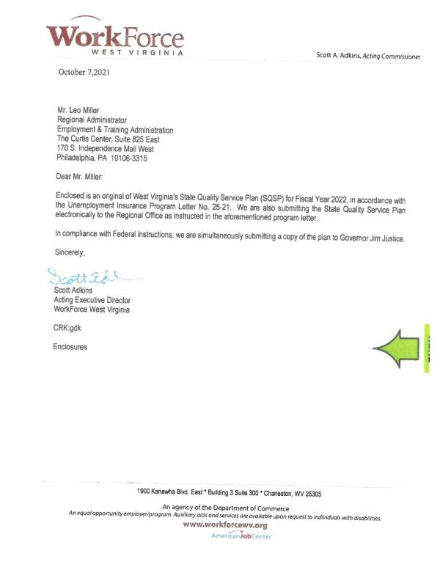

2. Budget Worksheets/Forms
Budget worksheets/forms and plan for program administration based on projected allocations received from the Federal partner. These forms include Worksheet UI-1 and SF 424, SF 424A and SF 424B. The SF 424A is only required if the State vary the quarterly distribution of base claims activity staff years.
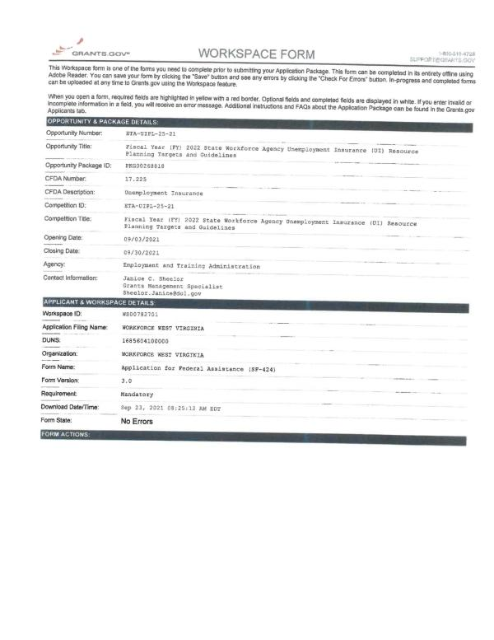
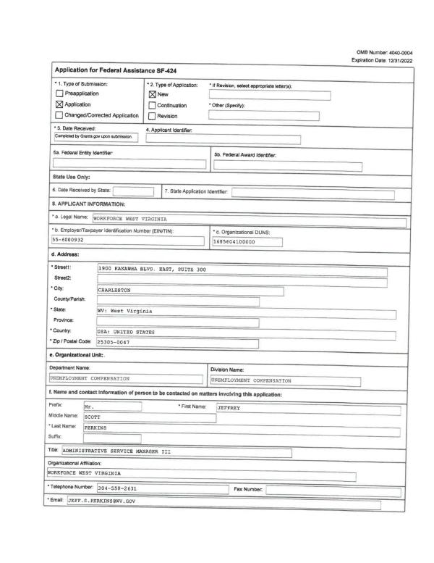
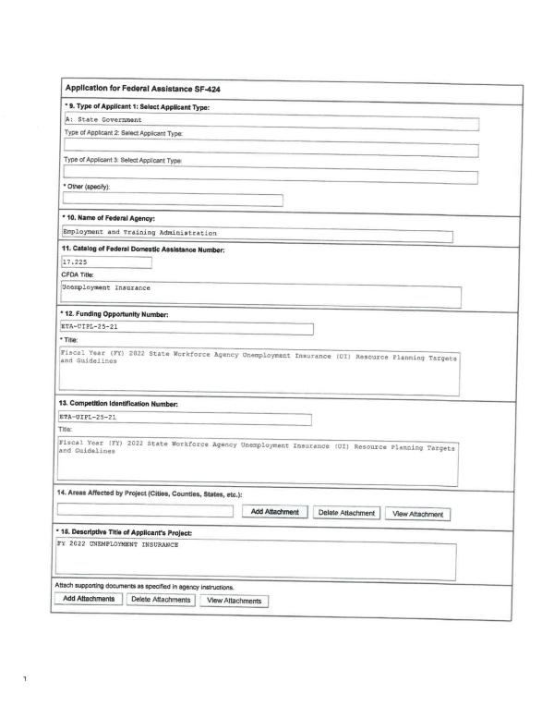
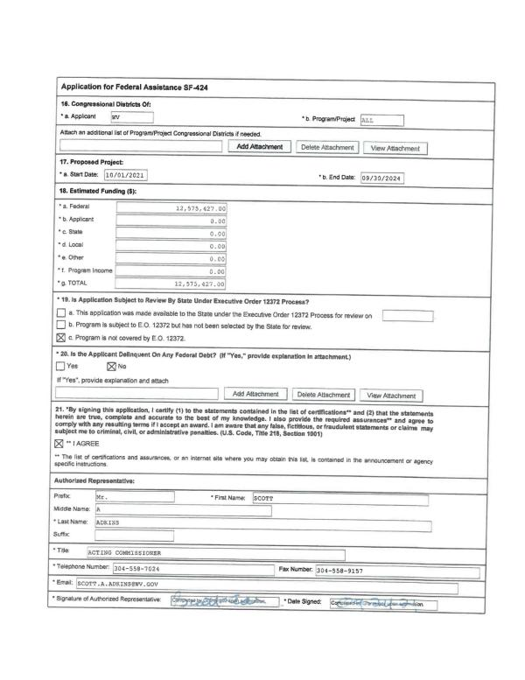
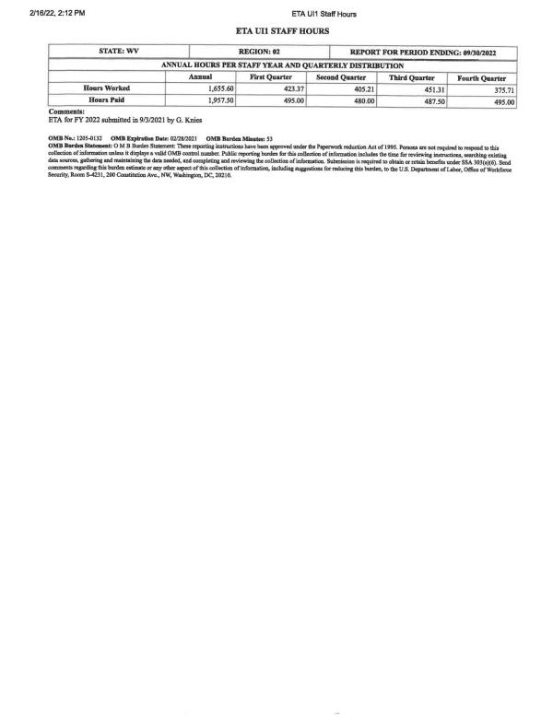

3. The State Plan Narrative
State Plan Narrative is a vital element of the SQSP that provides a vehicle for sharing with the Federal partner State-specific efforts that affect the administration of the UI Program. The State Plan Narrative allows the State to describe in a single narrative: a) State performance in comparison to the Government Performance Review Act goals; b) actions planned to correct deficiencies regarding UI programs, UI program reviews and reporting requirements; and c) results of customer satisfaction surveys (optional).
West Virginia
Two-Year State Plan Narrative
FY 2022-2023
Overview
Like many states during the Pandemic, WorkForce West Virginia's (WFWV) Unemployment Insurance (UI) Program struggled to handle the workload in an effective and efficient manner. It was apparent in the first few months that changes in the techniques used to process all unemployment claims needed to be enhanced through various means such as call centers, updated technology, etc. In addition, it became quite clear that WFWV could not meet the challenges associated with the loss of key subject matter expertise due to turnover and retirements. WFWV could not train new staff at a level necessary to ensure accurate claims processing. Although the Pandemic caused chaos for State agencies and for jobless Americans, it did provide a crucial lesson in that it underscored West Virginia's desperate need for improvements in technology, clarified that better techniques were needed to process questions from claimants, and it demonstrated that a more robust approach to training new staff would be essential. As WFWV recovers from the workload created by the Pandemic, the agency is focusing on various factors that impact the UI Program, including West Virginia's ability to rapidly adjust to economic downturns. WFWV's main goal now is focusing efforts on improving performance in every aspect of the UI Program to ensure the timely delivery of benefit payments. These efforts will be achieved through the effective modernization of the UI system and through having a skilled and well-trained workforce. Without technology and an investment in human capital, the high standards of performance in West Virginia cannot be maintained. Therefore, WFWV's strategic plan is to rebuild all aspects of the UI program to equip West Virginia with the capability to endure future service delivery issues.
Based on the lessons learned during the Pandemic, WFWV's priorities for FY 2022 are already aligned with the national priorities outlined in UIPL 24-21. WFWV is developing two purchase requests to open the bidding process for two new modernized systems. One system will be designed to replace the Employer Service Program and the other will be for the Unemployment System. Implementing these two systems is imperative for accomplishing the task of improving WFWV's overall services to the jobless citizens of West Virginia through providing enhanced reemployment services and through addressing Integrity to ensure proper payments will be made within the 14/21 day from the week-ending date of the first compensable week. The overarching principle as these systems are developed is the focus on improving the end users' experience, the timely delivery of accurate benefit payments, the equitable access to UI Programs and Reemployment Services, and Integrity. Considering the loss of key subject matter expertise due to staff retirements and turnover, the Subject Matter Experts will be diligently working with the vendor to incorporate complex filters within the system that will enable the system to process various claims activities accurately with little staff intervention to ensure accurate payments. A clear filtered process will take claim processing and job service activities to a new level and alleviate issues created by new staff, especially during a time of high workload.
The Pandemic revealed that certain business processes as well as performance and key functions did not promote an effective and efficient UI program. During the Pandemic, WFWV was forced to outsource calls to a corporate call center that was unfamiliar with the UI program. WFWV also had to use in-coming staff that had not been trained in all aspects of unemployment. These two issues created more work for merit-based staff and prevented claim issues from being resolved quickly. WFWV has already begun to address service delivery issues by developing two in-house call centers which will have the expertise to address claimant issues immediately and handle Reemployment Services to the unemployed quickly. In addition, WFWV is beginning to implement more intensive training for newly-hired staff as well as for recently-hired staff. An all-inclusive training program is being developed that will lead to all staff having a comprehensive knowledge of the UI Program. This training will use the modules already available through the National Association of State Workforce Agencies (NASWA) as well as training developed by WFWV merit staff that is specifically geared toward the UI Program in West Virginia. These training tools will allow WFWV to respond to an influx of new staff due to turnover or retirements. Moreover, mandating the NASWA training modules will allow staff to be trained on all facets of unemployment. This training will provide staff with an overarching view of the UI Program in every area, not solely on their specific area of assignment. WFWV recognizes that an overall unemployment knowledge base is greatly beneficial during times when the agency suffers a mass influx of workload or a loss of staff.
Along with the two in-house call centers, the inclusive training modules, and the modernization of the Employment Service and UI systems, WFWV will improve customer service, ensure equitable access to all services, have an improved ability to adapt to economic trends and will administer and operate the UI Program effectively and efficiently. Although the use of WFWV's strategic plan will ensure the quality of service delivery and that all UI program performance indicators are met, WFWV recognizes that to provide the quality of service and to achieve Department of Labor performance standards, it is necessary to reduce all backlogs as quickly as possible. Therefore, WFWV will continue to develop and produce various system queries that will be used to determine how to clear the backlog in adjudications and appeals in the most effective manner. These queries provide data on the level of staffing needed in the various areas and allow WFWV to reassign staff with specific skill sets to dissipate the backlog. It is imperative that WFWV continues to fill all vacant positions and also adds additional staff. Additional staff will allow WFWV to work steadily toward the goal of clearing the backlog, rebuilding staff levels, and to ensure the transfer of knowledge from senior staff. The agency will continue to hire additional staff and will continue to reassign staff to areas that have backlogs. It is WFWV's goal that the backlogged claim issues will be processed by the end of the second quarter of FY 2022.
The reemployment of UI claimants and of jobless individuals remains a top priority for WFWV. The agency currently uses a combination of evidence-based strategies such as the WPRS profiling model and Job Search Assistance to identify and serve individuals who are selected for the RESEA program. Additionally, WFWV incorporated a virtual experience for RESEA participants. Although this change was part of WFWV's response to the Pandemic, it has proven to be an excellent venue to conduct RESEA interviews and will be used in FY 2022.
West Virginia's RESEA State Plan continues to mandate that participants have a reemployment plan and that WFWV provides them with a variety of resources that supports finding new employment as quickly as possible. Additionally, all RESEA participants have complete access to WIOA services and all partner programs to align with the One Workforce Vision.
Realizing the changes that are being contemplated in WFWV's RESEA Program as well as potential enhancements and best practices that may be implemented within the year, WFWV has determined that a separate unit should be designated to handle the RESEA Program. The staff in this unit will be trained to conduct virtual RESEA interviews. After this training, RESEA staff will become familiar with the restructured eligibility review portion of the documentation used during the RESEA interview that prompts additional questions that are geared toward the availability and ability to work as well as the individual's job search efforts. It also includes questions that involve pension and retirement income and the receipt of worker's compensation payments. Staff will be trained to recognize potential eligibility issues during the RESEA process with emphasis placed on the importance of such recognition prior to the improper payment of benefits. Moreover, the new RESEA unit will have a coordinator who is will supervise the entire RESEA Program including productivity, performance outcomes, and grant expenditures. The improvements in the monitoring of the RESEA Program should enable West Virginia's RESEA Program to remain in compliance with the Department of Labor's guidance. This change should also allow WFWV to adopt general best practices and easily transform the RESEA Program into one that provides statistical evidence that this kind of intervention reduces the need for UI benefits.
Although WFWV anticipated having the RESEA service model evaluated by an outside source in FY 2021, the Pandemic delayed this phase of the RESEA provisions outlined by the Department of Labor. However, this evaluation will be a top priority for the agency in FY 2022. WFWV is not only committed to completing this evaluation as soon as possible, but is also committed to transforming RESEA to ensure that the program's outcomes are improved and that WFWV's statistics demonstrate a reduction in the average duration of unemployment.
In conjunction with the RESEA Program, WFWV uses early intervention and customer service in the design and deployment of WFWV's Rapid Response Team. This team provides quick services to dislocated workers to transition these individuals into new employment as soon as possible. To accomplish this goal, dislocated workers are advised of programs and services that are available to them such as reemployment and transition services along with resume development, unemployment information, and various training opportunities.
Before the Pandemic and the upsurge nationwide in fraudulent UI activity, WFWV was already designing and incorporating an Integrity Unit under the agency's umbrella. The main goal of this unit is to intensify and streamline WFWV's ability to combat fraud, prevent improper payments and detect and recover improper or fraudulent overpayments. It was determined early that for the Integrity Unit to operate to its fullest potential, additional staff would need to be added. Therefore, WFWV has hired a manager and an Employment Programs Specialist, Senior in the Integrity Unit. In addition, the Fraud Section, Investigative Section, and Crossmatch Section will add the following staff: two additional fraud agents; four additional investigators strategically located throughout the state; and six interviewers for the Investigation Unit.
WFWV uses the tools, strategies, process improvements and procedural changes listed below to ensure that all claims are authenticated prior to entry into the system.
If the following characteristics are detected in a claim, the claim is vetted by a staff member in the Fraud Section prior to entry into the system for payment:
- Known suspicious security answers
- Throwaway email domains (for example @yopmail.com)
- Multiple or known emails
- Multiple or known phone numbers
- Multiple or known mailing addresses
- Known bank accounts
- Limited Personal Identification Numbers (PIN)
- As of August 23, 2021, claims are also vetted if a high-risk IP address is detected.
Current procedures are that upon the initial discovery of a potential fraudulent claim, the system sends the claimant an Identity Theft Notice (ITN) that advises the claimant to contact WFWV to address the issue identified with the claim. These claims are transferred to the Fraud Unit to be reviewed. In addition to WFWV's in-house process, the agency also submits all new claims each week to NASWA's IDH. WFWV also participates fully with the Suspicious Actor Repository (SAR), Suspicious Email Domains, Foreign IP Addresses, Multi-State Claims, Identity Verification (IDV), Fraud Alerting, and the Suspicious Prepaid Routing Numbers list. This list is maintained by NASWA and contains 161 numbers. Fraud team members receive multiple lists daily associated with potentially fraudulent activity to review. All members of the Fraud Unit have access to the IDH as an investigation resource including individual lookups, etc.
WFWV has partnered with CATCH Intelligence. This software allows staff to use various services and specialized tools including IDH Alert Matches, Multi-State Claimant Matches, Tumbled Emails, Temporary Domains, Dashed Emails, and RapidMiner Studio. Additionally, the staff use fraud detection tools such as the collective claim informational database, Social Networking Level I variables, and email text segments and Social Networking Level II variables for each claimant's claim filed between January 1, 2020 and the most recent data refresh. These two database tools are used by investigators to find schemes associated with indirect email address matches.
As the partnership between WFWV and CATCH continues, WFWV anticipates using the vendor to assist with the following endeavors to combat ID theft, fraud, abuse, and improper payments:
- Develop the technology to verify emails including those with suspicious domains
- Verify mailing addresses and phone numbers
- Develop an automated driver's license verification process that can be used nationwide
- Develop an IP address analysis process and an enhanced IP GEO Location process
- Develop an API to retrieve bank names, bank city and state. This will allow WFWV to analyze accounts to identify padding or other variances.
- Deploy a fictitious employer predictive model
- Deploy a fraudulent overpayment predictive model
- Deploy an overpayment predictive model
- Deploy an incorrect separation predictive model
WFWV also partners with the West Virginia Department of Corrections which allows for a crossmatch process between the agency and incarceration records. This allows staff to determine if active claims were submitted while the claimants were incarcerated. Each week, the Fraud Team receives a report of hits. In the future, WFWV anticipates participating in the Federal Corrections crossmatch when available.
Along with the above mentioned practices and changes in policy, WFWV continues to improve and use new tools and strategies as well as existing methods of detecting potentially fraudulent activity, such as the submission of claims to the Social Security Death Registry. Due to the issues associated with claimants and bank accounts, WFWV worked with a vendor to engineer a program that will lock bank accounts for 12 hours when a claimant or a potential bad actor has attempted to register for direct deposit three consecutive times unsuccessfully. This policy allows the Fraud Team to review a daily list of locked accounts that can result in a team member either assisting a claimant with the direct deposit enrollment process, determining that the claim is case of ID theft, or concluding that a potential bad actor is attempting to hijack a claim to facilitate the payments being sent to a bank account that is not affiliated with the actual claimant.
Another partnership that formed during the Pandemic is between WFWV and the West Virginia Division of Motor Vehicles (DMV). This allows investigative and fraud staff to obtain access to DMV records for investigation purposes. Since WFWV has begun to require claimants to upload a government-issued photo ID, it is imperative that staff have the capability to discern if a driver's license is authentic. This policy change was implemented based on NASWA guidance and was necessary due to the increase in fraudulent activity.
In collaboration with other purchasing activities related to modernization, an RFQ has been initiated to solicit bids for a Case Management System. This new system will be designed to store all fraud cases and allow documents to be scanned and linked to those cases. The goal for this system is to eliminate duplicate work and to allow all fraud cases to be stored in a case management tool that allows documents to be scanned and linked.
WFWV formed partnerships with various law enforcement entities during the Pandemic. These partnerships have proven to be greatly beneficial in resolving fraudulent activity, significantly bolstering detection methods associated with imposter claims filed with stolen or false identities, as well as assisting in collecting money owed to the agency from improperly paid claims. WFWV uses the following partnerships to aid in detecting and preventing fraudulent activity:
- United States Department of Labor Office of Inspector General
- United States Attorney's Office
- The West Virginia Fusion Center
- Homeland Security
- West Virginia State Police
- United States Postal Inspection Service
- City Police Departments
- County Sheriff's Offices
- United States Secret Service
- Federal Bureau of Investigation
- West Virginia Commission on Special Investigations
- West Virginia Auditor's Office
Due to WFWV struggling with escalating improper payments due to the discontinuation of the waiting week and the employer community's difficulties in finding employees, in June 2021 West Virginia reinstated the waiting week and changed state unemployment policy to require weekly job search activities for all active claimants. WFWV recommends to claimants that they keep a log of job applications submitted in-person, online and via email. In addition, WFWV will work diligently to provide claimants with targeted automated messages to educate claimants on the importance of proper work search activities and document retention as well as reminders concerning job opportunities suited to their specific skill set. As the UI Program changes nationwide, West Virginia will also monitor a possible change to existing law that would follow the Model Work Search Legislation referred to in TEN No. 17-19. In addition to the reinstatement of both the waiting week and the work-search requirement, WFWV is also considering requiring that employers use the SIDES Separation Information Exchange as well as the SIDES Earning Verification Exchange. Since WFWV is in the process of sending a Request for Bid through the state's Purchasing Division for new UI and Employment Services systems, the incorporation of all available SIDES modules will be one of the factors requested in the new system. WFWV has always been an advocate for the SIDES Exchange Systems because the information template used to gather the facts provides every element needed to adjudicate issues quickly.
West Virginia's UI Program strives daily to provide top-quality performance in all functional areas associated with the UI Program. Even through the Pandemic, staff continued to monitor and disseminate monthly and quarterly performance reports to management. Although West Virginia's performance suffered due to the Pandemic, WFWV was able to maintain a 10.14% Improper Payment Rate which is lower than the national rate of 15.58%. While West Virginia still struggles with circumstances associated with the Pandemic, WFWV expects performance to improve considerably in the next year and to stabilize in 2023. WFWV also anticipates that the performance of all areas in the UI System will begin to recover during FY 2022. Therefore, WFWV is committed to meeting or exceeding the three following GPRA goals and targets set forth by ETA:
- 87% of intrastate first payments for full weeks of UC within 14/21
- 57.5% establish rate of estimated detectable and recoverable overpayments
- 90% of status determinations for new employers made within the 90-day time period.
Several changes are now underway which will assist WFWV in delivering these performance measures. The two main factors that have been set in motion that will enable WFWV to meet these goals are the transition of all tax staff working solely on tax activities and the hiring of new staff in the Benefit Payment Control area that were lost in the last year. In addition, the claim activities have been realigned with local offices which are now functioning in a pre-pandemic manner.
The Workforce Innovation and Opportunity Act (WIOA) has been implemented in all of our local offices since its inception. West Virginia's WIOA Plan details specific attributes that address the goal of using the UI Program as a One-Stop partner. Developing the cohesive delivery of services between the partners as directed by the WIOA guidelines was relatively straightforward for West Virginia because WFWV's UI and ES staff are fully cross-trained to assist individuals in all aspects of job placement and unemployment benefits. By providing access to a full range of services and by housing our partners within the One-Stop Centers, we can provide outstanding services to both employers and job seekers. We provide a step-by-step guide to job seekers to help them return to work, to use educational opportunities, and to learn how to network effectively to accomplish their overall goals. RESEA participants are offered a full array of partner services that will meet their individual job search needs.
West Virginia has always valued the accuracy and timeliness of all of its federal reporting to the Department of Labor. Thus, it was unprecedented when WFWV was cited with a Reporting Requirements failure. It was such a disruption that West Virginia requested a list of the reports in question. While reviewing the reports listed by the Regional Office as missing, WFWV staff found that the three ETA 204 reports had indeed been submitted but were listed as missing on the SUN System. It is thought that this may have occurred due to West Virginia needing federal assistance to transmit these reports. During the review, it was also discovered that the PEUC ETA 227 report listed as missing was inadvertently submitted on the wrong report template (TEUC) on the SUN System. To rectify this situation, the TEUC report was zeroed out and the PEUC template was completed and transmitted on September 29, 2021. The two missing PEUC ETA 227 reports had not been completed. However, as of September 29, the two reports have been completed and transmitted. In addition, the FY 2021 Data Validation reports due for the Benefit Population that were listed as not submitted have been completed and transmitted.
In addressing a key program objective for FY 2022, WFWV would like to report that the Contingency Planning and Assurance Systems Security was completed by the West Virginia Office of Technology (OT) from May 10-14, 2021. All technology systems used by WFWV are maintained and disaster recovery tested by OT.
WFWV also assures the Department of Labor that the Disaster Unemployment Assistance (DUA) Program will be at the forefront of the agency's priorities in FY 2022. Due to the loss of two senior DUA merit staff in 2021, WFWV is now rebuilding the DUA area. WFWV has posted the job openings and is in the process of training staff on the DUA Program. WFWV is committed to conducting annual training and will use the DUA modules available. To ensure staff are trained on a continual basis and that the state DUA Policy Handbook is updated regularly, WFWV will conduct training and update the handbook annually. All tasks related to staff training and the DUA Policy Handbook will be completed by November 30 of each year.
As WFWV prepared the narrative for the FY 2022 State Quality Service Plan, it became more apparent from the statistics that the massive amount of workload that hit the Unemployment Program nationwide as well as the fraud that plagued the program due to the Pandemic has thrust most states into a complete rebuilding process. Whether it be related to the changes in policies required, additional technological tools or systems, or the rebuilding of subject matter experts, most states will experience a loss in meeting reporting goals for some time. West Virginia is not exempt from this rebuilding process. However, WFWV has made great strides in learning from the issues the Pandemic exposed. As WFWV moves into FY 2022, the agency is certain that the acquisition of expertly trained staff, newly modernized systems, and the development of two in-house call centers will equate to higher performance in all areas associated with the UI Program.
Most state, local, and federal government agencies were suffering a major loss of staff before the Pandemic which only exacerbated the shortages nationwide. Although this remains a dilemma within WFWV, the agency has been able to hire new staff recently. Additionally, the Governor has awarded WFWV exempt positions that allow the agency to hire individuals at a higher salary and without the Division of Personnel's approval. The Governor also reactivated positions that had been removed from WFWV to assist the agency in increasing its staff. These measures should equip WFWV with the tools needed to hire qualified staff immediately which will provide improved performance and service delivery.
WFWV extends the agency's appreciation for recognizing the massive number of operating changes and hardship the Pandemic unleashed on its state partners and for providing the states with flexibility in this year's performance criteria. As stated in the UIPL, WFWV will refocus efforts into meeting the performance measures thereby ensuring that West Virginia's UI Program achieves its goals during FY 2022.

4. Corrective Action Plans (CAPs)
CAPs are expected as a part of the SQSP when State’s annual performance does not meet the established criteria for core measures, Secretary’s Standards, UI program, assurances, and other program deficiencies identified in the annual SQSP guidance provided by the Department. The CAP must list both specific milestones for key corrective actions or improvement activities, and the completion date for each milestone.
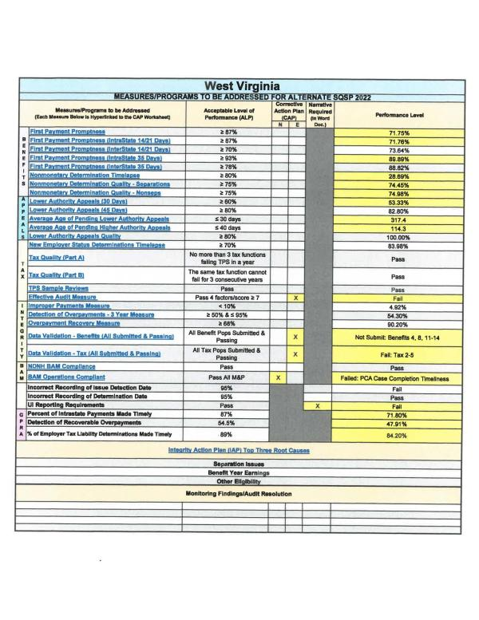
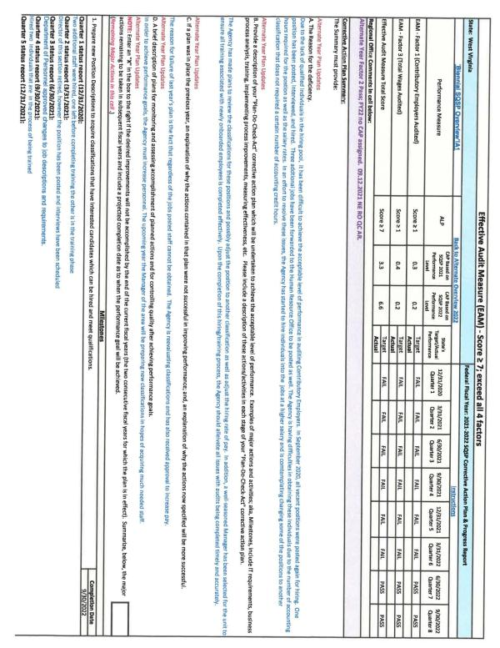
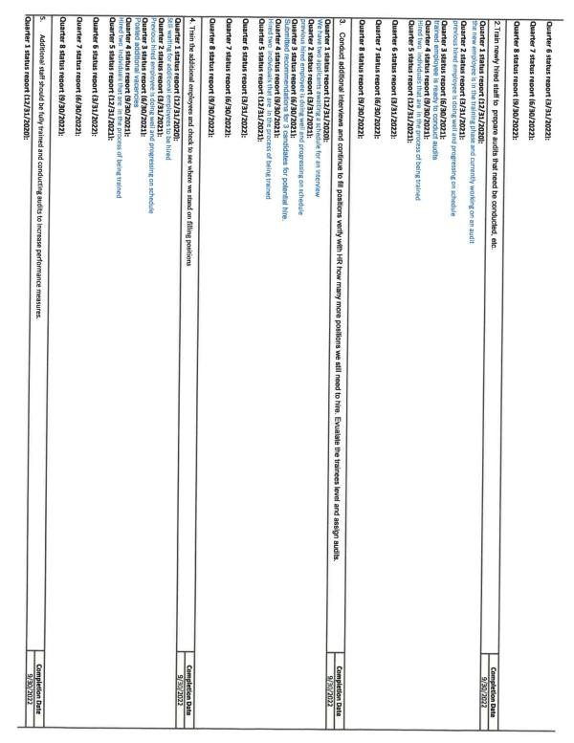
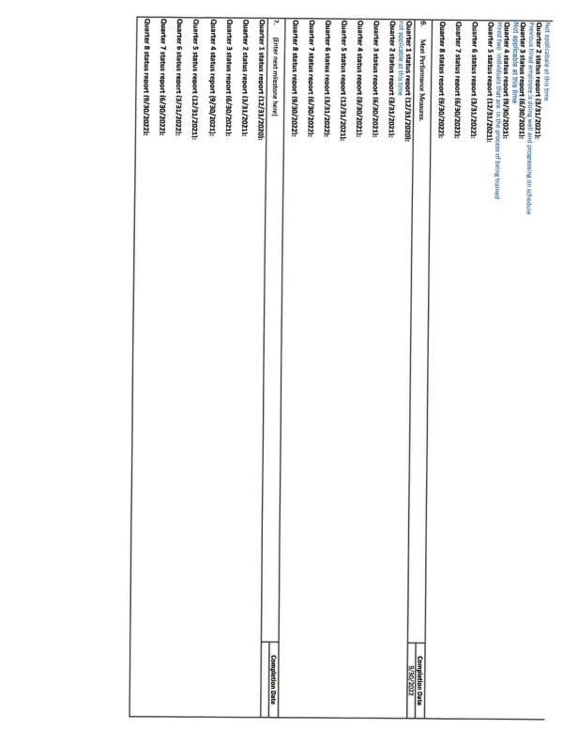
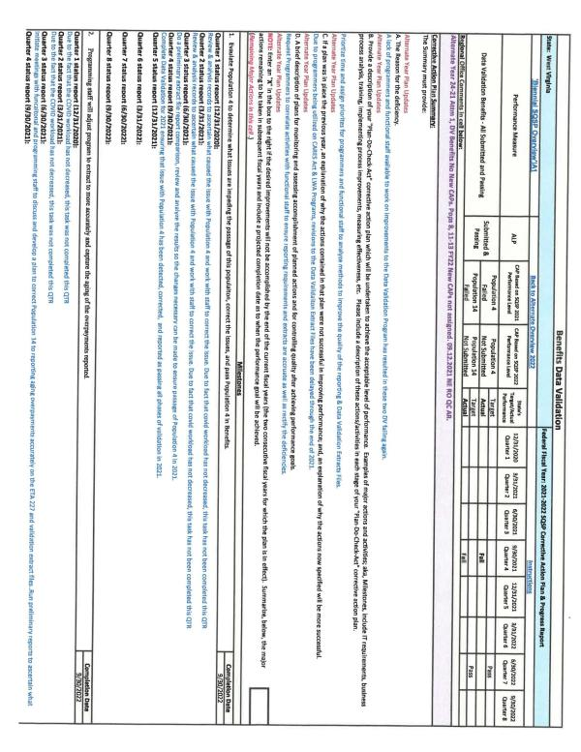
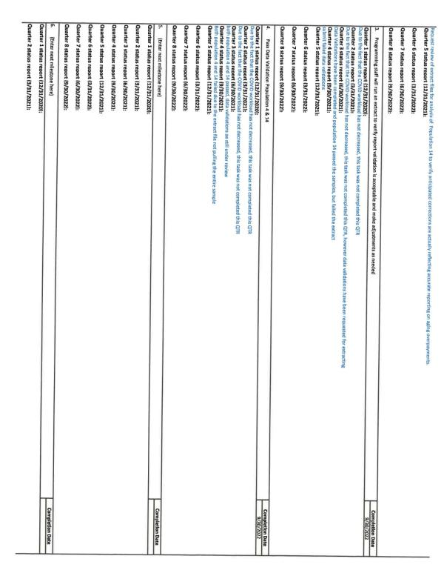

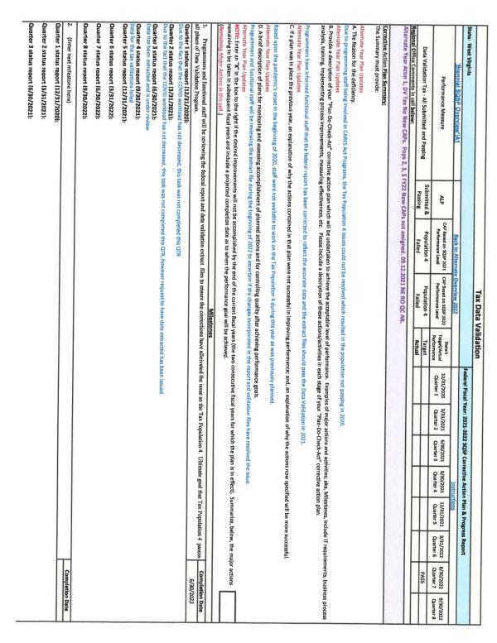
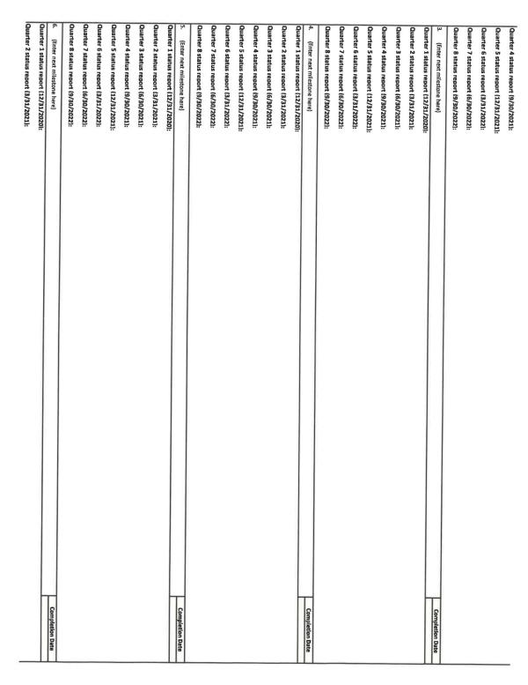

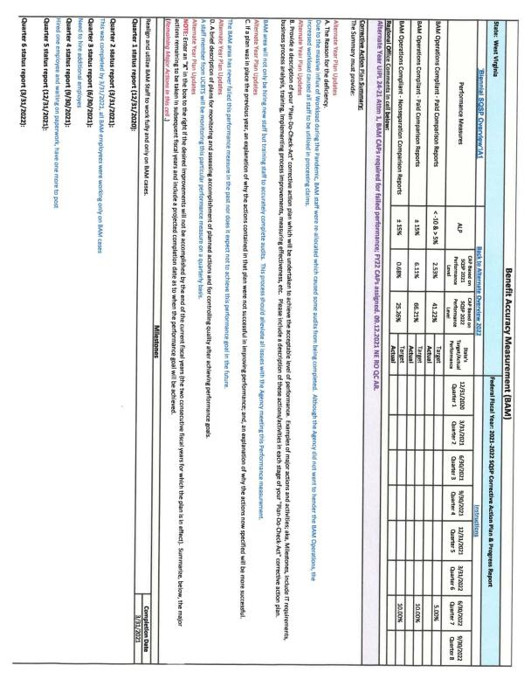
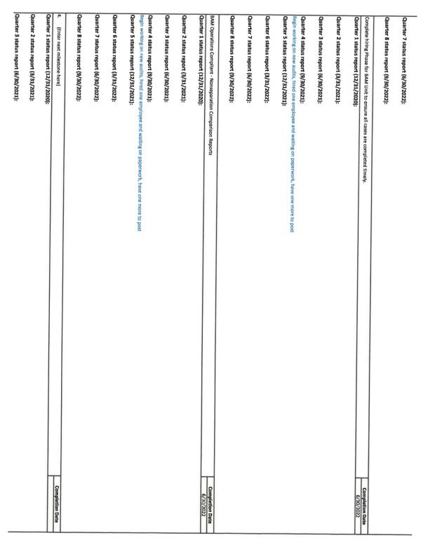
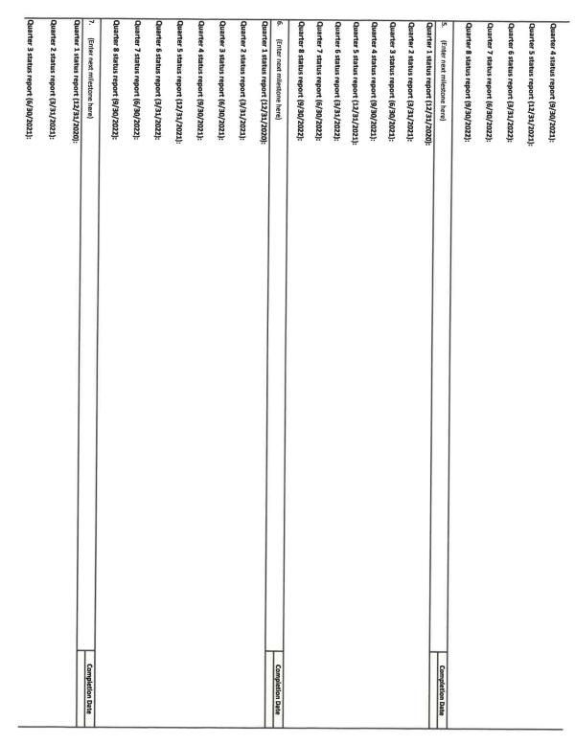


5. UI Program Integrity Action Plan (UI IAP)
The UI IAP outlines the strategies the State will undertake during the planning period regarding the prevention reduction and recovery of UI improper payments.
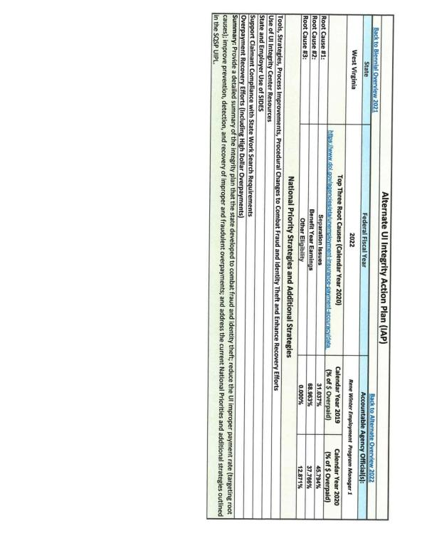
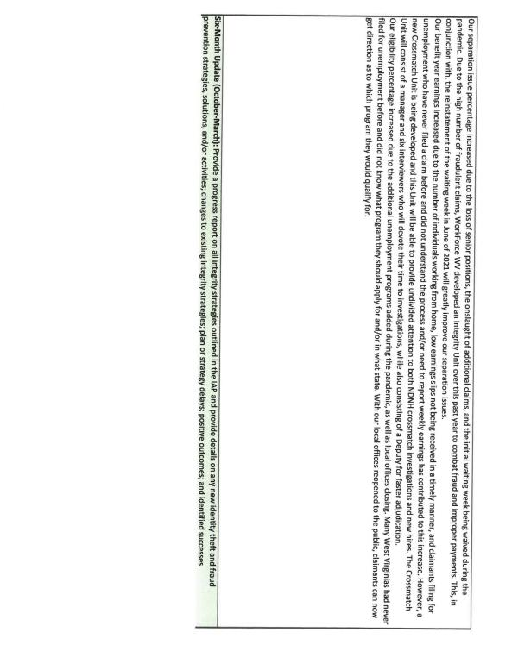
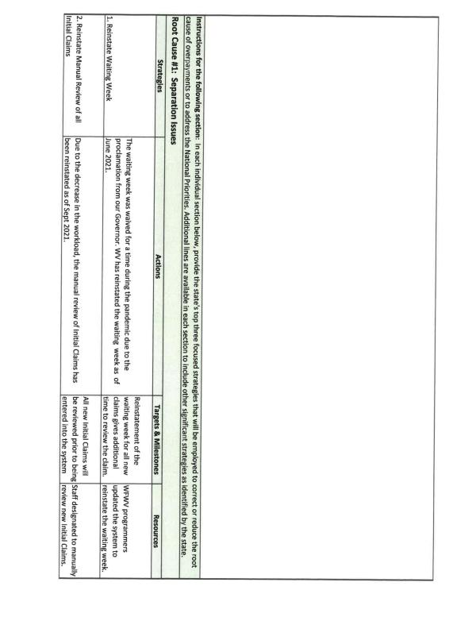
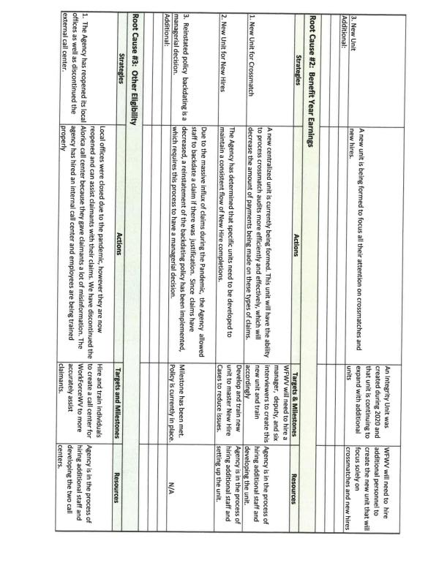
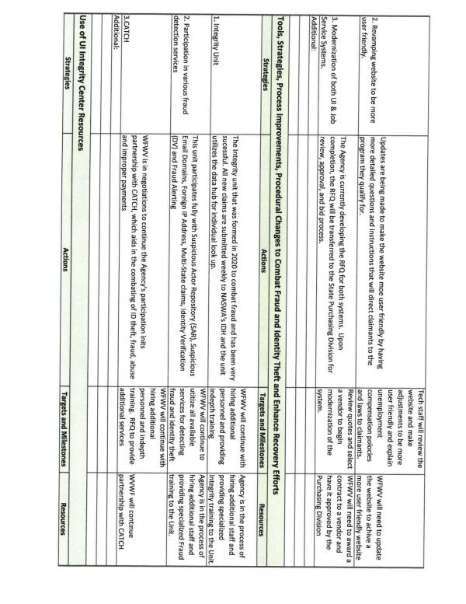
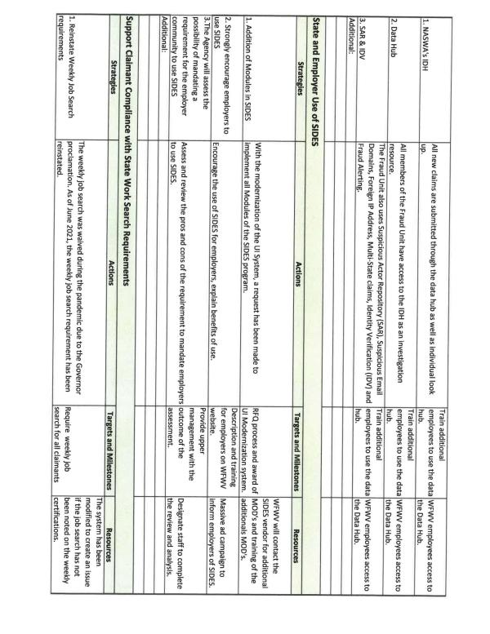
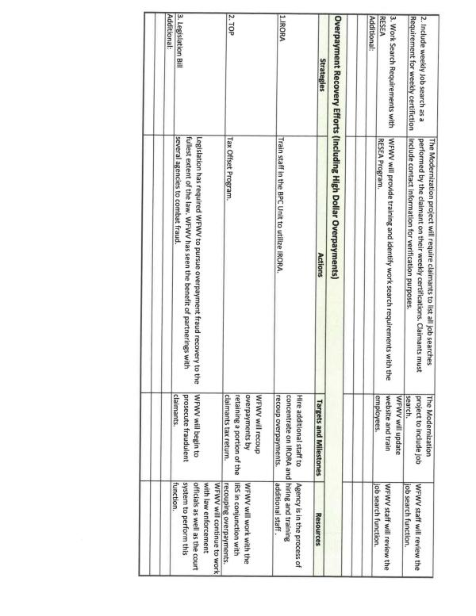

6. Organizational Chart
The organization chart must conform to the requirement for delivery of service through public employment offices, or such other designated providers as the Secretary may authorize; show the State's configuration from the Governor of the State down to the point of Employment Service and UI customer service delivery; and provide sufficient detail to show each organizational unit involved and the title of the unit manager.
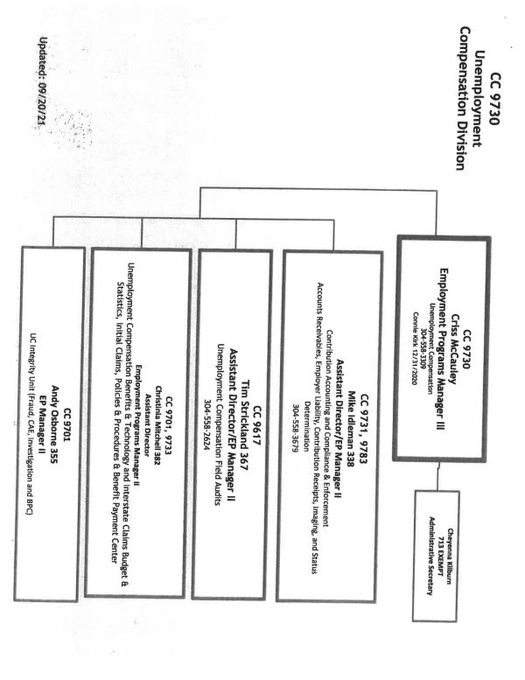
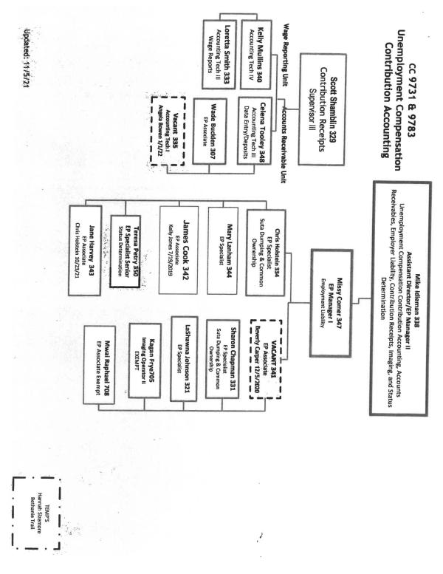
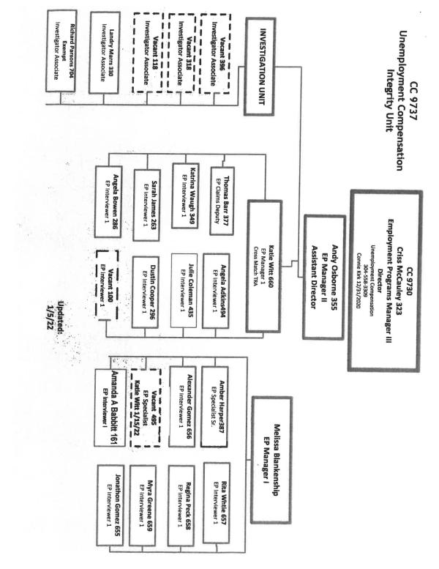
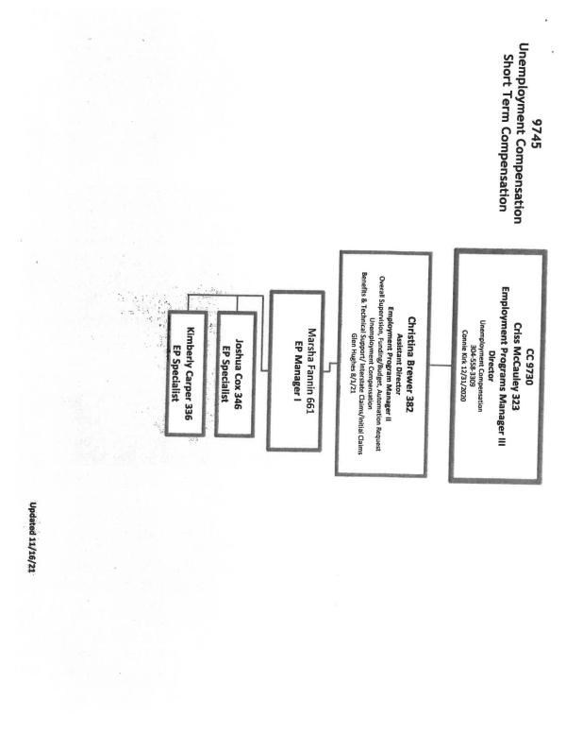
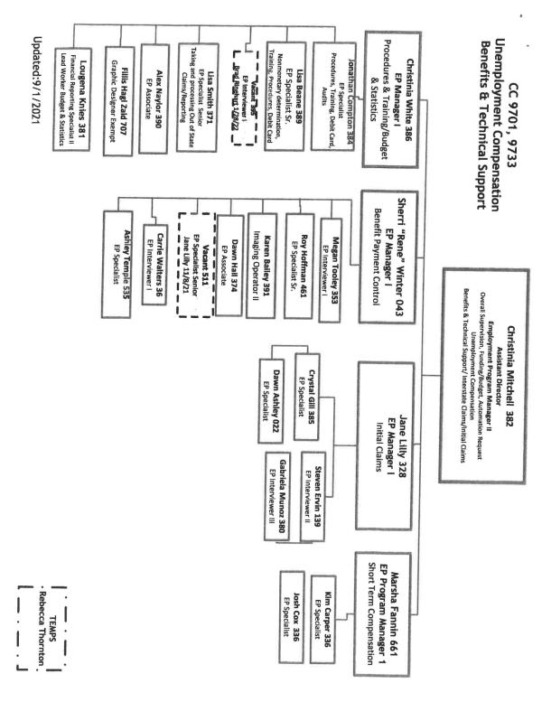
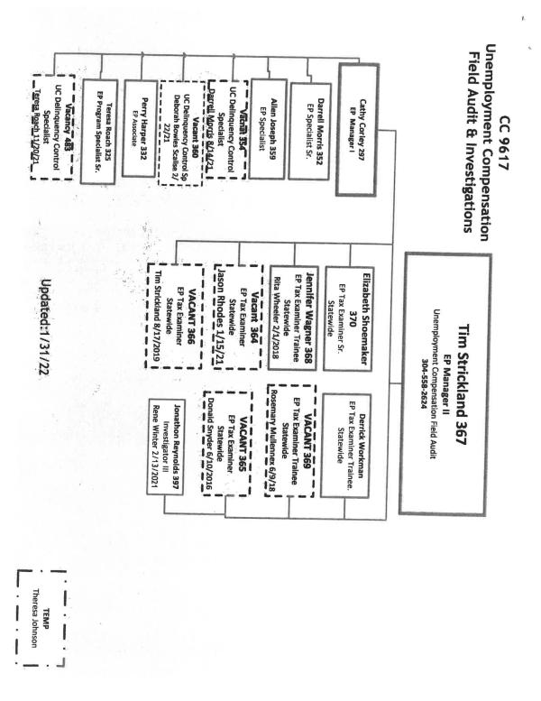

7. SQSP Signature Page
The State administrator must sign and date the SQSP Signature Page. By signing the Signature Page, the State administrator certifies that the State will comply with all the assurances and activities contained in the SQSP guidelines.
Though a State needs to submit the complete SQSP package on a 2-year cycle, there are certain documents contained in the SQSP package which are required to be submitted by States annually as part of the off-year submission. The documents which are required to be submitted annually are considered a modification to the complete SQSP submitted the previous year. Since funds for State UI operations are appropriated each year, each State is required to annually submit the transmittal letter, budget worksheets, organizational chart and the signature page. The modification may also include CAPs for new identified performance deficiencies, and any required modifications to existing CAPs.
Since the UI program is a required one-stop partner, States have the option of including UI in the Combined State Plan authorized by WIOA sec. 103.
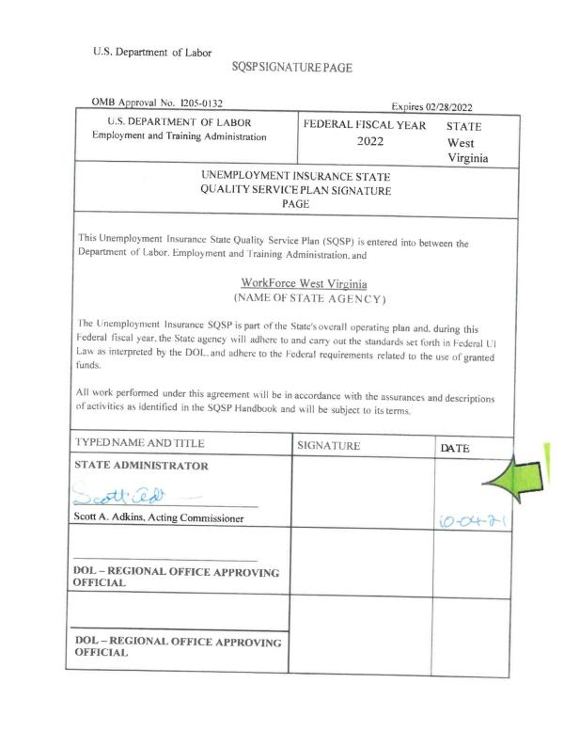
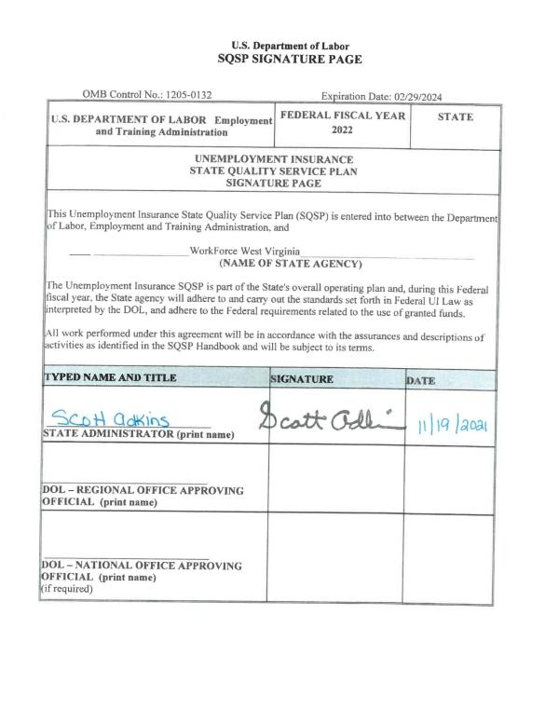

b. Requirements for States electing to include UI in the Combined State Plan
States that elect to include UI in the Combined State Plan must:

1. Submit an SQSP in the following manner depending on their timing in the SQSP cycle:

A. If a State is in the first year of their 2-year cycle, the State is required to submit the most recently approved complete SQSP package. A complete SQSP package will include the Transmittal Letter, Budget Worksheets/Forms, State Plan Narrative, CAPs (including the milestones and the completion date for each milestone), the UI IAP, Organizational Chart, and the SQSP Signature Page. One of the key goals for the UI program is to ensure that claimants are able to successfully return to work. As such, the SQSP State Plan Narrative must provide a discussion of the plan coordination with other WIOA Combined Plan programs to ensure a coordinated effort and integrated service delivery.
Please see the complete SQSP package submitted in sections 'a' and 'b'.
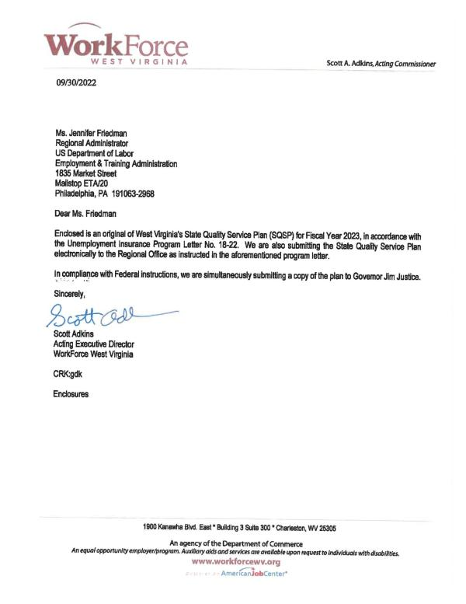
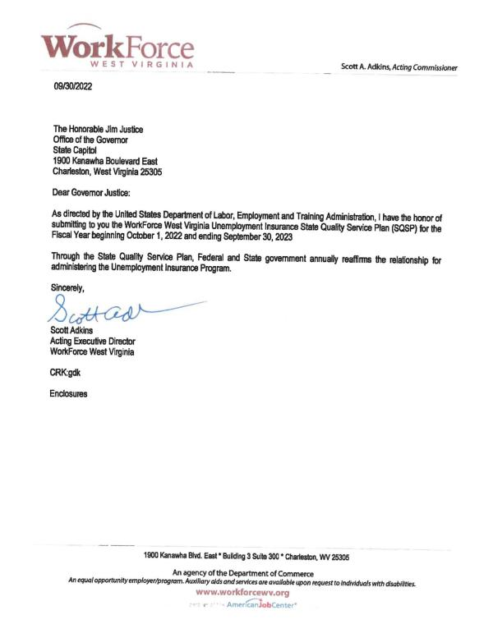

West Virginia's Two-Year State Plan Narrative FY 2023 - 2024
Overview
WorkForce West Virginia's (WFWV) Unemployment Insurance (UI) Program continues to struggle from the aftermath of workload which occurred during the pandemic. Even though the workload has steadily decreased in the past few months due to the low unemployment rate, the Agency is still struggling to clear backlogs in nonmonetary decisions, appeals and overpayment areas. While working to mitigate the backlog and ensure current workload is processed in a timely manner, WFWV has developed a two-team approach that involves staff working simultaneously on both the backlog and the current workload. This maneuver should allow the Agency the ability to clear the backlog without jeopardizing the timeliness of the current workload. Management is projecting the backlog will be complete by the end of 2022 or at the latest the first quarter of 2023. If the Agency's approach succeeds, as anticipated, workload will be up to date at that time. The rebuilding process began in WFWV during FY 2022 due to various lessons learned from the pandemic. During this rebuilding process, it is imperative that WFWV not only resolve all backlog but also restore the performance criteria West Virginia maintained prior to the pandemic. Therefore, the strategic plan begins with the completion of all backlog items and focuses on improving the timely delivery of every facet of the Unemployment Program. West Virginia has always taken pride in its ability to meet or exceed performance criteria associated with the delivery of unemployment benefits to the State's unemployed. The Administrative Management Team will be monitoring the timeliness of initial claims, benefit payments, nonmonetary determinations, appeals, etc. This process will allow WFWV to make changes immediately to compensate for any unknown obstacles that could potentially cause an area of performance to fail. For WFWV to evolve from this disastrous situation with a clear path forward, Agency initiatives must include various technologic ventures to increase productivity. Although technology is key in many instances, the Agency must also invest in human resources as well. For the agency to meet the challenges of a comparable economic decline, WFWV will not only need a skilled dedicated team of Unemployment specialists, but also the completion of technologic endeavors such as a new UI System, call-centers to meet demand for information, and a mechanism to ensure new staff are fully trained in an effective and efficient manner. As West Virginia and the nation recover from the pandemic and the repercussions left behind, it is imperative that lessons learned from this experience not be forgotten by State's or Nationally. All states, including West Virginia, are going to need additional funding and assistance from the Department of Labor to not only ensure that new technology is adopted, but that states have the resources to maintain and attract a skilled workforce that can meet future service delivery issues which may arise. These rebuilding efforts for West Virginia and many other States will be achieved only through effective modernization of UI Systems and having the ability to attract qualified individuals and maintain a well-trained and dedicated workforce. Without technology and an investment in human capital, the high standards of performance in West Virginia cannot be maintained.
As stated last year, WFWV priorities for FY 2023 are already aligned with the national priorities mentioned in UIPL 17-22. Currently, the Agency is re­ evaluating whether to purchase an Unemployment System from an outside vendor or possibly obtaining a fellow state's newly modernized UI System. This course of action will require the Agency's UI Management Information Systems Team to adapt the system to process claims utilizing West Virginia Law as well as Agency policies and procedures. This change in thought process occurred because most technological firms do not adequately build, vet, or support systems to the Agency's standards. In addition, the fellow state's UI System can be transferred to WFWV without monetary funding. Following this course of action, will allow the Agency the ability to maintain their own UI System without acquiring astronomical implementation costs or future maintenance fees. This approach would provide the Agency the ability to adapt rapidly to any measure passed by Congress or the Department of Labor due to having in-house programmers. At this point WFWV has not made a commitment to either plan as it relates to a newly modernized UI System. However, the decision was made to utilize an in-house approach for the Employment Service Module. Implementing these two new systems are imperative to accomplishing the task of improving the Agency's overall services to the jobless citizens of West Virginia. This action will result in enhanced reemployment services and timely accurate benefit payments. The overarching principle that will be constant in both systems is the enhancement of the system to a degree that improves the end users' experience, the accuracy of timely benefit payments, and the equitable access to unemployment and reemployment services. Expecting the loss of key subject matter expertise due to staff retirements and turnover, the subject matter experts will be diligently working with the Agency's programmers to incorporate complex filters that will enable the system to process claim activities accurately with little staff intervention. Utilizing a filtered process within both new systems will take claim processing and job service activities to a new level. This will ideally alleviate issues created by new staff, especially in times of high workload. The Agency will also emphasize the use of plain language in all communications, provide a feedback method for claimants, and improve system access across different platforms. Additionally, WFWV is still maintaining a physical presence in various locations around the state so in-person assistance can be obtained if the need exists.
The pandemic was instrumental in revealing business processes, performance, and key functions that did not promote an effective and efficient UI Program. During the pandemic, WFWV was forced to outsource calls to a corporate call center unfamiliar with unemployment and use in-coming staff that were not trained in all aspects of unemployment. These two issues caused more work on merit-based staff and delayed claim issues from being resolved quickly. The Agency has already begun to address this service delivery issue by developing two in-house call centers which will have the expertise to address claimant issues immediately and handle Reemployment Services to the unemployed quickly. In addition, the Agency is beginning to address more intensive training for staff who are being on-boarded as well as recently hired staff. An all-inclusive training is currently being developed that will lead to all staff having a comprehensive knowledge of the Unemployment Program. This training will utilize the modules already available through the National Association of State Workforce Agencies (NASWA) as well as training developed by merit staff that is specifically geared toward the Unemployment Program in the State of West Virginia. These training tools will allow the Agency to respond to an influx of staff due to workload or retirements. In addition, mandating the NASWA training modules will allow staff to be trained on all facets of unemployment. This type of training will give staff an overarching view of the Unemployment Program in every area instead of their specific area of assignment. It has been recognized by the Agency that an overall unemployment knowledge base is greatly beneficial during times when the Agency suffers a mass influx of workload or loss of staff.
A top priority of the Agency is supporting the reemployment of UI claimants and jobless individuals. WFWV continues to use a combination of evidence­ based strategies such as the WPRS profiling model and Job Search Assistance to identify and serve individuals that are selected for the RESEA program. Additionally, the Agency incorporated a virtual experience for these participants. Although this change was in conjunction with the Agency's response to COVID-19, it has proven to be an excellent venue to conduct RESEA interviews and will be utilized in FY 2023.
West Virginia's RESEA State Plan mandates that participants of the RESEA program have an individual re-employment plan and that the Agency provides them with a variety of resources that supports obtaining reemployment as quickly as possible. WFWV has started conducting subsequent RESEA interviews for all program participants, which includes eligibility assessments, a review of the initial re-employment plan, and additional re-employment services as needed. Additionally, all RESEA participants have complete access to WIOA services and other workforce system partner programs.
Changes have been made within the Agency's RESEA Program that include potential enhancements and best practices that may be implemented within the year. The Agency has established a separate unit that is designated to handle the RESEA Program. The staff in this unit are trained in the processing of unemployment claims, general reemployment services, and conduct RESEA virtual interviews. Through the training, staff involved in RESEA will become familiar with the eligibility review portion of the documentation used during the RESEA interview that prompts additional questions which are geared toward not only to the ability to work but the availability for work and the individual's job search efforts. It also includes questions that involve pension, retirement, and the receipt of worker's compensation. Staff are trained to recognize potential eligibility issues during the RESEA process with emphasis on the importance of such recognition prior to improper payment of benefits. To further provide guidance for the RESEA Program and ensure improved integrity and employment outcomes, the new RESEA Unit will be provided a coordinator designated for oversight of the RESEA Program including the area's productivity, performance outcomes, and grant expenditures. The improvements in the way the RESEA Program is monitored should enable the West Virginia RESEA Program to remain in compliance with the Department of Labor's guidance. This change should also allow WFWV the ability to adopt general best practices and easily transform the RESEA Program into a program that provides statistical evidence that this type of intervention reduces the need for unemployment.
The Workforce Innovation and Opportunity Act (WIOA) has been implemented in the Agency's local offices since WIOA's inception. West Virginia's WIOA Plan details specific attributes that address the goal of utilizing the Unemployment Insurance Program as a One-Stop partner. Developing the cohesive delivery of services between the partners as directed by WIOA guidelines was relatively straightforward for the state because WFWV's UI and ES staff were cross trained to assist individuals in all aspects of job placement and unemployment benefits.· By providing access to a full range of services and housing our partners within the One­ Stop Centers, we can provide outstanding services to employers and claimants. This plan provides a step-by-step guide to assist claimants in returning to work, utilizing educational opportunities, and learning how to effectively network both in person and through social media to accomplish their overall goals.
In 2021, legislation was enacted which established a Short Time Compensation (STC) Program in West Virginia due to be implemented by July 1, 2023. WFWV intends to have the STC Program operational in late 2022. This includes marketing the program to employers, providing a means for employers to submit plans for approval, a pathway for claimants to apply for STC initial and continued claims, and programming changes in the State's Automated Benefit Payment System to accommodate the STC Program.
In conjunction with the RESEA Program, WFWV utilizes early intervention and customer service in the design and deployment of WorkForce West Virginia's Rapid Response team. This team is utilized to provide quick services to dislocated workers to transition these individuals into new employment as soon as possible. To accomplish this goal, dislocated workers are advised of the programs and services that are available to them such as reemployment and transition services, including resume development, unemployment information, and various training opportunities.
In coordination with the Department of Labor's top priorities, WFWV has completed the task of incorporating an Integrity Unit under the Agency's authority. This unit's main goal is to intensify and streamline the Agency's ability to combat fraud, prevent improper payments, and detect and recover improper or fraudulent overpayments. To ensure the area operates without bias, the Integrity Unit operates outside of the Unemployment Division and answers only to the Acting Commissioner of the Agency. In addition, all activities involved with combatting fraud and ensuring accurate payments are housed in this area. These areas include the Fraud Section, the Investigative Section, and the Crossmatch Section. At this point in the process, all positions for the Integrity Unit have been filled and the unit is fully operational.
WFWV utilizes all strategies that were highlighted in both UIPLs for FY 2023 & FY 2022 regarding "Additional Planning Guidance for the Unemployment Insurance State Quality Service Plan". As required, WFWV has highlighted the specific tools, services, strategies, process improvements, and/or procedural changes adopted by West Virginia to combat fraud, verify identities, and enhance recovery efforts in the SQSP IAP Narrative.
In conjunction with the practices, technology, and changes in policy directly mentioned in the SQSP IAP, WFWV continues to improve and utilize new tools and strategies as well as long standing methods of detecting potentially fraudulent activity such as the submission of claims to the Social Security Death Registry. Due to the issues associated with claimants and banking accounts, WFWV worked with one of the Agency's vendors to engineer a program that will "lock" banking accounts for twelve hours when a claimant or potential "bad actor'' has attempted to register for direct deposit three (3) consecutive times unsuccessfully. This policy allows the Fraud Team the ability to review a daily list of "locked accounts" which can result in a team member either assisting a claimant with the direct deposit enrollment process, identify that the claim as a ID theft case, or concluding that a potential "bad actor'' is attempting to hijack a claim and the benefits associated with that claim to facilitate payments being sent to a bank account not affiliated with the claimant. WFWV has continued its partnership with the West Virginia Division of Motor Vehicles (OMV) which is utilized for verification of identity. This agreement allows various staff members the ability to access to OMV records for verification purposes. Since the Agency has begun to require claimants to upload government issued photo ID, it is imperative that the staff have the capability to discern if a driver's license is authentic or fake. This policy change requiring identity verification was implemented using NASWA's guidance and due to fraudulent activity was necessary. In addition, the partnerships formed during the Pandemic between various law enforcement entities and WFWV have been maintained and strengthened. In fact, the partnerships are resulting in actual prosecutions for fraudulent activities against the Unemployment Program in West Virginia. The Agency anticipates that once these cases are publicized by the media fraud may be reduced in the state.
To assist the Agency with reducing improper payments and assist the employer community in finding employees, in June 2021 West Virginia reinstated the waiting week statewide and changed state unemployment policy to again require weekly job search activities for claimants in active filing status. Although claimants were informed by the Agency to maintain a log of applications submitted in-person, online, and via email, WFWV plans to move forward utilizing technology to mandate that claimants enter all job contacts during the filing of their weekly certifications. Additionally, the Agency will be working to provide claimants with targeted automated messages to educate claimants on proper work search and document retention. Automated reminders concerning job opportunities suited to their specific skill will also be sent through the Employment Service System. As cited last year, West Virginia submitted a law change that followed the Model Work Search Legislation mentioned in TEN No. 17-19. However, this legislation was not passed during the most recent Legislative Session. In an effort to enhance work search activities, WFWV has already started the process to introduce the "Work Search Law" during the January 2023 Legislative Session.
Regarding the implementation of the various SIDES Modules, the Agency is making plans to utilize all aspects of the SIDES Exchange Systems. WFWV has always been an advocate for the modules within the SIDES Exchange Systems since the informational templates are beneficial in the fact-finding needed by state adjudicators. An additional benefit to the employer community is the ability for each employer to have immediate access to documents and postage savings for employers and the Agency.
Quality performance in all unemployment functional areas is a major concern for the Agency. Although the pandemic has played havoc on state unemployment programs nationwide, the Agency has been able to maintain a moderately low Improper Payment Rate during the last few years. In fact, the Improper Payment Report for April 1, 2021, thru March 31, 2022, which is the latest report, reflects a rate of 12.12% for West Virginia. Based upon data in the report, the rate also reflects West Virginia with the 16th lowest Improper Payment Rate. While comparing the Improper Payment Rates, it appears that 22 states have rates above 20% at the time the report was calculated. Regardless of the rankings, WFWV is committed to improving the rate in FY 2023 to below the 10% threshold. While the Agency continues to struggle with the aftermath of the pandemic, WFWV expects performance improvements during FY 2023 in most areas. Most functions are showing improvements in the last few months. For example, the First Payment Promptness measure reflects an Acceptable Level of Performance at 75.37% which is higher than last year's data. WFWV anticipates the performance in the State to increase in FY 2023 in most areas and be at the level obtained prior to the pandemic by 2024. The Department of Labor can trust that West Virginia will do its best to meet all performance goals in the upcoming year including the three GPRA target goals set by ETA which are 87% percent of intrastate first payments for full weeks of UC within 14/21 days; 57.5 % established rate of estimated detectable & recoverable overpayments; and 90% of status determinations for new employers made within the 90-day period. However, if the backlogged workload is not completed on schedule, the Agency may have a more difficult time meeting the GPRA goals in FY 2023. To keep the management team informed of the current performance levels, the UI administrative section will continue to produce performance reports that reflect the percentage levels associated with each month and year-to-date statistics. This activity should allow management the ability to adjust workload to ensure staff can increase performance.
Timely and accurate federal reporting has always been an Agency goal. Although most of the federal reporting was completed in a timely manner, the loss of knowledgeable full-time staff has resulted in WFWV being cited again this year with a "Reporting Requirements" failure. To ensure that any reporting issues were resolved the Agency requested a list of reporting that the Regional Office used to determine this failure. In researching the list provided, the Agency uncovered that some of the reports were submitted timely, some reports showing late were due to SUN System issues in which the state had reach out to the national office for assistance, as well as reports that were on the list showing due dates in the future, etc. Although some of the reports on the Regional Office list were not late due to WFWV, the Agency recognizes that the reporting area needs additional training on topics such as: the reason for timely submission of the federal reports, methods to get assistance from the National and Regional Office, review of due dates, etc. The UI Division Administrative Unit has suffered the loss of several merit-based staff which is causing some of the delays and issues. To ensure federal reporting compliance and timeliness, the Agency is mandating training and having a seasoned staff member review all reporting. The Corrective Action Plan for the failure of "Reporting Requirements" will be addressed. The Department of Labor can depend on the Agency to submit all federal with accurate statistics in a timely manner in the upcoming year.
In preparing the FY 2023 State Quality Service Plan, the Agency realized that the impact on the entire Unemployment Program including staff and the mainframe Automated Benefit Payment System was more significant than first anticipated. As FY 2022 began, WFWV fully anticipated completing all the backlog workload as well as meeting most of the performance goals set forth by the Department of Labor. As the year progressed it became apparent that the aftermath of the pandemic as well as the volume of fraud had caused more damage than even the Agency suspected. However, as the Agency focuses on the issues and weaknesses that the pandemic exposed, WFWV is certain that the acquisition of expertly trained staff, a new modernized UI System, and the adoption of in-house call centers will equate to higher performance in all areas associated with the Unemployment Program in the future.
Although the Governor and Legislature of West Virginia awarded the Agency the ability to utilize exempt positions which afforded WFWV the capability to hiring individuals at higher salaries without approval from the Division of Personnel, staffing is still an issue. Due to the pandemic and aging staff, WFWV continues to lose knowledgeable merit employees. As private sector and government entities continue to have shortages of qualified staff, West Virginia only been able to moderately increase staff. One issue the Agency has noticed is that even though staffing levels have increased it is difficult to maintain the newer staff. Therefore, the Agency is in a continuous cycle of training new staff. Based upon nationwide statistics, it is quite possible all employers whether private or government will continue to struggle to maintain knowledgeable staff. To mediate the staff turnover, WFWV is offering staff a stronger career mentorship program which will hopefully provide employees with a more professional outlook on their careers, enhanced skill sets to assist them in obtaining pay raises, and a ladder to higher level jobs within WFWV as they grow in their respective jobs.
The Agency provides the following assurances:
- Assurance of Equal Opportunity (EO).
- Assurance of Administrative Requirements and Allowable Cost Standards.
- Assurance of Management Systems, Reporting, and Recordkeeping.
- Assurance of Program Quality.
- Assurance on Use of Unobligated Funds.
- Assurance of Prohibition of Lobbying Costs (29 CFR Part 93).
- Drug-Free Workplace (29 CFR Part 98).
- Assurance of Conformity and Compliance
- Assurance of Confidentiality
The Agency also assures that staff has received training on Disaster Unemployment Assistance (DUA). DUA training for identified staff was completed on October 14, 2022. WFWV has also developed a standard operating procedure for use during a major disaster.
WFWV implemented Information Technology (IT) Contingency Plan on September 21, 2011. The IT Contingency plan was last reviewed and tested May 10 through 14, 2021. During Fiscal Year 2022 the West Virginia Office of Technology began migration of the existing on-premises mainframe to a cloud laaS (Infrastructure as a Service). The first phase of the migration should be complete during the 1st quarter of 2023. The State will also revise the Disaster Recovery and Contingency plan as well as conduct Disaster Recovery testing during the 1st quarter of 2023. WFWV also reviewed the system security plan October 4-8, 2021.
In closing, the Agency hopes that the Department of Labor will understand the many hours staff are still working to resolve the tremendous amount of workload and disruptions caused by the pandemic. The pandemic unleashed hardships on the economy as well as all state unemployment programs. West Virginia has always prided itself in achieving high performance marks and providing excellent customer service to the citizens of West Virginia. Based upon the Agency's dedication and work ethic, the Department of Labor can rest assured that the Agency will continue the rebuilding process to achieve its Unemployment Program mission critical goal, with the final objective being - "An Unemployment Program deliberately designed to utilize a specialized merit-based cross-trained workforce in conjunction with a modernized UI system where both are easily adaptable to program changes or an influx of workload associated with any economic decline or national disaster."
State Quality Service Plan (SQSP)
Integrity Action Plan (IAP) rev 08.09.2022
State Name West Virginia - Fiscal Year (FY) 2023
AccountableAgencyOfficial(s).
List the person or persons accountable for ensuring integrity in the state's unemployment insurance (UI) program.
Name: Timothy Bledsoe
Title: Investigation Manager • WorkForce West Virginia
Email: timothy.bledsoe@wv.gov
Phone: 130455887024
- (Topic #1)-The specific topics areas identified under the "Combatting Fraud; Strengthening Identity Verification; Improving Prevention, Detection, and Recovery of Improper and Fraudulent Overpayments; and Reducing the UI Improper Payment Rate" National Priority outlined in the FY 2023 SQSP Unemployment Insurance Program Letter (UIPL).
To better detect, deter, prevent and combat fraud WFWV has implemented a dedicated fraud investigation unit within the Integrity Section. Senate Bill 2005 was passed in April 2022 during a special session of the WV Legislature and statutorily created the fraud investigations unit within Workforce WV and clearly establishes the authority of the unit and the duties prescribed to it. This legislation empowers Workforce WV to now not only identify fraud and identity theft within unemployment claims, but to pursue those matters now independently through the investigation process as well as seek prosecution and restitution. The fraud unit can now present criminal investigations for both federal and state prosecution and utilize court ordered restitution included in these prosecutions to greatly enhance the recovery efforts for monetary loss. And in creating this fraud unit the entire Integrity Section can work in unison to accomplish multiple tasks to better protect the agency from fraudulent activity by identifying known fraud conduct and fraudulent schemes being used against the agency and be able to place checks and balances in place that are fluid and can quickly adapt to the everchanging attempts and efforts of fraudulent actors. The Integrity Section is currently working with LexisNexis to implement their fraud prevention products to also assist in the prevention and detection of fraud and identity theft threats against the agency.
- State use of tools, services, strategies, process improvements, and/or procedural changes adopted by the state to combat fraud, verify identities, and enhance recovery efforts.
  - Identify which tools, solutions, and service provider(s) are used in the state's fraud management operations, including but not limited, to the following areas: data analysis, identity verification, fraud prevention and detection, and cybersecurity.
The newest solution being implemented by WFWV into fraud management operations are the subscription to LexisNexis which is a twofold partnership. LexisNexis is assisting the agency with their forward-facing fraud detection software and strategies which are currently in the implementation stages and have not yet been fully installed but that is anticipated to be completed by November 1, 2022, at the very latest. LexisNexis also provides investigative analytical support to the fraud unit through their Accurint system which offers a variety of intelligence data products that investigators and investigative analysts can access to enhance fraud and identity theft investigations. Workforce WV information technology support staff are not only engaged in the LexisNexis process, but they also work daily with Diamond, the agency's cyber vendor, to use creative ways of utilizing captured data to prevent and detect fraud. The information technology support staff also work independently within the Workforce WV mainframe to diligently identify fraudulent patterns, indicators, known threats, etc..., to be prepared to adjust operations of the mainframe to address identified issues in real time.
As previously stated, the recovery efforts are being greatly enhanced through prosecution/restitution related to fraudulent conduct and identity theft. The fraud unit is working closely with the United States Attorney's offices in both districts of WV, while also working with Homeland Security, FBI and US Secret Service to increase efforts in pursuing and recovering monetary loss. The fraud unit is also in the early stages of working with Truist bank, who is the financial institution responsible for check and ACH payments made in response to claims filed with Workforce WV, to develop potential investigative strategies to track fraudulent schemes through previous fraudulent payments as well as current attempts to receive fraudulent payments.
- Include strategies, solutions, and/or activities related to identity verification, fraud prevention and detection, and overpayment recovery using funds the Department has made available to states for combatting fraud under UIPL Nos. 28-20; 28-20, Change l; 28-20. Change 2; and 22-21.
- Provide details on overpayment recovery efforts, including actions with banks, financial institutions, and with Federal law enforcement's forfeiture and seizure efforts.
  - Include information on how the state is using waivers of recovery of overpayments both for regular UI and temporary unemployment compensation (UC) programs created by the Coronavirus Aid, Relief, and Economic Security (CARES) Act, including if the state is using approved blanket waivers as described in UIPL No. 20-21, Change 1, for CARES Act overpayments.
  - State use of UI Integrity Center resources, with a particular focus on state connection to the Integrity Data Hub (IDB) and use of its datasets to cross-match UC claims and aid in the prevention and detection of fraud.
The state submits every claim through the IDH weekly. Workforce West Virginia is fully participating in all available IDH capabilities. The state has executed the Version 5.0 participation agreement. The Assistant Director of our Integrity Section is an Integrity Steer Committee member, and each member of the Fraud team in the Integrity section is enrolled or has completed the National Integrity Academy's IDH certificate. The Agency has received approval from the West Virginia Department of Personnel, to provide pay increases to staff upon completion of the National Integrity Academy's Fraud certificate.
- Discuss the state's connection to the IDH, including frequency of IDH use.
- If the state is not connected to the IDH and/or is connected but not regularly submitting UI claims data through a webservice/real-time connection to IDH, provide details on the state's plan for how to use and anticipated timeline to:
  - Connect to the IDH.
  - Increase frequency of IDH use.
  - Fully leverage all available IDH capabilities. IDH capabilities include:
    - Suspicious Actor Repository (SAR)
    - Multi-State Cross-Match (MSCM)
    - Identity Verification (IDV)
    - Bank Account Verification (BAV).
    - Fraud Alerting
    - Foreign Internet Protocol (IP) Address Detection
    - Suspicious Email Domains
    - Update the IDH connection to a webservice/real-time connection.
    - Identify barriers to using any of the available IDH capabilities.
- Note: The IDH Team has a one-page dashboard report for each state summarizing current IDH utilization and areas where IDH use might be expanded. Please reach out to IDHTeam@naswa.org to request a copy of your state's IDH utilization dashboard report.
  - If the state has not executed IDH Participation Agreement- Version 5.0 (see TEN No. 24-21), provide details on the anticipated timeline to update to IDH Participation Agreement- Version 5.0.
  - Discuss the state's use of the UI National Integrity Academy's virtual trainings and/or eLearning lessons, the use of UI Integrity Knowledge Exchange Library resources, and participation in State Consultative Services
- State use of required and recommended cross-matches and overpayment recovery activities as outlined in UIPL No. 23-20, including any additional effective cross­ matching and recovery activities and identified best practices.
WFWV utilizes the SSA crossmatch upon the entry of every initial claim. Staff review the State Identification Inquiry (SID) on ICON while entering new initial unemployment claims. The state also administers a weekly National New Hire, daily State New Hire, Quarterly Wage Crossmatch, and a weekly In-state Incarceration Crossmatch. The state is in the process of initiating the federal PUPS incarceration crossmatch. The state has a unit solely dedicated to the Crossmatch process. Their efforts include, checking for accurate payment of UI benefits, PEUC, LWA, EB, and FPUC benefits. The Crossmatch unit's biggest barrier is working with third party administrators. Specifically, their ability or lack thereof to provide relevant or easy digestible infonnation that pertains to the crossmatch.
WFWV utilizes the SSA crossmatch upon the entry of every initial claim. Staff review the State Identification Inquiry (SID) on ICON while entering new initial unemployment claims. The state also administers a weekly National New Hire, daily State New Hire, Quarterly Wage Crossmatch, and a weekly In-state Incarceration Crossmatch. The state is in the process of initiating the federal PUPS incarceration crossmatch. The state has a unit solely dedicated to the Crossmatch process. Their efforts include, checking for accurate payment of UI benefits, PEUC, LWA, EB, and FPUC benefits. The Crossmatch unit's biggest barrier is working with third party administrators. Specifically, their ability or lack thereof to provide relevant or easy digestible information that pertains to the crossmatch.
WFWV utilizes the offset of current benefits to recover improper payments of benefits. When the benefit payment system identifies a claimant with a current claim who also has an overpayment established, current benefits are used to offset the pre-existing overpayment(s). The benefit payment system then prepares and mails a notification to the claimant which discloses the amount of the overpayment, the current benefits which are withheld and applied to that/those overpayment(s), and the balance of the overpayment remaining after application of the offset current benefits.
WFWV is enrolled and utilizes the Treasury Offset Program (TOP). When the benefit payment system detects an overpayment that is eligible to be recovered through TOP a notice is sent to the claimant. If the claimant's balance remains unpaid, the debt is submitted to the Department of Fiscal Services servers. When TOP matches the claimant's name and SSN to a debt on TOP's servers, certain payments to the claimant are intercepted and electronically sent to the agency, or programming is notified who in tum notifies the Benefit Payment Control (BPC) unit that an offset has occurred and must be manually applied. Once notified of the existence of the payment, BPC then manually applies the offset to the overpayment(s) existing at the time.
WFWV utilizes the Interstate Recovery Offset Recovery Arrangement (IRORA) IB8606 Intestate Overpayment Reports to crossmatch claimant's Open!New claims in other states against open/new claims in West Virginia. The crossmatch detects potential overpayments due to open claims in two states and detects potential Identity Theft claims in other states and in West Virginia. Where potential identity theft claims are detected, Workforce West Virginia notifies the integrity/fraud unit for follow-up. The state also uses the IRORA IB8606 request database to recover West Virginia overpayments and recover overpayments for other states. Workforce West Virginia utilized the IRORA IB8606 enhancements to crossmatch open/new PUA, PEUC and FPUC claims in other states against open/new UI, PUA, PEUC and FPUC claims in West Virginia. This crossmatch detects potential overpayments due to CARES Act claims in other states while eligible for UI claims in West Virginia.
WFWV is currently working on establishing policies and procedures to begin filing civil suits with the Magistrate and Circuit Courts to obtain judgments against all claimants who have overpayments resulting from fraud and non-fraud causes. Overpayments caused by administrative error will not be included in the overpayments subject to civil suit. Upon being granted a judgment against these claimants, Workforce West Virginia will begin the process of garnishing the claimant's wages. These policies and procedures should be in place by early 2023.
WFWV is currently working on establishing policies and procedures to begin utilizing property liens against all claimant who have overpayments resulting from fraud and non-fraud causes. Overpayments caused by administrative error will not be included in the overpayments subject to property liens. Where a claimant has an outstanding balance on an overpayment, the claimant will be notified that unless they contact BPC to make arrangements to either enter into an agreement of restitution, or pay the balance in full, a property lien will be presented to the appropriate court for issuance. As with wage garnishments, these policies and procedures should be in place by early 2023.
- Provide details regarding the state's use of each cross-match and recovery activity (required and recommended) as outlined in UIPL No. 23-20. Cross-matches and recovery activities include:
  - Cross-matches
    - National Directory ofNew Hires (NDNH)
    - Quarterly Wage Records Cross-match
    - Systematic Alien Verification for Entitlement (SAVE)
    - State Directory of New Hires (SDNH)
    - Social Security Administration (SSA) Unemployment Insurance Query (UIQ)
    - Interstate Benefits (IB) Cross-match.
    - State Identification Inquiry (SID) and IB8606 enhancements made to the Interstate Connection (ICON) network cross match to prevent concurrent claim filing in multiple states.
    - Incarceration Cross-matches - If the state is already connected to an incarceration cross-match, provide details regarding what incarceration cross-match the state is currently using (e.g., the Social Security Administrator's Prisoner Update Processing System (PUPS), third-party vendor, etc.)
    - Other Cross-matches
- Recovery Activities
  - Benefit Offsets
  - Treasury Offset Program (TOP)
  - Cross Program Offset Recovery Agreement (CPORA)
  - Interstate Reciprocal Offset Recovery Arrangement (IPORA)
  - State Income Tax Offset Program
  - Wage Garnishments
  - Civil Actions
  - Property Liens
  - Collection Agency Referrals
  - Credit Bureau Referrals
  - Other recovery methods as determined by state law or policy
  - Include details on the frequency of crossmatch use (e.g., cross-match conducted on all initial claims, all continued claims, only when suspicious activity is identified?) and frequency of recovery activities.
  - Identify any additional cross-matches or recovery activities the state uses that are not listed in UIPL No. 23-20.
  - Provide cross-matching or recovery promising practices.
  - Identify challenges with cross-matching or recovery activities.
  - If the state does not currently use one of the cross-matches or recovery activities listed in UIPL No. 23-20, provide the state's plan and anticipated timeline to request and obtain access to the cross-match or to implement the recovery activity.
- Note: If the state does not plan to obtain access to a cross-match or implement a specific recovery activity, please explain.
- State use and employer participation in the State Information Data Exchange System (SIDES).
From the six available SIDES exchanges WFWV currently utilizes two: Separation Information and Earnings Verification. West Virginia does not currently use all available SIDES exchanges, however a RFQ was recently submitted that will allow the implementation of all SIDES exchanges. We will be working on pursuing the additional exchanges and will provide a timeline for the implementations once that has been established with the vendor. The barriers Workforce WV has encountered in employer adoption of the SIDES exchange participation have been the lack of intenet services within the rural areas of the state.
- Provide details on the state's current usage of SIDES.
- If the state does not currently use all available SIDES exchanges, provide the state's plan for how to use and anticipated timeline to implement each SIDES exchange. Sides Exchanges include:
  - Separation Information
  - Monetary & Potential Charges
  - Additional Fact-Finding
  - Determinations & Decisions
  - Earnings Verification
  - Benefit Charges
  - Identify any barriers to SIDES exchange participation, either in state promotion or in employer adoption.
  - State strategies designed to facilitate claimants' compliance with state work search requirements while also supporting their reemployment such as adoption of the work search requirements in the Model Work Search Legislation.
From April 2021 until June 2021 during this performance period work search was waived under the Governor's proclamation. It was reinstated in early June 2021. In addition, legislation that was introduced for the January 2021 legislation pertaining to more stringent requirements on work search did not pass. Currently our law only requires a minimum one work search requirement and does not require them to provide any detailed information other than the number of job contacts unless they are selected for RESEA or a Quality Control Audit. Legislation is being introduced again for January 2023 requiring individuals to make more job contacts than one and provide more detailed information of whom they contacted, when etc.
- Outline the state's work search requirement and explain state challenges with work search improper payments.
- Discuss the state's plan to improve work search compliance by reducing work search errors and strengthening reemployment.
- (Topic #2)-State plans and actions to address the state's top three improper payment root causes in 2021 for Payment Integrity Information Act (PIIA) purposes.
Separation Issues, Benefit Year Earnings and Other Eligibility Training for inexperienced new deputies and field staff has been a major hurdle due to backlog of claims, limitations on experienced merit staff to train and funding to carry out the training. Identify the major areas of concern that are creating the improper payments through better communication between management staff in the various areas which can impact the improper payments. Once those areas are identified then make a plan of action to present training on specific areas. Management will monitor reports and decisions to identify improper decisions or areas that need to be addressed.
- Identify the state's top three improper payment root causes.
- Explain the state's challenges in reducing improper payments in the top three root cause categories.
- Discuss the state's plan to reduce improper payments in each root cause category.
- (Topic #3)-State coordination and collaboration with the Department of Labor's Office of Inspector General, Office of Investigations (DOL-OIG) and other state and Federal law enforcement agencies to investigate and prosecute UI fraud.
With the creation of a dedicated fraud investigation unit within WFWV, the agency is now working more closely with DOL-OIG agents to pursue federal prosecution of unemployment fraud and identity theft. The Workforce WV fraud is currently collaborating with DOL-OIG agents as part of a very recently identified ongoing fraudulent scheme that is targeting multiple state unemployment programs across the US. The ultimate goal for this investigation will be to not only prevent and protect state agencies from this scheme, but to hopefully track substantial monetary loss through financial institutions identified through investigative efforts and potentially identify and recover funds of multiple state unemployment agencies that have been lost to this scheme.
As previously stated, the recovery efforts are being greatly enhanced through prosecution/restitution related to fraudulent conduct and identity theft. The fraud unit is working closely with the United States Attorney's offices in both districts of WV, while also working with Homeland Security, FBI and US Secret Service to increase efforts in pursuing and recovering monetary loss. The fraud unit is also in the early stages of working with Truist bank, who is the financial institution responsible for check and ACH payments made in response to claims filed with Workforce WV, to develop potential investigative strategies to track fraudulent schemes through previous fraudulent payments as well as current attempts to receive fraudulent payments.
- (Topic #4)-State plans to strengthen program integrity in UI tax operations, including current activities and plans to identify and prevent worker misclassification, State Unemployment Tax Act (SUTA) Dumping, and Fictions Employer schemes, and development/use of effective employer audit strategies (i.e., use of remote audits).
WFWV conduct audits of registered employers which includes reviewing the 1099's by applying the Classification of lndependant contractors and employees test enacted by the WV Legislature in June of 2021. During the audits, we also review other accounting records to potentially identify misclassified workers. Selection of audits are done through random, by NAICS Code, from a 1099 NEC extract, fraud tips or internal tips. Future plans are to use the FUTA crossmatch assignments and convert those to field audits due to the amount of reporting errors found in the past. Auditors have been given the new guidelines to follow and will be responsible to educate the employers during the audits. This will allow employers the opportunity to properly classify the workers. We are currently exploring options to securely obtain employer records to conduct remote audits.
The Status Determination Unit continues to use the SUTA Dumping Detection System program. While only a few possible SUTA Dumping cases have been found, it has been very helpful in identifying successions that were not reported by employers. To better identify possible SUTA Dumping and Fictitious Employer schemes, Workforce have initiated the following procedures: Making phone calls to contact listed on all new applications where the new employer indicates they are starting operations with five or more employees, and calling employers that have requested that we close their account, if the employer sold the business, any assets such as equipment, buildings, and the status of employees, etc. Regarding employer schemes, we are adding an alert to our system anytime that an address that is entered which matches an address already in our system. We believe this will help to prevent SUTA Dumping and help us to detect successions.
- Identify current activities and plans to address:
  - Worker Misclassification
  - SUTA Dumping
  - Fictitious Employer Schemes
  - Development/use of effective employer audit strategies (including, but not limited to, use of remote audits).
- (Topic #5)-State plans and actions to strengthen internal security and ensure that all appropriate internal controls and processes are in place and are adequate to assess internal risks and threats, ensure program integrity, and minimize program vulnerabilities (see UIPL No. 14-17).
WFWV is the Agency that administers the Unemployment Insurance Program for the State of West Virginia. The Agency has always strived for Internal Security Controls that ensure all facets of vulnerability associated with Unemployment Insurance. In addition, various levels of staff are utilized to adequately access and mitigate these safety measures to ensure the integrity and security of the entire Unemployment operation. The Agency has continued to enhance various security policies related not only to its physical business locations and equipment but also the agency employees. In fact, all physical building locations have undergone intensive changes to upgrade building security and public access. One of these changes initiated a yearly review of all permitted building access for agency staff. This review not only ensures no entity has access to the facilities but also limits hours and days of the week that employees can access the premises based upon level of job responsibilities. Various premises also have official guards on duty as well as metal detectors. The administrative policy currently requires Agency employees to sign a new Privileged and/or Confidentially and Information Technology Usage Policy Acknowledgement agreement on an annual basis. Various other agreements are signed between employees and the Agency which relate to ethics, telephone usage, workplace security, acknowledge of policy to return an Information Security Incident, etc. To combat potential fraudulent employee activities the Agency has instituted various automated reports that list questionable system access, building access, or other factors are that considered to be abnormal behavior. The occurrence of this type of activity is investigated by the Agency's Internal Security Division. The Internal Security Division is a separate impartial division within the Agency that has the authority to investigate any type of internal fraudulent activity, risk, or threat as well as perform reviews, assessment, or audits deemed necessary to ensure the integrity of the Unemployment Program operations or systems. To be diligent regarding separation of duties the Agency has always maintained separate divisions within the Unemployment Insurance Program. This security measurement not only provides the separation of duties required but also provides an additional measure of integrity against staff being able to manipulate various processes for personal gain. This type of separation also eliminates one staff member from having the ability to complete all transactions associated with either setting up an employer account or approving unemployment benefits for a claimant.
Currently, the Agency's Unemployment Program is maintained and operated through a statewide Mainframe System. The Mainframe System is controlled overall by the State's Office of Technology (OT) and potentially serves various other State Agencies such as Department of Motor Vehicles, Department of Health and Human Resources, etc. OT in conjunction with each Agency's IT staff set user authentication, system access protocols, permissions, password criteria, event logs, fire walls, data encryption, data connections, data security, safeguards for the confidentially of the data, disaster recovery plans, antivirus software, security awareness policies & amp; training and overall system security. WFWV's Unemployment IT Staff are utilized by the Agency to monitor batch processes, system programming updates, issues within the Unemployment Programming files and data as well as monitor the mainframe for any system vulnerabilities that could prove to be a potential security risk. However, the Office of Technology has the overall management oversight of the Statewide Mainframe System. As the overall Mainframe management team, OT is responsible for maintaining the integrity, security, and data for the entire state's mainframe computer system including libraries of backup files, disaster recovery, etc. WFWV has been involved in several attempts to acquire a more modernized system for the Unemployment Program, however, this has proven to be a difficult task based upon the Software Vendors that currently offer these types of modern systems. The vendors in the community of Unemployment Insurance System are either not diligent in the way the program is developed causing efficiency issues or long-term system vulnerabilities. In addition, the vendor's prices for both the acquisition of the System and the maintenance are not affordable for a small state. Even though OT has alleviated the issues the Agency experienced last month with the Mainframe System as well as assured the Agency the system is sound. The Agency has determined it is in the Agency's best interest to have a more hands on approach to the Unemployment Program. Therefore, the Agency is currently working toward obtaining a copy of an already developed modernized Unemployment System from another state. Utilizing West Virginia's existing Reed Act Funds as well as funding acquired through the West Virginia State Legislature, the system will be updated and modified to process the Unemployment Program in West Virginia as it relates to West Virginia Unemployment Law. This West Virginia Unemployment System will be maintained by the Agency's IT staff which will provide the Agency the ability to ensure the integrity of the system, have the tools available to detect any system issue prior to the incident becoming a major security crisis.
- (Topic #6)-State plans and actions to balance the need to identify and prevent fraudulent activity while ensuring that eligible individuals with legitimate claims get the benefits they are entitled to when they are due.
WFWV has designed our prevention measures specifically to avoid friction and barriers for legitimate claimants. In West Virginia, state law requires a one week waiting period for all claims. This allows the Integrity team to review and evaluate all claims filed for suspicious activity without delaying payments in most cases. All claims are entered manually. The Agency has trained claims professionals who review each claim entered for eligibility issues, traditional fraud indicators and suspicious activity. As previously stated, all claims also receive a similar review by an Integrity team member. This occurs within the initial waiting period. During the life of the claim, the CrossMatch Unit monitors employer wage reports, with automated programs, to detect possible misuse or fraud. Currently, West Virginia does not use a scoring element or prioritization in our fraud detection process. Soon, LexisNexis will be used as a forward-facing fraud detection tool, but we will not place stops on claims or reject claim attempts based on this product. Therefore, its usage will not add friction nor create barriers for legitimate claimants. The Integrity team maintains unique data identified in known identity theft claims that is used by the system to place review flags on initial claims with similar characteristics. Additionally, each new claim filed is reviewed by staff to identify red flags and suspicious behavior or to remove unwarranted stops within three days of the claim being received. All claimants are required to provide a government issued photo identification during the initial claims process, and anytime they change their direct deposit. These documents are reviewed in the previously mentioned two-phased staff review. Workforce West Virginia utilizes the full spectrum ofNASWA's IDH review in each claim. We are also in the process of implementing Lexis Nexis on all applications. However, we do not place automated stops on claims based on IDH results and do not anticipate placing automated stops on claims based on Lexis Nexis results. Workforce West Virginia has dedicated staff in local offices statewide who are trained to assist legitimate claimants with any barrier they encounter in the claims process. Any stops placed on claims can be removed by contacting one of our local offices or calling one of our customer service 1-800 numbers. All denied claims receive appealable decision letters that give them access to due process.
- Identify potential barriers that are created by fraud prevention and detection functions for legitimate claimants. Provide plans and actions designed to mitigate such risks.
- Include how the state flags cases for suspected fraudulent activity (including both eligibility fraud and identity fraud) and how investigation resources are assigned, including:
  - What risk scoring elements and/or prioritization elements are used.
  - How the risk scoring elements and/or prioritization elements are weighted.
  - How the state evaluates the weights based on false positives and negatives.
  - How risk scoring elements and/or prioritization elements are updated.
  - How the state ensures the fraud risk scoring and/or prioritization of cases does not negatively affect legitimate claimants
- Include details on how the state measures claimants' usage of both digital and nondigital identity verification options, how the state reviews digital services for false positive and false negatives, and how the state ensures legitimate claimants have alternative paths to prove their identity and/or resolve issues, including providing a possible recourse.
- (Topic #7) - If the state has not provided complete and accurate overpayment reporting on the ETA 227 reports (Overpayment Detection and Recovery Activities), and the ETA 902P report (Pandemic Unemployment Assistance Activities), specifically Section C. Overpayment Activity and Administration (all activity EXCEPT for Identity Theft) and Section D. Overpayment Activity Related to Identity (ID) Theft of the ETA 902P report, the state must provide information on their plans for improvement, including timeframes and milestones, for addressing the issue and ensuring complete, accurate, and timely reporting in FY 2023.
WFWV was emailed questions related to the PUA and PEUC ETA 227 Reports last week. Until this information was received, the Agency was under the impression that all ETA 227 Reports have been accurately submitted in the SUN System. While reviewing the ETA 227 reports, staff have uncovered issues with both the PUA and PEUC overpayment reports. Various staff have been assigned to work on this issue and correct all reports that reflect incorrect data. The National and Regional Office can expect all reports associated with overpayments to be reviewed and if analysis uncovers errors the reports will be re-submitted by the end of October 2022. It is apparent that the Agency's needs to re-train staff on some of the reporting requirements such as accuracy and timeliness. WFWV assures the Department of Labor that these activities will be handled quickly and effectively.
If the state has submitted all data for the ETA 227 or 902P reports, this section is not applicable, and the state can input "NIA".
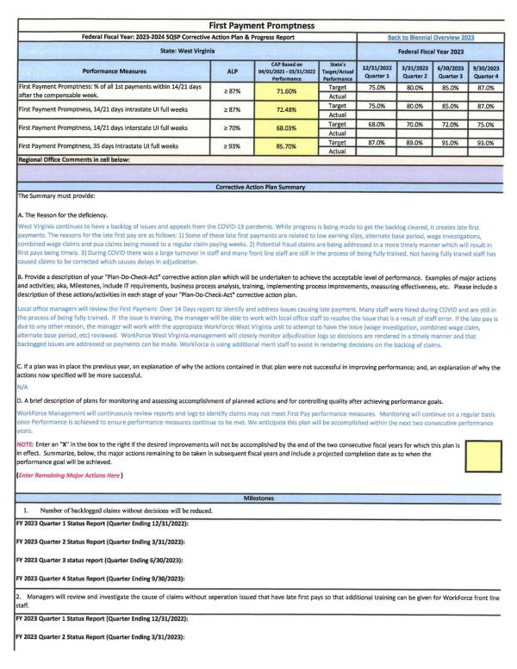



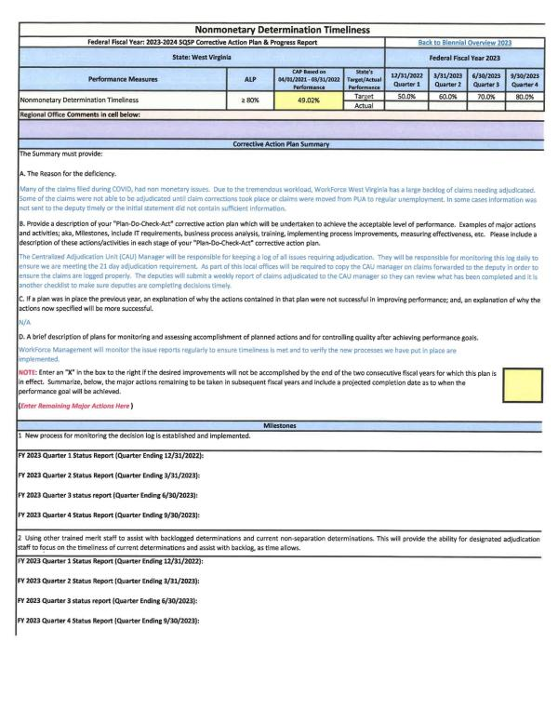


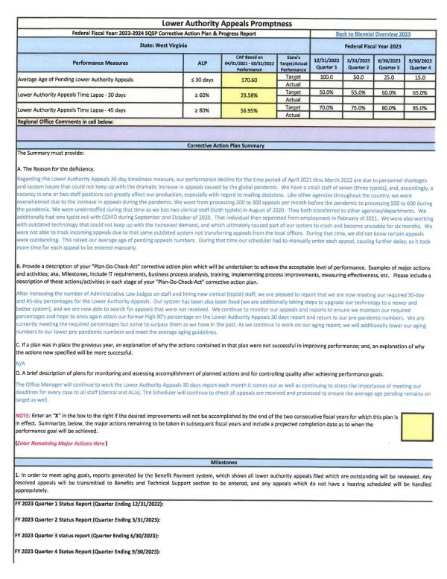



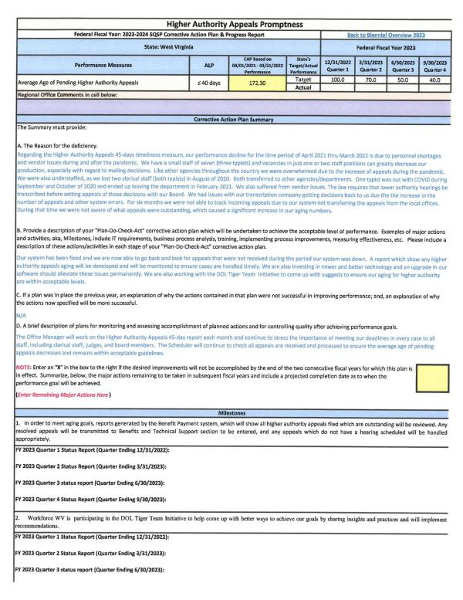


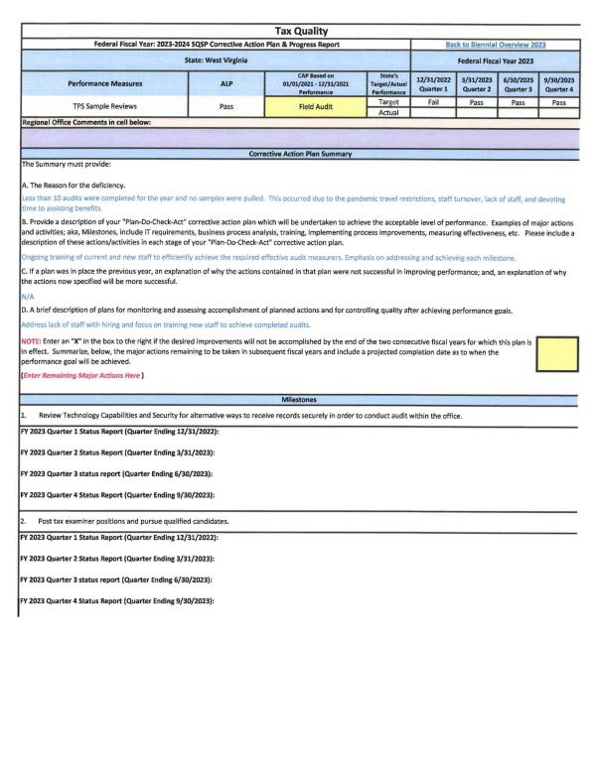


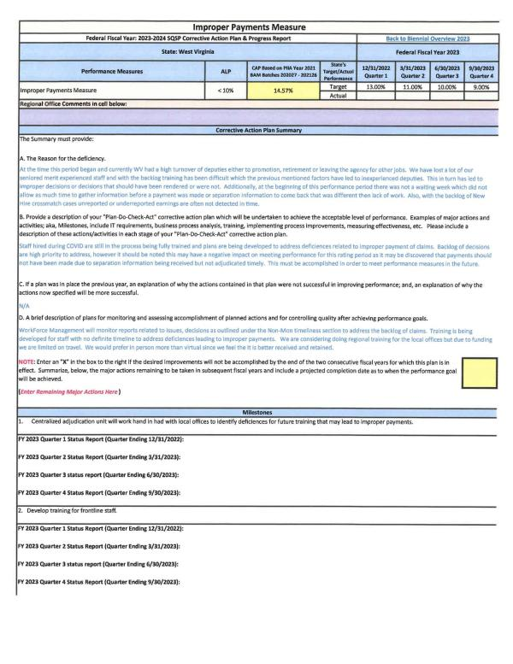


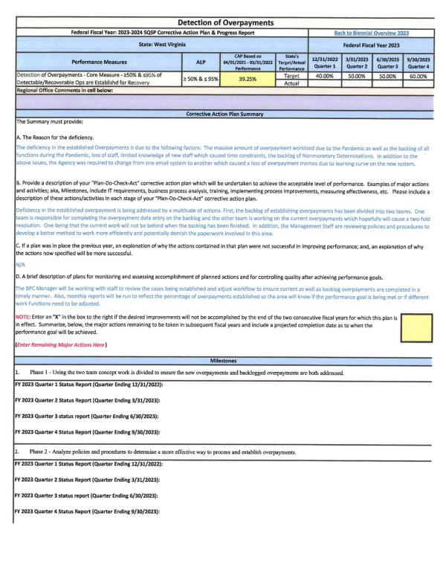


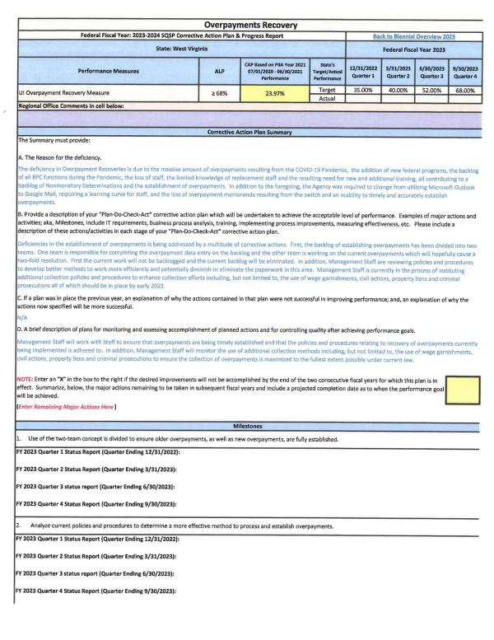


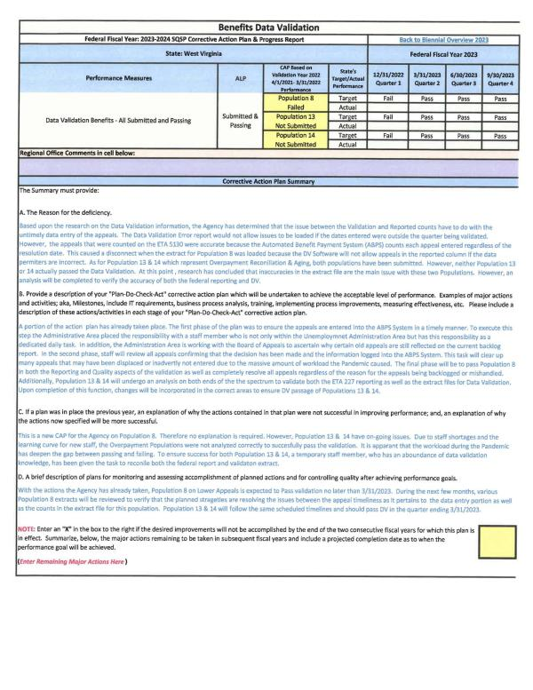
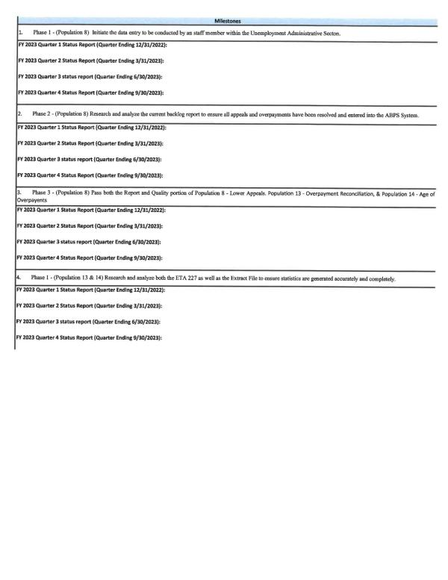

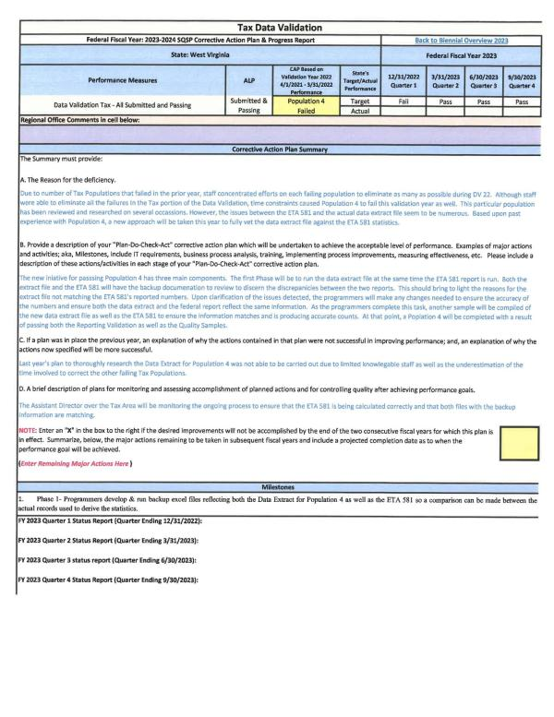


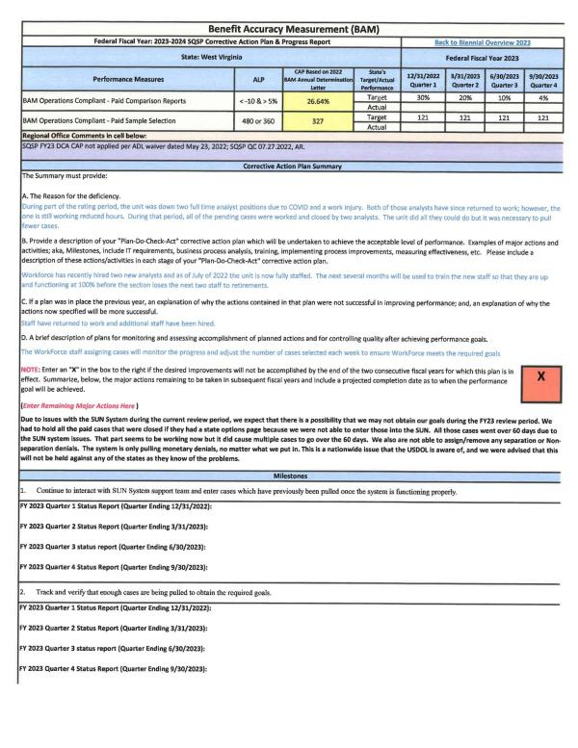


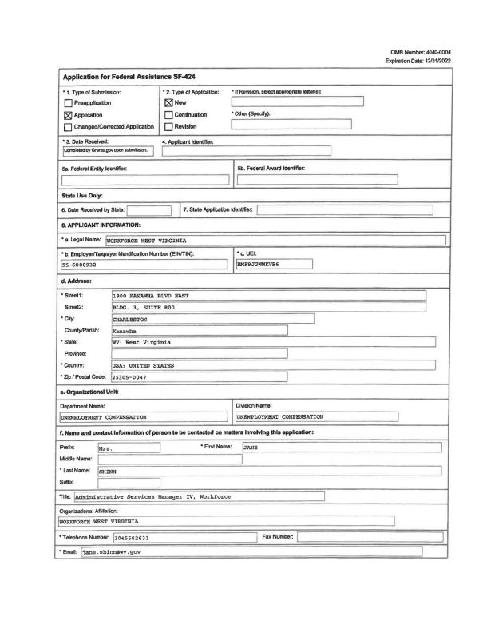
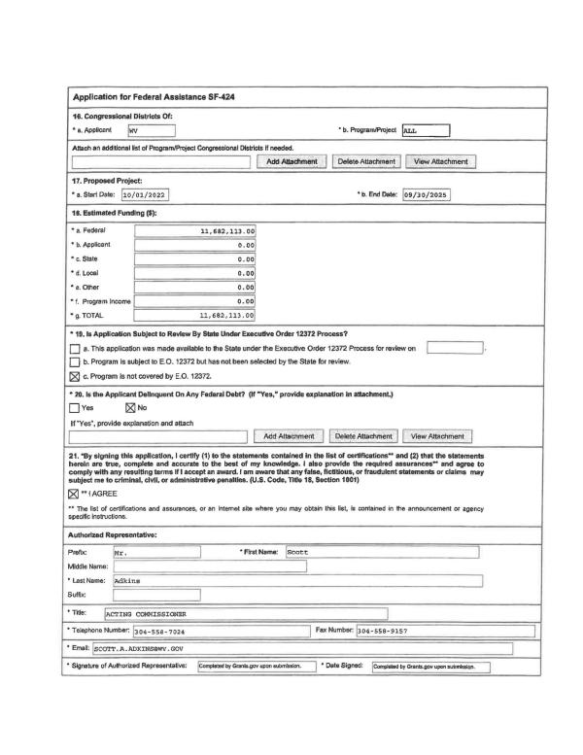
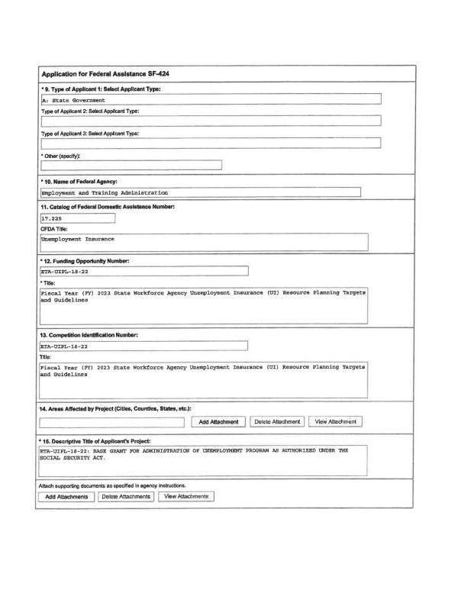
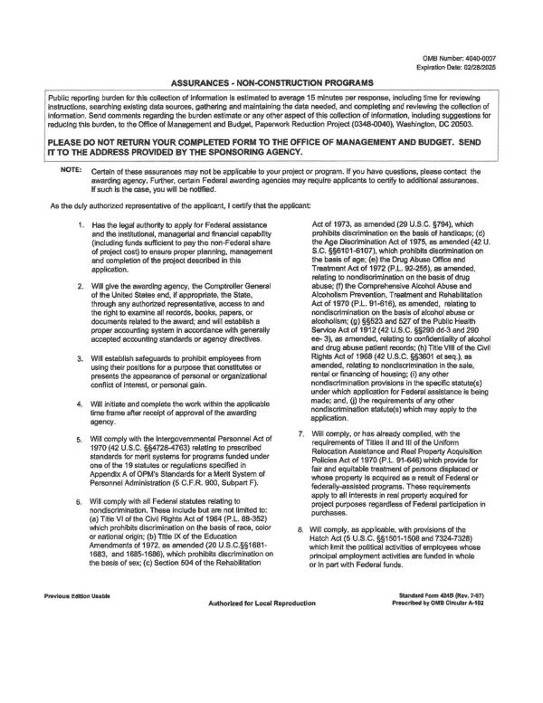
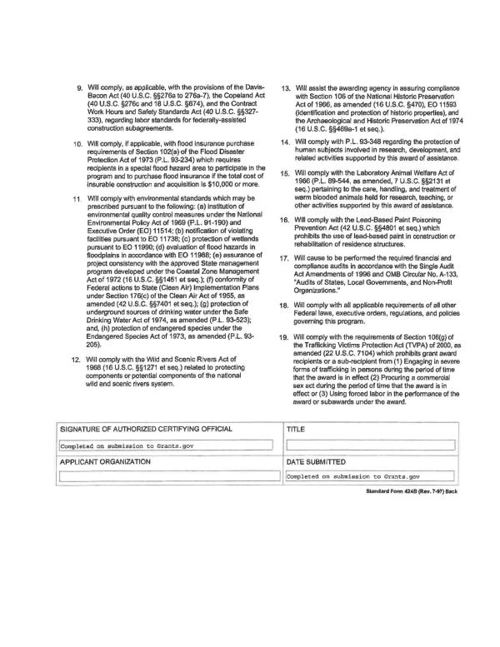
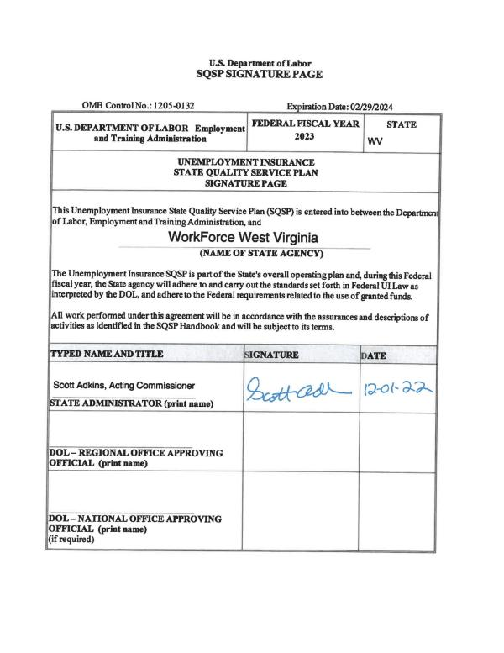

B. If a State is in the second year of the 2-year cycle, the State is required to submit the most recently approved complete SQSP package with a modification that must include the Transmittal Letter, Budget Worksheets/Forms, Organizational Chart, and the SQSP Signature page. The modification may also include CAPs for new identified performance deficiencies, and any required modifications to existing CAPs. The CAP must list both specific milestones for key corrective actions or improvement activities, and the completion date for each milestone.
Please see the complete SQSP package submitted in sections 'a' and 'b'.

2. Submit the required off-year SQSP components as a modification to the Combined State Plan on the same cycle as the regular SQSP process which must be approved by September 30th each year
Please see the complete SQSP package submitted in sections 'a' and 'b'.

Senior Community Service Employment Program (SCSEP)
(OMB Control No. 1205-0040)

a. Economic Projections and Impact

1. Discuss long-term projections for jobs in industries and occupations in the State that may provide employment opportunities for older workers. (20 CFR 641.302(d)) (May alternatively be discussed in the economic analysis section of strategic plan.)
A. ECONOMIC PROJECTIONS AND IMPACT
- DISCUSS LONG-TERM PROJECTIONS FOR JOBS IN INDUSTRIES AND OCCUPATIONS IN THE STATE THAT MAY PROVIDE EMPLOYMENT OPPORTUNITIES FOR OLDER WORKERS. (20 CFR 641.302(D))(MAY ALTERNATIVELY BE DISCUSSED IN THE ECONOMIC ANALYSIS SECTION OF STRATEGIC PLAN.)
According to the United States Census Bureau, West Virginia’s population totaled 1,852,994 during the last conducted census in 2010. The total number of West Virginians aged 55 and older totaled 562,229, comprising 30.4% of the state’s total population. Table 1-SCSEP illustrates the total population categorized by age ranges.
Table 1- SCSEP
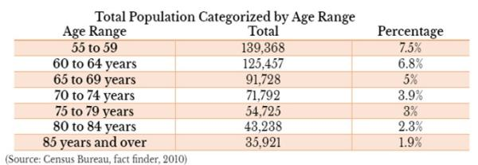

Figure 1- SCSEP shows the age distribution of West Virginia’s working age population in all industries which are broken down into twenty sectors. These sectors include Finance and Insurance; Real Estate; Professional; Scientific, and Technical Services; Management of Companies and Enterprises; Administrative Support; Waste Management and Remediation Services; Educational Services; Health Care and Social Assistance; Arts, Entertainment, and Recreation; Accommodation and Food Services; Other Services; and Public Administration.
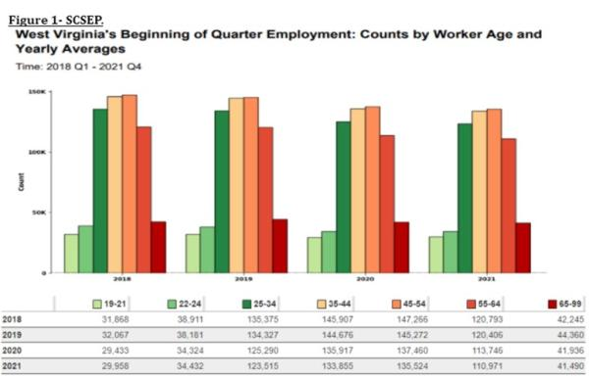
Figure 2- SCSEPnarrows down the population results showing only SCSEP’s target audience (55+) in all industries. As depicted in the figures, there is evidence of a slight decrease in the representation of (55+) seniors entering the workforce. This decrease in representation is a result of the Covid-19 Pandemic as SCSEP’s target audience being the most at risk to the disease. Once the numbers start to decrease not only statewide but nationally, I believe there will be an uptick of program participants entering the program.
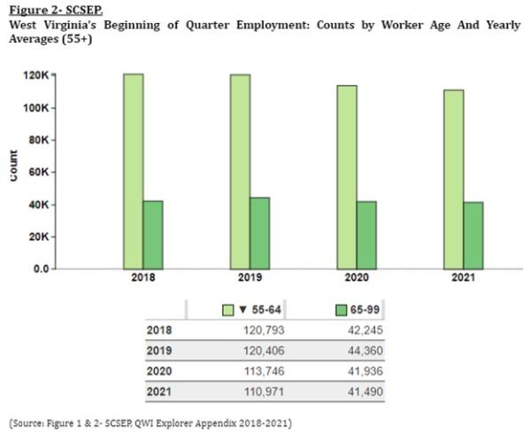
According to the Quarterly Workforce Indications (QWI), out of the twenty industries, the industry sectors that represented the largest numbers of employed seniors during 2018-2021 were Health Care and Social Assistance, Education Services, Retail Trade and Manufacturing. These sectors were the top four employers for older workers 55+ during 2018-2021. Table 2- SCSEP illustrates the industries during 2018-2021 that had the largest number of older workers.
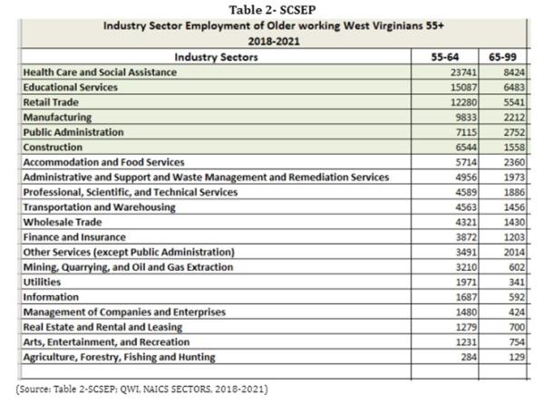
Information from the QWI was narrowed down to display which of the 20 Industry Sectors had the highest number of hiring older workers (55+). Industry Sectors with the largest number of hires of older workers during 2018-2021 for age range 55-64 were Health Care and Social Assistance, Construction, Administrative and Support and Waste Management and Remediation Services, Retail Trade. For the age range of 65-99 the results varied. Similar to the age range 55-64, Health Care and Social Assistance was also the top employer for age range 65-99. Educational Services, Retail Trade, Accommodation and Food Service were the remaining top employers that had the highest number of employed seniors for the age range 65-99 . Table 3-SCSEP illustrates the industries during 2018-2021 that had the largest number of 55+ seniors hired.
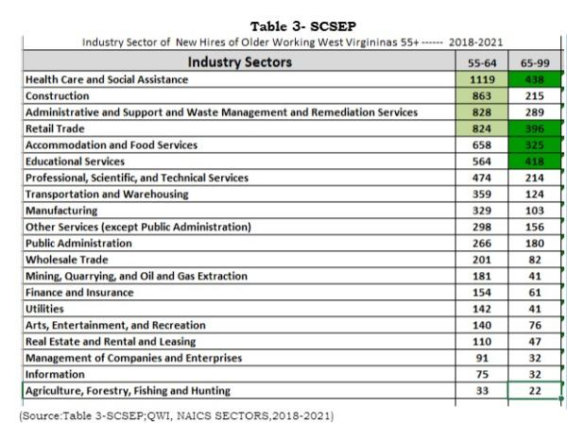
From the information gathered in Table 3-SCSEP, the staffing patterns from the top three Industry Sectors of New Hires show employment in Construction, Healthcare and Social Assistance, Administration and Support and Waste Management and Remediation Services, Accommodations and Food Services, Educational Services and Retail Trade . We can forecast that these industries will continue to hire older workers, thus providing employment opportunities in the following Equal Employment Opportunities (EEO) Occupations Groups based off the Industry Sector of New Hires: Transportation, Natural Resources, Construction & Maintenance Occupations, Sales and Office Occupations, Service Occupations, Education, Legal, Community Service, Arts & Media Occupations, Management, Business & Science. EEO Occupational Groups are categorized into 14 groups and further categorized into nine job categories.Table 4-SCSEP illustrates the twelve Occupational Groups that were narrowed down from the top Industries.
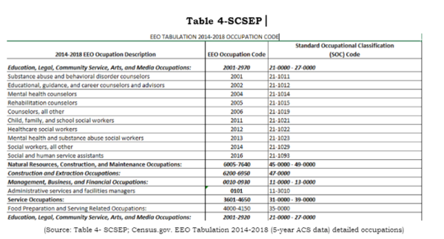

2. Discuss how the long-term job projections discussed in the economic analysis section of strategic plan relate to the types of unsubsidized jobs for which SCSEP participants will be trained and the types of skill training to be provided. (20 CFR 641.302(d))
In order to maximize SCSEP participant placement in unsubsidized employment in high demand jobs, the statewide SCSEP network; which consists of the one State and one National grantee, will focus their on-the-job training opportunities and host agency recruitment efforts with agencies that can provide training for the types of occupations that are listed in Table 3 -SCSEP that are forecasted based on Industry Sector of New Hires 2018 to hire older workers.
When available, training opportunities will be increased to provide a variety of opportunities that have a higher percentage of developing into unsubsidized employment. Training for computer literacy will continue to be at the forefront, as this is a necessity in a majority of the occupations that forecast continued employment. Computer training opportunities are provided through many entities, such as local American Job Centers (AJC), local Community Colleges, and public libraries. When appropriate, program coordinators and host agencies will encourage participation in specialized computer training opportunities.
Access to training classes offered by the local American Job Center and other non-profit organizations will help increase the skills that enrollees will need to continue to pursue employment.
Another strategy for older workers to be placed into unsubsidized employment would be to look into occupations that require minimum training, as this would help the statewide SCSEP network meet the employment goals listed in the core measures that are set forth by DOL.

3. Discuss current and projected employment opportunities in the State (such as by providing information available under §15 of the Wagner-Peyser Act (29 U.S.C. 491-2) by occupation), and the types of skills possessed by eligible individuals. (20 CFR 641.325(c))
Per the Workforce West Virginia (WFWV), Labor Market Information (LMI) Ten(10) year projections of the high demand occupations that require minimum education and fit our SCSEP participants’ education and training levels include the following:
- Bus Drivers, Transit and Intercity
- Customer Service Clerks
- Social and Human Service Assistants
- Community Health Workers
- Animal Caretakers
- Post Secondary School
- Personal Care Aides
- Home Health Aides
- Rehabilitation
- Janitors
- Counter Attendants
Some of these occupations require less than a high school education. Others require a high school diploma or some college. Per the data received from SPARQ, the majority of our participants meet the education requirements for the jobs listed above. Hourly wages for the listed occupations start at a minimum of $10.41. Table 5- SCSEP provides the educational level of program participants. Figure 54 in the Economic and Workforce Analysis showcases West Virginia's occupational projections by level of education.
Table 5- SCSEP
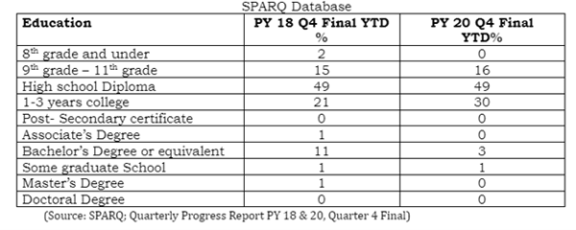
Table 5a- SCSEP provides employment projections based on the eight education levels in West Virginia.
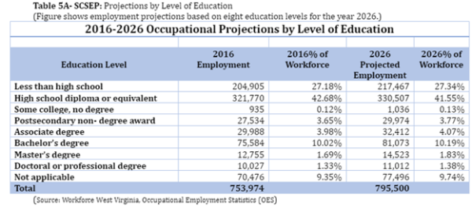
Table 6-SCSEP illustrates the required level of education, on-the job training, work experience required, and growth rate of each occupation.
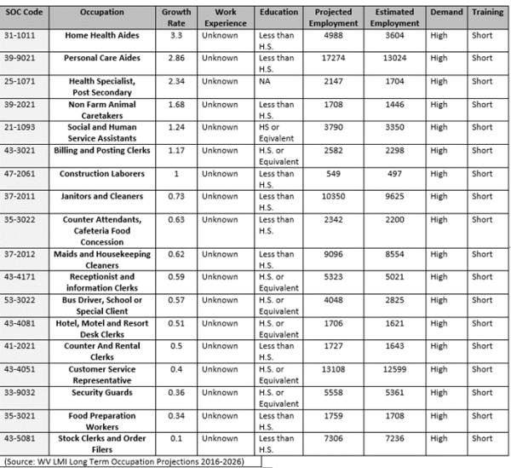
The Workforce West Virginia (WFWV) office divides the state into seven geographic regions that covers all 55 counties shown on the map in Figure 60 in the Economic and Workforce Analysis. As shown in Figures 12-18 and Figures 46-52 of the Economic and Workforce Analysis, each region shows their specific region’s Greatest Growth Occupation and Top Occupational Projections in the state. Not only does the WFWV consist of seven (7) geographic regions, the seven (7) regions each have at least one comprehensive AJC, at minimum. In total, the seven regions hold Ten (10) comprehensive centers, five (5) satellite centers and seventeen (17) affiliate sites throughout the State. One of the goals of the AJCWV is to offer job seekers and employers ready access to the many workforce development resources available in a local region. The WVWF office offers resources equally across the state as stated above. The SCSEP Network will continue to partner and utilize resources such as transition programs, adult displacement resources, utilization of the MAAC database, resume enhancement, computer classes, mock interviews and all other events that are offered at the AJCWV.
Within the seven (7) regions that WFWV has divided the state into, each region shows that Host Agency recruitment and enrollee training will have to be individualized to adapt to that particular Region’s occupational demands and projections. The SCSEP Network will maintain working relationships with all WFWV offices to obtain relevant employment and training information that pertains to that Region. Sub-grantees will continue to inform enrollees of their specific region’s occupational projections.
Also as the State continues to adapt to the unforeseen changes that have and continue to occur due to the pandemic, we will continue to develop and offer opportunities for program participants to participate when appropriate in a virtual platform to keep participants and program partners safe.

b. Service Delivery and Coordination

1. A description of actions to coordinate SCSEP with other programs. This may alternatively be discussed in the State strategies section of the strategic plan, but regardless of placement in document, must include:

A. Planned actions to coordinate activities of SCSEP grantees with WIOA title I programs, including plans for using the WIOA one-stop delivery system and its partners to serve individuals aged 55 and older. (20 CFR 641.302(g), 641.325(e))
West Virginia’s statewide SCSEP network includes the State Grantee and one National Grantee operating in WV. Communication with this network is accomplished through email and teleconference as needed throughout the Program Year. The State Grantee is the West Virginia Bureau of Senior Services, which provides a multitude of services for older Americans in West Virginia under the Older Americans Act (OAA). As the designated State Unit on Aging, the Bureau administers all OAA services throughout the 55 counties that are tailored to Older West Virginians. The Bureau maintains contracts with each of the 55 County Aging Programs, three (3) Statewide Aging & Disability Resource Centers and four (4) Area Agencies on Aging. The Bureau’s mission is to be West Virginia’s premier advocate for the provision of in-home and community-based services for the state’s seniors and others served by our programs and to be a faithful steward of the federal and state monies entrusted to our care for the provision of services throughout West Virginia.
Through a Memorandum of Understanding, the WV Statewide SCSEP network, a mandated partner, partners with the local Workforce Investment Boards operating the American Job Center (AJC)/ One-Stop Centers. The mission and vision between the AJC and WV SCSEP are to empower area employers, individuals and communities to prosper and grow the region’s economy through a workforce development system that is inherently customer-centered, seamless and effective. The mission is to establish a workforce system that provides data-driven and employer-validated talent solutions through the integration of education, workforce and economic development resources across the systems. Its vision is assisting individuals in obtaining employment.
West Virginia’s American Job Centers (AJC’s)/One-Stops are currently located within the local Workforce centers in West Virginia. All SCSEP information is disseminated throughout the AJC for other programs and to the general public. The WV Statewide SCSEP network will continue to work closely with the AJC’s to utilize the partners’ resources that are tailored to SCSEP’s target audience by co-enrolling and by providing SCSEP’s program eligibility requirements, priorities and training slots availability. SCSEP will continue to have a weekly presence at the AJC/One-Stop. The Statewide SCSEP network will continue to require enrollment of SCSEP enrollees into the Local Workforce to ensure that enrollees are abreast of employment opportunities in their areas. The network will also continue to utilize all training, job postings and job fairs that are offered at the Local AJC’s and will also participate/relay information from other resources outside of the AJC’s One-Stop Partners. The WV Statewide SCSEP network will also encourage enrollees who are approaching their durational limit to enroll in other training programs to ensure a continuous improvement of skills that enrollees receive. As needs become prevalent, the WV Statewide SCSEP network will encourage AJC’s to become Host Agencies and/or consider enrollees for employment opportunities.

B. Planned actions to coordinate activities of SCSEP grantees with the activities being carried out in the State under the other titles of the Older Americans Act (OAA). (20 CFR 641.302(h))
As stated previously, West Virginia’s statewide SCSEP network includes the State Grantee and one National Grantee operating in WV. The State Grantee for SCSEP is the West Virginia Bureau of Senior Services, which provides a multitude of services for older Americans in West Virginia under the Older Americans Act (OAA). As the designated State Unit on Aging, the Bureau administers all OAA services throughout the 55 counties that are tailored to Older West Virginians. SCSEP Coordination with OAA programs, meetings and events will be continued. Information will continue to be disseminated throughout the State.

C. Planned actions to coordinate SCSEP with other private and public entities and programs that provide services to older Americans, such as community and faith- based organizations, transportation programs, and programs for those with special needs or disabilities. (20 CFR 641.302(i))
The WV Statewide is a member of the Interagency Collaborative Team (ICT), which is composed of leadership from entities such as the Division of Rehabilitation, WV Correctional Industries, Veteran Services and more that represent the workforce target groups. One of the primary goals of this group is to enhance communications, maximize resource sharing and program standardization. Additionally, the Bureau sits on the WV Workforce Development Board, which is composed of key state players within the workforce arena, including legislators, members of the Governor’s Cabinet, labor leaders and corporate representatives. The main purpose of this group is to approach the system-based issues that require changes in law or formal regulations pertaining to workforce initiatives. As stated, these entities are composed of private and public key stakeholders. The WV Statewide SCSEP network will continue to maintain relationships and participate in meetings and events to guarantee that SCSEP is considered for program partnership, employment opportunities for enrollees and ultimately remains relevant in discussions regarding barriers to employment. The Bureau will remain an advocate for Older Workers in these groups.
Partnerships will be increased with organizations that provide resources on how to alleviate employment barriers throughout the state, such as transportation, rural location, age discrimination, fear of health care being discontinued due to program participation, fear of losing subsidized housing benefits, just to name a few. The Area Agencies on Aging (AAAs) who contract with county aging providers continue to be utilized and researched to determine what additional employment barriers seniors in rural/urban counties might face. Furthermore, the Bureau will take a more active approach with reaching out to AAA’s to also determine additional resources and/or training opportunities that may be available in covered areas. Faith based and community organizations will be utilized to help disseminate information regarding the program while reaching the most in need population. Also look to increase these entities as Host Sites.

D. Planned actions to coordinate SCSEP with other labor market and job training initiatives. (20 CFR 641.302(j))
The WV Statewide SCSEP network will continue to utilize the Labor Market Information (LMI) data that is county specific to ensure that enrollees are receiving the most updated training to warrant eligibility for those high demand occupations in growing industries as discussed in the “Economic Projections” of this report. Ultimate goal for enrollees is that when they leave the program, they will be better off than when they entered. Workforce WV provides quarterly information regarding the job market, as they are the clearing house of employment opportunities for State, Private and non-profit sectors. This information will be researched by the Grantee to ensure that Sub-Grantees are providing enrollees with the essential tools needed to be marketable. Also, resources such as O*net Online will be utilized to determine the necessary skills needed for different occupations that enrollees may be interested in. The WV Statewide SCSEP network will continue to participate with Boards and Commissions.

E. Actions to ensure that SCSEP is an active partner in the one-stop delivery system and the steps the State will take to encourage and improve coordination with the one-stop delivery system. (20 CFR 641.335)
As stated previously, The WV Statewide SCSEP network will continue to work closely with the AJC’s to utilize the partners’ resources that are tailored to SCSEP’s target audience by co-enrolling and by providing SCSEP’s program eligibility requirements, priorities and training slots availability to AJC partners. SCSEP will continue to have a weekly presence at the AJC/One-Stop. The Statewide SCSEP network will continue to require enrollment of SCSEP enrollees into the Local Workforce to ensure that enrollees are abreast of employment opportunities, and training in their areas. The network will also continue to utilize all training, resources and job fairs that are offered at the Local AJC’s. The Statewide SCSEP network will continue to participate in quarterly meetings and retreats as this provides insight on each program that partners with the One-Stop.

F. Efforts to work with local economic development offices in rural locations.
The WV Statewide SCSEP network will continue to collaborate with entities such as the Workforce Development Board and AJC’s that have representation of local economic development offices whose presence is in both Rural and Urban locations throughout the state. Efforts will be continued to persuade these organizations to become Host Agencies. Outreach efforts to areas that have a more vulnerable populations of eligible enrollees will continue to be increased to maximize outreach efforts.

2. The State’s long-term strategy for engaging employers to develop and promote opportunities for the placement of SCSEP participants in unsubsidized employment. (20 CFR 641.302(e)) (May alternatively be discussed in the State strategies section of strategic plan.)
West Virginia’s local SCSEP projects will continue to recruit public and non-profit organizations in the communities that are covered. Local Projects will continue to advocate for older workers through presentations, brochure dissemination, poster dissemination, job fair and community events participation and increasing awareness of the program's vision and mission to community stakeholders. We will also utilize social media as a resource to engage employers by showcasing SCSEP enrollees’ skills.
Local SCSEP projects train participants to help develop the skills and experience necessary to be competitive in the current labor markets. Due to the longevity of organizations that participate as Host Agencies, local SCSEP projects have built a rapport with current Host Agencies and past Host Agencies to consider enrollees for employment opportunities within their organization when available. They have established cooperative relationships with the local AJC and public and private employers as well. Coordination and co-location of services at the AJCs help to identify suitable job openings in high demand occupations. Local SCSEP projects will continue to build strong rapport with the communities they are in.

3. The State’s long-term strategy for serving minority older individuals under SCSEP. (20 CFR 641.302 (c))
West Virginia will continue its recruitment efforts in serving and recruiting eligible minority individuals as well as other eligible individuals. SCSEP projects will continue to locate offices in culturally and ethnically diverse neighborhoods (i.e., Community Centers, Church's). The SCSEP Network will continue to have a presence at events such as the West Virginia Minority Business Expo, Juneteenth Celebration and Herbert Henderson Office of Minority Affairs Listening Tours to target minority audiences throughout the state. SCSEP will continue to collaborate with the State’s Minority Affairs office when available .Per the United States Census, West Virginia’s 55+ Older American population during 2010 represented 30.4 % of the overall population. Table 7a- SCSEP illustrates West Virginia demographics categorized by age, while Table 7b-SCSEP illustrates the overall race population in West Virginia.
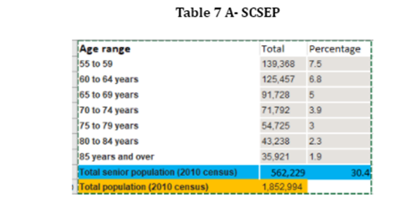
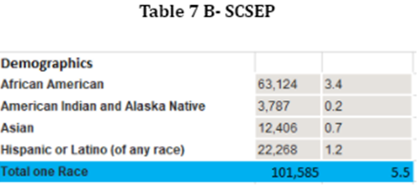
(Source: 2010 United States Census: Factfinder)
Even with the overall population of minority demographics representing 5.5 % of the entire state, WV Local SCSEP projects are able to capture a high percentage of minority representation throughout the program. Table 8-SCSEP illustrates the minority representation currently in the program, captured from the SPARQ database. The WV Statewide SCSEP network will continue to reach out to local NAACP and HBCU throughout the state to partner and collaborate with.
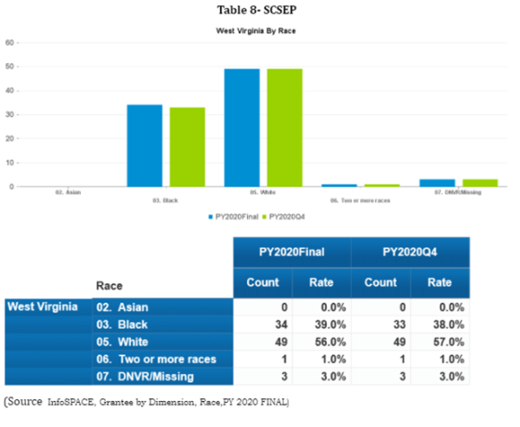

4. A list of community services that are needed and the places where these services are most needed. Specifically, the plan must address the needs and location of those individuals most in need of community services and the groups working to meet their needs. (20 CFR 641.330)
SCSEP has a two-fold approach: helping Older Americans reacclimate themselves back into the workforce with the skills and training needed to be more marketable in the workforce while also helping the communities that the program operates in. The participant training hours support social services and other services provided in communities throughout the State.
West Virginia’s top occupations per the West Virginia Workforce, Labor Market Information (LMI) 10-year projections of high demand occupations that require minimum education that fit our SCSEP participants’ education and training levels include the following:
- Bus Drivers, Transit and Intercity
- Customer Service Clerks
- Social and Human Service Assistants
- Community Health Workers
- Animal Caretakers
- Post-Secondary School
- Personal Care Aides
- Home Health Aides
- Rehabilitation
- Janitors
- Counter Attendants
With these projections, Host Agency (H.A.) training site recruitment will focus more on entities that will develop skills for these high demand jobs. Also, to ensure that SCSEP’s two-fold approach is being accomplished, local SCSEP projects will continue to research nonprofits, religious organizations and Government agencies in the counties that are covered to assess if there is a need. Recruitment of entities such as the West Virginia Department of Agriculture where they have programs such as Veterans and Warriors to Agriculture and Rural Rehabilitation programs that need participants will be utilized.
Recruiting of Host Agencies (H.A.) is currently accomplished by relationships with past and current H.A., great rapport with the American Job Centers (AJC’S), attending meetings, community events, job fairs, health fairs and presenting on behalf of SCSEP. Other avenues of recruitment include marketing campaigns, where Project Directors market SCSEP services and the skills of job ready participants to organizations. Word of mouth is also utilized to recruit host agencies.
Local SCSEP projects will continue to utilize Senior Centers, Aging & Disability Resource Centers (ADRN), OAA programs, AJC’s, and one-stop partners to determine the need in the counties and will continuously refine the strategy for job development to guide employer outreach and participant readiness. The WV Statewide SCSEP network will also continue to have a virtual training presence to utilize in the event a training site is shut down due to circumstances at hand.

5. The State’s long-term strategy to improve SCSEP services, including planned long-term changes to the design of the program within the State, and planned changes in the use of SCSEP grantees and program operators to better achieve the goals of the program. This may include recommendations to the Department as appropriate. (20 CFR 641.302(k))
The strategy to improve SCSEP services within the State is to do the following:
- Marketing Campaign- not only disseminate information regarding SCSEP but also promote the program at key meetings to educate organizations of the Mission and Vision
- Reach out to hiring entities to discuss SCSEP
- Exchange information regarding eligible Older Workers with AJCs
- AJCs become H.A.
- Encourage cross training in training opportunities for enrollees
- Inclusion within the WIOA State Plan
- Provide more incentives, such as drug screenings, criminal background checks for hiring entities
- Develop relationship with State DHHR to improve requirements for SCSEP target audience (i.e. Medicaid allotment of income)
- Revise goals with DOL to reflect actual program funding
- Increase funding to provide more trainings for enrollees
- Increase H.A. recruitment for a variety of training opportunities ( I.e., having all state agencies utilize the SCSEP program)
- Partnering with local Correctional industries to minimize recidivism rate of seniors 55+
- Creating a virtual training platform to help most in need individuals.
These recommendations will strengthen the SCSEP program within the State, affording not only potential and current enrollees’ opportunities, but also strengthening the organizations that work with the program.
Regarding the long-term changes in the use of grantee and program operators to better achieve goals, the SCSEP network, with its sub grantees, continuously refines its expertise on the basic elements of job development by staying abreast of the many barriers that eligible enrollees face. By trying to alleviate these barriers, Sub-Grantees are continuously assessing skills of participants, revamping Individual Employment Plans, offering additional resources, preparing for exit, resume revamping through workshops and offering one-on-one interaction with SCSEP Staff. As new barriers arise, grantee staff will adapt and provide resources.

6. The State’s strategy for continuous improvement in the level of performance for SCSEP participants’ entry into unsubsidized employment, and to achieve, at a minimum, the levels specified in OAA Section 513(a)(2)(E)(ii). (20 CFR 641.302(f))
The entered employment performance goal continues to be a challenge. During PY 18, the Core Performance measures were revamped from being measured as Common Measures Entered Employment and Common Measure Employment Retention to now Employment Rate 2nd and 4th quarter after exit. This major change came about with the Interim Final Rule (IFR) SCSEP Performance Accountability that was issued by USDOL/ETA on December 1, 2017. The purpose of the New Core Measures appears to be an alignment of SCSEP performance data with Workforce Innovation and Opportunity Act (WIOA)performance data to provide usable data comparisons between the programs. Prior to the adjustment, the rate of meeting the projected goals fluctuated. Table 9 SCSEP reflects the variance during each PY.
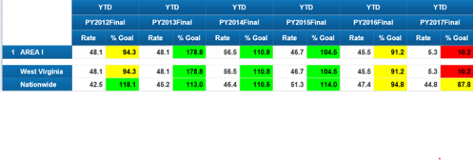
(Source: Infospace, Core measures, entered employment Sub-grantee)
After the modification of the goals, it was evident that the employment goal/retention needed much improvement and was a barrier that the program faced. Table 10 SCSEP reflects the performance of entered employment for 2nd and 4th quarter after exit during the final quarters of PY 17-20.
Table 10-SCSEP
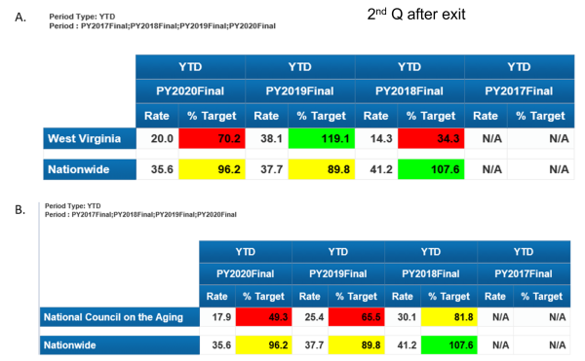
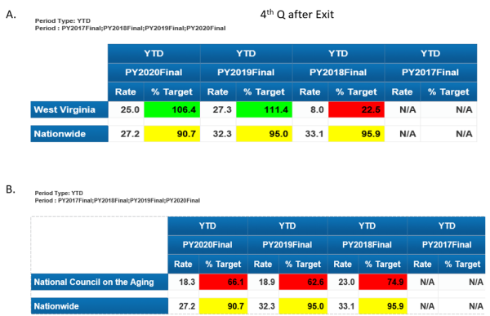
(Source: Infospace, Core measures, entered employment Sub-grantee)
Due to the performance during the program years, our approach moving forward is to ensure that the program, specifically the employment aspect of the program, has continuous improvement, the following strategy must be implemented:
- Ensure that Sub-Grantees are aware of the LMI high-demand positions
- Provide adequate training for enrollees
- Increase accountability of job search log of enrollee
- Continue and increase partnerships with hiring entities to ensure that enrollees are being considered
- Increase H.A. sites to provide a variety of training opportunities
- Collaborate with other employment programs
- Increase program outreach and program resources
- Revamp individual employment plan (I.E.P) of individuals to ensure job search complies with employment plan
Another barrier that was identified is the majority of SCSEP’s target audience have supplemental insurance, reside in subsidized housing, and/ or receive Social Security Benefits, and because of this factor, the likelihood of them obtaining employment at the completion of the program is very slim. This is due to the fear that benefits will be lost and/or adjusted. Another strategy would be educating enrollees regarding employment and their current benefits. Eligible seniors want to work but are apprehensive.

c. Location and Population Served, including Equitable Distribution

1. A description of the localities and populations for which projects of the type authorized by title V are most needed. (20 CFR 641.325 (d))
Most recent West Virginia U.S. Census data shows the 2010 total population for the state of WV at 1,852,994. The population of individuals who are the SCSEP target audience, 55+, shows 562,229, which is 30.4 % of the total population. Of this population, an estimate of 27.7% are at poverty rates for families and people for whom poverty status is determined.
WV partners with a plethora of State and non- profit organizations that play the role of Host Agencies (H.A.). Majority of our H.A. are unable to hire additional help within their organizations due to the limit in funding, but they express that help is needed. H.A. range from local municipalities to State agencies to a local YMCA. All H.A. are essential to the overall success of the program, as they provide the hands-on training that is needed and vital to the program.
Within the SCSEP, priority of service is offered to the following individuals:
o Veteran or a Spouse of a Veteran
o 65 Years or Older
o Has a Disability
o Has Limited English Proficiency
o Low Literacy Skills
o Resides in Rural Area
o Low Employment Prospects
o Homeless or At Risk of Homelessness
o Failed to Find Employment After Utilizing Services Provided Under Title I
o Severely Low Employment Prospects and Living in an Area of Persistent Unemployment
o Formerly Incarcerated

2. List the cities and counties where the project will be conducted. Include the number of SCSEP authorized positions and indicate where the positions changed from the prior year.
Within West Virginia, there were two SCSEP providers covering 455 authorized positions during PY 20. Modified positions during Program Year 2019 were 368 while during Program Year 2020 there were 378 statewide. Currently, West Virginia has one National Grantee, National Council on Aging, and one State Grantee, West Virginia Bureau of Senior Services, that comprise the Statewide SCSEP Network. These grantees are experienced SCSEP administrators and are respected, capable partners. The Sub Grantee has created well-established relationships with host training sites, employers, supportive service resources and training providers.
Among these providers, they cover all 55 counties in WV. The distribution of authorizations is based on the Equitable Distribution as provided by U.S. DOL, which identifies each county’s percentage of the state’s program-eligible population.
In 2016, SCSEP held a national competition, which resulted in one National Grantee being eliminated. Due to the elimination of the National Grantee, slot allocations changed, and the National Grantee, NCOA inherited all allocated slots of the eliminated National Grantee. Table 11-SCSEP represents the Authorized Positions that each grantee had during Program Year 2019 to Program Year 2020. Table 12-SCSEP goes more in-depth, showing how the counties are distributed amongst the 55 counties that are covered in West Virginia with each provider.
Table 11-SCSEP
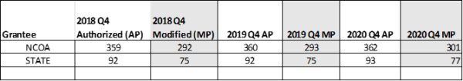 ( Source- SCSEPed.org, Authorized and Modified Positions by State Q4)
Table 12-SCSEP
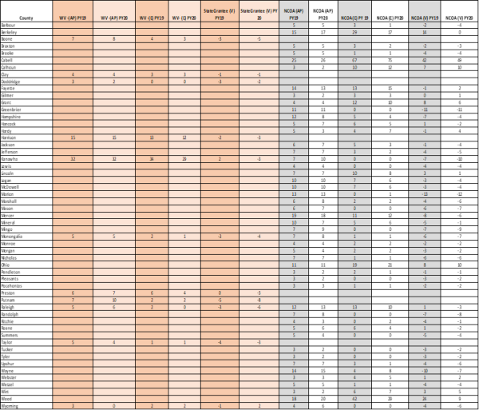
( SOURCE: SCSEP.ORG, WV PY 19 & PY 20, Modified and Authorized Positions by State)

3. Describe current slot imbalances and proposed steps to correct inequities to achieve equitable distribution.
Equitable distribution imbalance is caused by many factors, as shown below, that cause a variance in the slots in the Statewide SCSEP Network. The main variance factor in West Virginia is minimum wage. Due to the rising minimum wage and funding, the number of participants who can be assisted are impacted by this factor, and slots must be adjusted to meet the minimum wage fluctuations. In order to achieve the Modified Positions goal with the factors at hand, the SCSEP Network would have to minimize participant hours to accommodate more participants.
Another cause for imbalance/variance is the State’s layout. Majority of our counties are categorized as rural counties and because of this, there are many barriers such as:
- Transportation
- Limited training site opportunities
- Limited hiring entities
- Over income seniors
- Small applicant pool
- Unaware of program (potential enrollee and potential training)
As a State, we want to ensure that we are fully enrolled and want to minimize any variance in SCSEP’s equitable distribution enrollee count. How we will attain this goal is by continuing partnership with local WorkForce offices, continue and increase outreach in areas that are under enrolled while curtailing areas that are over enrolled and begin the discussion of interchanging information among National and State Grantees to fulfill the equitable distribution of all urban and rural counties that are under enrolled. We will also continue to secure partnerships with local AAA’s as well as trying to partner with local universities and HBCUs.

4. The State’s long-term strategy for achieving an equitable distribution of SCSEP positions within the State that:

A. Moves positions from over-served to underserved locations within the State in compliance with 20 CFR 641.365.
West Virginia is divided into 55 counties. The State and National Grantee covers 13 urban counties collectively, with the remaining counties being considered rural. Based on the 2016-2018 Persistent Unemployment data, 36 of the 55 counties in West Virginia are considered having persistent unemployment. Of the 42 rural Counties, 31 show as having persistent unemployment. As stated previously, rural communities face a multitude of barriers. To alleviate the imbalances, the SCSEP Network will continue and increase outreach (i.e., brochures, posters, partnerships and presentations) efforts in the rural counties to ensure that nonprofits and government entities are aware of the program.
The U.S DOL determines how counties are distributed based on information obtained from the Bureau of Census report which is then transposed into the Equitable Distribution report for each county. The State of West Virginia SCSEP Grantee has no authority to move national grantee positions within the state; however, constant contact is maintained with the National. Conversations and recommendations to alleviate variances will continue to be discussed within the statewide SCSEP Network.

B. Equitably serves rural and urban areas.
As stated previously, West Virginia is divided into 55 counties. The State and National Grantee covers 13 urban counties collectively, with the remaining counties being considered rural. Based on the 2016-2018 Persistent Unemployment data, 36 of the 55 counties in West Virginia are considered having persistent unemployment. Of the 42 rural Counties, 31 show as having persistent unemployment. As stated previously, rural communities face a multitude of barriers such as limited resources, transportation , over income, low employment skills and more while on the other hand, Urban areas also face barriers. Barriers that Urban counties face are similar to those in Rural areas such as income requirements, duplication of efforts , low employment skills. and transportation. Efforts of dissemination of program specific material and partnership is equitable in both Urban and Rural areas. The WV SCSEP Network will continue its efforts in both urban and rural counties, specifically those counties that house individuals who are most in need will be continuously reviewed.

C. Serves individuals afforded priority for service under 20 CFR 641.520. (20 CFR 641.302(a), 641.365, 641.520)
Program regulations require SCSEP Grantees to give priority service to individuals with one or more of the following characteristics:
- Veteran or a Spouse of a Veteran
- 65 Years or Older
- Has a Disability
- Has Limited English Proficiency
- Low Literacy Skills
- Resides in Rural Area
- Low Employment Prospects
- Homeless or At Risk of Homelessness
- Failed to Find Employment After Utilizing Services Provided Under Title I
- Severely Low Employment Prospects and Living in an Area of Persistent Unemployment
- Formerly Incarcerated
The statewide SCSEP Network employs the following tactics to ensure that individuals who meet the criteria above are targeted:
- Outreach Materials (brochures and posters) are strategically placed at locations that target our priority of service audience (i.e. Veterans Hospitals, shelters, library, rehab disability office, parole services, etc.)
- Locates offices in culturally and ethnically diverse neighborhoods
- Targets AJC’s
- Presents and collaborates with entities that target low income populations
- Collaborates with National Grantee on successful tactics utilized

5. The ratio of eligible individuals in each service area to the total eligible population in the State. (20 CFR 641.325(a))
5(c). THE RATIO OF ELIGIBLE INDIVIDUALS IN EACH AREA TO THE TOTAL ELIGIBLE POPULATION IN THE STATE. ( 20 CFR641.325(A))
Table 13-SCSEP
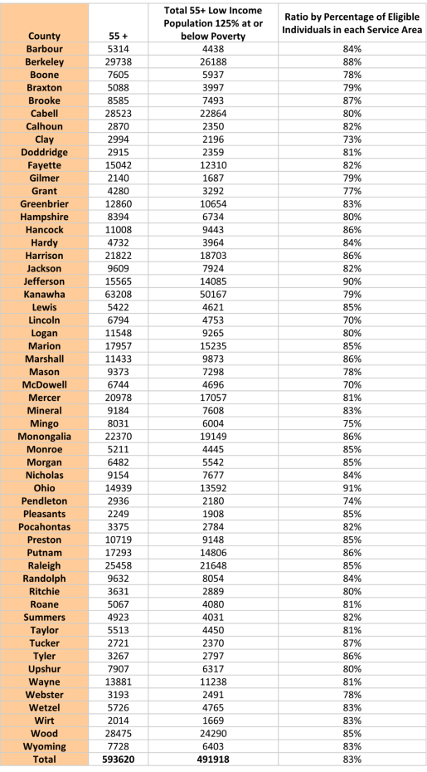 (Source: AGE BY RATIO OF INCOME TO POVERTY LEVEL IN THE PAST 12 MONTHS 2013-2017 American Community Survey 5-Year Estimates, B170248)

6. The relative distribution of eligible individuals who:

A. Reside in urban and rural areas within the State
6. (A). RESIDE IN URBAN AND RURAL AREA WITHIN THE STATE
Table 15-SCSEP
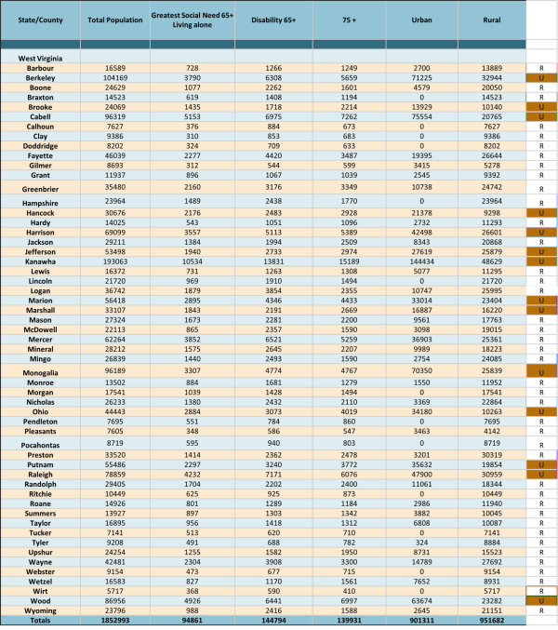
(Source:P2 Urban and rural universe :total population 2010 census summary file 1, P1 Total population Universe : Total Population 2010 C, Table DP02 2018 ACS 5yr ( living alone & disability),:Table B01001- Age sex 2017 (75+ 2013-2017 ACS 5yr estimates

B. Have the greatest economic need
HAVING THE GREATEST ECONOMIC NEED
Table 16- SCSEP
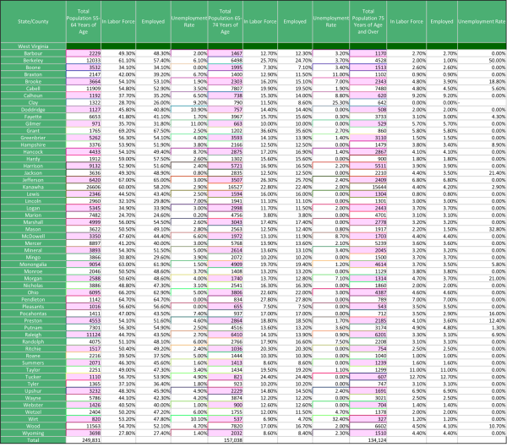
(Source: Census Bureau ACS,S2301)
Table 17A-SCSEP
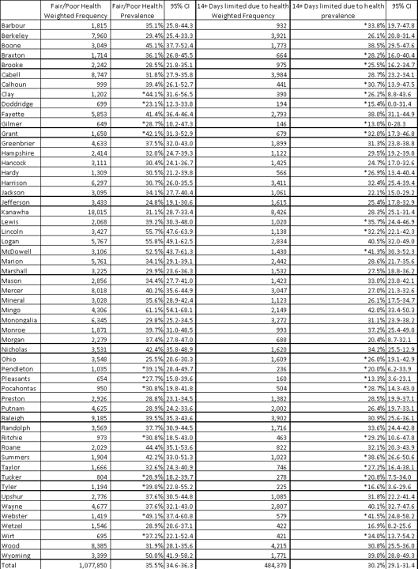
Table 17B-SCSEP
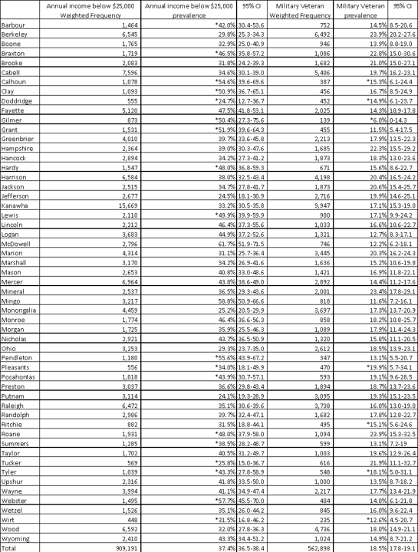
**Estimates are unreliable due to confidence intervals wider than 20% or relative standard error greater than 30%. Percentages are calculated with the unknowns removed.
(Source: Table 17A-B , Selected Health Outcomes and Demographics among WV Residents 55+, 2014-2018, WV Health Statistics Center, Behavioral Risk Factor Surveillance System)

C. Are minorities
6.(C). Are Minorities
Table 18-SCSEP
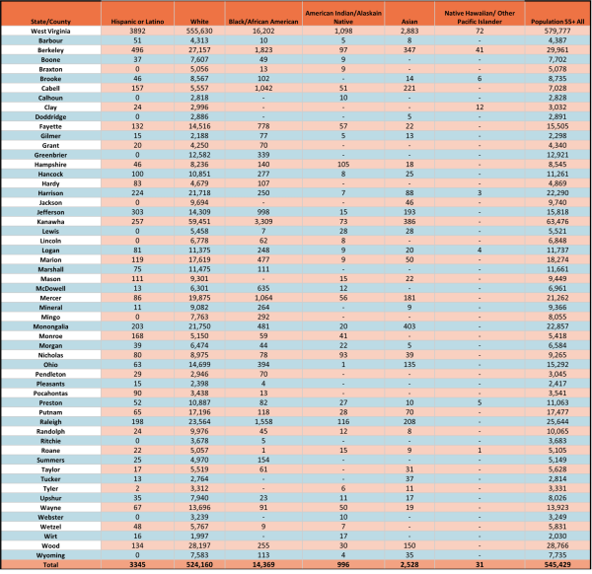
(Source: Census Bureau, Universe AMS 5-year 2013-2017 Estimates B01001)

D. Are Limited English Proficient
Are limited English Proficient
Table 19- SCSEP
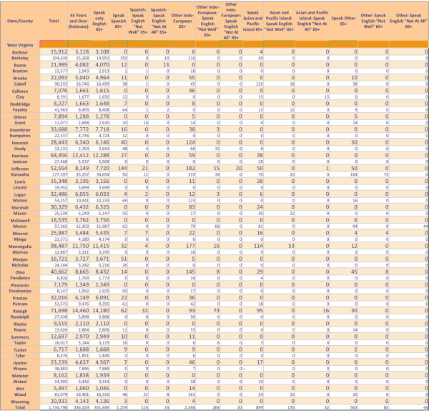
(Source: Census Bureau, ACS B16004,Age by population spoken at home, Total population)

E. Have the greatest social need. (20 CFR 641.325(b))
HAVE THE GREATEST SOCIAL NEED (20 CFR 641.325(B))
Table 15-SCSEP
(Source::P2 Urban and rural universe :total population 2010 census summary file 1, P1 Total population Universe : Total Population 2010 C, Table DP02 2018 ACS 5yr ( living alone & disability),:Table B01001- Age sex 2017 (75+ 2013-2017 ACS 5yr estimates)

F. Formerly incarcerated individuals, as defined in TEGL 17-20
The WV SCSEP Network will continue to partner with the WV Division of Corrections and Rehabilitation and with entities whose target audience are the formerly incarcerated population. Entities that provide transitional housing will continue to provide referrals to the SCSEP program. The WV SCSEP Network will continue to provide outreach materials to case managers and parole officers so they are aware of the program’s mission. Table 20-SCSEP shows the formerly incarcerated release in each county of all ranges. Table 21-SCSEP further narrows down the data to illustrate formerly incarcerated individuals of the SCSEP target audience.
Table 20-SCSEP
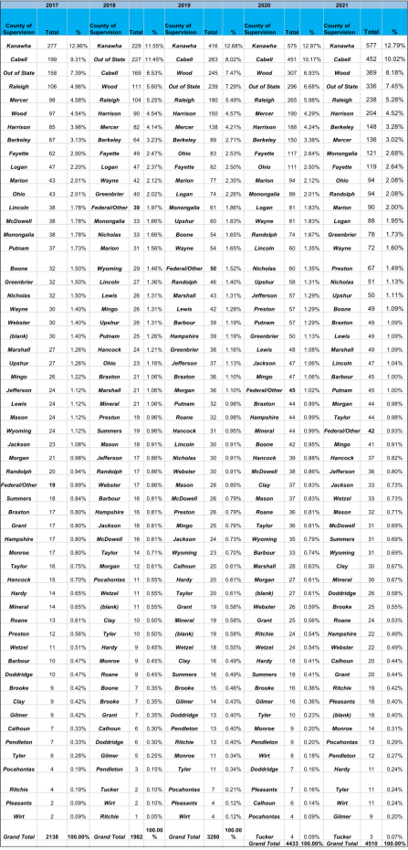
Table 21-SCSEP
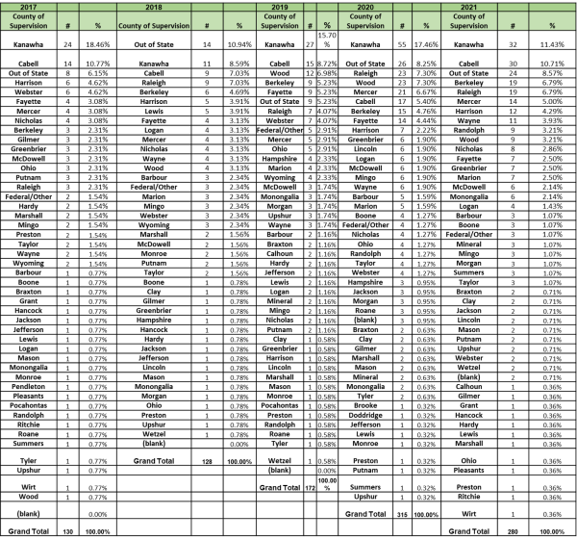 (Source: Table 20-21, WV Division of Corrections and Rehabilitation, 2017-2021)

7. A description of the steps taken to avoid disruptions to the greatest extent possible, when positions are redistributed, as provided in 20 CFR 641.365; when new Census or other reliable data become available; or when there is over-enrollment for any other reason. (20 CFR 641.325(i), 641.302(b))
In the event new providers are entered into the state, be it National Grantee or State Grantee, we will utilize the Equitable Distribution to ensure that slots are distributed to all grantees. To avoid disruptions to current participants, a conversation with all affected Grantees in the state will be required. Counties with continuous variances will be considered. For a seamless transition, enrollees will be transferred in the SPARQ database, which will allow the avoidance of disruption in service. Per Topic 81 of the SCSEP Data Collection Handbook, all records moved from the “old grantee” to the new are subject to data validation. During the transfer, we will ensure that all supporting documentation is sent via trackable delivery to the “new” grantee.
In response to the Covid-19 pandemic or any future outbreaks, to avoid disruptions in the event an agency shuts down or an enrollee becomes ill, the WV SCSEP Network has established a virtual training program platform for enrollees to participate in to encourage continuous growth and avoid disruption of services while recuperating.

Community Services Block Grant (CSBG)
Note: Below is information about the employment and training activities carried out under the Community Services Block Grant (CSBG) (42 U.S.C. 9901 et seq.) that is included in the WIOA Combined State Plan. The complete CSBG State Plan is submitted directly to the Federal agency that administers that program and is collected under OMB Control Number: 0970-0382.
Where CSBG is included in the Combined State Plan, the State CSBG Lead Agency (as designated by the chief executive of the State under the requirements of section 676(a) of the CSBG Act (42 U.S.C. 9908(a)) will coordinate plans for employment and training activities under CSBG as part of a larger antipoverty and workforce development strategy.
As part of the Combined State Plan, the State CSBG Lead Agency must:
(a) Describe how the State and the eligible entities will coordinate the provision of employment and training activities through Statewide and local WIOA workforce development systems; and may
(b) Provide examples of innovative employment and training programs and activities conducted by eligible entities or other neighborhood-based organizations as part of a community antipoverty strategy.
a) The Community Advancement and Development division (WVCAD) of the West Virginia Department of Economic Development administers the Community Services Block Grant (CSBG) to 16 Community Action Agencies throughout the State. The program has established active partnerships to facilitate and encourage coordination between the 16 Community Action Agencies (CAAs) participating in the State’s CSBG program and statewide and local workforce development systems. Several CAAs have executed memoranda of understanding with local workforce development agencies to foster greater workforce development coordination.
The usual role of a CAA in workforce development is to provide supplemental services that assist employment goals. These goals are decided locally based on a community needs assessment. Whereas a workforce agency provides assessment and job training, CAAs often provide funding for resume writing, job-related clothes and tools, and transportation to interviews or to a place of employment.
b) One Community Action Agency provides funding for car repair assistance for individuals who have been employed consistently for at least one year, meet our income guidelines, and are in need of a vehicle repair in order to continue their employment.
One Community Action Agency provides on the job training to laid off coal miners and others who are laid off due to the decline in the coal industry in trade areas including but not limited to plumbing, electrical, HVAC, welding, and construction.
A CAA in the North Eastern part of the state provides Fiscal management for the One-Stop Centers. As part of the direct service the CAA provides funds to assist with removing employment barriers such as assisting with the cost of textbooks, licensing, testing, special employment related clothing and other items necessary for the client to become employed after the training.

Performance Indicator Appendix

All WIOA Core Programs
The Departments determined that the Effectiveness in Serving Employers indicator will be measured as a shared outcome across all six core programs within each state to ensure a holistic approach to serving employers. The Departments will continue piloting approaches for measuring this indicator for the first two years of PY 2020-2023 plans. Therefore, states are not required to submit an expected level of performance for the Effectiveness in Serving Employers indicator for PY 2020 and PY 2021. However, core programs are expected to collect data and report on this indicator for PY 2020 and PY 2021 as they did for PYs 2016-2019 plans.

Adult, Dislocated Worker, and Youth Activities - Adult Program Performance Indicators
Performance Goals for the Core Programs
Each state submitting a Unified or Combined State Plan is required to identify expected levels of performance for each of the primary indicators of performance for the first two years covered by the plan. The state is required to reach agreement with the Secretary of Labor, in conjunction with the Secretary of Education, on state-negotiated levels of performance for the indicators for each of the first two years of the plan.
For Program Year (PY) 2016-2019 plans, the Departments used the transition authority under section 503(a) of WIOA to designate certain primary indicators of performance as “baseline” indicators to ensure an orderly transition from the requirements of the Workforce Investment Act of 1998 to those under WIOA. A “baseline” indicator was one for which states did not propose an expected level of performance and did not come to agreement with the Departments on negotiated levels of performance because sufficient data was not available to establish such performance levels. As a result, “baseline” indicators were not used in the end of the year adjustment of performance levels and were not used to determine failure to meet adjusted levels of performance for purposes of sanctions. The Departments designated indicators as “baseline” based on the likelihood of a State having insufficient data with which to make a reasonable determination of an expected level of performance.
For PYs 2020-2023 Plans, Title I programs (Adult, Dislocated Worker, and Youth) and the Title II program (Adult Education and Family Literacy Act) will have two full years of data available to make reasonable determinations of expected levels of performance for the following indicators for PY 2020 and PY 2021:
- Employment (Second Quarter after Exit);
- Employment (Fourth Quarter after Exit);
- Median Earnings (Second Quarter after Exit);
- Credential Attainment Rate; and
- Measurable Skill Gains
The Wagner-Peyser Act Employment Service program, authorized under the Wagner-Peyser Act, as amended by title III of WIOA, will have two full years of data available to make a reasonable determination of expected levels of performance for the following indicators for PY 2020 and PY 2021:
- Employment (Second Quarter after Exit);
- Employment (Fourth Quarter after Exit); and
- Median Earnings (Second Quarter after Exit)
The Credential Attainment Rate and Measurable Skill Gains indicators do not apply to the Wagner-Peyser Act Employment Service program; therefore, this program will not submit expected levels of performance for these indicators.
For the first two years of PYs 2020-2023 Plans, the Vocational Rehabilitation (VR) program, authorized under title I of the Rehabilitation Act of 1973, as amended by title IV of WIOA, will have two full years of data available for the Measurable Skill Gains indicator only. Therefore, the Departments will designate the following indicators as “baseline” for the VR program for PY 2020 and PY 2021:
- Employment (Second Quarter after Exit);
- Employment (Fourth Quarter after Exit);
- Median Earnings (Second Quarter after Exit); and
- Credential Attainment Rate
VR agencies must continue to collect and report on all indicators, including those that have been designated as “baseline, pursuant to section 116(d) of WIOA.” The actual performance data reported by these programs for indicators designated as “baseline” for PY 2020 and PY 2021 will serve as baseline data in future years. The Departments will require VR agencies to submit expected levels of performance for these indicators for PY 2022 and PY 2023.
The Departments determined that the Effectiveness in Serving Employers indicator will be measured as a shared outcome across all six core programs within each state to ensure a holistic approach to serving employers. The Departments will continue piloting approaches for measuring this indicator for the first two years of PY 2020-2023 plans. Therefore, states are not required to submit an expected level of performance for the Effectiveness in Serving Employers indicator for PY 2020 and PY 2021. However, core programs are expected to collect data and report on this indicator for PY 2020 and PY 2021 as they did for PYs 2016-2019 plans.
Each core program must submit an expected level of performance for all of the other indicators, as applicable, with the exception of the four indicators designated as “baseline” for the VR program in PY 2020 and PY 2021. The Departments will work with states during the negotiation process to establish negotiated levels of performance for each of the primary indicators for the core programs not listed as “baseline.” Each state must update its plan to include the agreed-upon negotiated levels of performance before the Departments approve a state’s plan.
States may identify additional indicators in the plan, including additional approaches to measuring Effectiveness in Serving Employers, and may establish levels of performance for each of the state indicators. Please identify any such state indicators under Additional Indicators of Performance.
Performance Indicators | PY 2022 Expected Level | PY 2022 Negotiated Level | PY 2023 Expected Level | PY 2023 Negotiated Level
Employment (Second Quarter After Exit) | 72.0% | 72.0% | 72.0% | 72.5%
Employment (Fourth Quarter After Exit) | 70.0% | 70.0% | 70.0% | 70.5%
Median Earnings (Second Quarter After Exit) | $6,200 | $6,300.00 | $6,200 | $6,400.00
Credential Attainment Rate | 81.0% | 81.0% | 81.0% | 81.5%
Measurable Skill Gains | 38.0% | 45.0% | 38.0% | 45.5%
Effectiveness in Serving Employers | Not Applicable ¹ | Not Applicable ¹ | Not Applicable ¹ | Not Applicable ¹
¹
The Departments have not issued the final rule defining Effectiveness in Serving Employers. As a result, states will not submit expected levels of performance for this indicator and the Departments will not establish negotiated levels of performance for PYs 2022 and 2023.

Adult, Dislocated Worker, and Youth Activities - Dislocated Program Performance Indicators
Performance Goals for the Core Programs
Each state submitting a Unified or Combined State Plan is required to identify expected levels of performance for each of the primary indicators of performance for the first two years covered by the plan. The state is required to reach agreement with the Secretary of Labor, in conjunction with the Secretary of Education, on state-negotiated levels of performance for the indicators for each of the first two years of the plan.
For Program Year (PY) 2016-2019 plans, the Departments used the transition authority under section 503(a) of WIOA to designate certain primary indicators of performance as “baseline” indicators to ensure an orderly transition from the requirements of the Workforce Investment Act of 1998 to those under WIOA. A “baseline” indicator was one for which states did not propose an expected level of performance and did not come to agreement with the Departments on negotiated levels of performance because sufficient data was not available to establish such performance levels. As a result, “baseline” indicators were not used in the end of the year adjustment of performance levels and were not used to determine failure to meet adjusted levels of performance for purposes of sanctions. The Departments designated indicators as “baseline” based on the likelihood of a State having insufficient data with which to make a reasonable determination of an expected level of performance.
For PYs 2020-2023 Plans, Title I programs (Adult, Dislocated Worker, and Youth) and the Title II program (Adult Education and Family Literacy Act) will have two full years of data available to make reasonable determinations of expected levels of performance for the following indicators for PY 2020 and PY 2021:
- Employment (Second Quarter after Exit);
- Employment (Fourth Quarter after Exit);
- Median Earnings (Second Quarter after Exit);
- Credential Attainment Rate; and
- Measurable Skill Gains
The Wagner-Peyser Act Employment Service program, authorized under the Wagner-Peyser Act, as amended by title III of WIOA, will have two full years of data available to make a reasonable determination of expected levels of performance for the following indicators for PY 2020 and PY 2021:
- Employment (Second Quarter after Exit);
- Employment (Fourth Quarter after Exit); and
- Median Earnings (Second Quarter after Exit)
The Credential Attainment Rate and Measurable Skill Gains indicators do not apply to the Wagner-Peyser Act Employment Service program; therefore, this program will not submit expected levels of performance for these indicators.
For the first two years of PYs 2020-2023 Plans, the Vocational Rehabilitation (VR) program, authorized under title I of the Rehabilitation Act of 1973, as amended by title IV of WIOA, will have two full years of data available for the Measurable Skill Gains indicator only. Therefore, the Departments will designate the following indicators as “baseline” for the VR program for PY 2020 and PY 2021:
- Employment (Second Quarter after Exit);
- Employment (Fourth Quarter after Exit);
- Median Earnings (Second Quarter after Exit); and
- Credential Attainment Rate
VR agencies must continue to collect and report on all indicators, including those that have been designated as “baseline, pursuant to section 116(d) of WIOA.” The actual performance data reported by these programs for indicators designated as “baseline” for PY 2020 and PY 2021 will serve as baseline data in future years. The Departments will require VR agencies to submit expected levels of performance for these indicators for PY 2022 and PY 2023.
The Departments determined that the Effectiveness in Serving Employers indicator will be measured as a shared outcome across all six core programs within each state to ensure a holistic approach to serving employers. The Departments will continue piloting approaches for measuring this indicator for the first two years of PY 2020-2023 plans. Therefore, states are not required to submit an expected level of performance for the Effectiveness in Serving Employers indicator for PY 2020 and PY 2021. However, core programs are expected to collect data and report on this indicator for PY 2020 and PY 2021 as they did for PYs 2016-2019 plans.
Each core program must submit an expected level of performance for all of the other indicators, as applicable, with the exception of the four indicators designated as “baseline” for the VR program in PY 2020 and PY 2021. The Departments will work with states during the negotiation process to establish negotiated levels of performance for each of the primary indicators for the core programs not listed as “baseline.” Each state must update its plan to include the agreed-upon negotiated levels of performance before the Departments approve a state’s plan.
States may identify additional indicators in the plan, including additional approaches to measuring Effectiveness in Serving Employers, and may establish levels of performance for each of the state indicators. Please identify any such state indicators under Additional Indicators of Performance.
Performance Indicators | PY 2022 Expected Level | PY 2022 Negotiated Level | PY 2023 Expected Level | PY 2023 Negotiated Level
Employment (Second Quarter After Exit) | 77.0% | 77.0% | 77.0% | 77.5%
Employment (Fourth Quarter After Exit) | 79.0% | 79.0% | 79.0% | 79.5%
Median Earnings (Second Quarter After Exit) | $9,500 | $9,500.00 | $9,500 | $9,600.00
Credential Attainment Rate | 84.0% | 84.0% | 84.0% | 84.5%
Measurable Skill Gains | 43.0% | 43.0% | 43.0% | 43.5%
Effectiveness in Serving Employers | Not Applicable ¹ | Not Applicable ¹ | Not Applicable ¹ | Not Applicable ¹
¹
The Departments have not issued the final rule defining Effectiveness in Serving Employers. As a result, states will not submit expected levels of performance for this indicator and the Departments will not establish negotiated levels of performance for PYs 2022 and 2023.

Adult, Dislocated Worker, and Youth Activities - Youth Program Performance Indicators
Performance Goals for the Core Programs
Each state submitting a Unified or Combined State Plan is required to identify expected levels of performance for each of the primary indicators of performance for the first two years covered by the plan. The state is required to reach agreement with the Secretary of Labor, in conjunction with the Secretary of Education, on state-negotiated levels of performance for the indicators for each of the first two years of the plan.
For Program Year (PY) 2016-2019 plans, the Departments used the transition authority under section 503(a) of WIOA to designate certain primary indicators of performance as “baseline” indicators to ensure an orderly transition from the requirements of the Workforce Investment Act of 1998 to those under WIOA. A “baseline” indicator was one for which states did not propose an expected level of performance and did not come to agreement with the Departments on negotiated levels of performance because sufficient data was not available to establish such performance levels. As a result, “baseline” indicators were not used in the end of the year adjustment of performance levels and were not used to determine failure to meet adjusted levels of performance for purposes of sanctions. The Departments designated indicators as “baseline” based on the likelihood of a State having insufficient data with which to make a reasonable determination of an expected level of performance.
For PYs 2020-2023 Plans, Title I programs (Adult, Dislocated Worker, and Youth) and the Title II program (Adult Education and Family Literacy Act) will have two full years of data available to make reasonable determinations of expected levels of performance for the following indicators for PY 2020 and PY 2021:
- Employment (Second Quarter after Exit);
- Employment (Fourth Quarter after Exit);
- Median Earnings (Second Quarter after Exit);
- Credential Attainment Rate; and
- Measurable Skill Gains
The Wagner-Peyser Act Employment Service program, authorized under the Wagner-Peyser Act, as amended by title III of WIOA, will have two full years of data available to make a reasonable determination of expected levels of performance for the following indicators for PY 2020 and PY 2021:
- Employment (Second Quarter after Exit);
- Employment (Fourth Quarter after Exit); and
- Median Earnings (Second Quarter after Exit)
The Credential Attainment Rate and Measurable Skill Gains indicators do not apply to the Wagner-Peyser Act Employment Service program; therefore, this program will not submit expected levels of performance for these indicators.
For the first two years of PYs 2020-2023 Plans, the Vocational Rehabilitation (VR) program, authorized under title I of the Rehabilitation Act of 1973, as amended by title IV of WIOA, will have two full years of data available for the Measurable Skill Gains indicator only. Therefore, the Departments will designate the following indicators as “baseline” for the VR program for PY 2020 and PY 2021:
- Employment (Second Quarter after Exit);
- Employment (Fourth Quarter after Exit);
- Median Earnings (Second Quarter after Exit); and
- Credential Attainment Rate
VR agencies must continue to collect and report on all indicators, including those that have been designated as “baseline, pursuant to section 116(d) of WIOA.” The actual performance data reported by these programs for indicators designated as “baseline” for PY 2020 and PY 2021 will serve as baseline data in future years. The Departments will require VR agencies to submit expected levels of performance for these indicators for PY 2022 and PY 2023.
The Departments determined that the Effectiveness in Serving Employers indicator will be measured as a shared outcome across all six core programs within each state to ensure a holistic approach to serving employers. The Departments will continue piloting approaches for measuring this indicator for the first two years of PY 2020-2023 plans. Therefore, states are not required to submit an expected level of performance for the Effectiveness in Serving Employers indicator for PY 2020 and PY 2021. However, core programs are expected to collect data and report on this indicator for PY 2020 and PY 2021 as they did for PYs 2016-2019 plans.
Each core program must submit an expected level of performance for all of the other indicators, as applicable, with the exception of the four indicators designated as “baseline” for the VR program in PY 2020 and PY 2021. The Departments will work with states during the negotiation process to establish negotiated levels of performance for each of the primary indicators for the core programs not listed as “baseline.” Each state must update its plan to include the agreed-upon negotiated levels of performance before the Departments approve a state’s plan.
States may identify additional indicators in the plan, including additional approaches to measuring Effectiveness in Serving Employers, and may establish levels of performance for each of the state indicators. Please identify any such state indicators under Additional Indicators of Performance.
Performance Indicators | PY 2022 Expected Level | PY 2022 Negotiated Level | PY 2023 Expected Level | PY 2023 Negotiated Level
Employment (Second Quarter After Exit) | 60.0% | 64.5% | 60.0% | 65.0%
Employment (Fourth Quarter After Exit) | 61.0% | 61.0% | 61.0% | 61.5%
Median Earnings (Second Quarter After Exit) | $3,400 | $3,400.00 | $3,400 | $3,500.00
Credential Attainment Rate | 61.0% | 61.0% | 61.0% | 61.5%
Measurable Skill Gains | 36.0% | 43.5% | 36.0% | 44.0%
Effectiveness in Serving Employers | Not Applicable ¹ | Not Applicable ¹ | Not Applicable ¹ | Not Applicable ¹
¹
The Departments have not issued the final rule defining Effectiveness in Serving Employers. As a result, states will not submit expected levels of performance for this indicator and the Departments will not establish negotiated levels of performance for PYs 2022 and 2023.

Wagner-Peyser Act - Wagner Peyser Program Performance Indicators
Performance Goals for the Core Programs
Each state submitting a Unified or Combined State Plan is required to identify expected levels of performance for each of the primary indicators of performance for the first two years covered by the plan. The state is required to reach agreement with the Secretary of Labor, in conjunction with the Secretary of Education, on state-negotiated levels of performance for the indicators for each of the first two years of the plan.
For Program Year (PY) 2016-2019 plans, the Departments used the transition authority under section 503(a) of WIOA to designate certain primary indicators of performance as “baseline” indicators to ensure an orderly transition from the requirements of the Workforce Investment Act of 1998 to those under WIOA. A “baseline” indicator was one for which states did not propose an expected level of performance and did not come to agreement with the Departments on negotiated levels of performance because sufficient data was not available to establish such performance levels. As a result, “baseline” indicators were not used in the end of the year adjustment of performance levels and were not used to determine failure to meet adjusted levels of performance for purposes of sanctions. The Departments designated indicators as “baseline” based on the likelihood of a State having insufficient data with which to make a reasonable determination of an expected level of performance.
For PYs 2020-2023 Plans, Title I programs (Adult, Dislocated Worker, and Youth) and the Title II program (Adult Education and Family Literacy Act) will have two full years of data available to make reasonable determinations of expected levels of performance for the following indicators for PY 2020 and PY 2021:
- Employment (Second Quarter after Exit);
- Employment (Fourth Quarter after Exit);
- Median Earnings (Second Quarter after Exit);
- Credential Attainment Rate; and
- Measurable Skill Gains
The Wagner-Peyser Act Employment Service program, authorized under the Wagner-Peyser Act, as amended by title III of WIOA, will have two full years of data available to make a reasonable determination of expected levels of performance for the following indicators for PY 2020 and PY 2021:
- Employment (Second Quarter after Exit);
- Employment (Fourth Quarter after Exit); and
- Median Earnings (Second Quarter after Exit)
The Credential Attainment Rate and Measurable Skill Gains indicators do not apply to the Wagner-Peyser Act Employment Service program; therefore, this program will not submit expected levels of performance for these indicators.
For the first two years of PYs 2020-2023 Plans, the Vocational Rehabilitation (VR) program, authorized under title I of the Rehabilitation Act of 1973, as amended by title IV of WIOA, will have two full years of data available for the Measurable Skill Gains indicator only. Therefore, the Departments will designate the following indicators as “baseline” for the VR program for PY 2020 and PY 2021:
- Employment (Second Quarter after Exit);
- Employment (Fourth Quarter after Exit);
- Median Earnings (Second Quarter after Exit); and
- Credential Attainment Rate
VR agencies must continue to collect and report on all indicators, including those that have been designated as “baseline, pursuant to section 116(d) of WIOA.” The actual performance data reported by these programs for indicators designated as “baseline” for PY 2020 and PY 2021 will serve as baseline data in future years. The Departments will require VR agencies to submit expected levels of performance for these indicators for PY 2022 and PY 2023.
The Departments determined that the Effectiveness in Serving Employers indicator will be measured as a shared outcome across all six core programs within each state to ensure a holistic approach to serving employers. The Departments will continue piloting approaches for measuring this indicator for the first two years of PY 2020-2023 plans. Therefore, states are not required to submit an expected level of performance for the Effectiveness in Serving Employers indicator for PY 2020 and PY 2021. However, core programs are expected to collect data and report on this indicator for PY 2020 and PY 2021 as they did for PYs 2016-2019 plans.
Each core program must submit an expected level of performance for all of the other indicators, as applicable, with the exception of the four indicators designated as “baseline” for the VR program in PY 2020 and PY 2021. The Departments will work with states during the negotiation process to establish negotiated levels of performance for each of the primary indicators for the core programs not listed as “baseline.” Each state must update its plan to include the agreed-upon negotiated levels of performance before the Departments approve a state’s plan.
States may identify additional indicators in the plan, including additional approaches to measuring Effectiveness in Serving Employers, and may establish levels of performance for each of the state indicators. Please identify any such state indicators under Additional Indicators of Performance.
Performance Indicators | PY 2022 Expected Level | PY 2022 Negotiated Level | PY 2023 Expected Level | PY 2023 Negotiated Level
Employment (Second Quarter After Exit) | 57.0% | 57.0% | 57.0% | 57.5%
Employment (Fourth Quarter After Exit) | 53.0% | 56.0% | 53.0% | 56.5%
Median Earnings (Second Quarter After Exit) | $5,200 | $5,300.00 | $5,200 | $5,400.00
Credential Attainment Rate | Not Applicable | Not Applicable | Not Applicable | Not Applicable
Measurable Skill Gains | Not Applicable | Not Applicable | Not Applicable | Not Applicable
Effectiveness in Serving Employers | Not Applicable ¹ | Not Applicable ¹ | Not Applicable ¹ | Not Applicable ¹
¹
The Departments have not issued the final rule defining Effectiveness in Serving Employers. As a result, states will not submit expected levels of performance for this indicator and the Departments will not establish negotiated levels of performance for PYs 2022 and 2023.

Adult Education and Family Literacy Act Program - Adult Education and Literacy Program Performance Indicators
Performance Goals for the Core Programs
Each state submitting a Unified or Combined State Plan is required to identify expected levels of performance for each of the primary indicators of performance for the first two years covered by the plan. The state is required to reach agreement with the Secretary of Labor, in conjunction with the Secretary of Education, on state-negotiated levels of performance for the indicators for each of the first two years of the plan.
For Program Year (PY) 2016-2019 plans, the Departments used the transition authority under section 503(a) of WIOA to designate certain primary indicators of performance as “baseline” indicators to ensure an orderly transition from the requirements of the Workforce Investment Act of 1998 to those under WIOA. A “baseline” indicator was one for which states did not propose an expected level of performance and did not come to agreement with the Departments on negotiated levels of performance because sufficient data was not available to establish such performance levels. As a result, “baseline” indicators were not used in the end of the year adjustment of performance levels and were not used to determine failure to meet adjusted levels of performance for purposes of sanctions. The Departments designated indicators as “baseline” based on the likelihood of a State having insufficient data with which to make a reasonable determination of an expected level of performance.
For PYs 2020-2023 Plans, Title I programs (Adult, Dislocated Worker, and Youth) and the Title II program (Adult Education and Family Literacy Act) will have two full years of data available to make reasonable determinations of expected levels of performance for the following indicators for PY 2020 and PY 2021:
- Employment (Second Quarter after Exit);
- Employment (Fourth Quarter after Exit);
- Median Earnings (Second Quarter after Exit);
- Credential Attainment Rate; and
- Measurable Skill Gains
The Wagner-Peyser Act Employment Service program, authorized under the Wagner-Peyser Act, as amended by title III of WIOA, will have two full years of data available to make a reasonable determination of expected levels of performance for the following indicators for PY 2020 and PY 2021:
- Employment (Second Quarter after Exit);
- Employment (Fourth Quarter after Exit); and
- Median Earnings (Second Quarter after Exit)
The Credential Attainment Rate and Measurable Skill Gains indicators do not apply to the Wagner-Peyser Act Employment Service program; therefore, this program will not submit expected levels of performance for these indicators.
For the first two years of PYs 2020-2023 Plans, the Vocational Rehabilitation (VR) program, authorized under title I of the Rehabilitation Act of 1973, as amended by title IV of WIOA, will have two full years of data available for the Measurable Skill Gains indicator only. Therefore, the Departments will designate the following indicators as “baseline” for the VR program for PY 2020 and PY 2021:
- Employment (Second Quarter after Exit);
- Employment (Fourth Quarter after Exit);
- Median Earnings (Second Quarter after Exit); and
- Credential Attainment Rate
VR agencies must continue to collect and report on all indicators, including those that have been designated as “baseline, pursuant to section 116(d) of WIOA.” The actual performance data reported by these programs for indicators designated as “baseline” for PY 2020 and PY 2021 will serve as baseline data in future years. The Departments will require VR agencies to submit expected levels of performance for these indicators for PY 2022 and PY 2023.
The Departments determined that the Effectiveness in Serving Employers indicator will be measured as a shared outcome across all six core programs within each state to ensure a holistic approach to serving employers. The Departments will continue piloting approaches for measuring this indicator for the first two years of PY 2020-2023 plans. Therefore, states are not required to submit an expected level of performance for the Effectiveness in Serving Employers indicator for PY 2020 and PY 2021. However, core programs are expected to collect data and report on this indicator for PY 2020 and PY 2021 as they did for PYs 2016-2019 plans.
Each core program must submit an expected level of performance for all of the other indicators, as applicable, with the exception of the four indicators designated as “baseline” for the VR program in PY 2020 and PY 2021. The Departments will work with states during the negotiation process to establish negotiated levels of performance for each of the primary indicators for the core programs not listed as “baseline.” Each state must update its plan to include the agreed-upon negotiated levels of performance before the Departments approve a state’s plan.
States may identify additional indicators in the plan, including additional approaches to measuring Effectiveness in Serving Employers, and may establish levels of performance for each of the state indicators. Please identify any such state indicators under Additional Indicators of Performance.
Performance Indicators | PY 2022 Expected Level | PY 2022 Negotiated Level | PY 2023 Expected Level | PY 2023 Negotiated Level
Employment (Second Quarter After Exit) | 28.0% | 30.1% | 28.0% | 30.1%
Employment (Fourth Quarter After Exit) | 36.0% | 36.0% | 36.0% | 36.0%
Median Earnings (Second Quarter After Exit) | $2,700.00 | $2,700.00 | $2,700.00 | $2,700.00
Credential Attainment Rate | 40.0% | 40.0% | 40.0% | 40.0%
Measurable Skill Gains | 50.0% | 50.0% | 50.0% | 50.0%
Effectiveness in Serving Employers | Not Applicable ¹ | Not Applicable ¹ | Not Applicable ¹ | Not Applicable ¹
¹
The Departments have not issued the final rule defining Effectiveness in Serving Employers. As a result, states will not submit expected levels of performance for this indicator and the Departments will not establish negotiated levels of performance for PYs 2022 and 2023.

Vocational Rehabilitation Program (Combined or General) - Vocational Rehabilitation Program Performance Indicators
Performance Goals for the Core Programs
Each state submitting a Unified or Combined State Plan is required to identify expected levels of performance for each of the primary indicators of performance for the first two years covered by the plan. The state is required to reach agreement with the Secretary of Labor, in conjunction with the Secretary of Education, on state-negotiated levels of performance for the indicators for each of the first two years of the plan.
For Program Year (PY) 2016-2019 plans, the Departments used the transition authority under section 503(a) of WIOA to designate certain primary indicators of performance as “baseline” indicators to ensure an orderly transition from the requirements of the Workforce Investment Act of 1998 to those under WIOA. A “baseline” indicator was one for which states did not propose an expected level of performance and did not come to agreement with the Departments on negotiated levels of performance because sufficient data was not available to establish such performance levels. As a result, “baseline” indicators were not used in the end of the year adjustment of performance levels and were not used to determine failure to meet adjusted levels of performance for purposes of sanctions. The Departments designated indicators as “baseline” based on the likelihood of a State having insufficient data with which to make a reasonable determination of an expected level of performance.
For PYs 2020-2023 Plans, Title I programs (Adult, Dislocated Worker, and Youth) and the Title II program (Adult Education and Family Literacy Act) will have two full years of data available to make reasonable determinations of expected levels of performance for the following indicators for PY 2020 and PY 2021:
- Employment (Second Quarter after Exit);
- Employment (Fourth Quarter after Exit);
- Median Earnings (Second Quarter after Exit);
- Credential Attainment Rate; and
- Measurable Skill Gains
The Wagner-Peyser Act Employment Service program, authorized under the Wagner-Peyser Act, as amended by title III of WIOA, will have two full years of data available to make a reasonable determination of expected levels of performance for the following indicators for PY 2020 and PY 2021:
- Employment (Second Quarter after Exit);
- Employment (Fourth Quarter after Exit); and
- Median Earnings (Second Quarter after Exit)
The Credential Attainment Rate and Measurable Skill Gains indicators do not apply to the Wagner-Peyser Act Employment Service program; therefore, this program will not submit expected levels of performance for these indicators.
For the first two years of PYs 2020-2023 Plans, the Vocational Rehabilitation (VR) program, authorized under title I of the Rehabilitation Act of 1973, as amended by title IV of WIOA, will have two full years of data available for the Measurable Skill Gains indicator only. Therefore, the Departments will designate the following indicators as “baseline” for the VR program for PY 2020 and PY 2021:
- Employment (Second Quarter after Exit);
- Employment (Fourth Quarter after Exit);
- Median Earnings (Second Quarter after Exit); and
- Credential Attainment Rate
VR agencies must continue to collect and report on all indicators, including those that have been designated as “baseline, pursuant to section 116(d) of WIOA.” The actual performance data reported by these programs for indicators designated as “baseline” for PY 2020 and PY 2021 will serve as baseline data in future years. The Departments will require VR agencies to submit expected levels of performance for these indicators for PY 2022 and PY 2023.
The Departments determined that the Effectiveness in Serving Employers indicator will be measured as a shared outcome across all six core programs within each state to ensure a holistic approach to serving employers. The Departments will continue piloting approaches for measuring this indicator for the first two years of PY 2020-2023 plans. Therefore, states are not required to submit an expected level of performance for the Effectiveness in Serving Employers indicator for PY 2020 and PY 2021. However, core programs are expected to collect data and report on this indicator for PY 2020 and PY 2021 as they did for PYs 2016-2019 plans.
Each core program must submit an expected level of performance for all of the other indicators, as applicable, with the exception of the four indicators designated as “baseline” for the VR program in PY 2020 and PY 2021. The Departments will work with states during the negotiation process to establish negotiated levels of performance for each of the primary indicators for the core programs not listed as “baseline.” Each state must update its plan to include the agreed-upon negotiated levels of performance before the Departments approve a state’s plan.
States may identify additional indicators in the plan, including additional approaches to measuring Effectiveness in Serving Employers, and may establish levels of performance for each of the state indicators. Please identify any such state indicators under Additional Indicators of Performance.
Performance Indicators | PY 2022 Expected Level | PY 2022 Negotiated Level | PY 2023 Expected Level | PY 2023 Negotiated Level
Employment (Second Quarter After Exit) | 64.0 | 64.0 | 65.0 | 65.0
Employment (Fourth Quarter After Exit) | 60.7 | 61.6 | 61.0 | 61.9
Median Earnings (Second Quarter After Exit) | 5,190 | 5,371 | 5,350 | 5,425
Credential Attainment Rate | 40.0 | 44.2 | 41.0 | 45.2
Measurable Skill Gains | 55.0 | 55.0 | 57.5 | 57.5
Effectiveness in Serving Employers | Not Applicable ¹ | Not Applicable ¹ | Not Applicable ¹ | Not Applicable ¹
¹
The Departments have not issued the final rule defining Effectiveness in Serving Employers. As a result, states will not submit expected levels of performance for this indicator and the Departments will not establish negotiated levels of performance for PYs 2022 and 2023.

Vocational Rehabilitation Program (Blind) - Vocational Rehabilitation Program Performance Indicators
Performance Goals for the Core Programs
Each state submitting a Unified or Combined State Plan is required to identify expected levels of performance for each of the primary indicators of performance for the first two years covered by the plan. The state is required to reach agreement with the Secretary of Labor, in conjunction with the Secretary of Education, on state-negotiated levels of performance for the indicators for each of the first two years of the plan.
For Program Year (PY) 2016-2019 plans, the Departments used the transition authority under section 503(a) of WIOA to designate certain primary indicators of performance as “baseline” indicators to ensure an orderly transition from the requirements of the Workforce Investment Act of 1998 to those under WIOA. A “baseline” indicator was one for which states did not propose an expected level of performance and did not come to agreement with the Departments on negotiated levels of performance because sufficient data was not available to establish such performance levels. As a result, “baseline” indicators were not used in the end of the year adjustment of performance levels and were not used to determine failure to meet adjusted levels of performance for purposes of sanctions. The Departments designated indicators as “baseline” based on the likelihood of a State having insufficient data with which to make a reasonable determination of an expected level of performance.
For PYs 2020-2023 Plans, Title I programs (Adult, Dislocated Worker, and Youth) and the Title II program (Adult Education and Family Literacy Act) will have two full years of data available to make reasonable determinations of expected levels of performance for the following indicators for PY 2020 and PY 2021:
- Employment (Second Quarter after Exit);
- Employment (Fourth Quarter after Exit);
- Median Earnings (Second Quarter after Exit);
- Credential Attainment Rate; and
- Measurable Skill Gains
The Wagner-Peyser Act Employment Service program, authorized under the Wagner-Peyser Act, as amended by title III of WIOA, will have two full years of data available to make a reasonable determination of expected levels of performance for the following indicators for PY 2020 and PY 2021:
- Employment (Second Quarter after Exit);
- Employment (Fourth Quarter after Exit); and
- Median Earnings (Second Quarter after Exit)
The Credential Attainment Rate and Measurable Skill Gains indicators do not apply to the Wagner-Peyser Act Employment Service program; therefore, this program will not submit expected levels of performance for these indicators.
For the first two years of PYs 2020-2023 Plans, the Vocational Rehabilitation (VR) program, authorized under title I of the Rehabilitation Act of 1973, as amended by title IV of WIOA, will have two full years of data available for the Measurable Skill Gains indicator only. Therefore, the Departments will designate the following indicators as “baseline” for the VR program for PY 2020 and PY 2021:
- Employment (Second Quarter after Exit);
- Employment (Fourth Quarter after Exit);
- Median Earnings (Second Quarter after Exit); and
- Credential Attainment Rate
VR agencies must continue to collect and report on all indicators, including those that have been designated as “baseline, pursuant to section 116(d) of WIOA.” The actual performance data reported by these programs for indicators designated as “baseline” for PY 2020 and PY 2021 will serve as baseline data in future years. The Departments will require VR agencies to submit expected levels of performance for these indicators for PY 2022 and PY 2023.
The Departments determined that the Effectiveness in Serving Employers indicator will be measured as a shared outcome across all six core programs within each state to ensure a holistic approach to serving employers. The Departments will continue piloting approaches for measuring this indicator for the first two years of PY 2020-2023 plans. Therefore, states are not required to submit an expected level of performance for the Effectiveness in Serving Employers indicator for PY 2020 and PY 2021. However, core programs are expected to collect data and report on this indicator for PY 2020 and PY 2021 as they did for PYs 2016-2019 plans.
Each core program must submit an expected level of performance for all of the other indicators, as applicable, with the exception of the four indicators designated as “baseline” for the VR program in PY 2020 and PY 2021. The Departments will work with states during the negotiation process to establish negotiated levels of performance for each of the primary indicators for the core programs not listed as “baseline.” Each state must update its plan to include the agreed-upon negotiated levels of performance before the Departments approve a state’s plan.
States may identify additional indicators in the plan, including additional approaches to measuring Effectiveness in Serving Employers, and may establish levels of performance for each of the state indicators. Please identify any such state indicators under Additional Indicators of Performance.
Performance Indicators | PY 2022 Expected Level | PY 2022 Negotiated Level | PY 2023 Expected Level | PY 2023 Negotiated Level
Employment (Second Quarter After Exit)
Employment (Fourth Quarter After Exit)
Median Earnings (Second Quarter After Exit)
Credential Attainment Rate
Measurable Skill Gains
Effectiveness in Serving Employers | Not Applicable ¹ | Not Applicable ¹ | Not Applicable ¹ | Not Applicable ¹
¹
The Departments have not issued the final rule defining Effectiveness in Serving Employers. As a result, states will not submit expected levels of performance for this indicator and the Departments will not establish negotiated levels of performance for PYs 2022 and 2023.

Additional Indicators of Performance
States may identify additional indicators in the plan, including additional approaches to measuring Effectiveness in Serving Employers, and may establish levels of performance for each of the state indicators. Please identify any such state indicators under Additional Indicators of Performance.

Other Appendices

