On the Main Menu please select Apply for Short-Time Compensation Benefits and then Continue
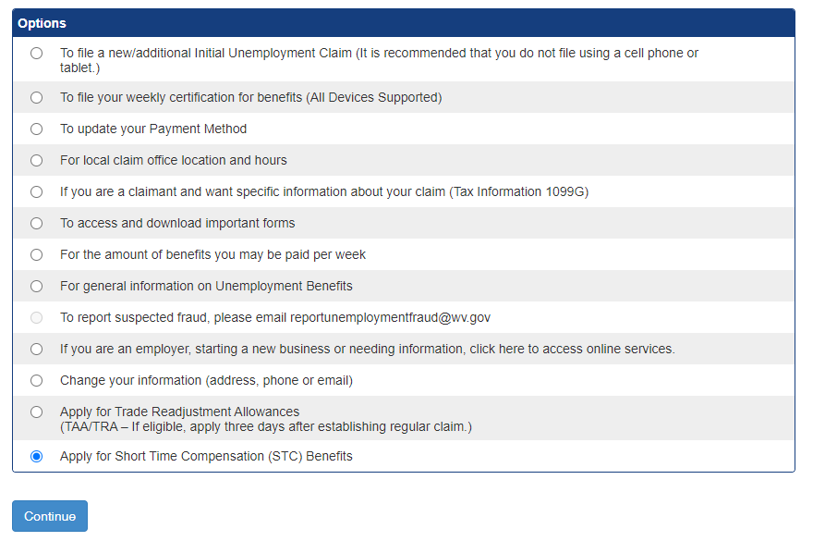

Please select Employer

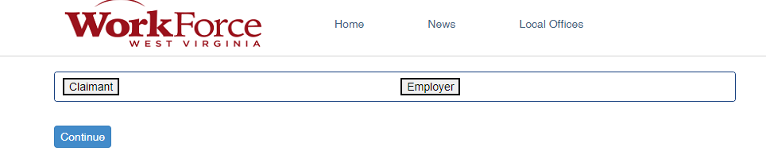

Once Employer is selected, a new drop-down menu will appear as seen below. Please select I am applying to participate in the Short-Time Compensation Program and then select Continue.

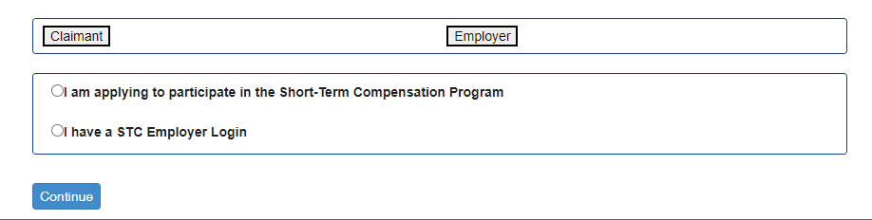
The next screen is the STC Plan Application. Please fill in all fields marked with an asterisk
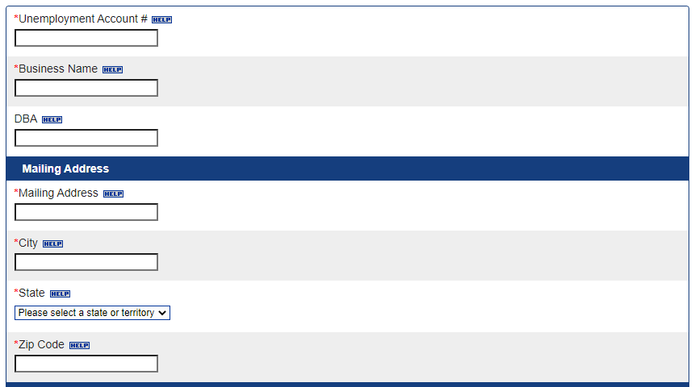
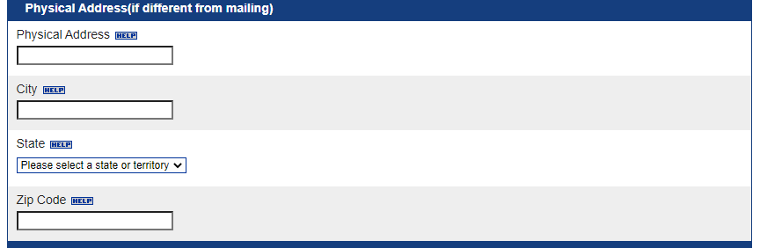

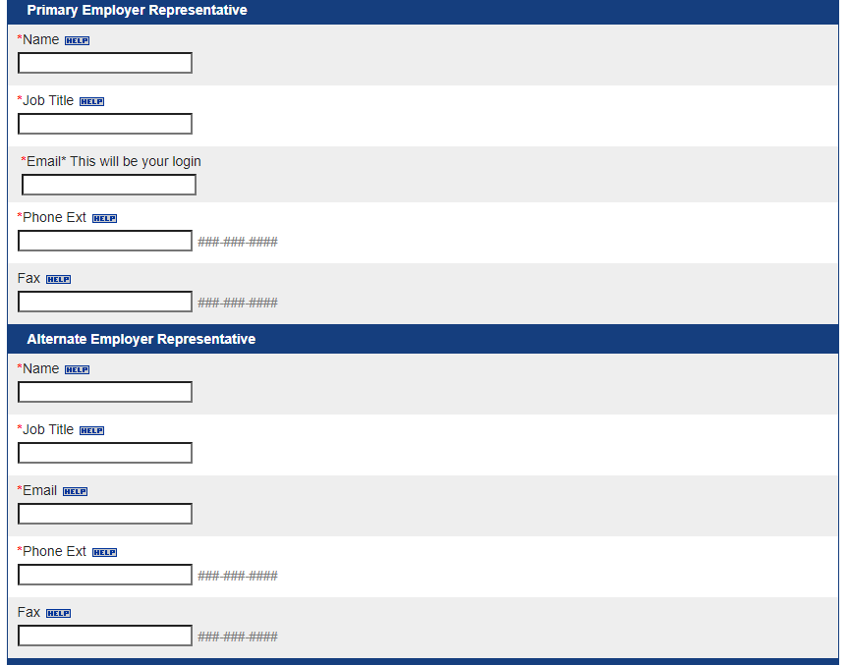
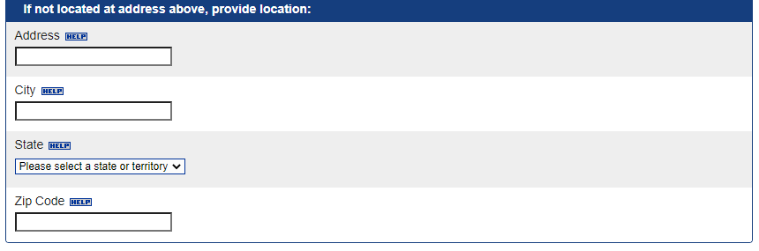
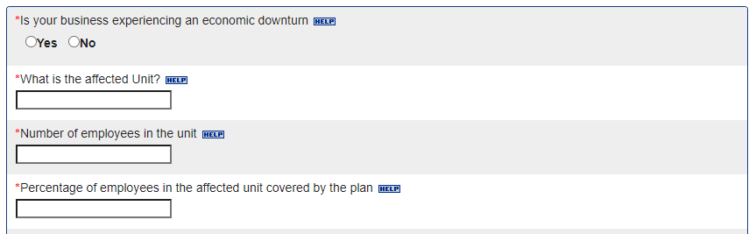
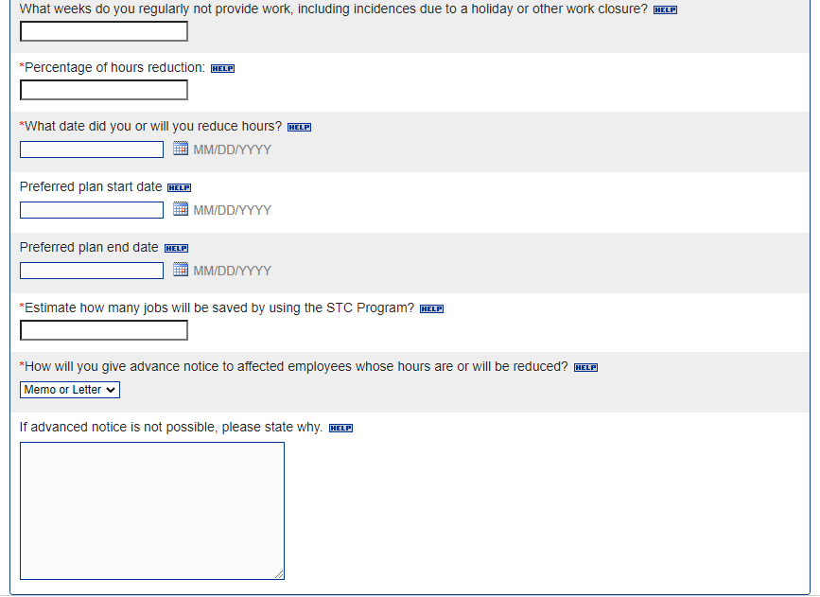

Once the application has been filled out, you may upload any additional documentation that is pertinent to the STC Plan Application. If there is none, please select Continue.
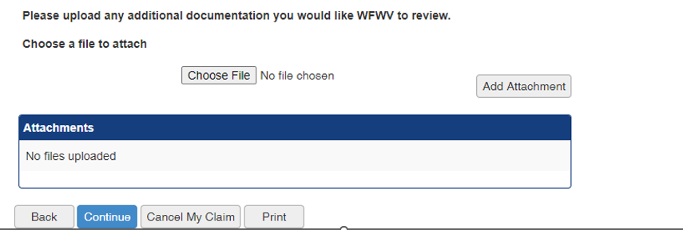

Please list each employee who will be participating in the STC program and answer the corresponding questions. Select the Add Employee button to add more employees to the list. Once all employees have been added, please select Continue.
Please note: Only employees who are listed here will be eligible to participate in this STC Plan. Employers will not be able to add any new employees to their STC plan once this application has been submitted.
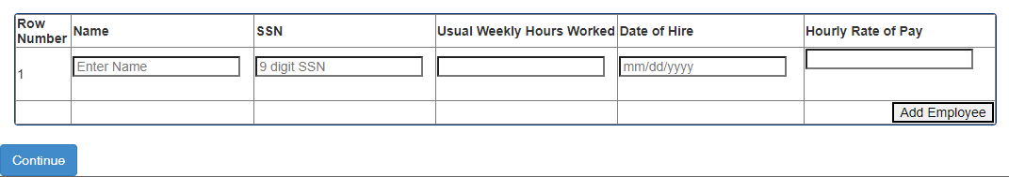

Please read the certification page, check the I certify box, and put Name, Title, and Date in the boxes listed and then select Continue
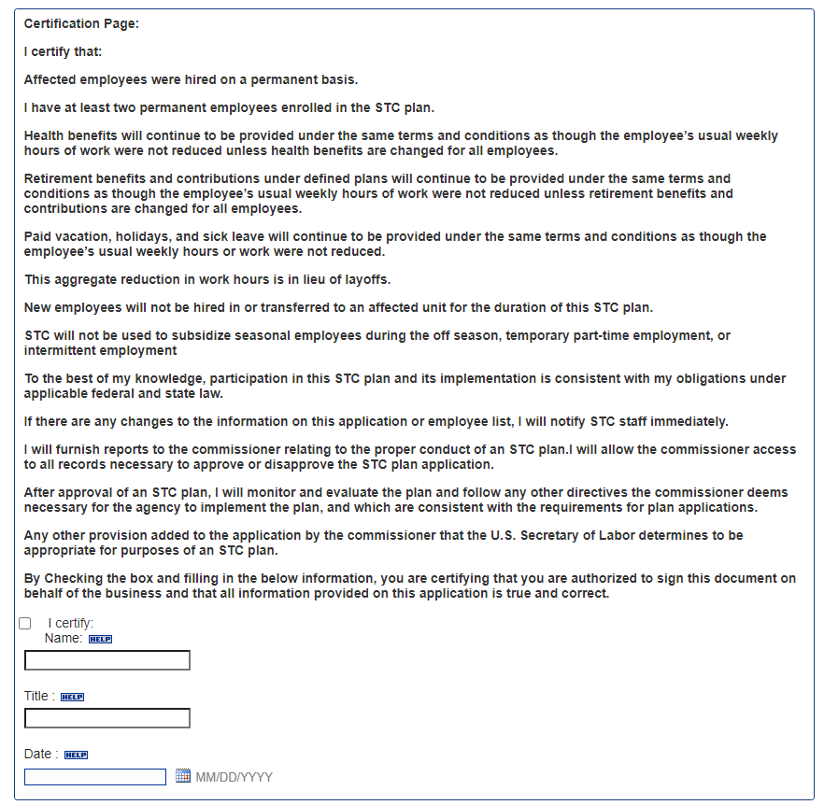

Once you select Continue, the Employer Plan Application has been submitted. A confirmation screen will pop up with a Reference Number. Employers can expect to be contacted within 10 business days.

Thank you for your interest in STC!

